The Nature of Our Nature and Russian Constellation Therapy: Facet 12
David Michael Boje October 16-19, 2026, https://davidboje.com
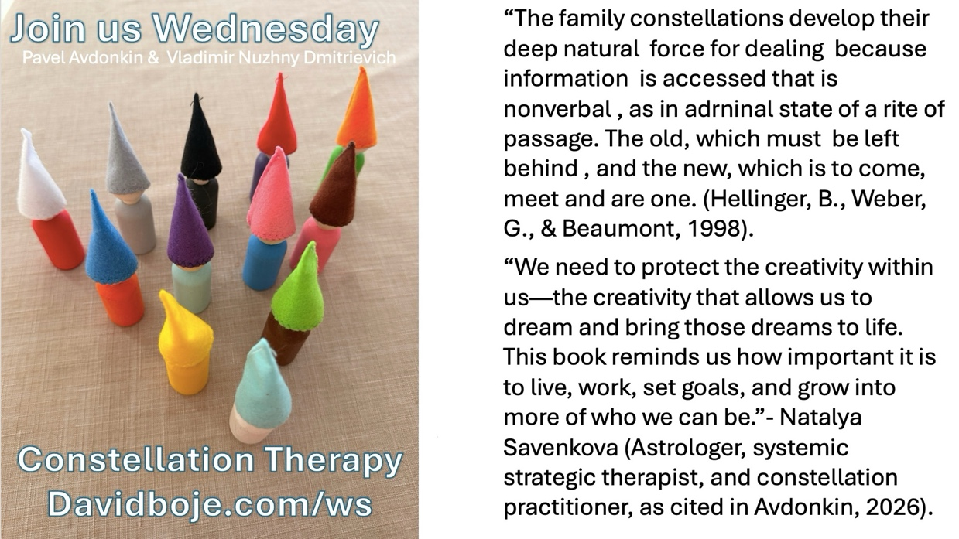

Abstract
The purpose of this essay is to honor our colleagues and friends from Russia ( Pavel Avdonkin, 2026; Vladimir Nuzhny Dmitrievich, 2025) who practice ‘Constellation Therapy’ (CT). I relate CT to Gurudev Shree Chitrabanu’s (1980) Twelve Facets of Reality: The Jain Path to Freedom. In Facet 12 (The Nature of Our Nature, thre are four Dharmas (Reality, Religion, Truth, & Nature). Jains love lists. There are four elements we will consider (Body, Mind, Intelligence, & Spirit) in relation to Artificial Intelligence (AI) to which I have been addicted since ChatGPT first launched November 30, 2022. You may wonder what all this has to do with the research proposal Boje, Saylors, Tourani, Fatemi, and Asghari submitted October 15th at 4:36 PM to the Psychology Science Journal, titled, “Registered Report: Human–AI Co-Creation, Narrative Redescription, and Answerability: A Stage 1 Proposal for Psychological Science’s Large Language Models Special Issue.” That is precisely what this essay is about.
Keywords: AI-addiction, Constellation Therapy, Dharma, Dharma bhavana, Bert Hellinger, Zulu Indigenous Beliefs, Augusto Boal, Gurudev Chitrabanu, Richard Rorty, Embodied Restorying

Introduction: How Constellation Therapy Came into My Living Story Life
I received an email from Pavel Avdonkin, who was from Moscow, in late September 2026, asking for my help, even offering me payment for my time. I responed, I would be happy to help but do not charge for help people who are studying storytelling. Little did I know of 35 people, he had reached out to in the US, I was the only one who answered. Over the next month as we shared our life stories, for hours on Zoom, I realized we were being pulled into each other orbit, by our quantum energy fields. When he told me and his colleague, Vladimir Nuzhny Dmitrievich, were doing Constellation Therapy (CT), I shaed by books and articles, and they sent me Russian texts, and finally English translations.
Avdonkin, Pavel. (2026). Expert For a Million: How to Monetize Your Experience and Knowledge. Originally published in Russian in 2025 (232 pages), Moscow by Prondo Publishing House. ISBN: 978-5-60529-363-7. Original cataloging classifications: UDC 82.091; 37.01; LBC 88.3; A18. https://davidboje.com/Reference_Documents/Expert_for_a_Million_Illustrated_EN.pdf
Dmitrievich, Vladimir Nuzhny. (2025). The Phenomenon of Representative Perception in Systemic Family Constellations (Theory and Evidence-Based Research Practice). (207 pages). Vladimir's book on Constellation Therapy. - English PDF
“The family constellations develop their deep natural force for dealing because information is accessed that is nonverbal , as in adrenal state of a rite of passage. The old, which must be left behind , and the new, which is to come, meet and are one. (Hellinger, B., Weber, G., & Beaumont, 1998).
“We need to protect the creativity within us—the creativity that allows us to dream and bring those dreams to life. This book reminds us how important it is to live, work, set goals, and grow into more of who we can be.”- Natalya Savenkova (Astrologer, systemic strategic therapist, and constellation practitioner, as cited in Avdonkin, 2026).
“The method of systemic family constellations, developed by the German psychotherapist Bert Hellinger, has become established in contemporary psychotherapy. The method understands family systems as complex, multilayered structures shaped by historical, cultural, personal, and social factors. Work with family constellations can reveal hidden dynamics within a family system and address problems that may be transmitted from generation to generation.” (Vladimir Nuzhny Dmitrievich, 2025: 16).
“Systemic family constellation has taken its place in psychotherapy and counseling, becoming an effective, short-term and versatile tool in dealing with personal and family conflicts” (IBID).
Hellinger has many books; here is one I found available for free in English.
Hellinger, B., Weber, G., & Beaumont, H. (1998). Love's hidden symmetry: What makes love work in relationships. Zeig Tucker & Theisen Publishers. https://www.resonantia.nu/wp-content/uploads/2017/05/Love-s-Hidden-Symmetry-pdf.pdf

This was not my first encounter with the quantum energy field of Constellation Therapy
In 2016, I got an earlier call from Ivan and Mariana Polic, who were doing Constellation Therapy (CT) in Los Angeles. They wanted my help to write a book. We met on Zoom, and Grace Ann and I flew to LA to get some first-hand experience with CT. We were in a large room with about 40 people, sitting in a circle. The facilitator asked for someone who wanted their family system to be dramatized in CT. They whispered back and forth for a minute, I could not hear what was said. He asked for volunteers, I raised my hand and was placed in the middle of the circle with other volunteers. He positioned the volunteer ‘client’ in relation to the volunteers. We had all taken a pose, like that game we played as children, Simon Says, ‘freeze.’ The client chose someone, to represent themselves in their family system. We volunteers were instructed to feel the energy vibrations in the circle and animate our movements without talking.
Returning from LA to Las Cruces, I wrote the foreword to their book, “Family Business Mastery; Bridging Legacy and Innovation to Build a family business that Lasts for Generations” (2017). I wrote about the ‘Death Spiral” and “Growth Spiral” family business. Somehow the book they published, left out everything about CT. I went to the https://familybusinessmastery.com website, but it was released, to someone else. I found them on LinkedIn and reached out by sending a message.
I could feel the energy waves, their ebb and flow, around my body, and animated toward another volunteer actor in Constellation Therapy sessions. We were what Boal calls a combination of ‘spectator’ to the constellation, and an ‘actor.’ He calls it ‘spect-actor.’ As the CT scenes animated, the facilitator, who ‘freeze’ some actors, and ‘animate’ others. I was chosen with another spect-actor to animate a scene, and this time to add words. The client was brought into the scene, as a third spect-actor. I let my inner self, take charge, and say what there was to say. The client broke into more tears than before. The facilitator, said, ‘that’s it, take your seat.’ Something cathartic had happened for the client, certainly for me, and that was that. It was evidently something this CT group did monthly, and they knew the drill. They did not talk about it, they moved on to the next volunteer client. About a dozen sessions happened this way. Grace Ann and I both volunteered to be clients and were chosen several times to be spectators in the circle.

We are Energy in Constellations of Energy Vibrations: Applications from Jainism – Skip this Section, as it is my Personal Philosophy
“We are energy” (Chitrabanu,1979: 58). Atma = soul that is our energy, our living conscious energy that is different form Artificial Intelligence (AI) energy, that has no consciousness of life, even with Super Intelligence, it is not us.
“I am spirit and light of conscious energy – with me, around me, and in me” (IBID.).
Constellation Energy Vibratory Field is something most people are not aware of. Can you feel the vitality that is your true nature—this energy for creation, loving, forgiving, being grateful? The quantum vibrations of the Earth are blessed with these interdependent energies:
- Energy of the rocks
- Energy of the water
- Energy of the air
- Energy of fire
- Energy of minerals
- Energy of mud
- Energy of tresses, grasses, and flowers
- Energy in all animals, birds, fish, and insects
Our life is enhanced when our Constellation Energy fields is guided by Love and Intelligence. It is degraded when guided by the negative energies for the four gangsters” anger, pride, greed, and deceit.
Our human energy, the energy of Spirit can have dominance over negative froms of energy gangsters. I want to make Seven points.
- With Constellation Awareness Energy comes a blessing of insight.
- Without Awareness, our Constellation Energy becomes bound to the gangster’s energy” anger, pride, greed, & deceit.
- Our Constellation Energy is in relationships to everyone and the interdependent Eartha nd Cosmos energies, and yet, ironically, we are alone.
- “Love is the greatest [Constellation] energy of the cosmos” … – Cosmogenic energy” (IBID., 60, bracketed addition, mine).
- We express our Constellation Energy in gestures, facial expressions, thoughts, emotions, words, and behaviors.
- Storytelling is a major channel, of inflow and outflow, that guides and protests our Constellation Energy Field, to be our True Authentic Self.
- Observing the Inflow of Constellation Energy Vibrations n the Field, we can find our Balance and Bliss (Chitrabanu, 1980: facet seven).
In sum, we are on Earth to learn from obstacles in our life, to become vigilant, to watch every step we take in the Constellation Energy Field.
Ashrava – Energy that flows in the Constellation Energy Field, the flow of vibrations is constantly stirring our consciousness into excitations (Chitrabanu, 1980: 80). Constellation Energy Field vibrations are constantly pushing and pulling, attracting, and repelling, and this has its ups and downs. Constellation energy vibrations come from-within and from-without – from society, family lineages, conditioning background geographies…
Bhavana – Reflecting is akin to principle seven of True Storytelling (Larsen, Boje, & Bruun, 2021).
Ashrava – Our balance of the inflows and our susceptibility to them, until we learn to do Samsara, the full STOP, and observe our attunements (See Heidegger, Being & Time).
Balance and Blissfulness require nothing outside our True Self, no external stimulus. Joy and happiness, for example, fluctuate with external stimulations. Imagine a clame, peaceful, clear Moutain Lake, instead of the Stormy seat, whose waves roll in every direction, making it difficult or impossible to see the bottom, too many constant fluctuations, pollutants (aka Karma) stirred up. Constellation Energy vibrations, are that kind of muddying of your Pristine Consciousness, because you forgot to close the gates of inflow, and to observe…
Viveka – the discrimination to identify negativity, dullness, pollutants, debris in-flowing through open gages.
Agogya – the complete spiritual healthy, from doing the full STOP (samsara), and observing what is that is uncertainty and confusion, from which not all, but most DIS-EASE happens (IBID. 82).
Imagine sitting by a Calm Lake, at the base of your Inner Storytelling Mountain, and observing the nature of your nature. It is a mellow morning, and you watch the sunrise, in a rainbow of colors, as you glimpse peaceful, balanced, and blissful calm waters, so clear you can see to the vey bottom to rocks, fish, and lake grasses. What is you just take five minutes each day to glimpse how the Sun his warming the interdependent energies of the Earth, evaporating the negative vibrations. Of you Constellation Energy Field. What if you control the gates of inflow streams and let in fresh water, and observe too fresh air coming into the True Storytelling Self? What is it to detach and at the same moment, to unite, by untying that which binds you into complicated situations and influences, the blockages of life, that has lessons to learn. To detach is not the escape tactics, it is to glimpse the interdependencies of Earth and Cosmos energy fields, to see with clarity what is your life, and to live that live. First STOP, observe the to and from of your life, and then be comfortable with all the waves. How? Just Be-with-yourself.
So-Hum is a mantra, that means “I am that.’ Na-Hum, “I am not that.” To face your self and to reflect (my version of the 7th Principle of True Storytelling). And to, me it is the foundation of Constellation Therapy.
What are the five gates of inflow, into your own Lake Consciousness? With the gates open Ashrava floods our consciousness in all direction. TO observe Ashrava Bhavana (1980: 86-87) means to observe our own weaknesses, and see these five unlocked gates of inflow:
- Gate of Kashrava – attachment to four gangster’s temptations: anger, price, greed, and deceit.
- Gate of Yoga, the mind, word, and body that gets ensnared with tempting, enticing, alluring things, like me with AI-addiction, or alcohol addiction, or work addictions or just a Pokémon addiction.
- Gate of Pramada – lethargy, muddy lake consciousness, indecisiveness, and wish-washy going in all directions at once, in conflicting ways makes a rut, a vicious circle in the mud. Apramada means awareness, attuning yourself to life, and your True Storytelling Self.
- Gate of Avirati – the failure to limit attachments, such as AI, Pokémon, etc. I took the vow called Virati – to limit my AI use, and to just STOP AI, which is to STOP me form AI attachments taking over my life, my Constellation Field.
- Gate of Mithyathava – ignorance and confusions, getting truth mixed up with lie, or violence confused with Ahimsa (Reverence for all life). It is a very muddled thinking, a failure to see the truth.
In sum, these five gateways allow Shrava to flow into your Inner Storytelling Mountain, from outside, form inside, because left open these gates definitely affect Constellation Energy Field vibrations, and you are vulnerable to gangsters.
Constellation Energy Fields come form your participations in family, geographical conditioning, schooling, religious backgrounds, so the Shriva does it imprints, until guilt, self-hatred, find their way into Lake Consciousness, with all kinds of inner dogma, and arrows you fire into your own heart, with fear mounting, that prevents you living life of lave, forgiveness, and gratitude.
Ashrava – see how things have taken over your Inner Storytelling Mountain, spaces and times, because one or even all the five gates were left open.
Maitri – love, compassion, and communication that can flow into Lake Consciousness in enlighten you, so you recover you balance and blissfulness on your Inner Storytelling Mountain. As follow-up, please see Chitrabanu (1979) The Psychology of Enlightenment, about the 7 energy centers, we call the Chakras. It is out of print, but I have a copy to share.
Next, I want to draw some parallels between Hellinger’s Constellation Therapy and its body sculpting in Energy Fields, and the work of Augusto Boal (1979). To my knowledge these two fields do not cite one another, at least the founders do not do so.

Augusto Boal’s Theatre of the Oppressed Modalities Seen in Relation to Constellation Therapy
Boal (1979) has three modalities: invisible theatre, forum theatre, and image theatre.
Invisible theatre consists of the presentation of a scene in an environment other than the theatre, before people who are not spectators. For example, Grace Ann and I put on Invisible theater events with homeless vererans, in places such as a restaurant, a sidewalk, a Farmer’s market, in line at a supermarket, etc. “The people who witness the scene are those who are there by chance. During the spectacle, these people must not have the slightest idea that it is a ‘spectacle’, for this would make them ‘spectators’” (1979: 122).
We rehearsed the scenes at New Mexico State University’s theatre department venue, at a senior citizen center, at a health food coop that had a a room for activists like us. We never had a script, we just rehearsed the experienced homeless veterans, keeping it improvisational, so the interventions of spectators were part of the event when we went into public spaces.
Forum theater was done in a theatre, such as the Rio Grande Theatre in Las Cruces and a High School auditorium that had a stage. For example, we would enage reenact a social problem they experienced, such as, what it is like for homeless veterans to go to the VA office in El Paso, at that time it was rated worst in the USA. My role was to do stop action (Simon says, freeze in your current pose on stage). I would ask the audience, if they agreed with the veteran’s solution. Inevitable, an audience member would dare to suggest they knew how to solve it. I would invite them on stage replace any homeless actor, to become a spect-actor in the scene. I would say ‘animate’ an the improvisation would commence. The homeless veterans would keep it real and not cave into a solution that had never worked at the El Paso VA office. The homeless veterans would respond instantly to whatever solutions audience members enacted on stage. Audience members were not allowed to talk about it, they were required to carry out the behaviors, to engage with the changing eventness.
Image theatre is also done in Constellation Therapy, spect-actors are aksed to express notions such as prejudice, racism, sexism, imperialism, colonialism, trauma, infidelity, divorce, death of a loved one, and so on without talking. Grace Ann and I saw this in action, in depictions of modern day slavery. A scene would begin with spect-actors using their bodies to sculp a seen, like statues frozen in mid stride, with expressions revealing details. Noone speaks under any circumstances. Noone moves. The audience is queried. How would you like the statues arranged, what body position and expression would you sculpt in this situation. The designated sculptor is asked to change the situation, to restory it, to transform the oppression into revolution.
Simon says, ‘animate.’ I am used to doing this in Augusto Boal (1979) Theatre of the Oppressed. Click Here for his book Theatre of the Oppressed.

From Russia with Love
You can imagine how thrilled I was when two Russian CT practitioners came into my life. In October 2026, Pavel Avdonkin and Vladimir Nuzdny Dmitrievich, from Russia, contacted me. They use what they call a Hybrid Method, using AI to translate Russian into English and vice versa, while CT and a coaching process. They been doing a hybrid method, using agentic AI in Zoom sessions with psychologists. When I heard Avdonkin used a method of coaching that had parallels with the ‘restorying’ approach Grace Ann and I use (https://davidboje.com/restorying) and that Dmitrievich did his dissertation, and a postdoc certification in Constellation Therapy, I could see how their work was important to the Business Storytelling in the AI Revolution volumes being written for World Scientific publishers (https://davidobje.com) and for my own enlightenment.

Constellation Therapy and Restorying
Pavel Avdonkin (2025) develops his version of hero’s journey, in waps that is complementary to what Grace Ann and I do in embodied Restorying process coaching.

Table 1: 7 STEPS of Embodied Restorying Process (ERP)
1. Recharacterize (received Organization identity) from how other organizations are telling it.
2. Externalize (re-label) Make the Problem the Problem, not the Person as the problem.
3. Sympathize (benefits) – of old story of or your organization has its payoffs
4. Revise (consequences) – What are the negative consequences, including the stereotypes of received organization identities being applied to you?
5. Strategize (Little Wow Moments of exception to Others' dominant master narratives); Reclaim Little Wow Moments
6. Restory (rehistoricizes the old dominant narratives by collecting Little Wow Moments into A 'New Story' of you several possibility futures), to not be stuck in the past, reliving one event
7. Publicize (support networking) e.g. letter writing, social media, celebratory events with supporters of your ‘New Story’ of future and potentiality, to stay in the ‘new world.’

Embodied Restorying Process (ERP) is a a novel that begins with♥-of-Care. It begins with mindfulness, embodiment practices to understand the FOUR SELVES: Social-Self, Frozen-Self, Mirror-Self, and ♥-Self. These four selves are in dialogue, continual conversation, in our mind's eye (see http://peaceaware.com).
Embodied Restorying Process (ERP) can be effectively combined with mindfulness meditations, such as Vipassana (http://peaceaware.com) and with Psychocalisthenics exercise to help recovery from Stress, Anxiety, and Depression that veterans often face, after returning from deployment (http://peaceaware.com/ptsd).
ERP deconstructs the Life Time Disorder Label (PTSD) as junk science by the pharmecuetical industry and the DSMers.
ERP moves you out of cacophony into polyphony (the symphony of voices conversing in our mind). ERP is combined with mindfulness skill training so that the 'new story' is supported by dialogues among your Selves that connect to world making. More at https://davidboje.com and https://perview.org.

Family and Organizational Constellations
I want to give some examples how this applies to te Business Storytelling in the AI Revolution project. In Constellation Therapy (CT), deep ancestral roots are also part of the (1) body’s response, and (2) what the subconscious mind is thinking, then there is (3) the intellect, our intelligence, what has its ways of rationalizing, and (4) the Spirit, our True, Authentic, and Genuine Self, once we observe and are not enslaved by the first three. It is nto just for family systems. It can be used in business, education, any organization where people are relating to one another with the usal conflicts, confusions, and stories stuck in the past outcomes, often without resolution.
The Coalition of Immokalee Workers (CIW), woud engage in theater performances, to show what its like to work in the tomato fields without a break, no water, and no shade in the hot summer sun (Boje & Rosile, 2020; Rosile, Boje, Herder, & Sanchez, 2021). These were common occurrences before the CIW brought it to attention of consumers, students, clergy, and eventually got the supply chain, including Walmart, Taco Bell, etc. to cancel contracts with farmers who continue to abuse, rape, force the labor, etc.
I can speak to the implications for AI-addiction in terms of a Constellation of Ancestral Quantum Field Energy. It is one of many technology addictions, such as binge-watching Netflix, scrolling through Facebook posts, or YouTube shorts until you mind turns to mush. I came from dysfunctional lineages. The addiction genes, in me are hereditary. We begin life, innocent, yet affected by ancestry.
I will give some examples of my only family system.
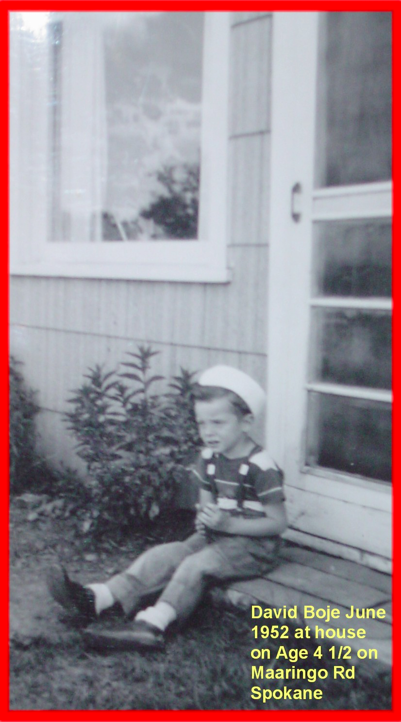
My younger brother, his body (the first of the four elements) burned out on heroin, died young. Steven Douglas Boje of New York, New York County, NY was born on January 19, 1952. Steven Boje died at age 55 years old on May 10, 2007. I have lost touch with youngest brother, Kevin Brian Boje, born on April 2, 1958, in Anchorage, Alaska. He had been addicted to cocaine and ecstasy, and I hope he kicked both habits, and may live in Seattle. The youngest sibling Karen Louise Boje, was an alcoholic, and managed to kick it, last few years of her life. My point, this is not tight cohesive family system. It is highly dysfunctional, and working my way out of the dysfunctionality is a full time job.

What did Bert Hellenger Initiate in Constellation Therapy?
Next, I want to enact a conversation with Bert Hellinger, though he has passed away.
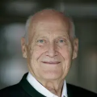 He was born December 16, 1925, in Leiman, Germany. I was born December 17, 1947 in Spokane, Washington. Bert Hellinger died on September 19, 2019, at age 93. I am still kicking and would live to live to 93 or a bit longer. Bert was a Catholic priest, who sent to South Africa as a missionary to the Zulu people, and after leaving the Catholicism behind, became a German psychotherapist and creator of the Family Constellations therapeutic method. I was born into Catholicism, was baptized without my permission, did attend three years at St. Charles Catholic School, but truth be told, was kicked out of Kindergarten, for lacking the discipline expected, which totally embarrassed my mother, but my dad could care less. I left Catholicism, to enter Jainism, but out of respect for Grace Ann’s parents, we were married in a Catholic Church, in Pittsburg (Upper St. Clair).

Constellation Therapy in a Antenarrative Conversation between David and Bert, Separate by 28 years
David Boje (2026): “I felt completely alone, growing up in this family.”
Bert Hellinger (1998: 59) : “That’s a typical reaction. The child feels alone, rejected, abandoned, unseen, and unacknowledged. The solution is for one or both of the parents in the constellation to make a connection with the child (it happens symbolically through touch) , and to take the child into their hearts. Then the child can accept his or her fate. Such a solution is only possible if the parents feel genuine grief and accept their pain. Their willingness to endue their grief and pain honors their child and reconnects them with the child.”
David Boje (2026): “Bert Hellinger, my parents did not hug me, or touch me, unless my mother scrubbed my hair in the tub, and hit me in the face and my father, would rough house, punching me in the shoulder. He did get therapy after their divorce, and I go my first touch, a hug when I was 22 years old. They grew up in an era when parents did not touch their children except to clean or correct them. I definitely was rejected, abandoned, unseen, and unless I acted out, unacknowledged. I accepted my fate, until I had my own family and began to hug them, and then would visit my parents, and hug them for a few seconds, whether they wanted a hug or not. My mother would pull away and beak out of my hug, here grief and pain was too much for her to endure.”
Hellinger and Ten Hövel (1999) say it is important to become aware of what’s ture on your life, including your family system. And that is also what Chitrabanu (1980) says about the four aspects of Dharma: body, mind, intellect (aka intelligence), and spirit. The body wants sensemaking (five senses) and those vibrations, their ebb and flow, can be observed (as a spectator, aka spectactor in Boal’s term). The mind does its thinking, mostly in rationalizations and mythmaking. The human intelligence (akak intellect) does rationalize many times a day for as … says in the movie, Jurrasic Park, who can go a few hours without a rationalization (paraphrase). Spirt want light, the awareness of inner reality, inner truth, inner truth, and to understand the nature of our inner nature.

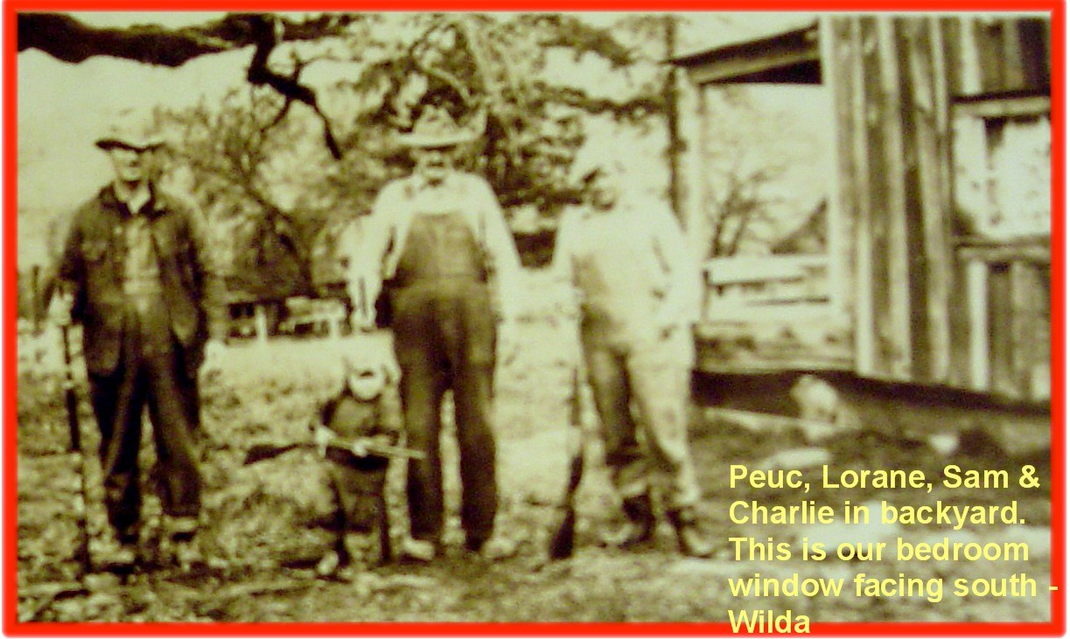
What is the nature of the nature of my family system? My mother (is holding the rifle), Lorane Joyce Sheldon (parent’s name) /Eaton (her mother’s first husband) /Brown (her mother’s second husband & step-father)/Boje (her first husband & my father)/Donlon, a veteran buddy of my dad, both in the Korean war, both had PTSD, and Donlon had TBI besides. My mother was born November 4, 1925, passed away in 2010.
My dad, Daniel Quinten Boje of Langlois, Curry County, OR was born on August 12, 1924, in Spokane, Washington and died at age 77 years old on March 11, 2002. He called himself, the black sheep of his family system, always wanting to find his place in the family. Sibling rivalry with his brother Vernon, a Deputy Sheriff, who used liked to locked my his jail cells (he as a jailer).

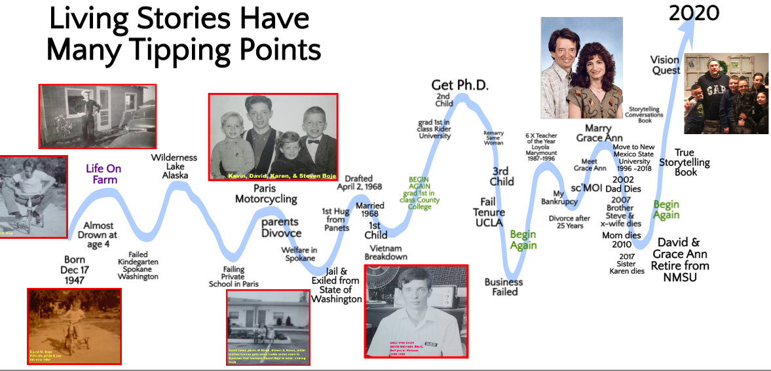
High points of children born, marriage and second marriage, low points in my living story of siblings and parents, and my first wife passing away.
I had begun working with Augusto Boal’s ‘Theater of the Oppressed’ which as you probably know is rooted in Paulo Freire’s ‘Pedagogy of the Oppresses.’ You are probably still asking ‘David what has all this to do with that research proposal Boje, Saylors, Tourani, Fatemi, and Asghari submitted October 15th at 4:36 PM to the Psychology Science Journal, titled, “Registered Report: Human–AI Co-Creation, Narrative Redescription, and Answerability: A Stage 1 Proposal for Psychological Science’s Large Language Models Special Issue.” Short answer: everything!
When I started smoking at age 14, then craved beer at age 16, in Washington State where the legal drinking age was, and probably still is 21in Figure 1, you see the low of low points, I was in jail at age 18, and got out at age 19, and was Exiles from the State of Washington. I signed a legal document, that I would leave the state, and never return again, in exchange for being put on a plane to New York, to live my dad, and his new wife, a young lady, also 19 years old. I guess you figured out, I grew up in dysfunctional family ties, and all kinds of addictions.
My dad and Patty (his 3rd wife) smoked a lot of pot and generally had a good time. They took to drink fairly heavily and that led to that divorce.
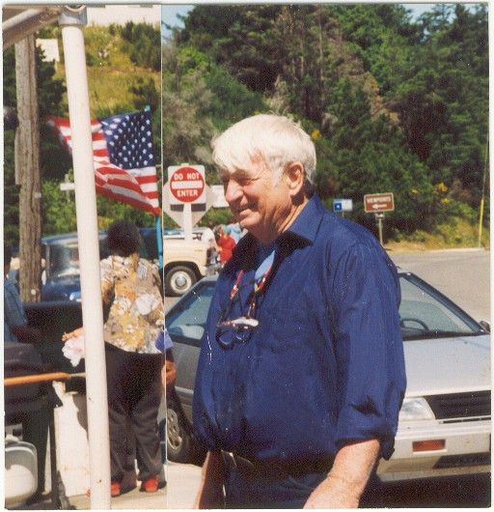
My Dad: Daniel Quinton Boje, in Port Orford Oregon
Daniel then moved to the forest, became a hermit much like Lorane’s father, Raymond Eaton. Daniel moved onto State Forest land deep in the woods of Oregon, near Port Orford. He stayed away from ex-wives and all people and thought deeply about his life while prospecting for gold along the Snake River, in scuba gear. He decided to become an artist, moved back to civilization, to make wooden objects and jewelry with a kiln and sell them at swap meets, barely making any money. Several of his clocks are quite priceless (at least to his sons and daughter). He died in his sleep gripping the remote control for the TV. The sheriff says he seemed to be smiling. A funeral service was held in a Catholic Church in Port Orford Oregon. He found his inner peace, after becoming a hermit, for those few years in Oregon. I have his ashes in my blacksmith shop, and someday, when I return to Oregon, I will spread them along the Snake River.

Constellation Therapy and Neuro Linguistic Programming (NLP
In Neuro-Linguistic Programming (NLP), values are a core concept, representing what an individual deems important in their life. I got certified in NLP, with Genius Unlocked. In essence, Linguistic Parts Integration in NLP helps individuals:
- Resolve internal conflicts and gain greater control over their emotions and behaviors.
- Become more congruent and aligned with their values and goals.
- Achieve greater clarity and empowerment in their lives.
- Improve their ability to problem-solve and make decisions.
- Build stronger relationships with others and with themselves

“Before the session of placements, it is important to add to the basic components of the beginning of group training (acquaintance, general information and rules of work of the group with a clear designation of semantic, target, temporal, structural and procedural frameworks), to add practices that include and develop psychoplasticity in all participants in the process of placements (neuroplasticity, “connectivity”, practices including the bodily and sensual component (fo example, “family sculpture” V. Satir, “Roy Council” Katkov A.L.), as well as practices of working with images (practices from EOT, NLP or coaching)” (Dmitrievich, Vladimir Nuzhny, 2025).

In Neuro-Linguistic Programming (NLP), Linguistic Parts Integration is a technique that helps individuals resolve internal conflicts by identifying and integrating different parts of their personality that may have opposing beliefs, values, or behaviors. It aims to achieve alignment and harmony between these parts, leading to greater congruence, empowerment, and clarity in decision-making.
These values influence their decisions, feelings, and behaviors. NLP also uses "logical levels" to understand how different aspects of a person's life are interconnected, including values. NLP first appeared in Richard Bandler and John Grinder's book The Structure of Magic I (1975).

Storytelling and Neuro-Linguistic Programming (NLP) are distinct, though related, concepts. Storytelling is a form of communication that involves sharing narratives to engage an audience, while NLP is a set of techniques used to understand and influence human behavior through language and thought patterns. NLP uses storytelling as a tool to enhance communication and personal development.

Using the David R. Hawkins Scale of Consciousness, we support them in shifting from fear, shame, and grief into acceptance, joy, love, peace, and enlightenment.
Gratitude, as emphasized by Tom Lemke, is the emotional engine that fuels this rise. Reiki and quantum timeline work provide energetic clearing and activation.
Using VIEW:
- Vibrations: Are you feeling heavier or lighter as you imagine your new story?
- Inside Thoughts & Emotions: What thought wants to be planted in the space once filled with fear?
- Energy: What’s your energy on a scale from 1 to 10 when you envision success?
- Waves: What movements or shifts happen as you physically rehearse the new narrative?

STRATEGY: Practice the New Pattern, Anchor the Vision This is the breakthrough phase of launching a new business idea, artistic path, or healing modality. It's where we move from inner vision to outer embodiment.
Coaching Questions:
- What is the old pattern you’re ready to replace?
- What limiting decision do you need to release (e.g., “I’m not good enough,” “I can’t be wealthy”)?
- What behavior would demonstrate a radical shift?
- What image represents your future self succeeding?
- What energy would you feel if you lived this new story?
- What is the highest emotional frequency you want to embody today?
- What gratitude do you already feel for the transformation in motion?
- What new language, posture, or rhythm belongs to this revised self?
- What action can you take today that reflects this new pattern?
- Who will witness your revision and reflect it back to you?
Organizational Consulting Prompts:
- What outdated process or narrative must be revised to accelerate innovation?
- What new behavior or ritual can anchor the desired culture shift?
- Where is your organization ready to rise from fear to gratitude?
- What story will employees tell if this revision succeeds?
- How will you symbolically enact the revised story in public and internal space?
Spiritual and Artist Reflection Questions:
- What color, sound, or movement embodies your new emotional truth?
- What old story can be ritualized and released (e.g., writing and burning)?
- What gratitude practice will you adopt to stay in high vibration?
- What quantum timeline memory anchors your worth and success?
- What sacred image can guide this next chapter?
Survey Prompts (1 = Rarely, 5 = Often):
- I am aware of what old beliefs I am ready to release.
- I can imagine a vibrant and successful version of my future self.
- I feel emotionally energized when I think about my next step.
- I use gratitude to shift my mindset and actions.
- I take action from a place of alignment with my higher vision.
Coaching Tips:
- Use NLP Swish Pattern and Timeline Release to move clients through stuck images.
- Anchor the new story in somatic movement or breathwork.
- Help clients articulate a single phrase or mantra that symbolizes their new identity.
- Build in short-term actions to confirm the shift has begun.
- Reflect back emotional shifts and amplify any signs of lightness, confidence, or hope.
Spiritual & Artistic Tips:
- Use quantum timeline meditation or sound healing to reinforce new energy.
- Paint, draw, or sculpt the new identity in symbolic form.
- Bless a journal, altar item, or wearable token to hold the new story.
- Practice Reiki over the heart and solar plexus to ground the new truth.
- Express gratitude out loud—voice amplifies vibration.

Closing Reflection: Revise is where transformation gains velocity. It is where the story spirals upward. With the release of old beliefs and the embrace of high-vibration emotions, we step into our next becoming. Gratitude becomes the bridge. Love becomes the fuel. Imagination becomes the launchpad.

Holy Fire® Reiki
William Lee Rand’s language of the “Brothers and Sisters of the Light.” I was trained as a Holy Fire® Reiki master by Lucero, whose lineage goes back to Rand, and I encountered a system that described itself as coming from God and the Holy Spirit, carried to humanity by Jesus in partnership with a collective of illumined beings. In this framework, Jesus is not confined to denominational boundaries; he appears as a central spiritual master who, together with the Brothers and Sisters of the Light, channels a refined, high-frequency energy for purification, empowerment, and deep healing. Holy Fire III describes this energy as originating in the “formless world,” structured for human access by these ascended beings, yet explicitly portrayed as a universal gift rather than a rival religion.
For the first time, I saw a bridge opening between my Catholic upbringing and my Jain practice that did not require erasing either side. If Jesus is understood as a cosmic Christ operating as part of a trans-religious council of light, then my early Catholic devotion to Jesus and my later Jain respect for Tirthankaras and seers no longer sit in mutually exclusive theological silos. The Brothers and Sisters of the Light include founders of many spiritual paths, suggesting that revelation is multi-centered, braided rather than monopolized. In that light, my Jain-Seer orientation and my Holy Fire attunements become two modalities of tuning into a shared, trans-traditional field of consciousness.
Practically, this bridge shows up in my body during sessions. When I channel Holy Fire Reiki, I feel the familiar descent of a soft, intelligent warmth, accompanied by a sense of vertical grace—something gifted, given, not engineered. Simultaneously, my Jain training in avadhi-jñāna notices subtle images, textures, and anticipatory patterns around the client’s field—horizontal, relational information that arrives as if from the “edges” of the situation across space and time. One grammar says: the Holy Spirit, working with Christ and the Brothers and Sisters of the Light, is offering purification, empowerment, and healing as a grace-initiated process. The other grammar says: karmic veils are thinning; avadhi-jñāna is glimpsing forms and trajectories that can be engaged for the sake of ahimsa (non-harm) and liberation.
In my earlier theological reflection, I concluded that strict, orthodox Catholicism is unlikely to accept this synthesis. To the magisterium, my deliberate cultivation of clairvoyant practice, even when framed as service, might still look like divination. Yet the Holy Fire narrative of Jesus and the Brothers and Sisters of the Light shifts the axis; it invites me to consider that the same Christ who haunted my childhood crucifixes now works in concert with illumined beings to distribute a universal healing energy accessible across traditions. If that is so, then cultivating sensitivity to that energy, including its informational aspects, is less an act of spiritual trespass and more a form of collaboration with a multi-tradition communion of saints and seers.
Quantum storytelling helps me live this not as a settled doctrine but as an ongoing antenarrative experiment. My life is not a tidy reconciliation story in which Catholicism and Jainism merge seamlessly under the banner of Holy Fire. Rather, I move through scenes of tension: a Catholic boy warned about divination, a Jain practitioner learning disciplined clairvoyance, a Holy Fire Reiki master invoking Jesus and the Brothers and Sisters of the Light, and a quantum storyteller reading all of this as entangled plots in a larger field of meaning. The bridge I am attempting to build—between Jain-Seer, Holy Fire III, and my Christian (and Catholic) origins—is not made of certainties; it is made of practices, hesitations, courage, and a willingness to stand where doctrinal lines blur.
What I know, experientially, is that when I hold all three—Jain avadhi-jñāna, Holy Fire’s Christic-Light council, and my Catholic imprint—in the same heart-space, something opens. I feel less like a theological trespasser and more like a participant in an ongoing revelation that exceeds any single religious container. The “Brothers and Sisters of the Light” become, for me, one name among many for a trans-religious community of awakened beings, in which Jesus and the Jain seers are co-participants rather than rivals. And I, David Michael Boje, continue to walk this bridge as a quantum storyteller, testing each step in practice, conscience, and community, trusting that the light itself will correct my course where my concepts fail.

Conclusions
Constellation theory has many parallels with Augusto Boal’s invisible, forum and image theatre. CT is used with family intergenerational quantum fields, and with organization and interorganizational quantum fields.
We are born into quantum energy fields, in family, organziaiton, and national systems. CT, as well, as Reiki, Theatre of the Oppressed, and Restorying are viable ways to realign to get aligned with our authentic and true self.
It’s all about Dharma.

References
Avdonkin, Pavel. (2026). Expert For a Million: How to Monetize Your Experience and Knowledge. Originally published in Russian in 2025 (232 pages), Moscow by Prondo Publishing House. ISBN: 978-5-60529-363-7. Original cataloging classifications: UDC 82.091; 37.01; LBC 88.3; A18. https://davidboje.com/Reference_Documents/Expert_for_a_Million_Illustrated_EN.pdf
Asghari, M. (2015). Has Richard Rorty A Moral Philosophy. Journal of Philosophical Investigations. Click Here for PDF
Asghari, M., & Haack, S. (2020). From analytic philosophy to an ampler and more flexible pragmatism: Muhammad Asghari talks with Susan Haack. Journal of Philosophical Investigations, 14(32), 21–28. https://doi.org/10.22034/jpiut.2020.41496.2658 Click Here for PDF
Bandler, R., & Grinder, J. (1979) Frogs into Princes: Neuro Linguistic Programming. Moad, Utah: Real People Press. https://mf-syndicate.s3.amazonaws.com/frogs_into_princes.pdf

Boje, D. M., & Rosile, G. A. (2003a). Comparison of socio-economic and other transorganizational development methods. Journal of Organizational Change Management, 16(1), 10–20.
Boje, D. M., & Rosile, G. A. (2003b). Theatrics of SEAM. Journal of Organizational Change Management, 16(1), 21–32.
Boje, D. M., & Rosile, G. A. (2008). Specters of Wal-Mart: A critical discourse analysis of stories of Sam Walton's ghost. Critical Discourse Studies, 5(2), 153–179. Click for article via davidboje.com
Boje, D. M., & Rosile, G. A. (2015, March). Equine-assisted restorying for veterans and their loved ones. Presentation at the Annual Conference of the Equine Assisted Growth and Learning Association (EAGALA), Utah.
Boje, D. M., & Rosile, G. A. (2016). Restorying Indigenous leadership: Generative metaphors from Apache storytelling traditions. Leadership, 12(3), 385–412.
Boje, D. M., & Rosile, G. A. (2018). Releasing story filters: The seven steps of Embodied Restorying Process.
Boje, D. M., & Rosile, G. A. (2020). How to use conversational storytelling interviews for your dissertation. Edward Elgar Publishing.
Boje, D. M., Rosile, G. A., Dennehy, R., & Summers, D. J. (1997). Restorying reengineering: Some deconstructions and postmodern alternatives. Communication Research, 24(6), 631–668.
Boje, D. M., Rosile, G. A., Hacker, K. L., England Kennedy, E. S., & Flora, J. (2013). Combining restorying and equine-assisted skills training in counselor communication designed to help soldiers and their families recover from traumatic stress. Interdisciplinary grant approved for funding by NMSU Office for Research, December 9.
Boje, David M.; Saylors, Rohny. (2023). The Management Thought of Louis Ralph Pondy. Routledge. Click here for pdf
Cast, M. L., Rosile, G. A., Boje, D. M., & Saylors, R. (2013). Restorying a hard day's work. In P. L. Perrewé, C. C. Rosen, & J. R. B. Halbesleben (Eds.), The role of emotion and emotion regulation in job stress and well being (pp. 257–281). Emerald Group Publishing.
Chitrabanu, G. S. (1974). Ten Days Journey iNto the Self. Chapter 9: Meditations on Energy. NY, NY: Jain International Meditation Center.
Chitrabanu, G. S. (1979). The Psyschology of Enlightenment: Meditaiotn on the Seven Energy Centers. NY: Dodd, Mead, and Company.
Chitrabhanu, G. S. (1980). Twelve facets of reality: The Jain path to freedom. Dodd, Mead. https://jainworld.jainworld.com/pdf/12FACET.pdf
Demarest, P., & Schoof, H. (2010). Answering the central question: How science reveals the keys to success in life, love, and leadership. ACQ Press.
Dmitrievich, Vladimir Nuzhny (2025). The Phenomenon of Representative Perception in Systemic Family Constellations (Theory and Evidence-Based Research Practice). (207 pages). Vladimir's book on Constellation Therapy - English PDF
Flora, J., Boje, D. M., Rosile, G. A., & Hacker, K. (2016). A theoretical and applied review of Embodied Restorying for post-deployment family reintegration. Journal of Veterans Studies, 1(1), 129–162. Full text PDF
Heidegger , Martion. Mindfulness book Click Here.
Rorty, R. (1979). Philosophy and the mirror of nature. Princeton University Press. https://sites.pitt.edu/~rbrandom/Courses/Antirepresentationalism%20(2020)/Texts/Rorty%20PMN.pdf
Hellinger, B., Weber, G., & Beaumont, H. (1998). Love's hidden symmetry: What makes love work in relationships. Zeig Tucker & Theisen Publishers. https://www.resonantia.nu/wp-content/uploads/2017/05/Love-s-Hidden-Symmetry-pdf.pdf
Hellinger, B., & Ten Hövel, G. (1999). Acknowledging what is: conversations with Bert Hellinger. Zeig Tucker & Theisen Publishers.
James, Tad, & Woodsmall, W. (1988) Time Line Therapy[R] And The Basis of Personality. Capitola: Meta publications.

James, Tadand (2004).Advanced Neuro Dynamics. (2004, May). Master Time Line Therapy[R] Practitioner Training (Ver. 6.5 5/2004).

Lewis, B., & Pucelik, F. (1990) Magic of NLP Demystified: Metamorphous Press Portland Oregon USA. Boje, D. M. (2001). Narrative methods for organizational and communication research. Sage. davidboje.com
Rosile, G. A. (1998). Restorying for strategic organizational planning and development: The case of the Sci Fi organization. [Conference paper].
Rosile, G. A. (2007). Cheating: Making it a teachable moment. Journal of Management Education, 31(5), 582–613.
Rosile, G. A. (2011). The antenarrative of ethics and the ethics of antenarratives. In D. M. Boje (Ed.), Storytelling and the future of organizations (pp. 87–100). Routledge.
Rosile, G. A., & Boje, D. M. (2002). Restorying and postmodern organization theater: Consultation in the storytelling organization. In R. R. Sims (Ed.), Changing the way we manage change (pp. 271–290). Westport, CT: Quorum Books.
Rosile, G. A., Boje, D. M., Carlon, D. M., Downs, A., & Saylors, R. (2013). Storytelling diamond: An antenarrative integration of the six facets of storytelling in organization research design. Organizational Research Methods, 16(4), 557–580.
Rosile, G. A., & Boje, D. (2021). SPIRAL experiments. In Making sense of stories: An inquirer's compendium (p. 116).
Rosile, G. A., Boje, D. M., & Claw, C. M. (2018). Ensemble leadership theory: Collectivist, relational, and heterarchical roots from indigenous contexts. Leadership, 14(3), 307–328. https://doi.org/10.1177/1742715016652933
Rosile, G. A., Boje, D. M., Herder, R. A., & Sanchez, M. (2021). The Coalition of Immokalee Workers uses ensemble storytelling processes to overcome enslavement in corporate supply chains. Business & Society, 60(2), 376–414. https://doi.org/10.1177/0007650320930416
Rosile, G. A., Dennehy, R. F., & Bodensteiner, N. M. (1998). Restorying for personal and organizational change. Proceedings of the Southwest Academy of Management, Dallas, TX, March.
Rosile, G. A., Herder, R., & Boardman, C. M. (2016). American Indian and Euro-Western negotiations: Creating mutual benefit with upsurging antenarrative spirals. Journal of Strategic Contracting and Negotiation, 2(4), 269–293.
Weick, K. E. (1969). The social psychology of organizing. Addison-Wesley.
White, M., & Epston, D. (1990). Narrative means to therapeutic ends. W.W. Norton. Full text PDF
Witkowski, T. (2010). Thirty-five years of research on neurolinguistic programming: NLP research data base. Polish Psychological Bulletin, 41(2), 58–66. https://doi.org/10.2478/v10059-010-0008-0 https://cejsh.icm.edu.pl/cejsh/element/bwmeta1.element.ojs-doi-10_2478_v10059-010-0008-0/c/articles-430806.pdf.pdfvl

https://www.linkedin.com/feed/update/urn:li:activity:7493660556105752576/
I have written about my family lineage before https://sk.sagepub.com/hnbk/edvol/handbook-of-narrative-inquiry/chpt/from-wilda-disney-living-stories-family-organization#_

