A Storytelling Systems Review Essay on America’s Return to Original Politics
version Feb 21 2021; Feb 28

David Boje’s book review of Glenn Aparicio Parry’s (2020) Original Politics: Making America Sacred Again (NY: Select Books Inc.).

With the January 6 2021 siege of the Washington Capital Building, is there hope for healing America? The mob had no deep respect for anything sacred about its government. The assault on the Capital Building and the murders that day, showed the world there is no more common ground in America. We all witnessed American political and economic system devolve into a state of chaos and anarchy. This situation sets the context to why this is such a timely and important book everyone in politics, business, and every school child needs to take seriously.
The express purpose of Original Politics is “Helping to create a whole and sacred America” (Parry, 2020: xix). Glenn Aparicio Parry is a storyteller reconnecting us to untold stories covered over by westernized dominant narratives Greek and British heritage. Parry cleverly deconstructs America’s ‘Western Ways of Knowing’ (WWOK) by retelling the history of untold stories of the influence of Original Peoples ‘Indigenous Ways of Knowing’ (IWOK) on the founding fathers and the founding mothers. His focus is on six sacred IWOK concepts:

- Natural rights
- Liberty
- Egalitarian justice
- Interconnectedness of all living things
- Turtle Island Reverence for Biophilia (Love of Nature)
- Respect for dialogue

Bottom line, this is a book that deserves to be on your shelf because it make important contributions to rehistoricizing America’s history by remembering how Native American wisdom contributed to founding fathers and founding mothers, in ways that go far beyond Greek philosophy of democratic republics. It also contributes to a complex adaptive storytelling systems that roam the global stage.
Parry does not present the usual linear chronology of forgotten debts to IWOK. Rather it is a nonlinear storytelling, an enduring cycle, a Nietzschean eternal return, how the past becomes manifest in the present in an interplay clash of evolving with devolving events in order that some true storytelling dialoguers might glimpse and even foretell a potential future that can negate each of four devolutions and forestall the inevitable forces of entropy. This is the deep insight Parry has into complex adaptive systems, how the forces of devolution and evolution not just simultaneous in eventing of events, but actually necessary.
Parry’s book gives hope for America’s future if and only if it can recreate governmentality and a return to civility and wholeness by remembering the founding fathers and founding mothers, borrowed many constitutional concepts from the Iroquois Confederacy. Parry throughout, emphasizes our houman history is only a subset of large natural unfolding of the system dynamics of the whole planet and cosmos. In his words, “human political actions is nested in the natural world” (2020: xx). Parry begins the book recounting a conversation on a train ride about President Trump, that included poignant comment by Red Hawk:
“What none of you seem to realize is the extent that Native America has made this country is this country. This country is built upon this land of my ancestors, the blood, seat and ears fo my Native brothers and sisters. It is from the living philosophy of Native America, not form books, that your founding faters learned about liberty and justice… the economy like nature goes in cycles-- summer and winter, boom and bust, and throughout, the water, the soil, the light, and the area are being poisoned by greed, by fracking, by the pipelines that transport the oil. This is what Standing Rock is all about… The true spirit of America is in the land. It is in each breath we take, which is only the recycled breath of our ancestors….: (p. xiv-xv, boldness mine).

The term Native American refers to the Original Peoples and to the place of Nature. Red Hawk’s storytelling-rhizome testifies to the connections among all things together. This rhizomatic understanding pervades Parry’s own storytelling as he presents as the together pathways to once again find its ‘Sacred Politics’ and a ‘Return to Wholeness.’ How can America put Humpty Dumpty fragments of broken dreams and estranged relationships back together again? Parry’s answer, by breaking out of linear thinking and revitalizing our understanding of the mysterious and sacred unfolding of our nonlinear embeddedness in Nature. Parry’s KISS message: politicians must recognize the source of becoming does not begin with human kind, we are conduits of Nature’s togetherness.
The structure of the book is four parts, each of which is a fundamental principle of organizing that highlights a particular evolving and devolving pair of processes and practices that I want to make clear for the reader in this review essay. To put it simply, the principle of Oneness cannot be sustained and becomes a principle of Two parties. Then, as more diversity is included, the Twoness exceeds three, and finally the cycle closes its loop because it is after all is said and done, One-ness that has been driving the whole process through the cycle. Parry proposes these four principles each a phase of a cycle for ‘Making America Sacred Again’: Unitive Consciousness, Dance of Opposites, Maximum Diversity, and Return to Wholeness. In each phase-principle there is a wave of evolving opposed by a counter-wave of devolving processes and practices.

- Unitive Consciousness: Evolved Mode of Unity in Diversity and Devolved Mode Homogeneity of race, religion, etc.
- Dance of Opposites: Evolved Mode of Healthy Spark/Awareness of each as aspect of whole with the Devolved Mode Factions/Selfishness.
- Maximum Diversity: Evolved Mode of Harmonious Teamwork pooling of individual Strengths with the Devolved Mode Fragmentation specialization/ Anarchy/Destruction of Whole.
- Return to Wholeness: Evolved Mode of Renewal/Re-integration with theDevolved Mode of Movement toward Oneness is through Separation/Exclusion.

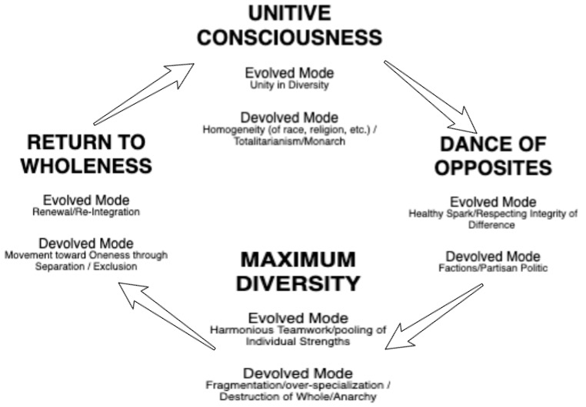
Figure 1: Parry’s Recurring Cycle of Natural Unfoldment

This evolving opposing devolving is the key insight of the book, which I endeavor to unpack.

“The devolved mode is necessary at some point to move from one stage to the other, for a system must degrade and break down (principle of entropy) before something new can be created” (Parry, 2020: xxii).

Parry makes pivotal move in storytelling that few, if any, historians have ever dared: to tell rhizomatic-history of the founding values and sacred politics concepts of America that is not one more tired recast as Plato’s (360 BC) plot of The Republic. This brings me to the purpose of this book review essay. I want to make clear how important it is to rehistoricize America’s founding as not just Plato, but in the Sacred Politics of Original Peoples, and how Parry adds something rhizomatic to Plato’s timeless model of politics. I situate Parry’s contributions among several books that attempt to explain this conundrum of American politics, the divided America, an American as Tom Petty might put it that is Free Fallin’.
Parry’s innovative move as a storyteller is to organize the rhizomatic structure of his book, using the teachings of The Tao Te Ching instead of Plato’s (360 BC) Republic. For example, in The Tao Te Ching (p. 9): the focus is on how systems devolve and evolve phase by phase of partial & wholeness, full & empty, die & reborn. We are given everything yet give everything up.

“If you want to become whole, let yourself be partial. If you want to become straight, let yourself be crooked. If you want to become full, let yourself be empty. If you want to be reborn, let yourself die. If you want to be given everything, give everything up.”

Next, in Table 1, I summarize how Plato’s Republic and Parry’s Original Politics present history and a dynamic systems model of governmentality quite differently in our future:

Table 1: Integrations of Parry’s Cycle and Oppositions with Dynamic Storytelling Systems
PLATO’S  REPUBLIC | PARRY’s ORIGINAL POLITICS | PARRY’s  OPPOSITIONS | ANTENARRATIVE SYSTEM PROCESS IMPLICATIONS
TIMOCRACY | UNITIVE CONSCIOUSNESS | Evolved Mode of  (Unity in Diversity)  Devolved Mode  (Homogeneity of race, religion, etc.) | Going deeper than Abstracting  POLEMIC Narrative-Counternarrative Echo Chambers
OLIGARCHY | DANCE OF OPPOSITES | Evolved Mode of  (Healthy Spark/Awareness of each as aspect of whole)  Devolved Mode  (Factions/Selfishness) | Futuring  Many Futures
DEMOCRACY | MAXIMUM DIVERSITY | Evolved Mode of  (Harmonious Teamwork pooling of individual Strengths)  Devolved Mode  (Fragmentation specialization/ Anarchy/Destruction of Whole) | Finding Common Grounding  Among Our Differences
DESPOTISM | RETURN TO WHOLENESS | Evolved Mode of  (Renewal/Re-integration)  Devolved Mode  (Movement toward Oneness is through SeparationExclusion) | Rehistoricizing  Many Pasts

My main point in drawing this comparison between Plato and Parry is to show that the phases of their model are misaligned, but also have some important comparative insights we can draw out. In the next image, Plato’s four phases of government are in red, and they necessarily devolve and degenerate, one into the next in a cycle of successive governmentalities: Timocracy, Oligarchy, Democracy, and Despotism. These connect somewhat, but not exactly to Parry’s four phases: Unitive Consciousness, Dance of Opposites, Maximum Diversity, and Return to Wholeness. The difference is that, for Parry, it’s not a succession, rather the relationship is rhizomatic (the system can evolve/devolve in any direction, see Deleuze & Guattari, 1985). For example, with the Trump presidency, the political, economic, and social systems already have oligarchy mixed with democracy, but as it ‘maximizes diversity’ half the population of America demands a strong willed, authoritarian leader to ‘drain the swamp.’ In other words, a choice of Timocracy intrudes for half the population, while the other half interprets this president at a despot. Such fragmentation is possible was nation moves off the Plato’s Republic sort of Ferris Wheel of succession and loses any cyclic or spiral axis and turns rhizomatic (all fragments network unpredictably until a blockage prevents movement in that direction). In this next figure, I position Parry’s Original Politics of evolve/devolve as off kilter to Plato’s Republic necessary degradation cycle.
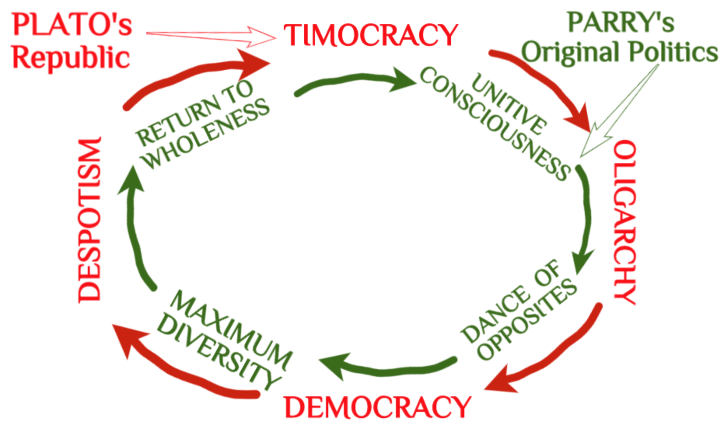
Figure 2: Comparison of Plato’s Cycle of Four Political Systems and Parry’s Original Politics

Since the model is key to my review, I will summarize it before getting into the claims made the four phases. It needs to be stressed, Parry’s storytelling system, is not just a cycle of four phases (in green in following diagram) with Plato’s four phases of political systems. Rather Parry’s storytelling of Original Politics is rhizomatic. Before reviewing Parry’s rhizomatic contributions, I would like to provide the reader a brief summary of Plato’s model, making some contrasts with Parry’s work along the way.
Timocracy For Plato, a leader of Timocracy had quite contradictory traits: more self-assertive, a lover of power and honor, but less cultivated, obedient to authority, yet a friend of culture, and a good listener, yet rough with slaves (unlike an educated man, too proud to do that), and was not a good speaker (nor eloquent), however was quite courteous to freemen. Such a political leader claimed power because he had been a soldier (good at gymnastics) and performed feats of arms, not for a love of money (p. 519-520, section 687). Plato’s dialogue describes how this strange Republic changes from Timocracy to Oligarchy.

“First, then, I said, let us enquire how timocracy (the government of honor) arises out of aristocracy (the government of the best). Clearly, all political changes originate in divisions of the actual governing power; a government which is united, however small, cannot be moved” (Plato, 360 B.C: p. 512, section 687).

As Timocracy devolves, there is opening for capitalist merchants and trades persons to become oligarchic players.
Oligarchy As private individuals accumulate their own treasury, a Timocracy falls into ruin. All kinds of legal inventions, happen that remind me of making a corporation in America, a private individual, and an entity that has Freedom of Speech (aka freedom to lie in ads), not to mention Political Action Committees (PACS) that finance political elections and political parties. Plato, interlocutors ask, “what do they or their wives care about the law?” (p. 523, section 687). Tension and division builds as the State tries to become as rich as possible.
This compares to what Plato calls Oligarchy, for Parry is ‘Dance of Opposites” with and evolved mode of (harmonious teamwork pooling of individual strengths) at same time as an evolved mode, with fragmentation specialization as the whole divides, and opens itself to anarchy and the destruction of wholeness (or unity).
Plato, by contrast, like Smith (2020), focuses on wealth disparity. Oligarchy rulers are aware that their power rests upon their wealth and estates. The Oligarch does not curtail extravagance or their love of wealth (p. 535. section 687). Plato’s principle of Oligarchy: love of wealth and spirit of moderation cannot coexist in the same State, to any great extent. Oligarchical States spread carelessness and extravagance, while the less rich, are reduced to owing money or to beggary. Some form a class that conspires against those with property and wealth, and are eager for Revolution (p. 536, section 687). Mean and women of business are “stooping as they walk, and pretending not even to see those whom they have already ruined” (IBID.). Oligarchs multiply their fortune many times offver, into family, while paupers abound in the State.
“The evil blazes up like a fire; and they will not extinguish it, either by restricting a man's use of his own property, or by another remedy” (p. 537, section 687). To stay in power, Oligarchs, compel citizens to look to their own character, to enter contracts at their own risk, and to (externalizing) risk to the Oligarchic State, who treat their subjects badly. There is a downside to wealth and luxury, idleness of body and mind. Oligarchic families are incapable of resisting pleasure or pain. In other words, the Oligarchic State devolves, and there is room for something else to evolve. As this State falls sick, democratic parties stray from the privileges of wealthy, luxury, and extravagant leisure.
Unlike Plato, what we see worldwide today, is oligarchy does not just give way to democracy, it integrates with it, to its very core. In America, in my view, both parties are financed by oligarchy, and those with the money make the game rules.
Democracy Democracy comes into Being for Plato as the ‘Democratic man or woman’ brings up the Oligarch’s greed and obvious wealth-disparity, for judgment. This is an ideal model, and the question to be asked: does it happen, in the real? Both Plato and Parry claim Democracy will devolve/evolve into a next cyclic-phase. The difference, is for Parry, its not just 4-phase succession that us linear sequencing of history, which of course, is ridiculous assumption. I conclude it is nto the same, next phase for both authors. For Parry, other phases that are non-linear choices are possible system states to evolve/devolve into.
For Plato, the Democracy form of government comes into ‘Being’ by (a) arms, by one party driving the Oligarchic party to withdraw, or there is an insurrection as the poor conquer their opponents, slaughtering some, banishing others, while those who remain receive equal shares of freedom and power (p. 539, section 687). The turning point is a government with magistrates who are elected. Perhaps the fairest of States will emerge. Plato argues citizens are still not free, while full of freedom to be frank, and do whatever he or she likes, ordering life as one pleases. There is the greatest variety (diversity) of human natures, like an “embroidered robe which is spangled with every sort of flower” (p. 540, section 687). It is interesting to me that while US politicians debate Democracy versus Communism and Socialism (Schumpeter does this), there is very little debate about Oligarchy in this new century.
In Plato’s Republic dialogues, for a short while, the interlocutors cannot image any form of government better than Democracy. Why? There is such liberty, an assortment of constitutions, sort of like ‘multi-use’ policies of how Department of Interior, Parks Service, and Forestry, have a bazaar approach to letting fracking, oil gas coal minings, recreational vehicles, cattle and sheep grazing, logging, etc. Compete to sell leases for the land, water, and mineral rights. The Democracy becomes a Bazaar. Going to war is all that keeps such a Democracy together. At peace, anyone who fancies can cast the dice and run for office (p. 541, section 687). So diverse and forgiving is the spirit of Democracy, you get the kind of January 6, 2021, parade of those who walk around like heroes, confronting the State, and nobody much cares. In other forms of State, they would be sentenced to death or exile, and not be walking with pitch forks and automatic weapons into Senate and House chambers of the Capital Building. Such a “forgiving spirit of democracy”, few are even arrested for riffling through offices, breaking doors and windows, assaulting police officers (p. 542, section 687). Legislators debate fine principles, while no one cares about trifles. Occasionally a good man, who since childhood had joy, studied, about fine notions, but never gave a thought to being a statesman, will step forward. January 6th, such beautiful, noble, and fine notions of Democracy were trampled by a mob. I
There are parallels of President Trump’s popularity and what Plato anticipates as the downfall of democracy. Elected for years ago, to the White House, an admitted corporate person of wealth, President Trump professed to be not a statesman, but the “people’s friend” promoting the honor of the nation (Plato, p. 542, section 687), and promising to ‘Make America Great Again’. This form of government, Democracy, has lots of variety and diversity, but it can devolve into disorder, inequality, a manner of individualism that is beyond the misery, and the unnecessary pleasure and pain pursuits, inherited from the Oligarchic ancestry a Democracy had succeeded (Plato, p. 543, section 687). President Trump promised in 2016 to restory order. How does Plato imagine that a despot might serve to correct or save a democracy from falling into what Parry calls ‘Maximum Diversity’? When democracy turns towards anarchy, which was how the Trump campaign, positioned itself to justify a wall between Mexico and US to stop the migrants taking jobs from blue collar workers, and draining the political swamp of the moneylenders (fact and fiction in a strange alliance).
Despotism When Democracy turns towards anarchy the society is said by Francis MacDonald Cornford (1941: 287) to divide into three classes:
- Spendthrift Desperadoes
- Capitalists Amassing All The Wealth
- Country (rural) People Uninterested In Politics

Cornford is amending and amplifying Plato, to make sense of how a people could choose a ‘human wolf’ (IBID.) as their political leader. Dominion of unlawful (or made lawful) corporate-centric appetite forms its alliance in Democratic/Oligarchic/Despotism capitalism (in short, a rhizomatic network, that is every which way, but ethical). This is exactly how Despotism arises inside Democratic-Oligarchic capitalism. The change from Oligarchy to some idealized or pure Democracy is phantasmagorical, yet does have agential storytelling force. Our of the lower depths of the populace, a search for a leader to turn from Oligarchic/Democratic capitalism, even one with a Despot, is preferred to all out anarchy and chaos.
Parry’s book was written before the election of President Biden. His call of ‘unity’ for ‘dialogue’ and ‘consensus’ brings to the fore a question: Is this call for unity a return of the heroic Timocracy, the person who takes on the system, to bring order to chaos? In other words, is President Biden, the candidate of the two-party (oligarchic) political system, or is he responding to a demand for ‘Unitive Consciousness’? Whose unity? How much unity? At what consequence? These are the questions that the remnant of Trump loyalists keep asking.
In sum, while there are some parallels between Plato and Parry, there are many important differences. At the same time, the two together, especially with Cornford (1941) present an integrated understanding of global capitalism players, and their relation to socioeconomics of noun-adjective language games being played that do not get down to changing the root (verb) processes (Wolf, 2020).
I want to turn now to how Parry’s call to do story-listening and dialoguing with Native American (and all Indigenous Peoples’) wisdom may be what is needed to tame the dominion of oligarchic and stage capitalism, as well as its despotic and democratic mixtures (rhizomes). There pare particular processes and practices that Parry offers at the end of his book (last two chapters):
- Return To Humility
- Stance, Not Strategy
- Remembering: What It Is To Be Human
- Remembering How To Talk With The Elements
- The Lungs of Mother Earth
- The Heart of Mother Earth
- Refamiliarizing Ourselves With Nature
It is these practices and processes that offer us all opportunity to do world-making future, in what Parry calls “A Turtle Island Renaissance” by “Coming Back Full Circle” in “The Dusty World of Human Affairs” (261-262, 276).
Original Instructions Next I want to focus on Parry’s rhizome of Original Politics, to which I will add an ‘antenarrative’ understanding of dynamic, and adaptive storytelling systems. I am adding antenarrative processes because I think it is important to understand how dynamic storytelling systems play out historically. In particular, I will focus on how Parry’s book relates to my work on Tamara-land storytelling systems (Boje, 1995) and more recent work on ‘ensemble leadership’ (Rosile, Boje, & Claw, 2018), and ‘ensemble storytelling’ (Rosile, Boje, Herder, & Sanchez, 2021). This contribues ways to enact corporate social responsible capitalism. Clearly the Natural World has an operating system that teaches us the correct way to conduct ourselves as individuals and as the collective organism. It includes new approaches to storytelling systems that point to an ecological shift if business modeling. The relation to Parry’s wor, is if our institutions of government and business and eduction don’t follow these Original Instructions of IWOK we all pay the consequences (‘we reap what we sow’).
As shown in Table 1, each cycle phase, evolves order as it simultaneously devolves into entropy. Parry’s point is socioeconomic/political systems cannot have one without the other. Parry is not the first to declare such cycle relationships. Joseph Schumpeter (1942) called his devolving phases,, creative destruction less extreme, without which evolving development in capitalism would stall out. Schumpeter is the prophet of doom, whereas Parry sees hope for western capitalism and its political economy to return to Original Instructions, to Indigenous Ways of Knowing (IWOK). Schumpeter is less optimistic, asking the question: “Can Capitalism Survive?” Schumpeter’s own cyclic narrative lends credibility to Parry’s Original Politics thesis, but has important differences. Schumpeter (1942) is a prophet, and predicts the “Growing Hostility” (p. 155) of the political capitalist order as an inevitable moral collapse. We have seen his prophecy fulfilled because people do not understand how socioeconomic political systems actually need creative destruction to keep the global economcy happening. Without it, capitalism cannot keep ever-evolving. As is the case globally, and in today’s America, they just come apart at the seams. Wolff (2020) says we are witness to three economic failures of capitalism and politics during our newest century: 2000, 2008-2009, and 2019-2020 (still ongoing). There is good reason for these failures of social, political, economic, education, ecology, and health conditions. Schumpeter (1942: 149) calls it as it is: “The destruction of the institutional framework of capitalist society.” That is what the world witness January 6, 2021 as civil protest transformed into a riotous mob invading the sanctity of one of its most sacred buildings, the Capital Building, invading the offices and chambers of a legislature, meeting to fulfill its sacred obligation, certifying the ballots, state-by-state. For Wolff (2020) it is a story of he collapse of the a sick system of capitalism with its cash-corrupt politics and special interest political action groups, economic deregulation, granting the corporate legal rights if citizen, even protecting corporate free speech lie in advertising. This is not creative destruction that Schumpeter had in mind to offset wealth inequality between rich who lost entrepreneurial drive and poor scrambling to find food and water to feed their starving family.
Since Parry’s thesis about the dual role of entropy (devolving) and what in systems theory is negentropy (evolving), I want to offer the reader some context in dynamics of complex adaptive systems, to help readers understand why Original Politics is one of the most important books of the new century. I want to compare its overall entropy/negentropy (devolving/evolving) cyclical history model, to that of a seminal work by Prigogine and Stengers (1984) book, Order Out of Chaos. Theirs is an entire book on entropy in Natural systems, with profound implications for socio-economic, and even political systems. It is important to look at entropy if you are to comprehend the magnitude of what Parry’s is proposing: To look to natural systems, to indigenous ways of treating natural systems as sacred, so that the cycle of four phases of simultaneous evolve and devolve do not degenerate into complete disorder, chaos, and collapse. Both the Prigogine and Stengers, and the Parry book, propose a dialogue with Nature. For Prigogine and Stengers (1984) is its a ‘New Dialogue’ and for Parry, and ‘Original and Sacred Dialogue’ not of the Founding Fathers of America, but rather, the First Peoples, through their First Contact, and centuries of colonization.
Here I review Parry’s Original Politics addresses what Richard Wolff (2020) declares: The System Is The Sickness, but provides the reader with a very different answer to what it is about ‘the system’ that has become so sickly. Wolff stresses that America’s system problems are becoming visible to all in the global COVID-19 pandemic, and the new century of one economic crisis after another. The problems are visible to all, how socioeconomic and political systems are decomposing. There is growing wealth inequality, structural racism outcry of Black Lives Matter movement, Me Too movement confessions, and growing calls to put science first by Climate Emergency movement. Wolff’s amazing insight is the world has several forms of capitalism systems, each facing exactly the same system problems while blaming the other capitalisms for all the problems of the world. Wolff ( 2020:iii-vi) says at least four versions of capitalisms try to solve the same problems:
1. Enterprises organized undemocratically
2. Unstable business cycles of boom & bust
3. Inequality of wealth & income

In a seminar we gave at True Storytelling Institute (https://truestorytellinginstitute.com) we presented this image of four-play chess, inspired by Wolff’s (2020) and Parry’s (2020) books:

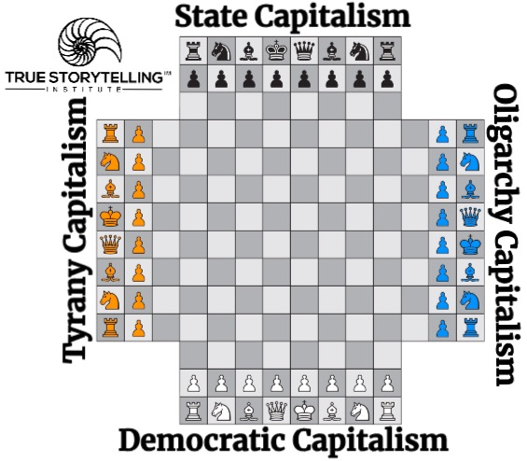
Figure 3: 4 Player Global Capitalism used by permission of True Storytelling Institute (https://truestorytellinginstitute.com)

Each Capitalism’s historical narratives claims the other capitalisms are the worst solutions. There is a language game here I would like to highlight. It is a special use of capitalism as a noun-character in an emplotment repeating six adjectives to blame the other guys, while none of the Capitalisms seem to work on the Whole System (processes), and therefore are not solving basic process problems creating the system problems in the first place. To be clear: A process is an action-verb, the capitalisms are nouns, and instead of solving the 3 problems, each blames the other using these six adjectives:
1. racism
2. Unemployment
3. Sexism
4. Poverty
5. Inequality
6 Political corruption
while Other Capitalisms, increase them

POINT: its a Game of plotting with Noun and Adjectives of blame the other capitalisms,
without ever being answerable for doing the Verb (process) system changes.

In this review essay, I will use my background in dynamic storytelling systems, in order to unpack amazing insights I find in Parry’s Original Politics. I created ‘antenarrative’ process theory, to understand how storytelling systems behave. An antenarrative is double meaning of ‘ante’ as ‘before’ (history), and the ‘bets on the future’ that are foretellable. Since this is to be published in a journal that focuses on whole system change thinking, I will introduce this figure which is about noticing what kind of antenarrative process is the pattern to be changed (linear, cyclical, spiral, or rhizome). In four player capitalism games of nation-to-nation strategy it is important to know the game board (is it a squre, a spiral, or rhizome). At very least, you must recognize you are not the only player-nation in the world, which has finite fresh water, live soil, clean air, etc.
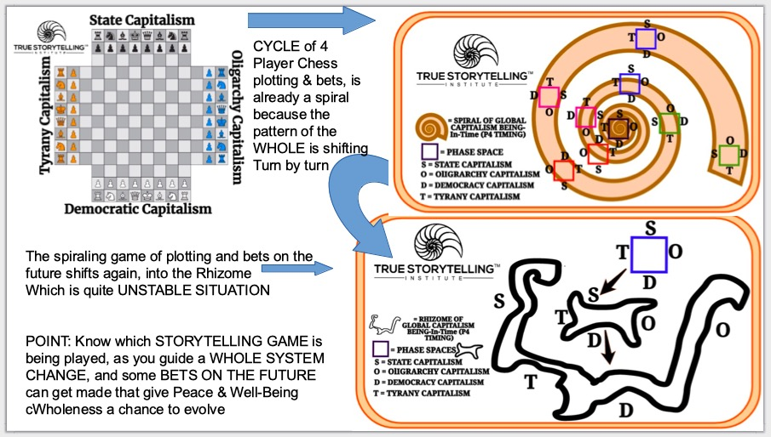
Figure 4: Transformation of Global Capitalisms from 4-player cycle, to spiraling captialisms, to rhizomae capitalism Note: used by permission of True Storytelling Institute (https://truestorytellinginstitute.com).

The political and social system polarities and their dynamics have been evolving from generations of socioeconomic and ecological crisis for hundreds of years. America as a nation is now so polarized, unity is is the lost American Dream, mob anarchy its nightmare. Without common ground storytelling, civil discourse nigh impossible, in the family, classroom, boardroom, or legislative chamber (Larson, Boje, & Bruun, 2021; Boje & Rosile, 2020). Wolff’s (2020) solutions point to taming capitalism, and to try a more democratic version of capitalism. What Parry does that Wolff overlooks is to recover Native America’s forgotten contributions to democratic capitalism.
Parry (2020), for example, asks the fundamental question, ‘How to Make America Sacred Again?’ What Wolff (2020) adds is an understanding that America’s capitalism is not the only player on the board. America is in a game of ‘four-player global capitalism’. I want to suggest here, that Parry’s main contribution, to rehistoricize America’s history by reinserting Native American storytelling, connects well to what Melissa K. Nelson (2008) calls, Original Instructions: Indigenous Teachings for a Sustainable Future.

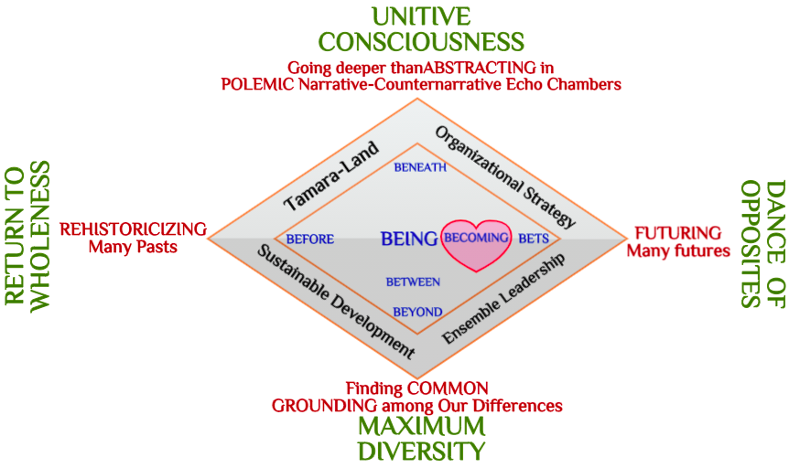
Figure 5: Four Phases of Original Politics Cycle (in green) and Antenarrative Processes (in blue) Pre-constitutive of Narrative-Counternarrative Polarities in American Political Economy (adapted from work done for True Storytelling Institute (https://truestorytellinginstitute.com)

I have seen Parry present his ideas from the book on Zoom meeting. He is fond of the Native American story of a mother weaving a garment and a child pulls on a thread, and the garment comes all undone. Rather than fret about it, the mother weaves the fragments into a garment even more glorious than what the child had undone.
One of the issue of history that Parry raises is how a simple system mutates and acquires more and more dimensions, becoming more complex, but simultaneously retrograde by entropy. We create technologies (processes & practices with nuclear energy, weaponized viruses) that modern theory fits to a progress development narrative, somehow beyond grasp of Native Science (Cajete, 2000). These material technologies falling into hands of tyrants or zealots divorced from Nature, has had cataclysmic consequences, and is one of our greatest challenge to future generations, according to cultural historian Jean Gebser (1949, 1953/1985). Gebser’s concern was how humans attempt to control time by spatializing and dividing time into clocktime (schedules, deadlines) thereby enslaving their own freedom as they move away from what he terms ‘The Ever-Present Origin’ (Gebser 1949, 1953/1985). As spacetime becomes denatured, artificial clock time, Chronos takes over. In other words, there is danger ahead in trampling willy-nilly over ontological spacetime. To Parry’s and Plato’s four phase cycle, Gebser, proposed a fifth evolution of consciousness, called integrality, a synergistic integration of the preceding four consciousnesses.
Conclusions
In sum, I have teased out what it is about Parry’s book that is lacking in Schumpeter’s (Can Capitalism Survive), Wolff’s books (The Sickness is the System), and only hinted at in Prigogine and Stengers (Order Out of Chaos). My focus has been on how important it is for socioeconomic political systems to be understood historically as they learn the lessons of Mother Nature and her natural systems. Then we can move along to how books by Parry (and by Nelson, among others), add a something that is lacking in Schumpeter, Wolff, and Prigogine and Stengers seminal books. Prigogine and Stengers, in particular, show how a linear can morph to a cycle, and morph again to a spiral, then lose its centering axis and turn rhizomatic. US is not the only capitalism on the world stage, and with at least four-players, this is an unwieldy and dangerous chase match to be playing. If it is in a downward spiral, headed to anarchy, then it is not the rhizome of weaving together, that Parry deems possible. Some key questions are left to unravel.
What is a cycle? When does it become a spiral? Does the spiral bring a system upward or plunge it into the abyss of anarchy? When does anarchy turn rhizomatic? Parry answers these questions differently than Schumpeter, Wolff, Gebser, and Prigogine and Stengers. Schumpeter advocated long, uninterrupted cycles of boom and bust, in order to experience the full benefits of creative destruction. Parry has one cycle, a history with four phases, and in each phase the creative destruction of devolving, necessary for an evolving to manifest. Schumpeter and Parry agree on this point. For Wolff, its more about two centuries of one socioeconomic and political crisis after another. What is different about January 6, is with the COVID-19 pandemic, yet one more economic collapse, the disparities of wealth and the devastation of the ecology globally (as the UN reports that keep telling us since year 2000) are becoming visible to all. The storytelling problematic, everyone is in their own echo chamber of social media, as polarized as ever, perhaps even more so, and there is no longer a common ground for ‘reality’ and ‘truth.’ There is certainly a call for unity, but polarity of narrative and counternarrative is still deeply divisive. People do not listen to the same storytellers.
I will conclude with my own standpoint on a world future that seem possible. The storytelling is going on in different room of what I call Tamara-Land (Boje, 1995). We chase those stories, room to room, but the meaning of any event, even a 911-type event of January 6, 2021 (the 621-event) is a divided truth, a divided reality. Can we turn to ecological political and business modeling that favors dialogues of listening to one another, instead two-party semantic debates, and engages in the conversational storytelling, with story-listening to Nature Parry is all about (Boje & Jorgensen, 2020; Boje & Rana, 2020; Boje & Rosile, 2020). This might just rescue a ‘true storytelling’ from the fake telling so prevalent these days (Larsen, Boje, & Bruun, 2021). There are examples of social responsible capitalism and an engaged politics of its citizenry in ensemble leadership (Rosile, Boje, & Claw, 2018) and ensemble storytelling with ‘together telling’ as key praxis (Rosile, Boje, Herder, & Sanchez, 2021). In this way capitalism may get past its obsession with growth, and actually survive in ways that tame the boom and bust cycles Schumpeter (1942/1976) and Wolff (2020) warn us to not ignore.
References

Boje, D. M. (1995). “Stories of the Storytelling Organization: A Postmodern Analysis of Disney as ‘Tamara-land.’” Academy of Management Journal. 38(4): 997-1035. https://davidboje.com/vita/paper_pdfs/AMJ_Disney.pdf

Boje, David M.; Jorgensen, Kenneth Mølbjerg. (2020). A ‘storytelling science’ approach making the eco-business modeling turn. Journal of Business Modeling, Vol. 8, No. 4, pp. 8-25. Click here for pre-press pdf.
Boje, David M.; Rana, Mohammad B. (2020). Defining a Sustainably-Driven Business Modeling Strategy with a ‘Storytelling Science’ Approach. Chapter to appear in Markovic, S., Sancha, C. and Lindgreen, A. (Eds.), Handbook of Sustainability-driven Business Strategies in Practice, Northampton, MA: Edward Elgar. Click here for pre-press pdf.

Boje, D. M.; Rosile, G. A. (2020). How to Use Conversational Storytelling Interviews for Your Dissertation. UK: Edward Elgar Publishing Ltd.

Cajete, Gregory. (2000). Native science: Natural laws dependence. Foreword by Leroy L. Littlebear. Santa Fe, NM: Clear Light Publishers.

Cornford, Francis MacDOnald. (1941) The Republic of Plato. Translated with Introduction and Notes by Francis MacDonald Cornford. London: Oxford University Press.
Deleuze, Gilles; Guattari, Feliz. (1987). A thousand plateaus: Capitalism and schizophrenia. Trans. And foreword by Brian Massumi., University of Minnesota, Minneapolis.
Gebser, Jean. (1949, 1953/1985). The ever-present origin (N. Barstad & A. Mickunas, Trans.). 1953 German, 1985 English. Athens: Ohio University Press.
Nelson, Melissa K. (2008). Original Instructions: Indigenous Teachings of a Sustainable Future. Nelson editor and Introduction, Preface by Kenny Ausubel. Rochester, Vermont: Bear & Company.

Parry, Glenn Aparicio. (2020). Original Politics: Making America Sacred Again. NY, NY: Select Books, Inc.

Plato's Republic (360 B.C.) Online text, Translated by Benjamin Jowett, accessed Jan 13 2021 at https://www.fulltextarchive.com/pdfs/Plato-s-Republic.pdf

Prigogine, Ilya; Stengers, Isabelle. (1984). Order Out of Chaos: Man’s New Dialogue with Nature. Shambhala. Boulder/London: New Science Library.

Rosile, Grace Ann; Boje, D. M; Claw, C. M. (2018). Ensemble leadership theory: Collectivist, relational, and heterarchical roots from indigenous contexts. Leadership, Journal 14(3), 307-328.
Rosile, G. A., Boje, D. M., Herder, R. A., & Sanchez, M. (2021). The Coalition of Immokalee Workers uses ensemble storytelling processes to overcome enslavement in corporate supply chains. Business & Society, 60(2), 376-414.
Schumpeter, Joseph A. (1942/1976). Can Capitalism Survive: Creative Destruction and the future of the Global Economy. Originally published, 1942, as Capitalism, Socialism and Democracy. 1976, published by NY: NY: HarperCollins Publishers.

Wolff, Richard D. (2020). The Sickness is the System: When Capitalism Fails to Save Us from Pandemics or Itself. Edited by Liz Phillips & Maria Carnermolla. NY, NY: Democracy at Work.

Tao Te Ching written by Lao-tzu Translation by Stephen. Mitchell Last updated 20 July 1995, accessed Feb 21, 2021 at http://albanycomplementaryhealth.com/wp-content/uploads/2016/07/TaoTeChing-LaoTzu-StephenMitchellTranslation-33p.pdf
I gratefully acknowledge insights in conversations with Duncan Pelly and Sabine Trafimow about this image
Thankful for conversation with Bob Skinner, Jan 13, 2021.

