How to Teach Organization Theorizing?

David M. Boje

February 27, 2021; revised Mar 1, 2021

This is a question I was asked to answer by Henry Mintzberg and Richard Swedberg, in the first conversation-salon. **Theorizing in Organization Studies Insights from Key Thinkers.** It is based on the book by Anne Vorre Hansen and Sabine Madsen (2019) *Theorizing in Organization Studies: Insights for Key Thinkers*(Elgar). Based on interviews with David Boje, Barbara Czarniawska, Kenneth Gergen, Tor Hernes, Geertz Hofstede, Henri Mintzberg, Edgar Schein, Andrew Van de Ven, and Karl Weick.

<https://www.politics-society.aau.dk/research/research-groups/cim/conversation-salons>

Learning and Teaching Theorizing in Organization Studies

Chapter One: What Are Alternative Ontologies of Organization Theorizing 2

Chapter Two: What is Called Thinking in Organization Theorizing 8

Fabula – Back to the Future – from 1977 to 1978 at UCLA 10

Flashing Back from the Future to 1977, University of Illinois 11

Back to the Main Storyline 11

The idea was that the three paradigms were dialogical in our department, but there was an inability to hear what the other paradigm was saying because no one was taking the time to learn the paradigms (except us doctoral students) and be able then to talk their language, while communicating between (a process Maruyama calls transpection). Transpection is process of empathizing across cultures (i.e. intercultural conversations at their very best). Climax of my dancing partners story 12

David Whetten once told me in 1978, Organization Theorizing is between a rock and a hard place. I came across this same notion in 2020. 14

Chapter Three: Flashback to U of I: Before to a Little Wow Moment that Changed My Life 15

Can Students Learn Theorizing? 15

Chapter Four: Thought Experiments in Organization Theorizing, Pros and Cons 19

Chapter Five: On the Differences Between Hierarchical-Models and Field-Models in Organizational Storytelling 22

TYPE ONE: Hierarchical-Theorizing 22

Lots of Problems with this theory 23

Figure 7: Assistant makes Metatheatre entrance wearing a Rebecca Mark mask as Mark looks on at right wearing Harley costume. 25

Chapter Six: Some Practical Tips for Teaching Theorizing in Organization Storytelling Studies 26

Chapter Seven: Tom Petty Theorizing with Song Lyrics 37

Chapter Eight: Multifractal Theorizing in Organization Studies 38

References 38

# Chapter One: What Are Alternative Ontologies of Organization Theorizing

Theme One: My answer. Organizational theorizing is in a deep existential crisis. Not just Climate Change (global heating), not just COVID-19 pandemic. Not just 17 UN sustainable development goals, not being addressed in most business schools. Rather, we as a field are not thinking! We are not doing falsification Karl Popper held more important than just verifying statements or factoids, and calling it an integrative theorizing. We are not thinking, especially in the U.S, where the arts, history, litterature, and philosophy is separated from the business school. We have an existential crisis because our technology grows leaps and bounds to affording organizations DOMINION over what Merleau-Ponty (visible & invisible) calls Wild Nature. Thinking is required to change praxis (theory + method, in practices of doing). We need alternative ontologies, if we are to get out of this existential crisis after crisis. Its all because we are not thinking.

We in organizational theorizing are in silos, playing the game of keeping the other silos from scoring any goals. The so called ‘integrative theories’ are grab bags of concepts, without a quest for the underlying essence of what is the unifying field theory (as Einstein called it; think of Kurt Lewin’s field theory; Mary Parker Follett’s relational process ontology of the situation of systems and environments). The answer is simple, to do ‘together-telling, and together-listening’ to start over, ditch the silors, and deal with the situation at hand, the existential crises. We has humankind need to find our PLACE, our way of life on Planet Earth. Our thinking head, and our feeling heart, and our spirit need to get into alignment, balance, harmony with the trillions of other species dwelling on Earth. There is a deadline. To begin the process of thinking so the 7th generation, our grandchildren’s children have earth, air, fire, and water to live.

“What is most thought-provoking – that we are still NOT thinking; None of us including me who speaks to you, me first of all” (Heidegger, 1950/1951 What is Thinking? Page 14).

***The future of the 7th generation from what I am doing, is thought-provoking.***

Organization theorizing can learn the wisdom of Indigenous Ways of Being. That is an ontology of balance, harmony, and respect, and the stewardship with, instead of the dominion over Mother Earth. Organizational theory is just not thinking.

My good friend Sabine Trafimow translates German philosophers (Hegel, Heidegger) into English, whenever I teach ontology to students of management and organization studies. I add lots of Merleau-Ponty, Deleuze, Latour, Debord from French philosophy, and from Russia With Love, Bakhtin’s 5 dialogisms (see Beyond Heart). Sabine and I help organization students to move from integrative process-theories (aka hierarchical classification theories, and towards unifying process-field theory (TrafimowD., 2012). David and Sabine Trafiwmow have been frequent quests in the organization theory and method classes I taught at NMSU.

I am an ontologist, not an epistemologist. I am a process theorist of the ontology of organizing focused on unifying the field of storytelling. This question revolves around the difference between ‘integrative theorizing’ and ‘unified field theorizing’ (Trafimow, 2012) of processes in organization theorizing.

**Figure One: In the Heart of the Beneath, six blind monks, debate what they cannot see** (illustration by Hans Moller)[1]

Each process theorists is using sensemaking (without sight) to deduce if their proposition is correct. Heidegger asserts that debating correct and incorrect propositions does not answer the question: What is the essence of truth?

“The question regarding the essence of truth is not concerned with whether truth is a truth of practical experience or of economic calculation, the truth of a technical consideration or of political sagacity, or, in particular, a truth of scientific research or of artistic composition, or even the truth of thoughtful reflection or of cultic belief. The question of essence disregards all this and attends to the one thing that in general distinguishes every “truth” as truth” (Heidegger, 1931-1932/ p. 243 in Median & Wood, Eds. 2008).

**Figure Two: The Four Hearts of Organization Process Theorizing attempting to answer the questions: What is the essence of Truth** (used by permission of <https://TrueStorytellingInstitute.com>).

This Four Hearts illustration is a way we teach students and practitioners, true storytelling (Larsen, Boje, & Bruun, 2021). It is an illustration of 7 Principles (an integrative theory) and 7 processes of antenarrative (Boje, 2001a) with Rosile’s (2016) book, Tribal Wisdom for Business Ethics. Rosile brings in the 6th sense of the Beyond-Heart with horsesense, and Indigenous Ways of Being-in-the-world. The illustration is something that Sutton and Staw (1995) say is not a theory, is what Weick (1995b) in that same issue calls a placeholder: *What theory is not, theorizing is*! In short, the illustration is both an integrative set of principles (concepts), antenarrative processes in the fields we call Beneath, Before, Bets, and Beyond. All pointing to revealing truth in the essence of Being. If we don’t teach storytelling process theorizing, practices, and methods, then praxis will cease. As Walter Benjamin and Gertrude Stein put it, storytelling is coming to an end, replaced by grand beginning-middle-end linear narratives (& counternarratives) because the nature of work and life has changed so radically. That is the existential crisis I am talking about, and what we are trying to avoid.

My good friend Sabine Trafimow translates German philosophers (Hegel, Heidegger) into English, whenever I teach ontology to students of management and organization studies. I add lots of Merleau-Ponty, Deleuze, Latour, Debord from French philosophy, and from Russia With Love, Bakhtin’s 5 dialogisms (see Beyond Heart). Sabine and I help organization students to move from integrative process-theories (aka hierarchical classification theories, and towards unifying process-field theory (TrafimowD., 2012). David and Sabine Trafiwmow have been frequent quests in the organization theory and method classes I taught at NMSU. Our goal is to help students to have a few integrative principles of True Storytelling (Larsen, Boje, & Bruun, 2021), and then get into the processes I call seven antenarrative (beneath, before, bets, between, becoming, Being, and beyond). I am after how the principles interact with each other, and how the antenarrative processes interact with each other, and how the principles and processes interact in ‘together-telling.

***The Heart of the Beneath in Organization Theorizing.*** My ‘unifying field theory’ begins with the antenarrative processes of the ‘*Heart of the Beneath’*. I want to answer this research question: ‘***What is the essence of truth?***’ (Heidegger, 1931-1932) in organization theorizing. My theory is antenarrative foreconception processes crystalize into concepts that then fossilize into what Barbara Czarniawska (2004) calls petrified narratives, and then are debating with counternarratives (Lundholt & Boje, 2018).

Organization theory and its theorizing process is in an existential crisis, an existential dread. Organization theorizing never quite falsifies its integrative process theories. Organizational process theorizing is in Plato’s ‘Allegory of the cave.’ (see Theaetetus section). In Plato’s cave-narrative, we theorists are chackled and only see shadows cast on the cave wall by the fire. In the Heart of the Beneath, organization theorists see shadows as their reality. Only by escaping into the light, do organization theorists and practitioners, see the shadows for what they are, illusions. Organization theorists are sitting around the fire in the cave looking at the shadows cast on the wall, debating the narrative and counternarrative dialectics of that they see. This is what Trafimow calls ‘integrative theorizing.’ We need to answer the question, ‘What is the essence of truth’ in field-process theory?’ That is the existential crisis. How to un-conceal the truth. Heidegger argues that debates over a bag of propositional statements about shadows does not uncover the truth of Being-in-the-world. Nor, can truth be possessed by correct propositions using the five senses of sensemaking. The allegory of six blind monks and the elephant fits well.

**Heart of the Before of retrospective sensemaking** Can we get at the essence of truth from doing retrospective sensemaking in the Heart of the Before? In the forehaving processes, the existential crisis of organization theorizing stems from writing histories that are incomplete, quite shallow, histories, and reifying them into static presentations of cases. The problem of the Heart of the Before, is history keeps being rehistoricized. Henri Bergson’s (1889/1910) theory of retrospective making of sense, was the basis for Karl Weick’s (1995a) standpoint on retrospective sensemaking. Until 2012, Weick did not acknowledge ‘prospective sensemaking’ what I call the antenarrative processes, the ‘Heart of the Bets on the Future.’

“These authors tell their own terse story when they remind us not to read storytelling as ‘hot air.’ In place of that they show how stories told by bankers were notable for the ways in which discursive devices justified actions and developed antenarratives” …

“‘Antenarrative is the fragmented, non-linear, incoherent, collective, unplotted and prenarrative speculation, a bet’ (Boje, 2001: 1). Organizing, in the context of antenarrative, is a bet that these fragments will have become orderly and that efforts to impose temporality on them will facilitate that ordering. People are often thrown into pre-existing, organized action patterns. They experience the middle of a narrative but only the vaguest beginnings or ends. Without those boundaries people dwell in antenarrative. But that is where sensemaking, organizing, and discursive devices make a difference.” …

“To talk about antenarrative as a bet is also to invoke an important structure in sensemaking; namely, the presumption of logic” (Weick, 2012: 144-145).

Weick got the point of prospective sensemaking, how the bets on the future are part of the sensemaking.

**Heart of Bets on the Future** Debating and studying what are the correct and incorrect proposition statements is not all there is to theorizing. I have been working on developing the case for prospective sensemaking since 2001 (Boje 2001a). It took decades before the gatekeepers of organization theorizing would acknowledge that there is an interplay of retrospective-prospective temporalizing in organizations. Prospective sensemaking in field theory is all about discerning antenarrative process patterns. Mikhail Bakhtin (1981), influenced by Einstein, called them spacetime chronotopes. Chronotopes are one of four dialogisms he wrote about in notebooks in 1920s and 1930s. The one everyone knows is polyphonic (many voices conversing), less known is stylistic dialogism, chronotopes dialogism, architectonic dialogism, and what I call ‘polypi’ the interanimation of all four in what we term ‘together-telling’ (Boje & Rosile, 2020; Larsen, Boje, & Bruun, 2021). These are process theories, not integrative theories or what Abe Kaplan (1973) termed ‘hierarchical-theories’. His other kind of theorizing was ‘field theory’. Both theories, he contended just never die in the behavioral sciences. I assert this is because in the debates over epistemologies, the statement-correction process theories does not answer the question: What is the essence of truth? It is an ontological question, Heidegger, Merleau-Ponty, Deleuze, Sartre, and Latour pursued. Did Heidegger (1962, *Being & Time*) shift his emphasis from Being (agency of *Da-Sein*) in the 1931-1932 essay (*Essence of Truth*)? In the later Heidegger asserts the essence of truth is ‘freedom’ in uncovering ‘open region’ so we encounter the relationship between truth and untruth, that cannot be sorted out as fact-checking for correctness in the Heart of the Beneath, in those language games, reading shadows on Plato’s cave wall, from the flickering fire.

“The transition from story to narrative is fostered by the belief that the fragments will have made sense although at the moment that is little more than a promise. Sensemaking, storytelling, and organizing become linked, in a Treasury inquiry or a recounting of one’s life story, when actors say to themselves and others, I will have moved on with these unplotted fragments because they promise to amount to something eventually. Even though closure is being displaced, experience and action and activity continue to build up, which increases the probability that order, coherence, a plot, and stability will somehow be stirred up. This is a minimalist account of organizing, which, minimal though it is, includes story (in Boje’s sense of antenarrative), ordering, action, sensemaking, and stabilizing, in the context of the impermanent and the temporary” (Weick, 2012: 145).

***The Heart of the Beyond*** This is where I have a short story to share. Grace Ann Rosile and I, were among the invited to go to Ohio State University for a two day conference, attended by about 40 academics from around the world, including Karl Weick, Ken Gergen (& his wife Mary) and Barbara Czarniawska (who were interviewed for the book by Hansen and Madsen (2019).

I was sitting in the back row, next to Karl Weick. It was Grace Ann’s turn on the stage. She spoke about her work on *horsesense*. She had about finished, when a professor from France, challenged her, “Grace Ann, if you actually read Foucault’s *Discipline and Punish*, then you would know that the horse is dominated by the rider, by the training. You as a dressage rider ought to know this to be true.”

I whispered to Karl, “Watch this. This is going to be good. This guy things he can make Grace Ann back down.” Grace Ann, squared her shoulders, and faced the Foucauldian interrogator. She said, something to the effect, “You think you can dominate an Arabian Stallion, who weights fifteen hundred or more pounds?” “Nahdion and I are in a relationship beyond language. We communicate with each other, we listen to each other, in ways embodied. I learn to make sense of what Nahdion is about to do, and he makes sense of what I want to do. We do this without words.” Karl, took it all in, and without pause, left the auditorium, saying, “I have to call my wife right now, and tell her about Grace Ann’s horsesense.” This is the Heart of the Beyond, how a 6th sense, call it horsesense is part of the process. It is called abduction (& retroduction) by Charles Sanders Peirce (see Boje & Rosile, 2020).

There is this relationship between truth and untruth, in the disclosing of Being, the open space of freedom.

“The difference between contested and uncontested polyphony may link to antenarratives. Boje (2001: 2) argues that when people translate stories into narratives they ‘impose counterfeit coherence and order on otherwise fragments and multi-layered experiences of desire.’ Counterfeit coherence is unstable, subject to detection and breaching, all of which link the degree of contestation to sensemaking, organizing, and transitions between stories and narratives” (Weick, 2012: 147).

To train students and practitioners in theorizing, I use dancing partner experiential exercises, dancing one theory with another theory. This is the topic of the next chapter.

# Chapter Two: What is Called Thinking in Organization Theorizing

**Theme 2: Approaches to theorizing (visualizations, models etc.)**

**Anne**: In a lecture from the 50s, Heidegger stated the following: “..we must before all else incline toward what addresses itself to thought – and that is, that which of itself gives food for thought.” Down the same line I would like to ask you; What gives you food for thought?

David: Anne, you are quoting from p. 17, of Lecture I, of “***What is Called Thinking?”*** (Translated by J. Glenn Gray and Fred Wieck, with intro by Gray). P. 17 of Lecture 1 on 21 lectures. Your answer comes at the end of this first lecture. I am NOT thinking, and yet I am called to think, to reason, and I possess the gift, this possibility to think.

Heidegger says something before and after your quotation

Before: “We must learn thinking because our BEING able to think, and even GIFTED for it, is still NO GUARANTE that we are capable of thinking. To be capable …”

After: “What gives us this GIFT, the gift of what must properly be thought about is what we call most thorught-provoking” (IBID).

**My answer:** We still are not thinking. We are still not thinking about the most thought-provoking existential crises. I am not thinking. I notice I turned away from the spirit of Nature and kept turning towards a withdrawal from Indigenous Ways of Being. I as BEING a Fugitive (Tom Petty, You don’t have to be a refugee). My mother disclosed to me when I was 53, the horrid way both sides of my family tree had behaved towards family members that married indigenous. Actually, invoking silence, never speaking their name again. I found out my great grandfather had led his family across Organ Mountain Trail from Iowa, in a covered wagon, and became a blacksmith, my grandmother Wilda a trick rider in the rodeo, her husbands, one a boot legger, the other a forest ranger protecting public land from people how do not know how to think. I am on a quest, to make sense of why neighbors started burning down trees January 6ht (eve) and keep doing so, since, week after week, in a desert with only a handful of trees as far as the eye can see.

In Lecturer II the truth of Being is in the disclosure of what keeps itself concealed (p. 19). The light is not without but within me. I myself am the light: (P. 245, Last Lecture before Heidegger retired from the stage). Heidegger has discovered his dwelling place in Nature as a whole, in the universe, in “the dynamic, unity aspect of life” and with this the “principle of differentiation” (p. 245). Think of it as Glenn Parry’s (2019) coming back to Wholeness, with and appreciation of unity in diversity.

My main pint Truing to be thought-provoking, “*We are still NOT thinking*” (p. 6, emphasis mine, italics his).

**I see the burning of the trees, week after week, since January 6th, and I want to ask “what are you NOT thinking?”**

***Photo 1; Burning Tress at the Pond in Las Cruces New Mexico, even of President Biden’s Inauguration***

On January 6, 2021, why are neighbors burning trees, and what are city, county, state, and federal agencies, and local businesses not doing a darn thing to stop it. What are organizations NOT thinking? I talk a lot of photos, make films, organize meetings, and nothing is changing. What are my neighbors and all these scores of agencies and businesses thinking and not thinking? Why no thinking in the business school about this? How can organizations unlearn what they are thinking and doing and get back to process? Easy answer, Multi-Use concept passed by Congress in 1960, lets any industry push and promote any use of public land, but what Congress did not do is put in a process for deciding how to decide among multi-uses, and what to do when there is abuse. Having a stack of regulations by a gaggle of agencies is not the same thing as enforcement. Having universities and schools is not the same thing as learning to think things through, at level of processes of whole systems of Gaia.

I love Nature. I am Nature. I am not separate from Nature. I am embodied. I dwell in Nature. The more I notebook every day my conversations with ontologists, and then walk in Nature, the more I am learning to think.

Has spirit withdrawn? Has God withdrawn? These are questions ontologists ask. And they are the important questions, “before all else” (Heidegger, 1950/1951: 10, What is Thinking?). It is what Heidegger asked in many books.

I am up an 4Am some mornings earlier, and I am slowly learning to think. How unaware I am, as I stand at the “chasm’s edge” of Alameda Arroyo (p. 12 IBID.)? Yet, Iknow I am not thinking.

“What is most thought-provoking – that we are still NOT thinking; None of us including me who speaks to you, me first of all” (Heidegger, 1950/1951 What is Thinking? Page 14).

***The future of the 7th generation from what I am doing, is thought-provoking.***

***Next some things about teaching students to think. How I began to learn to think, sometimes.***

***How I learned dancing partners theorizing. It was a Friday afternoon in 1976.******Lou gave me the weekend to come up with the final section of the paper Lou had written. My assignment was to do what I now know as a field-theorizing approach, we used to call, ‘dancing partners’. It means to dance two or more theories together, in a way created multi-paradigm possibilities.***

*Professor Lou Pondy invited me to be a co-author on the paper, ‘Bringing Mind Back In’ and it would become:*

Pondy, L.R. & Boje, D.M. (1980.)"Bringing Mind Back In: Paradigm Development as a Frontier Problem in Organizational Theory." Pp. 83-101, in William Evan (ed.) ***Frontiers in Organization & Management***, NY: Praeger Publishers.

In the initial ‘Bringing Mind Back’ paper, Lou had done what is called a hierarchic-theorizing (Kaplan, 1973) and left it to me to pull and ending together.

Kaplan, Abraham. (1973). The conduct of inquiryP Methodology for Behavioral Science: 1973 Aylesbury, 2017 Routledge.

# Fabula – Back to the Future – from 1977 to 1978 at UCLA

When I was a newly minted assistant professor at UCLA Anderson School of Management ,Abe Kaplan went on sabbatical. The powers that be assigned me to teach his doctoral seminar on theorizing. I remember how agile his theorizing was in ***Conduct of Inquiry*.** Abe Kaplan’s (1973) Conduct of Inquiry:

“To believe a proposition is not to lay hold of an abstract entity called ‘truth’ with a correspondingly abstract ‘mind’ it is to make a choice among alternative sets of strategies of action” (p. 65).

# Flashing Back from the Future to 1977, University of Illinois

Lou’s theory was that three kinds of organization theory/method/practice paradigms have a hierarchic ordering in the Academy of Management, and yet shared enough common elements, so multi-paradigm communication might just be possible. He wanted to make elbow room for the third paradigm, when most of the air time in the Academy, and the journal page space, went to the first two. The three paradigms are from George Ritzer’s (1975) work.

Ritzer, George. (1975). "Sociology: A multiple paradigm science." ***The American Sociologist****. pp.* 156-167.

***Here are the three paradigms applied to our Department of Organizational Behavior, at University of Illinois, in the 1970s:***

1. **Social Factists** – use survey methods, lists of statements in that are taken as ‘social facts’ using statistics of correlation. Lou was thinking of professors in the department we were in: David Whetten (cohort of Van de Ven, and becoming eventually my dissertation chair) and Greg Oldham a big deal in leadership and job design studies, with Hackman); Michael Mock who slides structures and technologies but has focus on language.
2. **Social Behaviorists** – Use lab studies and ANOVA and MANOVA statistics. Lout was thinking of Manual Honda and Keith Murningham who ran the behavioral science lab (undergrads of our college had to be participants in 2 required lab studies). I did one with Keith that was published in Management Science journal.

Boje, D.M. & Murningham, J.K., "Group Confidence Pressures in Interactive Decisions," Management Science, 28, 10, pp. 1187-1196, Oct. 1982. [PDF of article](https://davidboje.com/vita/paper_pdfs/Boje_MurnignhanMgtSCI.pdf)

NOTE: van de ven studied with Andre Delbec the inventor of Nominal Groups Technique, which Keith and I compared to Delphi and just individuals on a problem of accuracy.

1. **Social Definitionists** — Use field ethnographies and field studies (process interventions). These were the Weickians of our department. In our department, this was Lou Pondy (assistant editor to Karl Weick the editor of Administrative Science Quarterly), and Jerry Salancik (who wrote a lot with Jeffrey Pfeffer, and claims he invented enactment theory before Weick; and my advisor, Ken Rowland, a process consulting professor who dabbled in multidimensional scaling (I sues that method in my dissertation). Finally, Jean Bartuneck, was there from time to time and was into action theory and Schutz intersubjectivity, and Weick theorizing.

# Back to the Main Storyline

Over the weekend, I wrote 20 pages on Moagoroh Maruyama’s (1974) work on transpecting across multiple paradigms. Transpection is defined here as foundational intercultural-storytelling-conversations. Transpection is the process of empathizing across cultures (Maruyama, 1970). It is learning the other paradigm’s language, translating it to your own experiences and language, then translating it back to the other. It is the basis of multi-paradigm *praxis* (theorizing & method in practice).

Maruyama, Moagoroh. (1974). Paradigms and communication. *Technological Forecasting and Social Change*, *6*, 3-32.

It is a field-theory, His early work on cybernetics had taken a linguistic turn into translating between different paradigms.

Maruyama, Morgoroh. (1963). The second cybernetics: Deviation-amplifying mutual causal processes. *American scientist*, *51*(2), 164-179.

# The idea was that the three paradigms were dialogical in our department, but there was an inability to hear what the other paradigm was saying because no one was taking the time to learn the paradigms (except us doctoral students) and be able then to talk their language, while communicating between (a process Maruyama calls transpection). Transpection is process of empathizing across cultures (i.e. intercultural conversations at their very best). Climax of my dancing partners story

Lou Pondy took my 20 pages of single space (typed on a typewriter), and cut them up into fragments with his big scissors. Then he eliminated most of it, and taped together with scotched tape about 6 pages that became the ending section of how to communicate across and between paradigms by learning the language of that paradigm, then translating it to your own language ad then back again into something understandable by the other paradigm.  
  
 To this day, I still teach students skills in theorizing praxis, by having them do ‘dancing partners’. At New Mexico State University, when I teach doctoral students dancing partners theorizing, Sabine Trafimow is there with me translating German texts in ontology, into proper english, so we in the English speaking world can get a clue to what uncovering ‘Being-in-the-world’ means. The Being-process of true storytelling, Jens and Lena translate from Danish to English, the protreptic ontology of Ole Kirkeby (2009), and so on.

The multiple-paradigm approach to ontology is gaining ground in organization theorizing. Social Factist (not by survey) just tracing out routines of performance, paths of networking. Social Behaviorist is the performances of behaviors by humans, mediated by apparatuses (software, layout of building, etc.). Social Definitionist includes a network approach to narrative, and Weick sensemaking is featured. For example, such a multi-paradigm combo is Pentland at al. (2020) building on Bergson’s quantitative and qualitive multiplicities to differentiate and then relate substantialist and relational process ontologies. Bergson (1950) had been adamant about retrospection only. Weick (1995) is retheorized as retrospective-prospective sensemaking.

* *Substantialist* process ontology is “where entities exist as discrete units” that are countable (Pentland et al., 2020).
* *Relational* process ontology is “*qualitative* multiplicity” where entities are defined through relations with other entities” (IBID.).

“While a quantitative multiplicity foregrounds things as discrete entities, a qualitative multiplicity foregrounds how these things relate to form a distinctive whole” (IBID).

This is the main figure of process multiplicity, its patterning, paths, and performing of routines.

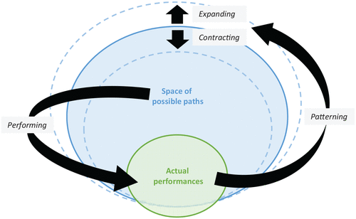

Pentland, B. T., Mahringer, C. A., Dittrich, K., Feldman, M. S., & Wolf, J. R. (2020). Process Multiplicity and Process Dynamics: Weaving the Space of Possible Paths. *Organization Theory*, *1*(3), 2631787720963138.

.

There is some galumphing in the theorizing. Besides taking a very quantitative networking approach to narrative, there is the ways quantitative and qualitative are related.

“Building on [Deleuze and Guattari (1987)](https://journals.sagepub.com/doi/full/10.1177/2631787720963138), [Linstead and Thanem (2007)](https://journals.sagepub.com/doi/full/10.1177/2631787720963138) argue that the ‘multiplicity of organization’ is inherently qualitative and ‘irreducible to numbers’ (p. 1485). More frequently, however, multiplicity is used in a quantitative sense, as a synonym for ‘several’ or ‘many’. For example, in their analysis of global standards for coffee, [Reinecke, Manning and von Hagen (2012)](https://journals.sagepub.com/doi/full/10.1177/2631787720963138) refer to a multiplicity of standards. [Denis, Lamothe and Langley (2001](https://journals.sagepub.com/doi/full/10.1177/2631787720963138), p. 825) talk about pluralistic organizations as ‘settings in which a multiplicity of actors and groups pursue varying goals’. This variation in the usage of the term multiplicity can be confusing at first, but it is easily understood once it is pointed out.”

# David Whetten once told me in 1978, Organization Theorizing is between a rock and a hard place. I came across this same notion in 2020.

“Organization theory seems to be caught between a rock and a hard place: on the one hand, there are arguments that the field is too preoccupied with theory, leaving its work abstract and practically irrelevant. On the other hand, there are arguments that the field is overly empirical and too methods-driven, which hampers the creation of ideas that resonate with constituencies beyond the organization studies community” (Korberger & Mantere, 2020)

Kornberger, M., & Mantere, S. (2020). Thought experiments and philosophy in organizational research. *Organization Theory*, *1*(3), 2631787720942524.

# Chapter Three: Flashback to U of I: Before to a Little Wow Moment that Changed My Life

***In 1976*** Lou Pondy had invited me to coordinate 14 sections of an undergraduate management course, doing ‘Experiential Learning Organization (ELO). I keep the letter he typed to me on my wall, all these many years. ELO treats the classroom as an organization, by placing students into departments (production, engineering, sales, accounting, internal auditing). Each department selects a manager. Managers became the board of executives, led by a student CEO. Departments designed experiential learning events, assessed and audited outcomes, designed their own tests, and did a class-as-a-whole service learning project (raising money, doing something with the money, accounting for every penny, speeding the money and sweat labor for some community need). Learning by doing, and learning from the experience by active reflection. Instead of a textbook, Daniel J. Brass, Louis R. Pondy, and I gathered our favorite articles, and did some writing of introduction sections, and some short articles (Boje, Brass, & Pondy, 1976/1977).

Boje, D.M., Brass, D.J. & Pondy, L. R., (1976/1977 Eds.), *Managing II*, Ginn Publishing, 521 pages, (Managing I,1st Edition, 1976; Managing II 2nd Edition, 1977) Lexington, Mass.: Ginn Publishing.

We included in Managing II (1977) the *dancing partners* approach to teaching theorizing to undergraduate students. Lou used it with us in the power and conflict and the systems theory doctoral seminars. We wrote short papers during the course, dancing one theory with another partner theory.

Boje, D. M.; Brass, D. J.; Pondy, L. R. (1977). Metaphors, dancing partners, and case episodes as training exercises in the art of organizational theorizing. Pp. 12-18 in D.M. Boje, D.J. Brass & L. R. Pondy, *Managing II.* Lexington, Mass.: Ginn Publishing.

# Can Students Learn Theorizing?

Theorizing is not the exclusive domain of academics. Theorizing is done by practitioners. Academics are supposed to theorize with a bit more scientific rigor. Does scientific training mean precise definitions of concepts resulting precision in the ‘discovery of ‘truth’? Or, is theorizing part of common everyday life process of sensemaking? “People constantly attempt to sort out and make sense of the things which happen around them” (Boje, Brass, & Pondy, 1977: 12). They use sensemaking storytelling to answer the question of ‘what causes what?’ These are espoused theories which may or may not match theories-in-use. Infants engage in curde theorizing when they form (abductive) hypotheses about their environment: “They discover the principle of gravity by repeatedly verifying that a released toy falls to the ground” (IBID.). My daughter, at age 18 months, would point to a picture of a dog, or horse, or an actual horse, and say ‘woof, woof.’ She was making sense of things by beginning to assign symbols (words) to patterns she saw. As she grew older she could differentiate between pictures and in-the-flesh animals, and toy animals. “Automobile mechanics skillfully employ theorizing to hypothesize the location of a problem by generalizing from a set of observations” They will listen to the sound of the motor, disconnect various elements, and test out a chain of hypotheses, eliminating one after another, until they isolate the defective component” (IBID.). It is what Karl Popper calls falsification or disconfirming. The point is academics and practitioners use informal theorizing by using deductive reasoning, perform inductive-tests (make experiments, talk to another expert), and sort through hypotheses (guesses about what is the matter). “In addition to deductive and inductive reasoning, we would like to suggest that the manager engages in ‘phenomenological’ reasoning” (Boje, Brass, & Pondy, 1977: 13).

Today, I am pragmatist-ontologist. I dod something called relational process ontology. By doing inductive tests (self-reflexivity, interviews, reading across paradigms, and doing experiments or interventions.) My storytelling theorizing, now takes on more scientific rigor, than when I was doing ‘dancing partners’ training undergraduates to theorize. The initial abductive-hypotheises can become principles that withstood inductive tests. I am using the abductive-inductive-deductive (AID) triad of Charles Sanders Pierce, to explain it now.

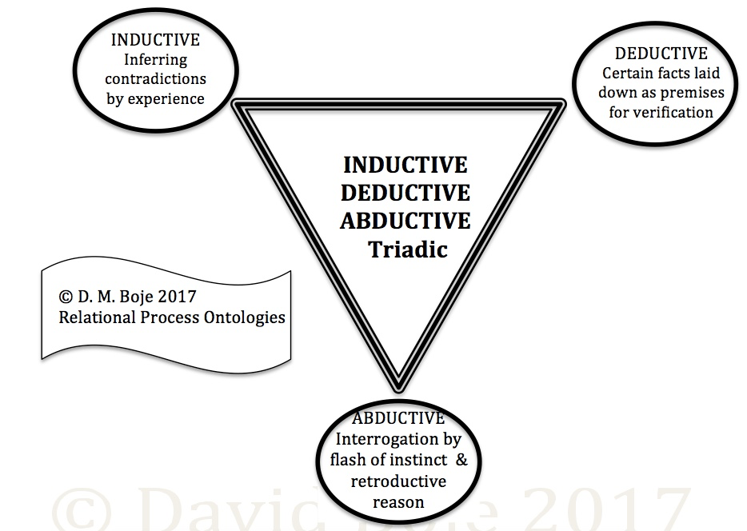**Figure 1: The Abductive-Inductive-Deductive (AID) Triad for doing Relational Process Ontologies**

AID is root in the semiotic-pragmatism of Charles Sanders Peirce. He has many triads, perhaps the most famous is Firstness, Secondness, and Thirdness. Firstness of experience, such as retrospective-sensemaking. Secondness we encounter actual facts in the here-and-now that are mattering (as in spacetimemattering. Firstness and Secondness combine in Thirdness, the [antenarrative’ future arriving. Retrospective-prospective mattering in Being.

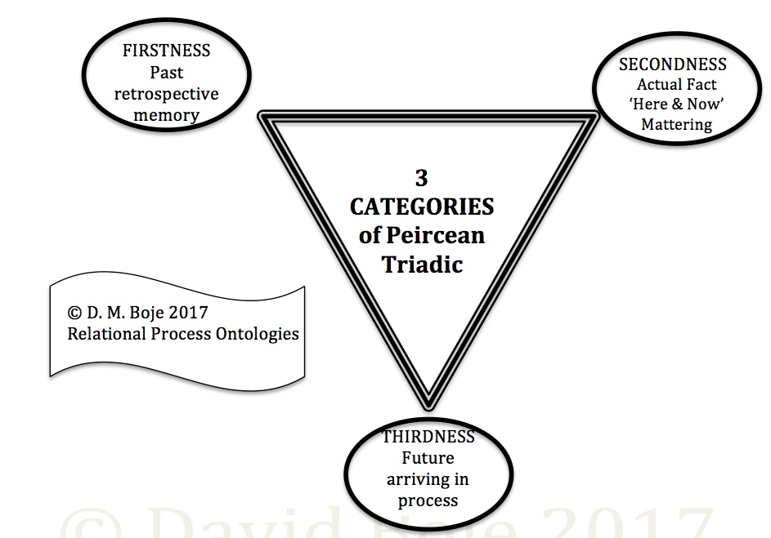**Figure 2: Firstness, Secondness, & Thirdness applied to retrospective-prospective sensemaking**

What is A-I-D triadic approach to self-correcting theorizing using conversational storytelling?

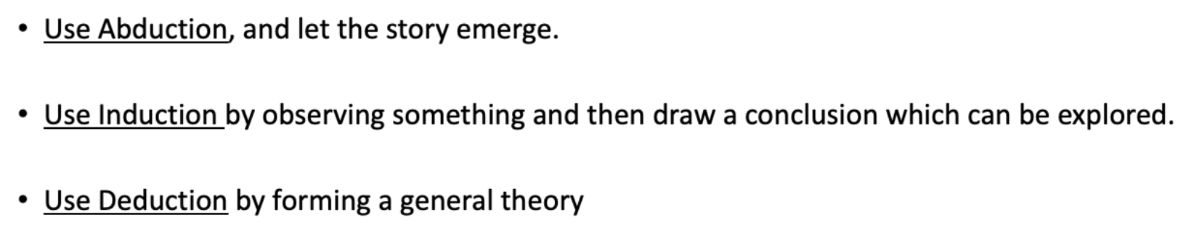

A-I-D inquiry moves past crude induction to qualitative and quantitative induction

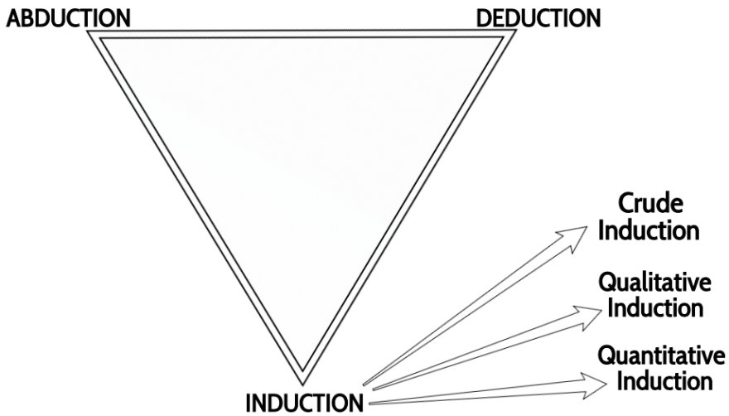**Figure 3: C. S. Peirce’s Three Kinds of Induction**

Self-correcting A-I-D inquiry moves toward ‘truth’ (or ‘true storytelling’) by tests that engage falsification, not just acts of confirming the narrative.

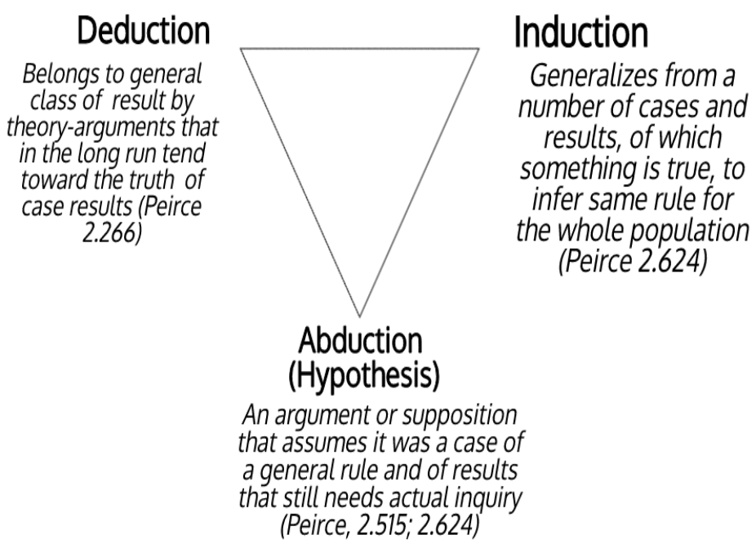**Figure 4: How Peirce Defines AID Triadic (from Boje & Rosile, 2020: 24)**

This illustration (a diagram) annotates how Peirce’s life time of writing gets at self-correcting towards the truth of case results. They are not just vignettes. It is not a choice of qualitative or quantitative induction, there is interplay. Nor, is this a method of triangulation using multi-method. Good practices, but there is something much more important going on here. The grounding for an abstract theory is how it gives an account of the Natural world. For example, Frigg (2006) gives example of how under conditions approaching speed of light, Newtonian mechanics is less correct than Einstein’s theory of relativity. At speeds less than light, Newton’s predictions of real world behaviors are correct. Inductive testing abductive (flashes of insight, creative speculations, surprises) using scientific method lets those abductions become falsifiable, so the theory gets some correction, in test after test. Popper says it’s a zigzag by trial-and-error, whereas for Peirce it is self-correcting triadic.

# Chapter Four: Thought Experiments in Organization Theorizing, Pros and Cons

Developing novel ‘new’ theory has become an ‘empty exercise.’ Organizational theory (see Chapter 1; & Barley, 2016) is in an existential crisis. Organization theory has lost its object (du Gay, 2015). Martin Park questions the need for business schools.

Question: Is organization theory too empirical, its ideas too abstract to resonate beyond the organization ivory theory tower? The thought experiment reviewed by Kornberger & Mantere (2020) is one way to teach organizational theorizing. For example: Bohr, Heisenberg’s gamma ray microscope, Einstein’s train, and Schrodinger’s cat, all did them, so perhaps we can too. Darwin relied upon thought experiments. Wittgenstein’s beetle in a box. Adam Smith (Wealth of Nations) pin factory thought experiment to explore division of labor in economics. Keynes beauty contest to explore stock market predictions. Prisoner’s dilemma in game theory.

Herbert Simon’s thought experiment of a mythical visitor from Mars, who sees red lines connecting market transactions in an organizational economy of green spaces. Simon’s visiting Martian, might question why why in the 1960s through 1990s organization and environment theorizing defined environment as just other organizations, environments were natural resources controlled by various organizations, in privatization and commodification scenarios. I was happy to be a co-signor to launch Organization and Natural Environment (ONE) interest group of Academy of Management. My own work is grounding in Nature, using Native Science, focusing on spiritual ecology, on finding our more balanced and sustainable role in nature.

The San Francisco trolly car experiment in ethics.

These thought experiments open spaces for reflection

“[Popper (1959)](https://journals.sagepub.com/doi/full/10.1177/2631787720942524) developed this critical function of the thought experiment (or as he says: imaginary experiment) as a tool to investigate whether theories account for all their implications and consider possible unintended consequences in depth” (Kornberger & Mantere, 2020).

This would mean students learning theorizing by doing thought experiments to model and predict behaviors, work out relationships, test out various bets on the future in the alternative scenarios.

Narrative scenarios of prospective sensemaking can be intersubjectivity interrogations of the relationships of situations and consequence.

A thought experiment is analogical induction (metaphors [Bentham’s panopticon], tropes or narratives for self-reflexivity and intersubjectivity scenarios).

Not just induction, but it can be abuction and deduction, or the entire triad Abudcution-Induction-Deduction of C.S. Peirce. For Peirce first of four inductive tests is self-reflexivity. Abduction (retroduction) is a guess, sometimes an intelligent guess, an intuition, a sixth sense, then to do the inductive tests. I prefer storytelling to metaphors, and like to move from abstracting to grounding beyond metaphor. Merleau-Ponty explores embodied pre-reflection in his thought experiment. Edmund Husserl (Ideas) explores space awareness as sense-giving.

Narrative fiction is a way to develop plausible stories with a narrative causality of events and characters in scenes (narrative scenarios). Polkingnorne (1988) does not see the agential aspects of any stories, and obsesses about anthropocentric approaches that go beyond the text.

A thought experiment can explore flaws in deductive logics of organization theorizing. For example, when I was trained in organization and environment theorizing, I read hundreds of articles, not one of which, included the ‘natural ecology’. Every definition of environment, was stakeholders, always other organizations, just natural resources, and organizations (ironically) being organic systems. Triple Bottom Line models, for example have trouble moving beyond profit measures to planet and people measures.

A thought experiment can help think through a situation in which organization theorizing does not yet exist.

As David Trafimow, might say, thought experiment could be a way to sort through some auxilllary assumptions that the theory assumptions are ignoring. It involves abductive reasoning.

Alvession and Karreman (2007) explore abductive reasoning. For example, people now stay home, work via Zooming, during the COVID-10 pandemic. This changes the brick and mortar approach to organizations. Bureaucracy of co-located individuals, goops, in work routines changes radically. Our sense of togetherness shifts when we were masses, work from home, appear in Zoom meetings like on Hollywood Squares, going to breakout rooms in digital space. The boundary between home and workplace shifts.

In True Storytelling, we focus on development of future scenarios, often in online meetings with plenary and breakout rooms. We are digital consultants in a digital world of distributed organization. It changes Tamara-Land (Boje, 1995), how people move from room to room. We work with material artifacts doing embodied restorying in ways Dennis POlkinghorne (1988) would not approve, since we look at story-agency, the aliveness of stories, the onto-story of vibrant mattering (Bennett, 2010). SOciomateriality is part of the embodied restorying process of moving from stuck-in-the-past to being flexible in new futures creation (world making).

Kornberger and Mantere (2020) stress that “thought experiment do not result in abstract theory”. Instead the thought experiments thinker concepts, give texture and detail. Too me this is not the same as grounding in field studies, doing ‘thick descriptions’ Gertz). It is too easy to conjure up verification in status quo values and do fact-finding that confirms rather than disconfirms (or falsifies the conjured abductions, inductions, and deductions). The thought experiment can get stuck in the existent theories vocabulary and concepts, and wise the natural world, what Merleau Ponty (Visible & Invisible) calls ‘Wild Nature.’ Claims and warrantees of ’stakeholder theory’ worked though without enfleshed stakeholders is problematic. It results in stakeholders-in-the-mind of the analyst, CEO, manager, or consultant, instead of actual realtime conversations with each of them.

I prefer ontology. There the thought experiments are working out subtle differences in meaning of concepts. I am not a fan of meta-theorizing. It seems to be the stuff of the debate over semantics society we hav become where people in the same family or community can not longer talk to one antlers in the Trump and post-Trump era.

The problem with Grand Narratives is they can be thought experiments, ways of non-engagement with the Other. An embodied sense of community, even over Zoom and other platforms (Google, Microsoft Teams, etc.) is not a thought experiment. People are in echo-chambers, even in Zoom-land, only relating to communities that are in the same echo of beliefs, assumptions, attitudes, and unchecked conspiracies.

Kornberger, M., & Mantere, S. (2020). Thought experiments and philosophy in organizational research. *Organization Theory*, *1*(3), 2631787720942524. <https://journals.sagepub.com/doi/full/10.1177/2631787720942524>

# Chapter Five: On the Differences Between Hierarchical-Models and Field-Models in Organizational Storytelling

**What are at least three kinds of theorizing?**

# TYPE ONE: Hierarchical-Theorizing

Aristotle (350 BCE) Narrative is a good example of hierarchical-theory. A narrative has six elements in a hierarchic ordering

1. Plot (defined as beginning, middle, and end) that could be performed in a day.
2. Characters (energia, characters did not change)
3. Theme
4. Dialogues
5. Rhythm
6. Spectacle

What happens to hierarchical theory and its theorizing? It is a deduction from a small number of elements (six in a narrative) and using it as a lens (optic) for the life of departments, organizations, industries, nations, and the world. Hierarchic-theories deduce by analysis, classification, into the taxonomy.

E.g. Maslow’s Hierarchy of Needs

E.g. Einstien’s E=MC2, Keynesian Economics, and so on.

E.g. Kenneth Boulding’s (and Lou Pondy & Ian Mitroff’s) hierarchy of types of systems theories from framework, mechanistic, control, open, organic, image, symbol, network, and transcendental (Pondy & Mitroff left off the transcendental). Each systems model has a master narrative (metaphor, simile, or trope).

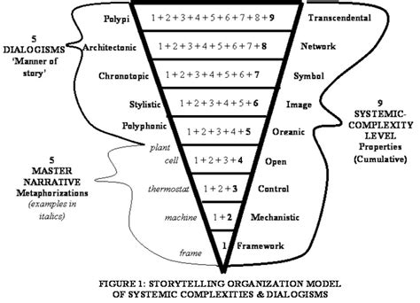**Figure 5: Storytelling Organizational Models**

## Lots of Problems with this theory

The hierarchical theorizing has its abstract model of classification to sort different entities from different contexts. In Figure 1, I contrast a strict hierarchic classification with a cumulative classification that assumes each higher level includes variants of the lower levels. Hierarchic-theorizing has a set of coordinating definitions of its concept-elements. It becomes standard practice to reify, to leave out the whole history, and entire situation. The hierarchical model takes over the entire social, economic, and environment stage.

Of course, the above hierarchic ordering of systems (while popular) is full of fallacies. For example, most organizations have a framework, mechanistic machines (digital & other technologies), exercise control, but what if you skip some of these, and just include some out-of-order, such as a combination of framework, image, and symbol? My dissertation was on networks of organizations, and their centralities (types 8 and 3).

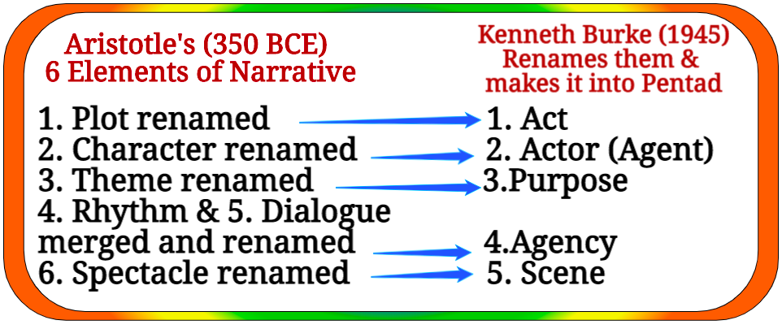 My point is the hierarchic theories don’t get negated, rather scholars add an element, delete one, combine two, redefine them a bit. The hierarchic-theories colonize by extension, with some changes here and their to elements, but the model just carries on and on. For example, Kenneth Burke (1945) modified Aristotle’s six elements by combining some elements, and making them ratios, such as Act/Scene, and Purpose/Agency. Late in life,

**Figure 6: Aristotle and Burke’s Hierarchical-Theories**

Kenneth Burke wanted to add an element called ‘frame’. In my early work, I noticed ‘frame’ was already in Aristotle’s narrative writing. Burke does succeed is suspending Aristotle’s strict ordering of the elements. This is necessary, since after two thousand years, the spectacle has taken center stage, overshadowing, particular in US movies and movies, the plot and character. Lots of action, lots of glitz, in the spectacle, fast paced rhythm, not much attention to the other elements.

**Table 1: Poetic, Pentad, and Septet Grammars of Dramatis Personae**

|  |  |  |
| --- | --- | --- |
| **Poetic (Aristotle)** | **Pentad (Burke)** | **Septet (Boje)** |
| 1. Plot (or Fable) | 1. Act | 1. **Plots**  have become inter-plots, interconnecting pre-plots in networks, in the middle of being worked out. |
| 2. Character (or Agent) | 2. Agent | 2. **Characters**  the cast of characters are in the middle of being enrolled, and characters morph their persona in schizophrenic ways. |
| 3. Theme (or Thought) | 3. Purpose | 3. **Themes**  themes of oppression fan out in rhizomatic weaves, and are met by themes of resistance. |
| 4. Dialog (or Diction) | 4. Agency | 4. **Dialogs**  obfuscating language and double-speak mixed with euphoric testimonials and bland reassurances attain and shed meanings. |
| 5. Rhythm (or Melody) | 5. **Rhythms**  rhythmic resonances self-organize in chaotic patterns that refuse to freeze, and often disintegrate what was just integrated. |
| 6. Spectacle | 5. Scene | 6. **Spectacles**  spectacles are intertextual to other spectacles; they embed in socio-economic contexts by decontextualizing and recontextualizing. |
| * Frame of Mind of spectator | * Frames of Acceptance/Rejection | 7. **Frames**  Frames are ideologies that are in dialectic contest, resisting each other, and refusing to synthesize. |

Key: * = Discussed, but not one of their main dramaturgical elements (Source of Table, Boje, 2002c). Appendix A offers re-readings of Aristotle, Burke, Boal, Freire, Debord, Best and Kellner, to set out the new Septet re-definitions.

Leadership is produced, distributed, and consumed in (4) dialogs (in talk, in stories, and in discourses). For example, leadership affects and is affected by the temporal (5) rhythms (seasons, cycles, recurring patterns). Leadership is the championing some (6) frames (ideologies) over others. And, leadership is most of all the (7) spectacle theatrics (four types), a dynamic hybrid of (a) ***concentrated corporate culture theatre***, (b) ***diffuse theatre on the global stage***, the (c) ***integration concentrated and integrated***, and the more and more frequent (d) ***megaspectacle of corporate scandal*** turned by media frenzy and spectator appetite into mass entertainment.

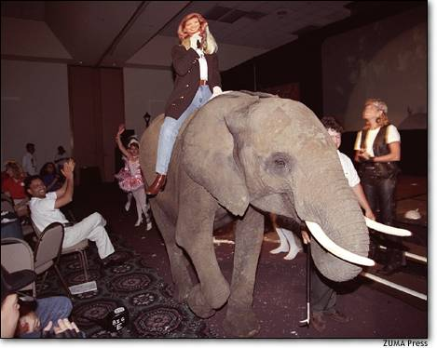

#### Figure 7: Assistant makes Metatheatre entrance wearing a Rebecca Mark mask as Mark looks on at right wearing Harley costume.

**TYPE TWO: Field Theorizing**

Kurt Lewin (1951) Field Theory in Social Science (NY). Lewin pointed out that stuff interacts in the field. A field theory is not just “recognizing a ‘multiplicity of factors as constituting phase space” (Kaplan, 1973: 348).

**TYPE THREE: Multi-Paradigm Theorizing**

We are talking now about praxis (theory + practice), in a community of praxis.

# Chapter Six: Some Practical Tips for Teaching Theorizing in Organization Storytelling Studies

**Tip One: Show Students that Storytelling is Theorizing, and Theorizing is Storytelling in Everyday Life** Students can learn theorizing by recognizing it as part of everyday life of their conversations. Mostly we do terse-telling (what is actually said) and leave the other person to fill-in-the-blanks. At UCLA, I worked with Harold Garfinkel. He taught me *praxis*, how theory and practice are implicated in everyday life. Grace Ann Rosile and I just published a book on ‘***Doing Conversational Storytelling Interviewing for Your Dissertation***’ (Boje & Rosile, 2020). It builds on Garfinkel (1967) process theory of storytelling as a kind of theorizing practices in everyday life we take-for-granted.

We are continually filling in the blanks of narrative-story with bits and pieces. For Garfinkel (1967: 17):

“These *whatever* bits and pieces that a story … might make intelligible are used to formulate a recognizably coherent, standard, typical, cogent, uniform, planful, i.e. a professionally defensible, and thereby, for members, a *recognizably* rational account of how society worked to produce those remains.”

In the everyday practices of “tell-a-story” (Garfinkel, 1967: 34) in social interaction the listener conspires to fill in the blanks to sustain the illusion of “appearances of consistent, coherent, clear, chosen, planful arrangements” that are “storyable” or narrate-able to maintain the illusion of a rationality that is not there (p. 34). Garfinkel is a theory of interpretation, a kind of sensemaking hermeneutics (see Ricoeur, 1984).

“Each story is at once larger and smaller than itself, includes itself without including (or comprehending) itself, identifies with itself even as it remains utterly different…” (1979: 82).; Derrida , treats story more in terms of their reflexivity web of story to other stories (99-100).

Dialogical manner of story is “The plurality of independent and unmerged voices and consciousness and the genuine polyphony of full-valued voices” (Bakhtin, 1973: 4). In 1991, I published work on the intersubjectivity of storytelling.

***“*Organizations As Storytelling Systems In organizations, storytelling is the preferred sense-making currency of human relationships among internal and external stakeholders** People engage in a dynamic process of incremental refinement of their stories of new events as well as on-going reinterpretations of culturally sacred story lines. When a decision is at hand, the old stories are recounted and compared to unfolding story lines to keep the organization from repeating historically bad choices and to invite the repetition of past successes. I**n a turbulent environment, the organization halls and offices pulsate with a story life of the here and now that is richer and more vibrant than the firm's environments”** (boldness, mine).

People leave most of the storytelling, untold, left in the ‘you knows’ and ‘etcetera’ gaps, so you fill in the blanks.

Fill in the blanks:

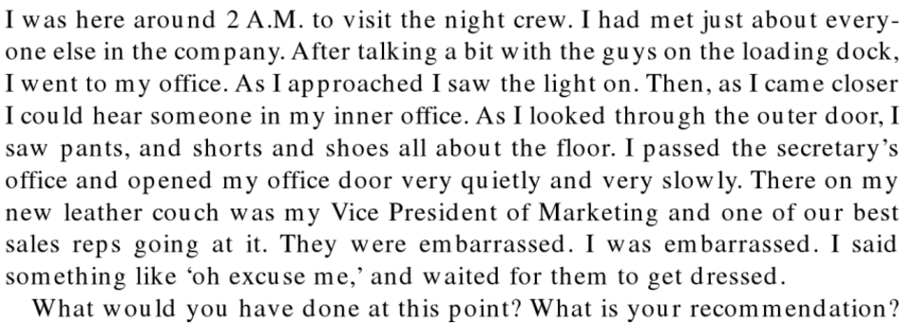

From Boje (1991: 106)

Wider Embeddedness of our conversational storytelling in narrative contract, to not breach the curtain, not reveal what is behind the veil of common sense theorizing we do every place, all the time, and it does matter (Boje, 1991: 106-107)

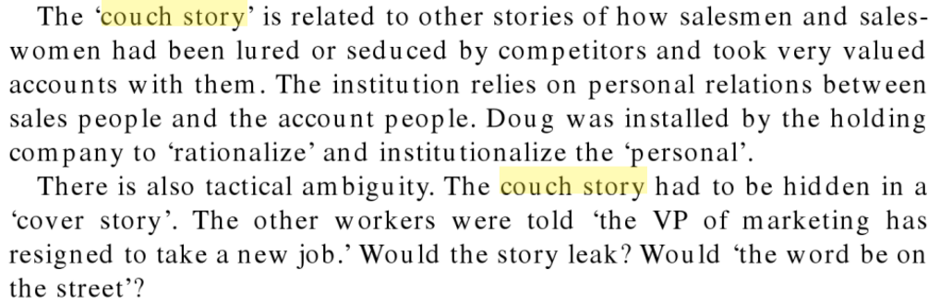

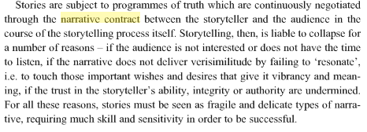

Here is another example of narrative contract, the tension between true storytelling and regimes of truth, and what happens if you breach the implied contact to let the intersubjectivity Be.

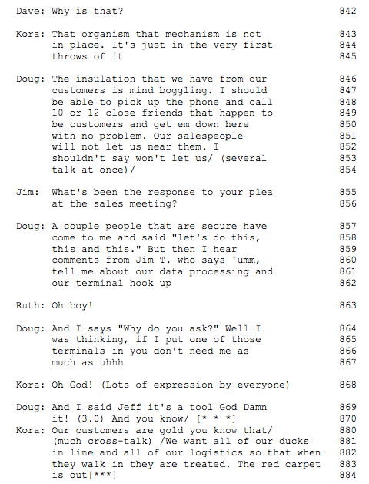

**Tip Two: Teach Students to Analysis the Theorizing People are Doing in Everyday Conversations:**

* For example, lines 846-54 above, the story details are so terse that, at first glance, there may not appear to be a story at all. Indeed in Gabriel (2000) this story does not fulfill the narrative contract. Czarniawska (2004) would say its not an emplotment, because it is not a Beginning, Middle, End telling and strong corporate cultures have petrified narrative plots.
* However, in lines 855-6, another executive hooks into the underlying experience to trigger more detail on the story behind the story. In 859-62, the story of a salesperson's reaction to executive attempts to implement computer information-system controls garners a severe group reaction. I used to accumpany Garfinkel to labs with one way mirrors where we watched together as childen do such story-continuing processes, and story-elaborating practices.
* In line 870, Doug uses a very common reflexive "you know" to reference experience that the other executives are expected to fill in between the lines. He references a story everyone knows all too well. People are expected to theorize, to fill in the gaps with context.

This is another excerpt for the 1991 article, highlighting the narrative contract between the audience and the storytelling process itself, that are subject to programs of truth, what today we call ‘true storytelling’ (*verisimilitude*) and regimes of truth (*faking it*)and both resonances interact here for the theory-in-use to be successful (Larsen, Boje, & Bruun, 2021).



Next is an example from an article Grace Ann and I wrote for journal on methods of storytelling theorizing. I build’s on the two column work of Garfinkel (1967: 25-26) experiments. In left column write only what was actually uttered. In right do the interpretation necessary for common understanding. It teaches students that theory-in-use is happening in almost every conversation they are in, every place, everyday.

**Table 1: What’s Actually Said and What’s Storytelling Unsaid, Taken-for-granted**

|  |  |
| --- | --- |
| **What They Actually Said (verbatim)?** | **What They Are Telling About (context)?** |
| Sound of footsteps  David: Ok, how can I help you? (Softly asked)  Grace Ann: I’m going to give him his second. So that’s his  David: OK  Grace Ann: And there’s a bowl outside, for now [more footsteps; sound of food entering bowl] See that bowl there  David: OK  Grace Ann: We keep them separate (scuffling sound) that’s all right, let him go, he’s going to go with you.  Grace Ann: Sparkles, Sparkles. Good girl. That’s a girl.  David: Here you go. Here you go. Come on. Come here. Come here. Here you go (sound of food entering bowl) There it’s in your bowl, for now. We’re outside. Hi Rusty. Here Rusty. Rusty here. Come on. Maybe some cat food.  Grace Ann: No he’s just worried he’s missing something (shuffling sounds). Eeh, Eeh, OK, come on sweetheart. Eeh, Eeh, No! (in louder voice). Come Kiss, Kiss (in softer voice) Yeah (sound of bowl moving) Yeah that’s a good boy. Yeah that’s a good boy (sound of food moving around bowl) That’s a good boy, good boy, good boy. See how he’s scared of somebody else taking his food.  David: See how he spit it out.  Grace Ann: Did he spit it out?  David: Yeah, but then he took it in again.  Grace Ann: Kiss, Kiss (clucking sound) Come.  Rusty: Sound of rapid breathing.  Grace Ann: There you go. There you go. That’s a good boy. Come on Schuk, Shuck (clucking sound). Come on.  David: Do you think we’ll need the yogurt?  Grace Ann: No  David: Or cat food?  Grace Ann: If he just settles down, then he’ll eat it. Here you go. Here you go (in soft voice with inflection at end, each time) Good fella. Good fella. Oh, there.  David: Oh, you were right.  Grace Ann: Good boy. Good boy, little sweetheart. Good boy. Good boy. Good boy.  Rusty: Sound of eating, and bowl moving along cement for 1.5 seconds)  Grace Ann: There you go. There you go. Yes.  Rusty: Sound of eating, and bowl moving less along cement now and again, for about 7 seconds) | David is in his home office in Las Cruces  Grace Ann walks in the office, interrupting David’s usual writing, with Sparkles who usually eats there. The new puppy from the Rescue Shelter is about to get first meal in our home (*Before*). The new dog gets his food second to reinforce to the old dog that she is now the senior dog, she knows the rules, and the new dog should respect her and follow her lead  David agreeing, to show he has heard. It’s more than that it’s got history (Before), since it is about how Sparky and Honey had been feed, before Sparky died, and Honey become top dog (fed first). The Sparkles came in, and become second to feed. Sparkles was getting lonely so we decided to accept a rescued puppy, and move Sparkles into top dog (eat first) and new puppy into eat second, rank. This is (*Rehistoricizing)* the dog-to-dog relationship.  (*Futurin*g) Giving her plan (*Foretelling bets on the future*) for how the feeding will be done. (*Grounding)* David is to feed Sparkles in his office (mistaken). Grace Ann points to Sparkles bowl, in his office.  David indicates agreement. More than that is getting communicated. David is inviting more input to resolve confusion.  Grace Ann explains the plan (*Futuring)*, while David (still not actively listening) anticipates (*bets on the future, wrongly*) he is staying in his office, but that’s not right. David now gets it, he’s going with new puppy, outside. Better to listen than to jump ahead is a lesson David has been learning slowly for 23 years (*Before*).  As David and new puppy head to outside, Grace Ann feeds Sparkles, first. Grace Ann has decided that Sparkles is the top dog, and will be respected by feeding her first. Grace Ann decides the kind of feed, and chooses meat-based pet food, even though David and Grace Ann are vegan.  Rusty is not final name (*Before-forehaving)*. There were several others including Snuggles, Cuddly, and finally settled on Cuddle-Bear. Rusty is very terrified in new place. We are being very gentle and patient. Rusty not eating, and we have cat food, perhaps, he’ll like it better, or as mix with the dog pellets.  Grace Ann indicates she will calm him with puppy language (*Beneath-foreconcepts*), resulting in some minor movement by Rusty of food in the metal bowl. Lots of positive reinforcement statements. We are outside, on the back patio, in a fenced yard, and Sparkles is indoors (finished her food in about 11 seconds).  It’s not working too well.  Are you sure?  Just then, Rusty took some back in  Rusty is heard for first time on the tape. It is not a scared breathing, more about anticipation.  Grace Ann keeps encouraging with more foreconcepting, kind of baby language  Maybe try what the people drove Rusty from the Shelter in Roswell to Alamogordo, had suggested  Grace Ann does not agree  David tries again on cat food  Grace Ann reasserts her strategy, and carries it out.  Rusty is eating  Grace Ann keeps encouraging  Some sound of eating more intensely  Reinforcement  Finally, Rusty is settled down, more at home, less terrified and can focus on eating. |

Note: This is what Donna Haraway (2015) calls ‘multispecies storytelling’ and ‘staying with the trouble’. She really took Tamara-Land (Boje, 2015) to a whole new level. We have two dogs, and had a cat and we are only two humans. There is also a cat, which helps train the dogs, but is not in this scene. This is not just species telling, there are important materialities that are agential (dog food, yogurt, cat food, metal dog dish, indoors, outdoors, and so on). We are transcribing the talk, the ‘untold stories’ (Hitchin, 2015), doing the historiography, predicting the future, grounding the telling in embodiment, using some abstracting, using sounds that are before actual words, in puppy talk.

**Tip Three: Help students see the usual reading of academic ‘grand narrativizing’ in Academic Theory Building→What Theory is Not?**

* Sutton, R. I., & Staw, B. M. (1995). What theory is not. Administrative science quarterly, 371-384. <https://vulms.vu.edu.pk/Courses/MGT704/Downloads/what%20theory%20is%20not.pdf>

That gives students the main KISS narrative of what not to do.

1. References are not a theory
2. Data are not theory
3. List of variables are not theory
4. Diagrams are not theory
5. Hypotheses are not theory

So, ask the students, ‘**What is theory?**’ and ‘**What is theorizing?**’ Sutton and Staw say “a process of building a theory is itself full of internal conflicts and contradictions?” (1995: 372). There are these tradeoffs of abstracting KISS generality narratives, and the complexity of the target system one is telling about.

***Theory is storytelling*** Then, if the students don’t pull out, how good theorizing is “a story about why acts, events, structures or thoughts occur” (IBID. p.372). And how John Van Maanen calls for a 10 year moratorium on theory, so that field ethnographies can take place. *Aim at the target before you shoot the theory arrow.* Find an organization (or system) that behaves and works like you say, then theorize it.

I usually invite the students to being their dissertation with an autoethnography, the process of how they got to the question.

As Henry Mintzberg put it, a deep theory spells out the processes, not just the principles of planning, organizing, controlling, leading, i.e. the Fayolism, Taylorism, or Weberian principles of organization that managers are not actually doing, most of the time, when you follow them around.

As Richard Swedberg, might cite this Sutton and Staw (1995: 382) quote:

“Rarely are qualitative studies accepted for publication when they simply provide data and validate an existing theory.” Its about making some ***creative moves***, some new theory mixed in to the old models.

**Step Four, ask students, themselves, for the counternarratives to the Academic Grand Narrative of Theorizing?**

Most practitioners and doctoral students are able to point out the counternarratives in the publish or perish game of organization theorizing or theorizing strategy narratives. The point of this exercise is to get beyond the dualities.

**What is a counternarrative to the grand narrative of what is good theorizing in academia?**

Start students with two KISS counternarrative articles on theorizing:

* DiMaggio, P. J. (1995). Comments on" What theory is not". Administrative science quarterly, 40(3), 391-397. <https://citeseerx.ist.psu.edu/viewdoc/download?doi=10.1.1.1068.9272&rep=rep1&type=pdf>
* Weick, K. E. (1995b). What theory is not, theorizing is. Administrative science quarterly, 40(3), 385-390. <http://crts.bilkent.edu.tr/readings_2015/weick.pdf>

Paul Dimaggio puts his counternarrative in simple terms of a list of what Sutton and Staw left out in their narrative (exaggerate for effect in brackets):

1. There is more than one kind of good theory (Abbott’s ordinary linear reality can be the WHAT, and as important as the HOW & WHY narrative; P.S. since Aristotle 350 BCE narrative has been defined with beginning, middle, end plot, the most important of 6 elements; now the least important [spectacle] gets top billing)
2. Theory as enlightenment (Good theory presents surprise, clearing the stage of representation-narrative for new insights; C.S. Peirce uses term ‘abduction’; Merleau-Ponty says ‘embodied pre-reflection; some call it the 6th sense)
3. Theory as narrative (gives an account of the social-economic processes that real humans use to accomplish their story account of theory and theorizing)
4. Defamiliarization (to see theory and system you inquire about, in new eyes, with new optics)
5. Comprehension versus memorability (logical deductions from first principles are easy to comprehend and the process relationship Van Maanen’s ‘Tales From The Field’ are more memorable than lists)
6. Theorizing construction is social construction after that fact (I like to say there is no ground and no theory in grounded theory; no action and no research in action research; I exaggerate).

These six points are exactly why I would (like Mintzberg & Swedberg) stress they get ahold of Karl Popper and Charles Sanders Peirce. See our new book on this, Boje & Rosile (2020) ***Doing Conversational Storytelling Interviewing for your Dissertation***.

Karl Weick’s (1995b: 389) counternarrative to Sutton and Staw’s narrative can be put in one quote:

“Do you publish just ends, or do you publish what Runkel and Runkel called "interim struggles?" The process of theorizing consists of activities like abstracting, generalizing, relating, selecting, explaining, synthesizing, and idealizing. These ongoing activities intermittently spin out reference lists, data, lists of variables, diagrams, and lists of hypotheses. Those emergent products summarize progress, give direction, and serve as placemarkers.”

That’s the tool room!

Maybe diagrams, references, and lists of hypotheses and variables are a good theory practice, for those interim placemarkers.

**Tip Four: Get into deconstructing both the narrative and counternarratives**

Joanne Martin’s amazing work in feminist deconstruction to develop new community of practice in organization and Stuart Middleton’s dissertation on the Salvation Army are excellent role models in using deconstruction of a dominant narrative to construct a counternarrative..

* Martin, Joanne. (1990). Deconstructing organizational taboos: The suppression of gender conflict in organizations. Organization Science, 1(4), 339-359.
* Middleton, Stuart. (2009). Reputation management in the Salvation Army: A narrative study. Journal of Management Inquiry, 18(2), 145-157. <https://www.mv.helsinki.fi/home/aula/Top20/middleton-reputation.pdf>

I put together 8 steps for deconstructing any dominant narrative. Of course, putting anything into KISS steps goes against Jacque Derrida’s stylistics of doing deconstruction without steps. My main points: (1) deconstruction happens all the time, as part of entropy (unraveling systems), and (2) deconstruction is done to get to the 8th step, the resituation of a reconstruction based on what one learned in the first seven steps. Western Ways of Knowing (WWOK) is full of dualities, hierarchies, and marginalizations of others’ voices and their side of the story. So denying any plot with a counterplot is the basis of not only deconstruction but dialectics. Exceptions (what’s left out of the model) is pretty easy to find. Harder to trace what is between-the-lines (writing on the Wall, invisible).

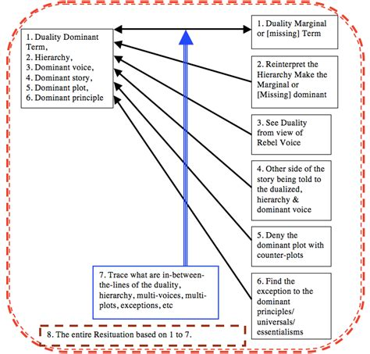**Figure 8: Deconstruction is sytle, not steps, but if you want to teach it, steps Help**

I began teaching this to undergraduates, who learn it more easily than graduate students. Anyone who has been through divorce and remarriage, understands it without any fuss. When I first started assigning Joanne Martin’s (1990) feminist deconstruction in early 1990s, got lots of resistance from the male doctoral students. Now a days, less so. It is the counternarrative of a male CEO’s narrative. His VP is pregnant, and he wants to install a video camera and audio feed in her hospital room. This way after the delivery, she can get right back to work. You can easily deconstruct this CEO narrative, but can you reverse the male over female hierarchy to resituate corporations, not just putting a Zoom camera in the CEO’s hospital room should he become ill, but to resituate the whole dynamic of gender in corporations so these egregious practices would happen. What would happen in their place?

Stuart Middleton’s (2009) article based on his dissertation is a good example students relate to in how to deconstruct a dominant narrative, and construct a counternarrative. Caution, anyone who took a class from Derrida, won’t allow publications that use the words ‘steps’ and ‘deconstruction’ in the same article.

**Tip Fife: There is the level of models and representations in everyday theorizing**

**People in everyday life use models, metaphors, tropes, euphemisms, ironies, opinions, and selective facts, in everyday theorizing.** People are ad-hocing, more often than not.

Any grand theory can be disproved by a single contrary case result. This was discussed by Mintzberg and Swedberg, as the need for falsification, lest we fall into the Black Swan effect. Mintzberg says ‘every theory is false.’ I prefer Charles Sanders Peirce’s focus on ‘self-correcting’ tests of induction, to get closer to truth, knowing that it is an impossible quest. For Karl Popper, using a zigzag scientific method that includes falsification is a way to not fall into the trap of induction fallacy. To me, this is where Grounded Theory, has fallen down, and I write a reconstruction as 4th Wave Grounded Theory that takes Peirce and Popper seriously. For Henri Savall and Veronique Zardet, it is self-correcting by ‘Agile’ modes using Peirces’ Abduction-Induction-Deduction triadic method of theorizing.

* Frigg, Roman. (2006). Scientific representation and the semantic view of theories. Theoria. Revista de Teoría, Historia y Fundamentos de la Ciencia, 21(1), 49-65. <http://philsci-archive.pitt.edu/2926/1/Scientific_Representation.pdf>

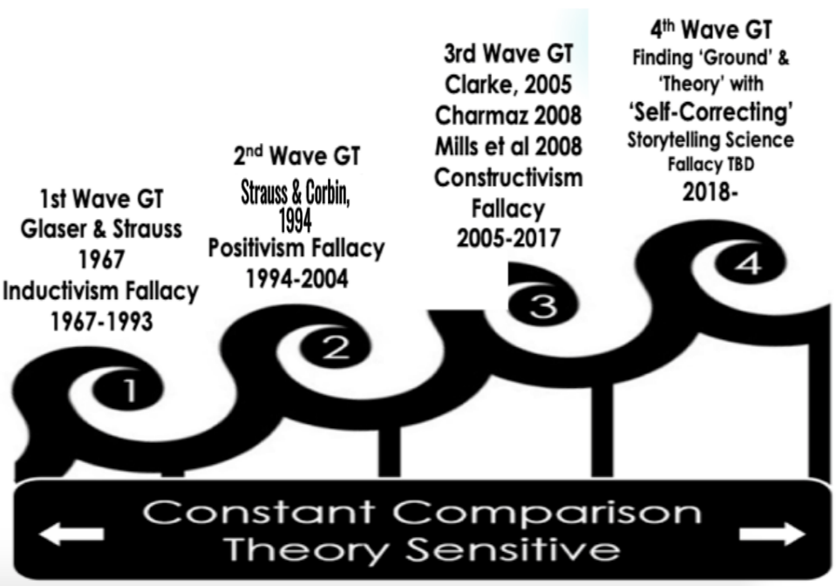

A theory is not just any story used to make predictions. A theory must go through the gauntlet of falsification. Peirce proposes four tests of a theory (I annotate and embellish in brackets).

1. Reflection (can you deconstruct it by autoethnographic reflexivity?)
2. Talk to others (have conversational storytelling, not just semi-structured interviewing)
3. Look at the problem from lens of other sciences
4. Do experiments (or intervenor-interventions as Savall & Zardet call them)

To continue with Frigg (2006), What does it mean that a theory may or may not be true? What does it mean for an organization theory or theorizing to represent the target system?

I am bringing the practitioners and students into an encounter with different ontologies. A scientific account is also a narrative-representation. There is the narrative of why this study is a next-step contribution to its field. There is the narrative the table, charts, graphs, and any pictures represents to the reader. There is the narrative concluding what it is that this study has done. And finally, a narrative about what comes next. A scientific narrative present an ontology conundrum. Are organizations fictional entities or concrete sociomaterial things, or processes and practices? This is the ontological puzzle facing anyone doing organizational theorizing. If the organization theorizing is an account of a selected parts, not the whole, or about a sample that is to represent the whole population, then what is being included or left out of the models presented becomes part of the ontological conundrum (see work by Swedberg).

Harold Garfinkel (1967) ***ethnomethodology*** applies here in my work with him at UCLA 1978 to 1986.

Everyday people are going through Abduction, Induction, and Deduction in everyday decisions they make day by day in their intersubjective interactions of storytelling (courtesy of Ken Long, Feb 27 2021).

I am an ontologist, and have been one for several decades. In the 1991 ASQ article on office supply corporation, its ‘storytelling organization’ had few examples of a beginning-middle-end narrative. In fact, there were few accounts in the transcripts that fit Aristotle’s or anyone else’s definition of narrative. Rather, most of it was terse-telling, a few ‘You know the story’ with the actual story left untold. And lots of etceteras, and just a nod, to let you know to fill in the blanks. Very intersubjective, these storytelling conversations.

* Boje, D. M. (1991). The storytelling organization: A study of story performance in an office-supply firm. Administrative science quarterly, 106-126. <http://business.nmsu.edu/~dboje/papers/Boje_Storytelling_ASQ_1991.pdf>

Theorizing about Disney as ‘Tamara-Land’ moved in another ontological direction (see Hitchin, 2015). I relied on Jean Francois Lyotard’s ways of deconstructing grand narratives by getting critical about Disney’s own theorizing, its universalisms, its essentialism, its marginalizations, who got a voice and who did not, etc.

# Chapter Seven: Tom Petty Theorizing with Song Lyrics

I want to discuss how sound and music, and sound of music, are part of the theorizing process.

We looked at five Tom Petty song lyrics, the rhythm and pace of the sound, to understand embodied restorying process (ERP). Retrospective-prospective sensemaking are happening in these songs in the temporalizing. Spatial interpretive work is happening from Beneath the language (we as listeners fill in the blanks with fore-conceptions, you know) to the grounding of the lyrics in the 6th sense of Beyond the five embodied senses.

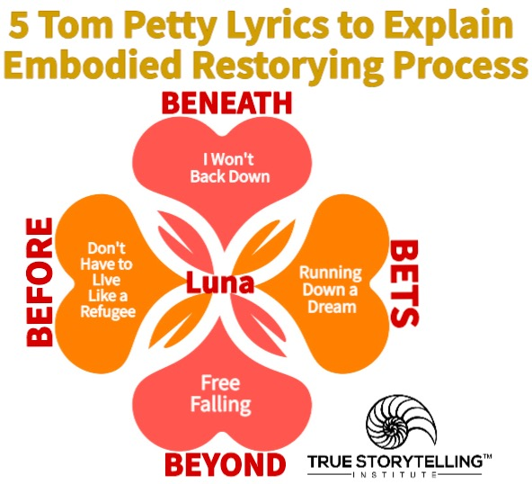

# Chapter Eight: Multifractal Theorizing in Organization Studies

Next I want to theorize about fractals and everyday multifractals that are in our everyday life. Diseny even has a song about fractals. Let it Go lyrics from movie, Frozen:

My power flurries through the air into the ground  
My soul is spiraling in frozen fractals all around  
And one thought crystallizes like an icy blast  
I’m never going back  
The past is in the past!

Let it go! Let it go!

Fractals are used to organize a theory of the Wikia:

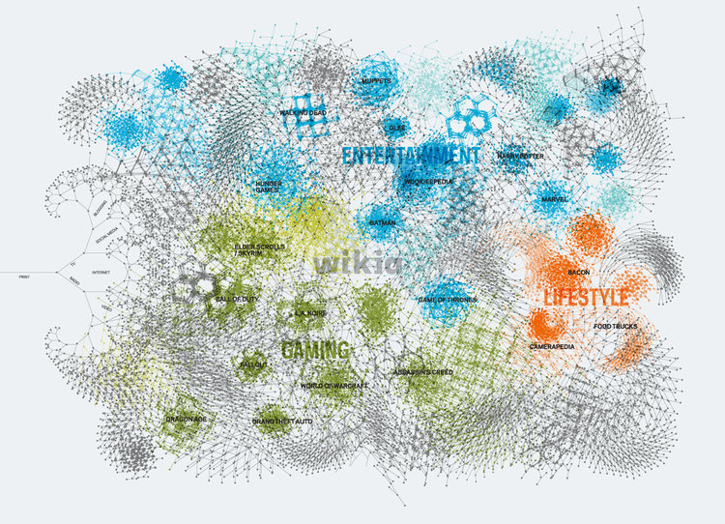

## References

Bakhtin, Mikhail. (1981). The Dialogic Imagination: Four Essays. Edited by Michael Holquist, translated by Caryl Emerson & Michael Holquist. Austin, TX: University of Texas Press.

Barley, S. (2016). 60th Anniversary Essay: Ruminations on how we became a mystery house and how we might get out. Administrative Science Quarterly, 61, 1–8.

Bergson, Henri. (1889/1910). Time and Free Will. 1889. *Trans. FL Pogson. NY: Macmillan*.

Boje, D. M. (1991). The storytelling organization: A study of story performance in an office-supply firm. Administrative science quarterly, 106-126. <http://business.nmsu.edu/~dboje/papers/Boje_Storytelling_ASQ_1991.pdf>

Boje, D. M. (1995). [Stories of the storytelling organization: A postmodern analysis of Disney as 'Tamara-land.'](http://business.nmsu.edu/~dboje/papers/DisneyTamaraland.html) Academy of Management Journal. 38 (4), 997-1035.

Boje, D. M. (2001a). [Narrative Methods for Organizational and Communication Research](http://www.amazon.com/exec/obidos/ASIN/0761965874/qid=996760152/sr=2-3/104-5347482-9721540). London Sage.

Boje, D. M. (2001b). Carnivalesque Resistance to Global Spectacle: A Critical Postmodern Theory of Public Administration. Administrative Theory & Praxis. Vol. 23 (3): 431-458.

Boje, D. M. (2001c). Global Theatrics and Capitalism. Presentation to Academy of Management Conference, Washington D.C., August.

Boje, D. M. (2001d) "Las Vegas  Spectacles: Organization Power over the Body." M@n@gement, 4(3): 201-207. Special issue on Deconstructing Las Vegas at <http://www.dmsp.dauphine.fr/management/PapersMgmt/43Boje2.html>

Boje, D. M. (2002a). Theatres of Capitalism. San Francisco, CA: Hampton Press (in process).

Boje, D. M. (2002b). Critical Dramaturgical Analysis of Enron Antenarratives and Metatheatre. July 10, 2002; July 31, 2002 version. Plenary presentation to 5th International Conference on Organizational Discourse: From Micro-Utterances to Macro-Inferences, Wednesday 24th - Friday 26th July (London).

Boje, D.M., Brass, D.J. & Pondy, L. R., (1976/1977 Eds.), *Managing II*, Ginn Publishing, 521 pages, (Managing I,1st Edition, 1976; Managing II 2nd Edition, 1977) Lexington, Mass.: Ginn Publishing.

Boje, D. M.; Brass, D. J.; Pondy, L. R. (1977). Metaphors, dancing partners, and case episodes as training exercises in the art of organizational theorizing. Pp. 12-18 in D.M. Boje, D.J. Brass & L. R. Pondy, *Managing II.* Lexington, Mass.: Ginn Publishing.

Boje, D.M. & Murningham, J.K., "Group Confidence Pressures in Interactive Decisions," Management Science, 28, 10, pp. 1187-1196, Oct. 1982. [PDF of article](https://davidboje.com/vita/paper_pdfs/Boje_MurnignhanMgtSCI.pdf)

Boje, D. M. & G. A. Rosile. (2002a). The Metatheatre Intervention Manual. To be published by ISEOR Research Institute of University of Lyon 2, France.

Boje, D. M. & G. A. Rosile. (2002b). Theatrics of SEAM. Journal of Organiztional Change Management Special Issue on Socio-Economic Approach to Management (SEAM), guest edited by Henri Saval.

Boje, D. M. & G. A. Rosile. (2020). How to do Conversational Storytelling Interviewing for your Dissertation. Cheltenham, UK: Edward Elgar Publishing Limited.

Burke, K. (1937). Attitudes toward history. Las Altos, CA: Hermes Publications.

Burke, K. (1945). A grammar of motives. Berkeley, CA: University of California Press.

Burke, K. (1972). Dramatism and development. Barre, MA: Clark University Press with Barre Publishers. Boje (1991). THE STORYTELLING ORGANIZATION: A STUDY OF STORY PERFORMANCE IN AN OFFICE-SUPPLY FIRM, Administrative Science Quarterly, Mar91, Vol. 36, Issue 1 pp. 106-126.

Czarniawska, Barbara. (2004). *Narratives in social science research*. London: Sage.

DiMaggio, Paul. J. (1995). Comments on" What theory is not". Administrative science quarterly, 40(3), 391-397. <https://citeseerx.ist.psu.edu/viewdoc/download?doi=10.1.1.1068.9272&rep=rep1&type=pdf>

Du Gay, Paul . (2015). Organization (theory) as a way of life. Journal of Cultural Economy, 8, 399–417.

Frigg, Roman. (2006). Scientific representation and the semantic view of theories. Theoria. Revista de Teoría, Historia y Fundamentos de la Ciencia, 21(1), 49-65. <http://philsci-archive.pitt.edu/2926/1/Scientific_Representation.pdf>

Hansen, Anne Vorre; Madsen, Sabine. (2019) ***Theorizing in Organization Studies: Insights for Key Thinkers***(Elgar). Based on interviews with David Boje, Barbara Czarniawska, Kenneth Gergen, Tor Hernes, Geertz Hofstede, Henri Mintzberg, Edgar Schein, Andrew Van de Ven, and Karl Weick. Cheltenham, UK: Edward Elgar Publishing Limited.

Haraway, Donna. J. (2016). *Staying with the trouble: Making kin in the Chthulucene*. Duke University Press.

Hitchin, Linda. (2015). Method and story fragments: Working through untold method. Pp. 213-238 in Izak, M., Hitchin, L., & Anderson, D. (Eds.). (2014). *Untold stories in organizations*. London” Routledge.

Heidegger, Martin. (1931-1932/2008). On the essence of truth.  Lecture in German delivered at Freiburg 1931-1932, I am quoting from 1943 English translation by John Sallis, in its 4th edition, 1961, accessed online January 8 2021 at <https://aphelis.net/wp-content/uploads/2011/02/Martin-Heidegger-On-the-Essence-of-Truth.pdf> You can consult 243-260 in José Medina & David Wood (Eds., 2nd edition 2008; 1st 2005) *Truth: Engagements across philosophical traditions*, Wiley. See discussion blog <https://cambridgeforecast.wordpress.com/2008/12/page/4/>

Heidegger, Martin. (1950/1951/1968). What is called thinking? Translated by J. Glenn Gray(with introduction).German 1950/1951 21 lectures. Published in English 1968 NY: Harper & Row.

Kaplan, Abraham. (1973). The Conduct of Inquiry: Methodology for Behavioral Science. Beverly Hills, CA: Alysebury.

Kirkeby, Ole. F. (2009). *The New Protreptic: The Concept and the Art*. Copenhagen Business School Press DK.

Kornberger, M., & Mantere, S. (2020). Thought experiments and philosophy in organizational research. *Organization Theory*, *1*(3), 2631787720942524.

Larsen, Jens; Boje, D. M.; Bruun, Lena.(2021). True Storytelling: Seven Principles for an Ethical and Sustainable Change-Management Strategy. London: Rouledge.

Kurt Lewin (1951) Field Theory in Social Science. NY.

Lundholt, M. W., & Boje, D. M. (2018). Understanding organizational narrative-counter-narratives dynamics: An overview of Communication Constitutes Organization (CCO) and Storytelling Organization Theory (SOT) approaches. *Communication and Language at Work*, *5*(1), 18-29.

Martin, Joanne. (1990). Deconstructing organizational taboos: The suppression of gender conflict in organizations. Organization Science, 1(4), 339-359.

Maruyama, Moagoroh. (1974). Paradigms and communication. *Technological Forecasting and Social Change*, *6*, 3-32.

Maruyama, Morgoroh. (1963). The second cybernetics: Deviation-amplifying mutual causal processes. *American scientist*, *51*(2), 164-179.

Middleton, Stuart. (2009). Reputation management in the Salvation Army: A narrative study. Journal of Management Inquiry, 18(2), 145-157. <https://www.mv.helsinki.fi/home/aula/Top20/middleton-reputation.pdf>

Pentland, B. T., Mahringer, C. A., Dittrich, K., Feldman, M. S., & Wolf, J. R. (2020). Process Multiplicity and Process Dynamics: Weaving the Space of Possible Paths. *Organization Theory*, *1*(3), 2631787720963138.

Pondy, L.R. & Boje, D.M. (1980.)"Bringing Mind Back In: Paradigm Development as a Frontier Problem in Organizational Theory." Pp. 83-101, in William Evan (ed.) ***Frontiers in Organization & Management***, NY: Praeger Publishers.

Ritzer, George. (1975). "Sociology: A multiple paradigm science." ***The American Sociologist****. pp.* 156-167.

Ricoeur, P. (1984). Time and Narrative, Volume I. Translated by K. McLaughlin and D. Pellauer, Chicago, IL: The University of Chicago Press.

Rosile, Grace Ann. (2016). Tribal Wisdom for Business Ethics. Bingley, UK: Emerald Group Publishing Limited.

Sutton, Robert. I., & Staw, Barry. M. (1995). What theory is not. *Administrative science quarterly*, 371-384.

Trafimow, David. (2012). The role of mechanisms, integration, and unification in science and psychology. *Theory & Psychology*, *22*(5), 697-703. On research gate: <https://www.researchgate.net/profile/David-Trafimow/publication/258190105_The_role_of_mechanisms_integration_and_unification_in_science_and_psychology/links/5918c7f6a6fdcc963e869e30/The-role-of-mechanisms-integration-and-unification-in-science-and-psychology.pdf>

Weick, Karl E. (1995a). *Sensemaking in organizations*. Thousand Oaks, CA: Sage.

Weick, Karl E. (1995b). What theory is not, theorizing is. *Administrative science quarterly*, *40*(3), 385-390.

Weick, Karl E. (2012). Organized sensemaking: A commentary on processes of interpretive work. *Human Relations*, *65*(1), 141-153. <http://ideanetworking.com.au/docs/sensemaking/Human_Relations-2012-Weick-141-53.pdf>

1. Hans Moller illustration accessed Mar 8 2021 at <https://linkiya.wordpress.com/2015/07/13/the-six-blind-men-and-the-elephant-differing-perspectives-on-grades/>