How Can True Storytelling Help End Systemic Racism?
A Plot Deconstruction and Re-Construction of Nickerson Gardens Public Housing
By David M. Boje, co-founder TRUE STORYTELLING INSTITUTE (© TSI)
https://true-storytelling.com
September 12, 2020

Summary: In this essay I illustrate how True Storytelling Principles (© TSI) can be conversational tools to deconstruct systemic racism and provide possibilities to re-construct systemic outcomes. As a systems thinker, I have learned one thing: Systems are perfectly designed to produce the results they are getting. By taking a systems approach to True Storytelling, we tat TSI facilitate global and local conversations using Zoom to intervene to produce different outcomes. The purpose here is to give you some of the underlying systems storytelling thinking beneath the True Storytelling Principles used in the module David M. Boje and Oscar Edwards, co-facilitated in four 90 minutes sessions, August and September 2020.

The True Storytelling Principles are rooted in the ethics of answerability, which is the topic of the Foundational Module, and is a prerequisite to understanding the thinking behind the module Oscar Edwards and I, co-hosted: Intercultural Conversations: A Community-Centered Storytelling Experience to Restory Narratives on Racism. I will present the principles and then illustrate them with a case, and a couple of storyboards.

True Storytelling Principles (copyright TSI)
        - Truth: You yourself must be true and prepare the energy and effort for a sustainable future
        - Make room: True storytelling makes spaces respecting the stories already there
        - Plot: You must create stories with a clear plot creating direction and help people prioritize
        - Timing: You must have timing
        - Help stories along: You must be able to help stories on their way and be open to experiment
        - Staging: You must consider staging including scenography and artifacts
        - Reflection: You must reflect on the stories and how they create value

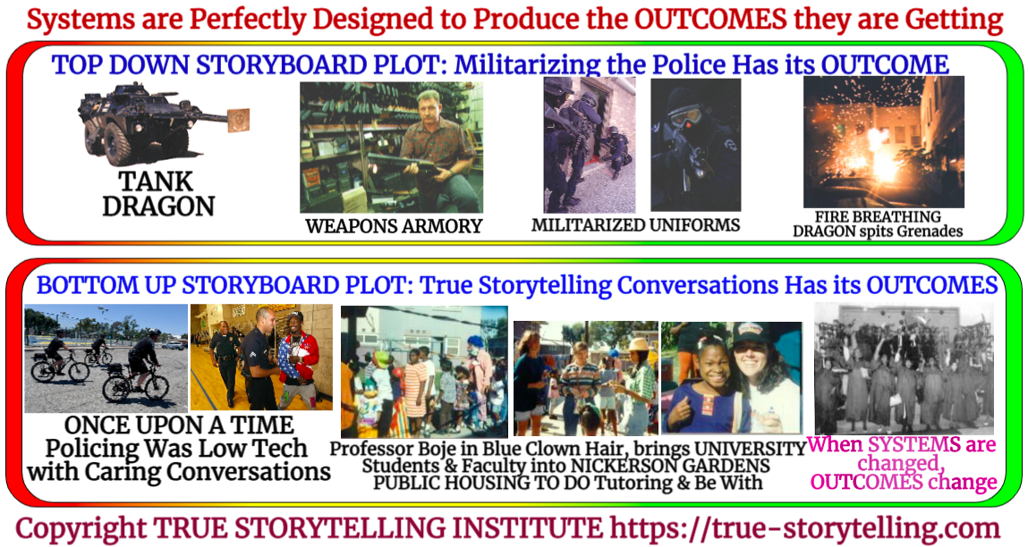
Figure 1: Two Storyboards of the Design Principle: Systems Are Perfectly Designed to Get the Outcomes they are Getting (Storyboards by D. M. Boje, Sep 12, 2020

The Events of the Story. I received a call from Mrs. Nora King, of Nickerson Gardens in 1998 (see Nickerson Gardens Chronology, 2020). She asked me to do something about a May 1997 Popular Mechanics magazine article that portrayed Nickerson Gardens Public Housing in South Central Los Angeles (the City of Angels) in a very disempowering way. I composed a Top-Down storyboard using the Popular Mechanics photos, and presented a second Bottom-Up storyboard, then published it in a journal article (Boje, 2000, EJROT). The storyboard I present is based on that article, with some updates. The deconstruction I will do is based on my (Boje, 2001) work on how to deconstruct, and then re-construct a plot, and on Larsen, Boje, & Bruun (20200) book, particularly, the third principle of True Storytelling: “You must create stories with a clear plot creating direction and help people prioritize.” A plot that prioritizes the police using militarized weapons to crash though the doors of residences, and practices of tossing in grenades, leaves out the counterplot, who is living behind those doors: mothers and their children. First I present the short story outline of deconstruction method, then the underlying story of deconstruction so you can see the roots, branches and leaves, and truck on it.

Short Story Summary: How the Deconstruction & Re-Construction is Worked Out in the Storyboarding?

Dualities of Top-Down Systemic Racism SWOT team against the Residents, and the Police on Bicycles in the Bottom Up Storyboard set out the dualities.

Reversal of Hierarchy of Dualities? Resident-Mothers running food bank, tutoring kids, and jobs & economic development.

How did you hear Rebel Voice, their Untold Story? Nor King called and said, David please tell our side of the story

What is the Other Side of the Story? There is the story of a police state, and the story of residents living in the police state. Many untold stories get left out of a dominant plot that divides and conquers a community in order to effect a particular outcome.

Deny the Dominant Plot with Counterplots. What Counterplots are already there? Community police on bicycles instead of tanks.

Find Your ACORNS, LITTLE WOW MOMENTS when you created a different outcome?
  - ACORN 1: Dressed as clown and trick or treated door to door in Nickerson Gardens
  - ACORN 2: City Attorney kept saying he never said that, we taped our next meeting
  - ACORN 3: Held hands of Nora & Pam at the community meeting to bring Love to the conflict

What is Between the Lines of Systemic Racism? A story of separation and the untold counter story is a story of whole system relationships and the power of engaging in conversational storytelling events.

IN ONE SENTENCE: Take steps 1 to 7, and RESITUATE YOUR ACORNS to Grow a New Plot, a new Bet on the Future. The new story of my ACORN Little Wow Moments brings me to this BET ON THE FUTURE Overcome the plot of separation, but brining parties together for together-telling conversations, listening to one another’s deep story (Boje & Rosile, 2020).

THE BIG STORY: How to Deconstruct a Plot, and Re-Construct A New Plot?
All seven True Storytelling Principles are in play in Figure 1, in visually, and narratively juxtapositioning contrasts between the two storyboards. For True Storytelling’s How to do Storyboarding, please see (Rosile, 2020 handout).

Next, we can use the eight steps of deconstructing a plot, in order to re-plot, and re-construct so that system change in systemic racism can become possible. A plot is defined as a few events, a few characters (characterized) to represent the whole system. A plot is a few events, not all the events. A plot is a few characters, not all the characters. A plot is some dialogue characters speak at a few events. A plot is not the entire chronology, not the entire history of the whole systemic dynamics. To deconstruct is done to get to the re-construction. It is a method of analysis to get to the changes.

8 Steps in Deconstruction (Boje, 2001)

- Dualities
- Reversal Hierarchy of Dualities
- Hearing the Rebel Voice Untold Story
- What is Other Side of the Story
- Deny the Dominant Plot with Counterplots
- Find Your ACORNS, LITTLE WOW MOMENTS
- What is Between the Lines
- Take steps 1 to 7, and RESITUATE YOUR ACORNS to Grow a New Plot, a new Bet on the Future

- Dualities There are many dualities in the Top-Down Storyboard (Figure 1). The militarizing of policing technologies and practices, even the uniforms are militarized. One term (militarizing) invites the absent referent term (non-militarized) policing tools, technologies, uniforms, practices. Tank, weapons armory, riot gear, the concussion and other grenades tossed into the doors of the two-floor homes invite presentment of the absent referents to be presented in the Bottom-Up Storyboard. Bottom-up, there are families, mostly mother-led households with children. 3000 of the 5000 residents are children. Do you really want to use a tank with a battering ram to bust down doors and toss in concussion grenades with children. Would such policing tactics occur in the suburbs? At Nickerson Gardens Public Housing, there is the 'the wall' of names is sacred ground inscribed on the wall of the community center (Santa Cruz & Malcon, 2015, LA Times).

- Reverse Hierarchy of the Dualities Instead of a Top-Down look, present a Bottom-Up look at the exact same community. Instead of fear of the other, present Being-With the other. Instead of fear, present love and caring. Black and White are dualities, that leave out the ways racializing one group to be against another racialized group sets up a pecking order (a hierarchy of peoples). The truth be told, there is only one race, the human race, and the racial stuff is done by rhetoric, by stories that characterize. To put the black on top, in the role of self-empowerment, is to reverse the received narrative pecking order of systemic racism. Doing the reversal helps you see the way things are constructed in the dominant culture’s narrative, so that it becomes possible to see the situation upside-down, and notice things the plot leaves out.

- Hearing the Rebel Voice Untold Story The untold story is important work done by Linda Hitchin (2014), and in her book (Izak, Hitchin, & Anderson, 2014). An untold story is one that is already there (as in Principle 2: Making Room - True storytelling makes spaces respecting the stories already there). The two storyboards hear the rebel voice of the untold stories that are already there, but not told in the mainstream media outlets, untold in the Popular Mechanics magazine article.

- What is the Other Side of the Story? When Nora King called me, she knew I knew the other side of the story. As soon as I read the Popular Mechanics magazine article, I knew the writers and magazine editors had left the other side of the story of Nickerson Gardens on the cutting room floor. So many times systems take up one side of the story, and leave out the other side, and the many other sides of the story. I had participated in co-creating the other side of the story. I know many mothers of the community who kept the kids out of gangs, and in school, and attended their college graduation. I also knew police had pulled me over and asked, “Do you know where you are. This is Watts, you don’t belong here!” I would replied, “Yes, I do belong, I volunteer here. I am protected by the mothers of the community.” I had jogged in the community on the 160 acres of land, and people knew me, there. I had a place to belong.

- Deny the Dominant Plot with Counterplots As we discussed above, the top-down plot is in the top storyboard, and the bottom-up emplotment in the one beneath. I am setting out visually the dualities, rebalancing the storytelling. In the top emplotment, all police are bad guys, doing racializing work of the empire force. In the bottom-up storyboard, I met, and know personally, as does Oscar, police that grew up in Nickerson Gardens, and as community policing became a thing, rode bicycles through the ‘Gardens’ and knew residents on a first name basis. These were low-tech police, and got to know residents in the community center, and low-tech policing meant actually having one-on-one story listening and storytelling conversations with the ‘Other.” When we deny the one-plot by introducing counterplots, we are able to open up the space of new possibilities, and new constructions, as we deconstruct.

- Find Your ACORNS, LITTLE WOW MOMENTS Acorns are opportune moments on ones past, where something different happened than the usual systemic outcome. They are moments when an ethics of answerability manifested. One became a system change agent instead of system victim. Principle 3: Timing – You must have timing. Little Wow Moments of opportune timing are memories, often in untold stories of acts of self-empowerment. No one empowers another person. Empowering someone else, is to confuse it with delegating a task to someone else. In an article Grace Ann Rosile and I (Boje & Rosile, 2001) wrote we asked the question, Where is the Power in Empowerment? It is those ACORN gathering moments of building one’s own power. It is the difference between what Mary Parker Follett, the pioneer of systems theory who compared Power-Over with an alternative called Power-With. The top storyboard in Figure 1 is Power-Over, the bottom storyboard is Power-With. By recalling the ACORN moments of self-empowerment we unleash memories of when we did power-with. This is part of the Restorying work of True Storytelling that I will explain below. For now here are three Acorns I gathered:
  - ACORN 1: Dressed as clown and trick or treated door to door in Nickerson Gardens (see Figure 1).
  - ACORN 2: City Attorney kept saying he never said that, we taped our next meeting. Then he agreed to do the Dual Management job training, if and only if Loyola Marymount University faculty were involved, and it did not cost the City of Los Angeles, any money.
  - ACORN 3: Held hand of Nora & Pam at the community meeting to bring Love to the conflict. In the Bottom-Up Storyboard, in last photo, is Pam Griffin, who became the elected successor to Nora King. I don’t have a photo, but I recall the current and former President of Resident Management Corporation, insulting one another in front of hundreds of residents, on bleachers, who were cheering them on. I grasped each by the hand, and said ‘You both can decide to do what is best of the Gardens, and I will continue to work with you both.” It was an opportune moment, when I, who knew them both, to intervene. The crowded gave thunderous applause, and I kept my promise. For me, this was a small gesture, at an opportune time that changed the outcome of a system in conflict.

- What is Between-the-Lines? Since US wars in the Middle East, the trend in policing has been to militarize. This has been happening in three ways. First, most police are recruited after serving in the military. An armed force using military weapons to overpower an enemy force makes perfect sense to veterans. Second, as wars wind down, the military us a lot of excess equipment to donate to the police. The industries making military equipment and armaments seek to remain in business. So as wars wind down, they seek new markets. In this case its police forces. There are other things between-the-lines, such as how militarizing the police increases casualties, demonizes the others, and isolates public housing, ghettoizing the community, cutting them off from the encompassing metropolitan area, Los Angeles.

- Resituate Your Acorns To Grow A New Plot This is a very important step that many don’t know is part of deconstruction. We have an ethical answerability to re-construct what we deconstruct. In the second session we used the metaphor of an Oak Tree that grows from Acorns. The roots are thoughts, the truck is the institutions, and the leaves are the behaviors. To change the behaviors of the Tree-System, change what you feed the roots. Water the Tree with Love and Care. We do the first seven steps of deconstruction so we can see what we need to see about the construction, in order to re-construct to be what we can be in the underling system. Help me see what I need to see to be what I can be, for the best of me, and the best outcome of all concerned. To deconstruct without a resituating re-construction is not helpful, caring, or loving way to do system change. That systemic racism is perfectly designed to get the outcomes it is getting for hundreds of years. The system is the problem. People are just acting out their assigned roles in the system. We are all playing our parts on the stage (as Shakespeare put it). In this case actors act in the plots of systemic racism. To change the system, water the Acorn Tree with thoughts of love and caring, get folks to put the community ahead of them selves. Show the other way to do the policing. No matter what, keep doing conversational storytelling with one another so we become diversity in unity, and see we are part of the whole system, complicit in its outcomes.

Some background on the True Storytelling Drama Cycle will be helpful in our deconstruction of systemic racism. It is a precursor to understanding how and why the restorying spiral tool works in the seminar exercises.

In 1968, Stephen Karpman, a member of the Screen Actors Guild, chose "drama triangle" rather than "conflict triangle" to understand the ‘game of life.’ He developed the Karpamn Drama Triangle in an analysis of the fairytales of Little Red Riding Hood, Cinderella, and the Pied Piper. People have three roles: Victim, Persecutor, & Rescuer. And people switch roles in the ‘game of life.’ People take on the ‘victim role ‘in the ‘game of life’ while others become the ‘persecutor role’ and others the ‘enablers.’ For example, in Little Red Riding Hood, the heroine begins the story as Rescuer (brining food & company to grandma). She switches roles to become the Victim to the wolf-Persecutor, who in trun, in turn falls Victim to the Woodsman-Persecutor, who is also playing the Rescuer of Little Red Ridding Hood, and Grandma. Little Red Riding Hood sews stones in the Wolf’s belly with the Woodsman (the end). Little Red Riding Hood is actually playing all three roles. Grandma also switches between roles, as does the Wolf and Woodsman.

I have represented the Victim-Persecutor-Rescuer as a cycle, rather than a triangle, to emphasize how you can move in clockwise or counterclockwise cycles. To take the example of the militarized police baching down doors with tank vehicles at Nickerson Gardens: The Police start out as Rescuer of the community and all of Los Angeles in the Top-Down Storyboard (Figure 1), The Police transform with their military hardware into the Persecutor of women and children, battering the door down (in Bottom-Up Storyboard). And Police being militarized into war tactics become the victim of a military-industrial complex (as President Eisenhower called it), playing their part in the armament political economy.

The role switching comes from my understanding of Tamara-Land (Boje, 1995), how in John Kriznac’s (1989) play, the people storytelling in one room, switch roles (aristocrat in love with the maid becomes spy getting information from her). Each character in the play called ‘Tamara” is switching from Victim-Persecutor-Rescuer roles (Kriznac & Boje, 2013). The heroine is the soft cubism Polish painter, Tamara Lempicka who visits her lover, the Italian aristorat, a prominent Polish lawyer, Tadeusz Lempicki.

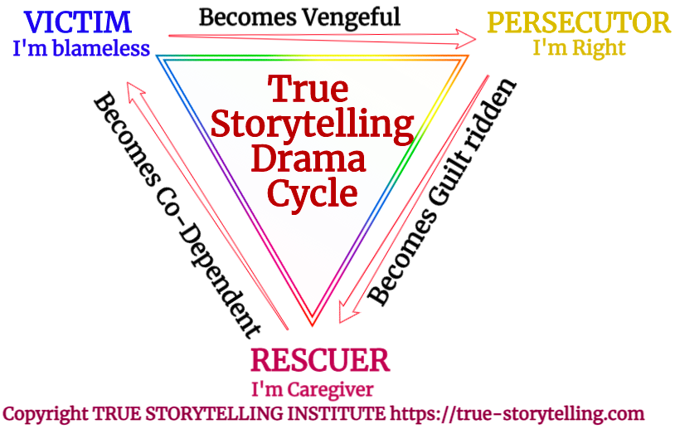
Figure 2: The True Storytelling Drama Cycle TRUE STORYTELLING INSTITUTE (© TSI)

What is possible (thanks to Charles Conatser) for the insight is one can reverse the cycle, and set some boundaries. The Victim and stop being a victim through acts of self-empowerment, and become assertive without enacting the aggression of the Perpetrator. The Perpetrator can lose the aggression, stop the ‘I’m Right, You’re Wrong’ blame game, and begin to see the outcomes inflicted by the ‘Game of Life’ of Perpetrator onto Victim. As they see themselves a Victim of systemic racism, for example, there is a possible transformation to Police-as-Caregiver (to Protect and to Serve, not in role of the System, but as human to human).
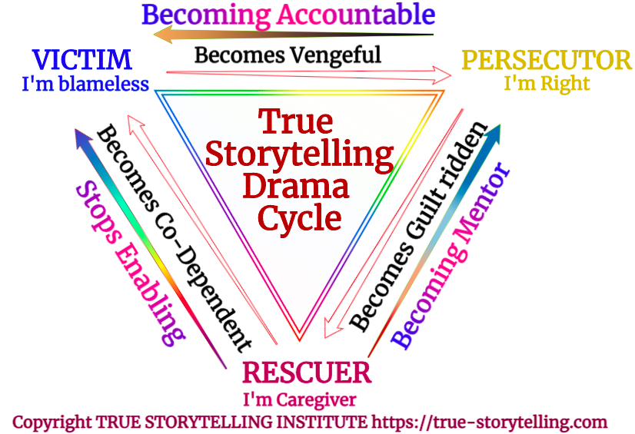
Figure 3 – Reversing the Cycle of Victim-Persecutor-Rescuer TRUE STORYTELLING INSTITUTE (© TSI)

In the above figure, the arrows between role switching go both ways. Clockwise is the positive loop of deviation amplification as systemic racism tips out of control. In the counterclockwise direction, a negative deviation-counteracting loop of self-correcting improvements to the system of institutions that are entangled work out boundaries. When the Rescuer stops being an enabler, they can play a new role, of Protect and Serve, a community policing role, as part of the community, rather than seeing the community as the Other. When the Persecutor sets boundaries on their thoughts and actions, they can become accountable, what Bakhtin (1993) call the moral ethics of answerability, to be the One Person In the Event of Being-There, in the Situation, who can Act to Intervene in the System Racism Cycle, and reverse it. To transform a cycle into a spiral, one only has to change the role enactment, and playing a different role than the system dictates, brings a cycle into a spiral, hopefully an upward spiral, rather than the current downward one.

Reversing the Cycle of Systemic Racism Requires a Restorying Spiral

In the seminar 3 of the Intercultural Module to Deconstruct Racism, you learned the basics of Restorying. The next part of the essay connects deconstruction to the restorying spiral tool. We have already looked at little wow moments. And in the handout by Grace Ann Rosile (2020). Please review that handout before going any further.

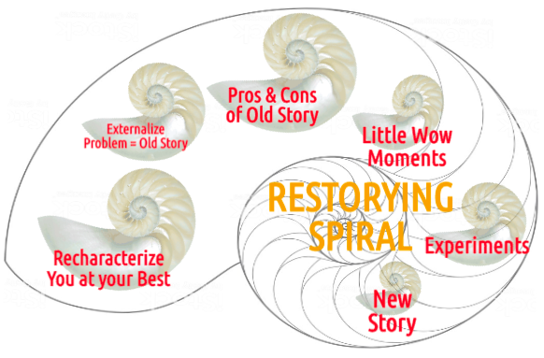
Figure 4:The Restorying Spiral Tool - TRUE STORYTELLING INSTITUTE (© TSI)

How to Use the Restorying Spiral Tool

- RECHARACTERIZE: Tell one time when you noticed you yourself were the problem & ACTED AT YOUR BEST for GOOD OF ALL.
- EXTERNALIZE A PROBLEM/CHALLENGE: Give problem a label, so problem is the ‘old story’ not you the person. E.g. RACISM DRAGON
- PROS & CONS of this Old Dominant Story?
- Little Wow Moments of exception when you bested the problem.
- EXPERIMENTS that can make Little Wow Moments into your ‘New Story’ for the future.
- What is your ‘New Story’ for the future in one sentence? Who in your network can you enlist to support your new story?

Let’s unpack these steps and provide some underpinning. It is rooted in the work of White and Epston (1990). We are headed to Principle 7: Reflection: You must reflect on the stories and how they create value.
Over the years, we have revised their text-based approach, which is quite excellent, and developed what we called an embodied approach (Flora, Boje, Rosile, & Hacker, 2016) as a way to treat post traumatic stress disorder (PTSD) of military families. We treat the family system, not the individual in isolation of the family. In embodied restorying, the system is the problem, and a traumatic stress experienced by, for example, a veteran returning from combat deployment, becomes the systemic stress of all the family members. In other words the family system embodies the stress and trauma, and treating just the one person does not change the family system. The veteran, for example, returns to the family system, who expects the system to continue as usual, and everyone to play their assigned roles: victims, perpetrator, enablers. In the Top-Down storyboard (Figure 1) everyone is stressed out and the entire systemic is traumatized. In the Bottom-Up storyboard, the system is being de-stressed
Recharacterize. This is the First Acorn to gather. Recall a little wow moment when you created a different outcome than racism ________
Externalize by Naming the Problem of Racism as a character named _____? In problem-saturated storytelling blame, judge, and vengence game of life, it helps to externalize, by making the problem monster, a character in the story. It helps get out of the Victim-Persecutor-Rescuer roles, to depersonalize, and see the system itself. This way we begin to change the game itself.
What are benefits of systemic racism?_______ _______ ________ List several benefits. Why? Because the system has benefits to those in power, benefits to the rescuers, and benefits even to the victims, such as, playing innocent of everything, playing dependent on others to act, rather than organizing in self-empowerment. One benefit to the power holders is in systemic racism, those at the bottom of the heap, do the work those at the top don’t do.
What are the costs of systemic racism? _______ _______ _______ There are visible costs (we see the injuries, death, and violence on film). There are also hidden costs. For example, the Congress allocates $6 billion to a war for the armaments, but what about the health care costs to care for the returning veterans who have long term care needs that far exceed the initial budget allocations. It costs a lot of money to militarize a police force and to have 1.2 million people of color in jails and prisons.
After gathering at least three ACORN Little Wow Moments from your life history, then you can create a NEW STORY.
Gather your 3 ACORNS into one Sentence. My NEW STORY is ______________________________________________________________________________________________?
This sets the direction the new plot for your own life. It is a new future, one that is unstock from the roles played in the past. It will take a support group, an entire family system supports the new story of each person in the family, to create and enact a new future.
A Breakout Exercise in Embodied Restorying

- ACORN 1: A little wow moment when you created a different outcome than racism ________?
- Externalize by Naming the Problem of Racism as a character named _____?
- What are benefits of systemic racism?_______ _______ ________
- What are the costs of systemic racism? _______ _______ _______
- ACORN 2: A little wow moment when you created a different outcome than racism ________?
- One more – ACORN 3: A little wow moment when you created a different outcome than racism _______?
- Gather 3 ACORNS into one Sentence. My NEW STORY is ____________?

Once you have the New Story and support system so you do not fall into the old stuck-in-the-past role, then and only then are you ready to do the Staging Storyboard.

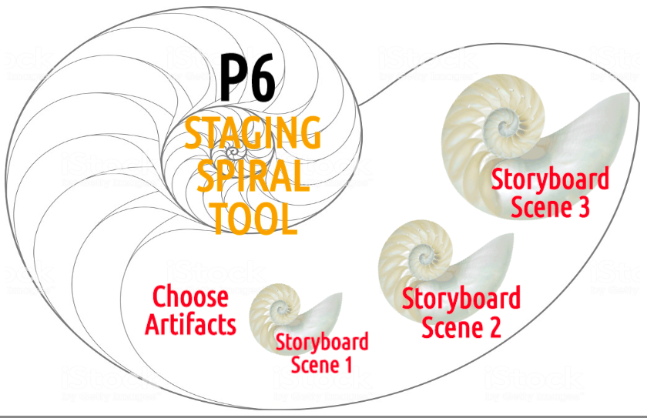
Figure 5: The True Storytelling P6 Staging Spiral Tool TRUE STORYTELLING INSTITUTE (© TSI)

You have gathered three acorns. Now gather the artifacts to do Principle 6: Staging -You must consider staging including scenography and artifacts. William James (1907) wrote about systems thinking, and made the point, ‘things tell a story.’ All things have vibrant matter energy (Bennett, 2010). In embodied restorying the staging is all about vibrant energy, the energy of the attractor. What artifacts can you put in your storyboard that attracts the understanding and involvement of your audience? Put things in the storyboard your readers will relate to.
The ABCs of Staging a Storyboard or Sandtray
Accuracy – Be accurate in the storytelling, and so it is True.
Brevity – Be brief in your material artifacts and narrations
Clear – Make it a clear, easily understandable plot (see Figure 1).
When we do in same place, sessions instead of Zoom, we use sandtrays, and do what Anete Strand (2012) calls ‘material storytelling.’ Each artifact has vibrant energy in its quantum field. We ask people to sense the vibrant energy before putting it into the Staging of the sandtray. On Zoom, we invite people to sense the energy of the things depicted, to imagine holding them, to feel the energy. And to do the energy sensing before they have thought out the story. In this way the little wow moments are energy bursts, coming out of the past, as untold stories, to become part of the New Story, and change the Game of Life.

References

Bennett, Jane. (2010). Vibrant matter: A political ecology of things. Duke University Press.

Boje, D. M. (1995). Stories of the storytelling organization: A postmodern analysis of Disney as “Tamara-Land”. Academy of Management journal, 38(4), 997-1035.

Boje, D. M. (2000). "Postmodern Détournement Analysis of the
Popular Mechanics Spectacle using Stories and Photos of the Festive Community Life of Nickerson Gardens. "Electronic Journal of Radical Organization Theory Vol VI (1), see online version, https://web.nmsu.edu/~dboje/pmdecon9705.htm

Boje, D. M. (2001). Narrative methods for organizational & communication research. Thousand Oaks, CA: Sage.

Boje, D. M., & Rosile, G. A. (2001). Where’s the power in empowerment? Answers from Follett and Clegg. The Journal of Applied Behavioral Science, 37(1), 90-117.

Boje, D. M. & Rosile, Grace Ann. (2020). Doing 'storytelling science' for Your Dissertation. NY: Edwin Elgar Press.

Flora, J., Boje, D., Rosile, G. A., & Hacker, K. (2016). A theoretical and applied review of embodied restorying for post-deployment family reintegration. Journal of Veterans Studies, 1(1), 129-162. Accessed Sep 12 2020 at https://pdfs.semanticscholar.org/cf83/1c88ec40a66c552ca2159044477f95c063aa.pdf

Hitchin, L. (2014). Fabricating Methods: Untold connections in story net work. Tamara Journal for Critical Organization Inquiry, 12(1), 59-73. Prepress copy accessed Sep 12 2020 at http://eprints.lincoln.ac.uk/id/eprint/13606/2/Fabricating%20methods%20-%20Tamara%20Paper%20Linda%20Hitchin%20final%20draft.pdf

Izak, M., Hitchin, L., & Anderson, D. (Eds.). (2014). Untold stories in organizations. London: Routledge.

Karpman, Steven. (1968). Fairy tales and script drama analysis. Transactional analysis bulletin, 7(26), 39-43. Accessed Sep 12 2020 at https://www.karpmandramatriangle.com/pdf/DramaTriangle.pdf

Krizanc, J. (1989). Tamara: a play. London: Methuen Drama. Chicago

Krizanc, J., & Boje, D. (2013). Tamara journal interview with John Krizanc. Tamara: Journal for Critical Organization Inquiry, 5(3). Accessed Sep 12 2020 at http://tamarajournal.com/index.php/tamara/article/viewFile/265/pdf_96

Larsen, Jens; Boje, D.M; Bruun, Lena; (2020). True Storytelling: Severn Principles of an Ethical and Sustianable Change-Management Strategy. London: Routledge.

Nickerson Gardens Chronology by D. M. Boje, accessed Sep 12 2020 at https://business.nmsu.edu/~dboje/rmctimeline.HTML

Rosile, Grace Ann. (2020). HOW TO DO STORYBOARDING for RESTORYING Sep 9 2020 copyright TSI. TRUE STORYTELLING INSTITUTE (© TSI) https://true-storytelling.com September 9.

Strand, Anete M. C. (2012). Enacting the between: on dis/continuous intra-active becoming of/through an apparatus of material storytelling. Unpublished Doctoral Dissertation) Aalborg University, Denmark. Retrieved from: Books, 1 & 2. https://vbn.aau.dk/files/68299563/Anete_strand_eng_summary.pdf

White, Michael K., & Epston, David. (1990). Narrative means to therapeutic ends. WW Norton & Company.

