Principle 7 of True Storytelling

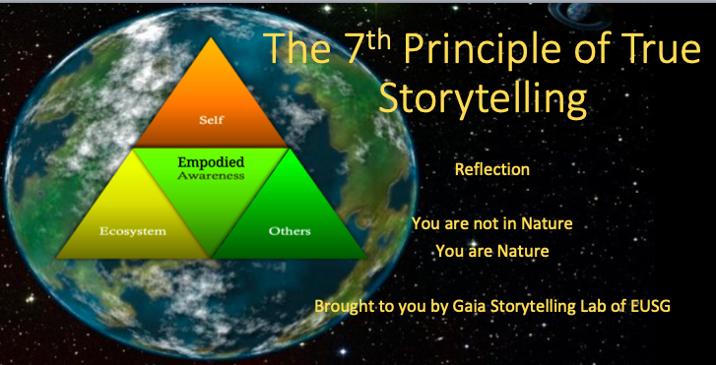

Theme for session: We are not in Nature. We are Nature!

          - Truth: You yourself must be true and prepare the energy and effort for a sustainable future
          - Make room: True storytelling makes spaces respecting the stories already there
          - Plot: You must create stories with a clear plot creating direction and help people prioritize
          - Timing: You must have timing
          - Help stories along: You must be able to help stories on their way and be open to experiment
          - Staging: You must consider staging including scenography and artifacts
          - Reflection: You must reflect on the stories and how they create value

TODAY’S PLAN for Principle 7
- 15 MINUTES for Principle 7 introduction by co-facilitators: Jens (how to work with this principle, mountain trips) & Lena (startup living story) & Julia (channeling with Gaia); Kenneth (Arendt’s contemplation-to-connect & for becoming human-Gaia-consciousness); Duncan (a-sensory realm of introspection in Monk’s chambers);
- 10 MINUTES slides David – We are already inseparable from Nature – ‘We are Gaia’ (slides)

- 20 MINUTES Break Out session – see questions below (in slide)

- 10 MINUTES Wrap Up: What effect have the 7 True Storytelling Principles had on you?

- 5 MINUTES Thanking co-facilitators and participants

  - Jens Larsen
  - Lena Bruun
  - Kenneth Mølbjerg Jørgensen
  - Julia Hayden
  - Duncan Paley
  - Anete Strand
  - David Boje and Grace Ann Rosile

- 20 MINUTES Plans for Gaia Storytelling Lab (we take break for a month; restart in June; WHAT TOPICS DO YOU WANT? Put them in CHAT.
- 5 MINUTES - Dancing

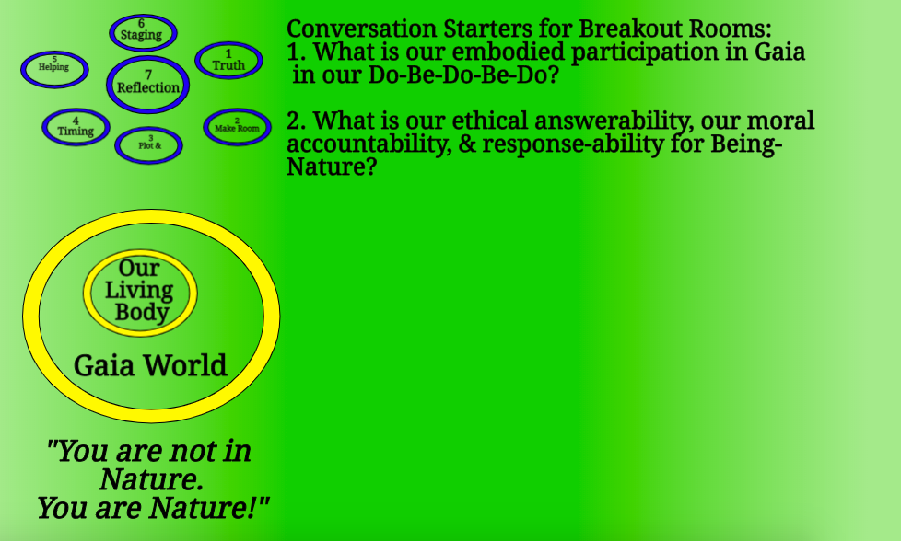

Background info for breakout exercise: How are we personally and collectively accountable, answerable, and response-able for Gaia-World? How do our choices transgress Gaia in the Do-Be-Do-Be-Do? Is our doing and Being connected? This is a relational ontology (Being) how every material thing, is also in Kaupapa Maori (Hoskins & Jones, 2017 book) already a living thing, with agency in Maori ontology. We are part of live-nature world, its balances and imbalances, its harmonies and disharmonies. This reflection goes beyond empirical separation of subject and object, and beyond the linguistic notions of social constructivism, and is all about our inseparability, in a post-humanist understanding of Gaia, in an Indigenous Way of Knowing (IWOK). See work Karen Barad (2003). Posthumanist performativity: Toward an understanding of how matter comes to matter. Signs: Journal of women in culture and society, 28(3), 801-831; and by Grace Ann Rosile (2016). Tribal wisdom for business ethics. Emerald Group Publishing Limited. More on the https:davidboje.com/shamanic website on the ways of onto-story – see https://davidboje.com/shamanic/#onto-story exercise based on Jane Bennett’s work on vibrant matter (Bennett, J. (2010). Vibrant matter: A political ecology of things. Duke University Press)).

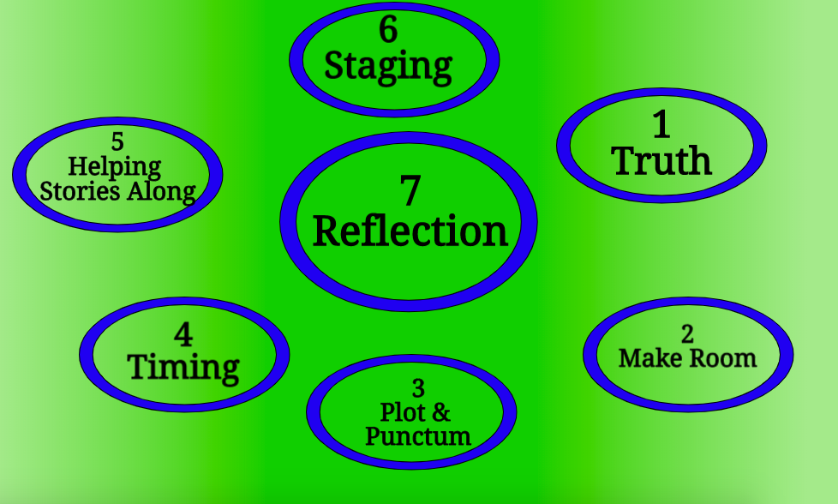

Our living body is in dynamic interconnection because we are part of Gaia. Our reflective self-consciousness is about our awareness of self, other, and ecology.

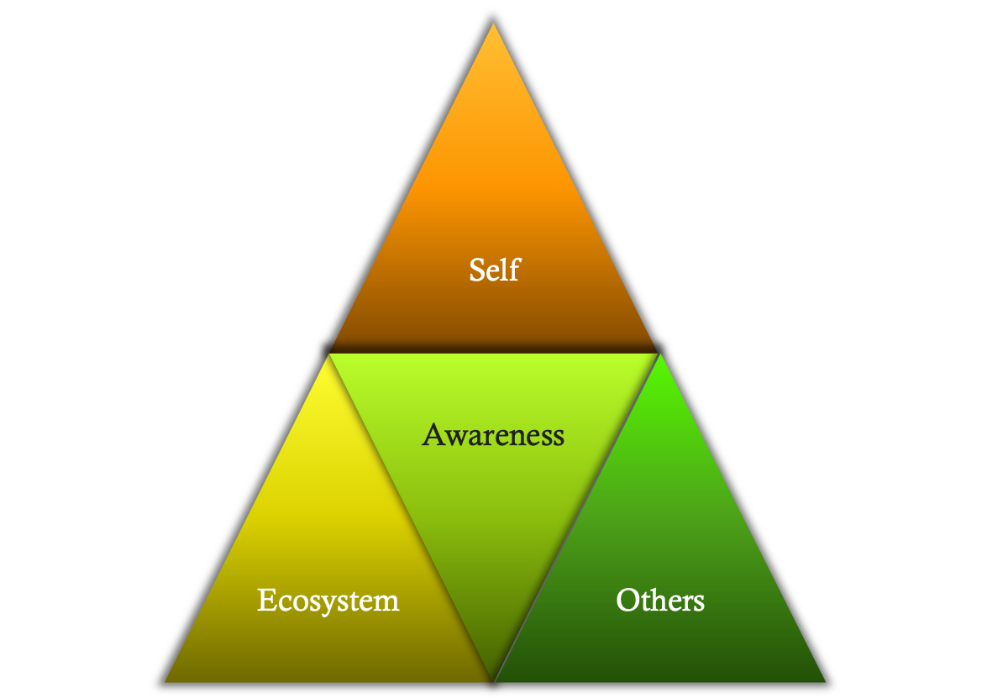
Model provided by permission of Dr. Tonya Henderson: Relational Introspection is defined as: threefold dynamic awareness of the self, others, and the ecosystem (Wakefield, 2012)

We are Self, Awareness, and Ecosystem and in relationships with Others. Here are some introduction questions about exploring ‘Reflective Consciousness’:

Self
- Do I know myself well?
- What is my intention for this situation?
- How do I feel today?
- Am I in tune with my emotions?
- What am I projecting (voice, body language,
word choice)?
- Have I set appropriate boundaries?
Others
- Who are these people around me?
- What are their limitations?
- What do they need?
- What do they expect of me?
- Are they truly present and focused on the task at hand?
- What can we accomplish together?
Situation
- What’s the context (business, social, family)?
- What’s going on around us?
- Are things changing or is the situation stable?
- Is this a healthy environment? If not, what are my choices?

We live in intersubjectivity of living embodiment, and Being Nature, transgression Nature we have ethical and moral answerability (Bakhtin, 1993, Toward a Philosophy of the Act book). We accountable for ‘Giving an Account of Our self” even if it is something unnarrativizable or unstoryable, not yet put into storytelling accounts (Judith Butler). See Judith P. Butler ‘Giving an account of oneself’ NY: Fordham University Press, 2009. We have Response-Ability for our Do-Be-Do as part of Gaia-World.

Here we draw on the work of Merleau-Ponty (Phenomenology of Perception) and his later work on Nature consciousness. His point is we are ‘Living Bodies’ in an untold story (as Hitchin, 2014) calls it of our ‘grounding in Nature’ (the point of Principle 7 of True Storytelling).

We are storytelling-bodies-on-a-ground doing our sensemaking experiences. The body-ground relationships are constitutive of our storytelling experience, by our bodily involvement in Gaia, though we may not yet be giving an account of oneself.

We nevertheless commune with Nature bodily, inhabiting Nature and Nature inhabiting us all. It is not just an intellectual (thinking) or an emotional (feeling) existence. Rather, we have layers upon layers of bodily experece:

- Our bodily chemical components of Gaia
- Our Living Boial existence in Gaia biological milieu
- Our social body in various groups
- We are an ensemble of Gaia Pathways in existence of living bodies

In short we are embodied existence in the drama of existential crises.

The body field we are already embodied in the emergence of Gaia existence, with some (limited) sense of intersubjectivity, and reflection on the living project of admitting we are Nature, part of Gaia-World, involved in the whole process of Becoming.

Merleau-Ponty’s existential writing is about transgressing, how we are crossing one another’s, each other’s boundaries, by embodiment as transgression.

- The self-consciousness has a body, and is a body, in potential of self-awareness
- Reflective self-consciousness in True Storytelling Principle 7 is about self-reflexivity on our points of contact with Gaia, and
- Our answerability, our accountability, our response-ability tour connectivity with Gaia-World, being part of Gaia

What is the story value? True Storytelling is about attunements (as we introduced last week). We are in the Do-Be-Do of embodiment, and can be reflective and giving an account, alone, and in together-telling.

Instead of mechanistic or economic understanding of futuring, and presencing, we can look to potentialities to be in balance and harming in our connectivity to Gaia.

Together-telling is full embodied initiatives, communicative praxes emerging in embodiment reflection. This relates to work by Grace Ann Rosile and colleagues on ‘Ensemble Storytelling’ and ‘Ensemble Leadership’:

Rosile, G. A.; Boje, David M.; Herder, R.; & Sanchez, M.“The Coalition of Immokalee Workers Uses Ensemble Patchwork Social Movement to Overcome Enslavement in Corporate Supply Chains.”. Business and Society: Special Issue on Modern Day Slavery.

Rosile, G. A., M Boje, D., & Claw, C. M. (2018). Ensemble leadership theory: Collectivist, relational, and heterarchical roots from indigenous contexts. Leadership, 14(3), 307-328.

In ensemble leadership, we are all leaders, and co-respensible, co-accountable.

See Boje, D. M., Larsen, J., & Brunn, L. (2017). True storytelling. How to succeed with your implementation. Working Paper. Available at: oldfriendsindustries.com or true-storytelling.com and watch for the True Storytelling book (London: Routledge).

