How 5 Tom Petty Lyrics Explains Embodied Restorying Process (ERP)

This is a Masters Level II Guides Workbook with a taste of Level III
David M. Boje, Feb 9, 2021 Revision Feb 17 2021

We begin at Level I

In this Masters Class, the 7-7-7 is introduced to Guides.
7 Principles of True Storytelling
7 Processes of Antenarrative
7 Practice steps of Embodied Restroying Process
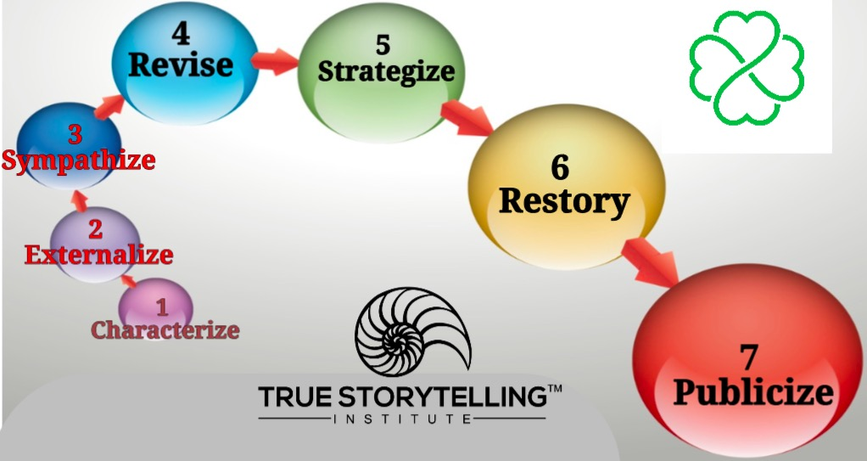

Level I presentation of 7 ERP steps are mostly just ‘metaphors’ for the participants. To go deep dive, Level II Guide practices are necessary. Here are the steps to present to participants.
- Characterize
- Externalize
- Sympathize
- Revise
- Strategize
- Restory
- Publicize
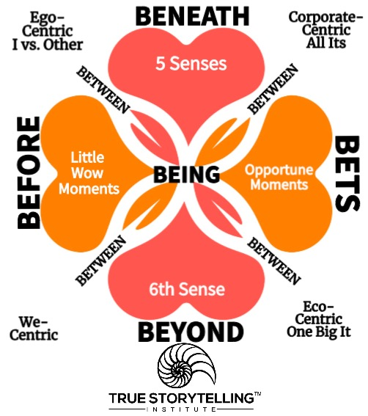
Another One
By Ron Padgett (poem written for the movie Paterson)
When you’re a child
you learn
there are three dimensions:
height, width, and depth.
Like a shoebox.
Then later you hear
there’s a fourth dimension:
time.
Hmm.
Then some say
there can be five, six, seven…
I knock off work,
have a beer
at the bar.
I look down at the glass
and feel glad.

A Restorying has three ‘Space’ dimensions, a 4th ‘Timing’,

and perhaps a 5th, 6th or more
Einstein: Time relativity → Different observers in different reference [space] frames show different times in their watches, but the laws of physics will remain the same. Movement → the faster you move in space, the slower you move in time. Welcome to spacetime inseparability. To move from Ego-centric and Corporate-centric linear (clocktime) to spacetime of We-centric and Eco-centric multiple times is what True Storytelling is all about. It is done by the double movement of time (Back to the Past uncovering ‘little wow moments’ and Back to the Future ‘opportune moments’). The tool to get this done is call ‘embodied restorying process’ and its a ‘tool’ that guides use in the end game of Principles 5, 6, and 7. It is a mattering of spacetime, a spacetimemattering inseparability.

LEVEL II: Train the Trainers
Purpose: The Three Levels of Training in 7-7-7. 7 Principles, 7 Processes of antenarrative, and 7 Practices of Embodied Restroying Process go together. We leave the land of metaphors of 7 steps behind, and journey to embodiment. We begin with an experiment in spatiality by pure consciousness.

Opening Experiment I first did this experiment as a doctoral student in Lou Pondy’s courses on systems theory, and ‘power & conflict’. It was here in 1974-1975, I wrote my first doctoral student papers on storytelling. Pondy had us read Edmund Husserl’s (1913/1962: 153 Ideas: General introduction to pure phenomenology) to get an understanding of “sense-giving” as somehow different than Karl Weick’s (1995) ‘sense-making.’ When I was hired in 1978 as assistant professor at UCLA Anderson School of Management, I landed in the phenomenology group, with several professors traveling yearly to the Husserl archives in Germany.

The Husserl experiment Close your eyes for two minutes. Let your standpoint in space/place wander in four cardinal directions of the compass, as well as up and down, into each limitless beyond, as far as you care to journey. Please do it now before reading on.

Example: As I sit in my home office, eyes closed, I imagine, the streets, and the Chihuahuan Desert on all four sides of me. I cross the street to the west, and travel the paths of Arroyo Secco Arroyo to the ephemeral pond. I head south to the bigger Alameda Arroyo. Both paths lead to a Hackberry Tree. I can go further south into Mexico, and down under to Australia and New Zealand. I can traverse north to Alaska, and East to Europe, to Denmark. I have been to these places, and know many of their spaces.

Deconstruction: Pure Phenomenology-Bracketing and Being-There are not the same Why is this important? Husserl wanted to bracket each kind of reality (1. Material Nature, 2. Animal Nature, 3. Spiritual Nature) set them on the side, and focus on Mathematical Logic. Heidegger was Husserl’s assistant, and decided to focus on ‘Being-There’ in actual encounters with the ‘Whole of Being.’ After my time at UCLA, I came to understand these different ontologies as Western Ways of Knowing (WWOK) and Indigenous Ways of Knowing (IWOK), especially after I met Grace Ann, and at age 54 when I learned the hidden stories on both sides of my family history, of Boje/Eaton (dad and mom’s sides) denying indigenous marriages, even writing the names out of the family record, and forbidding their names to be ever mentioned again. This was a turning point in restorying my life.

In the True Storytelling book (Larsen, Boje, & Bruun, 2021), and the Doing Conversational Interviewing book (Boje & Rosile 2020), both go BENEATH the Abstracting of debates over labels (language games) into BEING, and the BEYOND to ways of Grounding. Both go out of WWOK-dualisms and linear thinking logics to the deep dive into BEYOND. Ways of grounding for Husserl reduced to sense-giving logic of mathematics, to undergird science of empiricism, by bracketing out Nature-Wholeness.
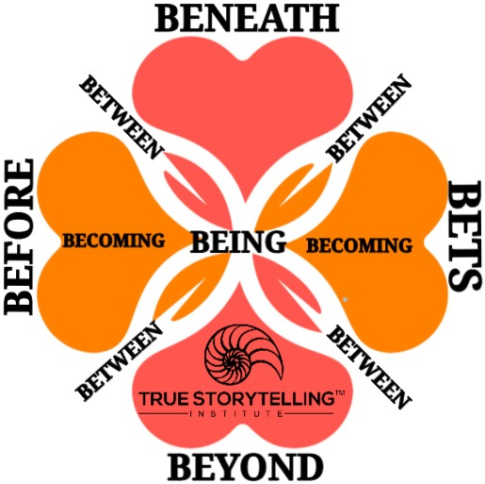
The problem with trying to debate your way through to wellness. A ‘sense-giving’ consciousness I call the BENEATH, bestows language (concepts or labels) onto Nature-World, that separate person and Nature (dualities proliferate). Subject and Object dualism. Husserl’s pure consciousness, reduces all experience to math, to the sum (additive) of this and that experience of sense-giving. Husserl flat out calls the ‘Wholeness of Nature’ as non-sense, and absurd logic. His assistant, Heidegger, parted ways and looked at encounters of ‘Being-There’, or ‘Being-in-the-World’. Heidegger began Being and Time book in 1927, and was writing in counterpoint to Husserl’s 1913 work on pure consciousness sense-giving to deduce math logic.

I use embodied restorying process (ERP) to turn around small and large businesses, stuck in the past. I also use it with military families attempting to get it back together, post-deployment. Finally, I have used it with homeless veterans, and found out many had PTSD before going into the military. This next example is from the small business course I taught for 22 years. It begins with a diagnosis of the BEFORE-Heart, and if this doom spiral is persisting, then there is a way to get to the wellness spiral, that upward spiral of solvability and potentiality (BETS-Heart) where negating all the doom, actually works. But you cannot jump there directly, or go through the debate heart of language games (BENEATH-Heart). By years of experience, I find when people are in problem-saturated BEFORE, stuck there, they hang onto it with a death grip, and won’t let go the grab a trapeze over to BETS on the future. Would be nice if they would, but the journey to Free Fallin’ into the BEYOND-Heart is a path that works, but takes a guide who knows how to let the person and organization find their own way. It is a more embodied mind-body-spirit path. You cannot do the work for them!

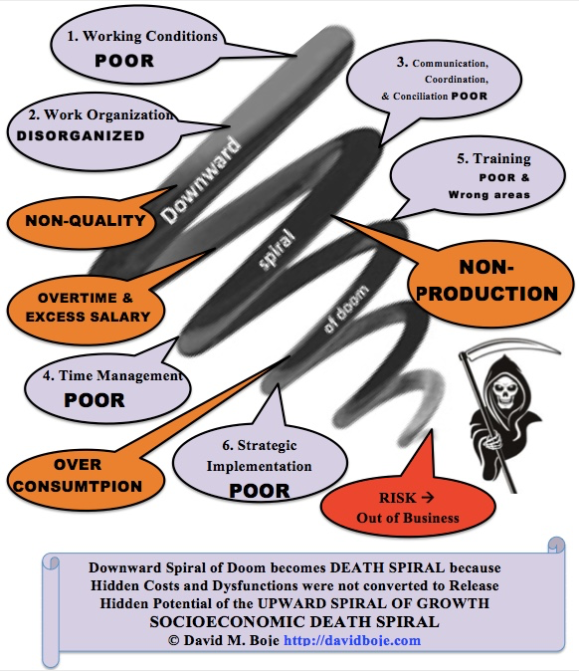
The Solution to a downward spiral of doom is not more debate, it is to take a deep-dive into the Beyond-Heart, to re-nature, re-embody, and then to head to Bets on the Future. The point of dialogisms of BEYOND (spaces of Nature) is we explore, “Making Being-Whole of Being-There accessible” by encounters with the primordial space and primordial time (Heidegger, 1927/1962: p. 205, section 240). Being-There is not the same as reduce the Being of beings to language debates and labels, to dualities of subject and object, to formal logic (math), to five sense experience reductionism and taking that to be what Husserl calls the additive of “synthetic truths” (p. 70). Husserl demands a “DISCONNEXION from Nature” (p. 155, caps, Husserl’s). I take DISCONNEXION to be the problem not the solution to ethical and sustainable change management (subtitle of True Storytelling book).

People and organizations come to us, oftentimes, stuck in past, in downward spiral of doom, in a problem saturated state. Embodied Restorying Process (ERP) is simple. People not ready to move on, cannot spot the ‘Little Wow Moments’ of their BEFORE, and directly transition into positive solutions of Bets on the Future (opportune moments).

Husserl also dualizes intuition into two different intuitions: 1) sense-giving pure consciousness of empirical/mathematical/geometrical and 2) intuition from BEYOND and above the BENEATH, Kant’s ethics of Categorical Imperative abstracting a transcendental with spacetime outside the world of humankind), what we covered in the Foundations Module of TSI. Heidegger, Bakhtin, Merleau-Ponty, Kierkegaard, Deleuze, and many others are all about intuition in its oneness, and spacetime BEING-THERE-in-the-World.

Transition & My Translation: Joanna Macy Interview YouTube August 2020: actually go into Nature, and look at the Night Sky to open our heart s to Nature, and waking up to ‘what is.’ Ecology (the IT) delivers info to scare the (Ego-centric & Corporate-centric) but the voice within Nature is covered-over (WE), and once we look at the We-World, (BEING-THERE) we begin the Free Fallin’ love into one’s ‘True Nature’ by engaging in story-listening to Nature.

Next, Tom Petty, sound-waves in space, that illustrate Principle 5: Helping Story Along, by taking the path of Free Fallin’ instead of the path of Debate of ‘I Won’t Back Down’ .

Question: How would you explain 4 Hearts of True Storytelling with 5 ‘Tom Petty and the Heart Breakers’ song lyrics?
Click for Lyrics to Journal of Veterans Affairs article before beginning
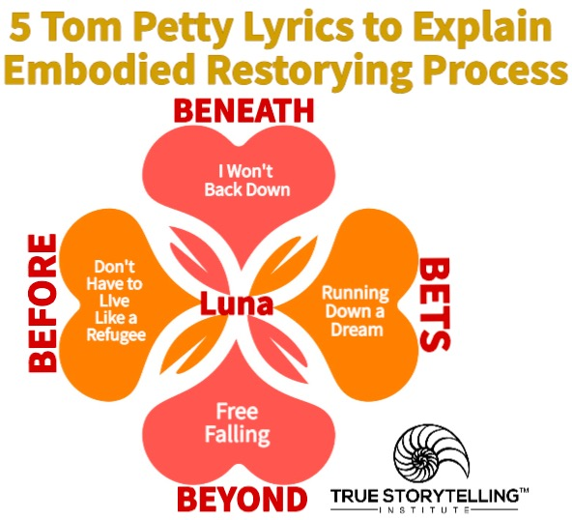
Click for Lyrics
Click for Lyrics
Click for Lyrics
Click for Lyrics
Click for Lyrics
Click for Lyrics

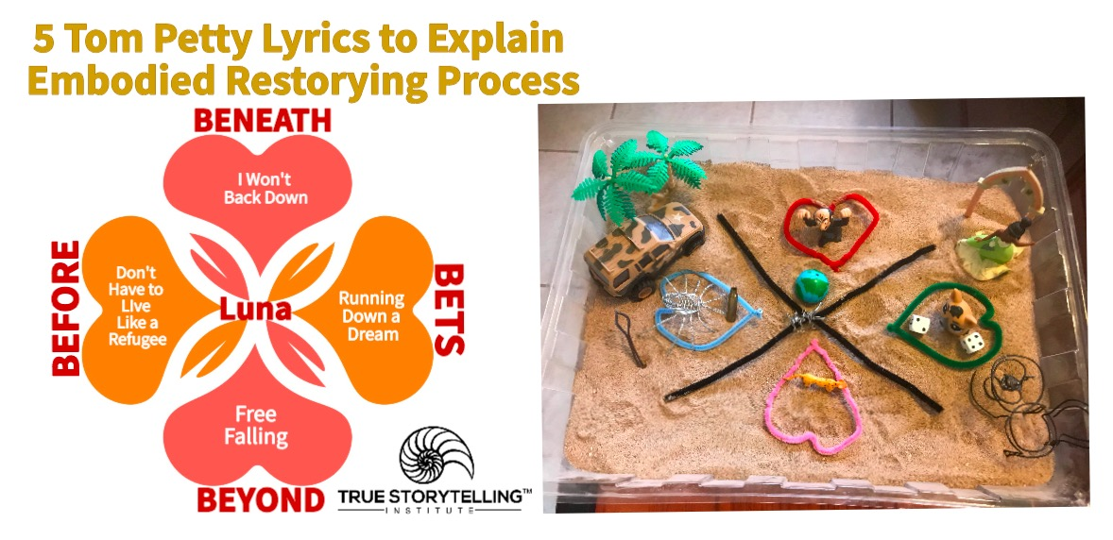
PURPOSE: How 5 Tom Petty song lyrics can help a Guide understand Embodied Restorying Process 7 steps. The songs are about 5 important moves (attunements) a client and guide are making together (with their permission) in sand tray (P7: staging the BETWEEN processes).

What are the 10 Attunements? People are attuned spatially to several of these attunements. If the persons of a family or organization come into a restorying session attuned to fear, anxiety, ambiguity, and turbulence, then the restorying process can help a story along to find pathways to understanding, caring, and the loving heart (not shown).

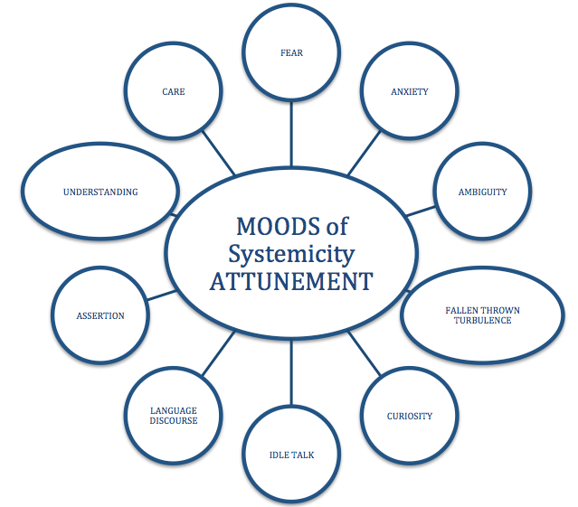

ASSIGNMENT: I will give an example of 5 songs for the 4 hearts and the between. Now you come up with 5 of you own songs, and why they pull on your heart-strings in an attunement systemicity (means a system whose parts are not merged into wholeness (for More see What is a Living Story Web?).

GROUNDING IN PLACE/SPACE: The sandtray is the SPATIAL territory of BEING, the place of BEING, the uncovering of BEING-There of place/space as we move uncovering Hearts of possibilities, and in BEING Here-and-Now we find our own ‘ways of BEING’. In the sandtray, I cobbled together, a person and I, are stuck in one path has a ‘way of BEING’, or a family stuck in a path in a ‘way of BEING’, can they see or find many paths and new ‘ways of BEING’? We often don’t see see the other possible paths in a ‘way of BEING’ because we are stuck in a ‘way we were BEING’ in some place/space.

When we each deployed in another country-in-war, we absorbed a ‘way of BEING’ then returning from deployment’ we have a ‘space-time warp’, a delay in embodiment of ‘way of BEING’ in place/space we inhabit here-and-now. I have experienced this and am attuned to it in other veterans I meet and greet. In the ‘open region’ (as Heidegger, What is Essence of Truth) puts it, is where your BEING is, and how the 4 hearts and between’s tie together (see ‘X’ of black pipe cleaners in the image).

“To free oneself for a binding directedness is possible only by being free for what is opened up in an open region” (Heidegger, section on Ground of Correctness, What is Essence of Truth).

Leaving it BE, Letting It Be, Letting beings be the beings that they are BEING, and not chiseling them into a shape. It’s allowing human, born free, but everywhere he is in chains, to discern their own chains (Rousseau, Social Contract 1762, para). So our Way of BEING in engagement with World in place/space we are living. In the sandtray a vertical (space) axis and a horizontal horizon (timing).

When I met (call him Doug), I was meeting myself. We, two veterans, returned from deployment, in the same building, the same city, but experiencing places we had been BEFORE, stell presenting (flashing back). Embodied Restorying Process (ERP) creates an open region of grounding all four hearts than their between. For more on embodiment, see work by our good friends and colleagues: Thanem, Torkild., & Knights, David. (2019) Embodied research methods:

Disembodied research erects false dichotomies between flesh and reason, and between the corporeal and the social. Their book explores the body’s onecapacity to generate knowledge, craft lively [storytelling] accounts, and create fleshy concepts. These approaches enrich our understanding of how people live, work, and interact with their bodies within the social world (adapted comment).

As the enfleshment of embodiment begins, Grace Ann and I flew to this place to give a session on ERP to 60 doctoral students and lots of faculty. They sat at tables in an auditorium space, organized into their cohort groups. Some cohorts had just met, others were returning, and had known each other one, two, or three years. Faculty and staff filled the rest of the spaces. I heard about new doctoral student, his first day in the program, had been confronting faculty and cohort:

Doug: “When do I start my dissertation?”
Doug: “Where is my committee?”

Can you pick the Tom Petty song in the figure, and the material object, I chose to depict him then-and-there. Doug was on a mission, and we (faculty) we in the way? He was disruptive, and out-of-touch, out-of-step, with the place/space he was in. And not polite about it? It was like the song: “I won’t back down” (Tom Petty). I knew this song, and lived it, when I had returned from my deployment to Vietnam. You forget you are not in Vietnam War, you are in a peaceful place, back home. Some call it flashback, but its more about BEING-embodied in a place, you have left behind, but the place is still in you, inhabiting you. It takes one veteran to another, to attune

The BENEATH-heart is known for its fore-conception, its debates, about labels, pushing and shoving verbal combat. Arguing with Doug would serve no purpose. There is not an attention to place/space, the in-dwelling of grounding of BENEATH. Yet, it is a kind of smoothing of space, ironing out and eliminating wrinkles. In ERP, we move from the debating space into a dialogism space of place, of things-mattering, places that got displaced. People orient spatially. Do-Be-Do-Bein-Doing-Spatial.

I expected his hand to shoot up when I took the stage, and entered that space.

Doug: “Professor Boje, when do we get to working on my dissertation? I got things to do, and I want to get started. I’d rather just meet with my committee.”

Boje: “Would you like to work on this here-and-now? If so, come on stage, and we will do that.”

Doug: (comes on stage) and says “My name is Doug.”

Boje: “What’s your story?”

Doug: (a long pause of reflection, then)“I enroll in a program to get my doctorate, and we just sit around, wasting time. I’d rather get down to business.”

Boje: “Ok. Is it OK if we do that here-and-now?”

If you do not know Tom Petty lyrics, then feel free to choose your own five songs. Songs are sounds that keep replaying, vibrations of other spacetimes.

(1). The Beneath Heart plays the song about a move of stuckness in-place/space, BEING-out-of-place. Tom Petty’s “Well, I won’t back down” plays in my head. I asked Doug: “how is it going?” Answers: “Not that well. Wife wants to leave. Kid scared of me. Cohort thinks I am pushy. Faculty pulling away from me.” I appreciated his honesty, and let the lyrics emplace me.

Then I asked, if you could give this a name, what would it be?”

Doug, “I guess, I’m BEING-Mr. Military, and people expect me to be someone else.”

Boje: “What’s the Mr. Military story?” And the lyrics play on and on and on. Let them sink in.

"I Won't Back Down"

Well, I won't back down
No, I won't back down
You can stand me up at the gates of hell
But I won't back down

No, I'll stand my ground
Won't be turned around
And I'll keep this world from draggin' me down
Gonna stand my ground
And I won't back down

(I won't back down) Hey, baby
There ain't no easy way out
(I won't back down) Hey, I
Will stand my ground
And I won't back down

Well, I know what's right
I got just one life
In a world that keeps on pushin' me around
But I'll stand my ground
And I won't back down

(I won't back down) Hey, baby
There ain't no easy way out
(I won't back down) Hey, I
Will stand my ground
(I won't back down) And I won't back down

(I won't back down) Hey, baby
There ain't no easy way out
(I won't back down) Hey, I
Won't back down

(I won't back down) Hey, baby
There ain't no easy way out
(I won't back down) Hey, I
Will stand my ground
(I won't back down) And I won't back down
(I won't back down) No, I won't back down

The BENEATH-Heart DECONSTRUCTION: Doug is in Debate Mode, and I don’t play that game. To get some distance from War and the place we are in, I did the EXTERNALIZE (step 2 of ERP), so we talk not about Doug (that’s personal), but ‘Mr. Military.’ Mr. Military stands his ground against all oppositional counter-narratives. That was (step 1 Characterize) a persona that got things done, attained a military objective, commanded respect in the war zone (place/space). Faculty told me before this eventing, he won’t back down, and stands his ground, on first day of his doctoral program, wants to work on the dissertation proposal, meet his committee, and get it done. I knew these lyrics, due to my own displacement. The military tells its grand narrative, of how a soldier is to be, and how a military family sucks it up and stands their ground, no matter who is pushing them around. You don’t just return from deployment, and reenter a place (it takes time to move out of the BEFORE). It’s a familiar song to me, a veteran. It sets up a duality, a polarity, because the Mr. Military does not abide soldiers or family members who back down from a fight, at the gates of hell. So now we take a trip into the BEFORE, to recover exceptions, eventing that was forgotten, such as when he was not a military-dad, not acting the role of military-husband. Important in sandtray work too, since its the stuff ‘new stories’ and ‘helping stories along’ is made of.
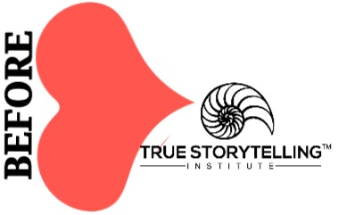
(2). The BEFORE-Heart is playing the song about a move: “You Don’t Have to Be a Refugee.” A veteran from a war zone, comes home and is like a Refugee, a Mr. Military in a place of peaceful-present. It is here that the ‘Little Wow Moments’ are findable, recoverable exceptions to the ‘I won’t back down’ song. Refugee lyrics includes “We don’t talk too much about it” yet there is an awareness of having been kicked around. My grandfather (World War I soldier in shell shock trenches), my dad (World War II, Pacific Islands; recalled to Korean War, taught Judo on General Douglas MacArthur’s aircraft carrier), and me (Vietnam War). None of us ‘talk about it.’ The song is familiar, and the lyrics sink in. Yet, it is in the untold stories of exceptions to the trauma, forgotten memories of how to BE, a way of BEING, overpowered by trauma of BEING kicked around.

"Refugee"

We got somethin', we both know it, we don't talk too much about it
Ain't no real big secret, all the same, somehow we get around it
Listen, it don't really matter to me baby
You believe what you want to believe, you see

You don't have to live like a refugee
(Don't have to live like a refugee)

Somewhere, somehow, somebody must have kicked you around some
Tell me why you want to lay there, revel in your abandon
Honey, it don't make no difference to me, baby
Everybody's had to fight to be free, you see

You don't have to live like a refugee
(Don't have to live like a refugee)
No baby you don't have to live like a refugee
(Don't have to live like a refugee)

Baby we ain't the first
I'm sure a lot of other lovers been burned
Right now this seems real to you, but it's
One of those things you gotta feel to be true

Somewhere, somehow, somebody must have kicked you around some
Who knows maybe you were kidnapped, tied up
Taken away and held for ransom
Honey, it don't really matter to me, baby
Everybody's had to fight to be free, you see

Don't have to live like a refugee
(Don't have to live like a refugee)
No you don't have to live like a refugee
(Don't have to live like a refugee)
You don't have to live like a refugee
(Don't have to live like a refugee).

The BEFORE-Heart DECONSTRUCTION: There are untold stories of hope, stories you only tell another soldier, and stories you dare not tell at all. Reliving the trauma, to desensitize you, gets you back into combat, but it does not recovery your authentic Self from all that military training. This is why material objects are so powerful. They call to mind a forgotten memory. Things are quantum energy fields, radiating energy direct to your body. Its what Jane Bennett (2010) calls ‘vibrant mattering’ of ‘Onto-Story.’ which we get to in the 3rd heart-move of ERP. An onto-story. An onto-story is an ‘ontological-story’ of our not just people, but of things Being-in-the-world, reaching out to your embodiment. The “onto-story” (Bennett, 2010: p. 3-4) is a tale of materiality that highlights how thinghood and human being overlap, and “slip-side into each other” (p. 4). “One moral of the story is that we are also nonhuman and that things, too, are vital players into world” (p. 4). Bennett does not say much about it.

“On a sunny Tuesday morning on 4 June in the grate over the storm drain to the Chesapeake Bay in front of Sam’s Bagels on cold Spring Lane in Baltimore, there was” (IBID.):

one large men’s black plastic work glove
one dense mat of oak pollen
one unblemished dead rat
one white plastic bottle cap
one smooth stick of wood

Each thing recalls a body memory. Traumatized bodies remember, even when the mind chooses to forget. TO continue with Bennett, 2010: 3-4):

“... stuff exhibited its thing-power: it issued a call, even if I did not quite understand what it was saying. At the very least, it provoked affects in me: I was repelled by the dead (or was it merely sleep tin?) rat and dismayed by the litter, but I also felt something else: a nameless awareness of the impossible singularity of that rat, that configuration of pollen, that otherwise utterly banal, mass-produced plastic water-bottle cap.”

Bennett, sees these things in the storm drain, an assemblage of things, with vibrant matter energy she calls thing-power. Her body reads the thing-message. Not just the power of each thing alone, but their power together, in assemblage. This is what we do in making-sense of vibrant matter. Consider the thing on your desk, in you place/space, here-and-now. The things come from different places, are made of materials at different times, and the things together have agency, and they are mattering a vibrant mattering. The things each call out memories from BEFORE.

Boje: “How did things work for you, BEFORE?”

Mr. Military: “I was in charge. I led a squad. We know our mission. We got our supplied, and we gook care of business.”

Boje: “How’s that working out for you?” (To Revise in Step 4, the consequences of displacement are brought to participant awareness).

Be gentle. The ground comes up real fast, and you can pass right through it into the abyss.

(3). The BEYOND-Heart is playing the song (sound waves) without its spaces of sound intervals, ERP does not work:. “Free Fallin’” is a song of how his mate is “a good girl, crazy about Elvis, loves horses” but a freeway runs through the yard (space), in a place called, Reseda. He’s breaking her heart. And he’s Free Fallin’. When you are Free Fallin’ the grounding is coming up to meet him, the place/space has a familiarity (he’s been there). In the lyrics, the boy and girl, know Reseda, Ventura Boulevard, and the 405-Freeway running through San Fernando Valley. There is a freedom in familiar places and things familiar. Mr. Military has been re-membering (re-embodying members of body, left behind in deployment). As the body re-members there is something shocking about it. So be kind and gentle as a guide. As Mr. Military talks of his love for wife and child, he begins ‘Free falln’...’

"Free Fallin'"

She's a good girl, loves her mama
Loves Jesus and America too
She's a good girl, who's crazy 'bout Elvis
Loves horses and her boyfriend too

And it's a long day livin' in Reseda
There's a freeway runnin' through the yard
And I'm a bad boy, cause I don't even miss her
I'm a bad boy for breakin' her heart

Now I'm free
Free fallin'
Yeah, I'm free
Free fallin'

Now all the vampires walkin' through the valley
Move west down Ventura boulevard
And all the bad boys are standing in the shadows
And the good girls are home with broken hearts

Now I'm free
I'm free fallin'
Yeah, I'm free
Free fallin'

Free fallin', now I'm free fallin', now I'm
Free fallin', now I'm free fallin', now

I wanna glide down over Mulholland
I wanna write her name in the sky
I'm gonna free fall out into nothin'
Gonna leave this world for awhile

Now I'm free (Free fallin', now I'm free fallin', now I'm)
Free fallin' (Free fallin', now I'm free fallin', now I'm)
Yeah, I'm free (Free fallin', now I'm free fallin', now I'm)
Free fallin' (Free fallin', now I'm free fallin', now I'm)

(Free fallin', now I'm free fallin', now I'm)
Now I'm free
Free fallin'
Oh (Free fallin', now I'm free fallin', now I'm)
Free fallin' (Free fallin', now I'm free fallin', now I'm)
Now I'm free (Free fallin', now I'm free fallin', now I'm)
Oh, free fallin' (Free fallin', now I'm free fallin', now I'm)
(Free fallin', now I'm free fallin', now I'm) Free fallin'

The BEYOND-Heart DECONSTRUCTION: ‘Free Fallin’’ is all about place/space, and names Reseda, the glide over Mulholland, the sky, and there is materiality here, a freeway running through the yard. You can visualize the sandtray of material artifacts in this deep dive into BEYOND. A statue of Elvis, a horse figurine, and so on. And he’s breaking her heart, but he’s free fallin’ and now he’s free, free fallin’. Finding the exceptions of ‘Little Wow Moments’ is not enough. There needs to be an open space for a reconfiguration of the sandtray material artifacts. It’s a freedom to retettitorialize the territory. Doug (Mr. Military) is deterritorializing, and its a necessary third move, or you don’t get to the BETS-Heart of potential futures. Without the reassembling, the “I won’t Back Down’ lyrics kick back in, and its a future-as-usual (from the BEFORE-Heart to the BETS-heart).

Guide Point: ERP does not work without a “Free Fallin’’ reterritorializing process. This is the Heart-of-Rhizome from Deleuze and Guattari’s (1987, Thousand Plateaus). The space/place is already territorialized (the military freeway runs through it). So the deterritorializing lines of flight (Free Fallin’) are necessary to get to reterritorializing (a new and different configuration, a different assemblage of material things, and relationships with family, military, self, and society), a new BET on the Future (Principle 5: Helping Story Along). Each Heart touches BEING. BEYOND-touches-BEING.

“Such being free points to the heretofore uncomprehended essence of freedom. The openness of comportment as the inner condition of the possibility of correctness is grounded in freedom. The essence of truth is freedom” (Heidegger, Section on The Ground of Possiblity of Correctness).

Let the lyrics bring you from grounding into the future. It is time for the Restorying Step 6. It is about gathering all the left-behind Little Wow Moments, just recovered, and invite Mr. Military to step out of that persona, and have a new future, a new Bet on the future, a new path. Must be his own path, his choice. No one can do it for him.

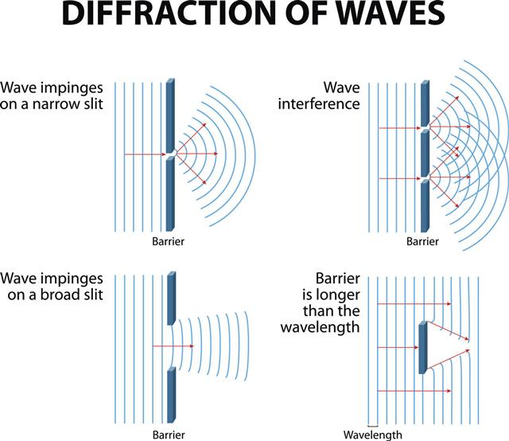
Musical sound waves diffract through space until a barrier. The diffractions of waves in a corporate space is important storytelling.

Example: I created a corporation with friends called ‘Personnel for Printers.’ I got the idea to hang a ship’s bell in the front office. When placement of a printer or graphic artist was made, the sales person ran into my office, and rang the bell. Celebration sound waves and waves of applause broke out. Then one day, accounting said, What about us? We want to ring the bell when we get the payroll out and the invoices delivered each Tuesday.” Of course, operations wanted their turn at bell-ringing celebrations. We were staging (P6) and doing embodied reflecting (P7) but also we were deterritorializing space of corporate-hierarchy by reterritorializing space of our system with an apparatus known as ‘celebration’ and that is ‘restorying’ by ‘helping stories along’ (P5). The celebrations began cascading, the bell apparatus (tool) did its work deterritorializing and reterritorializing into a practical ensemble. Isotropic (means moves in all directions equally) is a space of assembling brought about by a bell, a quasi-object around which the “Master of Truth” (Principle 1 of True Storytelling) of our corporate system became transformed into isotropic spaces equal vibrations, and ensembles of celebratory storytelling (Deleuze & Guattari, 1987: 426). This relative autonomy of celebration made one executive resign. He preferred hierarchy to equality wo weeks, and of practical ensemble (Rosile, Boje, & Claw, 2018; Rosile, Boje, Herder, & Sanchez, 2021). The bell’s quantum wave diffractions created melody, rhythm, and tempo of sound intervals and silent reflecting waves of celebration. The practical result is sales doubled in tripled the next month. The bell sound wave patterns is an example of a fractal change, from branching (hierarchy & division) into ensemble that deterritorializes hierarchy, reterritorializes ensembles. Overall point: Deterritorialization has a function of system change by a material apparatus that is musical across a whole corporate system, as the deterritorializing vectors of sound. Sounds take lines of flight in waveforms, of “so many becomings” (Deleuze & Guattari, 1987: 510) connection so many sociomaterial assemblages while “taking into account their potentialities” in all directions of sound movement (p. 512).

(4). The BETS-Heart move has a caution. Beware, it is so very tempting (skipping steps & moves). There is good reason why Mr. Military cannot just jump out of ‘I won’t back down’ or just having re-membered exceptional ‘Little Wow Moments’ does not just leap into BETS on the Future. Those ‘opportune moments may be obvious to Guide and everyone else, but Mr. Military did not do the work of [‘Free Fallin’] so not sense in arguing facts or empirics or sense [that’s Debate Mode]. He had to go through the BEYOND fallin’ into dialogism of the rhizome of reconfiguring his own sandtray, finding his own way to BETS on the Future. Here that beautiful song, “Runnin’ down a Dream’ gets heard by ‘Mr. Military.’ This is where some stepping stones are useful in sandtray work, to create pathes to multiple future BETS on the Future. Timing is everything. When he’s ready, Mr. Military, becomes Doug, once more. Look at the sandtray configuration, the dream and vision of his future, an onto-story I encounter.

"Runnin' Down A Dream"

It was a beautiful day, the sun beat down
I had the radio on, I was drivin'
Trees went by, me and Del were singin'
Little Runaway
I was flyin'

Yeah, runnin' down a dream
That never would come to me
Workin' on a mystery, goin' wherever it leads
Runnin' down a dream

I felt so good, like anything was possible
Hit cruise control and rubbed my eyes
The last three days the rain was unstoppable
It was always cold, no sunshine

Yeah, runnin' down a dream
That never would come to me
Workin' on a mystery, goin' wherever it leads
Runnin' down a dream

I rolled on, the sky grew dark
I put the pedal down to make some time
There's something good waitin' down this road
I'm pickin' up whatever's mine

I'm runnin' down a dream
That never would come to me
Workin' on a mystery, goin' wherever it leads
Runnin' down a dream
Yeah, I'm runnin' down a dream
That never would come to me
Workin' on a mystery, goin' wherever it leads
I'm runnin' down a dream

The BETS-Heart DECONSTRUCTION of ‘Runnin’ Down a Dream’. There is a good reason why Appreciative Inquiry (AI) is not the first or second or third move of ERP (see Boje & Rosile, 2020: p. 79; 116-120). There is a place for AI (Dream step), and its after a critical reflexivity, called ‘negation of the negation.’ Jean Paul Sartre’s ‘practical ensemble’ and its ‘ensemble storytelling’(Rosile, Boje, Herder, & Sanchez, 2021) has a special move. Negate works because the reterritorializing of the space/place happened in move 3 is a restorying of the relation of BEING and BETS, and BEFORE Mr. Military (and family system) had to negate [somewhat, not entirely] the totalizing military system (see totalizing in Boje, 1995, Tamara-Land). By this act of negation (critical inquiry), a marginalized self (restorying of little wow moments past, exceptions to the grand military system narrative) gets recalled, BACK TO THE FUTURE. In Kirkeby (2009: 167) there is a principle in which the guide “tries to let the other [find their own way] definite path until the moment has come, when it is time to confront the Other with what he says or have said.” A Guide can say (with Timing); ‘How is that working out for you’ to get the deep dive BEYOND & BEFORE, to unpack a Dream (BET).

Here is the wrap up The Protreptic Guide (Kirkeby, 2009) brings participants out of debate into several dialogisms (one is the sandtray) and out of partial histories BEFORE [P2: making room for already there] (e.g. trauma stuckness restorying little wow moments) into the futuring by negations with affirmations BETS (P3 plotting Chronos) with opportune moments (Kairos of P5: Helping ‘new’ stories along). This is the basis of Guides doing the ‘Embodied Restorying Process” (ERP) which has its own 7 steps (based on work by Rosile & Boje, and their colleagues, please see references). Let us deg deeper into what a Guide is doing here. Then we get to ‘Luna.’

Next, 4 important Guide Principles for helping stories along.

The Protreptic Guide Four Principles (Kirkeby, 2009: adapted from pp. 163-166)
First Principle Anchor in a dialogue the transgressive experience that breaks out of the sunlight in the Mr. Military story, its wife and child. Keep in mind, in the BEYOND-Heart, is an encounter with Nature forces. Being in combat, Nature gets displaced, and it can return to Doug.

Second Principle In BEFORE-Heart, the ‘truth for empirical knowledge’ of BENEATH (debates) is not helping the story along (principle 5). Mr. Military is still living on the road to self-deception (PTSD, or something akin to it), because in-the-BEFORE, they is how he survived the Afghanistan war, and Mr. Military is very pragmatic, in his ‘reality principle.’

Third Principle Mr. Military needs the Free Fallin’ into the BEYOND-Heart to find Doug, because Mr. Military (without Doug) is without the means to establish a path directly from BENEATH or BEFORE to BETS.

Fourth Principle The setting of the eventing, eventing-the-event and its contextual framing have five facets. Here the Greek Square gets a plus-one, the ‘Values of Military Culture that says ‘man up, suck it up, don’t back down ever’. There is The True (empirics of surviving), The Beautiful (family), The Just, and The Good (soldier). In other words, Mr. Military is obligated by the military system narrative to be acting and leading according to Military-Institutional-Ethics, and to swallow his own person-ethics.
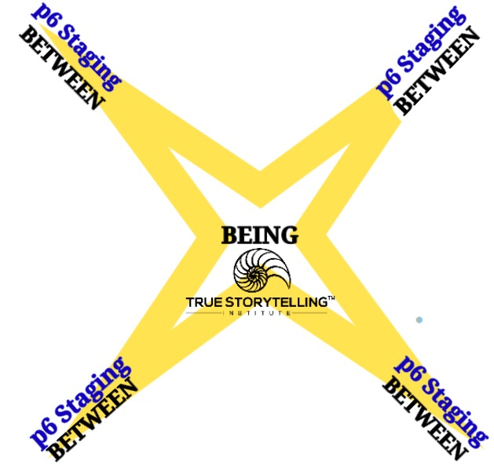
(5). The Four BETWEENS move around BEING and revealing the in-BETWEEN. This is where ERP step 7 meets Principle 7 (staging) in the in-Between-the-Hearts. A special song is ready to begin playing its lyrics, called ‘Luna.’ Nature comes into the ERP, but all in-BETWEEN ‘Luna, Glide Me Down from the Moon’.

"Luna"

White light cut a scar in the sky
Thin line of silver
The night was all clouded with dreams
Wind made me shiver
Black and yellow pools of light
Outside my window
Luna come to me tonight
I am a prisoner
Luna glide down from the moon

The clouds are all silver and black
Floating around me
Luna come into my eyes
Luna surround me
With black and yellow pools of light
Fall by my window
Luna come to me tonight
I am a prisoner
Luna glide down from the moon

The clouds are all silver and black
Floating around me
Luna come into my eyes
Luna surround me
With black and yellow pools of light
Fall by my window
Luna come to me tonight
I am a prisoner
Luna glide down from the moon

The BETWEENS CROSS-SECTION DECONSTRUCTION of ‘Luna’ In the sky is a scar (a pathway), a ‘thin line of silver’ glistens. I am looking at freedom, the BEING-in-the-world. The Wind makes Mr. Military shiver. Notice it is Nature doing the healing. Doug may or may not realize, ways of BEING, how he’s been a prisoner in Military Culture Norms, and now he’s Free Fallin’ into another place/space. “Luna Guide Down From the Moon.” He’s ready to do his STORYBOARDING. There are four storyboards to make silver line pathways BETWEEN-Hearts.

The Cross-Section of the 4 BETWEENS of BEING
There is the BETWEEN-hearts in-BEING of SpaceTimeMattering (inseparability).

In-BETWEEN (P6 Staging) and the cross-section of Four Hearts
Next we go deeper into the 7 Steps of ERP.
Level II presentation of 7 ERP steps
Level II Train the Trainers includes PRACTICES, 7 Steps of Embodied Restorying Process (ERP) and example of use with FAMILY SYSTEM, not just the individual veteran.
Source: Direct quote from Flora, Jeanne; Boje, David M., Rosile, Grace Ann; Hacker, Kenneth. (2016). A Theoretical and Applied Review of Embodied Restorying for PostDeployment Family Reintegration. Journal of Veterans Studies. Vol 1, No 1 Click to see full article.
Table 1. LEVEL II Guides:
Steps of the Embodied Restorying Process including Samples and Interpretations from ERP Sessions
1. Characterize: “Describe you at your ‘best,’ or your family at their best, either in words or by arranging a scene in the sand tray. What would a favorite grandparent, parent, teacher, family member, or best friend, say about you? This is you or your family on your best days, or the you that these favorite people know you have the potential to become. In contrast, there are the old ‘received narratives’, which have been imposed on you and your family by others. These received narratives constitute a received self-identity. For example, society, films, families, and institutions, such as the military or professional training, all tell us who we should be and how we should behave.”
2. Externalize: “Describe your ‘old story,’ your description of you/your family in the past. Feel free to make any problems or struggles into another character in your story (use an object in the sand tray to describe this character/problem).” (Note: Sometimes this step features very little talking at first, as participants choose characters, arrange scenes, and then later describe. Also, some people prefer to talk about their old story before they describe their “best” self.)
3. Sympathize: “How has the problem (the old story) benefitted you or how is it understandable?”
4. Revise: “Identify negative consequences of the problem.” This helps reaffirm the commitment to change them.
5. Strategize: “Find the ‘little wow moments’ of exception to the usual ‘same old story.’” For example, “How did you overcome the problem this time?”
6. Restory: “Re-write history and write a new future life/family story. This time, highlight all the ‘little wow moments’ from family members and make them the ‘new normal’ (instead of the exception) in the future story.”
7. Publicize: “Identify a support network and write letters to potential supporters to request participation in the new story of the future. It does not matter if the letter recipients respond or not. Consider family and friends who can support and ‘call you on it’ if the old story creeps back in.”

Next a video on how to use sandtray. Keep in mind, the guide never ever interprets things for anyone else. The participant does their own onto-story work.

Here is a video of how it works with artefacts, that have 'vibrant mattering' energy, material forces that attract our embodied relationship to things. Skykes is in the video, and five other homeless veterans living in an appartment, now homed, but still quite displaced.
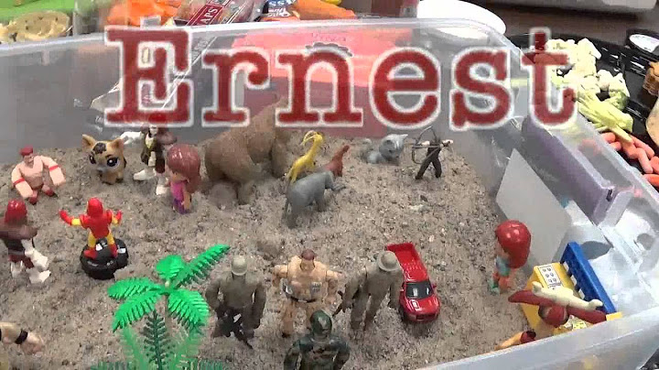
YouTube “Embodied Restorying Process, example done with 6 homeless veterans, facilitated by David M. Boje Ernest was one of the homeless veterans, and Sykes, another (both passed over).

Every thing has a story (William James, 1907: 96) in book, Pragmatism, available Free from Kindle). “Things tell a story”. In his approach to systems, there is an Aesthetic Union among things that sepeaks to us, because “their parts hang together so as to work out a climax” (p. 83 in Kindle Online version). Our human ideas and the assemblage of things, tell as story, if we pay attention to the configuation among things. Search on word “truth” and you find 226 results, which tells you that mean older truths, and the process of truth’s growth (p. 36) and what we may say about them (p. 38) are related.

We will next put this in antenarrative process focus.

LEVEL II: Advanced Guide Training

7 Embodied Restorying Process (ERP) steps in relation to BEFORE-Heart (P2: Making Room) and the BETS-Heart (P3: Bets, revisited), and the in-BETWEEN (P6: Staging)
The BEFORE nexus with P2 Already There, is where to find ‘Little Wow Moments’ that can become (BECOMING) new story BETS ON THE FUTURE, and a new grounding, a re-grounding of the BEFORE. The Re-embodiment of the living story life (BEYOND-Heart) is P7 (Embodied Reflection), making space and place for all the narrative-counternarrative debate excommunicated from BEING’s SpaceTimeMattering, I.E. (P4: Timing of both Chronos & Kairos).

This is where all 7 principles, all 7 processes of antenarrative (eventing), and all 7 steps of Embodied Restorying Process come into togetherness of your Guiding.

Table 1: 7 STEPS of Embodied Restorying Process (ERP)
1. Characterize (received Person/Organization identity) from how other persons/organizations are telling the BEFORE (P2).
2. Externalize (re-label to an artifact, material object) Make the Problem the Problem, not the Person as the (root) problem (often ‘sick’ system is the problem, not the person). This is BACK TO THE FUTRE (BETS-Heart)
3. Sympathize (benefits of problem as it is) – of old BEFORE (P2: Making Room) in dominant-narrative for your own living story Self by seeing payoffs in the present of the Dominant Narrative (P1 what is true) that holds a person in the loop
4. Revise (consequences) – What are the negative consequences, including the stereotypes (prejudices) of received person &/or organization identities, of this BEFORE still evoked? It is also a negation in the BETS-Heart so an affirmation of one’s own positivities enters and cracks the saturated problem narrative.
5. Strategize (Little Wow Moments of exception to Others' dominant master narratives of BEFORE of P2: Making Room); Guide helps (P5 Helping new Story) as participant does the work of reclaiming their very own Little Wow Moments of memory from their forgotten BEFORE
6. Restory (rehistoricizes the old dominant narratives BENEATH that clouded BEFORE, by collecting Little Wow Moments BEFORE (aka multiplicity of positivities) into A 'New Story' of there several possibility futures (BETS ON THE FUTURE, a revised P3 plot), that frees up FREEDOM of CHOICE), no longer stuck in the past-BEFORE, reliving one event in endless loop (e.g. PTSD flashbacks)
7. Publicize (support networking STAGING P6 BETWEENs) e.g. letter writing, social media, celebratory events with supporters of there very own ‘New Story’ of future and potentiality, so they stay in the ‘new world’ instead of STUCK-in-the-past BEFORE) repeating that loop. Storyboarding 4 BETWEEN 4 Hearts is very helpful.
Please read the Embodied Restorying pieces to get some sense of how 7-7-7 work together (7 principles, 7 processes of antenarrative, & 7 ERP steps of guiding) for personal change in sessions as it will come up, now and again in modules:

How to use Material Artifacts with Participants in doing ERP? Vibrant Matter (Bennett, 2010, free online version). Bennett (Preface: x) to simultaneously do three in one to overcome dualities of Western Ways of Knowing (WWOK:
“(1) paints “a positive ontology of vibrant matter, which stretches received concepts of agency, action, and freedom sometimes to the breaking point;

(2) to dissipate the ecological binaries of Iife/matter, human/animal, will/determination, and organic/inorganic … induce in human bodies an aesthetic-affective openness to material vitality; and

(3) to sketch a style of political analysis that can better account for the contribution of nonhuman actants.

The onto-story (ontological-story) of vibrant matter ‘tells a story’ in the assemblage of the material artifacts by the person themselves. The person intrprets their meaning (if they choose, or remain silent) and things speak fro themselves. No one else, interprets another person’s things-story, that is solely up to the participant. Following Ground Rules here is quite important.

What is an onto-story? Jane Bennett's (2010: 3-4) proposes an “onto-story” (meaning ontological story) of the vibrant matter of things, as an energetic force in an assemblage of material objects. She calls ‘onto-story’ of [socio] materiality, how human activities and (non-human) thinghood overlap, becoming vital players, Being-in-the-World (ontologically):

“The strangely vital things ... — a dead rat, a plastic cap, a spool of thread — are characters in a speculative onto-story. The tale hazards an account of materiality, even though it is both too alien and too close to see clearly and even though linguistic means prove inadequate to the task. The story will highlight the extent to which human being and thinghood overlap, the extent to which the use and the slip-slide into each other. One more of the story is that we are also nonhuman and the things, too, Are vital players in the world” (Bennett, 2010: 3-4).

What is IWOK-Shamanic understanding of place & presence & grounding & onto-story? (See online PDF by Boje relating vibrant matter onto-story to assemblage of things, that tell a story-together.

In Conclusion
The problem is the problem, not the person. With material artifacts, in the P6 (Staging) there is a process of in-BETWEEN the 4 Hearts, that by vibrant matter, an onto-story occurs in the choices and configurations (in the 7 ERP steps that allow the person and the material artifacts to co-tell a story. In narrative, the problem saturated account takes over. In using materail objects, vibrant mater can call to mind forgotten moments, including ‘Little Wow Moments’ out of which a ‘new’ story of a different plot (P3) and a different BEYOND (P7) of embodied reflection, by the client themselves becomes possible.

A TASTE OF LEVEL III MASTERS CLASS

The Double Mobius Strips of BEING SpaceTimingMattering is always storytelling in both directions (Timing & Spatializing). That is just one of two Mobius strips. Spatializing from Abstracting to Grounding is how Space/place embodying what narrative disembodied happens simultaneously while narrative-counternarrative debates keep exiling living stories, is happening simultaneously in both directions.

The Timing (P4) double directions of (clocktime & opportune moments; aka chronos & kairos) is also Going on in-BETWEEN. The Double Mobius Strips are therefore quite important practice, process, and principle (3Ps) of True Storytelling. Timing is not separable from Spacing. The horizontal timing horizon and the vertical spacing dimension is how we attune to our situation of Being-There.

We exist in six spaces spacing:

- The technological space
- The musical space
- The maritime space
- The mathematical (fractals) space
- The physical (physics) space
- The aesthetic space

(1) Technological Space keeps smoothing the striated space as vertical BENEATH-heart touches existence (onto-story) of BEYOND-heart. The smoothing space and the striating space meet strangely. The BENEATH (language labeling) keeps smoothing the striated space into smooth space. The BEYOND (grounding), Striated Space keeps undoing Smooth Space. The sandtray has its temporal horizon and its depth verticality. Most new-bees just lay out a line of time and list some tentative resume points. Children go to depth right at get-go.

Example: COVID-19 is a virus that is nomadic, refusing to succumb (so far) to technology striating its space with masks (layers of fabric sewn together), with vaccines, and supply chains. The state apparatus tries to enlist capitalism’s technologies, but the nomad COVID-19 keeps mutating into variants, moving globally despite distancing measures.

(2) Musical Space the smooth and striated space are in complex relation in all four hearts, especially the concepts and lyrics of the fields of music. See Example of Tom Petty lyrics. Choose your own songsters. Some music is metric, others non-metric, some both. Some music has standard breaks, pauses, and others has irregular intervals. Some music is statistically regular, and other beat out of a beat. Sonorous music speaks to your heart with sound vibrations, with frequencies and intevals, rhythms and tempos move our body. We harmonize between hearts, and in the hearts.

(3) Maritime Space On the waves of the ocean, surfers be. The smooth space of waves until the striated space of turbulent, nomadic striated waves and those deep currents pushing icebergs. In Deleuze and Guattari (1987) chapter on smooth and striated space, it is also about the desert sands, their waves, and I know the sand storms of New Mexico. I touch the waves (haptic, tactile) and I hear the waves, and see the optic of waves. The wind intensities of sea and desert, the sonorous sounds of both, “the sound of the sands” (Deleuze & Guattari (1987L 479). We map the waves of sea and desert, marking landmarks: an arroyo, an island, a tree, a barbed wire fence, a river, a submerged reef, and so on.

Example: I live in the desert, with water flowing beneath, sometimes rains fall (Valentine’s Day, rain fell, snow on Organ Mountains) this Valentine’s Day, here-and-now snow on our home. The city-space encroaches on the desert space, agriculture pumps the desert dry, nomadic mobs burn trees making space/place more encroach-able by city-suburb developers, cattle grazers miners (reliving the past), pecan tree plantations with diesel pumps size of dragsters, all spacing, getting the land and water, on the cheap, directionalities of exploitative misery. Such is the “power of deterritorialization” (Deleuze & Guattari, 1987: 480). Dreams of pre-urban, pre-colonial maritime desert: “to live striated on the desert”, steeps and seas like “true nomads” “Being in space.. alteration and superpositions” (p. 482).

(4) Mathematical space (multifractals) It’s snowing out there, on Valentine’s Day, a blizzard. Sounds of equal pitch, then different intensities. Som metric, others non-metric, all are not additive. The movements of qualitative intensities, an enveloping space, and intuitionist space. The relation of smooth and striated spaces of the hearts, with the necessity of cross-sections (BETWEEN), quite nomadic spatializing movements. See the Mandelbrot and Sierpinski fractals, and with the branching and spiraling fractals, you have the mathematics of multifractal trying to catch Nature’s multifractals. I’ve got several books on the topic with colleagues (Boje, 2015; Boje & Henderson, 2014; Henderson & Boje, 2015).

Example: Fractal Change Management tool. We want to do fractal change management. There are multiple fractals, I call wings of tetranormalizing: social norm fractals, trade norm fractals, ecology norm fractals, ad economy norms fractals, and together they interplay the multifractal dynamic processes of global systems.
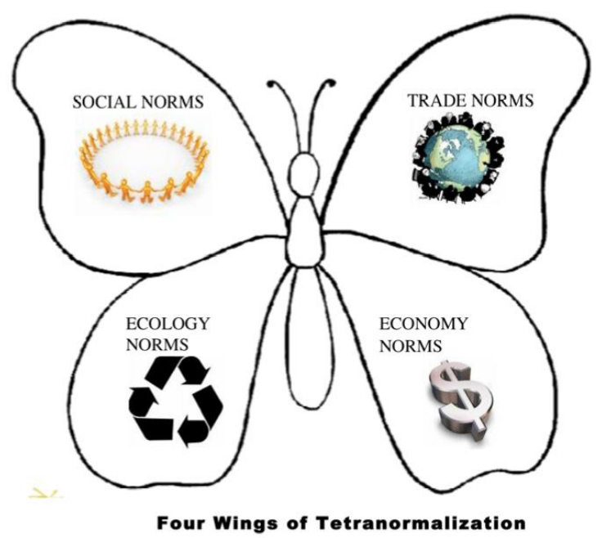

(5.) Physical Space (aka physics space) The smooth and striated spaces dance in the vortices, packets and turbulences, sometimes with catastrophic results. We looked at how harmony and melody occur in musical spaces, in intervals and notes. The diagonal cross-section of the 4 heart-spaces, the weaving of rhythmic norms and values in place/space. The vertical apparatus of Empire (and State), with the physics of city-state apparatuses, and the capitalisms, their regimes of truth (see BETS, P3 plotting 4 player chess example) invades the small and large spaces, spaces so small they are infinitesimal, and so large, they are universe. The physics of this, the vortices, turbulences, packs, and their catastrophes is the point of doing fractal change management, and quantum storytelling work.

Example: Doug in his haptic (tactile) space and in this surplus value space, that no longer requires his Mr. Military albor in space-time that is education. Yet, Doug and I co-exist in all four heart-spaces, and in the in-BETWEEN (the X made of pipe cleaners in the sandbox image). Education, the State and Capitalism in all their schizophrenia, tries to integrate the spaces of the heart. Free Fallin’ into sky, desert, sea, ice, steppe, those spaces of pure continuity – is healing and BEYOND. The sandtray is a haptic-optical (tactile & visual) of vibrant mattering energy (Bennett, 2010).

(6.) Aesthetic Space The sandtray is aesthetic spatializing, finding one’s depth of space, not just a time line, but lines of flight through the four hearts, and in-BETWEEN.

Example: Doug and I keeps Free Fallin’ BENEATH the language debates over labels, and into the BEYOD, “streaming, spiraling, zigzagging, snaking” (Deleuze & Guattari, 1987L 498). We find our horizon and our depth, we get centered in spacetimemattering. We get encompassed. We are “becoming-artist” (p. 496).

Point: All six relations of smooth and striated spatializing of spaces are about movement, what Kirkeby (2009), a fan of Deleuze, calls the eventing of the eventing.

Next, the twists as the four hearts tip at Being.

There is a twist as the point of each heart meets up with another heart.

Level 3 Training (just a taste)
A Mobius Strip makes a ‘twist’ in the loop, of our lives. There are two twist of BEING-BETWEEN 4 Hearts, as their heart-tips meet in real spacetimemattering.

Above is Horizontal Timing Mobius Strip BEING-BETWEEN the BEFORE-Heart and the BETS Heart meeting

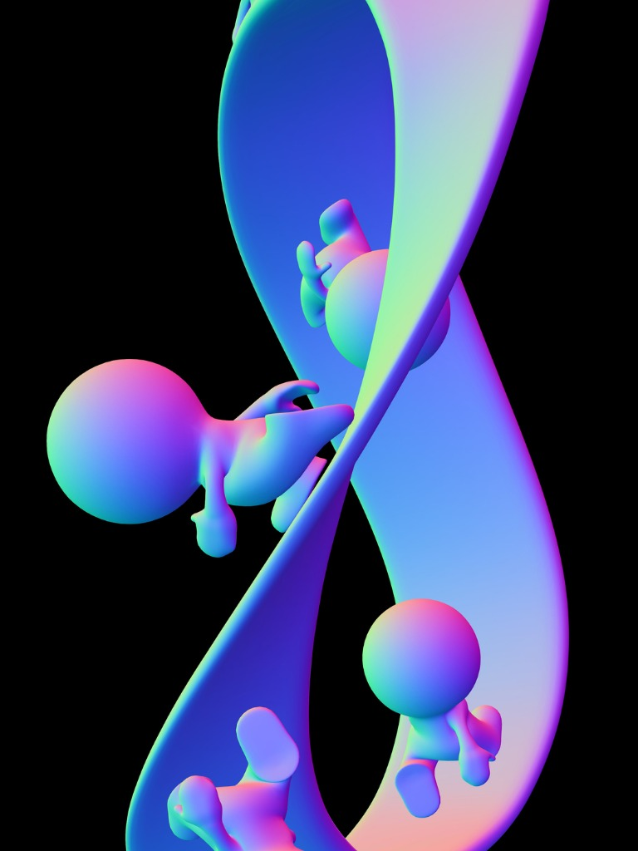
Above is the Vertical Mobius Strip BEING-BETWEEN the BENEATH-Heart and the BEYOND-Heart meeting
The First of Two Mobius Strips:

The Double Becoming

It is simultaneous Mobius Strip of (Principle 4: Timing) BEING in both timing-heart directions:
Back to the Past meets Back to the Future

and the simultaneous double direction hearts:
BEFORE-Heart is domain of partial histories, disputed, always in search of Whole-History (that never was).
BETS-Heart brings about BOTH “affirmation and negation” (Deleuze, 1969/1990 Logic of Sense: 31). Both are understood: “already there” (28).

The Second of Two Mobius Strips:

Beneath-heart (P1: What is True?) Domain of Debate doubling into Beyond-heart grounding uncovering space/place embodiment reflection (P7)

BENEATH-Heart of sense-making contrasts one term of duality with implied opposite term (proposition-representation & thing-itself; all duality (term & counternarrative ( of WWOK-narrative-counternarrative is done in endless DEBATE. The duality debates BENEATH-language games keep displacing living stories to the BEYOND.

BEYOND-Heart the living story displaced in the BENEATH-Heart endless language games. So find embodiment in grounding of space/place.

Conclusion

The reason why ERP works is because it does a deep dive that most folks miss, and don’t see or hear. It is the deep dive into the Beyond of rhizomatics. It is when the person reassembles their life, Free Fallin’. It is right out of Deleuze and Guattari’s (1987” 315-316). The rhizome is explained (p. 9 to 12) as movement that deterritorialized what is already territorialized, by acts of reterritorializing (notice its an active verb, not a noun). Storytelling that is quantum, is deterritorializing what is already territory-production (p. 315). It is about place/space, how it’s “territorialized” (p. 316). The reason Tom Petty songs grab your soul is because they speak to the rhythm of movement. The “rhythmic” is “not the repetition”, it is the “difference” (p. 314). It is nature-rhizome, “spider-fly relation” of two species spider and fly and its “Nature as music” (p. 314). There is this spatial range of BEYOND-Heart (and Principle 7 [embodied] Reflecting) that gets released and is Free Fallin’.

There are two kinds of BECOMING process (one is Principle 4 Timing, and other is Principle 5 Helping stories along). When we do ERP, there is two-way timing, a looping between the two hearts BEFORE and BETS, the Mobius strips of timing gets its twist, and we run on it. There is the second Mobius strip, twisting as we run BENEATH to BEYOND, and back again, and again (deep dive is important part of the ERP process). When we are “in truth” (D&G p. 318) the potentialities com out. In Bets the negations, open spaces for affirmations. This is how critical inquiry (deconstructions) relate well to Appreciative Inquiry.

I want to leave you with a puzzle: how can Appreciative Inquiry and Critical Deconstruction become one?

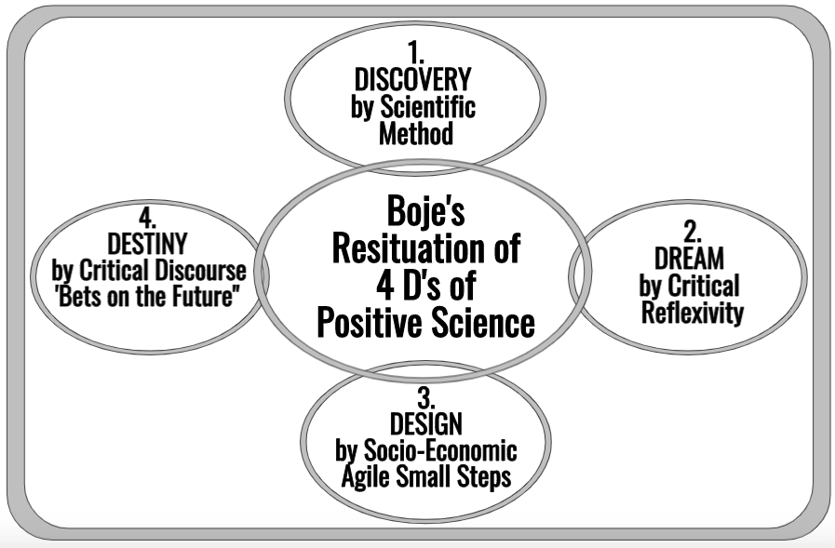
Source: Boje & Rosile, 2020: 79

Homework: Please see p. 79 of Boje and Rosile (2020 How to use Conversational Storytelling… book), and take a peek at how Appreciative Inquiry’s (4 D’s: Discovery, Dream, Design, and Destiny) can be combined with Boje’s Resituation, in the critical inquiry of Embodied Restorying (pp. 81-83) once it moves out of the text-based (White & Epson, 1990) into the Embodied Reflection of the 7 principles of True Storytelling (Boje & Rosile, p. 84). It works because of the dimension of depth in the 7*7*7 (7 principles, 7 processes, 7 practices of ERP steps).

References
Bennett, Jane. (2010). Vibrant matter: A political ecology of things. Duke University Press. Free online at http://www.open.ac.uk/ccig/sites/www.open.ac.uk.ccig/files/Chapter%207%20'Political%20Ecologies'%20Vibrant%20Matter%20(Jane%20Bennett).pdf
Boje, D. M. (1995). “Stories of the Storytelling Organization: A Postmodern Analysis of Disney as ‘Tamara-land.’” Academy of Management Journal. 38(4): 997-1035. https://davidboje.com/vita/paper_pdfs/AMJ_Disney.pdf
Boje, D. M. (Ed.). (2015). Organizational change and global standardization: Solutions to standards and norms overwhelming organizations. London: Routledge.
Boje, David M. (2019a).Organizational Research: Storytelling In Action. London/NY: Routledge.
Boje, David M. (2019b) Storytelling in the Global Age: There is no Planet B . Hackensack, NJ : World Scientific Publishing.
Boje, D. M., & Henderson, T. L. (Eds.). (2014). Being quantum: Ontological storytelling in the age of antenarrative. UK: Cambridge Scholars Publishing.
Boje, David M.; Jorgensen, Kenneth Mølbjerg. (2020). A ‘storytelling science’ approach making the eco-business modeling turn. Journal of Business Modeling, Vol. 8, No. 4, pp. 8-25. Click here for pre-press pdf.
Boje, David M.; Rana, Mohammad B. (2020). Defining a Sustainably-Driven Business Modeling Strategy with a ‘Storytelling Science’ Approach. Chapter to appear in Markovic, S., Sancha, C. and Lindgreen, A. (Eds.), Handbook of Sustainability-driven Business Strategies in Practice, Northampton, MA: Edward Elgar. Click here for pre-press pdf.
Boje, D. M. & C. Rhodes. (2005a). The Leadership of Ronald McDonald: Double Narration and Stylistic Lines of Transformation. Leadership Quarterly Journal Vol 17 (1): 94-103. see pre-publication draft at http://davidboje.com/McD/papers/Ronald_McDonald_LQ_2005.pdf
Boje, D. M., & Rhodes, C. (2005b). The Virtual Leader Construct: The Mass Mediatization and Simulation of Transformational Leadership. Leadership Journal, Vol 4 (1): 407-428. http://davidboje.com/McD/papers/Fast_Food_Virtual_Leadership _Boje_Rhodes.pdf
Boje, D. M.; & Rosile, Grace Ann. (2008). Specters of Wal-Mart: A Critical Discourse Analysis of Stories of Sam Walton’s Ghost. Critical Discourse Studies Journal.Click here for pre-press PDF version. Full journal article pdf
Boje, D.M., Rosile, G, Dennehy, B, & Summers, D.(1997). "Restorying reengineering: Some deconstructions and postmodern alternatives." Special Issue on Throwaway Employees, Journal of Communication Research.24(6): 631-668.
Boje, D. M.; Rosile, G. A. (2020). How to Use Conversational Storytelling Interviews for Your Dissertation. UK: Edward Elgar Publishing Ltd. Download for free until published in 2020
Boje, D. M.; Sanchez, Mabel. (2019a Eds.). Quantum Storytelling Consulting Handbook. London: Emerald Press. Click here fore pre-press of PREFACE pdf. Chapter 1: Ensemble Leadership by Boje, D. M. Click here fore PDF. London: Emerald Press.
Boje, David M.; Sanchez, Mabel. (2019b Eds.). Handbook of Management and Organizational Inquiry. London: Emerald Press.
Boje, D. M., Svane, M., Henderson, T. L., & Strevel, H. B. (in press). Critical corporate social responsibility in tamara-land: The role of tetranormalizing fractals. In R. Ocler (Ed.), Book chapter for a Springer collection, Rodolphe Ocler (ed.). http://davidboje.com/vita/paper_pdfs/CSR%20Chapter_16_March_2015.pdf
Boje, M., & Svane, M., Gergerich, E. (2016). Counternarrative and Antenarrative Inquiry in Two Cross-Cultural Contexts. European Journal of Cross-Cultural Competence and Management, Vol. 4, No. 1, 55-84. Pre-press draft available at http://davidboje.com/vita/paper_pdfs/CHAPTER_Fractal%20change%20management%20and%20counternarrative%20in%20crosscultural.pdf
Boje, D.M., Rosile, G, Dennehy, B, & Summers, D.(1997). "Restorying reengineering: Some deconstructions and postmodern alternatives." Special Issue on Throwaway Employees, Journal of Communication Research.24(6): 631-668.
Deleuze, Gilles. (1968/1994). Difference and Repetition. French, 1968. Columbia University Press. Online at Academia.com, accessed Jan 20, 2021 click here for PDF.
Deleuze, Gilles; Guattari, Feliz. (1987). A thousand plateaus: Capitalism and schizophrenia. Trans. And foreword by Brian Massumi., University of Minnesota, Minneapolis.
Flora, Jeanne; Boje, David M., Rosile, Grace Ann; Hacker, Kenneth. (2016). Journal of Veterans Studies. Vol 1, No 1 Theoretical and Applied Review of Embodied Restorying for Post-Deployment Family Reintegration ABSTRACT The purpose of this paper is to introduce the theory and application of Embodied Restorying Practices (ERPs), an intervention designed to promote military family reintegration.
Heidegger, M., Macquarrie, J., & Robinson, E. (1926/1962). Being and Time. Larsen, Jens; Bruun, Lena; Boje, D. M. (2021).http://users.clas.ufl.edu/burt/spliceoflife/BeingandTime.pdf True Storytelling. London: Routledge. Accessed online Jan 20 2021, first in German 1926.
Hegel, Georg Wilhelm Friedrich Wilhelm. (1807). Phenomenology of Spirit. See online version (Oxford Press) http://ns210054.ovh.net/files/Georg%20Wilhelm%20Friedrich%20Hegel%20-%20The%20Phenomenology%20of%20Spirit%20(Michael%20Inwood%20Translation).pdf
Hegel, Georg Wilhelm Friedrich (1817). Encyclopedia of the Philosophy of Science. Accessed online version https://hegel.net/en/pdf/Hegel-Enc-1.pdf g through untold method. Pp. 213-238 in Michal Izak, Linda Hitchin, and David Anderson (Eds.) Untold Stories in Organizations. NY/London: Routledge (Taylor & Francis Group).
Henderson, T., & Boje, D. M. (2015). Organizational development and change theory: Managing fractal organizing processes. London Routledge.
Husserl, Edmund. (1913/1962).Ideas: General Introduction to Pure Phenomenology. London” Routledge.
James, William. (1907). Pragmatism. Kindle Edition. (click for free E-book, Kindle).
Kirkeby, Ole Fogh. (2009). The New Protreptic: The Concept and the Art. Copenhagen, Denmark: Copenhagen Business School Press.
Larsen, Jens; Boje, David M.; Bruun, Lena. (2021). True Storytelling: Seven Principles for an Ethical and Sustainable Change-management Strategy. Routledge.
Plato's Republic (360 B.C.) Online text, Translated by Benjamin Jowett, accessed Jan 13 2021 at https://www.fulltextarchive.com/pdfs/Plato-s-Republic.pdf
Rosile, Grace Ann. (2016). Tribal wisdom for business ethics. London, UK: Emerald Group Publishing Limited.
Rosile, Grace Ann. (1998a) THE STORY OF THE SCIFI ORGANIZATION http://cbae.nmsu.edu/mgt/jpub/rosile/scifiblkrosile/index.html
Rosile, Grace Ann. (1998b) Restorying and the Case of the Sci-Fi Organization. Academy of Management Presentation. http://web.nmsu.edu/~garosile/garscifiacademy.html
Rosile, Grace Ann; Boje, D. M.. 2002. Restorying and postmodern organization theatre: Consultation in the storytelling organization. Chapter 15, pp. 271-290 in Ronald R. Sims (Ed.) Changing the Way We Manage Change. Wesport, CONN/London: Quorum Books. Click here for pre-publication pdf
Rosile, Grace Ann; Boje, D. M; Claw, C. M. (2018). Ensemble leadership theory: Collectivist, relational, and heterarchical roots from indigenous contexts. Leadership, Journal 14(3), 307-328.
Rosile, G. A., Boje, D. M., Herder, R. A., & Sanchez, M. (2021). The Coalition of Immokalee Workers uses ensemble storytelling processes to overcome enslavement in corporate supply chains. Business & Society, 60(2), 376-414.
Rosile, Grace Ann; Dennehy, R. H. (1998) Restorying for Personal and Organizational Change. Proceedings of the Southwest Academy of Management, 14th annual meeting in Dallas, Texas, March 5-7, (pp. 275-276).
Rosile, Grace Ann; Boje, David M; Herder Richard A.; Sanchez, Mabel. (2021). The Coalition of Immokalee Workers Uses Ensemble Storytelling Processes to Overcome Enslavement in Corporate Supply Chains. Business and Society. Business & Society, Vol. 60(2) 376–414. Click here fore pre-press pdf.
Saner, Raymond. (1999). "Organizational consulting: What a Gestalt approach can learn from Off-Off-Broadway Theater." Gestalt Review 3 (1): 6-21.
Sartre, Jean-Paul (1960/2004) Critique of Dialectical ReasonVOLUME 1: Theory of Practical Ensembles. Translated by Alan Sheridan-Smith, edited by Jonathan Ree, foreword by Fredric Jameson. First published as Critique de/a Raison Dia/erfique by Editions Gallimard, Paris 1960. This translation flrst published by New Left Books1976© Editions Gallimard 1960 Translation © New Left Books 1976 Corrected edition, first published by Verso in 1991 based on the revised French edition of 1985© Editions Gallimard 1960, 1985.This edition first published by Verso, 2004.
Schumpeter, Joseph A. (1942/1976). Can Capitalism Survive: Creative Destruction and the future of the Global Economy. Originally published, 1942, as Capitalism, Socialism and Democracy. 1976, published by NY: NY: HarperCollins Publishers.
Strand, Anete M. Camille, and Tonya L. Henderson. "Sociomateriality: The Emergence of a New Fractal of Entangled Engagements." In The Emerald Handbook of Management and Organization Inquiry. Emerald Publishing Limited, 2019.
Svane, M., & Boje, D. (2015). Tamara land fractal change management – in between managerialist narrative and polyphonic living stories. Sc’Moi, Standing Conference for Management and Organizational Inquiry, Las Vegas. Accessed Jan 21 2021 at http://vbn.aau.dk/ws/files/225730097/Tamara_Land_Fractal_Change_Management_Las_Vegas_Paper.pdf
Svane, M.; Gergerich, Erika M.; Boje, D. M. (2016). Fractal change managment and counter-narrative in cross-cultural change. Pp. 129-154 in Kuhn, Timothy, Mariann Wolff Lundholt, and Sanne Frandsen (Eds.) Counter-Narratives and Organization. NY/London: Routledge.Boje, D. M. (2018). Sandtray embodied restorying quantum storytelling. Pp. 113-116 in in Rixon (ed.)The Story Cookbook: Practical Recipes for Change. UK: Cambridge Scholars Publishing.
Thanem, Torkild., & Knights, David. (2019). Embodied research methods. London: Sage.
White, Michael; Epston, David. (1990). Narrative Means to Therapeutic Ends New York: Norton and Company.
Wolff, Richard D. (2020). The Sickness is the System: When Capitalism Fails to Save Us from Pandemics or Itself. Edited by Liz Phillips & Maria Carnermolla. NY, NY: Democracy at Work.

