How Guides can Integrate 7 True Storytelling Principles with 7 Antenarrative Processes for Better Conversations and to Change Tamara-Land by David M. Boje
A Handout for Level II TSI Guides
©TrueStorytellingInstitute.com
Jan 26, 2021 with Jun 5 2021revisions
Table of Contents
First Slide Egyptian King story True Storytelling: 9
Second Slide Freedom in TRUE STORYTELLING 10
Fourth Slide 4 Illusions of the BEFORE in relation to P2 (Already There) 13
Slide 5: Tree Story of 7 Antenarratives (day of Inauguration Jan 20 2021) 14
Slide 6 How BEFORE (P2 Already There) & BETS (P3 Plots relate: The Example of 4 Capitalisms 15
Slide 7: Annotate 4-player capitalism chess game on the world stage 16
Slide 8 – Phase-Space In P4 (TIMING) of BEING (ANTENARRATIVE PROCESS) SPIRAL of 4-Player Capitalisms 17
Slide 9 – True Storytelling of P4 Timing and the BEING antenarrative Process as Global Capitalism 4-player chess games phase-shifts to Rhizomatic process 18
Slide 8: Simple Version of Relation of 7 Antenarratives with 7 True Storytelling Principles 19
BEFORE (fore-having) has many historical events, P2 (already there). 19
BENEATH (fore-concept) is already in advance, there in thought/motive/value of P1 (What is True) 19
BETS (fore-sight) ON THE FUTURE & P3 (Plots) 21
BECOMING (fore-caring) and P5 (Helping Stories Along) 22
BETWEEN (fore-structuring) and P5 (Staging) 22
BEING (fore-given) Being-in-the-World 22
BEYOND (fore-grasping) is Intuitive (6th Sense, I-3) 24
7 Embodied Restorying Process (ERP) in relation to BEFORE 25
Table 1: 7 STEPS of Embodied Restorying Process (ERP) 25
References for Antenarrative & True Storytelling Principles 26

My favorite article on ‘true storytelling’ is by Walter Benjamin gives two examples of ‘true storytelling’ (p. 90, last paragraph section VII; p. 102, 2nd paragraph, section XVI). Please click and read it before continuing. His message: true storytelling is coming to an end. We revive it, bring it back to life.

My purpose here is to relate Principle 2 ‘What is Already There?’ of True Storytelling (Larsen, Boje, & Bruun, 2021) to Before-antenarrative process that undergirds all storytelling, be it narrative or story. All 7 Principles, for ease of presenting are related to 7 antenarrative proceses.
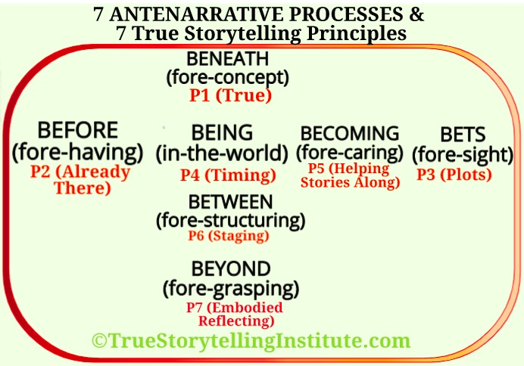

All Hearts Point to BEING
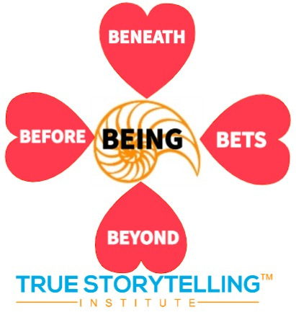
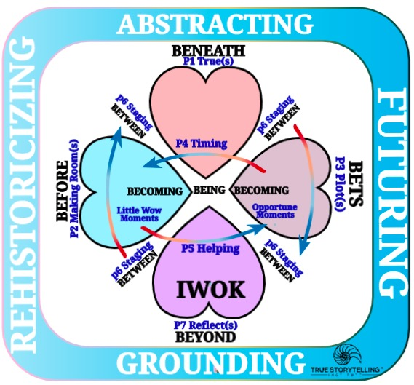
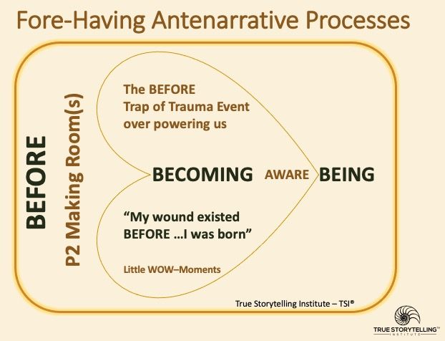
Let’s begin BEFORE-Heart (the process of fore-having, ‘Vorhabe’ in German). Before we are born, history is presented to us, and living through traumatic event after event, we can forget Little WOW-Moments. Thus, BEFORE-Heart is part of Embodied Restorying.
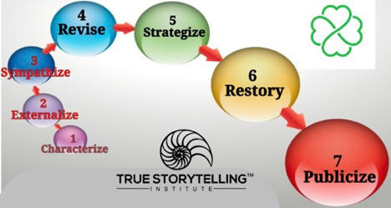

Fore-having is one of six fore-processes of antenarrative. Fore-having is never alone, it always has the other fores, and they all point to Being of our existence. Fore means already-there, and thus the meaning of antecedent-narrative (or antenarrative). Fore-having is already there in layer upon layer of history. Fore-having is ongoing rehistoricizing. True storytelling aims at a more accurate history of events, while forces of propaganda and ‘regimes of truth’ (Foucault) aim at covering-up.

Here are some of the definitions of the Before of fore-having in relation to the Beneath of fore-conception, the Bets of fore-sight, the Beyond of fore-grasping (by intuition, 6th sense), and the fore-structure of Between the 4 Hearts. Finally, there is the Restorying process of two locations of Becoming (one in Before, other in Bets) that get stitched together by protreptic.

BENEATH-Heart of Fore-conceptions:
Going beneath the opinions, concepts, facts, and thoughts people are stuck in that make for polarities, dualities of Western Ways of Knowing (WWOK).

BEFORE-Heart of Fore-having:
We are born into generations of background understanding that provides the context of interpretation and understanding of history. This history keeps being rehistoricized
BETS-Heart of Fore-sight:
Fore-sight is all the different Bets on the Future. People are working to produce different anticipated futures.

There are two dimensions, one temporal and other spatial
Temporality Dimension:
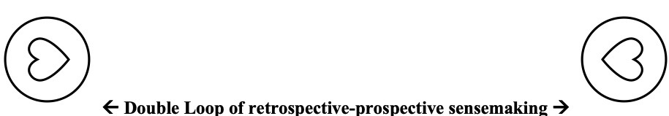

The Becoming Process links the Before and Bets Hearts, the Little Wow Moments with Opportune Moments (Kairos).
Becoming of Caring

Spatial Dimension:

All Hearts Point to Being-in-the-World. Therefore True Storytelling Principles, Processes, and Tool are an uncovering of Being-in-the-World.
BETWEEN the Hearts Fore-structure:
Going Between the Hearts, into how the hearts are related, and to what constitutes the intra-structure, the networking. In True Storytelling we call it ‘Staging’ the artefacts, the scenography, and us various kinds of storyboarding tools to present it to various audiences.

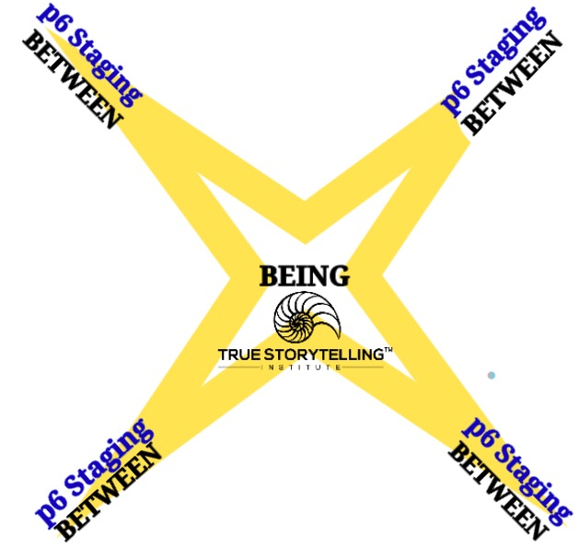

“Fore-having (Vorhaben), a component of hermeneutic circle, is not given a detailed explanation in Being and time. In Ontology: the hermeneutics of facticity, which is based on a lecture course and lecture notes written by Heidegger in 1923, four years before the publication of Being and time, we get more clues” (source).

“Fore-having is described by Heidegger as “concretely giving basic experience” (184). We find ourselves thrown into the world at a given time and place. Definite alternatives are open to us: “I am in certain possibilities: my job, my occupation” (186). These possibilities are not uniform throughout history. Traveling into outer space is a concrete possibility in one age and not in another. Determinate possibilities are technological, socio-economic, political, cultural, artistic. Greeting us at the door of life is a language, with its determinate ways of making sense of the world” (source):

Being-there as being-in-the-world is primarily governed by logos…Coming into the world, one grows into a determinate tradition of speaking, seeing, interpreting. Being-in-the-world is an already-having-the-world-thus-and-so. This peculiar fact, that the world into which I enter, in which I awaken, is there for me in a determinate interpretedness, I designate terminologically as fore-having (74).

“But fore-having is never given alone. It works with a fore-sight and fore-grasp to interpretatively disclose the world” (source).

Beforehand we are born into the historiological that keeps changing generation to generation. For example, ‘whiteness’ has a historiological set of BEFOREs, we are born into.

For example, BEFORE colonialism people around the world did not think skin color a big deal. History shifted, as colonialism and capitalism combined to secure indentured and slave labor. Colonial laws privileged Christians by preventing Africans from joining the faith. As conversions happened by 1680, the Bishop of London objected to the practices, and baptism was invoke as grounds for seeking freedom from plantation slavery. All kinds of eventing took place, to legitimate African slavery (bogus gene & IQ junk science), all of it proffered the invention whiteness.

“By the middle of the 20th century, the presumption that a race of people called white were superior to all others had supplied the central justification not just for the transatlantic slave trade but also for the near-total extinction of Indians in North America; for Belgian atrocities in Congo; for the bloody colonization of India, east Africa and Australia by Britain; for the equally bloody colonization of north and west Africa and south-east Asia by France; for the deployment of the Final Solution in Nazi Germany; and for the apartheid state in South Africa. And those are merely the most extreme examples” (source: Guardian, 2021).
“This gradual rejection of explicit, government-enforced white supremacy was hugely consequential in terms of public policy. Yet it did not mean that whiteness, as a political force, had lost its appeal: in the weeks after Powell’s speech, to take just one example, a Gallup poll found that 74% of Britons supported his suggestion that brown-skinned immigrants ought to be repatriated. It also left unresolved the more difficult question of whether whiteness was truly separable from its long history of domination” (source: Guardian, 2021).
“Instead of looking too hard at the sordid history of whiteness, many white people found it easier to decide that the civil rights movement had accomplished all the anti-racism work that needed doing. The result was a strange détente. On the one hand, whiteness retreated as a subject of public attention, giving way to a new rhetoric of racial color-blindness. On the other hand, vast embedded economic and cultural discrepancies allowed white people continue to exercise the institutional and structural power that had accumulated on their behalf across the previous three centuries” (source: Guardian, 2021).

In Heidegger (1926/1962, click here for online text) in these sections to study ‘fore-having’: 150, 153, 157, 232, 311, 327.

Fore-sight is the ahead-of-itself, already grounded in the future (#327). The BEFORE-heart indicates an already

How does each antenarrative process participate in each principle in the Tamara-Land of an organizaton you are part of?

BENEATH (P1 What is True?) are the surface and the core concepts, core values to aim to find, core motives (ethics and not ethics) we uncover.

BEFORE (P2 Already there) is the process of [true] storytelling by oral experience communicated to listeners, coming to its end (Benjamin, 1936/1968: 84-109), as modern wave of grand narrative progress (the information/digital age) changes everything about storytelling (click here for on line pdf).

How it fits together FOR TRAINERS ONLY
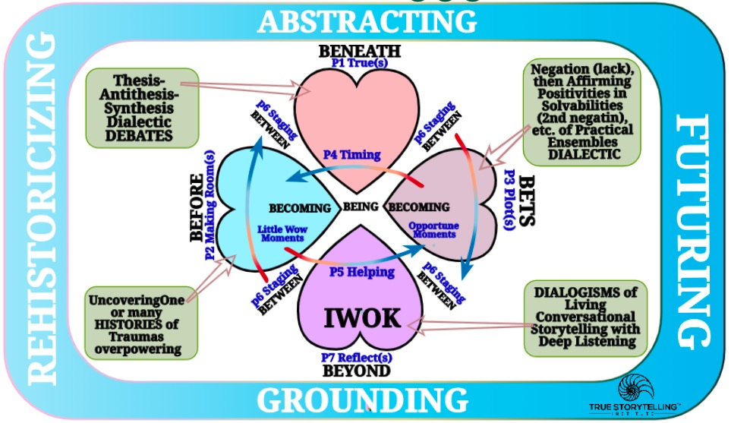

First Slide Egyptian King story True Storytelling:
An Egyptian king, his city captured by another king, witnesses the procession of his own royal family to the execution. The ceremony is meant to break the Egyptian king, to humiliate him to tears before the new King. But seeing his royal family has his own fate, the king is not moved. However, when the king sees his servant in the procession, the tears flow.
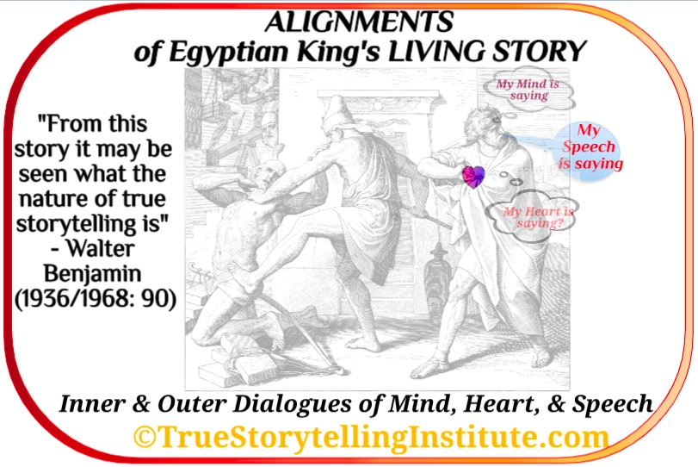
Discussion or Breakout Question: Why? Use Alignments to retell the experience.

Debrief: Walter Benjamin is among the first ever to use the concept ‘True Storytelling.’ He uses the story of Egyptian King who is in a ceremony of succession, as the new king (conqueror) tries repeatedly to humiliate him. There is a realignment of mind and heart (and no doubt a speech act uttered) as the king sees his servant will be executed. It is a way of storytelling the events, in which one reads the Situation (context). There is no excess explicating or explaining. It is example of Indigenous Ways of Knowing (IWOK) as opposed to the Western Way of Knowing) of narrating it all (Rosile, 2016). Walter Benjamin’s main point: IWOK kind of storytelling is coming to an end, and in the Digital Age that came after Benjamin wrote this in 1936, ‘True Storytelling’ is quite rare. (click here for on line Benjamin pdf).

Second Slide Freedom in TRUE STORYTELLING
Walter Benjamin (1936/1968: p. 102, 2nd paragraph, section XVI). Benjamin’s example is the great storyteller of fairy tales, in maritime, craft, blacksmithing, silver-making, and such occupations. In their BEFORE, concepts were conveyed without lots of explanation, akin to what Rosile (2016) calls wisdom of Indigenous Ways of Knowing (IWOK) [see tools, session 1). It relates to Greek Square, to what is freedom:
“All great storytellers have in common the freedom with which they move up and down the rungs of their experience as on a ladder. A ladder extending downward to the interior of the earth and disappearing into the clouds is the image for a collective experience to which even the deepest shock of every individual experience, death, constitutes no impediment or barrier (p. 102).

Giving “good counsel,’ the tutor of not only children, but “tutor of mankind”, “The first true storyteller is, and will continue to be, the teller of fairy tales” (Benjamin (1936/1968: p. 102, 2nd paragraph, section XVI).
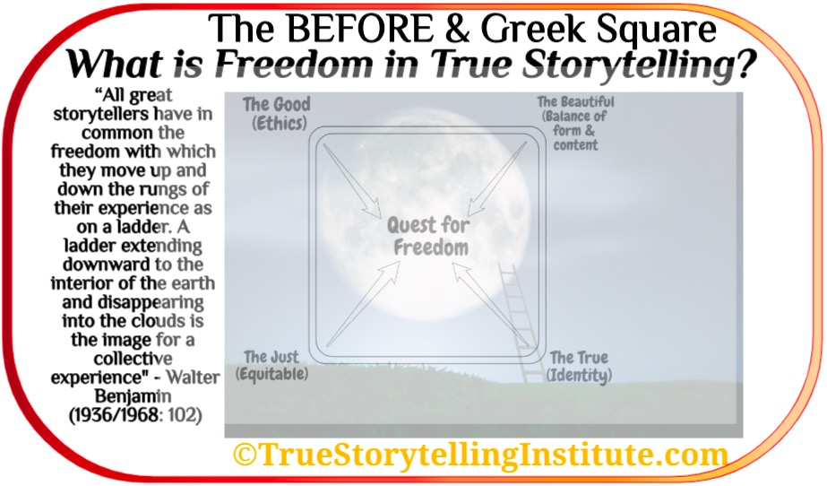
Question: What is your own Quest for Freedom in the ladder of your experience extending from Earth to Collective Experience?
We are increasing our modern distance from True Storytelling the BEFORE because oral-“experience has fallen in value” and “communicable experience” is contradicted by the new technologies of narrative-information in Digital Age (Benjamin, pp. 83-84). Those IWOK living story-oral-tellers that could witness and communicate experience, are, now rare: “the art of storytelling is reaching its end” and the “epic side of truth” is dying out (p. 87). What I refer to as ‘grand narratives’ (Boje, 2001) is an info-digital-wave, washing away the BEFORE wave of ‘microstoria’ of the little people who once surfed ‘True Storytelling’ (see that chapters on Grand Narrative & Microstoria, aka ‘living story’).
Third Slide BENEATH and BEFORE linked by Tamara-Land The second preparation to be a Guide is to study the Tamara-Land article (Boje, 1995). Click and read it now, please.

Question 1: How many storyline combinations does 12 rooms with 12 actors circulating between them, not all at same time, but over time in those space, provide?
Answer is on page 999.

Question 2: How does pre-modern, modern, and postmodern version of Disney play out?

Question 3: Give a story example of each of the following fromm the Disney Tamara-Land article, then one from your own life world?

- VOICES
- MARGINALIZATIONS
- TOTALISMS
- UNIVERSALISMS
- ESSENTIALISMS
- PANOPTIC GAZE

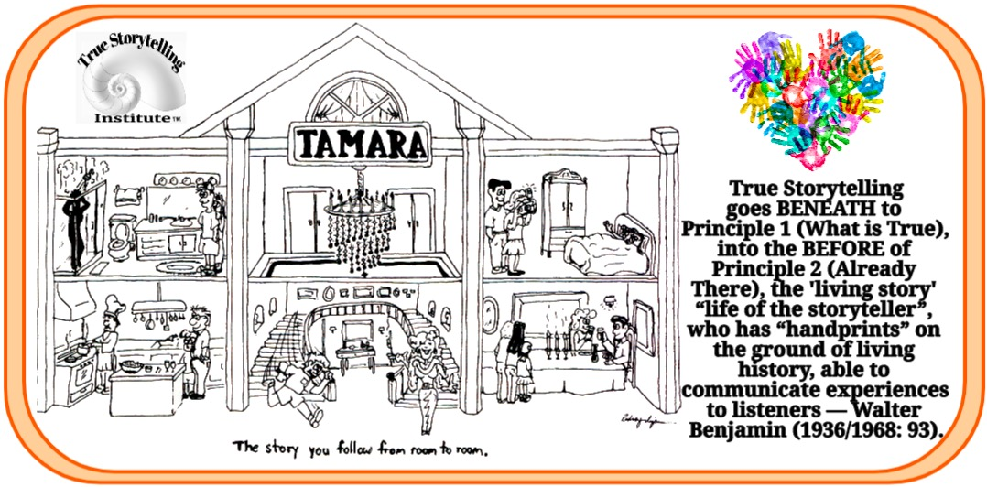
Tamara-Land is an analysis of Disney-Land (Boje, 1995). EXCERPTS: BEFORE Disney theme parks existed, premodern families went to medieval fairs, traveling circuses, and community and religious festivals. BEFORE - In 1919, Walt and Iwerks were equal partners in an enterprise called Iwerks-Disney Commercial Artists Company rather than something like Disney-Iwerks, a formulation that, Walt felt, made them sound like an optical firm. Ub Iwerks did 700 drawings a day, while Walt could do one (badly drawn). In the early 1900s, before Disney became partners with Iwerks, many animation studios "taylorized" cartoons. Like others in this industry, such as Max Fleischer, Gregory La Cava, Walter Lantz, Paul Terry, Raoul Barre, Charles Bowers, and Edwin Lutz, Walt Disney became an enthusiast of "scientific management." Eisner will invoke Walt's legend and then challenge it. Here Eisner discusses how there were no scripts at Disney for animated films before he took over:
I couldn't follow it. I'd go down there and they'd go through the storyboards. And you go through one storyboard and they'd bring in another storyboard. And I'd sit there for hours and I couldn't remember what was in the first storyboard. And it was a hard process for me to deal with. I'd been used to working in the script area.
And I was a little critical of some of our animated films that had been done before Walt died. Because I think there were great scenes but a lot of scenes put together. But sometimes the art of the story (as he motions his hands back and forth in an arc in the air) didn't follow the way I was used to thinking about stories, or what I learned in school about the construction of -- the stories and all that. More
Main Point: The corporate narrative is the official ‘grand narrative account’ however the microstoria of little people (like Up Iwerk) does not survive. Walt was an oral storyteller and did staging (P6) with storyboarding, whereas, for Eisner, scripts were written out, not orally or visually performed. In the article I am the epic-“history-teller” of definite events and the course of events of BEFORE (Benjamin, p. 97). In living story web of remembrance of every point of history is epic, and Tamara-Land you only experience a room at a time, and what I am taking into the epic-account is how people come to a particular room from many different sequences of BEFORE-rooms, so their take-aways are quite different.

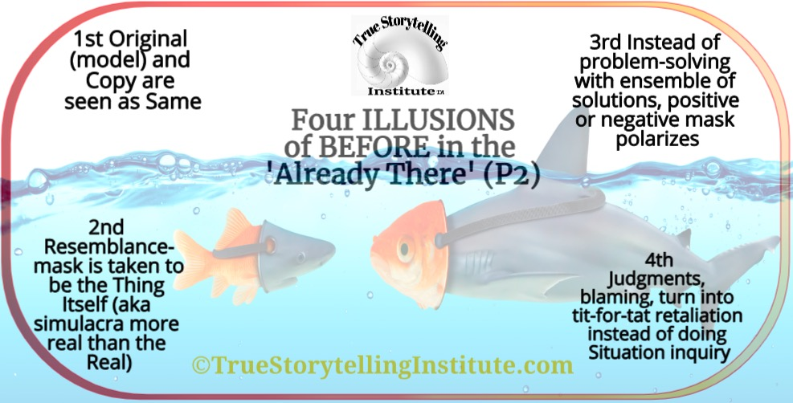
Fourth Slide 4 Illusions of the BEFORE in relation to P2 (Already There)
Based on Gilles Deleuze (1968/1994) Difference and Repetition. The BEFORE antenarrative is process always moving in the waves of rehistoricizing. A fish pretends to be a shark, while the shark pretends to be just another fish in the waters.

Possible Breakout Questions: What is the Truth of the BEFORE (model & copy)?
What is the Positivity of the BEFORE-Problem (copy becomes more real than original)?
The point of these questions is to get at BEFORE as problem solving, that is not the same as problem-fixing, and is not the “miscognized” reduction to SAME of identity narratives as “the negative takes wing” (Deleuze, 1968/1994: 269). The four Illusions of the BEFORE antenarrative process are all about the potential distortions in repetition and difference in conversational storytelling. A Level II Guide can facilitate in ways the are journey from the surface of dissension and strife to the problem solving of a positive dialectic. The four illusions of the BEFORE are all about the process of restorying that relates P2 What is Already There to the P4 Helping Story Along BECOMING by P6 Staging, a New BET on the Future P3 is gets its clarity of Plot, and P7 its BEYOND of embodied reflection.

Example: This relates to the 1st of 4 Illusions (model and copy are not the some), and Illusion 3 (the copy becomes more real than the real, a simulacra) (see examples of this simulacra, how leaders such as Colonoel Sanders, McDonald’s Brothers, and Sam Walton after they passes, became simulacra (more real than the real): Boje & Rhodes, 2005a, 2005b; Boje & Rosile, 2008).

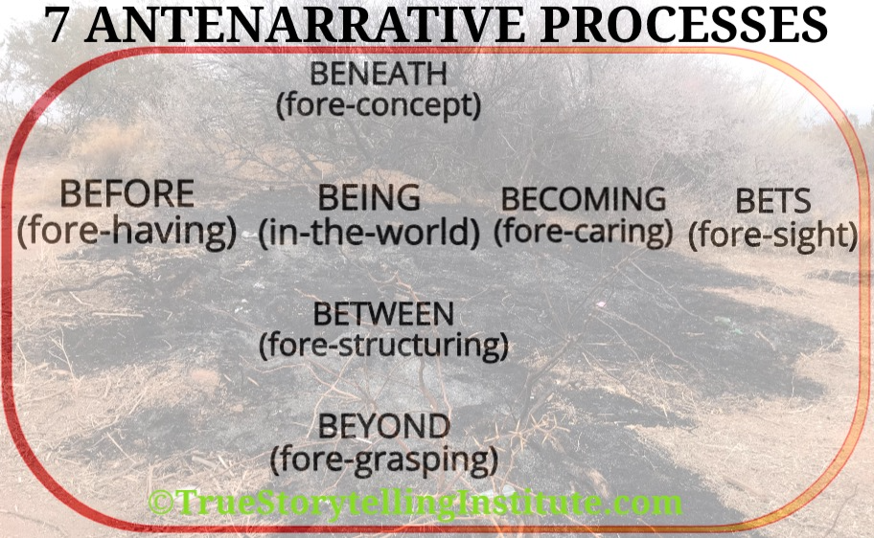
Slide 5: Tree Story of 7 Antenarratives (day of Inauguration Jan 20 2021)
Antenarrative is a Totality of Involvements within-the-World. Each Antenarrative, is antecedent to narrative and to story and Antenarratives relate to particular True Storytelling Principles. I took the above picture (the smoke still wafting, cinders too hot to touch) of the Tree burned on eve of Jan 20 2021, and then returned home to see the Inauguration. This is a story of the 7 Antenarratives. The fore-words are from Martin Heidegger (1962, Being and Time).

Slide 6 How BEFORE (P2 Already There) & BETS (P3 Plots relate: The Example of 4 Capitalisms
Question: What if here are at least 4 capitalism on the world stage today? Each has a BEFORE (P2 Already there), a retrospective history of itself and the Others (with opposite) BENEATH (concepts, motives, & values) as P1 (What is True). I will develop the example of 4-player chess to give an example of how the True Storytelling Principles have these Antenarrative Processes, in the gameplay of Global Capitalisms.
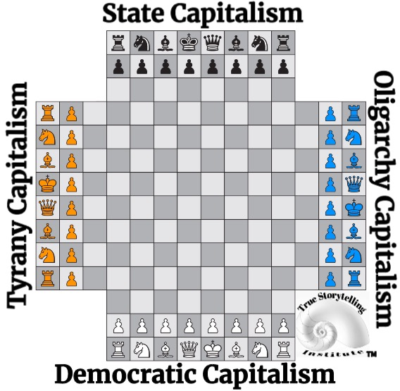
In Plato’s (360 B.C.) Republic, a State Capitalism (called Timocracy) had a military bent, and was quite authoritarian, but presented itself as heroic and honorable. Each capitalism presents itself linguistically as a Noun, and in its rhetoric history has particular adjectives, while the other capitalisms have the opposite (concept, value, motive) of these same adjectives. For this example I will list what Richard Wolff (2020) has as a list of adjectives various capitalism constitute in narratives of BEFORE (their history) and counternarratives of the other capitalisms’ BEFORE. Wolff’s contends that each of the capitalisms has 3 root problems: 1. Enterprises are organized undemocratically 2. Unstable business cycles of boom & bust recur (3 in the current century), and 3. Inequality of wealth & income.

Summary: At least 4 capitalisms play a kind of 4-player chess. Object: gain control of the center in game called Global Capitalism. Each Capitalism Plots (P3) itself as best solution to 3 problems & as the best BET ON THE FUTURE to solve (Wolff, 2020: iii-vi): 1. Enterprises organized undemocratically 2. Unstable business cycles of boom & bust 3. Inequality of wealth & income. Each Capitalism BEFORE claims the Other capitalisms are the worst solutions (P2 Already There) Each Capitalism (is a Noun) with 6 Adjectives to end: 1. racism 2. Unemployment 3. Sexism 4. Poverty 5. Inequality 6 Political corruption while Other Capitalisms, increase them.

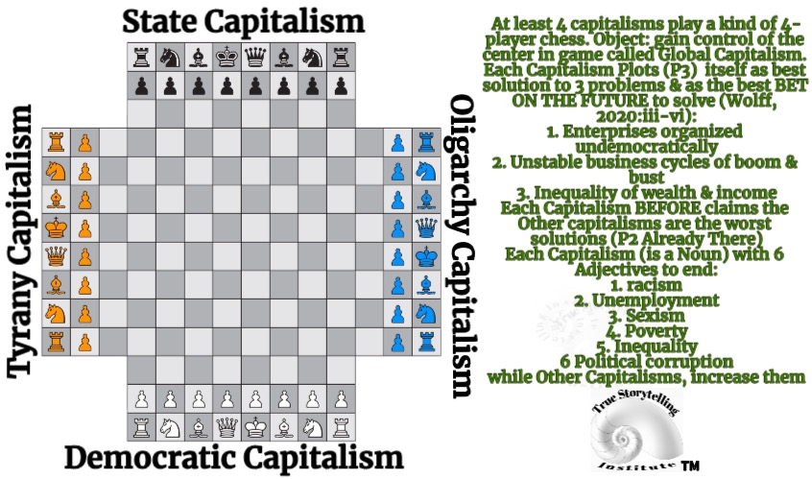
Slide 7: Annotate 4-player capitalism chess game on the world stage
For Plato, the four governmentalities are a one-way cycle: State (Timocracy) falls into Oligarchy, which comes undone by its own excesses, and falls into Democracy, which gets too many interest groups in play to sustain unity, which then falls into Tyranny. My main point of the 4-player capitalism chess game of strategy, on the world stage is simple enough. In Antenarrative analysis, we are especially skeptical about linear plots, and of histories of BEFORE, and Plots (BETS) that are exactly recurring cycles. Plato’s Republic begins in Aristocracy, then becomes a cycle of repetitions of the same four-phases. There are two other options that may be much more realistic: the spiral because the whorls vary in difference from one time to the next (P4 Timing) in BEING-in-the-World, here and now. The other option is the rhizome, in which all four (or even more capitalisms) are in game play at the same time, making sense of their own internal situation and what is happening (strategically) on the world stage as they PLOT (P3) and ‘ante-up’ with their BETS ON THE FUTURE.
Plato’s Republic Out of the Greek aristocracy of city states, emerged a perfect repeating cycle of governmental successions. First came the Timocracy (a State Capitalism) in which a lover of power and honor cultivated obedience to authority, but was good to place, though not that educated or eloquent. Ofter a good soldier rose to be leader of the Republic.

As Plato’s cycle-story (its PLOT) goes, when the treasury grew, so did the enterprises (what are now corporations) that could finance political elections. As Oligarchy emerged, the State and Corporation had common interests, but opened up a destruction of the wholeness (unity) due to wealth disparity (inequality). To stay in power, the Oligarchic Republic (its wealthy families) and wealthy enterprises, inevitably get too much into pleasure and the system falls sick with extravagant leisure for some, and poverty for the rest.

Democracy is seeded, as people become arrears of Oligarch’s greed and the wealth-disparity. There is a call for judgment, and justice. Plato foresaw that Democracy has its own Achilles Heel, such as when there is so much diversity the Republic cannot remain whole, and everyone begins to do as they please. It is common to keep the Democracy in play by flaming the allies on other forms of capitalism (such as State run capitalism, too penalizing and taxing of Oligarchy).

If and when Democracy becomes too unwieldily, there is a choice point, a return to Oligarchy (keep the banks and investors going), or a move to find a Tyrant to bring law and order.

Slide 8 – Phase-Space In P4 (TIMING) of BEING (ANTENARRATIVE PROCESS) SPIRAL of 4-Player Capitalisms
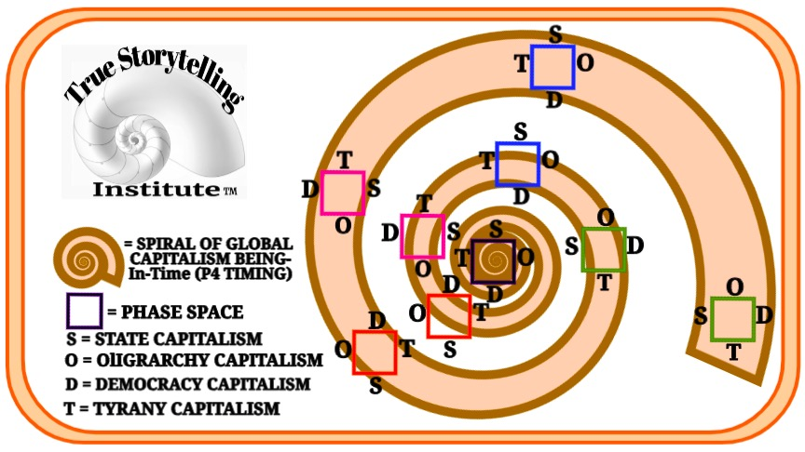
The four Capitalisms in gameplay of the BEFORE (P2 Already There) are encountered in-BEING (P4 Timing), in the process as the four capitalism’s “arbitrary initial conditions” (Prigogine & Stengers, 1984: 310) play out in-the-World we live. The Complex Adaptive Storytelling System of 4 Capitalisms evolves according to TIMING (P4) on a global scale, but we humans experience our BEING process on a much shorter time-scale. Our TIMING and BEING relationship, or storytelling experience of events changes in antenarrative processes (BEFORE, BEING, BECOMING, & BETS) that are the irreversibility (entropy, dissipative, devolving structures) of time, but there is also chance, the concentrative (centering, unifying, conjoining, evolving) possibilities emerge. There is no ‘True Storytelling” spiraling activity which is not already echoing the BEFORE (P2 Already There) in our conversational storytelling (Boje & Rosile, 2020; Larsen, Boje, & Bruun, 2021).

Slide 9 – True Storytelling of P4 Timing and the BEING antenarrative Process as Global Capitalism 4-player chess games phase-shifts to Rhizomatic process
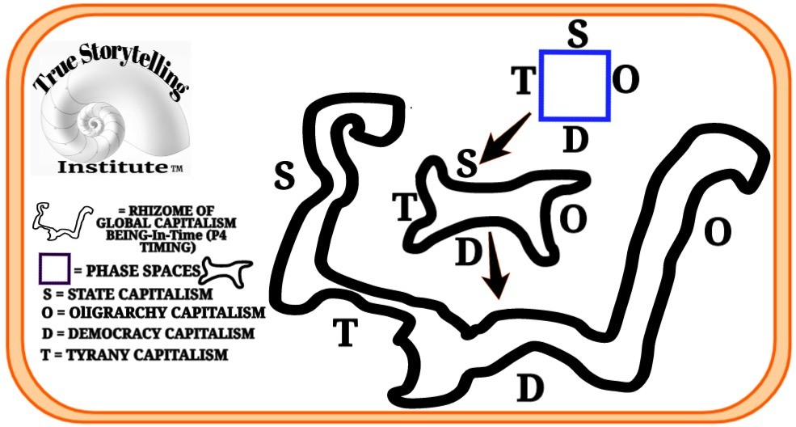
In Sum, for linear conception of capitalism’s progress narrative, we examined the cyclic narrative of repeating cycle of sameness, and in my view its not reality. Rather we have choice between spiraling-process of temporal understanding and the instabilities of rhizomatic phase-shifts of the dynamic storytelling system of global capitalism. The evolving chance possibilities for evolving (centring) can give us hope to balance out the instabilities (entropy) dissipative structures of four-player capitalisms on the global stage, in-BEING (Timing P4).
The next part is a case study about a Tree, to illustration all 7 principles and all 7 antenarratives.

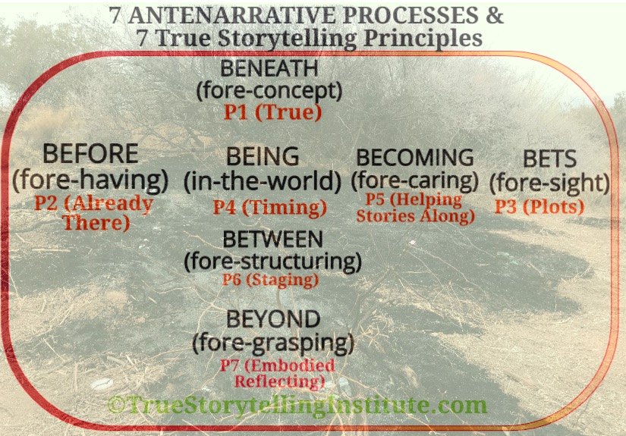
Slide 8: Simple Version of Relation of 7 Antenarratives with 7 True Storytelling Principles
Fore and Ante mean something already in advance and in relation to True Storytelling Principles. I use the 7 Antenarratives to get at the Whole ensemble of the Totality of involvements of what’s happening, with 7 True Storytelling Principles. That Ensemble of Antenarrative Involvements is already there, in the place I live, across the street from ‘Public Land’.

BEFORE (fore-having) has many historical events, P2 (already there).
BEFORE lies before us, already, as something potentially articulable, “for the first time” that is existential “constitutive state of understanding” what is “a priori” and “in every case this interpretation is grounded in something we have in advance – in a fore-having” (Heidegger, 1962: section #150). The BEFORE is potentially disclosable. I encounter the already-history, where I life.

BENEATH (fore-concept) is already in advance, there in thought/motive/value of P1 (What is True)
BENEATH (fore-conception) “does not understand in terms of a totality of involvements” and (#150) and this is the big problem for Guides of Principle 1 (What is True?). It is also the solution to the problem of Principle 1, to uncover what is BNEATH surface concept/value/motive to get to core values of Greek Square (which is a kind of IWOK). BENEATH is already in advance too, and it has connections to the BEFORE (fore-concepts).
Example: What is Multi-Use of Public Lands? Multi-use, I will claim, is “grounded in something we grasp-- in a fore-conception” (Heidegger, 1962: #150). There are many fore-conceptions of multi-use, and each institution, holds theirs to be True (Principle 1). This is a story of the ‘multi-use’ concept, of the Federal government of the U.S., and the history of this place where I life and call Home, and my fore-conception multi-use which is rooted in IWOK (my True: let us humans copy the model of Nature, since we already are Nature). The BENEATH of ‘multi-use’ is a concept in U.S. law (with its own history-BEFORE:
“… the Land Ordinance of 1785 and the Northwest Ordinance of 1787” for the settlement of the 13 U.S. colonies. In 20th century “the Mineral Leasing Act of 1920 allowed leasing, exploration, and production of selected commodities, such as coal, oil, gas, and sodium to take place on public lands” (IBID). The Department of the Interior (under each President’s guidance) has two bureaus: Bureau of Land Management (BLM), State Land Office (SLO), and I live across the street from an SLO parcel (about 300 acres).
In 20th Century, these two conceptions (BENEATH) of uses of public land were enacted in history of BEFORE, so a link of BENEATH to BEFORE is already there for this place where I live. The lease fee I am to be charge to have authority to do conservation is thousands of dollars per month, but if I was to graze cattle it would be $1.35 or so per cow per month. You can see the inequity (the grazing is heavily subsidized, but not so, to set up a conservation lease). There are two BEFORE and BENEATH links to make in telling this story of burning trees on Inauguration Eve. The first is grazing (which has a much longer BEFORE), and second is BENEATH-concept of ‘multi-use’ and its BEFORE (history):
A.) “The federal grazing fee is adjusted annually and is calculated using a formula originally set by Congress in the Public Rangelands Improvement Act of 1978. Under this formula, the grazing fee cannot fall below $1.35 per animal unit month (AUM), nor can any fee increase or decrease exceed 25 percent of the previous year's level. The grazing fee for 2014 was set at $1.35 per AUM, the same level as for 2013. Over time there has been a gradual decrease in the amount of grazing that takes place on BLM-managed land. Grazing on public lands has declined from 18.2 million AUMs in 1954 to 7.9 million AUMs in 2013” (IABD).
B.) “Public Rangelands Improvement Act of 1978 … Congress created a more unified bureau mission and recognized the value of the remaining public lands by declaring that these lands would remain in public ownership. The law directed that these lands be managed with a view toward "multiple use" defined as "management of the public lands and their various resource values so that they are utilized in the combination that will best meet the present and future needs of the American people”… “multiple use trails [are] used by motorcyclists, hikers, equestrians, and mountain bikers” (IBID.) and off-road 4-wheel motor vehicles.
In the 21st century, this recent history the BEFORE has this development, public land conservation is funded by coal, oil, gas, and fracking leases:
“On August 4, 2020, President Trump signed the Great American Outdoors Act into law, committing up to $1.9 billion from energy development revenues to the National Parks and Public Land Legacy Restoration Fund each year for five years for needed maintenance for critical facilities and infrastructure in national parks, forests, wildlife refuges, recreation areas and American Indian schools. The Act also committed $900 million a year in royalties from offshore oil and natural gas to permanently fund the Land and Water Conservation Fund investments in conservation and recreation opportunities across the country” (IBID).

BETS (fore-sight) ON THE FUTURE & P3 (Plots)
BETS (fore-sight) is a non-Western time, a time that arrives from the Future into the Present and Past. It is what I (Boje, 2001) call prospective sensemaking. Antenarrative is the total involvement-in-advance, in the 7 processes. Antenarrative makes distinctions between linear, cyclic, spiral, and rhizomatic plots of events.
Example 1: Multi-use I can see in advance – in fore-sight (Heidegger, 1962: #150) that since four trees (Sumacs) have been burned, and few are left unburned, the one remaining Hackberry Tree is quite vulnerable (i.e. a spiral scenario). It’s a BET, a fore-cast-scenario, a PLOT (P3), that instead of hauling in illegal dumping materials, Yahoos, will likely, most probably, just burn the existing living trees (changing their habit cycle of how bon fires happen, to an escalating spiral, just burn the trees already there).
Example 2: “The person who cuts off the first slide of bread gets the loaf ‘started’, the fore-sight – makes a start” (Heidegger, 1962: #150, footnote). The BET (foresight) is a linear progression plot (but reversed from usual past-->future), the FUTURE-time-in-advance, that hooks back into the Before (fore-having). Prospective sensemaking hooks back into Retrospective sensemaking, both already there. This is what I study in ‘quantum storytelling’ in which future-time is moving-in-advance into the past-time, and these both into present-time. It is not a linear PLOT of time events (Principle 3 of True Storytelling). In the book (Larsen, Boje, & Bruun, chapter 3) we try to get at all this with the notion of multiple futures (BETS) link back to P2 (Already There/BEFORE).
What will President Biden do with this BENEATH and this BEFORE? A naked tree, is present-at-hand, burning, on Inauguration Day (see photo above), the ashes of the smoldering trees, still burning on January 20, 2021. The Federal government, its State Land Office (SLO) puts one value on grazing and another on conservation (unsubsidized). I encounter these BENEATHs and BEFOREs as something “within-the-World” (Heidegger, 1962: #150), the tree “already has an involvement which is disclosed in our understanding of the world” burning (IBID.). My involvement of with Grandfather Hackberry Tree, as I call him is a tree at this same pond-site, but is not yet burning, and is already there. My concern is Grandfather Hackberry Tree is not only present-at-hand, it is already “ready-to-hand” to the next bond fire involvement (#150).

BECOMING (fore-caring) and P5 (Helping Stories Along)
BECOMING of care (fore-caring) is caring unconditionally. This is where (see Table 1, Embodied Restorying, the Little Wow Moments BEFORE, to counter a BENEATH (dominant narrative) by BECOMING (a new story out of Little Wow Moments). The BECOMING (Fore-Caring) is always done from a ‘point of view,’ and it can be in advance from BEFORE (fore-having something we have in advance, Little Wow Moments) or from BETS ON THE FUTURE (fore-sight, something we can see in advance), unveiled in Little Wow Moments of BECOMING. Something still veiled in Helping Stories Along (P5) into BECOMING by fore-caring is a major pivot point for Guides to do with people, families, groups, and or organizations.

BETWEEN (fore-structuring) and P5 (Staging)
To continue my example of the photo of the Tree burning. I took other photos of the preparations for the next fires. Foresightedly, (my BET) is already existing fore-structuring, there (BETWEEN) in the fire wood and broken branches already stacked-and-ready-to-hand, assembled in advance of the next bonfire. I assume Yahoos have a different BENEATH (fore-concept) of ‘freedom’ and ‘what is true’ (Principle 1) than the federal government, state sheriff, city and county codes officers (whose fore-conception) is tied to laws enacted by waves of history BEFORE, going back to the formation of 13 U.S. colonies, and their settlement.
Example: A supply chain, is a BETWEEN (fore-structure) of relations already there. The beer, wine, and liquor bottles in the fire ashes, and broken into the ground. These bottles and their contents are part of a supply chain. So are the plastic bottles of water, juice, and colas. In a deep sense, this is a clash between Nature (already there) and the Capitalism (production, consumers, suppliers, distributors) of the supply chain, and value chain (Boje & Jorgenson, 2020; Boje & Rana, 2020, both articles are about ecological supply chains). A supply chain is sociomaterial relations, and its within-the-world. As such, it is between Human Capitalism’s Activity System, and Nature’s Living Systems. The BETWEEN (fore-structuring) of two systems in strange relationship.
Question: How does History (BEFORE) relate to Nature in the (BETWEEN)? There are some who believe only Human Species has history, whereas, Nature has cycles of events. This notion of BETWEEN challenges Darwin’s (1859) evolution-theory of competition (has 45 references, not 1 for cooperation), as a copy of socio-economic model of human-competition, I.E., how human economic history works (e.g. Adam Smith’s Wealth of Nations) has one mention of “invisible hand” a person is “led by his own security” (p. 349); (competition references 130 times, and cooperation, just once). My point is the BETWEEN could look at cooperation in Nature, and Humans could copy such models in Biomimicry.

BEING (fore-given) Being-in-the-World
BEING (fore-given) is primordial processes, the already here and there (Dasein) in-the-World (Heidegger, 1962). BEING an antenarrative, means, stories and narratives are constituted out of stuff already there. For example, a narrative is “nover a presuppositionless apprehending of something presented to us” its a “fore-given” (Heidegger, 1962: #150, #150 footnote). BEING is not the empirical (that is the ontic). Rather, BEING is something veiled, and we do an uncovering, by going to deeper levels. Being is not just the now, it is the place, the here-and-now of a Situation. Things in the here-now, are either present-at-hand (such as some broken tool that is unusable) or ready-to-hand in a process such as in blacksmithing, a hammer that works, and is accessible, is ready-to-hand.
Example: The Trees (see photo) are already BEING-in-the-World. The trees are present-at-hand. Yet, if the concept of bonfire (BENEATH) changes to, burn trees ‘ready-to-hand’ in site, in the here-now, then BEING (fore-given) shifts. If trees are natural living systems of Nature, and if those are trees have entanglements of many other microscopic species (fungi, microorganisms, bacteria), and many species (birds, toads, rabbits) that are visible to us, then that presentment of bonfire-by-burning-live-tress is an existential shift.
Possible Breakout Questions: What if Humans are Nature and so are Trees? If Humans have history, do Trees and Nature have history? To just Be in the encounter with Tree-Nature, when we already are a species of Nature (homo sapiens), then it does seem strange to declare, as many have done, that only humans have history (BEFORE), whereas the BEFORE for all other species (micro & macro) is just cycles of repetition, by some evolution.
R. G. Collingwood lectures 1926-1928 (revised edition, 1993” 113) looks through many theories of history, says Hegel proposes a “new kind of history” that is distinct form merely empirical facts, in which history exhibits progress. BET (P3 Plot) is that ‘freedom’ develops which is a moral reason of the BEYOND (fore-grasping). Hegel refused to approach human history by way of nature (Collingwood, 1993: 114). In other words, Hegel is not doing Biomimicry (humans imitating Nature’s living systems of cooperation). The importance of this is “Heal flatly denies the evolutionary their whick makes the higher develop in time out of the lowere, asserting that people who believe this are mistaking a logical succession a a temporal one” (IBID.).
The point of the Tree Example: Human History never repeats itself in duplicative cycles, rather it is Nature that has repeating cycles (birth, maturity, death), whereas human history spirals (one whorl of a spiral is slight different from the succeeding whorl) because Humans beings enact logic, and the cycle changes into spiral, with the logic changes. Differences matter, and humans may try for repeating cycles (e.g. product development cycles, organizational development cycle models), but human socioeconomic systems, usual get spirals (whorl after whorl of difference in the repetitions), most every time, most every place.
But is Hegel mistaken, stating it wrongly that humans spiral, and Nature has its cycles of repetition? Are there not historical processes of Nature, an evolving and devolving, as in Climate Change of Anthropocene? (Boje, 2019b). Collingwood, 1993: 115) concludes about Hegel in ways the relates BEING and BECOMING:
“He is right to distinguish the non-historical processes of nature from the historical processes of human life, but wrong to reinforce this distinction by denying the doctrine of evolution… But it remains true that of nature is different from the process of history.”
Since Darwin most are convinced the processes of history resemble to processes of Nature. In antenarrative theory, however, there are differences of Being-a-cycle that repeats a process and event-stages of development, again and again, versus a spiral that has differences in the whorl with each repetition. The COVID-19 is mutating with each repetition in time, a material difference in the DNA of the virus spreads globally, place to place.

BEYOND (fore-grasping) is Intuitive (6th Sense, I-3)
BEYOND (fore-grasping) is done by intuitive sense, not by the 5 senses (see, hear, smell, taste, & touch). Many animals have a 6th sense, such as how bats have sonar, and migrating Swainson Hawks, and Monarch Butterflies and migrate thousands of miles. In humans, BEYOND is intuitive, a flash of insight, and not something done by mind or heart inner dialogue or by speech acts. In Boje & Rosile (2020) we link BEYOND to abduction (spontaneous guess, in the moment), that we recommend gets checked out with inductive tests, as you go about making deductive (theories. We call it a Peircean triad of Abduction-Induction-Deduction (AID). There is another sense of the BEYOND that is more mystical, and about the mind-body-spirit, with sprit (as in Hegel) the 6th sense. Hegel’s (1807) Phenomenology of Spirit.
“If we look at the appearance of such a demand in its wider context, and consider the stage at which self-conscious spirit stands at present, it is clear that spirit has now advanced beyond the substantial life it formerly led in the element of thought,—beyond this immediacy of its faith, beyond the satisfaction and security of the certainty that consciousness possessed of its reconciliation with the essence and of the universal presence of the essence both within and without” (Hegel, 1807: Preface, p. 7 #7)
Hegel’s BEYOND is different from Kant (who makes a strict divide between BEYOND and WORLD. For Hegel the Spirit can intrude and realize in-the-World, not as ghost, but as reason, which people can access.
“The spirit is clearly so impoverished that, like a wanderer in the desert longing for a simple drink of water, it seems to crave for its refreshment only the meagre feeling of the divine in general. The extent of spirit’s loss is to be measured by what satisfies it” (Hegel, 1807: Preface, p. 8 #8).
The relation of AID, the Peircean BEYOND of abduction to BEYOND of spirit of Hegel, is that both allow for mysticism to mingle with reflection. This is why I locate P7 (reflect) with the A7 (BEYOND).
Next, the embodied restorying process.

7 Embodied Restorying Process (ERP) in relation to BEFORE
The BEFORE nexus with P2 Already There, is where to find ‘Little Wow Moments’ that can become (BECOMING) new story BETS ON THE FUTURE, and a new grounding, a re-grounding of the BEFORE.

Table 1: 7 STEPS of Embodied Restorying Process (ERP)
1. Characterize (received Person/Organization identity) from how other persons/organizations are telling the BEFORE.
2. Externalize (re-label to an artifact, material object) Make the Problem the Problem, not the Person as the (root) problem (often ‘sick’ system is the problem, not the person).
3. Sympathize (benefits) – of old BEFORE story/dominant-narrative of or your Self or organization that has its payoffs in the present.
4. Revise (consequences) – What are the negative consequences, including the stereotypes (prejudices) of received person &/or organization identities, of this BEFORE still evoked?
5. Strategize (Little Wow Moments of exception to Others' dominant master narratives of BEFORE); Guide to reclaim Little Wow Moments of memory from their BEFORE
6. Restory (rehistoricizes the old dominant narratives in BEFORE by collecting Little Wow Moments BEFORE (aka multiplicity of positivities) into A 'New Story' of there several possibility futures, to free up FREEDOM of CHOICE), to not be stuck in the past-BEFORE, reliving one event in endless loop (e.g. PTSD flashbacks)
7. Publicize (support networking) e.g. letter writing, social media, celebratory events with supporters of there very own ‘New Story’ of future and potentiality, so they stay in the ‘new world’ instead of STUCK-in-the-BEFORE) repeating that loop.

References for Antenarrative & True Storytelling Principles
Boje, D. M. (1995). “Stories of the Storytelling Organization: A Postmodern Analysis of Disney as ‘Tamara-land.’” Academy of Management Journal. 38(4): 997-1035. https://davidboje.com/vita/paper_pdfs/AMJ_Disney.pdf
Boje, David M. (2019a).Organizational Research: Storytelling In Action. London/NY: Routledge.
Boje, David M. (2019b) Storytelling in the Global Age: There is no Planet B . Hackensack, NJ : World Scientific Publishing.
Boje, David M.; Jorgensen, Kenneth Mølbjerg. (2020). A ‘storytelling science’ approach making the eco-business modeling turn. Journal of Business Modeling, Vol. 8, No. 4, pp. 8-25. Click here for pre-press pdf. Please Click here for final print version PDF

Boje, David M.; Rana, Mohammad B. (2020). Defining a Sustainably-Driven Business Modeling Strategy with a ‘Storytelling Science’ Approach. Chapter to appear in Markovic, S., Sancha, C. and Lindgreen, A. (Eds.), Handbook of Sustainability-driven Business Strategies in Practice, Northampton, MA: Edward Elgar. Click here for pre-press pdf.

Boje, D. M. & C. Rhodes. (2005a). The Leadership of Ronald McDonald: Double Narration and Stylistic Lines of Transformation. Leadership Quarterly Journal Vol 17 (1): 94-103. see pre-publication draft at http://davidboje.com/McD/papers/Ronald_McDonald_LQ_2005.pdf
Boje, D. M., & Rhodes, C. (2005b). The Virtual Leader Construct: The Mass Mediatization and Simulation of Transformational Leadership. Leadership Journal, Vol 4 (1): 407-428. http://davidboje.com/McD/papers/Fast_Food_Virtual_Leadership _Boje_Rhodes.pdf
Boje, D. M.; & Rosile, Grace Ann. (2008). Specters of Wal-Mart: A Critical Discourse Analysis of Stories of Sam Walton’s Ghost. Critical Discourse Studies Journal.Click here for pre-press PDF version. Full journal article pdf
Boje, D. M.; Rosile, G. A. (2020). How to Use Conversational Storytelling Interviews for Your Dissertation. UK: Edward Elgar Publishing Ltd. Download for free until published in 2020
Boje, D. M.; Sanchez, Mabel. (2019a Eds.). Quantum Storytelling Consulting Handbook. London: Emerald Press. Click here fore pre-press of PREFACE pdf. Chapter 1: Ensemble Leadership by Boje, D. M. Click here fore PDF. London: Emerald Press.
Boje, David M.; Sanchez, Mabel. (2019b Eds.). Handbook of Management and Organizational Inquiry. London: Emerald Press.
Boje, D. M., Svane, M., Henderson, T. L., & Strevel, H. B. (in press). Critical corporate social responsibility in tamara-land: The role of tetranormalizing fractals. In R. Ocler (Ed.), Book chapter for a Springer collection, Rodolphe Ocler (ed.). http://davidboje.com/vita/paper_pdfs/CSR%20Chapter_16_March_2015.pdf
Boje, M., & Svane, M., Gergerich, E. (2016). Counternarrative and Antenarrative Inquiry in Two Cross-Cultural Contexts. European Journal of Cross-Cultural Competence and Management, Vol. 4, No. 1, 55-84. Pre-press draft available at http://davidboje.com/vita/paper_pdfs/CHAPTER_Fractal%20change%20management%20and%20counternarrative%20in%20crosscultural.pdf
Boje, D.M., Rosile, G, Dennehy, B, & Summers, D.1997. "Restorying reengineering: Some deconstructions and postmodern alternatives." Special Issue on Throwaway Employees, Journal of Communication Research.24(6): 631-668.

Deleuze, Gilles. (1968/1994). Difference and repetition. French, 1968. Columbia University Press. Online at Academia.com, accessed Jan 20, 2021 click here for PDF.

Flora, Jeanne; Boje, David M., Rosile, Grace Ann; Hacker, Kenneth. (2016). Journal of Veterans Studies. Vol 1, No 1 Theoretical and Applied Review of Embodied Restorying for Post-Deployment Family Reintegration ABSTRACT The purpose of this paper is to introduce the theory and application of Embodied Restorying Practices (ERPs), an intervention designed to promote military family reintegration.

Heidegger, M., Macquarrie, J., & Robinson, E. (1926/1962). Being and Time. Larsen, Jens; Bruun, Lena; Boje, D. M. (2021). https://www.mta.ca/uploadedFiles/Community/Bios/Cyril_Welch/Heidegger.pdf or http://pdf-objects.com/files/Heidegger-Martin-Being-and-Time-trans.-Macquarrie-Robinson-Blackwell-1962.pdf True Storytelling. London: Routledge. Accessed online Jan 20 2021, first in German 1926
Hegel, Georg Wilhelm Friedrich Wilhelm. (1807). Phenomenology of Spirit. See online version (Oxford Press) http://ns210054.ovh.net/files/Georg%20Wilhelm%20Friedrich%20Hegel%20-%20The%20Phenomenology%20of%20Spirit%20(Michael%20Inwood%20Translation).pdf
Hegel, Georg Wilhelm Friedrich (1817). Encyclopedia of the Philosophy of Science. Accessed online version https://hegel.net/en/pdf/Hegel-Enc-1.pdf g through untold method. Pp. 213-238 in Michal Izak, Linda Hitchin, and David Anderson (Eds.) Untold Stories in Organizations. NY/London: Routledge (Taylor & Francis Group).
Kirkeby, Ole Fogh. (2009). The New Protreptic: The Concept and the Art. Copenhagen, Denmark: Copenhagen Business School Press.
Larsen, Jens; Boje, David M.; Bruun, Lena. (2021). True Storytelling: Seven Principles for an Ethical and Sustainable Change-management Strategy. Routledge.
Plato's Republic (360 B.C.) Online text, Translated by Benjamin Jowett, accessed Jan 13 2021 at https://www.fulltextarchive.com/pdfs/Plato-s-Republic.pdf
Rosile, Grace Ann. (2016). Tribal wisdom for business ethics. London, UK: Emerald Group Publishing Limited.

Rosile, Grace Ann; Boje, David M; Herder Richard A.; Sanchez, Mabel. (2021). The Coalition of Immokalee Workers Uses Ensemble Storytelling Processes to Overcome Enslavement in Corporate Supply Chains. Business and Society. Business & Society, Vol. 60(2) 376–414. Click here fore pre-press pdf.

Sartre, Jean-Paul (1960/2004) Critique of Dialectical ReasonVOLUME 1: Theory of Practical Ensembles. Translated by Alan Sheridan-Smith, edited by Jonathan Ree, foreword by Fredric Jameson. First published as Critique de/a Raison Dia/erfique by Editions Gallimard, Paris 1960. This translation flrst published by New Left Books1976© Editions Gallimard 1960 Translation © New Left Books 1976 Corrected edition, first published by Verso in 1991 based on the revised French edition of 1985© Editions Gallimard 1960, 1985.This edition first published by Verso, 2004.

Schumpeter, Joseph A. (1942/1976). Can Capitalism Survive: Creative Destruction and the future of the Global Economy. Originally published, 1942, as Capitalism, Socialism and Democracy. 1976, published by NY: NY: HarperCollins Publishers.

Svane, M., & Boje, D. (2015). Tamara land fractal change management – in between managerialist narrative and polyphonic living stories. Sc’Moi, Standing Conference for Management and Organizational Inquiry, Las Vegas. Accessed Jan 21 2021 at http://vbn.aau.dk/ws/files/225730097/Tamara_Land_Fractal_Change_Management_Las_Vegas_Paper.pdf

Svane, M.; Gergerich, Erika M.; Boje, D. M. (2016). Fractal change managment and counter-narrative in cross-cultural change. Pp. 129-154 in Kuhn, Timothy, Mariann Wolff Lundholt, and Sanne Frandsen (Eds.) Counter-Narratives and Organization. NY/London: Routledge.Boje, D. M. (2018). Sandtray embodied restorying quantum storytelling. Pp. 113-116 in in Rixon (ed.)The Story Cookbook: Practical Recipes for Change. UK: Cambridge Scholars Publishing.

Wolff, Richard D. (2020). The Sickness is the System: When Capitalism Fails to Save Us from Pandemics or Itself. Edited by Liz Phillips & Maria Carnermolla. NY, NY: Democracy at Work.

Source accessed Jan 23 2021 at https://en.wikipedia.org/wiki/Bureau_of_Land_Management#History

