For Guides Only: A Protreptic Guides of 6 Eventums of True Storytelling
David M. Boje
Jan 28, 2021; revised Jun 5 2021 (newest version)

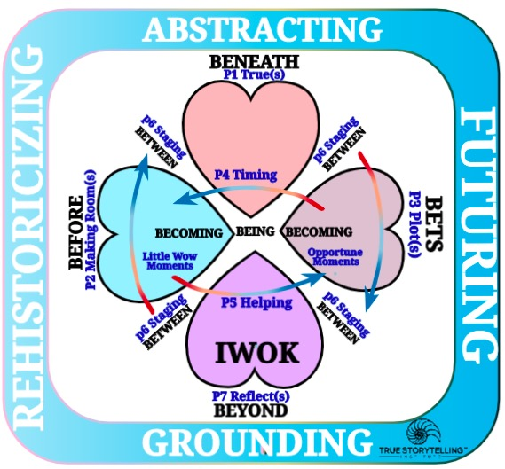
BREAKING IT DOWN – One Heart at each EVENTUM (process of eventing = verb not a noun)

We will take a journey into the EVENTUM of Guiding, one heart at a time, then go into the in-BETEEN. BEING is defined as an uncovering of 4 Hearts and their in-Between, as we journey from Debate and Difference Histories to 5 Dialogisms of True Conversational Storyteling.

We begin our journey with the BEFORE-Heart.
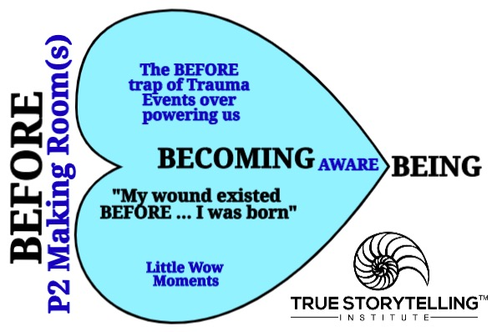
The BEFORE-Heart Tool for Guides Only
Little Wow Moments happen to us, and get over-powered by trauma events, so we can enter BECOMING-aware by RESTORYING the past, reclaiming Little Wow Moments (Priciple 5, Helping [new] Stories BECOMING our Future potentiality.

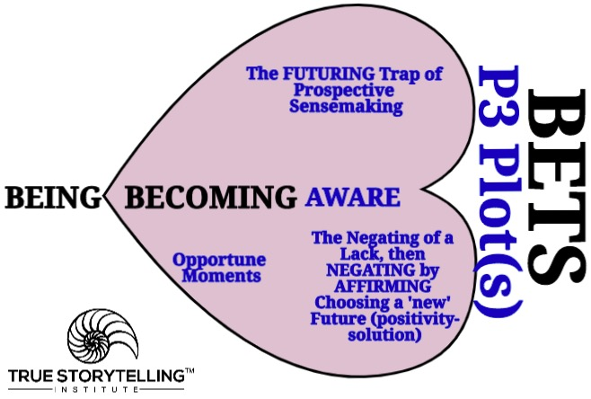
The FUTURING-Heart for Guides Only
The Futuring-Heart makes bets on the future (it is plotting) by an eventing of ‘Negation of the Negation’ → a lack in 1st Negation, an Affirming of a Future-choice, in 2nd Negation, and so on and so on. The Future is BECOMING into BEING (here & there spacetimemattering)!

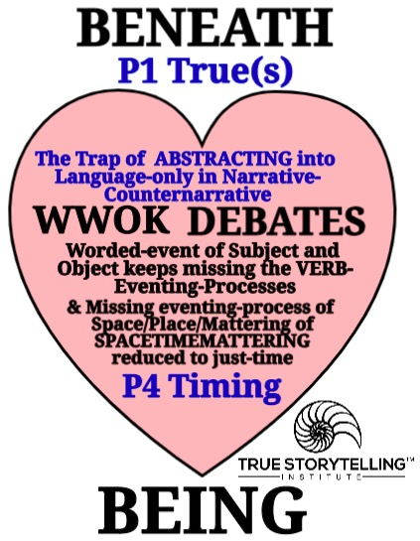
The ABSTRACTING-Heart of Guides Only!
Abstracting into worded-event in WWOK’s endless debates, is missing the eventing processes of spacetimemattering, that reduces BEING to just Time by erasing space/place/mattering is groundless and heartless, by itself.

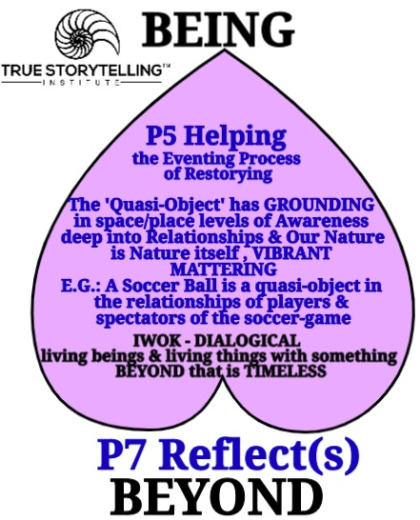
The BEYOND-Heart for Guides Only!
In IWOK, is a relation of BEING & BEYOND that is called by Boje and Pelly the ‘relational process ontoogy’ and eventing-process that goes deep BENEATH WWOK-word gaming into the spacetimemattering of the ‘vibrant mattering’ (Jane Bennett’s 2009) ‘onto story.’ In Embodied Restorying Process the material objects have vibrant energy aliveness in relation to the Intuitive participant’s work with artifacts, assembling artifacts into ensembles, in order to, develop awareness so the P5 Helping ‘new’ Story Along opens a space of freedom for a choice among futures. Here is where spacetimemattering meets in their indivisibility and inseparability.
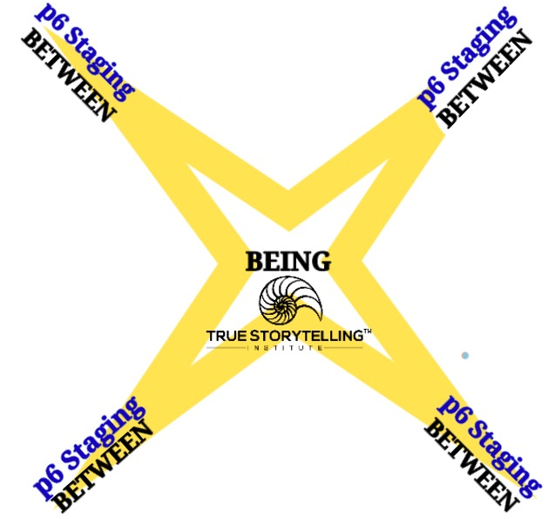
The BETWEEN (Staging) Tool is GUIDES ONLY
What is the in-Between. It is the relation of the BETWEEN (fore-structuring in-advance) as Guides prepare a way to get to the Essence of BING in its spacetimemattering. Guiding BETWEEN the 4 Hearts takes great understanding of the eventing-process is NOT an event (noun), it’s a verb-process, that gets worked out in the storyboarding, and in breakouts using DIALOGISMS, sometimes using Negation of the Negation process of practical ensemble work. 1st Negation (lack gets fulfilled), then 2nd Negation (a positivity created out of a Future-potentiality), is an Antenarrative Process of Prospective Sensemaking (Futuring arriving in fore-sight). It is also Restorying finding little wow moments of BEFORE to go BACK TO THE FUTURE, into choices of futures not in awareness of prospective sensemaking work guides facilitate.
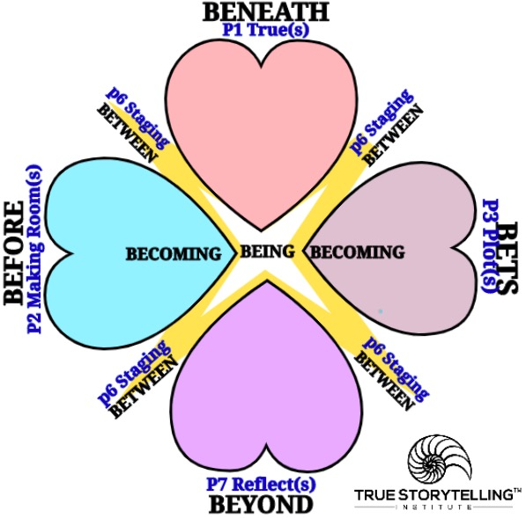
The BETWEEN Tool for Guides Only!
What is in-BETWEEN the 4 Hearts of True Storytelling?
It is where all that storyboarding pays off for participants.

In Sum: In each chapter of True Storytelling book, one principle is highlighted. The 7 antenarratives processes themselves are there too, but are not listed, for simplicity sake, for participants. Guides get both the 7 Principles and the 7 Processes, and in this handout, the Practicalities. The 3 P’s are in the NEW Figure above. For the 3rd P (practicality), you will need to learn how to guide from WWOK to IWOK, and from divisiveness dialectic of narrative-counternarrative polemic debating, into the dialogisms of living stories. It is a move Guides make from Abstracting junk to the Grounding in the ontological.
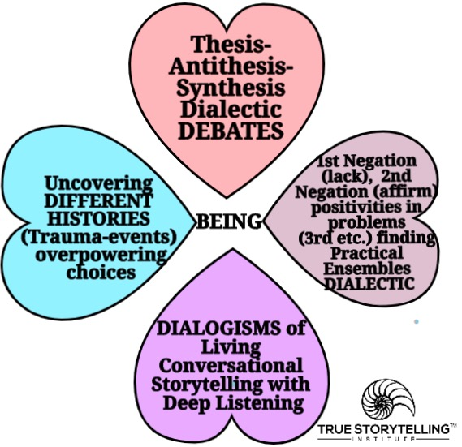
Four D’s of 4 Hearts and The Guide Moves from Debates and Different Histories into the Ensemble Dialectic and into the 5 Dialogisms of True Conversational Storytelling Deep Listening

Protreptic Guide guides the hearts where they agree to go.

“The protreptic must care absolutely for the other person” (Kirkeby, 2009: 88). Thus, the Protreptic Guide must be sincerely kind, to assist the other “never to judge” him or her (IBID.).

Question: What happens if a Protreptic Dialogue is about to turn catastrophic (such as a debate)?

If the Protreptic Guides loses control of what is happening, or just feels something that cannot be controlled is eventing approaching, and does not act in time, then the event of dialogue, its reflective processes breaks down, the Protreptic Guide must be the facilitator of the process of liberation (p. 89).
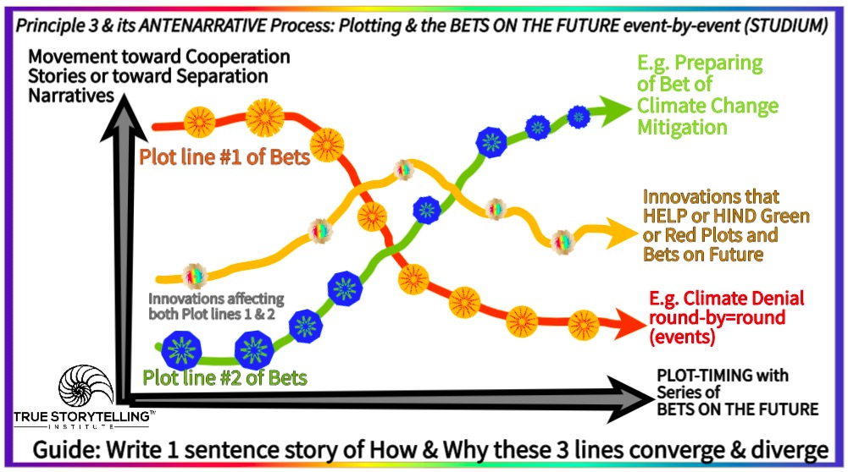
In Session 3 we looked at How to Guide Plot-construction, and the BETs-process of antenarrative.
I asked you, What is factorial of just one round of telling & listening in a breakout room?
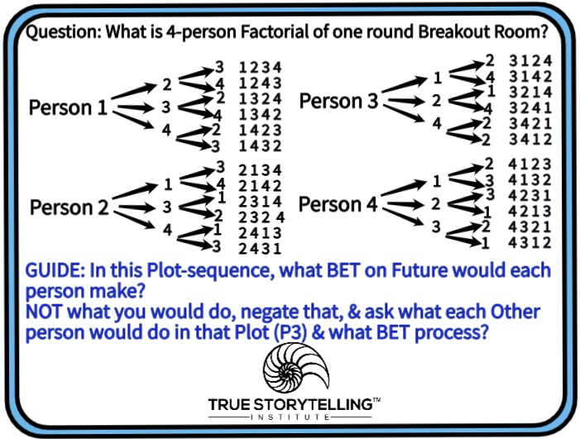
The answer: 24 is presented in the 4-person breakout tool.

This study guide for GUIDES ONLY, is about the new version of how Guiding a Protreptic Dialogism works, and how it is not a Debate, and not a Dialogue (as in Bohm Dialogue Circles). The 7 Antenarrative Processes and the seven True Storytelling Principles, go together hand-and-glove with Practical development of solutions to problems participants bring to the table. Both old and new tool maps of principles and processes have spacing (vertically) and timing (horizontally) dimensions. The two dimensions are TIME (on horizontal (goes both ways), and SPATIALIZING-SYSTEM on the vertical (from Parts to Whole is the Guiding happening in sessions and in client consultations.). The learning in this handout is space is never without timing, and timing is never without spatializing parts or to whole systems in the storytelling eventums (a new term from Kirkeby, explained below).
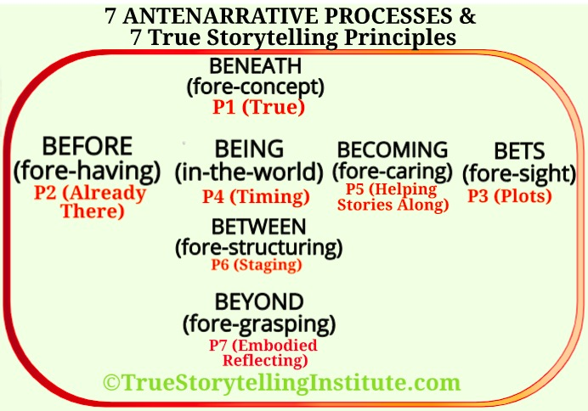
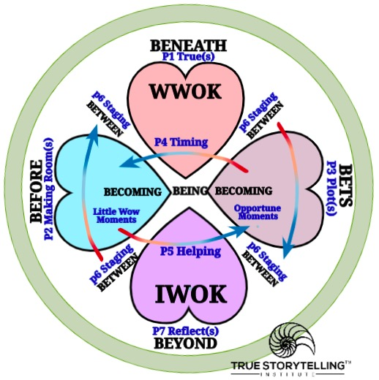
Old 7 principles & 7 Processes, and one just for Trainer of Trainers Guides

First Difference: In the new 4-Heart tool, TIMING (P4) moves in both directions (Retrospective Sensemaking & Prospective Sensemaking of antenarrative process)[chronos of clock time, and kairos of opportune moments]. BEING (P4 Timing).

Second big difference is to have at least four BETWEENS (P6 Staging of storyboard, between hearts). For example WWOK, have to do unidirectional past→present→future, but TIMING by Kairos moves future→present→>past. IWOK is more cyclic and spiral time/space, and WWOK is more linear timing, and very Beginning, Middle, End plotting of its storyboards (BETWEEN). Third, BEING is not just Timing, it is also Space (place), Matter (mattering), and these three are inseparable in-BEING-in-the-World.

Third point BEING is not only timing it is spacing and it is mattering, all are Primordial in what Ole Kirkeby (2009: 131-135) calls the six “eventums” of a Protreptic Guide, guiding and shaping a Protreptic Dialogue of conversational storytelling (Boje & Rosile, 2020) that is True Storytelling (Larsen, Boje, & Bruun, 2021).

Let’s us begin with the main points
1. Time has been divorced from Space and both divorced from Mattering, so BEING can be defined as uncovering the inseparability of SpaceTimeMattering-in-the-World we live in.
2. SpaceTime are inseparable, but without Mattering,
3. Mattering gets left out
4. In Quantum Physics SpaceTimeMattering are inseparable, anything else is illusion of metaphor

Next a look at just spacetime, but please keep in mind mattering is lurking there too, as we shall see in the chronotope dialogism.

The point is the 10 chronotopes of spacetime are interactive, additive, and cumulative in our existence, but the narrative word-work seems to focus just on time defining space, and time exploiting mattering. So Bakhtin sets out to do something never done before. Instead of typology, slotting and sorting into different (make one choice in 10), he lets them all interact in the chronotopic dialogism.

Keep in mind, Bakhtin went against all dialectics and all debates. His focus was on letting the chrnotopes interplay and interanimate. His big deal contribution is a system understanding called Heteroglossia (one force centers, the others unravels; aka centripetal and centrifugal forces).

So free your mind to let the chronotopes be dialogical in storytelling. It is a relational ontology process’ (RPO, Boje, 2019 book) of eventing as Kirkeby might call it, and work I do with Duncan Pelly on Mary Parker Follett’s RPO.
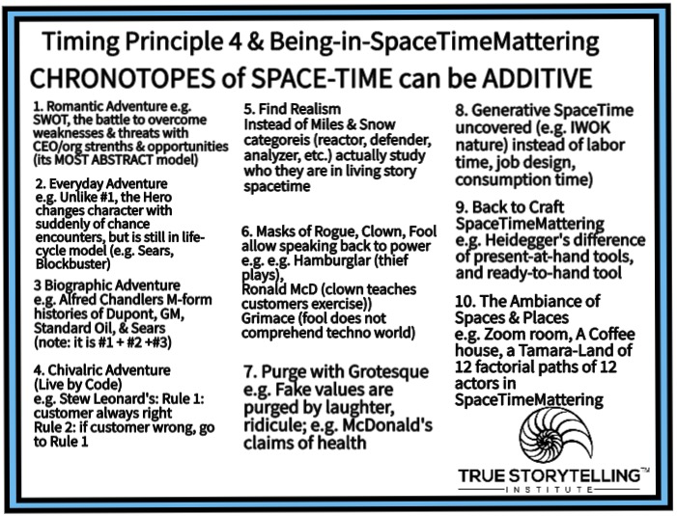
This is based on Bakhtin (1981) and on my book on storytelling organization strategy (2008). I put in some simpler labels. It combines 10 ways of SpaceTime (Spatializing and Timing together with Mattering) are in-BEING. #1 begins in something, common in organizations, but very abstract (SWOT) where tough CEOs never change character (don’t grow), but in #2, the adventure begins grounding as chance comes into play and people change their character Self & energy, #3 gets combined with 1 &2. Point is the 10 work in combinations. This is not choosing which of the 10, it is looking for how to combine what is there to transform by TIMING and BEING.

Please read Boje, David M.; Jorgensen, Kenneth Mølbjerg. (2020). A ‘storytelling science’ approach making the eco-business modeling turn. Journal of Business Modeling, Vol. 8, No. 4, pp. 8-25. It shows how to implement consultation to Eco-Business Modeling value chain as emplotment and Bet on fture Please Click here for final print version PDF
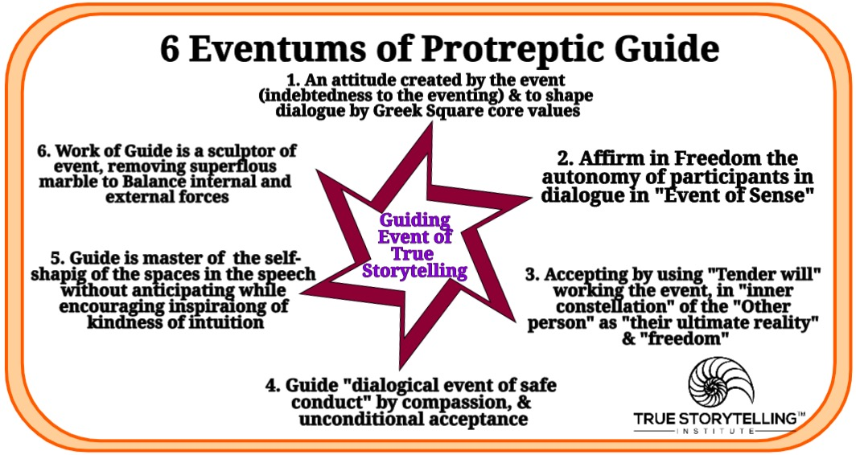
Above are the 6 Eventums tool, just for Train the Trainer Guides.True Storytelling can be compared to three other approaches using the 4 D Tool.
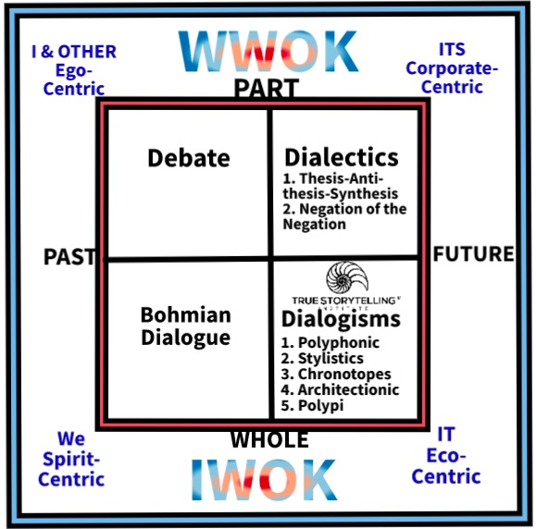
- I & Other is divisive (Debate); both Dialogue and & TSI move away from this
- ITS is Corporate-Centric, seeing everything as a resource (humans are resources, nature is a resource, …). Everything is a bunch of Its (parts in search of a whole). Both Dialogue and TSI Dialogisms move away from this
- IT of Eco-centric. Everything is a whole ecology, including humans (not spirit). This is science.
- WE – is Spirit-Centric, Everything is spirit (rocks, trees, rivers, mountains).
Note: I, ITS, IT, and We are applying Ken Wilbur’s work.

Bohmian Dialogue is leaderless groups (now on Zoom) doing leaderless projects (sometimes). True Storytelling uses Dialogisms as its Whole System Storytelling approach to guide participants from Parts to Wholes, and into practical results. Both move out of Debates.
We will return Bohmian Dialogue and True Storytelling Dialogisms. First, we will develop how BEING and Timing (P4) are related. For now you need to know that Bohmian Dialogues are leaderless groups, and True Storytelling has Protreptic Guides using 6 eventums.

The Primordial Disclosure of BEING as a Whole with Timing Principle 4

Next, I want to make a connection of BEING antenarrative process of the Whole System, and the Timing principle #4 of True Storytelling, eventums in a place, in a time, in mattering (all inseparable). Martin Heidegger’s (1926/1962) BEING and TIME could be called BEING and TIMING. The Being and Time book begins and ends with Hegel’s (1807) Phenomenology of Spirit and with Hegel’s (1817) Encyclopedia essay. Heidegger finds Hegel’s treatment of timing and of BEING of spacing problematic in both works.

All 7 Antenarratives and all 7 True Storytelling Principles help the Protreptic Guide to understand what Heidegger is amending in Hegel. It is important because a Protreptic Guide is facilitating a Protreptic Dialogue, in all its 6 eventums.

The Point: The 7 Antenarratives are all processes of existence in which Principle 4 Timing and is inseparable from Spacing and Mattering, all 3 inseparable together, in the quantum storytelling of ‘spacetimemattering’ without any dashes or separations. This next image is in the 2021 True Storytelling book in every chapter, to show the relationship of 7 antenarratives to 7 principles.

Heidegger thinks Hegel gets lost in BENEATH abstracting concepts (reifying timing & spacing, & lets add mattering to the list), thereby losing all GROUNDING. To reify is to treat a subjective-concept as a METAPHOR, making it something objective. Boje and Heidegger don’t do metaphors!. Secondly, Hegel has several awesome notions, but besides reifying, he makes a non-quantum leap into the BEYOND. Heidegger introduces 7 (already there ‘fore’) notions, Boje defines as ‘antenarrative processes’ in his own writing from 2001 to 2021. Keep in mind Principles and Processes already there, go hand-and-glove in True Storytelling facilitation.

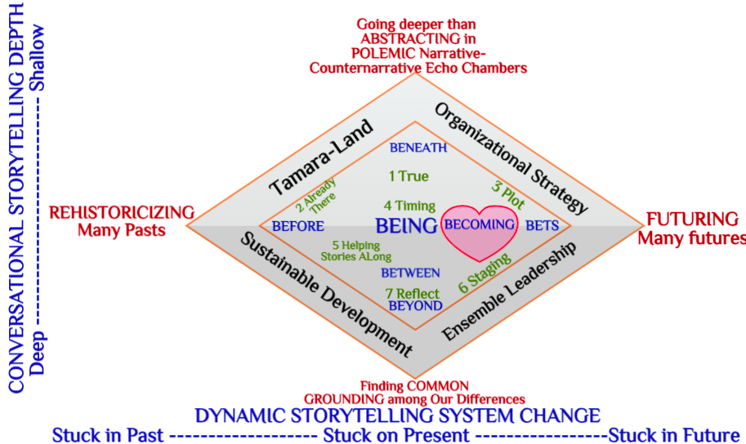

Above the two dimensions are visible with all 7 antenarratives related one-on-one to all 7 principles. This is a gross 1-to-1 oversimplification, but its simple enough to explain, and its a tool to start a diagnosis of conversations and of organization change dialogues.
Spacetimemattering is already there in-the-World in the eventums (Kirkeby, 2009) that Guide implements for guiding (shaping) Protreptic Dialogue events so that Greek Square (p. 50) core values are uncovered explicitly by the participants (see Train the Trainers, session 1 slides).

Heidegger, by contrast to Kirkeby, focuses on spacetime[let’s add mattering], thrown in-the-World of BEING, in ownmost potentiality-for-BEING (Timing & Spacing & Mattering, or as I prefer, spacetimemattering). You can see that Bakhtin and Heidegger get at how to increase authenticity with TIMING and BEING, moving from Abstracting to Grounding, and shallow History to Depth, and so on.

Heidegger wants to therefore amend Hegel’s use of two forms of dialectic because both are problematic. Please distinguish the two kinds, and of course we never mention the word ‘dialectic’ with participants, unless they have a philosophical bent:

1. Thesis-Antithesis -Synthesis Dialectic is is abstracting without grounding (spacing) never gets to grounding and its is temporalizing by rehistoricizing the past is without noticing how the futuring is arriving (timing). Space and Time dimensions of the above image. Hegel is often tagged falsely as advocating this dialectic, when his intention is to work out of it (its rubbish), to get to the second one that is the undergird of Ensemble Leadership, but only after working out of ensembles that mimic machine and central control.

2. Negation of a Negation Dialectic is used as a METAPHOR by most folks, but it could be used differently (get past the mimic to the spacetimemattering processes), if and only if, a primordial ontology (e.g. IWOK in Being) is invoked instead of classic ontology of Plato (note this is also the position of Jean Paul Sartre (practical ensembles book) and Gilles Deleuze (all his books, especially 1994, Difference & Repetition), and the current obsession of Slavoj Žižek (see his books & YouTubes about the time of Hegel is now here), and Heidegger has joined in the quest to understand it, as have I.

In short, uncovering the hidden treasures of the 2nd dialectic, without falling into the metaphor-trap of both Hegelian dialectics is a puzzle I have worked on for twenty years. What uncovering of the treasures of the 2nd dialectic does (once metaphor is jettisoned) is Guides have a way to get at conversations’ “existentell possibilities” (Heidegger, Being & Time 1962: section #301) and (Heidegger, The Essence of Truth 1931/2013).

Question: What is the Essence of Truth? (core concepts: truth of unconcealment, freedom, letting be)

One answer: It is the essential truth, the unconcealment of BEING (Principle 5 Timing) of freedom in open dialogue of True Storytelling: “Freedom was first determined as freedom for what is opened up in an open region” (Heidegger, The Essence of Truth 1931/2013: Section V). BEING is in concealment, and opens up in encounter of eventums. Aletheia is Ancient Greek: ἀλήθεια, for truth or disclosure of what is concealed, a core concept of BEING Heidegger brought back into philosophy:

“If we translate aletheia as ‘unconcealment’ rather than “truth,” this translation is not merely more literal; it contains the directive to rethink the ordinary concept of truth in the sense of the correctness of statements and to think it back to that still uncomprehended disclosedness and disclosure of beings”

In other words, BEING unconcealment is not same as saying this or that statement is true, a fact, and has sense of correctness. Rather, unconcealing BEING is a process of participants encounter with eventums in Protreptic Dialogue.

The 7 antenarrative processes put space and time and mattering together, so all three are the inseparable ‘essence of truth’ (Heidegger, 1931/2013, on line). Hegel’s dialectic makes time the truth, and space the metaphor by abstracting (BENEATH/Principle 1 What is True), and looses touch with mattering. In other words, Space, in Hegel, can only have truth as time (metaphor), and this is the problem with the dialectic, “the negation of space” (#430). It is subordinating space to time (P4 Timing) and there is a loss of the process of BEING. The result space does not get fore-gotten in its BEING and timing has something missing, ‘spacing’ in whole events (I-1, I-2, I-3) we covered in Session 1 of Train the Trainers.
Plotting (Principle 3) and BETS process a fore-sightedness, ON THE FUTUTE arriving. What we do in the True Storytelling Book, chapter 3, is plot a BME to have initial direction so people are secure, and then do a punctum twist because plotting is dynamic process of prospective sensemaking. Plotting is also strategy, the BETS on the future, and the 4 adventure chronotopes (Table 1 above apply) as do the 6 others that are more IWOK-BEING & TIMEspaceMATTERING.

Principle 4 (Timing) and BEING (process of disclosure)
Hegel’s problem is in using the punctuality of time as its essence of truth (and confining space’s BEING to time) and its linear (METAPHOR). In True Storytelling (chapter 4), there is also clocktime (cycle time, the METAPHOR), and its linear time (another METAPHOR, the BME of narrative-counternarrative fame), and it is not primordial time of Nature (seasons, day and night, life and death cycles in spacetimemattering). We do this differentiation of kinds of Timing because, we are headed to Chapter 5, the pivot turn, to ‘helping story along’ in its BECOMING OF CARE, where the 7 Embodied Restorying steps, take root in BEFORE-BEING-BECOMING-BETS (and this can reverse in futuring arriving, affecting becoming-being-before).

To summarize, the BEING of space is much more the for-itself, and not the metaphor which reifies space as BEING-outside-of-itself (#407, which is what Kant had done in abstracting both space and time other worldly-BENEATH). In other words, space has its own BEING and its own True Storytelling of its spacing (e.g. the silence that has fore-getting of eventums, that is not a for-getting to do silence guideline by Protreptic Guide, because silences are already there, is the embodied reflecting Principle 7 which meets the BEYOND). This would be so easy without the four illusions in the ocean of discourse.

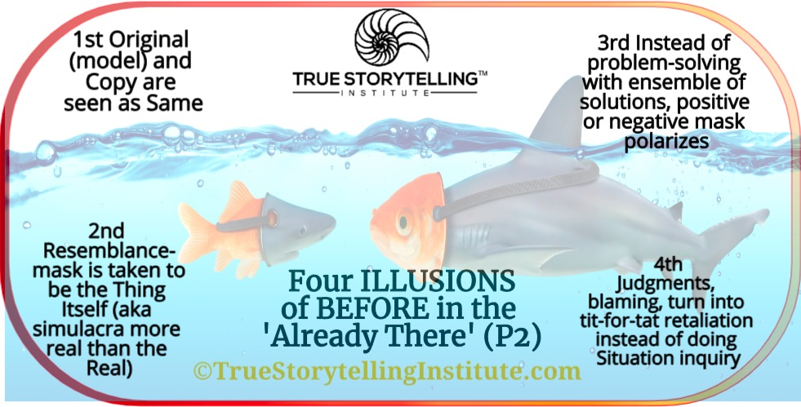
How do 4 Illusions take over a Dialogue/Conversation?

There is One and only One spacetimemattering so reducing space, time, mattering by separations, then framing not yet Now, is a problematic Guides encounter (#430). You encounter participants treating spacetimemattering as a Metaphor (actually its a Simile, but why quibble) and both become Metonyms (2nd Illusion) so due to 3rd Illusion, the actualities of potential solutions are missed completely, and the whole conversation descends to level of judging, blaming, shaming, stereotyping (4th Illusion).

If space gets represented in narrative as BME line metaphor, or a metaphor of a cycle, then that narrative is indifferent to the subsistence of space BEING, in all its points of whole BEING. If BEING gets treated in narrative as a sequence of events, by the BME METAPHOR, of now-past, now-NOW, and now-not-yet then retrospective-sensemaking (BEFORE, already there) and prospective sensemaking (BETS plotting) have flattened out time eventums, to a reifying METAPHOR (all four illusions take hold). When time is flattened out, it is a pre-conception, a narrative of selected (cherry-picked events & characters & themes). History, is not usually the whole history, its a partial account, and BME, becomes a part substituting for the Whole of history. Some with BENEATH, a simplifying concept substitutes for depth of a problem, so the roots of the problem, never gets into the narrative. History and metaphor (simile, metonym) are selective language games. There is a potentiality-for-Being-a-Whole system understanding of situation, and be closer to truth (P1: what is true?; BENEATH). A fore-conception can be a stereotype, a prejudice, and becomes taboo to discuss in some circles. Who decides what part of History (BEFORE, P2: make room for already there), or the eventness of the Whole situation really matters.

This session two of Train the Train image is a tool for relating BEFORE as well as BENEATH to how illusions of what is space, what is time, what is mattering, and what is spacetimemattering get worked into dialogues (conversational storytelling sessions you are guiding). Illusions are not simple untruths or lies, they are a natural part of what happens in unguided conversations where Guides are not working the 6 eventums.

Question to Guides: How can the spacetimemattering that is time-point, matter-point, and space-point that “posits itself for-itself” to occur in Guiding conversational storytelling?

In sum:
BEFORE →BEING → BECOMING →BETS is the simplified temporality dimension

BENEATH →BEING→ BETWEEN→ BEYOND is the simplified spatiality dimension.

Obviously, this is an interactive networking of all 7 antenarrative processes with the 7 principles not just in consulting but in Guiding Protreptic Dialogue in breakouts on line or in groups offline (Tamara-Land).

Hegel treats BEYOND as ‘pure intuition’ of spirit manifesting in time as its true, and in history (BEFORE). But, Heidegger finds Hegel’s spatiality too reduced to flattened time, and too big a (quantum) leap from BENEATH to BEFORE and to BEYOND, too big a jump that skips over several antenarrative processes in Whole System of processes. Instead of idealized (BENEATH) concept of space or time or mattering, the antenarrative processes are pregnant already with the future, and its eternity (#431). I am especially interested in uncovering the BECOMING of Heart-of-Care in the conversation/dialogue I am guiding and shaping that discovery. Hegel calls time ‘intuited BECOMING” (caps, mine, #431). I want spacetimemattering as the GROUNDING.

The Essence of Freedom in True Storytelling
There is a connection of corrections and freedom in Protreptic Dialogue that is about unconcealment-BEING (antenarrative process) and TIMING (principle 4). For me, it is moving out of ABSTRACTING, and deep diving into GROUNDING in Nature’s “domain of truth” (Heidegger, 1931/2013, on line). Please search the online text, for “domain of truth, Section IV, Essence of Freedom): “the ground of inner possibility of correctness” since Earth already had a more originary “essence of uniquely essential truth.” Freedom opens up in Nature, reveals itself, in an open region, where correct behavior (comportment) of beings: “freedom now reveals itself as letting being be”. We certainly do this in True Storytelling Protreptic Guiding of sessions (events). It is not about planning, managing, but rather “to let beings be as the beings which they are” (BEING meets Principle 4, Timing).

Now and Now as BEING and past-now as BEFORE, and not-yet-now as FUTURING BETS, all that is METAPHOR, not the flow of time or the subsistence of place in space, or the mattering of quantum energy vibrations of vibrant matter (see Jane Bennett’s books).

In sum, Heidegger’s quest, is to amend Hegel’s linear time, and his reduction of space to time-as-truth, by bringing space back into BEING, and making time arrive from futuring (not just from retrospective sensemaking the BEFORE), or plopping on the NOW-NOW-NOW series as if that is all that is in existential BEING. So two dimensions not one BME of time, and the spatializing and mattering are in-BEING, and all the other antenarrative processes and in the Principles if they be more than metaphors, and they are not just ABSTRACTING, the are GROUNDING something that is “self-manifestation” and the BEYOND is “progress of the spirit which actualizes itself in history” for Hegel, the BEFORE, but for Heidegger, and I agree, spirit (BEYOND) has more to it than that, that is truly amazing (#434) GROUNDING of Nature.

BEYOND – Spirit is restless for Hegel and for Heidegger, but not a nullity, of some version of the negation of the negation dialectic BEFORE) (#434). Rather than spirit as “concept-itself” BENEATH, or the BEFORE grasped as “World-history” spirit has its own Nature (#434).

Heidegger’s version of Hegel’s NEGATION of the NEGATION

Hegel’s “abstract negativity” is a concept BENEATH, and there are these other antenarrative processes (#435). “Spirit must first of all fall ‘into time”” but the dialectic of the “negation of a negation” has left out space and mattering that are primordial and the oneness of spacetimemattering of Nature, the spirit “in-itself” (#435). I am obviously into Nature spirits not into placing spirit BEYOND world. What “makes existence possible” (#436) is not just temporalizing, or spatializing, bu mattering of what is not just present-at-hand- but is the ready-to-hand (#437). Example, my blacksmith hammer is not just present-at-hand lying around my shop, it cared for, and prepared-in-advance, to be “ready-to-hand” (Boje, Quantum Storytelling Blacksmith Art in the Quantum Age, my keynote YouTube at the Process Conference in Greece on the Island of Kos
https://www.youtube.com/watch?v=a7pm_mRwL-0

In sum, Heidegger makes important reforms to Hegel’s negation of the negation dialectic, by resituating what is TIMING (temporalizing of temporality) and by putting the existential BEING of spactial on its own BEINGNESS, rather than it being a metaphor of time sequencing or linear, or cyclical narrative. The next section is about how ensembles of organizing work, and forming alliances in transforming organizations and societies (Rosile, Boje, Herder, & Sanchez, 2020).

Jean-Paul Sartre’s (1960/2004) Negation of the Negation to understand the practice of ‘Ensemble Organizing’

Summary Jean-Paul Sartre (1960.2004) has done important work to develop kinds of pratial ensembles, and how organizational change, and work redesign works by a negation of the negation dialectic. Sartre is critical of Marxist dialectic (an application of Hegel’s thesis-antithesis-synthesis). The point Sartre is making is how the second kind of dialectic in the work of Hegel (negation of the negation) can be developed to both be an understanding of BEING (Principle 4 Timing) but is also spatializing BEING, and mattering BEING. A clear example can help your understanding of what Sartre is doing. Her eis a tool showing the Game interplay of multi-player strategy to illustrate the BETS PROCESS of Plotting that of a Development Spiral, on its own. The question is How the Guide and or consultant can intervene to begin about harmony in the WHOLE SYSTEM?

The Negation of the Negation Plotting and Betting Tool

Example 1 The creation of a tool that can diminish scarcity is the negation of the negation (Sartre, 1960/2004: 151). It is productive labor., and changes the practical ensemble of how work is organized. E.g. a tool to clean the plastic out of the oceans, is a negation of a LACK, a negation of the negation. Negation: negation of negation is the creation of the tool that was not there before. Negation is lack of something; the creation of something is negation of the negation. Scarcity of anything to change the gyres of plastic in the oceans (negation), gets resolved by creation of a new tool (negation of that negation).

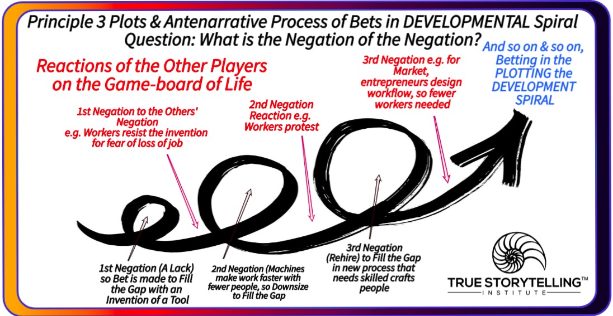
Example 2 The negation of the negation, such as “the unity of all” (Sartre, 1960/2004: 210) is not the negation of the machine in itself which crafts persons thrown out of work attempted in 1830. The negation of the negation, can only be the negation capitalism’s interest if it becomes the worker’s own destiny (IBID.). This negation of the capitalist’s interest, such as a protest to increase real wages in Lyon in 1830 (Sartre, 1960/2004: 211). E.g. The machine that cleans the ocean (a lack, negation), is a negation of the machine not there to a problem that is there (negation of the negation). But, it also throws people out of work to do it by hand (scooping it into barges, with hand tools).

Example 3 Negation of the negation of a group (seriality) and its relation between other groups, is a negations of the unity constituted by other groups’ praxis (363). A regroupment shifts reality. It is a reorganization of the environment of the work group, a shift in the “unity of the other praxis conditions” (Sartre, 1960/2004: 362), i.e. how processes of work are done by the group, and how work is organized. An alternative is to change the unity of the group by its own action (induction by action) (Sartre, 1960/2004: 362), i.e. just regulate the group by management or by apparatus (operating instructions that tells group what to do when). Example: A group of craft workers, has a computer program installed by operations (negating their autonomy to do the work), as the computer software (and its data engineers) dictate how work is done (its an apparatus that controls human behaviors, and their work processes). This second negation is behind-the-scenes, and further reduces freedom and autonomy of work, resulting in lower paid workers (deskilling), a 3rd negation, and the overall result is alienation and more division between employers and the employed (4th negation). In sum, a spiral of negations (not a cycle).

Example 4 Job rotation (is an organizing apparatus), so is teaching new skills (differentiating craft into division of labor), and a material effect (altering spatial distances between tasks and/or workers) in the work process is a negation of the negation, a practical negation of developing disorganizations of the craftwork, that had freedom, and is now a lack (a negation of the negation) (Sartre, 1960/2004: 545). Example: micromanaging a group of workers, by a central planning expert, who loves process reengineering, as a way to promote lower wages, downsizing number of workers, and to have deskilling of the craft and art of the work itself (this is a series of negations, of negations, that culminate in alienation, less pay, and less available work). This is why CEOs love reengineering because it accumulates higher bonuses for executives, and shareholders. Counter example: democratizing the work ensemble, has been shown to outperform reengineering, in empirical and in well-being results. See ensemble leadership work by Rosile, Boje, Herder, and Sanchez (2020): building ensemble alliances is actually more efficient, and has more learning for improvements than efficiency schemes in this example. Negation of the lack of democratic ensemble, allows for a series of negations of workplace problems that could be solved with an understanding of how whole systems and True Storytelling are related.

With these four examples of the negation of the negation dialectic, we turn now to how the antenarrative processes work with the True Storytelling Principles.
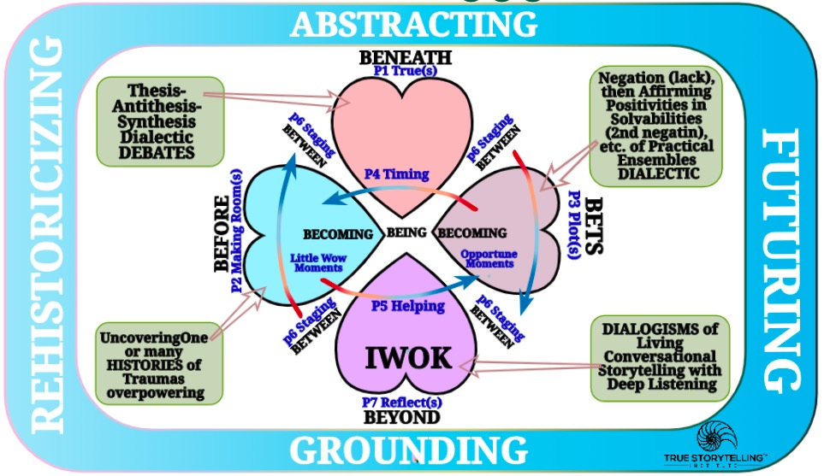
The Four Hearts Tool for Guides Only1
There are four kinds of conversations happening in Breakout rooms and Tamara-Land Storytelling Organizations: Debates of ABSTRACT-Heart, competing HISTORIES of BEFORE-Heart, the Negations of the BETS-FUTURING-Heart, and what we Guide todard, the DIALOGISMS of living Storytelling Conversations.
Here is an example of how to use this tool in working with groups as a Guide, and working with Organizations in a consulting. The Guide encounters people doing linear thinking, and working with parts in an us vs. Them dialectic of Thesis-Antithesis-Synthesis, but the synthesis never works out, never gets realized (except in the logic, in the head). A move to a Dialogical is amazing. Its democratic, its practical ensemble of relating, by deep listening, and authentic involvements.

Negation of the negation, can work either way, a way to go into positive solutions to problems that have Situation grounding in Whole Systems, or a way to move into the other kind of dialectic )us versus them. For know, the point is these two dialectics are completely different processes, with very different results. A negation of the negation can be quit good at problem solving, filling a lack by innovation, creativity and democratic workplace healing. But, beware, there are practical ensembles of thieves, of mobs, and they do not operate for your well being. There are practical ensembles that negate problems, by coming up with solutions.

Summary Above is the Four Hearts Tool. In True Storytelling Guiding we move the conversation from initial dialectics of narrative fights counternarratives to the dialogical of living story conversations. The second move is Restorying, from uncovering LITTLE WOW MOMENTS of one or many histories that become OPPORTUNE MOMENTS of ‘New Stories’. The BEFORE HEART and BETS HEART are temporality moves (one is P4 ‘Timing’ moves from FUTURES to PASTS; second is P5 ‘Helping’ from PASTS to FUTURES). The Hearts are in interconnectivity by the P6 (Staging) of the four BETWEENS. BEING is pivotal, the Being of Freedom to open one’s Self to the Open Space of the in-Between. There are two quite different dialectics. The metaphoric Thesis-Antithesis-Synthesis where unifying synthesis never emerges as unity. The ontological Negation of the Negation which can slip out of dialogic and become the Thesis-Antithesis-Synthesis of Abstracting polarities, once more. Guides of Protreptic Dialogical do their work to keep movements towards GROUNDING. It’s all about Guides helping participants find heart-felt attunements of Four Hearts. It is all about Guides guiding participants to uncover the BEING of attunements (4 Hearts).

True Storytelling can be compared to three other approaches using the 4 D Tool.

- I & Other is divisive (Debate)
- ITS is Corporate-Centric, seeing everything as a resource (humans are resources, nature is a resource, …). Everything is a bunch of Its (parts in search of a whole).
- IT of Eco-centric. Everything is a whole ecology, including humans (not spirit). This is science.
- WE – is Spirit-Centric, Everything is spirit (rocks, trees, rivers, mountains).
Note: I, ITS, IT, and We are applying Ken Wilbur’s work.

Bohmian Dialogue is leaderless groups (now on Zoom) doing leaderless projects (sometimes). True Storytelling uses Dialogisms as its Whole System Storytelling approach to guide participants from Parts to Wholes, and into practical results. Both move out of Debates.

Various approaches to training and consulting can be compared on two dimensions. Are they focused on parts (fragments) or whole systems. And, are they retrospective sensemaking (pat to present) or doing more prospective sensemaking (future). In P4 (Timing) this is important because, in antenarrative time is not one way (linear) from past→present→future. Prospective sensemaking includes fore-sight, and fore-casting in ways that the future is arriving (future→present →past).

True storytelling principles and antenarrative processes all movement from part (fragmentary) habits to Bohmian dialogue and to the five dialogisms (Boje, 2008). The dialogisms of Bakhtin (1981) were applied to ways in which organizational strategies and storytelling work together. Polyphonic is multi-voices in conversation, in which each person stands in their own standpoint while doing deep listening to others’ standpoints. Stylistics includes not only verbal, but written, and artistic artifacts used to convey stories (sociomateriality). Chronotope means ways space and time are constituted in narratives and constructions. Bakhtin was influenced by Einstein to look at alternatives spacetime approaches in narratives and stories. Many enterprises have linear and often rather abstract strategy plots, while some have more organic and grounded chronotopes. Boje (2008) develops 10 chronotopes and applies them to McDonalds, Wal-Mart, Burger King and other BETS (P3 Plots) of corporations (Boje, Haley, & Saylors, 2016; Haley & Boje, 2014; Boje & Rosile, 2008). Architectonic dialogism is the interanimation of three kinds of discourses (cognitive, ethics, and aesthetic) to systems theory. Originally Kant focused only on cognitive, but Bakhtin includes ethical answerability (and other sorts of ethical discourse, virtue, instrumental, etc.). In addition, Bakhtin includes the beautiful (i.e. Greek Square) discourses. These three discourses interanimate at level of antenarrative processes, out of which stories and narratives of enterprises, groups, etc. Are constituted. The word Polypi, is the interplay of the four discourses in an enterprise. Polypi is a term used by Hands Christian Andersen in his original version of Little Mermaid.
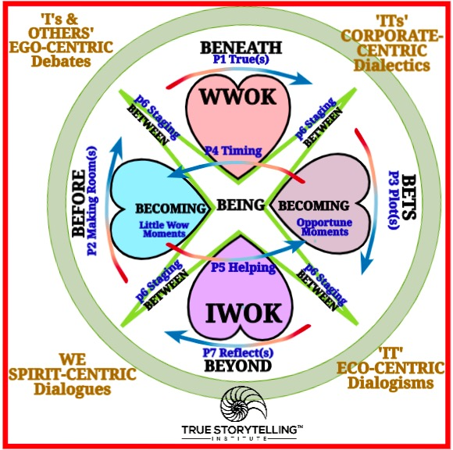

HOW BOHMIAN DIALOGUES, WILBUR’s AQAL and TRUE STORYTELLING/DIALOGISMS COMPARE?

Figure: Depicting the BETWEEN (P6: Staging) in relation to four quadrants of Ken Wilbur: I’s [& Others] (ego-centric), We (spirit-centric), It (eco-centric), and Its (corporate-centric) (adapted from Boje, 2008: 177, 189).

The 4-Hearts tool, in the above figure, is expanded from simpler version at beginning of this Guide handout, in order to show comparison and contrast of True Storytelling and Bohmian Dialogue (Bohm, 1996/2003, online text click here). It is also resorts Ken Wilbur’s 4 quadrant model, putting the I’s and ITS on top part (the parts) and the WE and IT (the Whole), what we have called Abstracting-parts, and Grounding in a Whole System understanding.

Bohmian Dialogues are the entanglement in quantum mechanics of two orders of ontology that are entangled:

(1) Implicative Order of enfolded surface notions of space and time that Bohm (1996/2003) goes to, what we call BENEATH-antenarrative to find surface of ‘P1: What is True’.

(2) Explicative Order of unfolded Wholeness of space and time in in mattering that is too small for the naked eye to see. Bohm observes that ways of solving this communication problem, the participants are not actually able to listen to each other.

Therefore, Bohm’s and the True Storytelling approach share a process approach in which every attempt to improve communication in WWOK, most always results in more confusion, and a sense of participant frustrating, shying away form talking about things that could erupt into argument, and for some more aggression of people defending positions, instead of metal understanding, and finding common ground, and trust-building.

What else we share in common Bohmian Dialogue and True Storytelling share many other similarities. Both are rooted in Whole System worldview in Indigenous Ways of Knowing (IWOK). Both move conversational storytelling from Western Ways of Knowing (WWOK) that enfold debate and dialectic polarities (thesis-antithesis; narrative-counternarrative; polarities; Part vs. Parts) into IWOK Whole Systems. A Bohmian Dialogue and True Storytelling both are meetings in which when one persons says something, the other person does not usually respond with exactly the same meaning (p. 2). This is also one of the key points of Tamara-Land (Boje, 1995). Intersubjectivity, is sharing something in common, from terse telling, even a ‘you know’. When intersubjective is not allowing the sharing of experience from one person to the other, or when people are not really listening to each other, prejudices take over, instead of “truth and coherence” (Bohm, 1996/2003: p. 3). There is a difference in understanding. Plus there is continual emergence of new content.Both Bohmian Dialogue and the Quantum Storytelling, have learned much about quantum for LeRoy LittleBear. Both focus on how in our modern economic, education, and political systems are different since the Digital technology took hold of the social and economic. People are in digital systems without the dialogue-ability to understand one another other. Bohmian Dialogue and True Storytelling conversations are enacted in small groups, and are encouraged to go deep, to share BENEATH ‘superficial assumptions; of ‘self-interest’ and to deal with barriers and issues, that in discussion or debate, would break and fragment meaning into taking sides. As with Walter Benjamin, True Storytelling and Bohmian Dialogue are deeply concerned with how newspapers, and now internet assemble unrelated fragments to produce sources of confusion and misinformation. “The point is that dialogue has to go into all the pressures that are behind our assumptions. It goes into the process of thought behind the assumptions, not just the assumptions themselves” (Bohm, p. 9).

Table 1: 8 Quantum Reality Approaches
Quantum Reality 1: No deep reality. Neils Bohr believed quantum entities do not possess unique dynamic attributes, but instead are creatures of the measurement situation (apparatus). (Karen Barad, 2007 Meeting Universe Halfway, adopts Bohr and rejects Heisenberg (Q#2 & Q#8). | Quantum Reality 6: Neorealism (Bell and Von Neumann reject non-locality
Quantum Reality 2: Observation (observer) Effect creates quantum dynamics (Heisenberg’s Uncertainty Principle; John Dewey). | Quantum Reality 7: Consciousness Creates Reality (aka, social constructivism)
Quantum Reality 3: World exist sin undivided Wholeness (Erwin Schrodinger & David Bohm) | Quantum Reality 8: Duplex Universe, Superposition of real and partly real (Werner Heisenberg).
Quantum Reality 4: Many Worlds Co-exist. | Quantum Reality 9: Quantum Spirituality (Goswami, 2012; Fred Alan Wolf, 1992)
Quantum Reality 5: World is non-Boolean Logic-Lattice (Bell’s Theorem). | Quantum Reality 10: Quantum Dialectic of Negation of the Negation (Zizek, 2012 reviews Barad (Quantum #1) and amends it with a Hegelian Dialectic and to include a Hegelian spiritual focus, Q#9).
Note: First 8 quantum realities based on Herbert (1985).

As Richard Feynman, puts it “Anyone who claims to understand quantum thoery iseither lying or crazy. That said, Bohmian Dialogue and True Storytelling approach quantum storytelling differently (for more on Quantum Storytelling, see Boje & Henderson, 2014).

There is something important about WWOK turns to IWOK. As Walter Benjamin (1936) puts it, storytelling that conveys experience to the listener, is coming to an end. Benjamin is among the first to define ‘true storytelling’ (p. 90, last paragraph section VII; p. 102, 2nd paragraph, section XVI). Both Bohmian Dialogue (1996/2003) and True Storytelling conversations (Boje & Rosile, 2020) focus on importance of story-listening, that are often missing in debate and dialectics, and how communication breaks down resulting in an absence of intelligent action in groups, organizations, and societies. Finally, both approaches have people in groups, wo come into a storytelling and story-listening sessions from a wide range of contexts. In sum True storytelling and Bohmian Dialog share a common focus on deep listening, to create something in common, Boje and Rosile (2020) call ‘together-telling’. For True Storytelling and Bohmian Dialogue to function, the most important thing is all parties are honest in their telling and their deep listening. There is continual emergence of a new ideas, not turn tested, in emergent conversation. Both share a focus on self-reflection (BEYOND & P7 embodied reflection process). Relevant to P7, Bohm (1996/2003) says “Evidently then, what is crucial is to be aware of the nature of one’s own ‘blocks.’”

Both work with phase shifts. Protreptic Guides help build up phase waves (Principle 2, [waves] already there, & BEFORE wave patterns). Breakout rooms (or mountain hikes) can help people get to know one another, and coherent wave-phases emerge, first at a vague feeling level (intuitively), of coherent movement of the conversational storytelling.

Finding the “tacit ground” (Bohm, 1996/2003:p. 14) is something Bohmean Dialogue and Conversational Storytelling share in common (Boje & Rosile, 2020). The point is the 7 antenarrative process are tacit, already there, and constitute the manner of the conversational storytelling in a dialogue group.

Both move from parts (fragmented-narratives, tersely-told ones) to the Whole System. People in dialogue have different opinions about BEFORE (experiences, in memory). People defend opinions, but why? When another person challenges our options, our experience, pr our background, defenses go up. What is unique about dialogue is the group goes into the whole of the thought process (antenarratives), and are engaged in the process. “Fragmentation is one of the difficulties of thought, but there is a deeper root”, for example “The whole ecological problem is due to thought, because we have thought that the world is there for us to exploit, that it is infinite, and so no matter what we did, the pollution would all get dissolved away” (Bohm, p. 9).

By contrast Bohmian Dialogue’s quantum storytelling focuses on ‘dialogue’ instead of ‘debate’ (or discussion), whereas True Storytelling takes ‘quantum storytelling’ in a different direction: Mikhail Bakhtin’s (1981), four ‘dialogisms’ (polyphonic voices, stylistic materialities, chronotopic spacetime, architectonic discourses, & what I call (Boje, 2008), the ‘polypi’ a term from Hans Christian Anderson’s Little Mermaid that is the interplay of first four dialogisms). The 2008 book, is all about strategies (BETS) corporate-centric approaches, and how to move into IWOK ways. Discussion, for Bohm (1996/2003: 6-7) is different game from dialogue, it ‘breaks up’ flow by ‘percussion’ and ‘concussion’. In breaking up, the discussion, results in each person presenting different points of view, in a “ping-pong game” of batting about ideas “back and forth” (p. 7). Whereas Bohmian Dialogue treats groups of 5 to 50, in dialogue as microcosms of society, in True Storytelling, subgroups are smaller on average, and there is a purpose to generate projects that make a difference in lives of individuals and projects that change institutions. One of the main differences is in Bohmian Dialogue, the groups are leaderless and there is no agenda, other than to explore a theme (without debate & discussion). In True Storytelling, there are Protreptic Guides facilitating, especially in early stages of group formation (where storming and norming, happen frequently).

Bohm focuses on thought and assumptions. By contrast, True Storytelling (and antenarrative processes) specify core values, core concepts, and motives of how participants see a ‘problem’ , and what is producing that sort of problem, not just the particular problem (in other words, move to a systems thinking level) [Bohm, 1996/2003: p. 10]. Defense are pre-thought, thinking of the defense, in order to defend something, which means in BEING-present, a lot of things get pushed aside, issue gets distorted, in order to defend basic assumptions against evidence.

Dialogue groups work best when the groups are leaderless and without agenda. Of course, people are not used to meeting without leaders, agenda, or purpose. Without that structure, participants work through anxiety. It is therefore useful for Protreptic Guide to explain what is happening from time to time, and session to session. The Guide works themselves out of that role as the group learns to be an ensemble (‘everyone is a leader’ and the group is acting in together-telling). In Bohmian dialogue the groups are not going to decide or do anything, and are therefore free to explore an empty space, not an occupied space.

Protreptic Guides sustain dialogue day to day, week to week, and month after month. As people trust one another, and relationships build, the sharing is deeper. The point however is for the group to be a microcosm of society or the enterprise and its environs.

In sum, we have more similarities than differences. Bohm’s solution to the BENEATH (language) and all our assumptions about how society works” (BEFORE, P2: making room for the already there). To Get BENEATH and BEFORE is to go to the thoughts themselves, and listen to people with different basic assumptions and opinions (this in True Storytelling/antenarrative is going deep from Abstracting (debates & discussions of narrative-counternarrative) to the Grounding, in [polyphonic] dialogism (Bakhtin). How does Bohm answer the Question: What is True?

“Each one may hold to a different view of the truth, so they can’t get together” (Bohm, p. 12).

Example: A corporation producing pollution has a certain self-interest in proving that their pollution is not dangerous. Other sub-groups have a self-interest in proving that it is dangerous. Finding an unbiased WWOK science, dedicated to Truth, while some other group has another kind of truth (Native Science). Each sub-group produces its own best intentions.

HOW NEGATION WORKS out of usual ABSTRACTING to find FUTURING and DIALOGICAL GROUNDING

From the BENEATH (Principle 1: What is True) one problem is when the totalizing of a system-unity, its processes and practices is an ABSTRACTING that negates the situation of work (and living), that is realized in BEING (Principle 4: Timing).

“The transparence of praxis (let us say, for the moment, of individual praxis) has its source in the indissoluble connection between negation (which totalizes in situation what it negates) and a project which defines itself in terms of an abstract and still formal whole which the practical agent projects into the future and which appears as the reorganized unity of the negated situation. In this sense, the very temporalization of an undertaking is accessible since it can be understood on the basis of the future which conditions it (that is to say of the Whole which praxis conceives as having to be realized)” (Sartre, 1960/2004: Introduction: 60).

FUTURING and TOTALIZING TIMING (P4) and HELPING (P5)

The BEFORE → BEING → BECOMING → BETS and the associated True Storytelling Principles (P2 → P4 → P5 → P3) can also be the Futuring (BETS) that impact the BEING, and Rehistoricize the BEFORE. In other words, instead of the assumed past → present → future, it is reversed. More accurately, it is both ways. The ensemble of moments (BEING, Timing) is totalized from Future, and re-totalized by work of practical agents (all kinds of stakeholders) affecting their environment (not just other organizations, but also Nature).

“On this basis, all the activities of a practical agent are to be understood through the future as a perpetuate-totalization of the provisional totality. And the ensemble of these moments, themselves re-totalized by the temporalization, is in fact original intelligibility, for the practical agent is transparent to himself as the unifying unity of himself and his environment” (Sartre, 1960/2004: 61).

FIRST NEGATION, of the NEGATION of the NEGATION, then more NEGATIONS

Negations occur in series, so that is a kind of antenarrative process we can identify in groups and organizations and their environs. These appear in matter (see discussion above of spacetimemattering). The 1st negation can appear in the mattering (think of vibrant matter of Jane Bennett’s work). A need a person, group, organization, or society his is a lack. To preserve and sustain (Principle 1, BENEATH), enterprises work through the contradiction between socio-economic and Nature , in the double sense of existence (BEING → BECOMING) and (BECOMING → BEING), and the example is how organizations exploit ecologies, and how ecologies adapt to human activities (e.g. COVID-19, and its variants that sustain).

“Indeed, it is through need that the first negation of the negation and the first totalization appear in matter. Need is a negation of the negation in so far as it expresses itself as a lack within the organism; and need is a positivity in so far as the organic totality tends to preserve itself as such through it. The original negation, in fact, is an initial contradiction between the organic and the inorganic, in the double sense that lack is defined in relation to a totality, but that a lacuna, a negativity, has as such a mechanical kind of existence, and that, in the last analysis, what is lacking can be reduced to inorganic or less organized elements or, quite simply, to dead flesh, etc.” (Sartre, 1960/2004: Book I, p. 80).

NEGATION of the NEGATION and HOW FUTURING WORKS in PRESENTMENT-BEING

This is another example of how FUTURING affects the presentment of BEING and the BETWEEN by negation of the negation.

“Determination of the present by the future, oscillation between the inert and the organic, negation, transcended contradictions, negation of the negation - in short, developing totalization: these are the moments of any form of labour, until - at a dialectical level that we have yet to consider - society develops the division of labour to the point of the specialization of machines” (Sartre, 1960/2004: 91).

Conclusion

It all comes back to involvements, engagements, and entanglements in Whole of BEING, out of concealment of BEING – underlying interconnectedness of relationships in the Whole that have significance in antenarrative processes and all 7 true Storytelling principles, together. This ties significance into the space, time, and mattering, – spacetimemattering. Inseparability involvements, of interconnectedness matter a lot for the BETS/plotting and the BETWEEN/staging, and BECOMING/helping stories along in the eventums of Protreptic Guide work.

Heidegger reimagines temporality and the negation of the negation in Hegel. So too, does Sartre rework Hegel’s negation of the negation dialectic. The value of understanding the ways time moves in double sense (past to present to future, and future to present to past) is a major shift in change management and consultation, and in ways to facilitate groups.

References

Bakhtin, Mikhail. (1981). The Dialogic Imagination: Four Essays. Edited by Michael Holquist, trans. By Caryl Emerson & Michael Holquist. Austin, TX: University of Texas Press.
Benjamin, Walter. (1936/1978). Illuminations: Edited and with an Intro. by Hannah Arendt. Translated by Harry Zohn. Schocken Books. 1936 is date of original essay ‘The Storyteller...’ Please click and read it before continuing.
Bohm, David. (1996/2003). On Dialogue. Edited & Foreword by Lee Nichols, 1st published 1996 by London: Routledge; e-edition, Taylor & Francis e-Library, 2003. Accessed Jan 31, 2021 at https://avalonlibrary.net/ebooks/David%20Bohm%20-%20On%20Dialogue.pdf
Boje, David M. (2008). Storytelling Organizations. Thousand, Oaks, CA: Sage.
Boje, D. M., Haley, U. C., & Saylors, R. (2016). Antenarratives of organizational change: The microstoria of Burger King’s storytelling in space, time and strategic context. human relations, 69(2), 391-418.
Boje, D. M., & Henderson, T. L. (Eds.). (2014). Being quantum: Ontological storytelling in the age of antenarrative. UK: Cambridge Scholars Publishing.
Boje, David M.; Jorgensen, Kenneth Mølbjerg. (2020). A ‘storytelling science’ approach making the eco-business modeling turn. Journal of Business ModClick here for pre-press pdfeling, Vol. 8, No. 4, pp. 8-25. . Please Click here for final print version PDF
Boje, David M.; Rana, Mohammad B. (2020). Defining a Sustainably-Driven Business Modeling Strategy with a ‘Storytelling Science’ Approach. Chapter to appear in Markovic, S., Sancha, C. and Lindgreen, A. (Eds.), Handbook of Sustainability-driven Business Strategies in Practice, Northampton, MA: Edward Elgar. Click here for pre-press pdf.
Boje, D. M., & Rosile, G. A. (2008). Specters of Wal-Mart: A critical discourse analysis of stories of Sam Walton's ghost. Critical discourse studies, 5(2), 153-179.
Boje, David M.; Rosile, Grace Ann. (2020). How to Use Conversational Storytelling Interviews for Your Dissertation. UK: Edward Elgar Publishing Ltd. Download for free until published in 2020
Goswami, A. (2012). The visionary window: A quantum physicist's guide to enlightenment. Quest Books.
Haley, U. C., & Boje, D. M. (2014). Storytelling the internationalization of the multinational enterprise. Journal of International Business Studies, 45(9), 1115-1132.
Heidegger, Martin. (1926/1962). Being and Time. Translated Macquarrie, J., & Robinson, E. Accessed online Jan 20 2021, first in German 1926, at http://users.clas.ufl.edu/burt/spliceoflife/BeingandTime.pdf
Heidegger, M. (2013). The essence of truth: on Plato's cave allegory and Theaetetus. Bloomsbury Publishing. Online version date of original version: 1943, based on a translation by John Sallis This translation based on 4th edition of the essay (1961) was accessed Jan 28 2021 at https://aphelis.net/wp-content/uploads/2011/02/Martin-Heidegger-On-the-Essence-of-Truth.pdf

Hegel, Georg Wilhelm Friedrich Wilhelm. (1807). Phenomenology of Spirit. See online version (Oxford Press) http://ns210054.ovh.net/files/Georg%20Wilhelm%20Friedrich%20Hegel%20-%20The%20Phenomenology%20of%20Spirit%20(Michael%20Inwood%20Translation).pdf
Hegel, Georg Wilhelm Friedrich (1817). Encyclopedia of the Philosophy of Science. Accessed online version https://hegel.net/en/pdf/Hegel-Enc-1.pdf
Herbert, Nick. (1985). Quantum Reality: Beyond the New Physics. Golen City, NY: Anchor Press/Doubleday.
Kirkeby, Ole Fogh. (2009). The New Protreptic: The Concept and the Art. Copenhagen, Denmark: Copenhagen Business School Press.
Larsen, Jens; Boje, David M.; Bruun, Lena. (2021). True Storytelling: Seven Principles for an Ethical and Sustainable Change-management Strategy. London, UK: Routledge.
Sartre, Jean-Paul. (1960/2004). Critique of Dialectical Reason.Vol. 1 Theory of Practical Ensembles. Translated by Alan Sheridan-Smith Edited by Jonathan Ree, Foreword by Fredric Jameson First published as Critiqlle de la &Jisoll Diale,1iqlle by Editions Gallimard, Paris 1960. This translation ftrst published by New Left Books 1976 © Editions Gallimard 1960, Translation © New Left Books 1976. Corrected edition ftrst published by Verso in 1991 based on the revised. French edition of 1985 © Editions Gallimard 1960, 1985. This edition first published by Verso 2004 © Verso 2004. Foreword © Fredric Jameson 2004.
Wolf, F. A. (1992). The Eagle's Quest: A Physicist Finds the Scientific Truth at the Heart of the Shamanic World. NY: Simon and Schuster.
Zizek, S. (2013). Less than nothing: Hegel and the shadow of dialectical materialism. London/NY; Verso.

