Storytelling As A Qualitative Approach For Organisational Management

**Abstract**

**Purpose:** Values and emotions are conveyed via stories, which may show the contrasts and similarities between people's life experiences. Personal experiences must be shared in order to be understood, and this may aid in the formation of connections and supporting networks.

**Design/Method/Approach (only for empirical papers):** Secondary research strategy was used for this study.

**Findings:** Throughout this study, the author makes the case that narrative is critical to effective organisational management and leadership. The growth of storey methods, although important and creative in the development of qualitative research in management, has resulted in a lack of consistency in the field.

**Practical implications**: Although the literature acknowledges the significant emotional and psychological advantages associated with using storytelling in studies, there has been no evidence of a link between the improvement of human adaptability and the use of storytelling in research. Throughout this study, the author makes the case that narrative is critical to effective organisational management and leadership. The growth of storey methods, although important and creative in the development of qualitative research in management, has resulted in a lack of consistency in the field.

**Originality/Value**: This paper addresses the application of storytelling to organisation managementand how storytelling could be used as a tool for qualitative research

**Research limitations**: The research was primarly focused on secondary research therefore could be limited to previous research findings.

**Keywords:** < Stories, Narratives, Storytelling, Qualitative Research>

**JEL Сlassіfіcatіon:** < C25, C35, >

# Introduction

In todays world stories and the ability of storytelling assist individuals in creating an understanding about the experiences and opinions, our relationships with the surroundings and with one another, and in creating views, identities, and values. Most profoundly the creation of **stories "reveals things to us that we know but didn't know we knew." Was stated by Merleau-Ponty, (1964**). The goal of storytelling is to communicate an event in such a manner that it seems genuine. Storytelling has appeal because it often incorporates facts into an individuals narrative which fascinates the user and could confirm their own evens in life. When considering a narrative there are three elements that need to be considered. These include the Beginning, Middle and End. The words 'narrative' and 'story' are frequently treated in a similar regard in the relevant literature.

A tale's events, on the other hand, may be presented in a number of ways, resulting in different narratives that are either sequential or non-sequence, but the story's overall storey remains the same. Changing the sequence of events alters the narrative but not the tale. In this review, the terms 'story' and 'storytelling' shall be favoured, unless particular instances necessitate the usage of 'narrative.' Stories are an essential kind of communication through which people, organisations, and society as a whole communicate messages, entertainment, emotions, and knowledge toward others (Bowles 1995). By communicating values and emotions, verifying and validating our lives and experiences, as well as linking individuals with their own inner-selves, others, and the community as a whole, stories provide meaning to our lives (Atkinson 2002).

Personal stories are greatly regarded in qualitative research since the goal is to acquire insight into people's lives, and this is achieved by individuals telling stories about themselves. Personal stories are answers to interviews that dig into people's lives and experiences (Thomas 2003). Stories are utilised in a corporate environment to educate, enlighten, communicate, and gain insight into human perspectives and events (Warne and McAndrew 2007). Employees at organisations tell their stories to emphasise aspects of their success and pleasure that they have experienced, employers share their experience of markets and circumstances with other experts, possibly enhancing the performance of the business (Vezeau 1994).

Storytelling may serve as a foundation for research, allowing for a better knowledge of human experience (Cronin 2001). The stories of people involved could offer insights into their historical roots and perspectives, resulting in a better comprehension of them in context. These enhanced perceptions have the ability to significantly contribute to knowledge and facilitate the effectiveness of expertise (Banks-Wallace 1999).

## What is this Storytelling?

The core of qualitative research storytelling is asking individuals to share their stories and then really listening to them. Isn't it as easy as that end of the storey? No, not exactly. There are a few tweaks that may be done to this storyline (Lewis & Hildebrandt, 2020). There are many important components that go into creating a storey:

* **Context, a setting**
* **Characters**
* **The plot, or action**
* **Passing of time**

There is also usually a beginning, an initiating event, acts and responses, repercussions and further actions, conflict and resolution, and, of course, an end.

## Stories and narrative

Storytelling and storey are confusing words that are often used in the same sentence to mean the same thing (Riley and Hawe 2005). Humans communicate and share tales rather than narratives, according to Frank (2000); nevertheless, many people believe that a storey is made up of three parts: the beginning, the midpoint and the conclusion, as described in the book Narrative. Wiltshire (1995), elaborates about stories and state that stories are informal and subjective accounts of human occurrences, while narratives are more organised and formalised representations of the same events. A further point is that in research, stories serve as the "phenomenon" under investigation, and the narrative serves as the researcher's "enquiry" (Connelly and Clandinin 1990). In addition, the scholars on this topic have said that individuals, for the most part, live storied lives and tell stories about them, while narrative academics categorise such lives, collect and tell stories about them, and build narratives of experience. Storytelling, in the opinion of Rubin and Rubin (2005), is efficient, organised description that is deliberately given and may have been changed, while narrative may be a partial depiction of a larger storey. For the purposes of this study, the two notions are defined as follows:

**Stories**: investigate individuals' own accounts of their experiences.

**Narrative**: formal and organised narratives including researcher additions and omissions

## Personal stories and their characteristics

Personal stories may highlight the parallels and contrasts in people's lives (Thomas 2003). Stories of indivduals have meaning and viewpoints (Atkinson 2002) and when people go on to tell their stories they involve themselves into the narrative to highlight or downplay certain aspects of the storey to avoid being seen adversely by others.To improve the storyteller's comfort and safety, it is important to spend time establishing rapport and cultivating an accepting attitude in an appropriate setting (Kitzinger, 2004).

Each individuals stories are personal and subjective to them and may change through time (Andrews et al 2004). They are affected by their surroundings, social circumstances, shifting views, the audience, and the goal of communicating the narrative (Chase, 2005). However, the fragility of human memory is such that individuals recall a storey in the context of their life in the way they want to remember it not the way that it actually happened (Kitzinger 2004).

Individuals make decisions about what to include and what to exclude in order to construct a complete storey, emphasising some events and traits while excluding others in order to achieve a comprehensive storey (Bauman 2004). If the storey's necessary components were not selected, lighted, and excluded, the storey would not be a storey. As a result, although each individual's narrative is unique and subjective, personal tales are different and valuable to both the storyteller and the listener because they are meaningful and valuable to both parties. In addition, it is essential to remember that tales, since they are subjective perspectives, will differ from one another, and that their purpose is to provide insight and information about a research focus area rather than to produce generalizable results (Koch 1998).

## Resilience and stories

The substantial body of research that attempts to explain personal stories, especially in the management literature, depicts both successful and tragic occurrences. Individuals are invited to revisit unpleasant and painful events, which may include unpleasant feelings such as sorrow, rage, grief, humiliation, and embarrassment, while they tell their stories that have tragic occurences. Therefore, storytelling has the ability to disclose repressed memories (Reichert 1998) and It is possible that this will serve as the basis for the creation of relationships and support systems (Dean 1995). Furthermore, while not specifically stated, the literature highlights how storytelling may assist study participants build personal resilience and celebrate their toughness. People's resilience may be described as their ability to withstand hardship (Rutter 1999).

This variable is influenced by both human and environmental factors, and it manifests itself in the form of individuals and organisations achieving success and remaining functional in the face of overwhelming odds (Schoon 2006).

Put another way, the term "resilience" describes a person's or a community's ability to generate and achieve positive outcomes in response to traumatic events or experiences that have the potential to have negative consequences and outcomes (Hauser et al 2006).

## Becoming reflective

If the voices and experiences of those who have experienced traumatic situations are listened to and heard, healing may occur (Leseho and Block 2005). Individual tales may be able to assist in making sense of and improving understanding of individual experiences (Frank, 1995). Murray (2003), on the other hand, demonstrated that sharing personal experiences with a researcher who is interested may lead to unexpected discoveries.

When it comes to raising awareness of and reflection on one's own situation, Carlick and Biley (2004) emphasised the significance of sharing and listening to tales. Cowling (2005), on the other hand, recognised the reasoning and motivation for progressive change that emerge as a result of narrative and discussion. Individuals' ability to acquire insight and understanding from their experiences is referred to as their capacity for reflective thinking (Jackson et al 2007). This information may then be used to improve the quality of such conversations and activities in the future.

Individuals' own experiences may provide insight on how they develop their own levels of resilience. Considering that resilience is 'influenced by an individuals experience and how the stories thry tell ourselves to manage experience change it and lead to alternate courses of action' (Hauser et al. 2006)

Storytelling strengthens the resilience of study subjects, as well as listeners and readers of the stories. Storytelling is as much about serving another as it is about serving oneself and personal stories may serve as a guide for the listener or reader which can be learnt by reflecting on the personal stories of others (Frank 1995). Through this reflection, one may acquire knowledge and insight into how others have survived and worked through adversity and pain, as well as how we can integrate these ideas into their own lives and experiences. As a consequence of studying and thinking on the stories of participants, researchers and readers of the study may improve their resilience.

## Taking use of supportive networks and positive emotions

It is necessary to build resilience by using supportive networks and relationships (Tusaie and Dyer 2004). In times of hardship, those who can depend on others for support are more receptive to receiving help and learning coping strategies from others who are more robust (Dyer and McGuinness 1996).

The help that a person provides and gets in a relationship is referred to as a support network (Tusaie and Dyer 2004). Individuals acquire a feeling of connection and belonging as a result of their interactions in these networks, which is crucial for the development of personal resilience (Chadwick 2004). A study which focused on stories about distresses in support groups, showed the connection between storytelling and personal resilience (Dean 1995).

Respondents seem to have been able to establish connections and relations in a supportive atmosphere by sharing their experiences, enabling them to make meaning of their circumstances (Dean 1995). It was sometimes necessary to use comedy to contextualise personal narratives, and it seemed to have a physiological action, making ailment stories that would otherwise be unbearable to hear bearable (Dean 1995).

Storytelling in this and comparable settings may improve personal and community resilience by evoking pleasant feelings and establishing support networks that promote a sense of belonging. Banks-Wallace (1999) showed that storytelling among women created strong connections and validated their experiences. Participation in the study project gave the women with the chance to acknowledge and celebrate their power, as well as to cooperate on strategies to fight future tyranny.

## Increasing and using emotional awareness

The capacity to identify and comprehend one's emotions is referred to as emotional insight (Roberts and Strayer 1996). (Roberts and Strayer 1996). Storytelling and contemplation have the ability to improve and extend emotional awareness. This was found in a research that investigated parental experiences through personal stories (Jackson and Mannix 2003). (Jackson and Mannix 2003). As per Jackson and Mannix, (2003) several participants were given the opportunity to tell their tales and reflect on their experiences with an audience of listeners in a relaxed and friendly setting. Following a period of reflection, individuals gained insight into their own emotions and behaviours. Similarly, research has shown that storytelling may assist participants in:

* Consider their experiences from many angles and try to make sense of them (Murray 2003).
* Consider their previous emotions and try to make sense of them (Peters 2006).
* to grow and progress in their life (Peters 2006).

## When to Use Storytelling

Only stories are suitable when depth and detail are required. There are numerous times when we do not want the whole storey (Lewis & Hildebrandt, 2020). For example, if the major goal of research is to elicit responses to advertisements or ideas, background material may be requested just briefly as a warm-up to the main topic. The richness gained via storytelling is usually unnecessary. However, there are times when we want more. Consider the job you've completed in the last six months. What kinds of subjects might have benefitted from some storytelling? When was the last time you went in search of the riches offered by a storey?

Anytime you want to hear how customers live, behave, think, or feel in their daily lives, a narrative may be appropriate. The following research goals may have gained depth and understanding as a result of storytelling:

* Understanding a particular experience and the effect it has on the person
* Understanding a time-consuming process, such as a decision-making process, the sequence of occurrences at a particular time of day, or the process of doing a regular task
* Gaining a broad knowledge of the consumer (asking for a recounting of an experience in storey form may be a great way to open up the conversation)
* Recognizing a broad theme or idea, such as order and disarray, attractiveness, parent-child relationship, or vacation.
* Investigating a comparison, such as before and after, then and now, what is real and what I want, how I do things vs how my spouse performs them, and so on.
* Investigating a person's connection with another person, a person's relationship with an organisation, or a person's relationship with a product or brand

## Why Story in Qualitative Research?

All of these components combine to make a narrative what it is: a compelling and comprehensive account of an event. This illustrates why we should think about using stories as a tool in qualitative research. At their finest, stories give us the entire shebang, the complete shebang, the broad picture. We gain context, depth of meaning, passion, and detail when we hear a good tale. Over time, we learn about events and processes, who is involved, and what is essential. We comprehend an event from the perspective of the person, and we hear their words as they relate it. Above all, we and our clients connect with the storyteller (Yavuz et al., 2016).

Allowing participants to share their stories adds another dimension to the study process by allowing the participant to recreate the event in question. Individuals who tell a storey fit the pieces together for themselves, making meaning from the event. This is acceptable since it corresponds to how psychologists believe memory works. It is thought that rather than delving into our memory bank for complete recollections, we rebuild our memories, generating a unique impressions of an event. When a researcher requests a narrative, he or she promotes self-examination, memory reconstruction, and meaning creation, all of which provide the depth of response that we researchers want. None of this is likely to occur if a responder is just asked to give a sound bite answer (Yavuz et al., 2016).

## Storytelling as a research method

Individuals who have had real-life or authentic experiences with public health issues are encouraged to share their tales as part of this review, which will seek for evidence of storytelling used as a research method or instrument in peer-reviewed studies. Many research objectives are included in the narrative process.

This includes the ability to teach the researcher, which is one of its primary objectives (through information extraction), also included in the research was an intervention designed to encourage the participant to engage in an ongoing process of "reflection and reworking of experience and knowledge." In order to gather information on public knowledge, attitudes, and behaviour, (KAB) storytelling has been utilised successfully.

As previously said, storytelling is a relatively new research technique whose validity is still being proven, in contrast to more traditional qualitative research methodologies. While there hasn't been a large body of evidence to support storytelling as a feasible research technique, this doesn't rule it out as a viable strategy in the near future. The most helpful outcome of this study would be the identification of papers that demonstrate the validity of storytelling in a research setting.

Stories have been used to conduct research in a wide range of areas, including those that are connected to management as well as others that are unrelated to management. In order to attempt to characterise storytelling as a research instrument, it is first essential to differentiate among science and storytelling/narrative as two distinct research viewpoints, which are then distinguished further. Second, storytelling has to be distinguished from other kinds of narrative research in order to be effective.

Management and storey, according to Bleakley, are two methods of knowing. Bleakley emphasises the importance of narrative in comparison to more traditional analytical techniques, which "tend to lose the concrete tale and its emotional effect to abstract categorisations, which may claim explanatory value but often stay descriptive." For the most part, however, Bleakley focuses on how storey adds value above and beyond objective measurements. He points out that, whereas objective morbidity and mortality statistics are often faceless, narrative inquiry frequently attempts to personalise and engage proactively with its study population through intentional intervention. This is known as research with, rather than on people.

This systematic study, according to Bleakley, is looking for instances of research that has been done with people rather than on people, and as well as work that attempts to connect proactively with the research population via the use of storytelling as a method. There are some similarities between storytelling as a research methodology and storytelling as a research method, but there are also major differences between the two.

In practise, storytelling as a research method may take on a variety of shapes and sizes. Digital storytelling (DST), also known as the verbal sharing of human experiences, has grown in popularity in recent years, and there is a growing body of literature on the topic both generally and specifically in the field of business research and analysis. DST has the ability to capture lived experiences and convey research findings in a compelling manner that might be made accessible on a digital platform, if implemented properly.

Storytelling as a research tool

Storytelling as a qualitative research technique is still in its infancy, but it has the potential to supplement data obtained via more traditional, empirical qualitative research methods. Certain subtleties of people' insights related to their experiences, on the other hand, may be inaccessible through some of these more recognised techniques of inquiry.

Furthermore, since reality is a function of degree and perspective, stories do not disclose a single discoverable truth. In this regard, utilising storytelling as a research tool is based on a concept that is diametrically opposed to that of a traditional scientific approach. The established narrative research technique both offer a distinct way of organising experience and building reality, and integrating the two knowledge systems to complement and improve one other may provide a wider and more in-depth understanding into an event than using one method alone.

In a discussion paper, Dahlstrom explores the use of storytelling as a means of conveying science to non-scientific audiences, particularly children. Storytelling, according to Dahlstrom, is easier to comprehend and more attractive to listeners than traditional logical-scientific communication. The kind of learning that may be gained via storytelling differs from the type of learning that can be obtained from more conventional scientific information, such as statistical data. Scientific information provides abstract facts that may be applied to a specific circumstance, such as in deductive reasoning; nevertheless, scientific knowledge does not provide specific facts.

While narrative information promotes deductive reasoning, which usually involves a description of an individual experience from which an assumption about a general or even a collective truth may be derived, descriptive information supports inductive reasoning. When it comes to communication, storytelling is a very complicated paradigm that often articulates cause-and-effect connections between events.

Relationships between events over time, usually with respect to a particular character. It is also predicated on a degree of realism that may be missing in other forms of communication. Storytelling has the capacity to depend on shared experiences between the narrative or the storyteller and the listener or reader. This, coupled with the underlying assumption of trustworthiness in the teller's storey or experience, has the potential to inspire and persuade individuals to change their behaviour and reduce resistance to any action recommended by the message.

Stories and storytelling have been studied for their effectiveness in connecting with and influencing people. One of the most significant arguments for using storytelling as a research method is that it is a very accessible medium that does not need specialised knowledge and abilities to connect with or draw meaning from.

# Storytelling in Management

As stated by Gandhi and Senthil Kumar (2021) the storytelling management process comprises six steps which includes

1. Development and collection of stories,
2. Selection of the storytelling type,
3. Organising the resources,
4. Storytelling activity,
5. Measurement of the effectiveness, and
6. Feedback preparation.

The six steps are further illustrated in the below figure to provide a clear understanding of how the process of storytelling takes place.

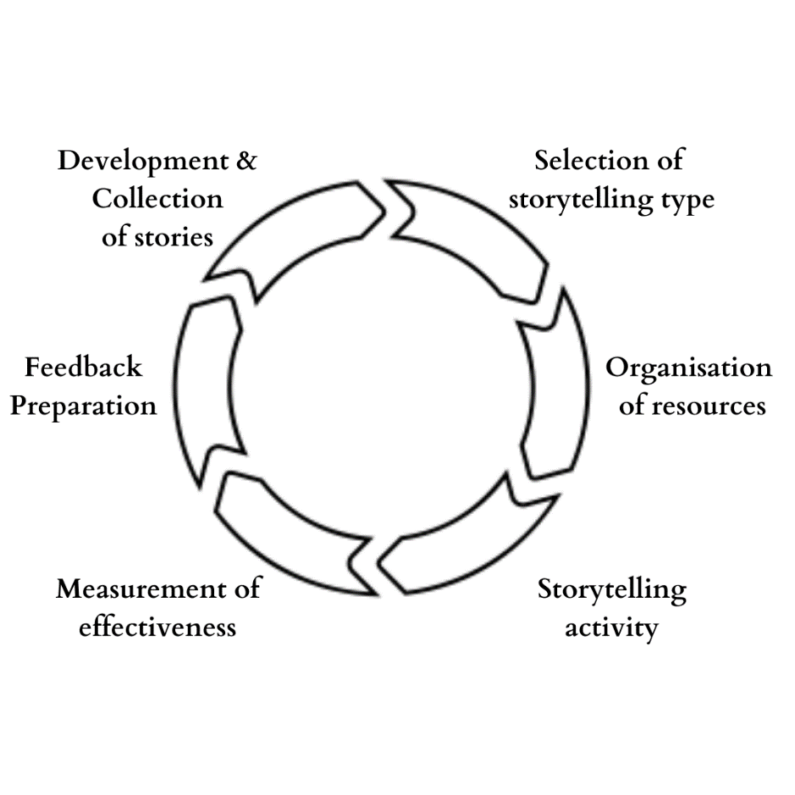

Figure 1. Process of Storytelling

## Development and Collection of Stories

Stories effectively convey latent messages while eliciting greater reactions and engagement from listeners. It stimulates the listeners' emotions as well as their thinking. Stories are useful input for a leader, and successful organisational leaders use storytelling to instil or enhance specific value-based behaviours in their organisations. Furthermore, stories are value-laden resources that promote a fast and simple comprehension of the context. As a result, organisational leaders, trainers, and storytellers must create storey banks and digital libraries containing a large number of stories.

Separate stories may be imbued with various values. As a result, organisations and storytellers should create as many stories as possible to accommodate various people's surroundings, context, culture, and emphasis. This may be derived or created in a variety of methods, as shown below.

* Self-development,
* Individual or organisational experience, as well as case studies
* Using secondary sources and published reports
* Stories from the epics and sagas of antiquity
* Traditionally passed on from elders

Even though each tale is unique, they can all be fit into specific templates. Overcoming the monster, rags to riches, the search, journey and return, comedy, tragedy, and rebirth are some of the categories used by Jane Hope (2013) to categorise stories. Stories may also be classified according to their format. The storytellers may choose any technique to categorise their stories, which will make it easier for them to obtain knowledge and apply it.

## Selection of Storytelling Type

Storytelling may be strategically incorporated in a variety of management areas within an organisation. Because storytelling is deliberately focused by leaders on organisational culture and is naturally persuasive, it is critical to select the appropriate kind of storytelling delivery. Storytelling may be classified in a variety of ways. Master Class (2020) divides storytelling into four areas (See Figure 2).

Specifically, oral storytelling, graphic storytelling, written storytelling, and digital storytelling. Oral storytelling is an old style of storytelling. One of the primary advantages of oral storytelling is that the storyteller may tailor his or her delivery to the audience. In today's internet-driven technology environment, storytellers may receive assistance in their oral storytelling delivery via tools such as clipboards, PowerPoint presentations, digital boards, and so on. Another tool for effectively telling stories is digital media. We must witness depicted stories in temples and cave paintings. Storytelling, with the use of such technologies, overcomes time constraints. The greatest examples of scripted storytelling that digital technology addresses are fables.

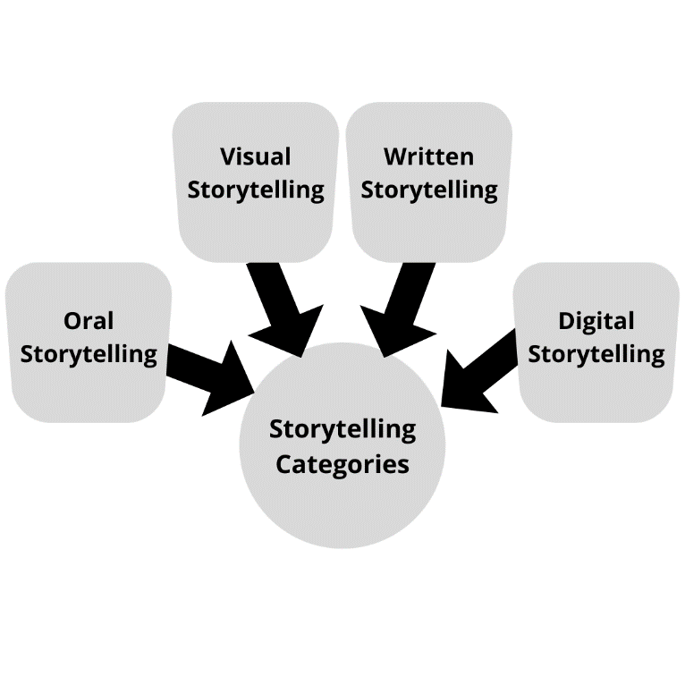

Figure 2. Story Telling Categories

## Organisation of Resources

Because each type of storytelling has its unique set of flips and flaps, a variety of materials are needed for each style of storytelling. In the case of oral storytelling in front of an auditorium audience, for example, a well-designed narrative clipped with high-speed internet and other technological devices may attract the audience's attention, whereas digital storytelling can combine a well-designed narrative clipped with high-speed internet and other technological devices.

The company will place more emphasis on the storyteller since the ability of the audience to recognise the importance of the tale is reliant on the storyteller's abilities. When it comes to delivering engaging narratives, a well-trained, managerially focused leader should be able to deliver. According to their observations, most political leaders flourish when they are able to deliver a compelling narrative. Organizational leaders are also expected to be better storytellers for the greater good of the organisation, according to expectations. As a consequence, when it comes to narrative, selecting the appropriate sources is critical. A skilled storyteller and a compelling narrative may make a significant contribution to the fast implementation of essential changes inside an organisation. It may be characterised as an organised storytelling endeavour with clearly defined goals carried out inside an organization's boundaries.

Determine the right delivery time and length as a consequence of this for the expected objectives is essential in order to achieve those goals. Excellent storytellers may be developed in internal employees, especially human resource professionals. Several of the company's members are also great storytellers, as shown by the following examples: The business may also employ storytellers who are well-versed in their craft. Despite the fact that storytellers are in plenty, organisations that choose the most suitable storytellers tend to get better results. It is essential in order to achieve the goals of the narrative process. It is equally as essential as other processes in storytelling to have instruments that assess the various components of storytelling since they enable the company to create a perfect storytelling strategy that is effective. The gadgets must thus be designed with caution as a consequence of this. Tools may be developed, invented, or changed in order to evaluate the effectiveness of the proposed narrative. Furthermore, the organisation should focus on developing methods to evaluate the event's preparations, as well as monitoring the impact and objectives of the storytelling activity, which will lead the business to excellence.

## Storytelling Activity

According to Denning (2006), "there is no one correct method to tell a narrative." Yes. Because storytelling is an art form, the same tale may be told in a variety of ways. It is influenced by a variety of factors, including emotions, strong words, voice modulation, and the manner in which the narrative is presented. The success of storytelling is based on how it stimulates, inspires, and motivates the listeners. As a result, the method or delivery of storytelling is critical to accomplishing its objectives. According to Holman (2001), storytelling is a strong tool for exploring and making meaning of values, beliefs, and behaviour. According to Asoka Change-makers (2013), stories contain three fundamental elements: the beginning, the middle, and the conclusion. At the start of the process, the storyteller should focus on methods for attracting the listener. In the middle stage, the storyteller may focus on the story's difficulties or knots and describe them.

Building enthusiasm and keeping the beneficiaries on track is a major task for a storyteller, and the efficacy is dependent on the storyteller's skill and natural characteristics. At the conclusion of the tale, the storyteller addresses the issues raised in the middle section of the storey. This is the moment for the storyteller to begin encouraging, inspiring, and convincing the audience about what he wants to emphasise. According to Mallan (1992), storytelling may help students develop problem-solving abilities. An effective choice of storyteller should indicate that the intended objectives are met, whether it is to discover a solution to a problem, to motivate employees, or to achieve any other purpose via the storytelling operation.

In his essay "how to tell a wonderful narrative," O'Hara (2014) explores the many ways in which one may profit from the art of storytelling. When it comes to accomplishing this goal, he stresses the importance of the following elements: there should be an initial message when starting a tale, and it should be possible to include the storyteller's own experiences when telling a storey, but the storyteller should not be placed in the spotlight and projected as a celebrity. In order to make a tale more interesting, a storyteller must depict a struggle, and the author advises that the storyline be kept simple in order to ensure that the story's reach is successful.

## Measurement of Effectiveness

It is possible to evaluate the success of a storytelling activity at two stages: during the presentation of the tale and immediately thereafter. Similarly, the success of a storytelling activity during delivery may be assessed by the emotions and reactions of the audience; that is, the success of the storytelling activity during delivery can be evaluated by the emotions and responses of the audience. The previously stated goal will be achieved via the use of a well-designed device.

Such emotions and responses may and should be recorded subjectively and quantitatively using the instrument that has been pre-determined for this purpose.The effectiveness of storytelling may be assessed by observing the audience's expressions with the storyteller. According to Wieser and Brosch (2012), expressions of individuals are reliable emotional reflectors. Senthil Kumar (2018) said that emotions have a larger impact on decision-making than rational considerations.

In order to evaluate the storytelling exercise after it has taken place, a questionnaire based on the responses of the participants may be used. This may also be evaluated after the narrative process has taken place, via indirect measures such as achieving the objectives.

## Feedback Preparation

By preparing feedback, it suggests recording the efficacy as evaluated by the various instruments mentioned previously. Any activity feedback is a useful technique for enhancing the activity itself. Any system that receives constant input will grow and evolve indefinitely. According to McCarthy and Garavan (2001), a 360-degree feedback system will lead to better employee performance and career growth. Nadler (1976) endorsed feedback as a tool for organisational transformation.

As a consequence, the organisation should focus its efforts at this stage on documenting the feedback in order to improve each phase of the narrative process in general. All stages of the storytelling activity need feedback from people who are engaged in order to improve each step and, as a consequence, to improve the management effectiveness of the activity. The documentation of the remarks will be very beneficial to the company and other stakeholders in the process of developing it.

# Conclusion

Storytelling is a very effective technique of persuading high-level executives to join the business. It provides applicants with a clear understanding of who their company is as an employer, allowing them to determine whether or not they would be a good match. Humans have the ability to break down the walls they construct to shield themselves from the outside world and new ideas via the power of storytelling. In this digital age, all of these gathered and classified storytelling materials should be preserved in digital form so that they may be accessed and utilised by storytellers in their respective fields. For managers, company success stories or difficulties may be used as "magic bullets" to strengthen their relationships with their workers. The advent of the digital age has hastened the paradigm shift away from all previous forms of storytelling and toward digital storytelling. Digital storytelling encompasses platforms such as websites, forums, YouTube videos, and other social media that are distributed via digital channels on the internet, such as the internet and mobile devices. The company will devote more resources to determining the kind of storey to use. This is dependent on the goals of the institution and the tales that are chosen. The company may even employ storytelling tools at the same time, which may help to emphasise the objective that needs to be accomplished via storytelling and ensure that it is achieved.

# Reccomendaions

A method to improve the storytelling for management would be adopt visual storytelling as a key method. Visual storytelling may seem to be a simple concept — it is the skill of conveying a sequence of messages using visual multimedia. However, the idea of visual storytelling is more important today than ever, particularly in our increasingly digitised era, when customers' attention is always being fought for. Today's visual storytelling makes use of graphics, images, photographs, and videos to engage viewers and elicit emotions and engagement (Arnold & Eddy, 2007). Visual material is not only more appealing and memorable, but it is also more engaging for its audience, which improves its credibility, strengthens the brand, and generates income for the business that commissions it. All forms of visual storytelling often offer reliable data, but it should come as no surprise that video is the most powerful medium. While video is the most popular form of visual storytelling, it is not the only one. Organisational management could use visual story telling in a multiple of ways inside and outside the organisation to deliver the message they want with high level of success than other story telling method specially with the use of digital media (Lim and Childs, 2020).

# References

Arnold, B., & Eddy, B. (2007). Visual storytelling. New York: Thomas Delmar Learning.

Atkinson R (2002) The life story interview. In: Gubrium JF, Holstein JA (Eds) Handbook of Interview Research: Context and Method. Sage Publications, Thousand Oaks CA, 121-140.

Bailey, P. H., & Tilley, S. (2002). Storytelling and the interpretation of meaning in qualitative research. Journal of advanced nursing, 38(6), 574-583. DOI: 10.1046/j.1365-2648.2000.02224.x

Banks-Wallace J (1999) Storytelling as a tool for providing holistic care to women. The American Journal of Maternal Child Nursing. 24, 1, 20-24.

Bartone PT (2006) Resilience under military operational stress: can leaders influence hardiness? Military Psychology. 18, Supplement 1, S131-S148. DOI: 10.1207/s15327876mp1803s_10

Bauman Z (2004) Wasted Lives: Modernity and Its Outcasts. Polity Press, Cambridge.

Benner PE, Tanner CA, Chesla CA (1997) The social fabric of nursing knowledge. American Journal of Nursing. 97, 7, 16BBB-16DDD.

Blythe, S., Wilkes, L., Jackson, D., & Halcomb, E. (2013). The challenges of being an insider in storytelling research. Nurse researcher, 21(1). DOI: 10.7748/nr2013.09.21.1.8.e333

Boje, D. M. (2008). Storytelling organizations. Sage.

Bonanno GA (2004) Loss, trauma, and human resilience: have we underestimated the human capacity to thrive after extremely aversive events? American Psychologist. 59, 1, 20-28. DOI: 10.1037/0003-066X.59.1.20

Bourbonnais, A., & Michaud, C. (2018). Once upon a time: Storytelling as a knowledge translation strategy for qualitative researchers. Nursing inquiry, 25(4), e12249. DOI: 10.1111/nin.12249

Bowles N (1995) Story telling: a search for meaning within nursing practice. Nurse Education Today. 15, 5, 365-369. DOI: 10.1016/S0260-6917(95)80010-7

Carlick A, Biley FC (2004) Thoughts on the therapeutic use of narrative in the promotion of coping in cancer care. European Journal of Cancer Care. 13, 4, 308-317. DOI: 10.1111/j.1365-2354.2004.00466.x

Chadwick S (2004) Peer-led programs: promoting resilience. Educare News. 148, 24-26.

Chase SE (2005) Narrative inquiry: multiple lenses, approaches, voices. In: Denzin NK, Lincoln YS (Eds) The Sage Handbook of Qualitative Research. Third edition. Sage Publications, Thousand Oaks CA, 651-680.

Connelly FM, Clandinin DJ (1990) Stories of experience and narrative enquiry. Educational Researcher. 19, 5, 2-14. DOI: 10.3102/0013189X019005002

Cowling WR (2005) Despairing women and healing outcomes: a unitary appreciative nursing perspective. Advances in Nursing Science. 28, 2,94-106.

Cronin C (2001) Storytelling... ’The future of nursing’. Nursing Forum. 36, 3, 4.

Dean RG (1995) Stories of AIDS: the use of narrative as an approach to understanding in an AIDS support group. Clinical Social Work Journal. 23, 3, 287-304.

Dyer JG, McGuinness TM (1996) Resilience: analysis of the concept. Archives of Psychiatric Nursing. 10, 5, 276-282.

East L (2005) Women’s Experiences Of Growing Up Without A Father: A Phenomenological Study. Unpublished honours thesis. University of Western Sydney, Sydney Australia.

East L, Jackson J, O’Brien L (2006) Disrupted relationships: adult daughters and father absence. Contemporary Nurse. 23, 2, 252-261.

Fairbairn, G. J., & Carson, A. M. (2002). Writing about nursing research: a storytelling approach.(Qualitative approaches). Nurse Researcher, 10(1), 7-15.

Fog, K., Budtz, C., & Yakaboylu, B. (2005). Storytelling. Berlin: Springer.

Frank AW (1995) The Wounded Storyteller: Body, Illness, and Ethics. The University of Chicago Press, Chicago IL.

Frank AW (2000) The standpoint of storyteller. Qualitative Health Research. 10, 3, 354-365. DOI: 10.1177/104973200129118499

Greene, E. (1996). Storytelling: Art and Technique: Art and Technique. ABC-CLIO.

Gyabak, K., & Godina, H. (2011). Digital storytelling in Bhutan: A qualitative examination of new media tools used to bridge the digital divide in a rural community school. Computers & Education, 57(4), 2236-2243. DOI: 10.1016/j.compedu.2011.06.009

Hauser ST, Golden E, Allen JP (2006) Narrative in the study of resilience. Psychoanalytic Study of the Child. 61, 1, 205-227. DOI: 10.1080/00797308.2006.11800771

Hunter LP, Hunter LA (2006) Storytelling as an educational strategy for midwifery students. Journal of Midwifery and Women’s Health. 51, 4, 273-278. DOI: 10.1016/j.jmwh.2005.12.004

Jackson D, Firtko A, Edenborough M (2007) Personal resilience as a strategy for surviving and thriving in the face of workplace adversity: a literature review. Journal of Advanced Nursing. 60, 1, 1-9. DOI: 10.1111/j.1365-2648.2007.04412.x

Jackson D, Mannix J (2003) Mothering and women’s health: I love being a mother but... there is always something new to worry about. Australian Journal of Advanced Nursing. 20, 3, 30-37. DOI: 10.3316/informit.405348324555038

Kendall, J. E., & Kendall, K. E. (2012). Storytelling as a qualitative method for IS research: heralding the heroic and echoing the mythic. Australasian Journal of Information Systems, 17(2). DOI: 10.3127/ajis.v17i2.697

Kitzinger C (2004) Feminist approaches. In: Seale C, Gobo G, Gubrium JF et al (Eds) Qualitative Research Practice. Sage Publications, London, 125-140.

Koch T (1998) Story telling: Is it really research? Journal of Advanced Nursing. 28, 6, 1182-1190. DOI: 10.1046/j.1365-2648.1998.00853.x

Landrum, N. E. (2000). A quantitative and qualitative examination of the dynamics of Nike and Reebok storytelling as strategy. New Mexico State University.

Leseho J, Block L (2005) ‘Listen and I tell you something’: storytelling and social action in the healing of the oppressed. British Journal of Guidance and Counselling. 33, 2, 175-184.

Lewis, P. J. (2011). Storytelling as research/research as storytelling. Qualitative inquiry, 17(6), 505-510. DOI: 10.1177/1077800411409883

Lewis, P. J., & Hildebrandt, K. (2020). Storytelling as qualitative research. SAGE Publications Limited. DOI: 10.4135/9781526421036754858

Lim, H., & Childs, M. (2020). Visual storytelling on Instagram: branded photo narrative and the role of telepresence. Journal of Research in Interactive Marketing.

Merleau-Ponty, M. (1964). Signs. Northwestern University Press.

Murray BL (2003) Qualitative research interviews: therapeutic benefits for the participants. Journal of Psychiatric and Mental Health Nursing. 10, 2, 233-236. DOI: 10.1046/j.1365-2850.2003.00553.x

Pennebaker JW, Seagal JD (1999) Forming a story: the health benefits of narrative. Journal of Clinical Psychology. 55, 10, 1243-1254. DOI: 10.1002/(SICI)1097-4679(199910)55:10<1243::AID-JCLP6>3.0.CO;2-N

Peters K (2006) Misguided Hope: A Narrative Analysis of Couples’ Stories of Childlessness Despite Treatment With Assisted Reproductive Technology. Unpublished doctoral thesis. Flinders University of South Australia, Adelaide, Australia.

Polkinghorne DE (1988) Narrative Knowing and the Human Sciences. State University of New York Press, New York NY.

Ranieri, M., & Bruni, I. (2013). Mobile storytelling and informal education in a suburban area: a qualitative study on the potential of digital narratives for young second-generation immigrants. Learning, Media and Technology, 38(2), 217-235. DOI: 10.1080/17439884.2013.724073

Reichert E (1998) Individual counseling for sexually abused children: a role for animals and storytelling. Child and Adolescent Social Work Journal. 15, 3, 177-185. DOI: 10.1023/A:1022284418096

Riley T, Hawe P (2005) Researching practice: the methodological case for narrative inquiry. Health Education Research. 20, 2, 226-236. DOI: 10.1093/her/cyg122

Roberts W, Strayer J (1996) Empathy, emotional expressiveness, and prosocial behavior. Child Development. 67, 2, 449-470. DOI: 10.1111/j.1467-8624.1996.tb01745.x

Rubin HJ, Rubin IS (2005) Qualitative Interviewing: The Art of Hearing Data. Second edition. Sage Publications, Thousand Oaks CA.

Rutter M (1999) Resilience concepts and findings: Implications for family therapy. Journal of Family Therapy. 21, 2, 119-144. DOI: 10.1111/1467-6427.00108

Sandelowski M (1993) Rigor or rigor mortis: the problem of rigor in qualitative research revisited. Advances in Nursing Science. 16, 2,1-8.

Schoon I (2006) Risk and Resilience: Adaptations In Changing Times. Cambridge University Press, New York NY.

Steiner JF (2005) The use of stories in clinical research and health policy. The Journal of the American Medical Association. 294, 22, 2901-2904. DOI: 10.1001/jama.294.22.2901

Thomas RM (2003) Blending Qualitative and Quantitative Research Methods In Theses and Dissertations. Corwin Press, London.

Tusaie K, Dyer J (2004) Resilience: a historical review of the construct. Holistic Nursing Practice. 18, 1, 3-8.

Vezeau TM (1994) Narrative inquiry in nursing. In: Chinn PL, Watson J (Eds) Art and Aesthetics In Nursing. National League for Nursing Press, New York NY, 41-66.

Warne T, McAndrew S (2007) Passive patient or engaged expert? Using a Ptolemaic approach to enhance mental health nurse education and practice. International Journal of Mental Health Nursing. 16, 4, 224-229. DOI: 10.1111/j.1447-0349.2007.00471.x

Wiltshire J (1995) Telling a story, writing a narrative: terminology in health care. Nursing Inquiry. 2, 2, 75-82. DOI: 10.1111/j.1440-1800.1995.tb00070.x

Yavuz, M. C., Sumbul, M., Ergec, N. E., & Derdiyok, C. I. (2016). Storytelling in destination brand communication: A qualitative analysis. Journal of Global Business Insights, 1(2), 63-72. DOI: 10.5038/2640-6489.1.2.1008