The Storytelling of Racism: A Norm of the Past Recognized as a Mental Health Crisis in the Present to Develop a Sustainable Social Construct for the Future

Wanda Tisby-Cousar

Abstract

Racism globally has different meanings as a recognized theoretical framework in the United States regardless of the desire to educate on this topic. Considering the multitude of frameworks depending on the country of origin, it is necessary to delineate what is and is not racism depending upon where one lives, travels, or becomes an expatriate. The following paper will explore its history abroad and in the United States to contribute to the organizational development framework of African and European countries as a focal point of those countries that have historically colonized and have resulted in discourse on how to define, recognize, and address racism. Leadership tools to address the discourse, when implementing business ethics to address racism as a sustainable or unsustainable practice perspective will be interpreted from the living stories of leaders who have racial barriers, benefited from racism,  survived it, or witnessed colleagues victimized from racism will also be presented in this discussion.

Racism was first defined as a social construct yet given the advent of the Black Lives Matters Movement, the police involved shootings of African American men and women, and the recent 1619 project it has evolved to encompass a variety of meanings resulting in a newly evolved discourse. Moreover, as the world is perplexed from its purview of western civilizations’ acts of violence and disparate applications of the law and policy against certain ethnic groups use of the Storytelling Process Model will be reflected in this study. Considering that a government funded institution and an academic degree granting institution the University of North Carolina at Chapel Hill (UNC), as an example has become involved in these acts of racism as currently defined, there is an overwhelming advocacy both for and against what is now referred to as diversity, equity, and inclusion. In this paper, racism will be interpreted from the classical to the contemporary meaning based on significant events and interpretation with the Antenarrative Processes model. By doing so, discourse can be addressed with a clear vision of why and how to address racism as a mental health crisis and develop leadership coaching strategies for a sustainable future that clearly defines racism to be addressed as a mental health dilemma.

**Racism as a Social Construct**

Racism has evolved and taken on a variety of meanings historically and globally. Since the advent of defining race as a social construct, American Sociologist W.E.B. Dubois, a graduate of Fisk University, a historically black college was also the first black to receive a Ph.D. in Sociology from Harvard University in 1896. He was concerned that race was being used as a biological explanation of what was understood as social and cultural differences among populations of people. This condition according to Dubois further contributed to ignoring the scope of diversity by viewing distinct populations as “black” and “white”. Science would favor Du Bois since the mainstream belief among scientists is that race is a social construct without biological meaning. In an article originally published in the Genetic Literacy Project, four scholars say racial categories are weak proxies for genetic diversity and this further validates it being phased out especially in its application in the scholarship of science (Pappas, 2012). Yudell, public health professor at Drexell University in Philadelphia adds “that modern research is operating in a paradox, which is that race is understood to be a useful tool to elucidate human genetic diversity. Yet to the contrary, race is also understood to be a poorly defined marker of that diversity and an imprecise proxy for the relationship between ancestry and genetics ( Otto, 2016 ).”

Another perspective aligned with that of W.E.B Dubois and scholars is that of Svante Pääbo, a biologist and director of the Max Planck Institute for Evolutionary Anthropology in Germany, who worked on the Neanderthal genome. He states, “What the study of complete genomes from different parts of the world has shown is that even between Africa and Europe there is not a single absolute genetic difference, no single variant for all Africans or Europeans, even when recent migration is disregarded. It is all a question of differences in how frequent different variants are on different continents and in different regions. (Pappas, 2012)" This is another scientific perspective that invalidates the use of race in research as a weak social construct. However, related theory emerges, and discourse ensues.

**Critical Race Theory Discourse**

The 1619 project, created by Nikole Hanna-Jones, is a Pulitzer Prize winning reporter who covers racial injustice for the New York Times magazine. Additionally, Hanna-Jones is the NY Times best-selling author of a series of 18 anthologies, 36 poems, and short stories leaving a legacy for the 400th anniversary in 2019 of the first enslaved Africans who landed in Jamestown, Virginia from Kongo|Angola region of South-Central Africa in 1619. It was not until 1660 that the demand increased and the Dutch seized control of the slave trade in 1630 from the Portuguese and began to transport slaves from West Africa (https://jyfmuseums.org/pdf/Curriculum-Materials/AngolanConnection.pdf, n.d.).

The 1619 Project was dedicated to over 300 million enslaved Africans who arrived according to Amy Goodman, host and Juan Gonzalez, co-host of Democracy Now. Also, it is a commemorative work for “The Year of Return” for those ancestors of enslaved Africans who returned in 2019-present, received their dual citizenship from the government of Sierra Leone, West Africa. The author Dr. Wanda Tisby-Cousar was among the first seven to receive dual citizenship and rites of passage including a new West African name which was sanctioned by 23 Paramount Chief, Maada Boima, Section Chiefs, and the Council of Elders.

What is referred to as Critical Race Theory has been met with discourse from government leaders at the state and federal level, faith-based organizations, and school officials in the United States in lieu of its intentions for the betterment of society. Former President Donald Trump implied banning it and pulling federal funding, and many states followed like North Dakota and Tennessee with penalties to teachers that teach it. Florida, Idaho, and Texas also passed laws to prevent its teaching in curriculum and are among up to 12 states. Laws such as the 1836 project, the year Texas succeeded from Mexico was signed into law by the Texas governor Greg Abbott to instead teach Texas patriotic values. According to Hanna-Jones, this is contrary to teachings about the lynching’s of Mexicans and African Americans in Texas that occurred during this period (#DemocracyNOW , 2021)

Professor Hanna-Jones was denied tenure at the University of North Carolina, Chapel Hill despite faculty and student unanimous support and protest. Though later offered tenure, refused and accepted an offer at the prestigious Howard University in Washington, D.C., a historically black university. Professor Hanna-Jones credits high school teacher Mr. Ray Dow for the vision of the 1619 project. Dow encouraged Hanna-Jones to write about black history stories in the school newspaper and revealed to Hanna-Jones that there was black history that had a legacy longer than the English people who are credited in history for their legacy though black history was not taught in some schools. African American history is taught in New Jersey schools. A bill was signed by Governor Bill Murphy (S-1028) January 7, 2021, that amended the law creating the Amistad Commission that would:

“Supplement existing law to require all boards of education to include instruction that infuses into all courses on the United States, the centuries of accomplishments by African Americans in the building and development of America including, but not limited to, the areas of industry, the professions, local communities, culture, arts, and the sciences.  The instruction must enable students to know and understand the nation’s heritage of slavery and freedom and the contributions of African Americans to all areas of American society throughout history. The instruction must also emphasize the personal responsibility of each citizen to fight racism and hatred and to uphold the national ideals of freedom and justice. The bill directs the Department of Education to work with the Amistad Commission to ensure that the assessment tools for New Jersey schools are inclusive of the curricular requirements established under the bill (NJPSA, 2021).

Additionally, there are anti-discriminatory laws that have emerged such as, Creating a Respectful and Open World for Natural Hair (CROWN) act, originally sponsored by Senator Holly J. Mitchell of California. According to Chaudry (2020), a Senior Policy Analyst and advocate for marginalized communities of women, “the CROWN Act’s ban on discriminatory hair policies in the workplace and in schools would foster Black women and girl’s ability to wear natural hair and hairstyles preventing discrimination against workers of the African American ethnic group from wearing natural hairstyles in the workplace. The Act also addresses the wearing of headdresses that represent cultural and religious identity. The bill is now law in 7 other states (CO, MD, NY, NJ, VA, WA, CT), (Dove, 2022).

This lack of protection was harmful, since rooted in historically racist practices of controlling Black women and girls’ bodies who had been forced to adjust, chemically alter, and change their natural hair to conform to workplace and school policies. Such policies prioritize Euro-centric beauty norms that are the perceived idealized perception of beauty noted by psychologists that are damaging to self-esteem. These Eurocentric beauty standards favor straight hair styles and discriminate against natural hair styles to the detriment of natural hair and Black women and girls’ mental health due to the impact on lowering body esteem (Frisby, 2004).

Rooted in West African culture, the Sande Leadership attributes perceptions of beauty and health practices are addressed ontologically through the storytelling of descendants of the African diaspora. Research uncovered how four different generations to include war veterans, baby boomers, generation x, millennials of male and female genders from government, private, nonprofit, and small business industries ranked the leadership attributes’ importance. Males ranked them highly important while females ranked both least important (Tisby-Cousar, 2015). Could this be reflecting an adaptation due to resilience in the female gender that their public image does not matter so just accept it since nothing has or will change?

**Racism and the Mental Health Crisis**

Professor Hanna-Jones implied that after being denied tenure in lieu of honors, awards and stellar work experience and thereafter offered it again after faculty and student protest, had to “wrap her mind around what was happening and how a board member could have so much power over her career in lieu of her accomplishments (Robertson, 2021).” A letter from Hannah-Jones’s lawyers said an unnamed “powerful donor” had contributed to the University of North Carolina board of trustees’ failure to grant tenure, Robertson (2021). This was why the offer was not accepted the second time. Such a decision implies protecting one’s mental health for the sake of a career that could result in another and better offer. Inadvertently, such elevates self-esteem.

Hanna-Jones suggests (2021), the act of making slavery invisible given it has influenced our society in many ways and doing so does not explain, the insurrection on capital hill, the killing of George Floyd in broad daylight by a police officer who believed getting away with it while doing it in front of witnesses was permissible. Hanna-Jones implies that such is memory control that could be damaging to citizens and does not increase knowledge of the connection to resilience and love as well as the horrors of violence in linking the past to the present. Even choosing a race on applications comes from a legacy of slavery along with many other amendments like citizenship laws that were originally intended for enslaved people to separate the enslaved from the unenslaved. Hanna-Jones finds solace in idol and ancestor Ida B. Wells an investigative reporter who pioneered elevating the act of lynching to a global audience and was a suffragist, civil rights activist, and co-founder of the NAACP. Wells received the Pulitzer Prize the same day that Nikole Hanna-Jones received the same prize. Such was confirmation that Hanna-Jones is fulfilling a calling from the ancestors and is related to spirituality, a Sande leadership attribute (Tisby-Cousar, 2015). The interviews of descendants of the African diaspora whose ancestors were delivered to U.S. slave ports from Africa was based on their family’s demographic migration patterns. Such revealed spirituality to be one of 16 leadership attributes when interpretating narratives that were stories of resiliency with spirituality (Tisby-Cousar, 2015).

**Storytelling Process Model Methodology**

According to (2017), the Storytelling Process Model consist of two pathways between living story and grand narrative, the linear- and cyclic-antenarratives antecedents are from past, predicted to recur in the future, hence slavery, the Civil Rights movement, Black Lives Matters movement living stories and the Grand Narrative, 1619 Project. The linear pattern is known as retrospective sensemaking, looking backward at history, at what is arriving into the now. In interpretation, this methodology explains how the Civil Rights Movement of the 1960’s has retrospectively reemerged restorying racism in the Black Lives Matters Movement living story created by three radical organizers in 2013, Alicia Garza, Patrisse Cullors, and Opal Tometi in response to the acquittal of Travon Martins assailant George Zimmerman. It is now a global network of 40 chapters (Black Lives Matter, n.d.). It is also the Grand narrative of the 1619 Project.

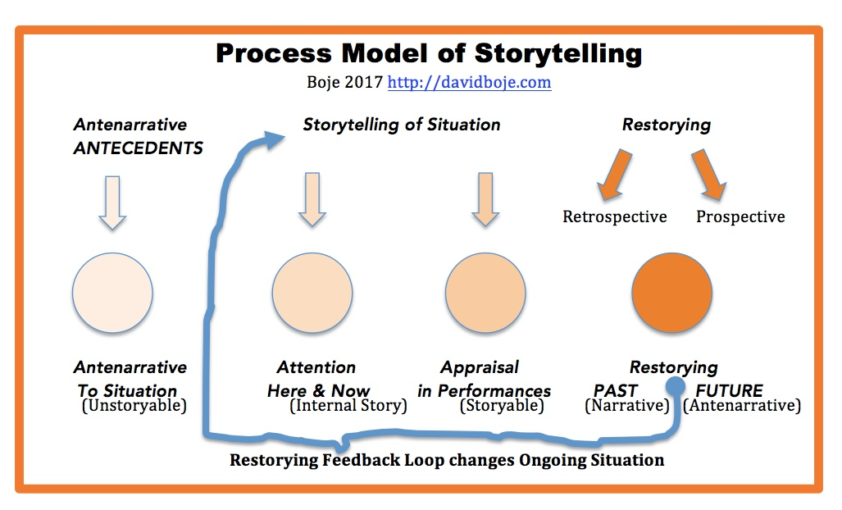

Here and Now. and is supported by scientists of the Genetic Library Project that such are weak proxies for genetic diversity and this further validates it being phased out especially in its application in the scholarship of science (Pappas, 2012). According to the Process Model Storytelling of Situation, this analysis gives attention “Here and Now” and “Appraisal in Performances”. Hence, reflects Internal Story of “imprecise proxy of the relationship between ancestry and genetics and race also understood to be a poorly defined marker of that diversity and an imprecise proxy for the relationship between ancestry and genetics.” as Yudell, Drexell University scientist stated. It is also Storyable (Boje, 2017) when connected to social and cultural differences (Gannon, 2016). The following interview questions in Appendix A were designed to interpret narratives using the Storytelling Process Model and identify Sande Leadership attributes in the participants.

References

Black Lives Matter (n.d). Herstory. https://blacklivesmatter.com/herstory/

Boje, D. (2018, June). What is Living Story Web?

https://davidboje.com/Boje/What%20is%20Living%20Story.htm#:~:text=

Boje, D. (2017). Process model of storytelling. *Antenarrative Processes Defined.*

[*https://davidboje.wordpress.com/2017/04/27/storytelling-process-model/*](https://davidboje.wordpress.com/2017/04/27/storytelling-process-model/)

Chaudry, I. (2020, December 2). The passage of the CROWN Act will be a win for black women

and girls health. https://nwhn.org/crown/

#DemocracyNOW (2021, November 23). Nikole Hannah-Jones on “the 1619 Project,” Teaching

Critical Race Theory & White Supremacy on Trial. [video]. <https://youtu.be/HXmaEJ3Yd_I>

Dove (2022). The CROWN Act. <https://www.dove.com/us/en/stories/campaigns/the-crown->

act.html

Frisby, CM (2004, January 1). Does Race Matter?: Effects of Idealized Images on African

American Women’s Perceptions of Body Esteem. Journal of Black Studies. 2004;34(3):323-

347. doi:10.1177/0021934703258989

Gannon, M. (2016, February 5). Race is a social construct. Scientific American.

https://www.scientificamerican.com/article/race-is-a-social-construct-scientists-argue/

Otto, F. (2016, February 4). Removing race from human genetic research. *DrexelNow.*

*https://drexel.edu/now/archive/2016/February/Race_Genetic_Study/*

Pappas, S. (2012, September 6). Unraveling the genome. *Journal of Science.*

http://www.swallowxx.com/2012/09/06/unraveling-the-human-genome-6-molecular-milestones/#

Robertson, K. (2021, October 13). Nikole Hannah- Jones says she won’t join U.N.C. faculty

without tenure.https://www.nytimes.com/2021/06/23/business/media/nikole-hannah-jones-university-of-north-carolina-tenure.html

Marks, A. (n.d.) The Angolan Connection and Slavery. https://jyfmuseums.org/pdf/Curriculum-Materials/AngolanConnection.pdf

# NJPSA (2021). New law: P.L.2020, c.153 Allocates Amistad Commission in but not of DOE; requires commission to elect chairperson and appoint executive director; requires public schools to include instruction on accomplishments and contributions of African Americans to American society. jpsa.org/new-law-p-l-2020-c-153-allocates-amistad-commission-in-but-not-of-doe-requires-commission-to-elect-chairperson-and-appoint-executive-director-requires-public-schools-to-include-instruction-on-acc/”

Tisby-Cousar (2015) Sande Leadership: Attributes of Sustainable Organizational Practices.

Lambert Academic Publishing: Germany.

Appendix A

Questions for Interviews:

1. How do you define racism based on your professional experience in the USA or globally?
2. How was racism directed at you, others, or both?
3. Based on your description, what was the mental health impact?
4. What organizational policies or procedures were made accessible to mitigate the racism experienced?

1. What would be your recommendation for managing racism in an organizational context?

,