Nature Walk and Talk Therapy: Together-Telling with People and Place

Elizabeth Harvey
elizabeth@elizabethharveycounseling.com
575-224-2008

As a licensed mental health counselor, in September 2021 I began to use a modality I had not previously used for therapy: nature walk and talk therapy. This approach consists of completing a standard 50-minute psychotherapy session outdoors while walking. I lead this therapy on a trail in a natural area within Las Cruces. I initiated this type of therapy after a year of seeing clients only virtually or over the phone due to the COVID-19 pandemic. In this way, I’ve begun to think of nature walk and talk therapy as a renewal of “together telling” – a way of coming back together after an extended period of isolation, witnessing one another in person again, within and interacting with the container of the natural world. Clients have stories that needed to be told. In nature walk and talk, I as counselor am not the only witness. The place and its inhabitants may also fill that role.

I notice that I see my clients in a new way in this environment. Sharing a space, even with distancing, is a much more intimate interaction than over the phone or on a video screen. Being able to see how someone is carrying themselves on a walk provides indicators of their state. Are they noticing things around them in nature, or staying “in their head?” Animals and plant encounters bring up childhood memories for some; the conversation takes a turn that might never have come up over video. Clients can’t help but notice the roadrunner, coyote, or jackrabbit crossing the trail in front of us or the hawk soaring above. Some find joy in the moment, others also delve into symbolism when this happens. In this way, the place and its non-human residents actively participate in the session. In considering the whole picture of a therapy session of this kind, both humans and the rest of the natural world play roles of storyteller and witness in a reciprocal and interconnected “together-telling.”

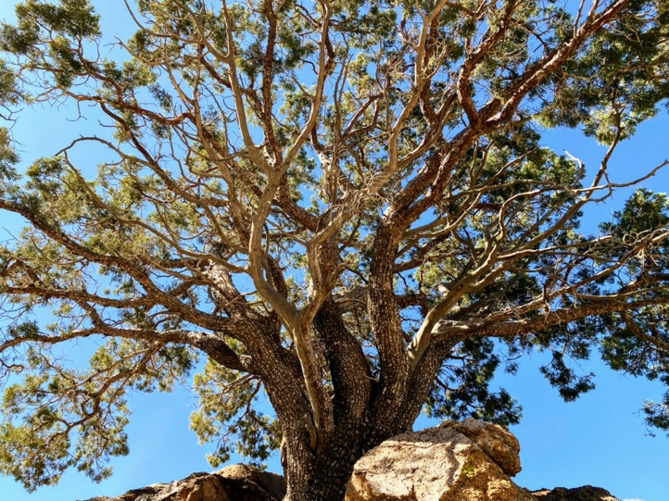
A solo expedition into a local canyon provides an example of another kind of together-telling with nature outside the formal therapy context. In March 2021, I made an intentional journey into a local mountain canyon to release the old and welcome the new for the change of season into spring. I spent time with jackrabbits, trees, desert, birds, mountains, wind. Words seemed to materialize on the wind as I moved up the canyon and approached a gnarled juniper. I recorded the words and phrases on my phone in real-time. I share the resulting poem and photos taken in the place as the results of “together-telling with place.”

Song for Spring
Cast off the crumbling shell of curses that have no power, discard the husk of possibilities that died on the vine.
Emerge from the ground like a noonish snake onto warm stone. Soak golden beams into your heart’s blooms, ready to unfurl with the mountain’s protection.

Release regret to be carried off like dust on surging currents of breeze, making space for the spring of earth and soul.

Find a tree for shelter and overlook, roots anchored by rock, branches unbothered by the gale.

Climb, climb to a high point. Surrender to the whipping wind and let it scourge you clean.
Stretch yourself out in all directions. Become one with the infinite openness over the landscape.

Shelter in the quiet shade of stones, resting and regathering the energy of ancient strength.
Descend, renewed, with ears to hear like the jackrabbits whose ears catch warm rays.

Go down with a new song gathered from every chirping, hopping, warbling friend that has blessed your path.

See clearly, as from the promontory of the strong tree, with timeless eyes and wizened yet supple heart.
Carry the strength of the stones in your skin, alive and breathing yet rooted to the center of the earth.
Soak in the warming light, feel it flow in your veins to the fingertips, the sap of a new season coming forth through your body.

Fly down on lighter feet, letting the trail thorns remind you that you can feel.

Kneel and wash your hands in the soft arroyo sand, humming a song of thanks.

Live in this spring, live. It is for you.

