Ken Long
Foundations Bootcamp
Modified Cornell Notes _Tortoise on Ruzuku
ptwu
12-12-2021

Table of Contents
How to setup your charts 4
Sample daily strategy podcast, applying ideas from the daily report 20210701 5
Ecosystem introduction (1 of 3) 6
Ecosystem (2 of 3) 7
Ecosystem (3 of 3) 8
The Time Structure of the Daily Trading plan 9
Preparing the Daily Trading Plan: Selecting and framing targets 10
The 2R Battle Drill: the single most important rehearsal 11
Coaching Overview 12
The challenge of developing a trader’s mind 13
Design thinking for innovative solutions 14
Life cycle management of trading production systems 15
Psychological state management in the usual phases of a trade 16
Estimating gains, with risk management in all time frames 17
Core and turbo, critical states, mechanical entries Green, yellow, red 18
Trade management and exit techniques, zero state 19
Intraday risk vs Overnight risk (short video) 20
Mindset and emotion state management 21
Plan, prepare, execute, assess 22
Plan, prepare, execute, assess part 2 23
Strategies, systems, techniques, tips 24
Volatility in fast and slow markets 25
Finding the mover, emotional hacking 26
The power of visualization 27
Frog theory (1 of 3) 28
Frog theory (2 of 3) 29
Frog theory (3 of 3) 30
Insights from day 1 live trading lessons learned 31
Rangestat, MACD 4 seasons, swing trade systems as signal generator! 32
Chain trading, the monkey mind, C- performance should be profitable 33
Integrating different bodies of knowledge 34
Simple WMB3 entry rule...an example of elegant simplicity 35
WMB3 (part 2 of 2) 36
Using the daily/weekend report to find targets of different types 37
Visual box trading, thoughts on precision and position sizing 38
Core & Turbo Trade frames 39
Visual Box Trading flashcards 40
Visual Box Trading examples from live trading 41
MTFMLA: 20190121 Multi Time Frame, Multi Lens Analysis 42
MTFMLA: 20190714 SPY example 43
MTFMLA: 20190810 44
MTFMLA 20191109 45
Strategic choice: 4 approaches plus a blend (clone) 46

Admin  Foundations Bootcamp  Tortoise on Ruzuku  60 min. | Context/Prep  How to setup your charts
Key Words  Chart type: Bars used (1:30)  Bollinger Bands (2:50)  River (3:00)  Floodplains (15:45)  Moving Regression lines (18:45)  RL10 (20:00)  RL30 Health of trend (32:20)  RL90 (37:50)  RL270 (40:00)  Simple Moving Average (25:00)  Spine of Dragon (25:00)  Skin of Dragon (25:00)  Regression line fractal framework (40:40)  PSAR Parabolic Stop & Reverse (49:00)  Baby Dragon (50:50)  MACD on RL10 (52:40) | Notes  Chart setups  1) Prefer to use bars for readability rather than candlesticks.  Price bars less complex to view in its relationship to the other indicators used  2) Bollinger Bands to show volatility of price movements  o Mean: 30 period simple moving average on price, red dashed lines  o Z1: +/- 1 standard deviation, dashed lines, shaded Blue, coined River  o Z2: +/- 2 standard deviations, dashed blue lines, coined Flood plains  o Z3: +/-3 standard deviations, thick red lines  Normal price action within Z1 bands, abnormal as price moves outside of Z1 (Floodplain)  3) Moving Regression lines (linear regression lines) on price  o RL10: 10 period linear regression line (blue), least squares best fit of price  o RL30: 30 period linear regression line (black), health of trend  o RL90: 90 period linear regression line (green), intermediate term trend  o RL270: 270 period linear regression line (purple), long term fair value  4) Simple Moving Average  o Mean: 10 period simple moving average on price, orange line, coined Spine of the Dragon  o Z +/- 0.5 standard deviation, orange shaded lines coined the Skin of Dragon  5) PSAR Parabolic Stop and Reverse  o Applied to RL10, acceleration factor 0.02, acceleration max 0.12  6) Baby Dragon  o 3 period simple moving average on the RL10 regression line  o RL10 crossing its 3 period SMA provide early directions on price  7) MACD on RL10  o Color code RL10 green, blue, red, or yellow based on seasons from the MACD indicator | Self  Chart understanding is simplified by remembering the descriptive terms and visualizing their relationships.
System
River & bands. Bollinger bands graphically shows price deviations from mean (15:00)

RL10 & Dragon. RL10 crossing Dragon agreement on fair value. Deviations between them provide actionable moments (26:00)

Dragon & River. Trending behaviour visually seen as Dragon (orange) swims in and out of the River (blue) (28:00)

Health of trend RL30. RL30 crossing 30 simple moving average visually shows the strength of trend (33:00)

Regression line fractal framework. RL10 to RL30 to RL90 to RL270 crossings reinforces price movement back to fair value (40:40)

RL10 vs Dragon vs PSAR. Provides several entries and exit strategies. (48:00)
Markets
The indicators used will help in understanding the price trends, volatility, and statistical probabilities.
Synthesis  The primary indicators and their setup parameters were described. The motivation and relationships between the indicators were also described. These indicators will be the foundations for subsequent trading strategies and techniques. |  | Actions  Setup these trading indicators on your platform.

Admin  Foundations Bootcamp  Tortoise on Ruzuku  70 min. | Context/Prep  Sample daily strategy podcast, applying ideas from the daily report 20210701
Key Words  SPY daily health (03:45)  Market (13:30)  Trade analysis (45:30)  Tortoise daily report (53:30)) | Notes  SPY Daily health (03:45)  10d Hi/Lo 431/415 3.8% range  Bollinger Bands (30) 422 mean Moving higher  Slope of Dragon Rising higher  30d Hi/Lo 431/415 3.8% range  RL10 Rising, Fall MACD  RL30, RL90 426/431  Dragon Top/Belly 426/422 Accelerating above the river as prices accelerates higher  PSAR 421 Inside body of Dragon -> Outside body due to sharp price move up  Z3 Hi/Lo 433/413  Net of above Bullish -- Price near 10 and 30 days high, all systems go  Today price 430.8 Opened at yesterday’s high  Trade Stop at 2 bar low, long side if price breaks above RL90, buy on dip  Trade analysis. Bar by Bar 1 min analysis  o EWZ (45:30)  Background prior to trade: 3 Collapsing Dragons followed by price leveling  Entry1 Supported Spring Crossing with good stop and target, Scratch trade  Entry 2 Kata 2 re-entry, stopped below Bollinger band mean for loss  Missed opportunity to re-enter short below Bollinger band mean  Entry 3 attempted Supported Spring crossing, exited for -1xR loss  Good lessons learned from this trade  o CLF (48:56)  Hybrid frog from gap up  Opportunity to short earlier after price reenters River for 3xR gain.  Opportunities in several instances to enter earlier or exit earlier based on price crossings  Good lessons learned from this trade | Self  Mindfulness challenge is making room for the present moment vs past or future to help reduce stress. “To be everywhere is to be nowhere” (01:00)
System
Disciplined systematic consistent approach looking at market sectors and targets in a robust way, with an edge in the market rather than impulsive trading.
Market (13:30) - Today's Market
SPY US market | +0.55% | positive
IWM small | +0.88% | winner
TLT bond | -0.12% | flat
DIA large cap | +0.4%
QQQ tech | +0.04% | flat
EEM global | -0.56% | lagging
Key Sectors | XLB, XLE, XLF, XLK, XLY vs XLP
Other Sectors | Lumber, FANG, WPM, DBC, DBA
Disrupters | MOON, LIT, ARKG/K/F, XBI, BLOK
Energy | XOP, PBW, DVN, CLF
Companies &  Country Index | X, AA, CUT, WOOD, MSOS, COIN  SPG, DE, MSFT, AAPL, NYFANG,  TSLA, SQ, PYPL, TWTR,EWZ,EWW
Tortoise daily report (53:30)
Market Health | Bullish Quiet, NDX overbought, weak ADX, Risk on, Riskz neutral, ILF Chanl
Dow tactical | Mechanical:7Doji, 1 Ch, , BA autoframer
ETF30 | Oil & S&P,Health brkouts, Brkdwn EWZ
Auto framer | BA autoframer candidate R/R 3.2
Daily Squeezed | Tight range compression: MRK
MACD season | Mix of fall, spring, summer, and winter
Multi-time NDX | Strong XLV, SPY, USO; Weak EWZ, WBA

Synthesis  Strategy podcast is a daily end of day review of today's market action as input for preparation to your next day's trading plan.  The daily strategy podcast starts with a review of the health of the market using SPY as the proxy. Then a broad review of the markets is discussed using a representative set of ETF indices, sectors, and stocks. Students' posted charts of their trades are then reviewed for feedback. Finally, the Tortoise daily report is reviewed as a market analysis and screener that will help guide your next day's trading plan. |  | Actions  Foundation students: post 1 trade frame setup and 1 closed trade case study per week for feedback. Plan, prepare, execute, and assess trades (40:00)

Admin  Foundations Bootcamp  Tortoise on Ruzuku  3:35 min. | Context/Prep  Ecosystem introduction (1 of 3) - a review of the Tortoise ecosystem
Key Words  Key words in the Notes diagram. | Notes  A combination of Operations working on live trading together, an Education set of products,  and Collaboration rooms for active learning via coaching and workshops.  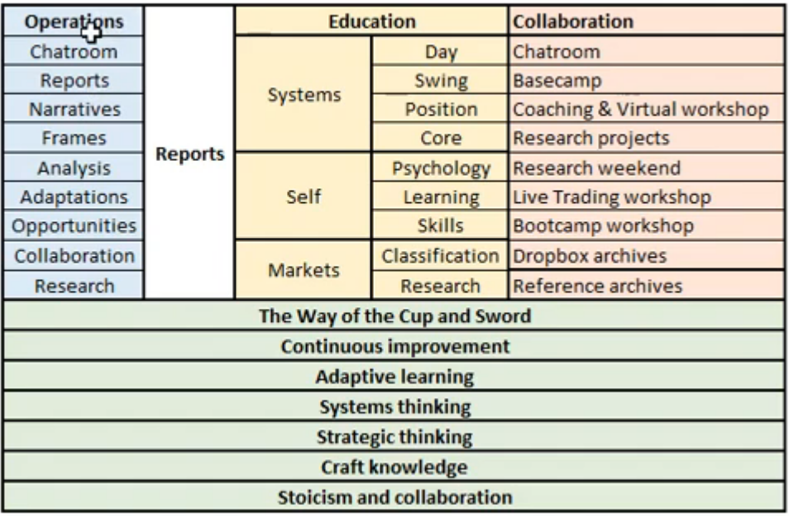  Cup and Sword: Cup representing the wooden bowl that we carve with our sword for insight mindfulness and self-mastery. Sword which is knowledge in action which we use to carve the cup.  Ecosystem for Collaboration and Learning. Treating trading as a Craft combining the best of strategic top-down thinking and adaptive systems thinking with a spirit of adaptive learning to a changing environment. | Self  Psychology  Learning adaptively  Skills acquisition
System
Day trading
Swing trading
Position trading
Core trading

Markets
Classification of markets
Research conditions of markets
Synthesis  Tortoise is an ecosystem for traders that offers Operations planning, Education and training, and Collaboration rooms to enhance learning procedures and techniques to empower the trader for future success. |  | Actions  Take full advantage of the Tortoise ecosystem to help guide your trading knowledge and expertise.

Admin  Foundations Bootcamp  Tortoise on Ruzuku  15 min. | Context/Prep  Ecosystem (2 of 3)
Key Words  Ken Long background (00:15)  View of the world ecosystem (4:22)  Environment (4:30)  Time (5:40)  Purpose (6:23)  IPB (7:40)  UVDDLA (8:48)  Learning organization (10:00)  Continuous estimates (11:00)  Wu-Wei and Duty to others (13:45) | Notes  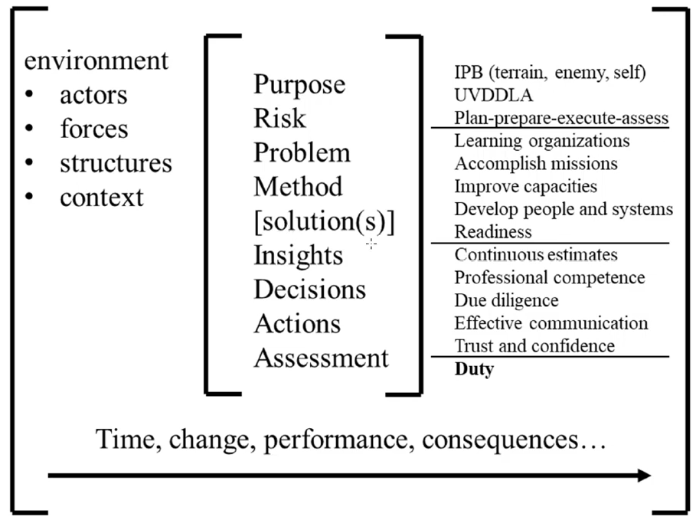  View of the world ecosystem.  o Environment – to be aware of the environmental actors, forces, structures, context how we got here,  that can affect me, and how my decisions can affect the environment (4:30)  o Time – time passes, and things change, with performance and resulting consequences (5:40)  o Purpose in mind, risks including doing nothing, estimate of the problem, methods to solve the problem,  trying out different solutions, looking for insights from this effort, to make better decisions and more  informed actions through the assessments. To iterate towards success with low risk and acceptable  costs. (6:23)  o IPB Intelligence Preparation for Battle - approach to see the terrain, enemy, self to shape plans (7:40)  o UVDDLA Understand, Visualize, Describe, Direct, Lead, Assess – operational process is a continuous  process for discovering and learning. (8:48)  o Learning organizations and continuous estimates towards professional competencies. Due diligence to  do the work, duty to others and life. (10:00) | Self  Ken Long background. To gain a better understanding behind his motivations, mindset, and approach to teaching others. Background in systems management, organization, logistics, and decision making under uncertainty and complexity. There are several similarities between the military environment and trading environment. The seriousness and professionalism applied to the military is translated into his approach to trading. (00:15)  Focus, motivation, purpose inspired by Wu Wei ring of effortless action and Duty to others. (13:45)
 |  | System
 |  | Markets
Synthesis  Informational session on Ken Long’s background to gain a better appreciation behind the development of the Tortoise ecosystem.  The rigors and problem-solving disciplines required by the military to address risks and uncertainties are directly translatable to trading. |  | Actions  Have the Tortoise Ecosystem diagram in your memory to fully benefit from its offerings.

Admin  Foundations Bootcamp  Tortoise on Ruzuku  20 min. | Context/Prep  Ecosystem (3 of 3) A learning ecosystem to develop professional skills for trading.
Key Words  Learning (1:00)  House of trading (1:51)  Model Bias (02:13)  Domains (02:29)  Body of Knowledge (02:44)  Principles (03:52)  Resources (05:00)  Execution (06:33)  Assess (09:50)  Management (13:24)  Alignment (17:59) | Notes  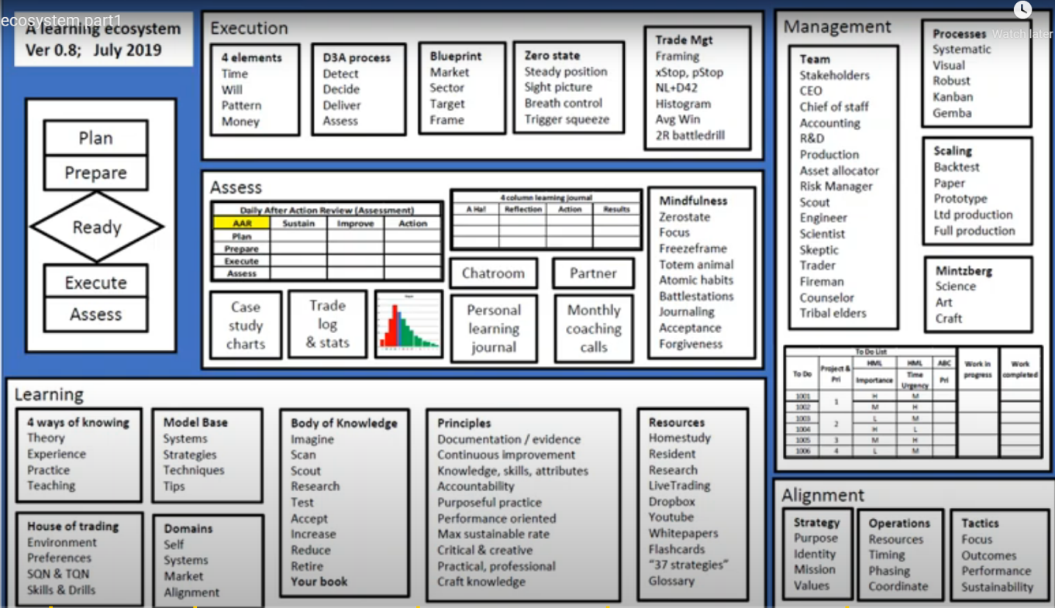  Execution. Education on how to deliver the trade in the right way. Four elements – time, will, pattern, money. Importance of zero state, in optimum mindset for executing trades. Trade framing, stops, position sizing, preserving profits, i.e., a professional approach to trading. (06:33)  Assess. Techniques taught include daily after-action reviews, specific measured improvements, learning journal, reflective thinking, commitment to action. Use of chat rooms, document trading in public, accountability partners, structured feedback, and mindfulness execution at the moment. (9:50)  Alignment. Our strategy – our purpose, identify our mission and values, and fence out distractions. Operations to coordinate resources and planning to setup Tactics for success. (17:59) | Self - Theory, Experience, Practice, & Teaching others. (1:00)  House of trading. Your preferences, what works for you, refine your skills (2:13)  Principles. Continuous learning thru practice and accountability. (03:52)  Management. Support teams to help your success through time management, prioritization, risk management, analysis, incremental improvements, professional business like behavior. (13:24)
System
Model bias. Collection of practical system strategies & techniques (2:13)
Body of Knowledge. Build trading knowledge expertise dynamically, practical professional knowledge (02:44)
Resources. Numerous forms of educational resources listed (5:00)

Markets
Blueprint. Understanding the market and sectors and targets (7:00)
Synthesis  Tortoise is a learning ecosystem to develop professional skills for trading success. The ecosystem encompasses Learning, Execution, Assessment, Management, and Alignment success modules. |  | Actions  Actively seek to learn and apply the knowledge from the Tortoise ecosystem.

Admin  Foundations Bootcamp  Tortoise on Ruzuku  20 min. | Context/Prep  The Time Structure of the Daily Trading plan
Key Words  Plan-Prepare-Execute flow diagram (00:15)  Structuring day in 30 min chunks  (03:00)  1st 30 min of trading day (06:00)  At 30 min of trading day (12:55)  At 60 min of trading day (14:20)  At 90 min of trading day (15:00)  Lunch period of trading day (16:00)  Afternoon of trading day (17:25)  Last hour of trading day (18:20)  30 min before close of trading day (19:00) | Notes  Plan-Prepare-Execute methodology for daily preparation and effective trade execution 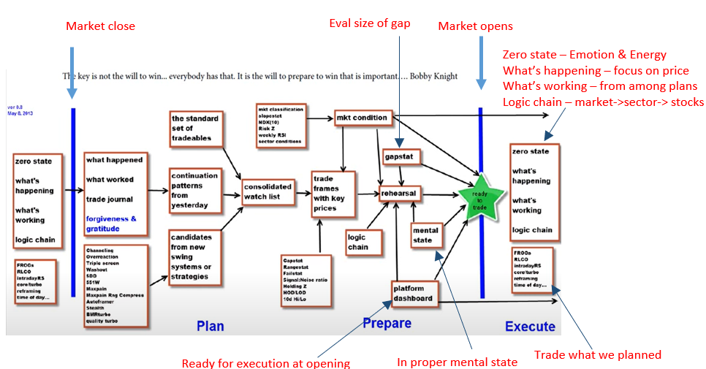  Outline of trading day schedule and strategies  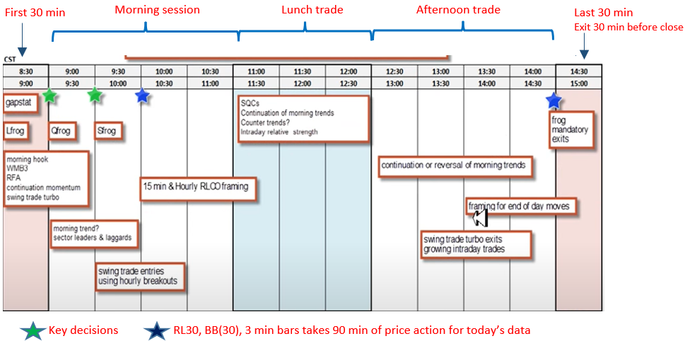 | Self  Plan-Prepare-Execute. A professional mindset requires planning for the next day trade based on yesterday’s action, and preparation prior to market open and mindset prior to market open.
System
1st 30 min – overnight orders, volatility at open
-> Gapsat, Leap frog Lfrog, morning hook,
WMB3, ReadyFireAim, Continuation
momentum, swing turbo
At 30 min - Quick Frog (QFrog), any morning
trend, sector leaders/laggards.
At 60 min - Slow Frog (SFrog), swing trade
entries, using hourly breakouts
At 90 min – 15 min & hourly RLCO framing
Lunch period – SQC, Cont. of morning trend,
counter trends, Intra relative strength
Afternoon – Continuation or reversal of morning
trends. Swing turbo exits, intraday trades
Last hour – framing for end of day moves
30 min before close – frog mandatory exits
Markets

First 30 min and Last 30 min behave differently

Last 30 min – market makers, unwinding
positions, setup for overnight,
more difficult trading period, so
exit 30 min before close.
Synthesis  A professional mindset requires rigorous planning and preparation for next day’s trading and execution. The day’s trading schedules are structured in increments of 30 minuets based on market behaviors and the trading strategies. |  | Actions  Have a daily trading schedule aligned to the market behaviors and trading strategies.

Admin  Foundations Bootcamp  Tortoise on Ruzuku  15:00 min. | Context/Prep  Preparing the Daily Trading Plan: Selecting and framing targets
Key Words  Zero state (01:05)  Strategies (02:53)  Preparation to trade (04:25)  Market condition (06:03)  Tradeframes with key prices (07:43)  Consolidated watchlist (09:19)  Plan-Prepare-Execute (14:05) | Notes  1) Objective: Ready to trade  Plan: identify trading targets -> Prepare: build trade frames for the targets -> Execute next day’s trades  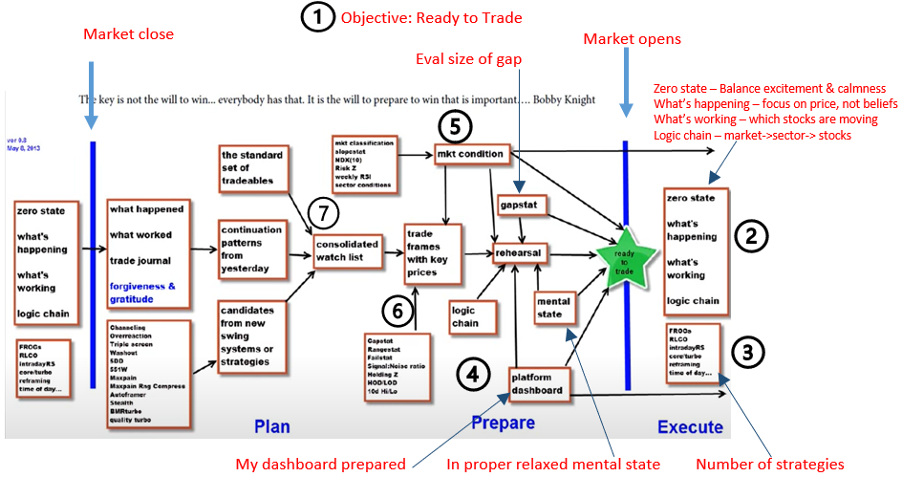 | Self  2) Zero state. Inner confidence and ready calmness to execute, don’t let emotions get in the way of executing what your rehearsed. What’s happening – focus on price, not your beliefs. What’s working – which stocks are moving  Logic chain – market->sector-> outperforming  4) Preparation to trade. Platform dashboard ready, mental state relaxed, market logic chain analyzed, rehearsed trades, gapstat data available for open, know market condition.
System
3) Strategies: Frog system, Regression line crossover, intraday relative strength, core & turbo, reframing 2:1 reward/risk, time of day-based trades.

6) Tradeframes with key prices. Critical price levels and support/resistance/turning points. Gapstat, Rangestat, Failstat, S/N, Holding z, High of Day/Low of Day, 10day Hi/Lo
Markets

5) Market condition. Market classification, slopestat, NDX (10), RiskZ volatility, weekly RSI, sector conditions

7) Consolidated Watch list. Sources include standard set of tradeables, continuation patterns from yesterday’s trades (trade journal, etc.), swing systems/strategies filters (channeling, overreaction, triple screen, washout, 5DD, Maxpain, Autoframer)
Synthesis  The daily preparation for the next day’s trade – identifying trading targets, building trade frames for the targets, and readiness to execute.  A detailed flow diagram of the tasks was provided from market close to next day’s market open. |  | Actions  Create a daily routine schedule that contains the recommended elements.

Admin  Foundations Bootcamp  Tortoise on Ruzuku  19:27 min. | Context/Prep  The 2R Battle Drill: the single most important rehearsal
Key Words  2R Battle drill motivation (00:10)  Case 1: Price moves above 2R (04:43)  Case 2: Price falters at 2R (Zeno stop) (06:20)  Case 3: Stop & Reverse (08:02)  Case 4: Re-enter trade after Zeno exit (09:27) | Notes  2R Battle drill What to do when price approaches the +2R level as a routine play  After Entry, price rises and is heading towards +2R. (For long side, equally valid for short side)  There are 4 cases to prepare for as price approaches +2R level:  - Price continues to rise easily through 2R resistance Add 2nd position and move trailing stop to 2nd position. Keep buy limit order in case 2, 3, or 4 happens and then we sell 1st position, but then price goes up again  - Price stalls & falters at +2R (aka Zeno stop) Consider exiting position – do not give back more than 1/3 of 2R gain (i.e., 0.25-0.6R).  - At moment of Zeno exit, decide whether to Stop & Reverse. Decide based on whether there is a 2:1 Reward/Risk (Target: BB mean or Frog Box)  - Did not stop & reverse after Zeno exit, decide on what condition to re-enter the trade. Re-entry on resumption of trend. Not later than limit order. Pull back, then find support north of BBmean. If re-entry is missed, there is still a limit order entry from case 1.  Plan and rehearse 2R battle drill so that it is firmly a part of your routine. | Self  2) Zero state. Inner
System
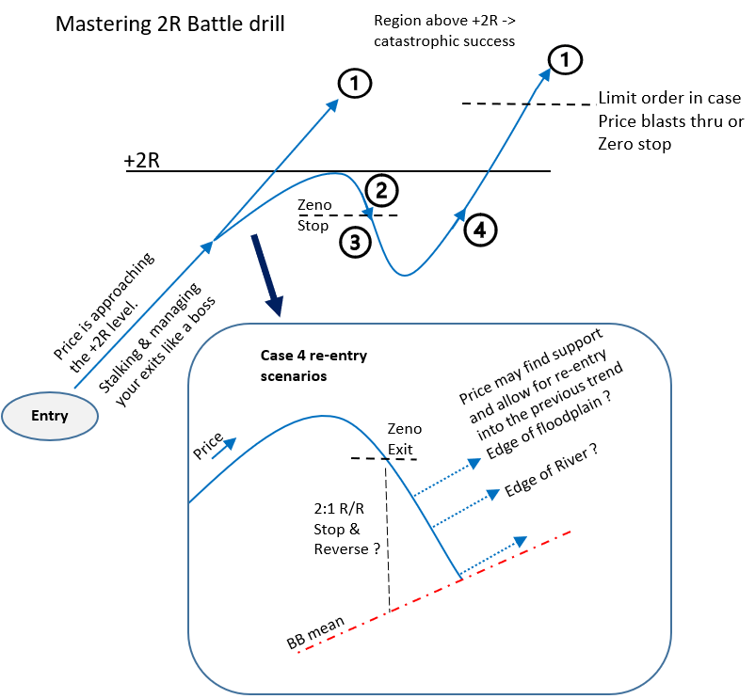
 |  | Markets
Synthesis  Have firmly in you mind the 2R battle drill – to know what to do as price approaches the +2R gain level either long or short. |  | Actions  Memorize the 2R battle drill so that its routine action on your part.

Admin  Foundations Bootcamp  Tortoise on Ruzuku  4:12 min. | Context/Prep  Coaching Overview
Key Words  Gold membership (00:14)  Coaching program (1:42) | Notes  Annual Coaching Program contains:  - Gold membership subscription to Patreon  Day trading home study workshop  Swing trading home study workshop  Strategic & Systems thinking home study workshop  Campfire – collaboration website  Daily & weekly reports  Weekend swing portfolio review of ETF30 and Dow30  - Coaching program  Weekly FAQ & lecture -- to cover your questions from the homes study workshops  Weekly Strategy & Systems lecture – doctoral level framework for critical thinking  Monthly performance check-in  Goals and accountability progress  Monthly coaching commentary – members in small groups provide 5 min summary  All sessions are recorded for playback  - Previous coaching archives -- goldmine of insights of practical applied lessons | Self
 |  | System
 |  | Markets
Synthesis  Review of the Annual coaching program that includes Gold membership to Patreon, Coaching program, and previous coaching archives. |  | Actions  Consider the Annual Coaching Program

Admin  Foundations Bootcamp  Tortoise on Ruzuku  22 min. | Context/Prep  The challenge of developing a trader’s mind
Key Words  Challenges faced by traders (1:45)  It's never the same world twice (5:39)  Challenges of a trader is to ensure (14:10)  Detect early those signals that tell us something's changing (18:35)  Tortoise ecological system (21:00) | Notes  Challenges faced by traders are similar those faced by army officers & PhD students  -- solutions needs to be robust and successful in chaotic environments  -- need to translate theoretical information into a practical manner  It's never the same world twice  -- need your creativity for new possible solutions and critical thinking to evaluate them  -- need to make choices in the face of incomplete information  -- updated strategies is to ensure that we have a blueprint to our goals  -- updated tactics with procedures, rules, systems to handle transactions in a regular way  -- operations to connect strategy to tactics, choosing which things to act on first  -- iterating to learn from some of the ideas to get better  -- continually manage this body of knowledge because of this changing world  -- mindfulness is to acknowledge that these emotions and trigger events are happening  Challenges of a trader is to ensure  -- that we are choosing actions to act in an efficient effective reliable consistent way  -- but also going through these critical and creative processes  -- ensure that we are putting the right action on the right problem  -- managing those results and improve our trader body of knowledge  -- to develop those habits and processes that support us and our toolkit  -- to be adaptive and anticipate things thru hypothesizing and testing  Detect early those signals that tell us something's changing  -- design new systems before needing them by looking at existing systems  -- make some tweaks to improve in case that change in the world happens  -- when it does happen, you have something prepared ahead of time  Tortoise ecological system designed to address the needs of the trader based on the above challenges | Self
 |  | System
 |  | Markets
Synthesis  Challenges faced by traders are like those faced by army officers and PhD students. They can all share in the same approach to handle the chaotic environment by enhancing their respective body of knowledge thru creativity and critical thinking on practical solutions. |  | Actions  Have alternative systems in place in case a change in market dynamics happens.

Admin  Foundations Bootcamp  Tortoise on Ruzuku  11:07 min. | Context/Prep  Design thinking for innovative solutions
Key Words  Design Thinking intro (00:20)  World is changing (00:32)  Need planning (7:40)  Design Thinking approach (10:00) | Notes  Design Thinking Intro – how to handle a world that is becoming more complex  World is changing, need to quickly understand the problem and solution approach:  - Routine problems: Standard Operating Practices (SOP) are used to handle  - More complex problems: Select best choice from a list of pre-approved solutions/tools  - New problems: Design a new approach (Design Thinking)  Need planning, forecasting, anticipating, and visualizing to accelerate problem solving  -- Be humble in allocating risk capital as there may be unknowns in the solution  Design Thinking approach ventures, responds, adapts, learns, improvises, overcomes  -- protects us from recency bias or knowledge bias of short term only solutions  Design thinking is an acknowledgment that the world is changing  -- that the SOP and standard pre-approved solutions no longer works  -- need to design new solutions to stay viable in this competitive environment  To design new solutions before we need them, so that they are ready if needed | Self  Chart
 |  | System
 |  | Markets
Synthesis  To address every changing problem, design thinking will be needed to find solutions to the problem. Design thinking can also be used to find solutions before we need them, so that the solution is a hand when we need them. |  | Actions  Continuously look to use design thinking to address new problems or anticipated problems.

Admin  Foundations Bootcamp  Tortoise on Ruzuku  11 min. | Context/Prep  Life cycle management of trading production systems
Key Words  Backtesting (1:20)  Prototyping (1:46)  Limited scale (02:27)  Production with statistical process control (5:00)  Risk management (6:39)  Mindset (7:00)  Systems in production (9:15)  Asset allocation (10:00) | Notes  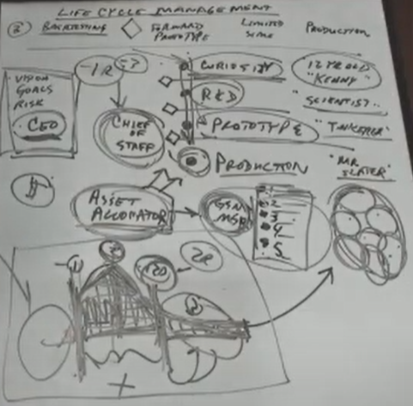  Organizing trading like a business with key leadership to direct directions.  Risk management. Use ruthless risk management to prevent losses greater than 1R on any individual transaction.  Chief of Staff. Managing the various systems, using asset allocation that is consistent with the CEO (e.g., wife), and how much risk to take, and measurements checkpoints.  Asset allocation. Have a variety of different systems in production and apply assets on those systems that are working. Using asset allocation to reward the systems that are currently working. If a particular system is working, more allocation is given in a risk managed way. | Self  Mindset that when trade placed, I already lost 1R, and that any gains is success. Work towards 2R gain opportunities.
System
Backtesting to decide that the new trade idea is good

Prototyping by paper trading first and then with one share or $10 risk per trade to compare with back tested results.

Limited scale to increase allocation on the way towards production.

Production with statistical process control to ensure system is stable and reliable. Desired histogram of results: 1) Between -1R and +2R, 2) Reliable and repeatable, 3) Possibility of Fat tails

Markets
Systems in production. Looking at the world as an opportunity, have one long term swing trade system, a short-term trade system, a reversion to the mean system, commodity trend following, intraday hybrid frog, etc.
Synthesis  Treat trading as a business and organize like a business in terms of risk management, asset allocation to a portfolio of different systems. |  | Actions  Treat trading as a business and approach all aspects from this perspective.

Admin  Foundations Bootcamp  Tortoise on Ruzuku  20 min. | Context/Prep  Psychological state management in the usual phases of a trade
Key Words  Strategy (00:54)  Systems (01:09)  Techniques (02:36)  Tips (03:20)  Roles (5:00)  Chief of Staff  Scout  Worker  Fireman  Manager  Sniper | Notes  Multiple Roles of a Trader  Chief of Staff manage the risks across all the components of trade frames. Overall co-ordination asset allocation, prioritization, decision maker. Provides developmental guidance.  Scout – job is to find specific patterns of a system such as 5DD  Worker – turns the Scout report into an actionable item to enter the trade. Entry is the least important task, just enter the trade and let other roles handle from here. Constructs the trade frame and have an action plan for all the typical decisions and situations in both directions  Fireman responsibility is not to take a full 1R loss. If a trade results in -0.7R loss, its psychologically considered a +0.3R win because a 1R expected loss was avoided. Success is to get to no lose plus dinner for two.  Manager is like a scientist, to manage the science project beyond no lose plus dinner for two.  It’s a research project to then apply one of the various exit rules to maximize gain. Results from the trade will be collected into a histogram for analysis by the statistician. The chief of staff will decide what to do next based on the report.  Sniper role normally only activated one out of ten or one out of 20 times. He's going to figure out how to add second positions or if this thing starts failing to quickly strike and cash in the biggest win that we can and not just let this thing come back and become a below-average loser. Never want to let an above average win become a below-average win because in the trade too long. | Self  Mindset after entry that you are going to lose the trade. At the moment of entry, I already know that I've lost my execution risk the price that was going to get me  out I know that I'm going to lose it and I'm going to lose one execution risk. If  the fear of losing 1R prevents you  from being systematic then you're  trading the too large a level of risk
System
Strategy is a generalized approach to the market, a collection of ideas

Systems is a coded mechanical rule set.
A trend following strategy might have multiple systems that it could generate to trade a strategy.

Techniques is a body of knowledge like a process or a practice or a checklist or a method that can be applied to many different systems or strategies.

Tips something that you learn along the way like using the RSI14 indicator.

 |  | Markets
Synthesis  The mindset of a trader takes on multiple roles with specific responsibilities. The roles include Chief of Staff, Scout, Worker, Fireman, Manager, and Sniper. All these roles work in a coordinated manner during the various phases of a trade. |  | Actions  Understand and take on the multiple roles and responsibilities of a trader.

Admin  Foundations Bootcamp  Tortoise on Ruzuku  40 min. | Context/Prep  Estimating gains, with risk management in all time frames
Key Words  2R Battle drill (2:07)  SQC (3:37)  Doji &  Critical State (4:02)  Frog (04:57)  Position size risk / Execution Risk (7:02)  mmrb (8:37)  Higher time frame (16:46)  Collapsing Dragon  (23:10)  Histogram / Ruthless Risk management/  Positive Expectancy  (29:14)  Scaling the system  (37:35) | Notes  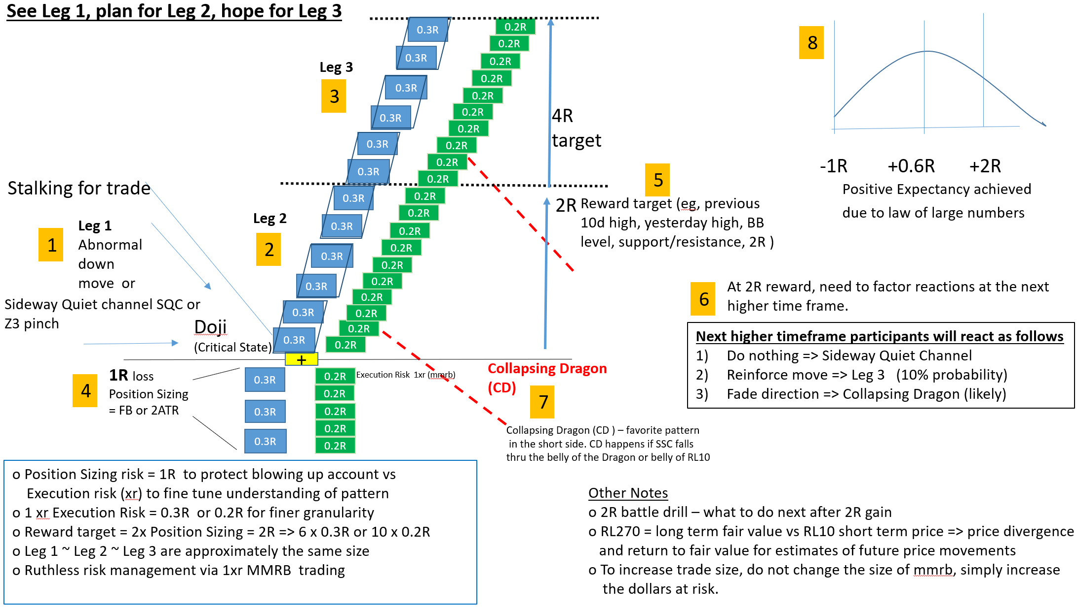 | Self  Trade with MMRB for psychological reasons
System
2R battle Drill
Frog box
Ruthless risk management
Collapsing Dragon
RL270 vs RL10
 |  | Markets
Synthesis  See Leg 1, plan for Leg 2, hope for Leg 3. Use of minimum manageable risk box and position sizing to psychological minimize the impacts of loss. Establish targets 2R & 4R with incremental risk boxes. Factor in high time frame impacts to shorter term gains or losses. |  | Actions  Remember the Leg 1, plan for Leg 2, and hope for Leg 3. Trade with mmrb.

Admin  Foundations Bootcamp  Tortoise on Ruzuku  16 min. | Context/Prep  Core and turbo, critical states, mechanical entries Green, yellow, red
Key Words  Critical state (01:03)  Core position (1:53)  5dd setup (03:33)  Yellow zone (11:40) | Notes  Critical state => Larger than normal probability of a larger than average directional move in either direction in a shorter than average period of time. Core Position trades are held weeks and months based on relative strength and momentum. To hold them until they stop working.  The best trading candidates include those symbols that are just starting a positive swing. Swing system to provide 5-8% gain in 5 days  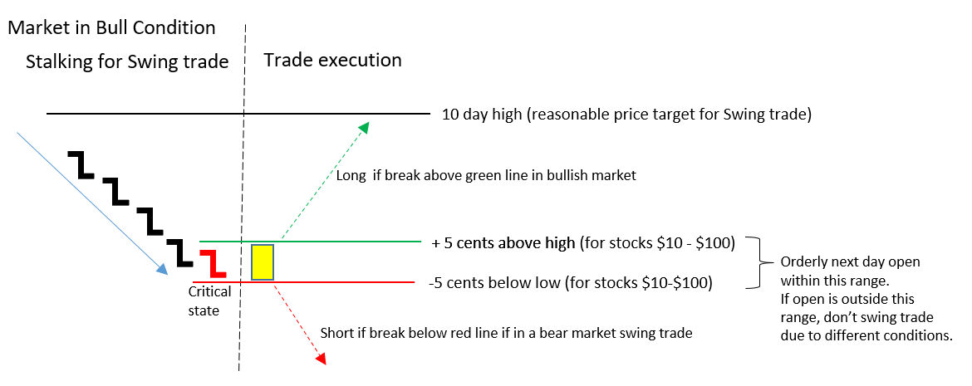 | Self  Chart
System
5dd. Five days down lower closes setup. Unusual behaviour, possible over reaction past fair value.
Expectation is return to fair value or continuation of second leg selloff.

Markets
Bullish market conditions will setup a long mean reversion swing trade such as the 5dd, back to the 10-day high.
Synthesis  The swing trade 5dd system setup and long and short entry conditions were described. Getting to a critical state will help find directional trades. |  | Actions  Practice finding critical states

-
Admin  Foundations Bootcamp  Tortoise on Ruzuku  17 min. | Context/Prep  Trade management and exit techniques, zero state
Key Words  Trade management time (00:15)  Position sizing risk (01:59)  Execution risk psychology (03:03)  Psychology of -0.2R (05:58)  2:1 Reward to risk ratio (06:30)  Never more than 1R loss (07:00)  Scaling up a trade (8:00)  Trade with skin in the game (09:48)  Core and Turbo (15:20)  - Intraday vs Overnight risk | Notes  Trade management. Spend more time on refining trade management and exit techniques than in entering a trade.  Position sizing risk is 5 times the size of the execution risk. Loss would be 0.2R. For $1 execution risk, the position sizing risk would be $5. For $100 at risk per trade, the number of shares = 20. (20 = $100/$5). After proficiency, you can increase $100 to a higher amount. Do not change the trade frame logic of execution risk to position sizing risk. Turbo trading. Intraday trading where xR is now $0.2, and position sizing risk $1, allowing purchase of 100 shares. At end of day, sell 80% (80 shares) and keep the prior Swing trade with 20 shares. This is the Core & Turbo trade.  In this example Intraday risk was with 100 shares vs Overnight risk with 20 shares at risk.  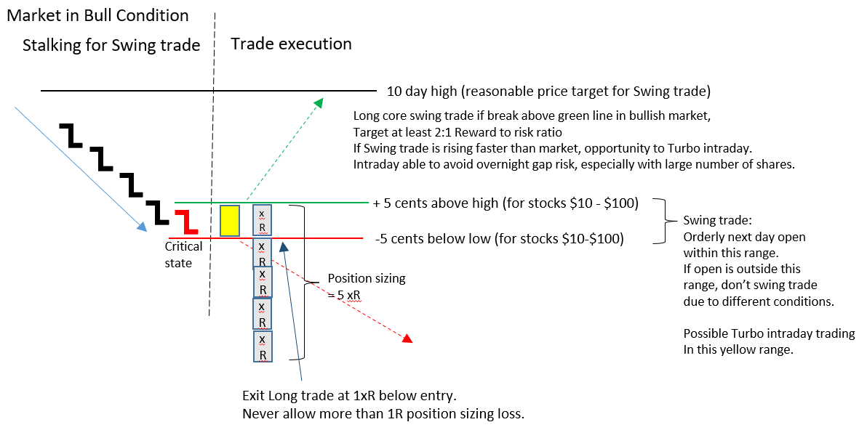 | Self  Execution risk psychology. Risk 1/5 of position sizing risk to psychologically be able to trade without fear of losing. Psychologically enables you to enter more trades with positive expectancy.  Psychology of -0.2R. Use this approach to  reduce the emotional response to losing a trade.  Trade with skin in the game. Best to enter trades with small $ at risk, and then scale up after your real trade data, rather than rely on theoretical analysis or back tests.
System
2:1 Reward to risk ratio. Enter trades that logically supports 2:1 Reward to risk ratio.

Never more than 1R loss. Never exit at more than 1R position sizing loss. Should exit at xR.

Scaling up a trade. Increase $ at risk on position sizing. Do not change other trade structure such as Position sizing to Execution risk.

Core vs Turbo. Turbo intraday trading based on signal from Swing trade direction. If Swing trade is rising faster than market, opportunity to Turbo. Intraday able to avoid overnight gap risk, especially with large number of shares.
 |  | Markets
Synthesis  The trade framework is Execution risk is 1/5 of the Position sizing risk. Scale trades by increasing the amount of dollars at risk, not the framework. Opportunity to combine Core Swing trading with Turbo intraday trading for further gains. |  | Actions  Trade with small dollars at risk till proficiency is achieved to allow scaling up.

Admin  Foundations Bootcamp  Tortoise on Ruzuku  1:20 min. | Context/Prep  Intraday risk vs Overnight risk (short video)
Key Words  Intraday and Overnight risk (00:10) | Notes  How Core & Turbo trading works together to maximize gains  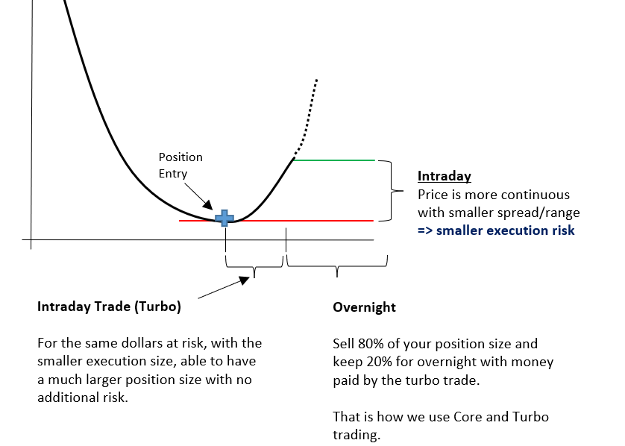 | Self
System
Core & Turbo trading. Intraday trading with larger position sizing possible due to smaller execution risk intraday. Prior to close, sell 80% of the position and keep 20% for overnight swing trade.

 |  | Markets
Synthesis  Use the combination of Core and Turbo trading to maximize gains. Intraday trading has a smaller execution risk, allowing a greater position size. Use the gains from intraday trading to help fund the overnight position. |  | Actions  Practice Core & Turbo trading.

Admin  Foundations Bootcamp  Tortoise on Ruzuku  10:43 min | Context/Prep  Mindset and emotion state management
Key Words  Execution risk buffer (00:06)  Mindset (01:30)  Scaling up trade (03:00)  Trading with bricks (05:40)  Stop and reverse (07:19)  Fear more powerful than greed (08:52)  Ego (10:00) | Notes  Execution risk buffer. Execution risk 0.2R buffer vs Position sizing risk 1R is to account for any slippage, internet disconnection, wrong order entry, span of control, any unintended exit delay.  Stop and reverse. If a trade goes in the opposite direction to initial expectation, then consider stop and reverse, if the reverse shows a potential for a 2R gain.  Fear is 3x more powerful than greed, causing falling prices to accelerate, hence the success of the Collapsing Dragon trade. If directionally wrong in long trade, be willing to accept a -0.2R loss and reverse to a short trade with a potential for a +2R gain. | Self  Mindset. Trading with execution risk psychologically allows you to be more relaxed, not stressed/agitated, since your trade risk is 1/5 position sizing. Allows you to trust the rules and accumulate evidence on the trade.  Trading with bricks. Analogy of trading with bricks that are identical and accumulating a pile of bricks. Trade with the same mentality of trading with xR “bricks” and accumulating trades resulting in positive expectancy.  Ego. Get past the ego of always being right. You don’t have to be right, but rather you cannot stay wrong too long. Stop and reverse.
System
Scaling up trade. To increase size, keep execution to position sizing risk the same, just increase the position sizing dollars per trade. Use the same risk dollars per trade on any system, i.e., same poker chip size. 2R reward is actually 10 xR gain to a 1 xR execution risk. Results in average win 0.6-0.7 vs average loss of 0.2.

 |  | Markets
Synthesis  The trading mindset is to trade with a lot of “bricks” using execution risk that is 1/5 the size of position sizing risk. The psychological benefit will enable you to enter more trades with less stress. To scale up, increase the position sizing dollars at risk, but keep the geometry between execution risk and positions sizing risk the same. |  | Actions  Have the mindset of trading with execution risk that is 1/5 the position sizing risk.

Admin  Foundations Bootcamp  Tortoise on Ruzuku  16:12 min | Context/Prep  Plan, prepare, execute, assess
Key Words  Self, System, Market aligned (1:00)  Plan, Prepare, Execute, Assess (3:00)  Time of day (5:00)  Rangestat (6:43)  No lose plus dinner for two (08:30)  Span of control (14:00) | Notes  Time of day. Research shows that the first hour of the trading day, establishes the high and low of the day 90% of the time.  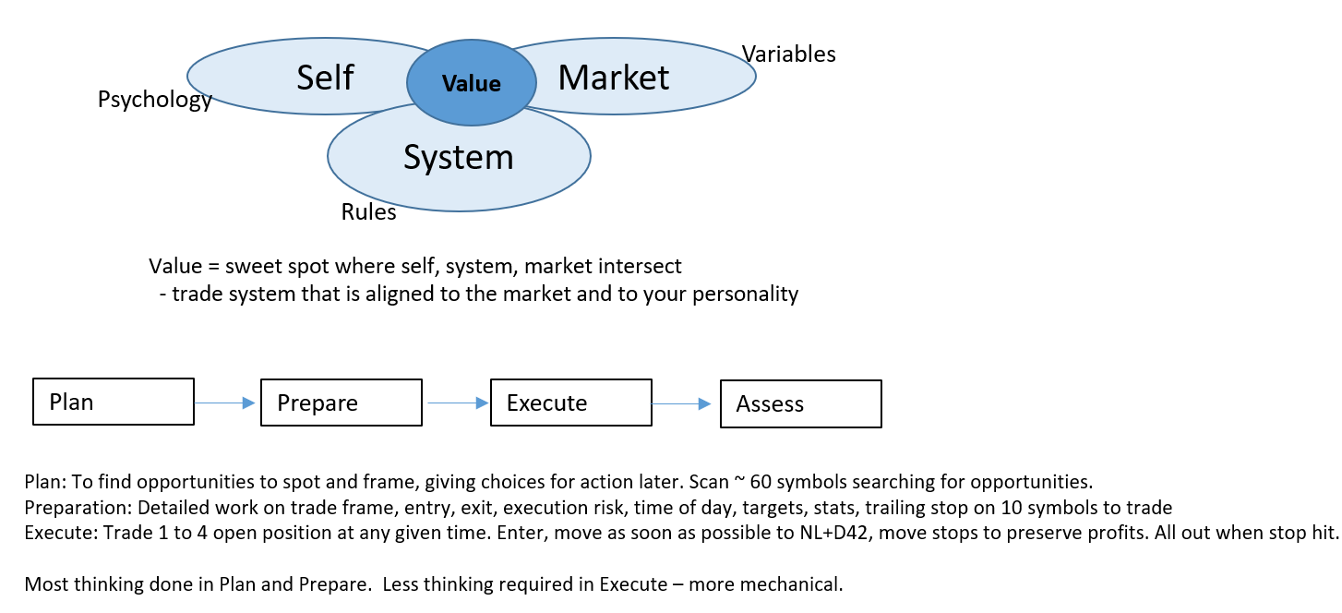 | Self  No lose plus dinner for two. Once in trade, get to move stop as soon as possible to No lose per dinner for two. Psychology changes since now my risk is out of the market and worst case is a dinner for two. Everything after is a science project.
System
Rangestat = average daily range plus one standard deviation over the past 30 days.

Span of control. No more than 4 open positions at any given time.

 |  | Markets
Synthesis  Need alignment of system, market, and self for greatest value. Plan to find opportunities, prepare detailed trade entry and exit and targets, and execute mechanically to no lose plus dinner for two, and the remaining profits is treated as a science project. |  | Actions  Understand the alignment of self, market, and system. Follow process flow of Plan, Prepare, Execute, Assess

Admin  Foundations Bootcamp  Tortoise on Ruzuku  16:12 min | Context/Prep  Plan, prepare, execute, assess part 2
Key Words  Time, will, pattern, money (00:07)  Trade process (03:03)  Assess (5:05)  Market assessment (08:12)  System development (08:50)  Acorn to tree analogy (12:29) | Notes  Trade process. How well did I plan, prepare, execute, and assess this trade? The most important phase is the prepare phase. Easiest is the plan phases to find trade candidates. Execution phase is relatively simple after rehearsing the battle drill – manage the entry and exits of all trades in the same manner. Assess the individual trade and combined trades at the portfolio level for a system view. Assess the entire dataset in a histogram to better understand the performance.  Acorn to tree analogy. Acorn at the ground level that leads to the tree structure and branches.  Branches includes position trading, swing trading, and day trading body of knowledge that are interrelated. For example, Latin America index longer term bullish trend (Core) creating shorter term opportunities for a swing trade (Turbo) mean reversion back to the longer-term bullish trend.  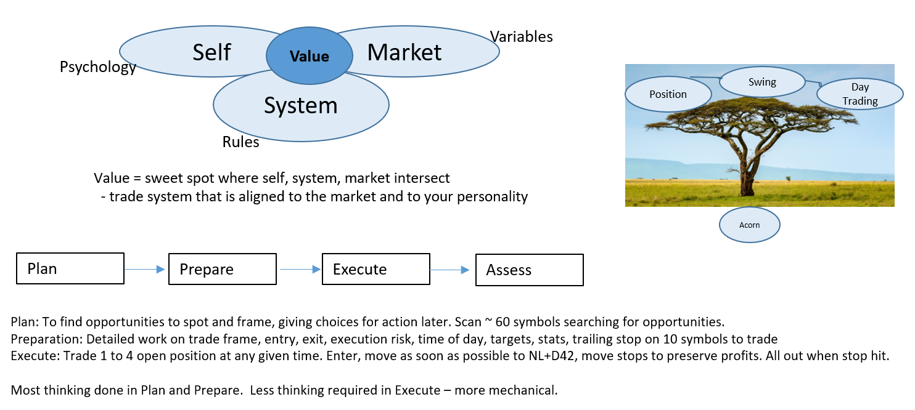 | Self  Time, will, pattern, money. Time – time left during day for trade to unfold. Will – in professional state of mind to trade. Pattern – to have a price pattern to trade with proper reward to risk. Money – to have enough risk capital available to trade. The weakest link is Will because of the challenge and difficulty of the psychology of trading.
System
System development. Example of developing a strategy for long-term position trading in the artificial intelligence sector: WIZ is an ETF that takes positions in ETFs and equities and income funds. Approach is to study and trade the components of the WIZ ETF and on a weekly basis compare the results vs the WIZ ETF itself.

Markets
Market assessment. Studying the market to find big moves in either direction, what are the trends and themes, where are people making money. Then assess if you have any trading systems to align with those emerging trends.
Synthesis  The Self-Market-System model integrates with the Plan-Prepare-Execute-Assess model from Market insights to trading system development. Position, Swing, and Day Trading can work synergistically using the Core & Turbo trading approach. |  | Actions  Have a top-down integrated view from Markets to trading process and execution.

Admin  Foundations Bootcamp  Tortoise on Ruzuku  13:46 min | Context/Prep  Strategies, systems, techniques, tips
Key Words  Common practices (1:11)  Strategy vs System (02:49)  System Quality Number vs Trader Quality Number (04:30)  Manager of Systems (06:04)  Discretionary vs Mechanical (7:13)  Techniques (11:40)  Tips (12:33)  Hybrid trading (13:13) | Notes  Strategy vs System. Strategy is a broad general approach to capture the values of a system. System has a specific set of rules that could be coded into a computer that could be robotically traded.  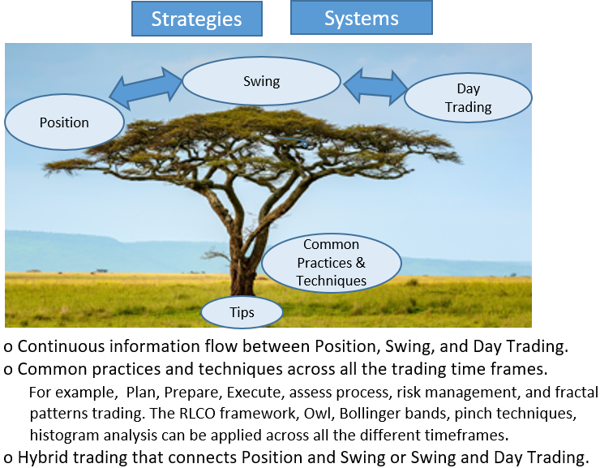 | Self  System Quality Number vs Trader Quality Number. System Quality Number is based off the strict robotic system rules vs Trader Quality Number which is based on my trading judgement.
System
Manager of Systems. Determine capital allocation to different available trading systems based on market conditions.

Discretionary vs Mechanical. Discretionary traders will turn their insights into rules for mechanical trading. Sometimes a mechanical trader may use discretion to enter or exit a trade earlier or later for additional profits.

Techniques. Processes or modules that support Strategies and Systems like 2R battle drill position size and risk, RLCO, getting to zero state mentally.

Tips. For example, if the weekly RSI14 goes below 30 and then rises above 30, its typically a good buying opportunity.
 |  | Markets
Synthesis  The relationships between Strategies, Systems, techniques and Tips forms an Ecosystem for trading across the Position, Swing, and Day Trading time frames. |  | Actions  Take advantage of the synergistic relationships between Position, Swing, and Day Trading aka, Hybrid trading.

Admin  Foundations Bootcamp  Tortoise on Ruzuku  16:11 min | Context/Prep  Volatility in fast and slow markets
Key Words  Stock Indices (00:24)  VXX (00:33)  Trading DIA while monitoring SPY, Russell 2000, and VXX and vice versa (09:40)  Using indices to gauge market conditions (12:04)  Why need to know market conditions (12:24)  Sectors in S&P500 (14:45) | Notes  Trading DIA while monitoring SPY, Russell 2000, and VXX and vice versa  DIA, SPY, Russell 2000, and VXX price behavior can be early warning signals of one another:  SPY stalling, Russell2000 stalling, VXX rising maybe time to exit Long DIA position  SPY rising, Russell2000 rising, VXX falling If DIA is stalling, then maybe time to exit SPY, Russell2000  DIA rising and beginning to stall, can use VXX to hedge the DIA position.  Using indices to gauge market conditions. Using the lens of DIA(Conservative), SPY(Normal), Russell2000 (Aggressive), VXX (Psychology) to get a view of the market conditions. | Self  VXX provides insight into the psychological calmness or agitation of futures traders who are hedging against market conditions.
System
Why need to know market conditions. To find the movers, look to SPY (50%), Sector (25%), Company (25%) to explains its price directions. If SPY is rising, and XLB is rising faster, look for rising stocks within the XLB sector for trade opportunities. Knowing the Market and Sector will influence the direction of the company stock.

Markets
DIA Dow 30 industrials that has 30 large cap multibillion dollar companies. Approximately 0.7x the move of SPY. Conservative behavior.

SPY S&P500 Index consists of 500 large companies, cap weighted. Normal behavior.

Russell 2000 small cap index consists of 2000 small cap companies. It is 1.5x more volatile than SPY and has a +0.8x correlation. Aggressive.

VXX is an ETP that tracks the VIX volatility index. Invented as a hedge on SPY volatility. It is 4x more volatile than SPY: a 10% fall in SPY would cause VXX to rise ~ 40%. Psychological lens.

Sectors in S&P500. XLB, XLE, XLF, XLI, XLK, XLP, XLU, XLV, XLY.

Synthesis  How to use the US indices DIA, SPY, Russell2000, and VXX, and sectors to help understand the likely stock price direction. |  | Actions  Understand the market conditions in preparing for the next day trades.

Admin  Foundations Bootcamp  Tortoise on Ruzuku  16:12 min | Context/Prep  Finding the mover, emotional hacking
Key Words  Primary moves in S&P500 (00:10)  Lowest risk trade (01:05)  Alternatives to company stocks (01:43)  Find the mover (03:55)  Entry management (05:46)  No lose plus $100 (09:53)  Feel 1R loss after entry (10:35)  2R win (14:54) | Notes  Lowest risk trade. If the Market (SPY) is rising, find the sector rising faster, then choose the stock within the fast-rising sector. If the Market (SPY) is falling, find the weakest sector, then choose the weak stock within that sector.  Find the mover. Get the market direction right, understand relationship between market and sectors, find the company movers within the sector. Rank order the stocks based on %gain. Pick the stock in the stack with the strongest stock on top of the rank ordered list, and weakest near the bottom of the stack. | Self  No lose plus $100. After trade moves to profitability, move stop to No lose plus $100. Removes stress on the trade and the rest is a science project for potentially more gains.  Feel 1R loss after entry. Psychologically assume a 1R loss after entry, so that any gain above a 1R loss is considered a Win. This will remove stress. A 0.2R loss will feel like a 0.8R win.  2R win. If trade moves above a 2R win, immediately raise the stop so that the trade never falls below the 2R win. A psychological gain.
 |  | System
Markets
Primary movers in S&P500. XLF (Finance), XLK (Technology), XLB (Materials), XLE (Energy), XLV (Healthcare). Alternatives to company stocks. VXX volatility instrument, or leveraged instruments such as SPXL, SPXU, UDOW, SDOW
Synthesis  Find the movers from top down, looking at the market, sector, and then the stock within the sector. Rank order the stocks in a stack, selecting the strongest near the top of the stack, and weakest near the bottom of the stack. Trade to take out risk asap. |  | Actions  Follow the techniques in the Tortoise daily reports to find trades and drive to take out risk to reduce stress in a trade.

Admin  Foundations Bootcamp  Tortoise on Ruzuku  13:02 min | Context/Prep  The power of visualization
Key Words  Visualize (00:18)  No lose plus dinner for two (NL+D42) (02:23)  Roles in trading (05:20)  Emotional state management (09:32) | Notes  Visualize. As basketball and soccer players goes thru the rituals in visualizing and taking shots, so should the trader practice and visualize the appropriate responses to trade situations.  No lose plus dinner for two. Entry is the least important task. Once trade entered it’s the management of the trade that is most important. Identify the execution risk stop and move your stop to No lose plus dinner for two as quickly as possible.  Roles in trading. Know what roles to play in each phase of trading.: Strategist, Planner, Architect, Draftsman for documentation, Accountant, Kid to enter trade (least important role), Fixer to manage trade in range between -xR and 2R and get to NL+D42 asap but never below -1R, Closer to manage above the 2R, and the Ace to manage a 2nd position. Need Chief of Staff to run the show, Plant Foreman to make sure everyone is doing their respective jobs and working for the Owner. You need all these roles in your psychological makeup. | Self  No lose plus dinner for two. There is a psychological advantage to moving a trade stop to no lose plus dinner for two. Then the worst that can happen in the trade is going out to dinner. This is a management technique for any trade at any timeframe.  Emotional state management. In the trading cycle 1) Time to trade 2) Pattern to trade 3) Money for trade 4) Will. Will is emotional willpower to do the right thing. That requires a lot of repetition of trades managed in the same way and to analyze your trades for improvements. Repetition will build muscle memory and habits to play the game. This is analogous to the training in sports.
 |  | System
 |  | Markets
Synthesis  As in sports, practice and visualize your trades so that its muscle memory when in the trade. Risk management at -xR and drive to get to NL+D42 asap to minimize stress in the trade. |  | Actions  Practice and visualize to -xR and NL+D42 asap as part of your muscle memory in a trade.

Admin  Foundations Bootcamp  Tortoise on Ruzuku  16:12 min | Context/Prep  Frog theory (1 of 3)
Key Words  Frog Box definition (00:13)  RangeStat (RStat) (3:15)  Reward Target (06:45)  Intraday Reward/Risk (07:15)  Slow Frog (07:40)  Quick Frog (09:13)  Leap Frog (09:46)  Standard 1.0 FB rule (10:06)  Trailing stop 0.7xFB (14:53) | Notes 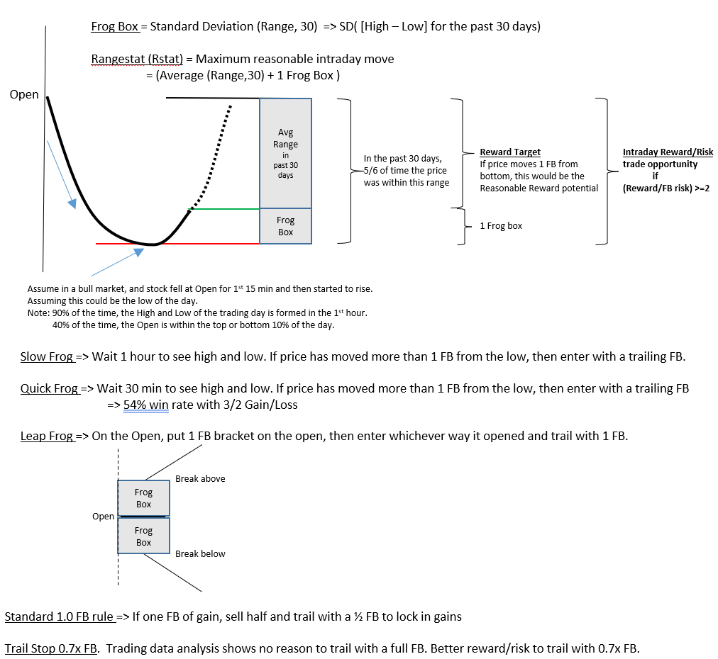 | Self
System
Slow Frog
Quick Frog
Leap Frog
Standard 1.0 FB rule
 |  | Markets
Synthesis  The Frog Box definition and statistical rationale behind it for intraday trading was described. Slow, Quick, Leap FB trading described. |  | Actions  Utilize FB for Intraday trading.

Admin  Foundations Bootcamp  Tortoise on Ruzuku  16:11 min | Context/Prep  Frog theory (2 of 3)
Key Words  Hybrid Frog (00:40)  Frog 2.0/3.0 (01:00)  1 FB vs 1.5 FB gain (01:46)  NL+D42 (03:12)  Dataset of trades (09:20)  Standard entry rules (09:45)  Learning challenge (13:02) | Notes  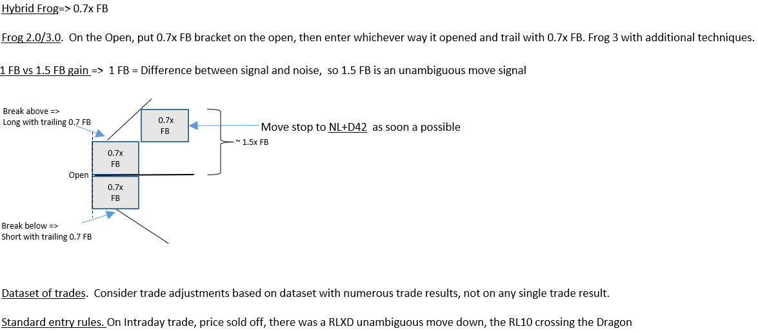 | Self  Learning challenge.  o In the next 100 days,  Listen to 2R battle drill every day  Listen to this recording every day  o Post 2 charts per week -- a trade frame setup planning + a closed trade execution & assessment  o Share lessons learned on what it did to your trading and psychology  o Report on the effect of listening to them 100 times
 |  | System
 |  | Markets
Synthesis  Additional Frog box techniques – Hybrid Frog, Frog 2.0 generation rules, and a learning challenge to build muscle memory was given. |  | Actions  Build muscle memory through repetition on 2R battle drill

Admin  Foundations Bootcamp  Tortoise on Ruzuku  08:48 min | Context/Prep  Frog theory (3 of 3)
Key Words  Learning to Practice (00:55)  Visual chart trading (02:14)  Score in a Trade (5:10) | Notes  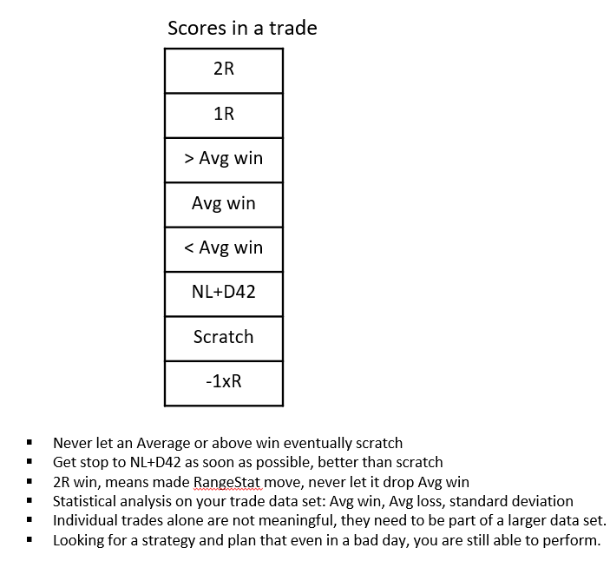 | Self  Learning to practice. 1) Listen to theory 2) Doing the work of learning and preparing and posting trade frame and closed execution trades in public 3) Getting the feedback 4) Adjusting your practice with dialogue with others 5) Lessons learned
System
Visual chart trading. Using Frog Box, RangeStat, Hybrid Frog, Minimum manageable risk box for one execution risk xR, position sizing risk. For intraday Turbo example: Opening 15 cent box, buy at breakout, orderly rise by 30 cents – all in the direction to supplement the Swing trade.

 |  | Markets
Synthesis  Applying learning to successful trading requires significant practice and execution. Visual chart trading using Frog Box and Rangestat are techniques along with risk management with minimum manageable risk box. Get stops to NL+D42 asap and trail stop closely above. |  | Actions  Build muscle memory through repetition on 2R battle drill and doing actual trades.

Admin  Foundations Bootcamp  Tortoise on Ruzuku  16:12 min | Context/Prep  Insights from day 1 live trading lessons learned
Key Words  Bootcamp day 1 debrief | Notes  Bootcamp day 1 debrief. Feedback and assessment of identifying the best things, the least effective things, the takeaways, the surprise moments, and open questions.  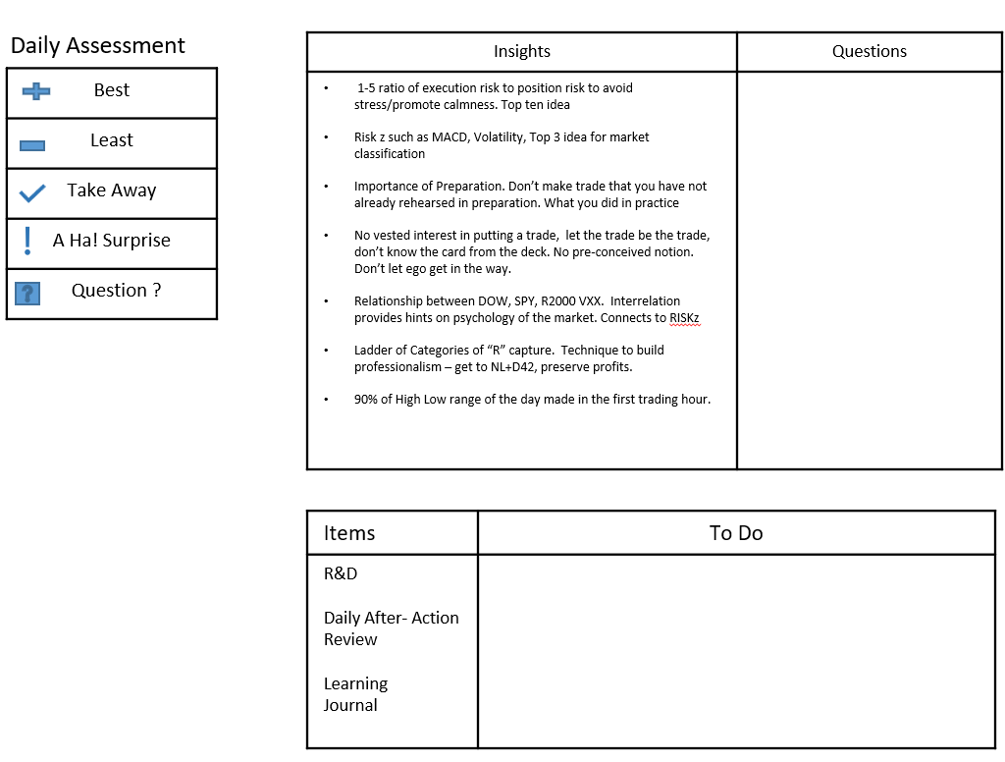 | Self  Importance of Preparation. Don’t make trade that you have not already rehearsed in preparation. What you did in practice  No vested interest in putting a trade, let the trade be the trade, don’t know the card from the deck. No pre-conceived notion. Don’t let ego get in the way.
System
1-5 ratio of execution risk to position risk to avoid stress/promote calmness. Top ten idea
Ladder of Categories of “R” capture. Technique to build professionalism – get to NL+D42, preserve profits.
90% of High Low range of the day made in the first trading hour.
Markets
Risk z such as MACD, Volatility, Top 3 idea for market classification
Relationship between DOW, SPY, R2000 VXX. Interrelation provides hints on psychology of the market. Connects to RISKz
Synthesis  Key insights from attendees of day 1 bootcamp in the areas of Self (preparation, no ego), System (execution risk, “R” capture, day range), and Market (Riskz, Indices relationships). |  | Actions  Use the key insights from the bootcamp attendees to reinforce understandings.

Admin  Foundations Bootcamp  Tortoise on Ruzuku  16:11 min | Context/Prep  Rangestat, MACD 4 seasons, swing trade systems as signal generator!
Key Words  Multiple Regression lines RLx (00:25)  Rangestat (03:35)  Speedrun (04:24)  Analyzing trade actions (06:07)  Managerial mind (06:57)  Swing trading systems (13:51)  Trading dashboard sheet (15:52) | Notes  Continuation from Day 1 debriefing.  Multiple Regression lines RLx. Fractal nature enables viewing the prices at higher level timeframes in one chart, without having to switch between minute, daily, weekly, monthly timeframes. When all RLx pinch together, it’s a super pinch condition for a breakout trade.  RL10 Price RL30 Health of trend RL10 in 3x higher timeframe RL90 RL10 in 9x higher timeframe RL270 RL10 in 27x higher timeframe On minute chart: half day On daily chart: monthly view  Swing trading systems. Frame from both long and short sides with information from the day and position trading. Core and turbo trading based on habits developed through practice.  Trading dashboard sheet. Single sheet checklist to decide trades to focus on. Looking at signal generators, market conditions, and favorite instrument targets. | Self  Analyzing trade actions. What triggered me to act that were not part of my prepared plan – difference between rational mind and intuitive (risk adverse or greedy) mind.  Managerial mind. Intentional wise mind that learns to put a wedge between impulse to act vs decision to act from practice and rehearsals to deal with uncertainties.
System
Rangestat. Defines the playing field for the intraday trade – the maximum reasonable intraday move. Price going beyond rangestat signals an abnormal day requiring other techniques. A top 5 idea.
Markets
Speedrun. Many opportunities from looking at 30 symbols using the MACD seasons.
Synthesis  Continuation from Day 1 debriefing covering Regression lines, Rangestat, trading psychology, and trading dashboard sheet. |  | Actions  Focus on interpreting the multiple Regression lines in the platform.

Admin  Foundations Bootcamp  Tortoise on Ruzuku  14:19 min | Context/Prep  Chain trading, the monkey mind, C- performance should be profitable
Key Words  Chain trading template (00:30)  C- minus performance (02:43)  Monkey mind (04:23)  Personal brand (06:02)  Smiling and laughing triggers (07:26)  Time, will, pattern, money (08:37)  Currency trading (13:40) | Notes  Continuation Day 1 debriefing.  Currency trading. The regression line fractal framework, rivers, collapsing dragons, the MACD histogram, Riskz – all applies to currency trading. The 5dd does not apply as they are equity relationships.  Chain trading template. Day trading system template flow diagram. Template accounts for different scenarios – pinch and stretch, unambiguous moves, owls, collapsing dragons, and others. Template can also be used for swing trades with an ATR stop instead of the Frog box. | Self  C- minus performance. Good enough to pass to make money. If we can have this mentality to be good enough to win to make a living without a lot of stress. Do not need to be error free.  Monkey mind. The way that the mind, brain, body, and spirit collaborate. Monkey mind allowed the species to survive. Learn to embrace it and use it and manage it. The relationship between the monkey mind and the rational mind need to work together.  Personal brand. Some essential principles and models that are most important to your guiding spirit. You pick the ones most important to you as your personal brand to present.  Smiling and laughing triggers. Able to trick the mind to affect physical responses by an internal chemical reaction. To help you achieve the psychological and physical state.  Time, will, pattern, money. Time, pattern, money are external measures. Will is an internal component in the moment, knowing yourself, your game face-on ready to go, professional ready to go.
 |  | System
 |  | Markets
Synthesis  Continuation Day 1 debriefing on chain trading, C- performance, Monkey mind, personal brand. |  | Actions  Find and document your personal brand in trading.

Admin  Foundations Bootcamp  Tortoise on Ruzuku  12:16 min | Context/Prep  Integrating different bodies of knowledge
Key Words  How we take in information (00:50) | Notes  How we take in information from different bodies of knowledge  - Audio Visual Kinesthetic (creative)  - Global Integrated Detailed  - Principals Examples Details Jargons (shorthand)  - History, Leadership, Strategy, Tactics, Logistics, Change management (narratives) | Self
 |  | System
 |  | Markets
Synthesis  How we take in information from different bodies of knowledge: Audio, Visual, Kinesthetic. Starting from top down or bottom-up approach. Starting from high level principals down to the detailed jargon levels or from body of knowledge of different expertise. |  | Actions  Determine how best you learn information and any improvements to learning.

Admin  Foundations Bootcamp  Tortoise on Ruzuku  16:14 min | Context/Prep  Simple WMB3 entry rule...an example of elegant simplicity
Key Words  WMB3 Morning Hook (00:41)  WMB3 Profit target (8:05)  WBM3 Stop & Reverse (12:50) | Notes  WMB3 Morning Hook setup conditions as follows for intraday or swing trades:  1) W Williams % R (10) Price is oversold on Williams % R  2) M MACD H (10,30,5) Up tick on MACD-H  3) B Breakout Price breakout above previous high  4) 3 3-minute 3 minute chart  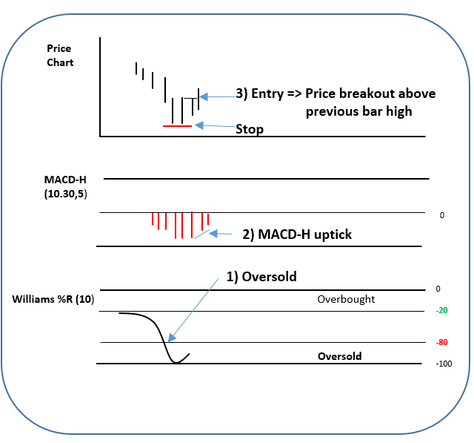 | Self  Chart
System
WMB3. Setup conditions 1) Willams %R oversold, 2) MACD-H ticks up. Then Long entry when 3) Price breaks above previous bar high, with Stop level at prior swing low as 1xR execution risk.
WMB3 Profit target. 1) At open or high of the day 2) Yesterday’s close 3) Rangestat higher
WMB3 Stop & Reverse. If price falls below stop level, hypothesis was incorrect, consider going short.
 |  | Markets
Synthesis  The WMB3 (Williams %R, MACD-H, Breakout, 3 min chart) pattern was described for Entry, Stop, and Stop & Reverse. |  | Actions  Consider searching for WMB3 opportunities to trade long or short.

Admin  Foundations Bootcamp  Tortoise on Ruzuku  03:51 min | Context/Prep  WMB3 (part 2 of 2)
Key Words  Examples of WMB3 on EWW (00:30)  WMB3 entry vs RLXD (01:35) | Notes  WMB3 Morning Hook setup conditions as follows for intraday or swing trades:  1) W Williams % R (10) Price is oversold on Williams % R  2) M MACD H (10,30,5) Up tick on MACD-H  3) B Breakout Price breakout above previous high  4) 3 3-minute 3-minute chart  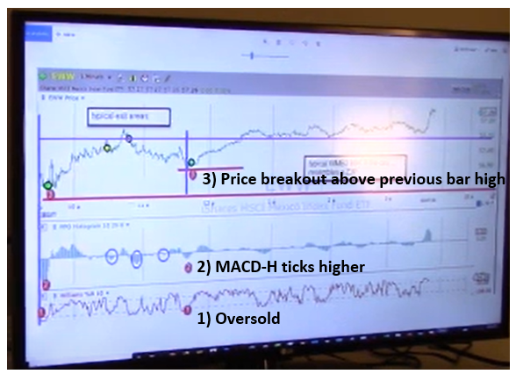 | Self  Chart
System
WMB3 entry vs RLXD. WMB3 entry can occur earlier than RLXD. Coincides with PSAR flip. After entry lock into NL+D42. Use Rangstat for target setting.

 |  | Markets
Synthesis  The WMB3 was shown on the EWW trade as an example of this trading strategy. |  | Actions  Consider searching for WMB3 opportunities to trade long or short in intraday and swing.

Admin  Foundations Bootcamp  Tortoise on Ruzuku  02:39 min | Context/Prep  Using the daily/weekend report to find targets of different types
Key Words  Overview of the daily/weekend report (00:10) | Notes  Overview of the screens and corresponding instruments selected in the report.  Frog Champions: EWW, EWZ, Wynn  Strong Sectors: XLK, XLF, MSFT, CSCO, GE, JPM  Squeeze: MRK  Doji + Breakout: MRK  Swing pattern: TLT channeling  Usuals suspects: AA  Auto Framers: CSCO, EPP  MPGC (Max Gain Pain Compression): HD, MCD  Super Pinch: WMT, INTC  RLFF (Regression Line Fractal Framework): Value CSCO, RS leader: JNJ, AAPL  MACD 4 Seasons: Winter: XLE, Spring: IYR, Summer: XME, Fall: USD | Self
 |  | System
 |  | Markets
Synthesis  The different categories of screens on the Tortoise daily/weekend reports were highlighted with corresponding instruments. |  | Actions  Get familiar with the Tortoise daily and weekend reports to find trading candidates.

Admin  Foundations Bootcamp  Tortoise on Ruzuku  06:54 min | Context/Prep  Visual box trading, thoughts on precision and position sizing
Key Words  How to select initial Stop level -xR (00:10) | Notes  After entering a trade, how do you pick a stop level?  Options:  - Based on technical indicators then multiply by 5 to get position sizing risk, or  - Based on position sizing risk, determine much smaller 1xr execution risk  -- e.g., bottom of box, belly of dragon, belly of RL10, PSAR flip  The absolute value of the initial stop xR does not matter because you move the stop to NL+D42 ASAP.  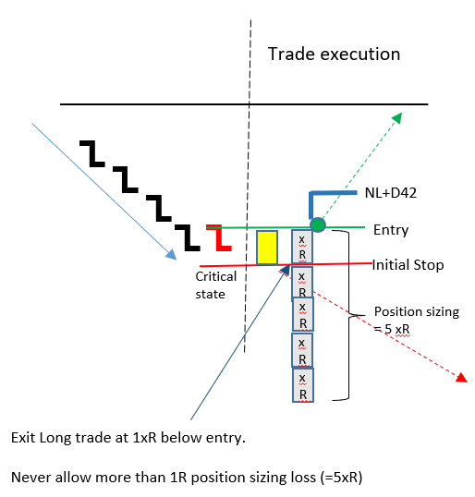 | Self  Key notion is that the initial xR stop just needs to be ~5x smaller than position sizing risk, as it is an initial seed capital to enter the trade. Once trade is on, move the stop to NL+D42 asap. That is the more important stop.
System
The absolute value of xR does not matter because its much less than position sizing risk. If the trade is correct, move stop to NL+D42 asap, if the trade is wrong, exit at –xR loss and move on to the next trade.
After NL+D42 it’s a science project for any additional profits
--- Profits today could be used to fund tomorrow’s risk seed capital
 |  | Market
Synthesis  The -xR execution risk is ~5x smaller than the position sizing risk, the absolute value is less important than moving the stop to NL+D42 |  | Actions  After entering a trade, get to NL+D42 ASAP.

Admin  Foundations Bootcamp  Tortoise on Ruzuku  37:27 min | Context/Prep  Core & Turbo Trade frames
Key Words  Trade framing (00:10)  Frame Usual suspect AA (03:25)  Frame RLFF AAPL (05:49)  Frame CSCO Auto-framer (14:32)  Frame DVN Frog Champ (23:00)  Frame DVN Intraday Turbo (26:41)  Frame Usual suspect EPP (28:43)  Frame Frog champ EWW (31:06)  Frame Frog Champ EWZ (34:00) | Notes  Trade framing. The control measures and frame of reference for the trade – the entries, exits, targets, stops. Trade frame examples from Tortoise daily reports listed in Markets section.  Usual suspect:AA (03:25) RLFF: AAPL (05:49) AutoFrm: CSCO(14:32)  Background MACD heading to Spring=> long RLFF trigger, RL10 VS RL270 11 ATR below RL270  Today PSAR flip, BB expanding, -> Long +5 ATR above RL270, $270 Autoframer =3.3 R/R, doji  Other RL90, Dragon rolling up -> Long RL90 rising, RL10 rising Opportunity Long  Setup Long Entry Break out bar high $20.9 At present price $270 +2ATR from bar low $44.66  Short Entry $262 2ATR below $270 2 day low $43.5  Target high 200d MA for 3:1 R/R $306 > 2ATR above entry  Target low RL270 $245  Stop Below bar low $19.9 $262 2 day low $43.5  Frog Champ: DVN (23:00) Intraday DVN (26:41) Usual suspect EP(28:43)  Background Dragon belly bottomed twice No resistance past 20 days 5 min Hybrid F breakout  Today RL10 reversed higher Hybrid down to 5 min chart 20 cent box intraday  Other Oil services USO, XLE rising Use prior z3pinch box size  Setup Long Entry Bar high+ 5c $23.32 Breakout above23:32 $46.16  Short Entry Below RL90 $21.43, $45.84  Target high Hump of dragon, 200d MA $26.3 RL270 $46.57, z3, z3  Target low $45.26  Stop Bar low $22.17 Lower risk box $23, 30c mmrb $45.84 | Self
System
Frame Frog champ EWW. Frame 1 min chart, use z3pinch box to frame next trade. On hourly it’s a 30-cent box. Several upside target and downside targets.
Frame Frog champ EWZ. Daily breakout Long above $44.8, short if below 200d MA. Downside target belly of dragon, Upside target z3 or hump of dragon. For intraday, use Rangestat for target setting higher and lower.
Markets
Frog Champions: DVN, EWW, EWZ, Wynn
Strong Sectors: XLK, XLF, MSFT, CSCO, GE, JPM
Squeeze: MRK
Doji + Breakout: MRK
Swing pattern: TLT channeling
Usuals suspects: AA, DVN, EPP
Auto Framers: CSCO, EPP
MPGC (Max Gain Pain Compression): HD, MCD
Super Pinch: WMT, INTC
RLFF (Regression Line Fractal Framework): Value CSCO, RS leader: JNJ, AAPL
MACD 4 Seasons: Winter: XLE, Spring: IYR, Summer: XME, Fall: USD
Synthesis  Frame setups done on several instruments identified by the Tortoise daily report – entries, targets, stops on both daily and intraday. |  | Actions  Practice framing picks from the daily market report

Admin  Foundations Bootcamp  Tortoise on Ruzuku  11:07 min | Context/Prep  Visual Box Trading flashcards
Key Words  IWM Visual trading 1m (00:10)  IWM Visual trading with MACD (08:55) | Notes  Visual box trading showing the entries and associated yellow risk box sizes.  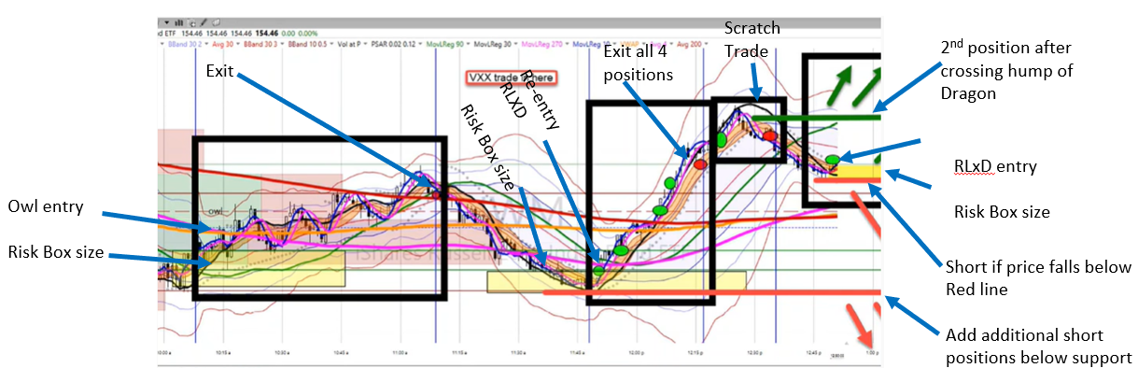  MACD Lines supporting the entries  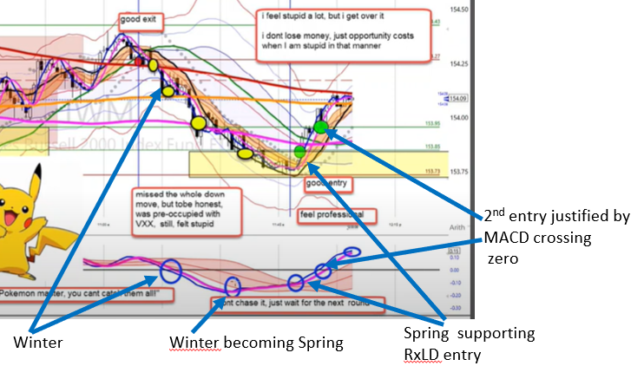 | Self
 |  | System
 |  | Markets
Synthesis  Visual box trading in IWM, showing how much of a buffer is needed in the risk box before going ahead with the trade. |  | Actions  Trade the frame with the visual risk box to know ahead of time the entry & exits.

Admin  Foundations Bootcamp  Tortoise on Ruzuku  12:42 min | Context/Prep  Visual Box Trading examples from live trading
Key Words  Determining size of mmrb IWM (00:10)  mmrb MRK (03:09)  mmrb WPM (04:12)  mmrb SPG (05:05)  mmrb WYNN (05:42)  mmrb X (07:13)  mmrb VXX (10:15) | Notes  How to determine the size of minimum manageable risk box (mmrb) in visual box trading.  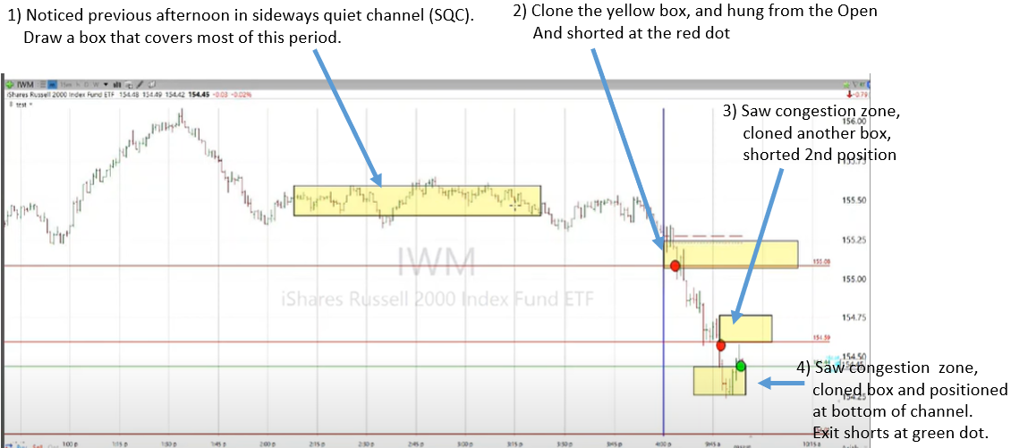  mmrb is the execution risk. The position size is then 5x mmrb size. Chart with MACD-H to see the red river interactions. | Self
System
mmrb. Look at previous day period of sideways quiet channel and draw a box. This box can be the mmrb for the next day trade.
Markets
VXX visual box trading mmrb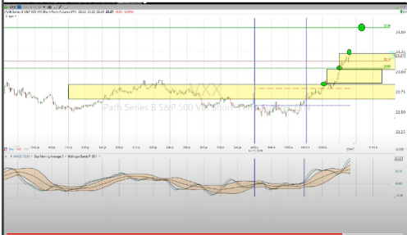
Synthesis  To determine the mmrb size, look at the sideways quiet channel of the previous day to help determine the box size. |  | Actions  Be comfortable in determining the mmrb. Multiply this mmrb size by five to obtain the position sizing risk for the trade.

Admin  Foundations Bootcamp  Tortoise on Ruzuku  55:55 min | Context/Prep  MTFMLA: 20190121 Multi Time Frame, Multi Lens Analysis
Key Words  Multi-timeframe checklist on DIA (00:10)  Multi-timeframe Swing-Intraday information exchange (52:52)  Multi-timeframe analysis as market condition indicator (53:00) | Notes  Weekly preparation and assessment on DIA – going from steps 1 thru 17 for swing and 2hr and 30 min for intraday trading.  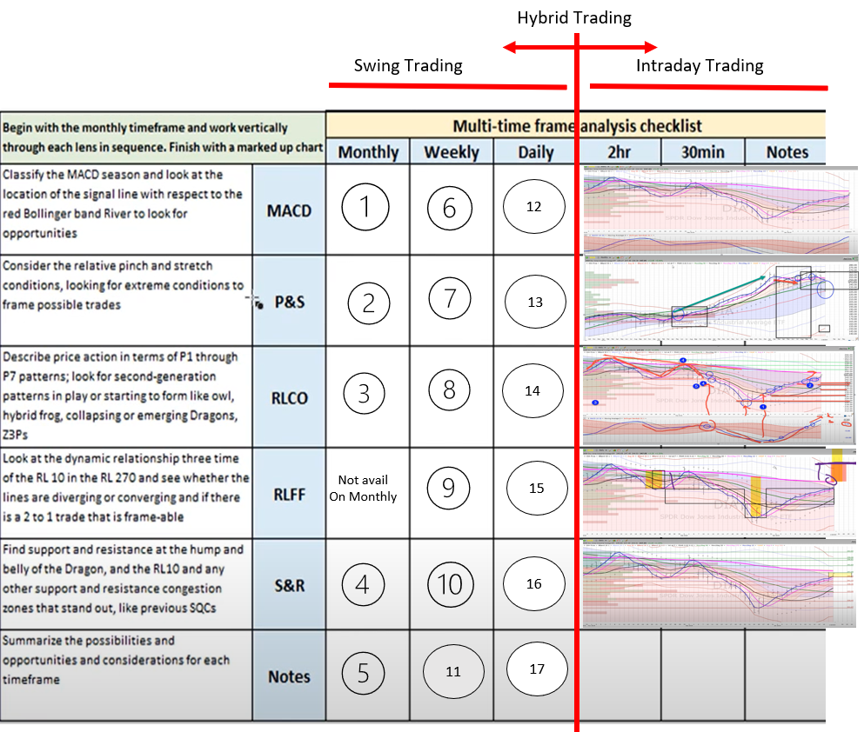 | Self
System
Multi-timeframe Swing-Intraday information exchange. Information from Swing can carry over to intraday trading and vice versa to continue or hedge the positions.
Markets
Multi-timeframe analysis as market condition indicator. Can use results from checklist analysis for market understanding.
Synthesis  A weekly checklist for multi-Timeframe analysis on DIA (Monthly, Weekly, Daily) for swing and position trading. |  | Actions  Consider using the multi-timeframe checklist in your weekly preparation.

Admin  Foundations Bootcamp  Tortoise on Ruzuku  43:52 min | Context/Prep  MTFMLA: 20190714 SPY example
Key Words  Multi-timeframe checklist on SPY (00:10)  Multi-timeframe MACD SPY monthly (02:45)  Long term buy & holders analysis (20:14)  Multi-timeframe MACD SPY weekly (21:45)  Multi-timeframe MACD SPY daily (35:30) | Notes  Apply a systematic disciplined process to look at SPY across multiple time frames from monthly to 30 minuet charts on MACD, Pinch & Stretch, RLCO, RLFF, and Support & Resistance  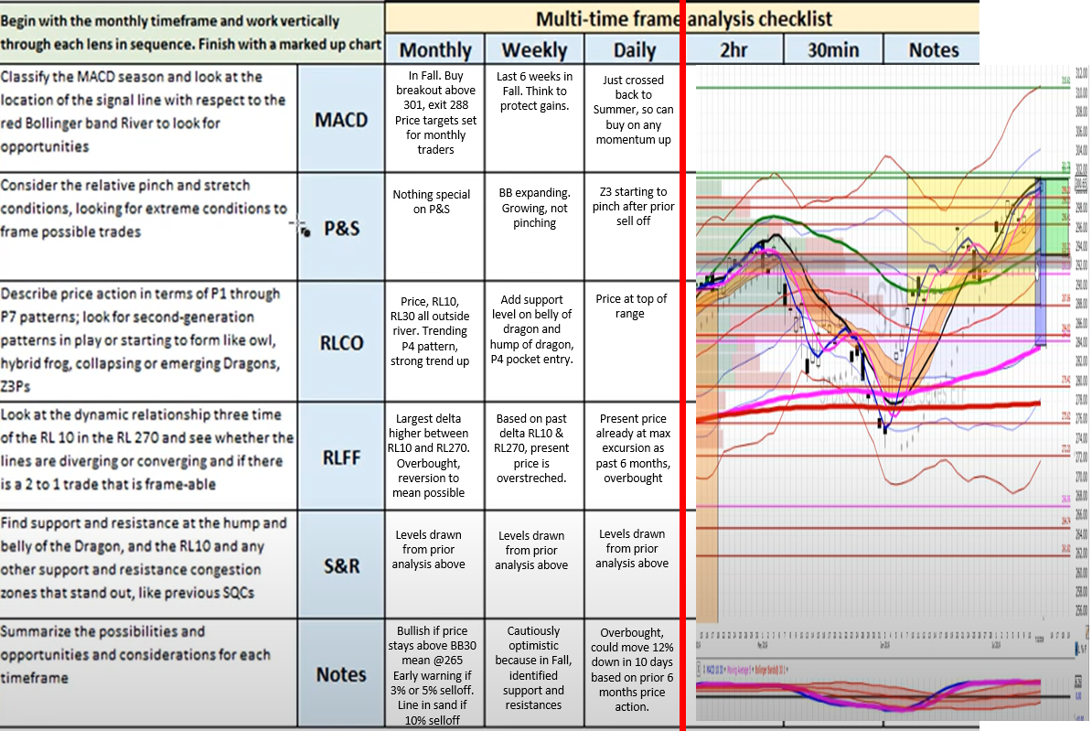 | Self
System
Long term buy and holders analysis. Start with monthly multi-timeframe analysis, then go to weekly analysis to help fine tune long term positions. To re-evaluate on weekly and monthly basis. No need for daily and below.
Markets
Multi-timeframe MACD SPY monthly. Bullish if price stays above Bollinger Band (30) mean @265. Early warning if 3% or 5% selloff. Line in sand if 10% selloff to short.
Multi-timeframe MACD SPY weekly. Cautiously optimistic because in Fall, identified support and resistances.
Multi-timeframe MACD SPY daily. Overbought, could move 12% down in 10 days based on prior 6 months price action.
Synthesis  A weekly checklist for multi-Timeframe analysis on SPY (Monthly, Weekly, Daily) for swing and position trading. |  | Actions  Consider using the multi-timeframe checklist in your weekly preparation.

Admin  Foundations Bootcamp  Tortoise on Ruzuku  13:55 min | Context/Prep  MTFMLA: 20190810
Key Words  Multi-timeframe MACD SPY monthly (0:10)  Multi-timeframe MACD SPY weekly (03:21)  Multi-timeframe MACD SPY daily (06:26)  Multi-timeframe MACD SPY hourly (09:29)  Multi-timeframe MACD SPY 15 min (10:57) | Notes  Process to look at SPY across multiple time frames from monthly to 15 minuet charts.  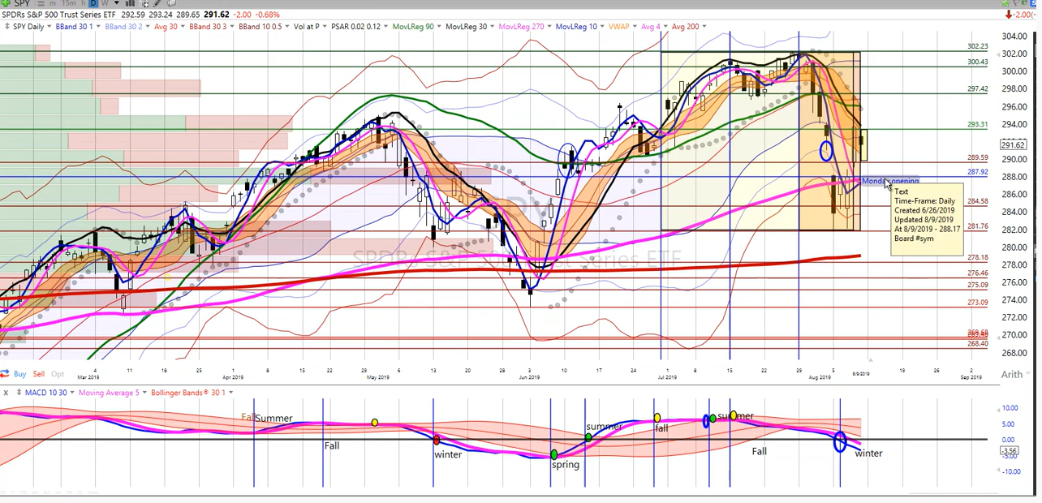 | Self
System
Analyze monthly, weekly, daily, hr, 15 min SPY chart.
Markets
Multi-timeframe MACD SPY monthly. Strong bull mkt, RL10,30,90 well above Dragon, well above RL270 value. In Fall, but flattening, critical state in monthly, cautiously optimistic. Multi-timeframe MACD SPY weekly. RL10, RL30 rolling over, well above BB, critical state at 290, target 310. MACD Fall to Summer. Cautiously optimistic Multi-timeframe MACD SPY daily. MACD in Winter, about to move to Spring. Price had collapsed to fair value then gapped higher. PSAR flipped down. Cautiously optimistic, critical state winter, above 296 bullish. Market in critical state can go either direction Multi-timeframe MACD SPY hourly. Optimistic bullish based on RL10 higher low. Multi-timeframe MACD SPY 15 min. RL10 higher lows, bullish
Synthesis  A weekly checklist for multi-Timeframe analysis on SPY (Monthly, Weekly, Daily, hourly, 15min) for intraday, swing, and position trading. |  | Actions Do a regular Monthly-Weekly-Daily-hourly-15 min analysis on SPY.

Admin  Foundations Bootcamp  Tortoise on Ruzuku  53:48 min | Context/Prep  MTFMLA 20191109
Key Words  Multi-timeframe checklist (00:10)  Timeframes (1:05)  Multi-timeframe MACD SPY monthly (02:35)  Multi-timeframe MACD SPY weekly (24:00)  Multi-timeframe MACD SPY daily (42:24) | Notes  Systematically look at SPY across multiple time frames from monthly to daily MACD, Pinch & Stretch, RLCO, RLFF, and Support & Resistance. Market contributes 50% of the instrument returns.  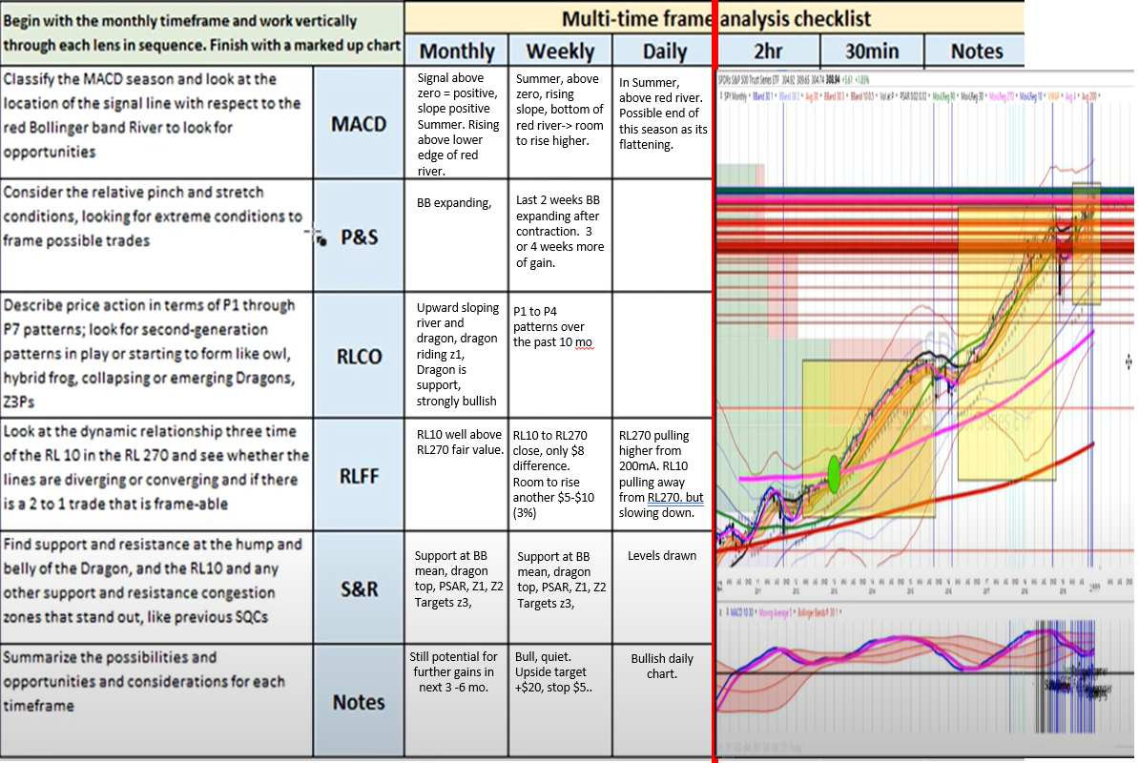 | Self  Gain confidence in the market by looking at the SPY across multiple timeframes against the Tortoise based indicators.
System
Timeframes. Swing use Weekly and Daily. Position use Monthly and Weekly, Slow day trader 2hr analysis.
Markets
Multi-timeframe MACD SPY monthly. Bullish. Still potential for further gains in next 3 -6 months
Multi-timeframe MACD SPY weekly. MACD histogram is summer fall summer, regression lines and river are sloping upwards, expansion starting, room for a 3-5 week rise
Multi-timeframe MACD SPY daily. Bullish daily chart. MACD in Summer, above red river. RL270 pulling higher from 200mA. RL10 pulling away from RL270 but slowing down.
Synthesis  A weekly checklist for multi-Timeframe analysis on SPY (Monthly, Weekly, Daily) for swing and position trading. |  | Actions. Gain confidence in the market by looking at the SPY across multiple timeframes against the Tortoise based indicators.

Admin  Foundations Bootcamp  Tortoise on Ruzuku  21:30 min | Context/Prep  Strategic choice: 4 approaches plus a blend (clone)
Key Words  Overview | Notes  Tortoise Ecosystem view of the environment and strategies taken to address those challenges.  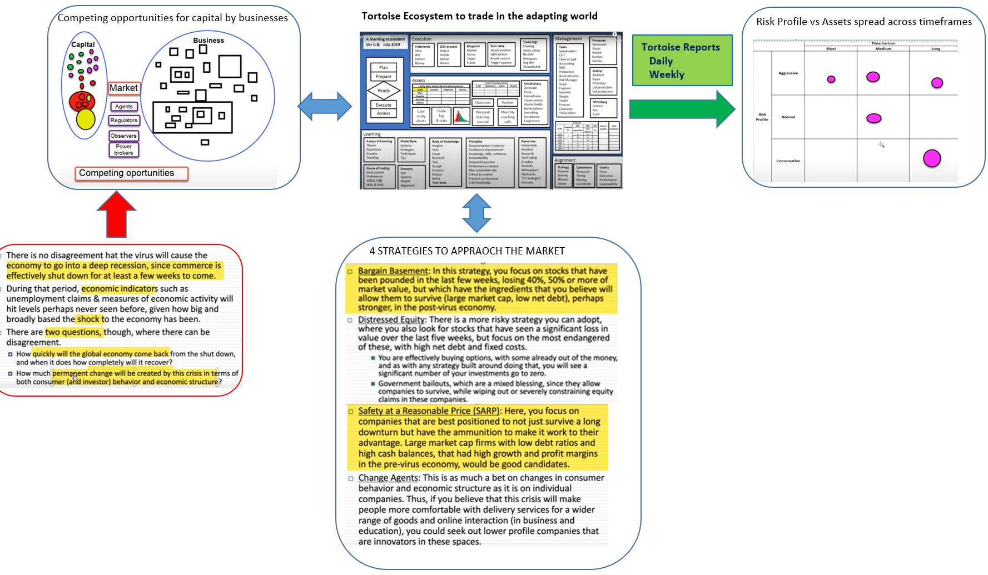 | Self
System
Tortoise ecosystem to analyse the global market risks and asset allocation across timeframes for the trading community.
Markets (Strategies)
Bargain Basement. Focus on stocks that have been pounded in the last few weeks, losing 40-50% or more in market value, but have the ingredients that will allow survival.
Distressed Equity. Look for stocks that had significant loss in value over the past 5 weeks. Focus on the most endangered. Effectively buying an option/ government bailout.
Safety at a Reasonable Price (SARP). Companies best positioned to not just survive a long down turn, but have make it work to their advantage. Large cap with low debt ratios and high cash balances, high growth and profit margins.
Change Agents. Changes in consumer behaviour. Crisis will make people more comfortable, companies that are innovative.
Synthesis  Tortoise Ecosystem view of the environment and four strategies taken to address recent challenges in 2020-21. |  | Actions  Fully utilize the Tortoise ecosystem.

