**Lessons learned from 2 years of applying True Storytelling Tools for people and organization**

**Ken Long[1]**

This paper shares a practitioner’s approach to applying the principles of True Storytelling, It summarizes a number of lessons learned and practical tools developed along the way that I hope will be useful to others seeking to help promote truth-telling, community action and transformational experiential learning to improve the world in an ethical manner.

These concepts represent the highlights of intense daily and weekly work from March 2020 to August 2021, while engaging with Covid. I have been a professional in the field of organizational development and change management within large public and private organizations for over 30 years, and I continue to be amazed at just how transformative, practical and inspiring True Storytelling is in every dimension of my life. I am privileged to be able to share these insights with you.

**Background:** I am a 63-year-old retired Army officer, with a doctorate in organizational development and business management with an emphasis on applied scholarship in organizational change and strategy making. My 25 year military career includes combat command experience as an infantryman. For 30 years I have been a small business owner engaged in boutique financial analysis for a global clientele of institutional investors; I’ve spent 20 years as an adjunct professor in various graduate schools of business and management specializing in strategy and change management. I have 20 years experiences as a year-round volunteer coach for a premier traveling team in competitive youth soccer. In each of these four dimensions plus in my own personal psychological work, I have found True Storytelling to be immensely inspiring, practical and transformative.

**Educational background:** my education includes an undergraduate degree in Asian history, a Masters degree in systems management and a doctorate in management and organizational development. During my dissertation research, I was exposed to the work of Dr. David Boje in the area of critical narrative inquiry and organizational storytelling. His work was instrumental in helping me analyze and make new sense of the organizational narratives that dominated my military profession and the military college where I was a faculty member. It helped me uncover the often unspoken games of politics and negotiation that are prevalent in all major organizations. I describe my exposure to the Boje narrative corpus as being at an academic level and I approached the use of narrative inquiry as a carpenter might apply a tool to perform a particular technical task, but without any emotional connection at the level of identity and values.

While organizational storytelling was useful and satisfying, I was hungry for more of the sense making and constructivist approach to knowledge creation in social settings that seemed to explain more of how decisions and policies are made in large organizations. I was also interested in the use of storytelling to help craft new and persuasive ways of proposing alternate futures in developing innovative solutions to common persistent problems. I reconnected with Dr. Boje’s work and the work of the True Storytelling Institute in early 2021 as the Covid virus began to propagate across the planet and it seemed like a natural way to conduct personal professional development on an interesting subject through Zoom and digital outreach. I took a series of True Storytelling Institute modules for foundations, ethics, antiracism, leadership, train the trainer certification and organizational change management, and in each case I began to appreciate the full power and potential of True Storytelling.

**Challenge:** the initial challenge that motivated me to engage with the True Storytelling body of knowledge arose from the educational mission of the military college where I am faculty member. Our mission is to support the personal and professional development of midcareer Army officers as they transition from small unit direct action leaders into large-scale organization leaders. To do that, they must develop new skills for self-awareness, collaboration, and professional development which includes critical thinking, creative thinking and self-awareness. The existing curricula was filled with traditional means of self-awareness with common psychological instruments like the Myers-Briggs type indicator, the Kolb Learning Style Inventory to name just two. My observation was that these instruments were very rational and one-sided in that they did not require officers to engage at fundamentally deep levels of values and identity when engaged in dialogue with their peers. Since the development of strong interpersonal collaborations are essential for military organizational leaders, it seemed to me that True Storytelling might be a way to engage the emotional intelligence and authentic self development that were clearly a requirement. And so, I undertook the courseware in True Storytelling to support the mission of empowering officers with the tools for self-awareness and organizational leadership in order to shape and guide the way forward of the military profession for leadership in both war and peace.

**Brief description of a set of useful True Storytelling Tools:**

This section presents practitioner tools that have been helpful in guiding and facilitating True Storytelling circles. These tools emerged spontaneously and creatively from live True Storytelling circles and classes, and were deemed to be so useful that we decided to standardize them and create tools for future leverage.

1. **The Walking Man metaphor:**

The Walking Man image symbolizes five ways of knowing about and engaging with the world. When we talk about each of these five ways of knowing, these five kinds of intelligences, we acknowledge that there are multiple paths to knowledge and understanding which lead to different ways of acting in the world towards our visions. These five ways of knowing offer insights into creativity, critical thinking and applied practical knowledge. This concept has been effective with groups of soldiers, leaders, business executives, equity market traders, youth soccer players and college faculty. Briefly the five ways of knowing are: The Knowledge of the Head-Heart-Gut-Hands-Feet.

a. **Head:** representing traditional classic objective structured cognitive knowledge. The knowledge of the head is concerned with models, concepts, theories, processes, underlying ontologies. It represents the knowledge of subject matter experts who know a lot about things.

b. **Heart:** representing idealistic and idealized knowledge of values and identity that form the core of our being and connect strongly to our purpose. It reminds us of the grand vision pulling us forward to a better place. It helps us ensure that our ends are connected to our ways and means as we go about taking action-in-the-world with her True Storytelling partners. It represents the knowledge of caring empathic nurturing caregivers and caretakers.

c. **Gut:** representing the lizard brain, the emotionally dominated, fear-based, risk averse primitive survival mind that sees a tiger in every shadow and drives us into fight or flight syndrome at a moment’s notice. It represents a powerful survival instinct that influences us every time we encounter something new or surprising, which shapes our ability and willingness to engage with novel ideas from others whom we are still learning to trust. It is responsible for the political conniving and socially destructive features of a dog-eat-dog world as described by Li (1911) in his treatise on Thick Black Theory.

d. **Hands**: representing the practical applied knowledge of craftsman who can make things and do things that work in the world. This shaping knowledge of quality craftsmanship in action provides us ways to make differences in the world with the tools we make and the projects we complete so that the people may thrive. It is the knowledge and wisdom of experience, of trial and error, of continuous improvement, and a inner drive for quality and excellence.

e. **Feet:** representing the resilient enduring knowledge of how to make way in a world that sets obstacles in your path every day and in every way. It is the knowledge of persistence and determination that helps us get through the challenges, bypass the challenges, find new ways to solve old problems, to find new sources of strength in surprising places, the knowledge of how to take the next step in spite of adversity.

A review of these five ways of knowing in a True Storytelling circle creates respect for multiple ways of knowing and values the individual life paths that lead us all uniquely to our own wisdom and our own unique point of view, about which we are expert and which we hope to offer to our collaborative friends in a mutually supporting community of practice.

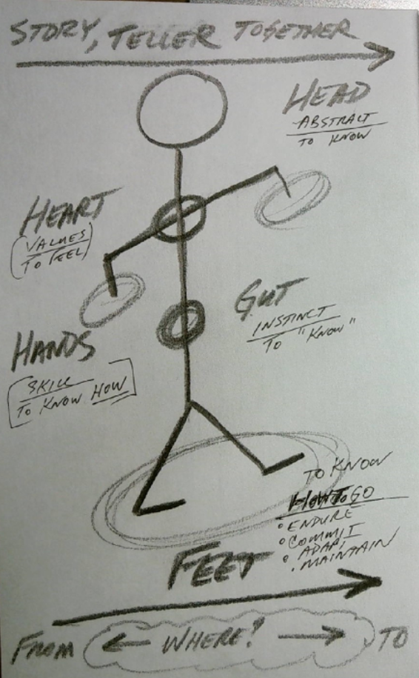

Figure 1: The Walking Man

2. **The Roundabout:** this is a pleasing and satisfying way of representing the dynamic energy found typically in a True Storytelling circle. Representing the circle as a roundabout communicates the sense of energy that infuses all of the “R-word” verbs that are seen in a lively and nourishing circle. These verbs of action and being are helpful to review with participants new and old to get a sense of the possibilities and value add opportunities that represent the collection of potentialities in the circle.

The list includes but is not limited to:

… ***resting, recovery, reviewing, refreshing, reverting, recognizing, relating, reorganizing, repurposing, rejoicing, reciting, restoring, rendering, reflecting, reenergizing, remembering, reviewing, resourcing, rotating*,…**

if you begin ***reciting*** this list with the dynamic image of a roundabout traffic circle in your mind you may begin to imagine the synergizing expansive multiplicative effect once you get going. It allows us to reframe the circle as a dynamic place that serves multiple simultaneous purposes in the development of opportunities to reshape the world toward our common collective vision. It is an especially powerful graphic to have on display in the physical and/or virtual setting during the conduct of a True Storytelling circle.

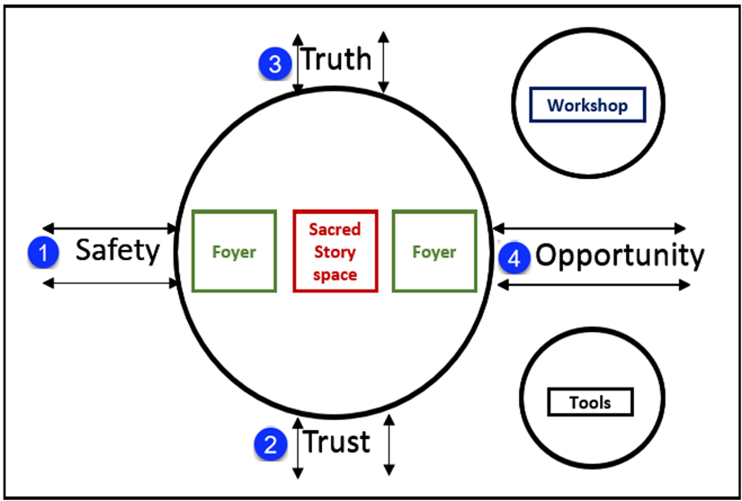

Figure 2: The True Storytelling Roundabout

Figure 3 captures the organizational model and best practices of one of our enduring True Storytelling circles, and which offers a proven way of getting your circle started. I am happy to collaborate with the reader on your own model.

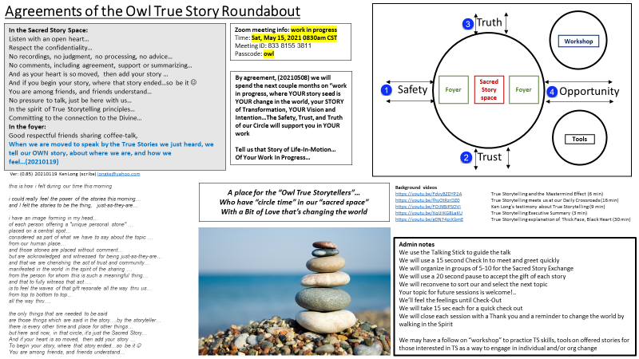

Figure 4

1. **The Water cycle/energy map:** This is a reframing exercise that is helpful in finding ways to move from one contentious problem environment with no apparent way out into an expansive world of multiple healthy nourishing possibilities that operates according to the principles of the natural water cycle. It helps you move from Sisyphus to harmony by deliberately drawing upon our visual cortex and mind’s eye imagination to explore circumstances and underlying beliefs in three phases: before after and finally in between. It solves the problem of how to get started from a tough place towards a better future when taking even the first step can feel daunting. By going in the directed sequence you create powerful motivations to leave the past behind to be drawn forward, pulled into a better future and only then developing the interim transformative beliefs that allow us to transfer our focus attention energy and confidence from the past through the present to the future. The transformative, transitional beliefs in the fifth step become the project management signposts along the way that lead us in our desired direction. I have seen this break the cycle of despair and powerlessness that keep people from just picking up and going, of taking the next step. It’s an inspiring way to raise the energy for transformative change.

To use the tool, take these five steps in sequence:

1. **Model the despair** of Sisyphus by describing all the forces that work against you making progress and make it an unfair fight. Make sure you account for all of the emotional baggage of the current state.

2. **List the underlying beliefs** that serve as a cage to keep us locked into our despairing view of the present. Spare no expense in documenting each and every negative feeling. Name those dragons. These are the motivating negative energies and enemies that we will leave behind.

3. **Draw to describe a beautiful vision** of the future along the principles of the water cycle that showed natural forces in harmony and motion and with our small but integral selves as parts of that natural scene moving along effortlessly, supported by water and natural power.

4. **List the underlying beliefs** that are true that allow the manifestation of that idyllic scene, which will be our realistic future at the end of this journey, towards which we are constantly moving with every step and intention. These are the beliefs and images that pull us forward.

5. **List the transformative and transitional beliefs** and actions that form a menu of potential, intermediate steps that we can take, no matter how small, that allow us to begin moving from the past to the future in the present. No step is too small, no direction is incorrect, every step is motion and progress of a sort from which we can learn and which help us endure the journey. This is powerfully connected to the five ways of knowing tool and the idea of the roundabouts that we can create along the way.

See figure 5 for a blank form that can be used to guide this effort and one living example from a group of professional traders who were in despair about the unfairness of trading in global markets against large and powerful competition.

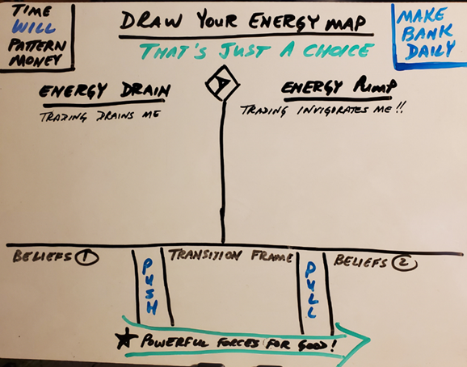

Figure 4: The Energy Map

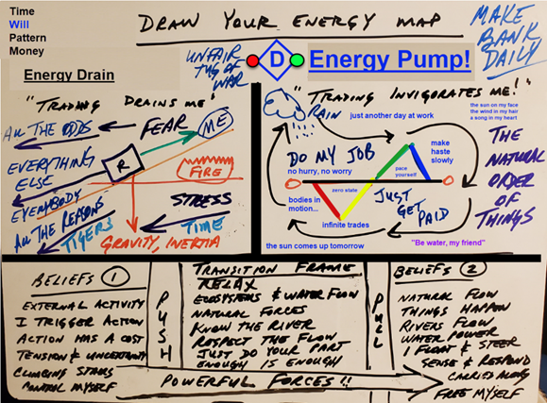

Figure 5: The Water Cycle energy map

4. **Mindmapping the Storyboard**: one of the most powerful features of a True Storytelling circle is the collaborative brainstorming that can occur to create some truly compelling ideas, process maps, eco-system views of the world or concept maps. The attached example of a Concept Map comes from a True Storytelling circle that was sharing stories of experiences of effective teaching and furthermore, how to do it in an efficient manner. What emerged from the group collaboration was a set of concise principles, models and concepts that the group called “Ratchet Learning”, and which became a useful storyboard on a single sheet of paper that could be used to express an entire approach to experiential learning in a single executive summary presentation. Developing skills as a brainstorming “sketch artist” does not require artistic gifts or skills or extensive training. It IS a skill that can be quickly and easily developed and which is a valuable addition to the tool kit of any True Storytelling practitioner. In this example you can see how incorporating artifactual drawings of the “Walking Man” and “The Roundabout” were becoming part of this group’s common collaborative language.

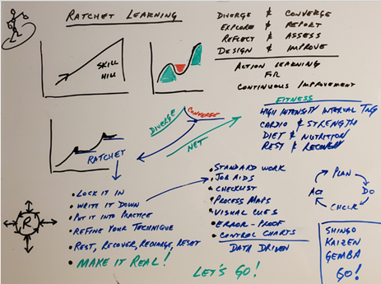

Figure 6: The Ratchet Learning storyboard

This storyboard captures the essential conceptual tension between the Safe-Trusting-Truthful-Opportunistic world of the True Storytelling circle with that of a world dominated by Li’s  
“Thick Black Theory”

.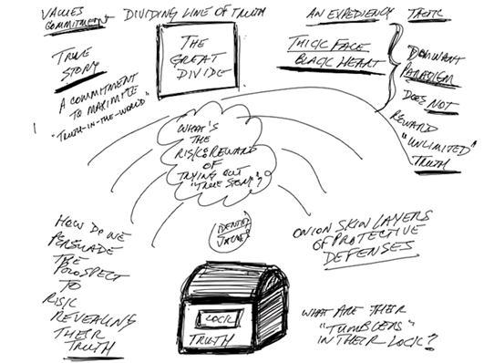

Figure 7: The Safety-Trust-Truth-Opportunity qualities of the True Storytelling circle

1. **Circumnavigating the Elephant:** this is a phenomenological insight that developed from the self-assessment of a True Storytelling group which had achieved a group-state where we had manifested a genuinely diverse set of points of view that incorporated a wide range of backgrounds into a safe, trusted, truthful and opportunistic space. Our group was familiar with the story of the 6 Blind Men and the Elephant, where individuals with limited senses and understandings can each only appreciate 1 small non-representative aspect of a complicated environment and that each different perspective offers what can be a confusing mélange of facts that are not easily synthesized into a common consensus of “sense-making”.

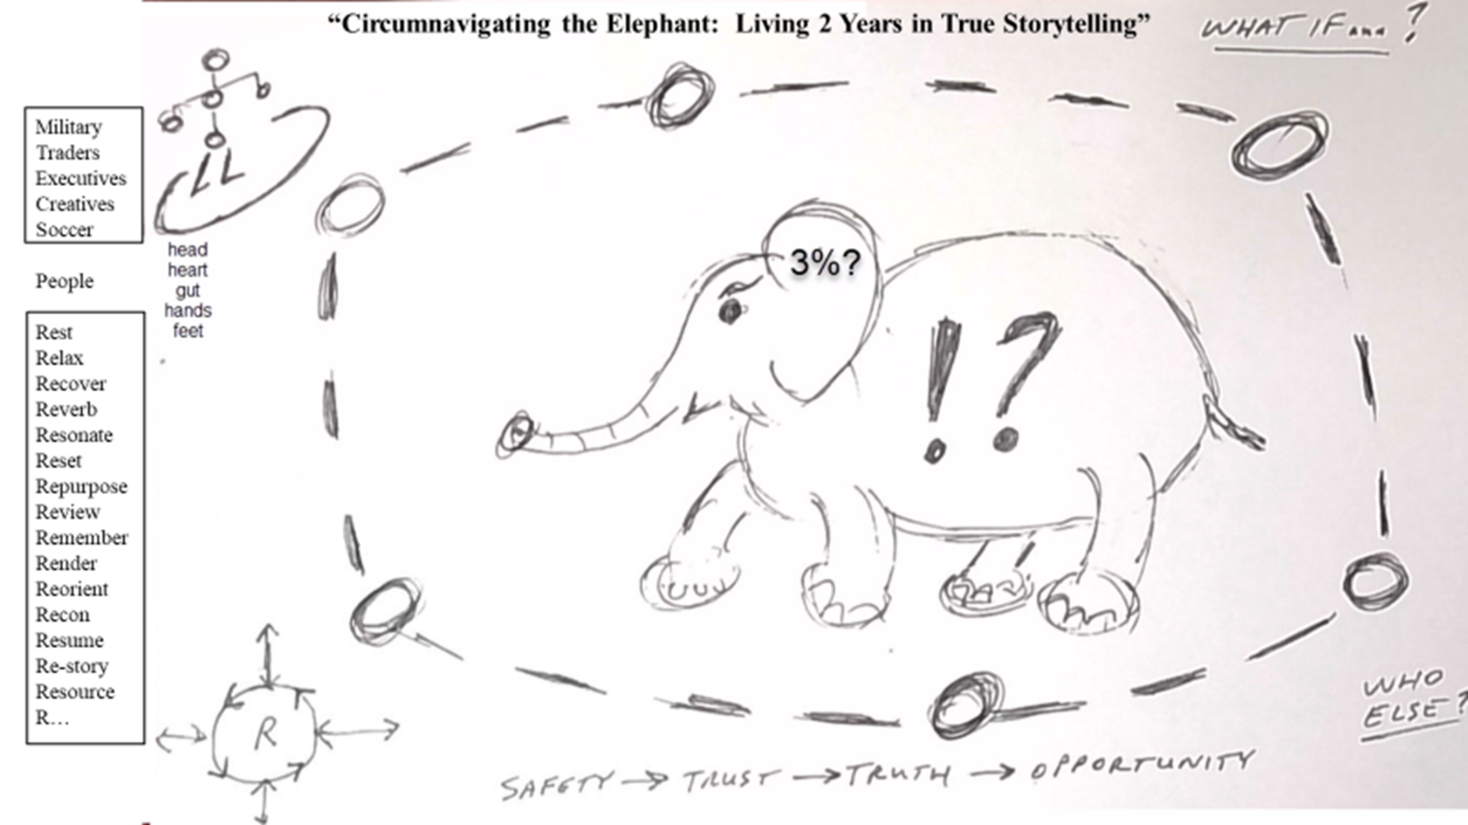

**Figure 8: Circumnavigating the Elephant**

Achieving a Safe-Trusted-Truthful-Opportunistic True-Storytelling space in our “Roundabout” gave us the capacity to create a higher-order of sense making about “the Elephant in the Room”. That didn’t mean we necessarily or even frequently achieved Consensus, but it DID allow us to have a more profound, nuanced, and multi-dimensional appreciation or the complexity of our individual human experiences. This gave us a richer sense of Principle 2: Acknowledge the stories that are already there in order to establish a more secure and durable foundation upon which to build our collaborations.

We noticed however that as we continued to work there were social norming pressures in evidence which tempted us to adopt “Consensus and Agreement” as high-level values. We noticed that this phenomenon, not unusual in collaborative groups, could have led, if unchecked, to substituting Consensus for Diversity and Truth. We coined the catchphrase of “Circumnavigating the Elephant” to capture the idea that the diversity, trusted communication and the exchange of unfiltered, unprocessed Truths could lead to a genuinely improved understanding and appreciation for the multi-faceted Truth(s) to be found in a social setting. We recognized the importance of committing to and maintaining our hard-won trusted Diversity in order to preserve the useful Engagement and Inclusion that we had worked so hard to create. This became a stated high-level value that we agreed to prioritize in our ongoing collaborations, and we made sure that we continued to effort the actions required to remain circumnavigating the elephant.

**Conclusion**

In this chapter I hoped to illustrate the wide variety of creative and practical tools, processes and insights that reliably emerge form the practice of True Storytelling. The best way to experience it for your self is to contact the True Storytelling Institute, and jump into the moment. Total immersion is painless and energizing and kindle your personal fire to make a positive difference in the world. You will remember how awesome your fellow travelers are when we simply take the time to listen deeply and tell our truths humbly and bravely. I am looking forward to your True Stories of success and encouragement!

References:

Larsen, J,. Boje, D., & Bruun, L. (2021). *True Storytelling: Seven principles for an ethical and sustainable change management strategy.* Routledge

Li, Z. (1911). Thick black theory. Thick Black Theory 厚黑學: Annotated Translation Chapter 8 LaPaglia, Gino. The Cultural Roots of Strategic Intelligence (Lexington: Dec, 2019), [ISBN](https://www.wikiwand.com/en/ISBN_(identifier)) [149858831X](https://www.wikiwand.com/en/Special:BookSources/149858831X), [ISBN](https://www.wikiwand.com/en/ISBN_(identifier)) [978-1498588317](https://www.wikiwand.com/en/Special:BookSources/978-1498588317), 302 pages

Raelin, J, (2016). *Leadership as practice: Theory and application*. *J. Raelin, Ed.). Routledge

1. Ken Long, retired Army lieutenant colonel (infantry, logistics, force management). Associate Professor at the US Army Command and General Staff College; Doctor of Management in Organizational Development from Colorado Tech University; Adjunct Professor at St Mary University in the doctoral program for Educational Leadership. Adjunct Professor Central Michigan University in the MPA program