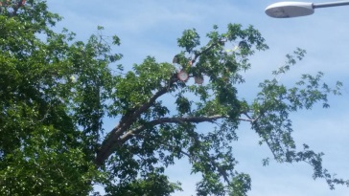
PETITION TO PROTECT TREES and HABITAT ON NMSU PROPERTY
BACKGROUND
2007 - The American College & University Presidents’ Climate Commitment (ACUPCC) was signed by NMSU as a commitment towards “a high-visibility effort to address global climate disruption undertaken by a network of colleges and universities that have made institutional commitments to eliminate net greenhouse gas emissions from specified campus operations, and to promote the research and educational efforts of higher education to equip society to re-stabilize the earth’s climate. Its mission is to accelerate progress toward climate neutrality and sustainability by empowering the higher education sector to educate students, create solutions, and provide leadership-by-example for the rest of society.
July 1, 2010 - The Office of Sustainability was created in the Facilities and Services (FS) department.
Mission: To be a resource for the NMSU community to develop a common vision of sustainability through innovation, education, and action.
Vision: To empower the NMSU community to care about the environment in which they live and work and to carry it into their personal lives and future generations.
Core Values
- Respect and love for humanity and all living things
- Passion for the environment
- Integrity of actions
- Exemplify an understanding that the natural and built environments are intertwined
- Unity of purpose through collaboration and interaction of ideas

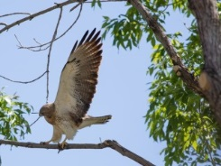
We the undersigned demand an end to Facilities and Services practice of cutting healthy tree branches & nests on the NMSU campus. Since 2007 the Board of Regents, Executive Administration, students and staff have committed to the practice of sustainability. Destroying healthy tree nests and bird habitat is in direct opposition to this mission, in action and in spirit.
First Last ___ Zip Code Email Student or Employee? Patricia ___Lodato_________ ___88001____ plodato@nmsu.edu__ Student Employ X
___________ _______________ _______ ___________________ Student Employ
___________ _______________ _______ ___________________ Student Employ
___________ _______________ _______ ___________________ Student Employ
___________ _______________ _______ ___________________ Student Employ
___________ _______________ _______ ___________________ Student Employ
___________ _______________ _______ ___________________ Student Employ
___________ _______________ _______ ___________________ Student Employ
___________ _______________ _______ ___________________ Student Employ
___________ _______________ _______ ___________________ Student Employ

