3.5 Hours (210 min) Methods course is lecture/discussion/presentation on the following:
Time | TOPIC | PRESENTATION | DISCUSSION | PRACTICE
10 min  I | 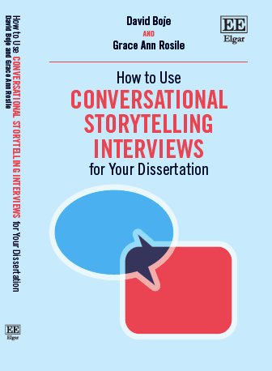 | We introduce ourselves  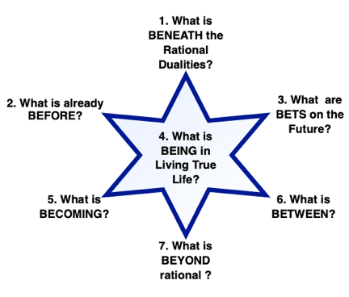 | Cohort intros in 3 sentences | Q: How are you Living a True Story Life?
40 min  II | Antenarrative, 7B Click Here for one page handout; | 4 hearts (gateways of spirit into Being) 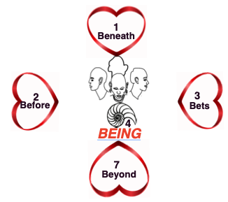 | Q: How does your Heart discern what’s true & what’s not? | Draw 4 hearts pointed at BEING; What direction are you looking?
30 min  III | A-I-D | 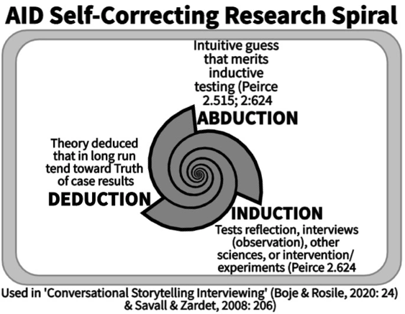 | Q: What Abduction are you exploring? | Breakout on use of abduction in dissertation
30 min  IV | Peircean Self-Correcting | 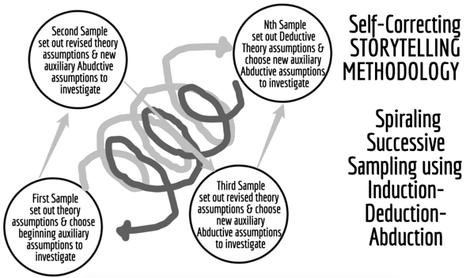 | Q: How do you sample in A-I-D? | Breakout pairs: Imagine using iterative cycles of spiraling sampling in your dissertation
40 min  V | Conversational Storytelling | 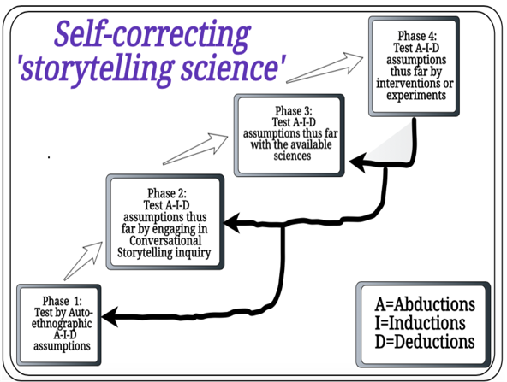 | Q: How to use A-I-D in conversational storytelling interviewing? | Breakout pairs: Tell story of your best and worst conversations
20 min  VI | Storytelling in 4th Wave Grounded Theory | 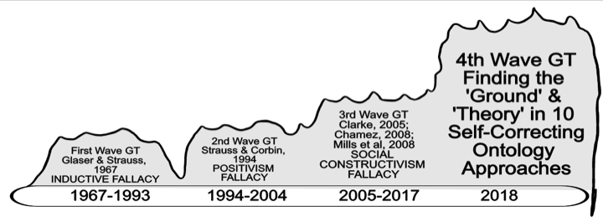 | Q: How to overcome confirmation bias fallacy? | Breakout pairs: Where is the ground and the theory in your dissertation?
10 min  VII | Phenomenology Ontology Existentialism | 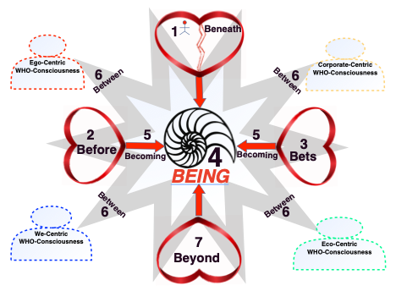 | Q: What are the 4 Who’s? | 2 Breakout groups: Q: Have a dialogue among the 4 Who’s
10 min | WRAP UP | Thank you | Your Takeaways

