2016-2017 SEASON PROGRAM ADS SALES PITCH
Produced throughout the year December 2016 through
December 2017 for four Veterans Theater shows.
Who: My Name is _____. I am a Volunteer for VETERANS ‘THEATER.
Why: They do plays about serious content to your target market: ‘Culturally Minded People with Disposable Income.”
What: Our plays use humor to bring light to current community issues such as the SPICE EPIDEMIC, the 22 SUICIDES-A-DAY among our VETERANS, 900,000 veterans dying while waiting for VA services, the CRISIS OF HEALTH CARE in NEW MEXICO, SOLUTIONS TO HOMELESSNESS, and so on.
When: Today I offer you a chance to become involved in your community and promote your business at the same time.
Ask: the business owner if they would be interested in purchasing or trading for ad space in the playbills for this year’s and next year’s season
How: Your INVOLVEMENT be done by simply taking up an ad in the VETERANS’ THEATER programs: 1,000 programs produced each year for two years means you reach 2,000 culturally minded people.
A bargain at only:
____Full page Color Ad- Back Cover $500
____Full Page Color AD $400
____Full Page Black & White Ad $200
____Half Page Color Ad $170
____Half Page Black and White Ad $140
____Quarter Page Color Ad $120
___Quarter Page Black and White Ad $100
____Business Card $70
____Your name and one line of well-wishing to cast members
___ Just your name as well wisher to Veterans Theater programs $10

Or, Trade Ad space for your own Free Service __________

Why should you do this? First, Programs have souvenir value that other print ads lack! Second, our audience is your target market, culturally minded people with disposable incomes. Third, this is excellent opportunity to let New Mexico know that your business is a supporter of the community.

High quality printing and production values in color or black and white.

For more information please contact David Boje at 575-936-95x78 or email at Veteranstheater@gmail.com - We appreciate your time. Thank you!
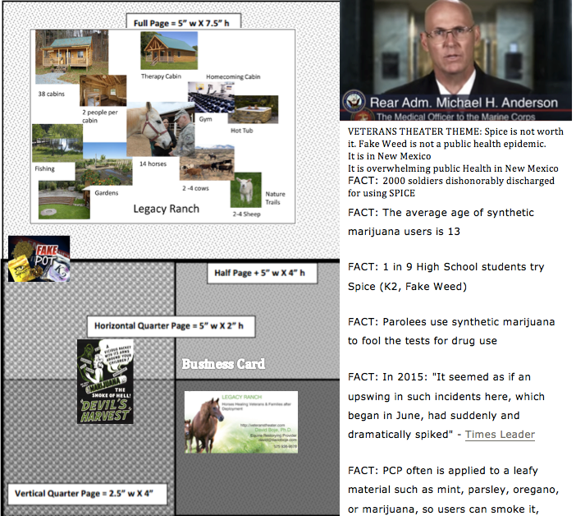

In New Mexico, in Las Cruces, Last Week, 17 overdoses, and 2 did die, and there are no kits to test for it. The Navy recognizes that they are having problems with sailors smoking this "legal" marijuana and put out a video last summer warning about the dangers of this drug. The side effects are devastating. You can experience heart attacks, strokes, psychosis, kidney failure, exaggerated thoughts of suicide and so much more. The ingredients in spice are hard to detect so many turn to spice because it will give a false negative on a drug test.
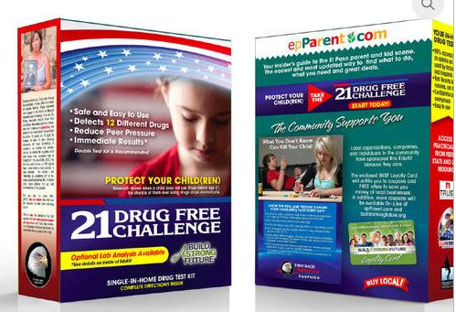
https://spiceisnotnice.org/spice-edukit/ Ruth Rivas, mother of Adam, who dies of Spice, in the Navy, will bring the kits for you bo buy, and they are free to non-profits on Dec 2nd, at EARLY CHRISTMAS play 7PM in Rio Grande Theater.
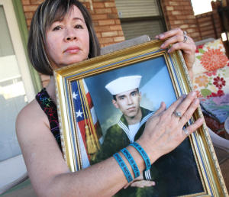 Ruth Rivas of El Paso. Her son died of Spice in the Navy.See http://spiceisnotnice.org and donate to make these kits available in New Mexico.

STEP-BY-STEP SALES PITCH

- Who: Introduce yourself as VOLUNTEER of VETERANS THEATER
- Why: They do plays about serious content to your target market: ‘Culturally Minded People with Disposable Income.”
- What: Our plays use humor to bring light to current community issues such as the SPICE EPIDEMIC, the 22 SUICIDES-A-DAY among our VETERANS, 900,000 veterans dying while waiting for VA services, the CRISIS OF HEALTH CARE in NEW MEXICO, SOLUTIONS TO HOMELESSNESS, and so on.
- Ask: the business owner if they would be interested in purchasing or trading for ad space in the playbills for this year’s and next year’s season
- How: Your INVOLVEMENT be done by simply taking up an ad in the VETERANS’ THEATER programs: 1,000 programs produced each year for two years means you reach 2,000 culturally minded people. Show them a size sheet of playbill ads
- Tell them: Your ad will be printed in four playbills a year, for two years, at one price
- Fill out the Playbill Ad Form. Be sure to sign your name at the bottom
- Collect the payment: Checks payable to VTERANS THEATER
- Give them a Receipt for their Payment; If they have a digital or printed image, include that with the payment
- Ask: can you please post a POSTER for the next Play?
Thank you for purchasing or trading for PLAYBILL Ad Space for the 2016-2017 season!. Your support of the VETERANS THEATER programs is greatly appreciated. We your support, are are able to pack the theater performances with the kinds of customers your business targets.
The VETERANS THEATER productions for the 2016-2017 Seasons are
- 2016 production of LABELS Dec 16 2016 at Alma D’Artes Las Cruces
- 2016 play: Health Crisis in New Mexico, a play at the Social Work Convention, Albuquerque

