PLAYBILL PROGRAM AD SALE FORM
We have a special ‘Early Christmas’ performance of Veterans Theater. One ad takes your message through one FULL season 2015-2016:
• Our December 2nd EARLY CHRISTMAS production in Rio Grande Theater has 421 seats
• Our February 25th 2016 Albrqueuque performance is the the Social Work Conference
• We are planning two more 2016 performances
• Your ad is permanent for the entire season
• We include your ad & logo and link on our website at no extra cost - http://veteranstheater.com and on our blogs
In Total, we will print over 1,000 playbills in 2015-2016
We at Veterans Theater believe every veteran is a star! Ad sales make it possible to continue offering experiences enabling veterans to discover and develop their own unique talents through theater. Veterans Theater is a nonprofit organization dedicated to providing the best Theater of Social Change and Justice in New Mexico and appreciates your support. Let all their stars shine! Feature your ad in the ‘Early Christmas' Playbill: Provide a camera ready copy of your ad or business card with payment in full.

Next Ad Deadline: Friday, November 12, 2015.
Thank you for your support! - David M. Boje, Ph.D.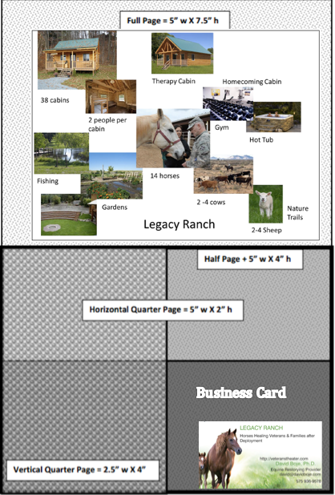
FILE FORMAT

JPEG GrayScale (200-300)

PDF with all fonts embedded

TIF Grayscale, or

Enclose Business Card

ARTWORK
Must be ready to publish. If you need our layout help, additional creative services charge ($30). Send your ad copy as high resolution file to David Boje at 4700 Dunn Drive, Las Cruces NM 88011 or scan and email ad copy to david@davidboje.com

PAYMENT INFORMATION
Payment is due at the time of sale. Please make checks payable to: VETERANS THEATER. Please complete this contract and return with payment to David Boje at 4700 Dunn Drive, Las Cruces NM 88011 or scan and email to david@davidboje.com
Sponsor’s (Purchaser’s) Name ___________________________________________________
Email ______________________ Phone ________
Address ____________________________________________________
What is your order?
____Full page Color Ad- Back Cover $500 ____Full Page Color AD $400
____Full Page Black & White Ad $200 ____Half Page Color Ad $170
____Half Page Black and White Ad $140 ____Quarter Page Color Ad $120
___Quarter Page Black and White Ad $100 ____Business Card $70
____Your name and one line of well-wishing $20 What is your name and one liner ____________________________________________________________
____Just your name ____________________ as well wisher to Veterans Theater $10
Layout/Design Fee (Optional $30) __________
Total Due: $_____________ Please make all checks payable to VETERANS THEATER
___ Yes, I need a non-profit tax donation receipt
SPECIAL NOTES: _____________________________________________
___________________________________________________________
Veterans Theater strives to make each ad stand out by carefully reviewing the playbill layout prior to printing.
Thank you for your support of PlayBills for one season.

