**The attractiveness of the IT occupation for Māori. The effects of culture and identity on Māori IT workers in the Aotearoa New Zealand Information Technology sector**

Mark Wynyard Van der klei

**Abstract**

**Keywords:**

# Glossary

Although translations and definitions have been given for the te reo Māori (the Māori language) words used in this research, please note that te reo Māori is highly contextual and words can have different meanings dependent on the usage and context. For example, the word kaumātua can be defined in the following ways:

|  |  |
| --- | --- |
| **Word or concept** | **Definition** |
| kaumātua | * To grow old, grow up * Elderly, old, aged * Adult, elder, elderly man, elderly woman, old man - a person of status within the *whānau*. |

Therefore, the definitions given below apply to the contextual use of those words in this research. Please note that all definitions (unless stated) have been sourced from Te Aka Māori Dictionary online resource (<https://maoridictionary.co.nz/>) (Moorfield, 2022).

|  |  |
| --- | --- |
| **Word or concept** | **Definition** |
| Ahau | I, me. |
| Aotearoa | North Island – now used as the Māori name for New Zealand. |
| Auaha | creative, innovative |
| Auahatanga | creativity, entrepreneurship, problem solving, learning, confronting challenges without emotional attachment to find the best solution. |
| Hapū | kinship group, clan, tribe, subtribe – section of a large kinship group and the primary political unit in traditional Māori society. It consisted of a number of whānau sharing descent from a common ancestor, usually being named after the ancestor, but sometimes from an important event in the group's history. A number of related hapū usually shared adjacent territories forming a looser tribal federation (iwi). |
| Iwi | extended kinship group, tribe, nation, people, nationality, race – often refers to a large group of people descended from a common ancestor and associated with a distinct territory. |
| Kaitiaki | trustee, minder, guard, custodian, guardian, caregiver, keeper, steward. |
| Kaitiakitanga | preserving, sheltering, and protecting in relation to the environment. |
| Kauae (Moko) | wahine chin moko. |
| Kaumātua | adult, elder, elderly man, elderly woman – a person of status within the whānau. |
| Kaupapa | topic, policy, matter for discussion, plan, purpose, scheme, proposal, agenda, subject, programme, theme, issue, initiative |
| Kawa | marae protocol – customs of the marae and wharenui, particularly those related to formal activities such as pōhiri, speeches and mihimihi. This seems to be a modern extension of the word. |
| Kingitanga | kingdom, reign (of a king), dominion, majesty, nation, country. |
| Kōrero | speech, narrative, story, news, account, discussion, conversation, discourse, statement, information. |
| Kotahitanga | unity, togetherness, solidarity, collective action. |
| Mahi | to work, do, perform, make, accomplish, practice, raise (money). |
| Mana | prestige, authority, control, power, influence, status, spiritual power, charisma – mana is a supernatural force in a person, place or object. Mana goes hand-in-hand with tapu, one affecting the other. The more prestigious the event, person or object, the more it is surrounded by tapu and mana. |
| Manaaki | to support, take care of, give hospitality to, protect, look out for – show respect, generosity and care for others. |
| Manaakitanga | hospitality, kindness, generosity, support – the process of showing respect, generosity, and care for others. |
| Māori | Māori, indigenous New Zealander, indigenous person of Aotearoa New Zealand – a new use of the word resulting from Pākehā contact in order to distinguish between people of Māori descent and the colonisers. |
| Marae | courtyard in front of the wharenui where formal greetings and discussions take place. |
| Mātauranga Māori | Māori knowledge – the body of knowledge originating from Māori ancestors, including the Māori world view and perspectives, Māori creativity and cultural practices. |
| Matua | parent, singular |
| Mātua | parents, plural |
| Mauri | life principle, life force, vital essence, special nature, a material symbol of a life principle, source of emotions – the essential quality and vitality of a being or entity. Also used for a physical object, individual, ecosystem or social group in which this essence is located. |
| Moko | Māori tattooing designs on the face or body done under traditional protocols. |
| Mokopuna | grandchildren, grandchild – child or grandchild of a son, daughter, nephew, niece, etc. |
| Pā | fortified village, fort, stockade, screen, blockade, city (especially a fortified one). |
| Pākehā | Aotearoa New Zealander of European descent – probably originally applied to English-speaking Europeans living in Aotearoa New Zealand. According to Mohi Tūrei, an acknowledged expert in Ngāti Porou tribal lore, the term is a shortened form of pakepakehā, which was a Māori rendition of a word or words remembered from a chant used in a very early visit by foreign sailors for raising their anchor. Others claim that pakepakehā was another name for tūrehu or patupairehe. Despite the claims of some non-Māori speakers, the term does not normally have negative connotations. |
| Papatūānuku | Earth, Earth mother and wife of Rangi-nui – all living things originate from them. |
| Pounamu | greenstone, nephrite, jade. |
| Pōwhiri | invitation, rituals of encounter, welcome ceremony on a marae, welcome. |
| Rangi-nui | atua of the sky and husband of Papa-tū-ā-nuku, from which union originate all living things. |
| Rohe | boundary, district, region, territory, area, border (of land) |
| Rūnanga | council, tribal council, assembly, board, boardroom, iwi authority – assemblies called to discuss issues of concern to iwi or the community. |
| Tamariki | children – normally used only in the plural |
| -tanga | a suffix used to make verbs into nouns, sometimes called derived nouns. |
| Tangi | rites for the dead, funeral – shortened form of tangihanga. |
| Tapu | restriction, prohibition – a supernatural condition. A person, place or thing is dedicated to an atua and is thus removed from the sphere of the profane and put into the sphere of the sacred. It is untouchable, no longer to be put to common use. The violation of tapu would result in retribution, sometimes including the death of the violator and others involved directly or indirectly. Appropriate karakia and ceremonies could mitigate these effects. Tapu was used as a way to control how people behaved towards each other and the environment, placing restrictions upon society to ensure that society flourished. |
| Tauira | student, pupil, apprentice, pattern, example, model, design, draft, sample, specimen, template, skilled person, cadet. |
| Te ao Māori | te = the; ao = world, globe, global. Therefore, this literally translates as the Māori World. |
| Te ao Pākehā | the world of the Pākehā. |
| Te reo Māori | the Māori language, dialect, tongue, or speech. |
| Tika | truth, correctness, directness, justice, fairness, righteousness, right. |
| Tikanga | a collective understanding and acknowledgement that what is being done is being done for the right reasons and is the right thing to do. |
| Tikanga Māori | the widely accepted way of doing or understanding things in the Māori world. |
| Tino rangatiratanga | self-determination, sovereignty, autonomy, self-government, domination, rule, control, power. |
| Tipuna | ancestor, grandparent, grandfather, grandmother (singular). The eastern dialectic version of tupuna. |
| Tīpuna | plural of tipuna. The eastern dialectic version of tūpuna. |
| Tohungatanga | expertise, competence, proficiency. |
| Tuakana / teina | older sibling / younger sibling. A way of learning and teaching which relies primarily on the older sibling teaching the younger, although the opposite also occurs. There are similarities between this concept and that of a mentor / mentee relationship. |
| Tūrangawaewae | domicile, standing, place where one has the right to stand – place where one has rights of residence and belonging through kinship and *whakapapa*. |
| Tutū | inquisitive playing, to play around with something, to take something apart to see how it works (Brockbank, 2020). |
| Utu | an important concept concerned with the maintenance of balance and harmony in relationships between individuals and groups and order within Māori society, whether through gift exchange or as a result of hostilities between groups – revenge, vengeance, retaliation, payback, retribution, cost, price, wage, fee, payment, salary, reciprocity. |
| Wahine | woman, female, lady, wife. |
| Wairua | spirit, soul – spirit of a person which exists beyond death. It is the non-physical spirit, distinct from the body and the mauri. |
| Wairuatanga | spiritual dimension of thinking, being and doing – with a spiritual and physical being connected by a mauri – the unique life energy in everything. |
| Whaea | mother, aunt, aunty. |
| Whaikōrero | oratory, oration, formal speech-making, address, speech – formal speeches usually made by men during a pōhiri and other gatherings. Formal eloquent language using imagery, metaphor, whakataukī, pepeha, kupu whakaari, relevant whakapapa and references to tribal history is admired. |
| Whakaaro | thought, opinion, plan, understanding, idea, intention, gift, conscience. |
| Whakamā | to be ashamed, shy, bashful, embarrassed. |
| Whakapapa | genealogy, genealogical table, lineage, descent. Also referred to as a layering concept where one thing is layered upon another and is applied to concepts other than ancestry. |
| Whakawhanaunga | to have a relationship, get together, get to know one another, get along with, make friends. |
| Whakawhanaungatanga | process of establishing relationships, relating well to others. |
| Whānau | People with whom one shares a familial relationship. These connections can originate in kinship or very close long-term friends who share no whakapapa ancestry |
| Whanaungatanga | Relationship, kinship, sense of family connection – a relationship through shared experiences and working together which provides people with a sense of belonging. It develops because of kinship rights and obligations, which also serve to strengthen each member of the kin group. It also extends to others to whom one develops a close familial, friendship or reciprocal relationship |

Additional acronyms used in IT

|  |  |  |
| --- | --- | --- |
| **Acronym** | **Stands for** | **Meaning** |
| BRT | Big Round Thing | See page 64 |
| BRTITC | Big Round Thing In The Corner | See page 64 |
| ICT | Information Communication Technology |  |
| IT | Information Technology | The field of computers, also includes ICT |
| ISP | Internet Service Provider | Company that provides internet connectivity to end-users / customers |

# 

# Introduction

The emphasis placed on statistics picturing Māori as underachieving in a variety of socio-economic statistics including education, employment, and incarceration is not new (Wall, 1997) but little is known of those that do not fit this stereotype.

Seeking answers, I travelled throughout Aotearoa New Zealand to kōrero with 18 Māori IT workers who were happy to share their stories. A newly developed approach called Kaupapa Tika was used to gather, analyse, and understand the experiences of Māori IT workers whose connections to te ao Māori varied from immersion to disconnection. Unstructured interviews were conducted as a co-creation exercise and they uncovered that while working *with* IT is fun and exciting, in many cases working *in* IT is not.

The overarching research question for this study was:

How can Māori IT workers be enabled to thrive in IT?

In addition to the main research question, I also chose to seek answers to the following sub-questions:

* How does Māori culture shape the identity of Māori IT workers?
* How do indigenous IT workers of Aotearoa New Zealand “identify” as being Māori?
* What are the challenges and barriers Māori IT workers face specific to their cultural background?

It is my intention to participate in the creation of a narrative centred on lived realities, what I refer to as a co-creation method. This is where I – as a knowledgeable facilitator – kōrero (converse, discuss) with Māori IT workers to uncover their lived realities of being Māori and working in the IT industry. The values I am using to underpin my evaluations of what I consider to be tika are manaakitanga, whanaungatanga, and whakamā.

Manaakitanga within this research is defined as “hospitality, kindness, generosity, support – the process of showing respect, generosity and care for others”, and in the “interviewer/information/participant” triad, manaakitanga elevates participants to the most important role. My mother told me what manaakitanga meant for her and if you are familiar with Māori whāea (mothers), what it should probably mean for me as well (if I know what is good for me). If a guest arrives at your home and you ask if they want a drink, then you are not applying manaakitanga because you are not trying to anticipate their needs. Instead, you would offer them a selection to choose from and ask them which one they would prefer. To add more depth to that example, while this was done in a respectful manner, this was not always done as a show of kindness. In shared stories from the past, people who deliberately forgo nourishment and other forms of hospitality do so in preparation for war. If your guests indulged in some form of nourishment in a relaxed manner, then the chances of direct conflict were lessened, and further social clues were sought to discern the reason for the visit. In this way, manaakitanga is one method of discerning intent and is why it was important to ask “which would you like?” as opposed to “would you like?” regarding refreshments when initial introductions are made.

The aspect of whanaungatanga applicable to the interview process was in the building of a relationship through shared experiences. After creating a welcoming environment through manaakitanga, whanaungatanga dictates that I share nothing less than that which I was asking of them. I demonstrate through the sharing of my stories (without privileging the content), that I share their language and understand the environment in which they work – he kanohi I kitea (a face seen) - the willingness to share enough about ourselves so that trust can be develop (Jones et al., 2006). This also included being honest about things I do not know, and not making this into a competition – rather a conversation. Hence the goal of fostering an environment of co-creation of ideas.

Whakamā (to be ashamed, shy, bashful, embarrassed) used in this context is to make the participant feel uncomfortable by doing any number of things that could result in them feeling like they should not be there, or they do not want to be there. This can be done by either making people feel under-appreciated or putting people on a pedestal and making them feel like they do not deserve the attention they are getting. It is a fine line to walk, but by engaging in manaakitanga and providing a safe place through whanaungatanga where ideas can be shared on an equal basis, feelings of whakamā can be avoided.

## Motivation for this study

While I have fond memories of the decade I spent working in information technology (IT), remembered moments of discomfort were the genesis for this research. There were things that I was required to do that clashed with my personal values regarding how I thought things should be done, and there were those that advanced faster than I whose values I had nothing in common with. At the time I thought I was somehow to blame; that what I valued was somehow wrong. This was in stark contrast to the 10 years previously spent working in hospitality. I had the opportunity to work in most areas of the hotel industry and there were jobs I did during this time, some quite mundane, that in retrospect were the most enjoyable I have ever had. That is not to say that working in IT was not enjoyable, but when tensions arose in IT I thought back to those other jobs and tried to reflect on what it was that was different. I certainly enjoyed IT as an occupation more than hospitality. I found working in IT exciting and fun because it is always changing, always evolving; for someone like me who is easily bored that was invigorating. The hours were far more conducive to family life and the remuneration for working in IT far exceeded that of employment in hospitality.

It was not until I started working in an IT position where the rest of the team shared similar values to mine that I became aware of what the differences were. The team members were all well-travelled, of different genders, had different interests, different family situations, and (for me a first) I was working with another Māori who was both a friend and mentor. We had fun. We worked as a team. As the infrastructure team, we were in constant contact with everyone in the organisation and not only did we get on well with others throughout the company, in my mind I envisioned our role as more than just IT – we were able to cross departmental boundaries. We organised social events and would frequently have people from all over the company, including the CEO, visit us to relax and talk. It was during this time that I theorised what it was that I enjoyed: the concept of our IT department acting as the company-wide social glue. Additionally, when I was working with another Māori, I could put my guard down and concentrate on doing my job and having fun. As things do, that changed when members of my team dispersed to higher honours, and I chose to return to tertiary study.

My personal theories on working with Māori and IT teams as social glue continued but were interlaced with alternative perspectives from secondary sources during my study, such as Bhabha on cultural diversity versus cultural difference (Bhabha, 1995), and Guzman on the IT occupation within a US setting (Guzman et al., 2008; Guzman & Stanton, 2009; Kaarst-Brown & Guzman, 2005). Some of the findings in those studies were contrary to what I had experienced, and I was unsure if the differences were geographical, ethnic, personal, or other but was unable to pursue it further at that stage. What I was able to take away from those studies was that problems of diversity and difference in the field of IT were not just local problems, but international.

**Research Methodology**

Figure 3.1

*Research Design Diagram*

## 

## My position in this research

I have spent most of my working life within the IT realm, be it practising or teaching. My first IT position was as an IT Administrator in a large multinational hotel in a team of one; a position I moved into after ten years of hospitality experience in a variety of operational and tactical roles. I had no formal IT qualifications or experience prior to that role but was a superuser, which included supporting and basic troubleshooting of systems within the departments where I worked. I then moved to a larger IT team (six) in a multinational software development company where I continued as a network/database administrator with additional roles in backups, disaster recovery, virtualisation, and network auditing. I had the opportunity to return to tertiary study (having previously completed qualifications in hospitality) and completed degrees in computer programming and management. During this time, I continued working as a contract systems engineer in a small IT company catering to small- and medium-sized enterprises (SMEs). Upon acceptance into postgraduate study, I decided to commit to study full-time and stopped contracting.

Two years into my postgraduate study the devastating 2010–2011 earthquakes in Christchurch occurred, and I was unable to proceed with my research, because other aspects of life took precedence for both me and the participants. I therefore put my research on hold and returned full-time as a Network Engineer. I worked for the next few years helping SMEs relocate away from their business premises (which in many cases had been destroyed) into any space they could find to get going again; be it their homes, garages, or other places that became available. After that I was able to return to my pending research and while I no longer engaged in contract IT work, I was able to pass on knowledge to students via lectures and tutorials at university in a range of different IT and business-related subjects. While I have experiences and qualifications in many different areas within the IT field, what I have learnt is that IT as an occupation is so vast that it is impossible to know it all. From my perspective and experience, being honest and admitting to other IT people that you do not know things is one of the cornerstones of the industry.

A lesson I learnt early in my career was from an engineer who had an extreme dislike for both acronyms and those that pretended to know what they meant. At our first meeting he purposely loaded our conversation with acronyms to see what I would do. There were two acronyms in particular he used that I had never come across before, so I asked him what they meant (BRT and BRTITC). He replied that I was one of the first to ask and that while he used those particular acronyms a lot, most pretended to understand by just nodding without comprehension. They stood for ‘Big Round Thing’, and ‘Big Round Thing In The Corner’. I try to use them occasionally but unlike him I have never been able to deliver them with a straight face, so it is very rare.

Understanding that I do not and will not ever know it all has enabled me to connect with this research topic and engage with those working in the field not only on an equal footing, but as an insider.

## World view, research philosophy, and research paradigm

Within indigenous research (in which this research is positioned), it is acknowledged that there is no one way of doing things (Barnes, 2000). While aspects of my approach may resonate with some, since we all differ, so do our world views.

When differentiating between a world view, research philosophy, and research paradigm, the terms are often used interchangeably, and yet subtle differences do exist which can lead to misunderstandings (Bunge, 2010). Perhaps most confusing of all is that the component parts of a world view, philosophy or paradigm are usually the same (ontology, epistemology, methodology, and sometimes axiology). Additionally, when cohesively constructed are explicitly explained they all have the potential to reveal the researcher’s lens which can be used to either view the researcher’s world or the research problem presented (Hart, 2010).

World views and research philosophies are perhaps the closest in definition, with the primary difference being scope. An individual’s world view is a macro-view of all that an individual believes, whether it is how they see the world around them (ontology), what they view to be right and how this is determined (epistemology), what they believe to be ethically and aesthetically right (axiology), or how they think things should be done (methodology). A research philosophy, however, can be viewed as a sub-class of an individual’s world view, because while it encompasses the same components, it is both a micro and siloed view of an individual’s world view, “micro” – as it is typically specific to a scholarly discipline (as opposed to everything an individual believes) and “siloed” – because it describes an individual phenomenon to the exclusion of all else. In this way an individual’s world view may not change or do so incrementally, while research philosophies can frequently change depending on the research being conducted.

A research paradigm can be thought of as a sub-class of a research philosophy since its scope and contents are the same. Where it differs is that a paradigm is a widely accepted research philosophy within a discipline which includes “… law, theory, application, and instrumentation together …” (Kuhn, 1970, p. 10); an example being Grounded Theory in Business and Management research. Any philosophy that is widely accepted within a specific discipline can be called a paradigm and encapsulates accepted areas of enquiry, definitions, and methods (Chen & Hirschheim, 2004) (see Figure 3.2 for a pictorial representation of how the different concepts (Worldview, Philosophy, Paradigm, and Kaupapa Tika) interrelate).

Figure 3.2

*Worldview, Philosophy, Paradigm and Kaupapa Tika*

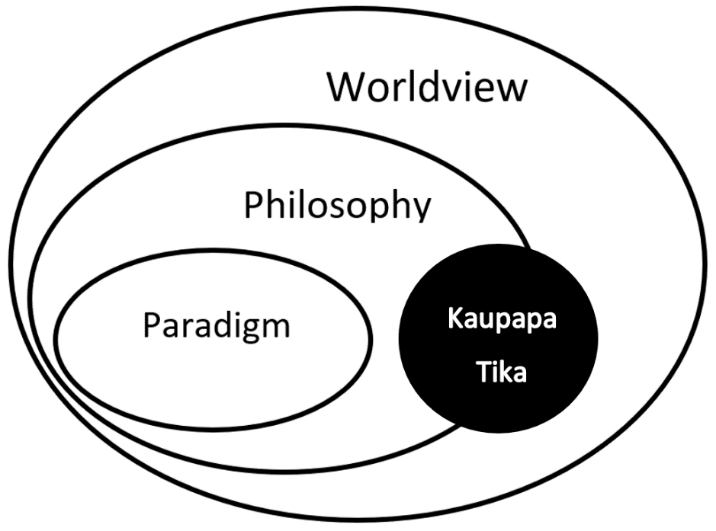

While the use of established paradigms can advance areas within a research discipline by collectively defining what problems are worth researching (ontology) and acceptable ways of doing so (Orlikoski & Baroudi, 1991), it has the potential to limit “… the type of problems studied, the use of research methods, and the possible research insights that can be obtained” (Chua, 1986, p. 602). Chua further elaborated on this by stating that “such limitations only become clear when they are exposed to the challenges of alternative world-views” (Chua, 1986, p. 602). Although Kaupapa Tika as a concept reflects my world view, the primary reason it was chosen as the underlying philosophy was dictated by the research itself.

An established paradigm within indigenous research is Kaupapa Māori, and while this research fulfils much of the criteria necessary to categorise this research within that paradigm, one of those principles (Taonga tuku iho) is problematic for this research.

Taonga tuku iho - the cultural aspirations principle: Kaupapa Māori theory asserts a position that to be Māori is normal and taken for granted.

While I acknowledge that this is an aspiration to ensure that neither researcher nor participants have to justify being Māori, it was problematic in this research because there was the possibility that participants who had grown up distanced from their iwi would find being categorised as Māori as neither normal nor something to be taken for granted. From my own personal experience, I know that there are Māori who work in IT that are disconnected from their iwi and hapū. They know they are Māori but have grown up exclusively in te ao Pākehā and are still trying to work out what being Māori means for them.

… assimilative practices by Māori were a “survival response” to historical trauma, which facilitated the internalisation of “negative views” of Māori ways of being. Hence, it cannot be assumed that those identifying as Māori will have an understanding of te reo Māori me ōna tikanga (Māori language and customs), or that that they will have access to knowledge of their whakapapa (genealogical) connections and subsequent associated bodies of knowledge.

As a result, the utilisation of te reo Māori me ōna tikanga in psychological practice may have the potential to facilitate a state of whakamā (embarrassment and/or sadness) in those who lack confidence in engaging with Māori practices, values and experiences. (McLachlan et al., 2017)

Using an approach based on the concept that being Māori is not only normal but can be taken for granted would risk ostracising those where this is not the case. While the use of an established paradigm would have eliminated the need for me to fully explain and justify my decision as to why I used Tika as a research philosophy and what this means in this research, a research paradigm is by design an all-or-nothing approach. The component parts of a research paradigm have been tested against each other to ensure that the output satisfies ontological, epistemological, methodological, and axiological demands. If one component does not fit and is therefore not used, then an alternative must be sought.

As with any world view or philosophy, it is impossible for the reader to dispute the researcher’s beliefs based on the content of those beliefs. The points of contention when discussing an individual’s research approach are whether the perspective created by the collective parts (ontology, epistemology, axiology, and methodology) can be used to logically reflect the researcher’s stated world view or philosophy. For a research philosophy, an additional requirement is whether collective knowledge is advanced as a direct result of this perspective (Guba & Lincoln, 1994).

As one who can whakapapa to two different cultures (and has interacted with many others during my lifetime), I have developed a personal world view that is the product of my continual internal interplay/war between te Ao Pākehā and te Ao Māori. Not only is this personal, but I know it to be unique because it is based on my individual experiences and struggles. A story I once heard resonated with me about the sometimes-uncomfortable struggle faced trying to reconcile these different parts:

An elder was talking with a child about emotions and the internal struggles they appeared to be facing. The child had been involved in a fight with another child and was not only angry about the fight, but also the unfair way they thought they were being treated.

The elder explained that inside each person were two wolves who continually fought to lead: one which hungers for love, and one for anger.

The child, having been defeated by someone full of anger and thinking that was what they needed to win, asked belligerently “Which one is stronger?”

The elder, who understood the question to mean “which one should I choose?”, replied “when they stop fighting and work together then they are strongest. Until then it is the one you feed the most”.

While the duality of love and anger portrayed by wolves cannot compare to the complexities found in conflicting cultures, I have found the concept of sustaining one part of the whole over another to be poignant in imagery and uncomfortably close in memory. I was raised in te ao Pākehā, and at that time te ao Māori was the subject of scorn rather than sustenance. Growing up I understood more English and Dutch because they were the languages my brothers and I were exposed to on a constant basis. I was only taught a few words of te reo Māori by my mother as she was not a proficient speaker and we lived in the South Island, far from my relatives in the North Island. My mother’s limited comprehension of te reo Māori can be directly attributed to deliberate discouragement by her parents and te reo Māori not being taught in schools. While te reo Māori was spoken at my mother’s home in her younger years, she and her siblings were actively discouraged from speaking te reo Māori for their own safety because she lived in a time in Aotearoa New Zealand’s history when speaking te reo at school (even accidentally) would result in state-directed corporal punishment. She still remembers vividly playing with her cousins on a break at school and someone getting highly enthusiastic and breaking into te reo Māori, only to be dragged off by a teacher and punished with the a cane or strap. Without the opportunity to use te reo Māori during her life, a majority of what my mother knew vanished to become a memory of a pre-gone era. While the language faded, what did not were the values she was taught as a child. The resolute nature in which she sought to sustain her values and identity was tested time and again by my Dutch grandmother who was less than complimentary of my mother’s (and our) Māori whakapapa.

Christchurch in the 1970s and 1980s was not a place renowned for its multi-culturalism, and while my Dutch grandmother did not quite fit the “stale, male and pale” stereotype typical of those in Christchurch at the time, the differences were gender rather than belief. Remembering fondly the intermittent moments I spent with my Dutch grandfather and extended family I met later in life while in the Netherlands, I am still baffled as to where and how her beliefs were built. While uncomfortable and something I would not wish on others, as stated earlier these experiences interlaced with memories of joy and laughter have influenced my personal world view and reinforce, for me, the unique outlook that I hold.

Although such a personal insight can be difficult to share, the importance of understanding and being able to explicitly state your world view, philosophy, or paradigm as it relates to your research cannot be understated. Self-reflection is a very important component of qualitative research and is one I will explore in greater detail in the section on data collection.

### Kaupapa Tika

I have named the research philosophy I have created for this research Kaupapa Tika, which translates as principles of being truthful, fair, or right. This is not intended as a carte blanche approach where everything I believe to be truthful, fair, or right is acceptable. Nor is it intended as a description of the only method that is right. Instead, it is a method that is right for me and is reliant on the adherence of underlying principles which I have used to guide my actions during this research, all with the knowledge that what I do will be subject to scrutiny and that I must be willing to explain why I have done things based on my underlying beliefs. In addition to the foundational concept of tikanga, the values of manaakitanga, wairuatanga, whanaungatanga, and tino rangatiratanga all form an important scaffold that binds this method together. The incorporation of these values is in line with the work of Jones et al, who investigated how tikanga guides and protects the research process (2006).

It should be noted that there are many contrary views on what tikanga and kawa mean, and how they relate. What is shared amongst different understandings is that collectively they encompass protocols and accepted ways of doing things relative to both time and place (Mead, 2003).

My understanding and application of tikanga as a world view and philosophy in this research are based on two heuristic principles:

* Identifying the right thing to do
* Once established, doing the right thing in the right way.

These principles have much in common with both ontological choices about what to research and epistemological concerns regarding truth and truth statements. However, limitations in the English language can be problematic when attempting to utilise a concept from another language.

… One’s understanding through te reo Māori is different from one obtained through the English language. (Mead, 2003, p. 2)

In essence, tikanga in this study is used as a moral and ethical heuristic (morals - deciding on what is right and ethics - actioning that decision in the right way) that governed what and how values were applied.

### The application of values

Manaakitanga, whanaungatanga, tino rangatiratanga and wairuatanga are important values in the formulation of kaupapa tika. They guide the actions of the researcher so that situations where participants could be made to feel whakamā are avoided, and an environment is constructed where ideas are freely discussed and can be developed organically in a co-creative manner.

Manaakitanga within this research was defined as “Hospitality, kindness, generosity, support – the process of showing respect, generosity and care for others”, and in the “interviewer/information/participant” triad, it elevated participant to the most important role. My mother told me what manaakitanga meant for her, and if you are familiar with Māori whaea (mother), what it should probably mean for me as well (if I know what is good for me). If a guest arrives at your home and you ask if they want a drink, then you are not being hospitable because you are not trying to anticipate their needs. Instead, you would offer them a selection to choose from and ask them which one they would prefer. To add more depth to that example, while this was done in a respectful manner, this was not always done as a show of kindness. In shared stories from the past, people who deliberately forgo nourishment and other forms of hospitality do so in preparation for war. If your guest indulged in some form of nourishment in a relaxed manner, then the chances of direct war were lessened, and further social clues were sought to discern the reason for the visit. In this way, manaakitanga is one method of discerning intent and is why it was important to ask “which would you like?” as opposed to “would you like?” regarding refreshments when I was interviewing people.

The aspect of whanaungatanga applicable to the interview process was in the building of “a relationship through shared experiences”. After creating a welcoming environment through manaakitanga, whanaungatanga dictated that I share nothing less than that which I was asking of them, that I demonstrate through the sharing of my stories (without privileging the content), and that I share their language and understand the environment in which they work. This also includes being honest about things I do not know and not making this into a competition – rather a conversation. Hence the goal of fostering an environment of co-creation of ideas.

Tino rangatiratanga (self-determination) was an important driver in the choice of unstructured interviews for this research. Unstructured interviews by design are interview techniques where participants are empowered to tell their story in a way of their choosing which does not privilege the language, ideas, or experiences of the researcher. By passing control of what is discussed, the participants are able to exercise tino rangatiratanga regarding what is discussed.

The way I have applied wairuatanga as a value of kaupapa tika in the methodology was as a means of elevating the importance of both participants and my physical and mental health. As an industry, IT can be quite stressful and, coupled with the low numbers of Māori working in IT, potentially isolating. Wairuatanga was bought to the fore to ensure that the physical and mental health of those I interviewed were safeguarded. This also included my own physical and mental health, since unstructured interviews can be both physically and mentally draining, so care is needed.

Whakamā (to be ashamed, shy, bashful, embarrassed) used in this context is to make the participant feel uncomfortable by doing any number of things which could result in them feeling they should not be there, or they do not want to be there. This can be done by either making people feel under-appreciated or putting people on a pedestal and making them feel like they do not deserve the attention they are getting. It is a fine line to walk, but by engaging in manaakitanga and providing a safe place through whanaungatanga where ideas can be shared on an equal basis, feelings of whakamā can be avoided.

### Reflexivity

Reflexivity is the process of self-reflection and is used by qualitative researchers to make constant comparisons between the data, the role of the researcher, and the influence the researcher brings to the research (Hennink et al., 2011). While it has been used as an integral component of different research theories and methodologies including grounded theory, ethnography, phenomenology and reflexive pragmatism, reflexivity is a general research tool that can be used to reduce personal bias in qualitative research (Carter & Little, 2007; Cope, 2005; Finlay, 2002; Holloway & Galvin, 2017; Ibegbulam, 2014; Myers & Tan, 2002). It is about positioning the researcher explicitly in the research project and effectively forcing the researcher to engage in a constant cycle of self-analysis regarding their role in the research and its outcomes (Holloway & Galvin, 2017).

From a positivistic philosophical perspective, researcher subjectivity is seen as a problem that needs to be mitigated and acknowledged as a limitation. However, reflexivity can have both positive and negative effects on research (Hanseth et al., 2001). The benefits commonly attributed to reflexivity in research include increases in rigour, credibility, accuracy, authenticity, confidence, and reliability (Alvesson, 2003; Gasson, 2004; Kornblith, 2012; Mills et al., 2006). Essentially reflexivity “… offers us a way to turn the problem of subjectivity in research into an opportunity” (Finlay, 1998, p. 453). Gasson further elaborated on the benefits of reflexivity by identifying that internal validity, rather than credibility or authenticity, was the major benefit, and the use of the term “internal validity” goes some way to describing the true benefits of reflexivity in qualitative research (2004). I initially found the abstract concept of internal validity difficult to grasp as a practical concept; specifically how does one go about using reflexivity to strengthen internal validity? The solution for me was to draw upon the conceptual architecture of database design. Databases, or software structures that store data, work and function because of internal validity or referential integrity and were created to quickly store and retrieve large quantities of information. Databases (non-OO) use tables to store data, with different tables being created to store different pieces of data. If we consider the example of a university, in their database they would have different tables for Students and Courses. Internal validity or referential integrity is achieved by linking the tables together to form relationships between the different pieces of data. These relationships would ensure that when a particular student is selected, we can be confident that the courses displayed match that student because some form of internal validation has occurred. The implications of this internal validation or relationship between the tables from an analytical perspective are profound, because deeper levels of analysis are now possible. Let us consider some examples of what would be possible if the Student and Course tables in our example were connected. After connecting these two tables it is possible to delve deeper into the data to discover things such as what is the average number of courses students are taking? What are the courses with the most number of students? What are the least popular courses? In a real university setting there would be many more tables than just these two and subsequently much deeper levels of analysis possible as the connections between the data points increase.

The correlation between the example given and my understanding is that reflexivity in qualitative research allows the researcher the opportunity to reflect on and form connections between their previous experiences and that which they are currently researching. By forming multiple connection points, levels of understanding and subsequent analysis can occur at deeper levels. A variety of different reflexivity techniques have been used to increase the chances of establishing multiple connection points, including research journals (Tsakissiris, 2015) and interview techniques for both conducting and analysing data (Brewer, 2000). Perhaps the most common use (but at a very abstract level) is an acknowledgement that the researcher is a part of the social world that is being studied, and this participation necessitates the need for exploration and self-examination (Alvesson, 2003). On a more prescriptive note, Finlay identified five different types of reflexivity that can be incorporated into qualitative research: introspection, intersubjective reflection, mutual collaboration, social critique, and discursive deconstruction (2002).

Introspective reflexivity is the process where the researcher analyses their own personal interests and experiences. By engaging in introspection, the researcher is better able to position themselves in the research and share an understanding, at the social and emotional levels, of the story shared by the participants (Finlay, 2002). This has the potential to position the research in such a way that the researcher is able to develop a deeper understanding of the data gathered, leading to additional insights (Holloway & Galvin, 2017). Problems can occur with this approach when the researcher loses perspective and unconsciously (or otherwise) changes the focus of the research from the participant’s stories to their own. When the researcher privileges their own personal story (including their own vocabulary) above that of their participants, there is the potential that they may block out “… the participant’s voice.” (Finlay, 2002, p. 215).

Intersubjective introspection focuses on the relationship between the researcher and participant. Specifically, this is an opportunity for the researcher to try to see through the eyes of the participants to see how the researcher and other environmental factors (e.g., location of interview, clothing, manner) can influence the research responses and subsequent research findings. As has been stated, empathy based on domain knowledge can be a powerful tool, enabling richer data to be gathered and more in-depth analysis to occur. However, dangers arise when the researcher influences the responses by privileging their knowledge, language and recollections during the interview process.

There is a degree of crossover between intersubjective reflection and social critique. However, while intersubjective reflection is about the importance the researcher attributes to their own personal experiences, social critique talks of actual power imbalances between the researcher and participants (Holloway & Galvin, 2017). The power imbalance can not only influence the responses of the participants but can influence the way data is used. Finlay identified an example where the researcher chose not to include some data gathered as the findings were speculative and based on stereotypical perceptions of a marginalised cultural group. Her reasoning was that the data gathered did not add any new findings but instead propagated existing stereotypes about a minority culture (2002).

Mutual collaboration is a way of bridging the problems experienced in social critique with power imbalances. Mutual collaboration is a built-in feature of several different methodologies including humanistic new paradigm and co-operative inquiry research where the goal is to enlist the participant as co-researchers. By utilising the participants’ capacity to be reflective, the researcher has the opportunity to include multiple voices and conflicting opinions in their research (Finlay, 2002).

Discursive deconstruction is linked to the language used to describe the research. It is acknowledged that meanings different from those intended may be drawn from the language used to describe the research findings. This is especially true when conducting research that spans multiple languages. An example used in this research is Whakawhanaungatanga. Whakawhanaungatanga translates as the “… process of establishing relationships, relating to other” (Moorfield, 2022). There are several similarities between reflexivity and whakawhanaungatanga, especially the relationships between people and ideas. Bishop’s book by the same name – *Whakawhanaungatanga: Collaborative research stories* – speaks to these similarities.

### Tikanga and Kawa

One of the compound structures in tikanga is tika which means to be right or correct (Moorfield, 2022); but what is right varies depending on both the situation and location (Mead, 2003). Tikanga is both an accepted way of doing things and a heuristic pattern to be followed when encountering things which are new. Different tribal regions or even different vocations (e.g., law or education) will have different views on what is tika and therefore, what is tikanga. If we compare tikanga to the concept of a research paradigm, at one level there are many similarities. A research paradigm is an accepted way of conducting research within a specific discipline; tikanga is an accepted way of doing things within a specific situation, location, and time. Where no accepted way exists then the heuristic principles detailed above are used.

This simplistic explanation does not convey the central position and importance that tikanga had and continues to have in te ao Māori. Mātauranga Māori is a more recent term, but also refers to Māori knowledge, and tikanga Māori was the means used to operationalise that knowledge. Mead (2003) stated that “Tikanga Māori might be described as Māori philosophy in practice and as the practical face of Māori knowledge” (p. 7). This practical application was enacted and mediated in a time and place where there were no laws to observe and no police to enact laws even if they did. What was and was not acceptable behaviour was determined and enacted communally through tikanga practice. An example of this could be seen in the following story:

In a Pā (village) lived a lady, and on her property was an apple tree. Each year the tree would bear fruit and her contribution to village life was to allow her neighbours to pick the fruit whenever they wished.

On the Pā one of the worst insults you can direct at an individual is to call them lazy. This kui (elderly woman) became known as one who asks for more than she gives so the community decided one year to not pick any apples from her tree. This communal decision and action let the kui know that her actions were not tika and that change was required.

While I have increased my understanding (and continued to do so), this explanation has been *built and evolved in the English language*. While this has made attaching the concept to the action difficult, I have come to understand that while I have found the word to be new, the concept was not. While I only learnt the te reo Māori word later in life, the values imparted by my mother resonated with what I discovered. In my youth and without the foundation of te reo Māori this was difficult to negotiate as my values differed significantly from my friends and I did not know why. I now realise that the problems I experienced were associated with the juxtaposition of using a language to explain behaviours and values that are fundamentally incompatible. There is no equivalent English word or phrase that equates to tikanga. Although there are some wonderful resources dedicated to understanding tikanga (see Mead, 2003), he makes no claims to being definitive or complete: “This book is but a preliminary exploration of tikanga Māori, an introduction” (Mead, 2003, p. 2).

From my own learning and attempts to understand tikanga, I now understand the inadequacies of trying to learn about a value not native to Pākehā understanding using the English language as an explanatory tool. Although I could find no other written accounts of those that had grown up with values associated with being Māori but without the language, I have had the opportunity to speak with other Māori who shared both a lack of te reo and similar values. Mead (2003) observed that those who natively speak te reo Māori have an advantage in comprehending and understand te ao Māori concepts such as tikanga: “Reo Māori participants usually have the advantage of prior knowledge and prior experience …” (Mead, 2003, p. 2).

What I have found is that unless those fluent in te reo Māori and who are immersed in te ao Māori have a specific reason to reflect on concepts such as tikanga, they are difficult to articulate because they are so intrinsically tied to what is done daily. They just are. As someone with little te reo Māori knowledge, I have found that experiences associated with age have afforded me a clarity I did not possess as a youth. Had I been immersed in te ao Māori and te reo Māori earlier in life, then this clarity may have happened earlier; but it is what it is. I do not blame nor begrudge my grandparents for not passing on te reo Māori to my mother, because it was done out of love. What knowledge my mother had, she willingly passed on to my brothers and me.

Thus, our beliefs were taught and reinforced in the home bubble and while the te reo terms were never used, in retrospect I now recognise the grounding I was given regarding rangatiratanga (self-determination), manaakitanga (hospitality), and tikanga (practical application of morals and ethics) – all of which I now understand to be values associated with Māori culture. Tikanga and kawa were particularly central in my life growing up. You do not sit on any surface where food could be served, you did not wear shoes inside. There was always something you did and there were always understandable reasons given that went beyond “because we have always done it that way”. They were understandable, made sense, and are things I continue to practice. There were a lot of kawa that my mother knew that we were not taught because we never had the opportunity to observe them e.g., protocols to be followed at a tangi. This was primarily because we lived so far away, we never had the opportunity to be involved in how things were done by members of our iwi, hapū, or at our marae. Looking back, while it felt right growing up with values that resonated, this was also a terribly confusing time in my life, as I neither knew the history nor names of what I was doing.

From an earlier time in my life, wanting to speak te reo Māori or even wanting to be identified as Māori were equivalent to actively choosing to fail. However, it was difficult for me to reconcile why I should adhere to the values I was taught when they were so different to those held by my friends. Without the basis in te reo Māori and the understanding that these values were not just my mother’s but were a product of intergenerational learning and practice, I did not feel grounded, and this led to more questions than answers. Throughout my life, however, I have continued to adhere to these values because they resonate with how I think and what I believe to be true and confirm to me the central place that tikanga holds; it is for these reasons that tikanga plays a central role in my life, my beliefs, and this research.

While tikanga underpins this research, it is useful (for clarity’s sake) to understand what this means and how this has been both expressed and operationalised in this research.

A research paradigm is a collection of different philosophical constructs designed to implicitly force the researcher to answer questions of who, what, where, why, when and how. The five Ws (and an H) are described as the building blocks of research and only after answering these interrogative words can research be considered complete. When explicitly answering these questions, you are informing others of:

* How you see the world
* What assumptions and information you have used to build your world view
* What you have done that confirms that you believe what you say you believe.

When attempting to understand another individual’s basic belief system, it is impossible to dispute whether someone believes something or not. To believe in something is to “… have confidence in the truth, the existence, or the reliability of something, although without absolute proof that one is right in doing so” (Houghton Mifflin Harcourt Publishing Company, 2002). This does not equate to right or wrong, merely belief or disbelief. Bertrand Russell’s teapot analogy is perhaps one of the most well-known excursions into belief systems. His premise is that there is a china teacup somewhere between Earth and Mars circling the sun in an elliptical manner. It is, however, too small to be seen (even by the most powerful of telescopes) and therefore cannot be falsified with current technology. Another example is Pastafarians who believe in the Flying Spaghetti Monster. Both based on philosophical ideas, what they propose as beliefs cannot be disputed by the statements and ideas, irrespective of whether others think they are true. The only thing that can be disputed are the believers’ actions and whether they contradict what they say they believe.

From a research perspective, the importance of not only understanding but articulating a research paradigm or world view is that it allows researchers and readers alike the tools necessary to understand the interpretation of the data gathered. When all the underlying concepts are linked and explained, the reader should feel confident that the researcher’s approach is logical and systematic, and should provide meaningful results. The only way to question a belief system such as a world view is to assess whether the perspective created by the collective parts (ontology, epistemology, axiology and methodology) can be used to logically reflect what the researchers tell us they believe, and whether collective knowledge is advanced as a direct result of this perspective (Guba & Lincoln, 1994).

## Identifying and recruiting participants

Recruiting participants was done in four different ways.

1. The first was via personal contacts and included Māori IT workers I either personally knew, had worked with, or had met while studying.
2. The next method was through contacts of these contacts (snowballing).
3. I presented at the ITx conference in Wellington, Aotearoa New Zealand, and asked in both my presentation and written abstract for participants.
4. As a spinoff from the conference, I was interviewed for the CIO magazine where I again made a request for participants.

I was able to gather participants through all these methods, and while personal contacts and subsequent snowballing of participants was by far the most successful, all avenues helped this research project reach a wide array of different Māori IT workers throughout Aotearoa New Zealand.

## Collecting data

The interviews took place intermittently over a period of 24 months, with most interviews taking place between September and December 2018. In total 23 scheduled interviews were conducted with 20 participants, 19 of whom were Māori and one Pasifika. There were participants I spoke with on a continual basis in non-formal settings (not recorded) throughout this research project. While some of the additional kōrero were set up to talk about the research, the majority were just about catch-up and talking about things other than this research. In these catchups, if there was anything raised that elicited more questions for either myself or the participant, these points were discussed, and clarification (if needed) was given. Participants were both sent and given copies of the information sheet and consent form (see Appendix A) to ensure that all information was known, and any questions could be answered prior to meeting if required. I was aware of the possibility that these areas of enquiry may be distressing to those being interviewed. To be confronted with questions of identity, especially for those that may have yet to reconcile conflicting cultural pressures, could be very difficult and was one of the main motivating factors for the selection of non-randomised research participants. It was hoped that recommendations through personal contacts will lessen any apprehension interviewees’ might have, and that my previous experience in IT will allow me to connect with participants in a deep and meaningful way and enable me to navigate these potentially difficult themes. As the research themes were provided to interviewees prior to the interviews, it was hoped that those with extreme levels of apprehension would choose to decline at that stage (although none did). Transcripts were made available as soon as transcriptions were completed and requests for corrections processed as received.

The sole Pasifika participant was included because I had spoken with them prior to finalising the research project and they had stated an interest in the subject matter. Their role as an initial pilot study participant was to determine if any identified problems or issues with the IT industry were specific to Māori or could be attributed more generally to others of minority status. They therefore volunteered to be involved in the pilot study, and while I did not include their findings in the research itself, the findings from that interview informed my interview agenda.

In this study there was one non-IT participant I consulted on several different occasions and at different times during this thesis process who had never worked in an IT position: my mother. She was an invaluable source of knowledge about my extended whānau, how tikanga, kawa, and whakapapa were conceptualised in my whānau and iwi, and my own formulation of culture and identity. From those interviews I was able to ascertain my own cultural starting points, find out more of her history, test any evolving ideas I had pertaining to Māori culture and identity, and self-reflect on concepts I thought I understood. Some of these themes were confronting and reminiscing with my mother about her youth demonstrated to me the distance we have come in such a short time. This also bought home to me the thin veneer covering what were darker times for Māori in our recent past and the sensitivity this subject matter required.

It should be noted that I deliberately did not assigned names to the vignettes and have not identified the quotes in this research as belonging to specific vignettes. The number of Māori in IT (especially wahine (women) is very small, and although slim, it may be possible that individuals could be identified from their comments, experience, and knowledge should some form of identification be used.

After the first exploratory interview I was able to redefine my areas of enquiry into three different categories (see Appendix Bfor the interview guide). The interview guide was designed prior to the interviews and example questions were created as a prompt should the need arise. While the objective was to explore all themes, ideas and concepts that arose in our kōrero (dialogue, conversations, discussions), this was not always possible because the direction taken was dependent on the direction chosen by the participant. During our kōrero I made efforts to introduce themes if they coincided with what was being discussed at the time. In addition to exploring these themes as standalone concepts, I was also interested in any relationship the participants may have observed between the themes, or any other areas that emerged during our kōrero. Irrespective of what I wanted to achieve; my main priority was to provide participants with the space they needed to tell their story.

It should be noted that I was always conscious of the time and frequently asked throughout the interviews if they were happy to continue, especially if our kōrero went over the allocated 60-90 minutes. As they had generously offered their time and they were all busy people, I never wanted to be the one to stop the interviews because of time pressures. Throughout the process I never scheduled more than one interview in either the morning or afternoon and stuck to a maximum of two interviews per day. Although this possibly made the process longer than it needed to be, I wanted to be able to give my complete attention to each participant without time pressures because of the added requirements for interviewers when conducting unstructured interviews (as will be discussed in the following section).

|  |  |  |  |  |  |
| --- | --- | --- | --- | --- | --- |
| Table 2.3 | |  |  |  |  |
| *Participant Breakdown* | |  |  |  |  |
| Interviewee No. | Occupational position/s * | Whakapapa | Age | No. of years’ experience | Caretaker\ Pathfinder\Trailmaker |
| P1 | Network Engineer \ database administration | Pasifika | 50-60 |  | N/A |
| P2 | Network Engineer \ Network Analyst \ Business Advisor \ IT Manager \ CEO | Māori | 50-60 | 35 | Trailmakers |
| P3 | Network Engineer \ Developer \ Business owner | Māori | 40-50 | 20 | Pathfinder |
| P4 | IT Educator | Māori | 40-50 | 10 | Pathfinder |
| P5 | IT Educator | Māori | 50-60 | 10 | Caretaker |
| P6 | IT Consultant | Māori | 20-30 | 4 | Caretaker |
| P7 | Network Engineer \ Network Analyst \ Business Owner | Māori | 50-60 | 35 | Caretaker |
| P8 | Infrastructure engineer \ network engineer \ Business owner | Māori | 30-40 | 10 | Trailmakers |
| P9 | Network Engineer \ Software Developer \ IT Manager | Māori | 40-50 | 30 | Trailmakers |
| P10 | Helpdesk | Māori | 30-40 | 10 | Caretaker |
| P11 | IT Educator | Māori | 50-60 | 20 | Caretaker |
| P12 | IT Account Manager | Māori | 20-30 | 3 | Trailmakers |
| P13 | Network Engineer | Māori | 20-30 | 5 | Pathfinder |
| P14 | Network Engineer | Māori | 20-30 | 5 | Pathfinder |
| P15 | IT Employment Consultant | Māori | 30-40 | 10 | Caretaker |
| P16 | IT Consultant | Māori | 20-30 | 2 | Trailmakers |
| P17 | IT Consultant | Māori | 20-30 | 2 | Trailmakers |
| P18 | Network Engineer \ Network Analyst \ Business owner | Māori | 40-50 | 35 | Pathfinder |
| P19 | IT Graduate role | Māori | 20-30 | 2 | Trailmakers |
| P20 | Non-IT worker | Māori | 70-80 | - | Pathfinder |

* The individuals interviewed were either currently employed or had held the following positions:

Table 2.4

*Breakdown of Participants (18) by Positions Held*

|  |  |  |
| --- | --- | --- |
| Positions held |  |  |
| 8 – Hardware (Network \ IT Engineers \ helpdesk) |  |  |
| 3 – Software (Software Developer) |  |  |
| 5 – Consultancy (Management \ Employment) |  |  |
| 8 – Management (IT Account Manager \ IT Manager \ Business Owner) |  |  |
| 3 – IT Educators |  |  |
| 5 – IT Graduate |  |  |
| Table 2.5  *Breakdown of Participants (18) by Age* |  |  |
| Age breakdown |  |  |
| 20 – 30 = 7 |  |  |
| 30 – 40 = 3 |  |  |
| 40 – 50 = 5 |  |  |
| 50 – 60 = 3 |  |  |
| Table 2.6:  *Breakdown of Participants (18) by Gender* |  |  |
| Gender breakdown |  |  |
| Male = 15 |  |  |
| Female = 3 |  |  |

Table 2.7

*Breakdown of Participants (18) by Age and Grouping*

|  |  |  |  |  |
| --- | --- | --- | --- | --- |
| Breakdown of participants (18) by grouping | | | | |
| Age | Total number of participants | Caretakers (6) | Pathfinders (5) | Trailmakers (7) |
| < 30 | 7 | 1 | 2 | 4 |
| 31–40 | 3 | 2 |  | 1 |
| 41–50 | 4 |  | 3 | 1 |
| 51 + | 4 | 3 |  | 1 |

Table 2.8

*Average Experience in IT (Years) per Grouping*

|  |  |  |  |
| --- | --- | --- | --- |
| Average Experience in IT (years) per grouping | | | |
|  | Caretakers (6) | Pathfinders (5) | Trailmakers (7) |
| Participants | 6 | 5 | 7 |
| Total experience (Years) | 89 | 75 | 87 |
| Average (Years) | 14.8 | 15 | 12.4 |

Table 2.9

*Breakdown of Experience in IT (years) per participant by grouping*

|  |  |  |  |  |  |
| --- | --- | --- | --- | --- | --- |
| Breakdown of Experience in IT (years) per participant by grouping | | | | | |
| Age | Number of participants | Caretakers (6) | Pathfinders (5) | Trailmakers (7) |
| <30 | 6 | 1 (4) | 2 (5 + 5) | 3 (3 + 2 + 2) |
| 31–40 | 3 | 2 (10 + 10) |  | 1 (10) |
| 41–50 | 4 |  | 3 (20 + 10 + 35) | 1 (30) |
| 51+ | 4 | 3 (10 + 35 + 20) |  | 1 (35) |

As age was not a question asked directly (although in some interviews it did come up), these groupings are approximate only and were created based on clues provided by the participants during the interviews, for example: “(50+) …when I got into IT a long time ago, so we’re going back to when I was 16, 17, so that’s … 35 years ago”.

### The interviews

Figure 3.2

*Interview Groupings*

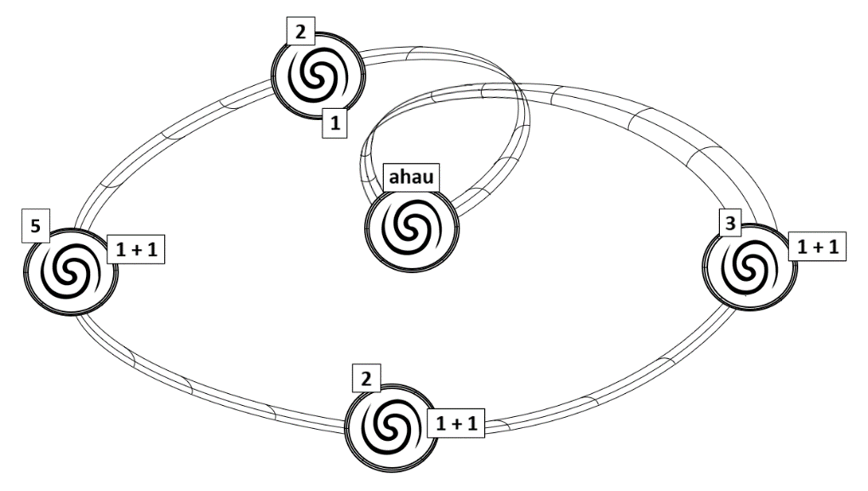

The interview process involved five different rounds of interviews, each represented by a double spiral inside a circle. The double spiral was used to symbolise the meeting of two equals and is representative of the kōrero or narrative praxis that underpinned the data gathering stage. Throughout the interviews there was a constant give-and-take as I actively participated and put some “skin in the game”, and by shifting my position during the interviews from an interviewer to a participant, this facilitated my aim of an environment of co-creation. While co-creation was very much the aim, the direction of the narrative was dictated by the participant and was driven by the value of Tino rangatiratanga; an integral component of Kaupapa Tika. Tino rangatiratanga is the value of self-determination and was enacted through the application of unstructured interviews where the topics of discussion were controlled by the participants of the research. By relinquishing control but contributing to what was discussed in the interviews, areas of enquiry and different experiences I had not otherwise considered were examined. This was neither easy nor fast as this area of research has been largely neglected and I found the potential scope to be both exciting and problematic at the same time. With so much to be researched, I really need to thank my supervisory team for their assistance and extreme patience while I settled on finalising my specific topic area and most importantly, my research question.

Each stage is symbolised by the double spiral indicating a cluster of interviews conducted closely together. Between each of these clusters was a span of time where transcribing and analysis could take place. The numbers atop each of the stages signify interviews conducted, with three separate positions of numbers indicating three separate conditions. The number at the top signifies interviews conducted with individual Māori IT workers during that stage. The number at the bottom of the stage show the number of interviews conducted with non-Māori IT workers (of which there was just the one). The numbers one plus one (1+1) signify instances when two participants were interviewed at the same time. More information on this is given in 3.4.2 when I discuss the process and learning I made when interviewing two participants at the same time.

The three lines connecting each stage represent three strands: (1) Analytical comparison – constant analysis was conducted on the information gathered, be it from theory, previous recalled experiences, participant interviews or supervisor feedback, (2) Self-reflection – throughout the process self-reflection was an integral part of the journey, since it was used to make constant comparisons between the data gathered, my role as a researcher, and the influence I brought to the research, and (3) Tikanga (correct procedure, plan, or practice) – this was to ensure that what was done was done for the right reasons, and then in the right way. An example of this was the gifting of pounamu to all participants. The explanation I gave in my ethics application was as follows:

While no enticement will be offered to garner participation, utu dictates that a balance be reached.

To return the interaction to a neutral state, the principles of utu require me to present a token in appreciation of the time they have freely given to provide me with information about their experiences and knowledge. As a Ngāi Tahu scholar, representative of Te Whare Wānanga o Waitaha and resident of Te Wai Pounamu, it is appropriate that this takes the form of pounamu (greenstone). Offering the pounamu at the end of the interview was also an effective way of closing the interview and ensuring that all participants (both the interviewee and I) left the discussion feeling uplifted. This typified my approach and made me constantly question if I was doing the right thing, and if so, was I doing it in the right way?

The transverse interconnections linking the three strands symbolise the constant interplay that occurred between the three strands throughout the interviews and later in the analysis stages of this research.

The first step was the stage labelled ahau (me) and was when I explored my own interests and experiences to determine the direction of this research project. The eventual decision to settle on the topic of how Māori working in IT can be enabled to thrive was an ongoing process that involved an interplay between the three lines described previously. One aspect which came to the fore during this process was an aspect of introspective reflexivity which included the desire to not lose perspective and start privileging my own experiences and memories of working in IT over those of the participants. This was quite an involved process and from this I developed an agenda which was then taken into the pilot interview.

The insider approach I took for this research closely resembles that of auto-ethnography as described by Hayano (1978). In his work, Hayano conceptualised a process where, instead of observing objectively from the outside, the researcher uses their position as an insider to gain deeper access and understanding when conducting research into their “own people” (Hayano, 1979, p. 99). Since that time, auto-ethnography has evolved and many examples of auto-ethnography in action typify research about self (Hughes & Pennington, 2018); akin to an ethnographic biography (Wolcott, 2004). This change in focus has given me pause to conceptualise this as auto-ethnographic research, so instead I have used the label “insider research” as the description of this approach (see Unluer, 2012) as this aligns better with what was done; to prioritise the co-created narrative through directed enquiry based on insider knowledge.

The pilot interview was with a Pasifika IT worker who was someone I met after starting my PhD journey but prior to solidifying what I was to study or my research agenda. The reason I wanted my first interview to be with a non-Māori IT worker was to see if the initial research agenda I had assembled identified problems faced by Māori specifically or were more general problems faced by others within the IT field. Additionally, I wanted to test my initial research agenda to see if the areas of enquiry made sense and if it was feasible to get through all the agenda themes within the hour specified in the consent form. I was also interested to see if any environmental factors (our kōrero was carried out at the participants place of work during work hours) played a part in how participants responded. Because we were at their place of work, would they be inhibited about what they said? If they were, what did that mean about future interviews – should I attempt to avoid conducting interviews at individuals’ places of work? Fortunately, this was not a problem but is an example of what I was consciously looking for. As with the initial first stage, I sought to ensure my perspective was not privileged over the participant’s voice.

The next two interviews in this stage were with Māori IT workers, both of whom were personal contacts. The first was someone I had worked with over a long period of time, and other than the chance to catch up I sought to double check my memories of working in IT to make sure I was not glossing over or had inadvertently forgotten anything of relevance. One thing I knew about this person was that if they did not agree with anything I said, they would let me know. Because of our history, at no time was I worried that my recollections or thoughts would influence their responses. Quite the contrary, I knew that any ideas I put forward would be discussed frankly and be a true reflection of what they believed to be true. This was also the case with the next participant and enabled me to put forward what I had discussed in previous interviews as a means of constantly checking the validity of any statements made.

At the beginning of each interview, I asked if the participants had any questions about the information sheet I had sent through and made sure they were aware of their rights as participants. I then asked again if they were happy if I recorded the interview. At that point I explained that the interviews were designed to be more of a conversation and that I had no formal questionnaire, all I was wanting to talk about was their journey and experiences of working in the IT industry. To break the ice and begin the kōrero I first asked, *“How did you get into IT?”* All subsequent questions were reactive and based on the direction participants chose.

The aim to continually check the validity of statements made continued throughout the different stages. This approach shares much with Boje’s conceptualisation of Self-Correcting Inductive Research, an emerging methodology based on narrative enquiry (Boje & Jørgensen, 2020; Boje & Rosile, 2022). Boje credits both Peirce and Popper in his methodology which seeks to continually test ideas/theories with a view towards the goal of refutation. While this is not intended as a review of this methodological approach, it is an acknowledgement that from a big picture process, continual testing and correcting is an important part of Kaupapa Tika and that like Self-Correcting Inductive research, Kaupapa Tika also draws inspiration from the work of Popper (see Appendix A).

While this process was rewarding from a research perspective, a lot of preparation work prior to each interview was required to ensure I kept on top of developing themes. Additionally, this level of engagement was exhausting and to keep going I had to be mindful of not only the wairua of the participants, but my own physical and mental health. By breaking the interviews into groups, I found I was able to sustain the effort needed to be entirely present during the interviews and be able to react to the quickly changing demands of unstructured interviews.

Since completing these interviews, I have had informal kōrero which reflect a second iteration of this model. In the second iteration I spoke with three different people again – the first being the same non-Māori participant that I spoke with in the first iteration, the second and third were with participants that contacted me to speak again and that I knew well. The interview with the non-Māori participant was the first to spark the second iteration and was at their request. After the first interview, a period of self-reflection had been initiated that they had previously not experienced, and they reached out to me as they wanted to talk about it and did not appear to have anyone else who knew what they were talking about. Interestingly, the second interview was more of a kōrero than the first interview that we had, like those I had experienced with Māori interviewees. While it could be that because we had spoken before, the relationship we had built enabled us to connect on a deeper level the second time, I believe it was the process of self-reflection that was the difference. This person was disconnected from their culture and had never reflected nor thought there was any relationship between IT and their Pasifika culture.

One of the most overwhelming feelings I got from participants was one of relief. Relief that participants could let their guard down (which many did not appear to know they had up), just talk about their journeys and unload with someone who understood and could empathise with their experiences. This was accompanied by an undercurrent of guilt that their issues were first-world problems or certainly higher up Maslow’s hierarchy of needs than many in their own whānau - whose problems centred on survival. This juxtaposition of feelings resulted in two general outcomes. Firstly, participants got a chance to tell their unique stories of how they grew up and how they got into their current position. Secondly, they were able to voice their frustrations about the IT industry and the various stakeholders that they were in a unique position to observe. I say unique position because one of the interesting aspects I found of working in IT (especially if in a support position) is that I was unconsciously treated as one of the invisible. I would be fixing someone’s computer and they would proceed with calls and conversations as if I were not there. The only time I was acknowledged was to see how long I would be. This gave me a special appreciation of what it must feel like to be either one of the cleaning or service staff – the invisible. Much like participants in this study, I was afforded additional insights that enabled me to see the different sides of not only the IT industry, but other industries associated with the jobs I have done in IT. This in-depth view offered me an opportunity to see and interact with many different stakeholders and see the effect their actions and decisions had on the IT workforce. Seeing these different actions and value systems at play affected all participants to different degrees depending on their connection to te ao Māori and te ao Pākehā, and to what degree they had engaged in self-reflection.

### Unstructured interviews

The decision to use unstructured interviews was an integral component of Kaupapa Tika and was driven by my wish to integrate this process with the value of tino rangatiratanga (self-determination). That the topics of discussion in the interviews would be directed by participants spoke of the need for participants to be able to tell their story in their way.

Although there is some debate as to how unstructured interviews are defined, there are some common characteristics which are generally agreed upon. These include no predefined theoretical framework upon which the interviews are based, and the need to generate questions in response to the narrative of participants (Zhang & Wildemuth, 2017). An agenda can be used to guide interviews but differs from a questionnaire in that the order of questions asked is determined by the direction of the participant’s narrative rather than any preconceived structure imposed by the interviewer.

Unstructured interviews are useful in instances where there is very little known about a particular phenomenon of interest and where the goal is to “gain an in-depth understanding of a particular phenomenon within a particular cultural context” (Zhang & Wildemuth, 2017, p. 246). As there is very little known about Māori IT workers, this approach was deemed the most appropriate; however, there are pitfalls which, unless negotiated, can reduce the effectiveness of this approach.

The role of the interviewer is very important in unstructured interviews, as they need to generate questions spontaneously in response to the participant’s narrative. For this to occur effectively, the interviewer needs to have a rich set of skills which include the ability to listen and rapidly generate questions and insights dependent on the developing narrative. Importantly, questions should be asked in such a way as to promote self-reflection and avoid imposing structure, interpretation, or judgement on situations. As a sympathetic listener and veteran of the same industry as the participants, I was able to approach both participants and the IT occupation with experience, knowledge, and a professional integrity which had them opening the door and – albeit with some initial apprehension or caution – engaging with me. This established an initial comfort level for engaging which an outsider to the industry may never have achieved. Some of the techniques I used included being prepared to be open, honest, and upfront about my experiences as a Māori in the IT occupation.

In all the interviews I had with those I had not met before; I could feel their apprehension at the beginning of the interviews and had to work quite hard to gain their trust. This was doubly so with multiple person interviews (discussed in the next section), and I could feel when we were able to get past this and start talking freely. Some of the methods I recognised as them testing me were when they injected swearing and humour into their stories. It should be noted that both swearing and humour are components of the way many of those I know in IT talk to each other (especially in the administration side). This is because the demarcation between those working in IT and users of IT is quite pronounced. Users of IT expect things to work and when they do not, want to know why they went wrong and to be assured that it was not their fault. IT workers need to remain calm and use defusing language to de-escalate situations because as the representative of IT, you need to appear as if you know what you are talking about. Those working in IT know that things always go wrong and often the reason it happened will never be known because of the complicated interactions between software and hardware needed to make computers work. Therefore, when IT people are together (especially in my experience) they swear and laugh a lot. I knew that as soon as that happen with my participants, trust was established, and the real sharing would start.

From what I had experienced in my field of study, swearing was definitely not a recommended interview technique, and humour is difficult (for some, impossible) to script into interviews and is therefore best avoided. By accepting and mirroring these behaviours, I immediately positioned myself as an insider and trust was gained. This should not be taken as a demeaning comment about uncivil behaviour or an observation about any perceived lack of intellect regarding vocabulary, just that working with computers can be incredibly frustrating and that it would be unhealthy if individuals were not given a safe space to vent when needed. In this research, it just meant that if they started to vent, then they saw our time together as a safe place.

The levels of trust established were necessary because although Māori are over-surveyed (Clark & Templeton, 2012), none of the participants had ever been asked about IT or Māori representation in the IT industry before. This includes being asked their opinion by those in either te ao Pākehā or te ao Māori. Instead, they were *subjected to* rather than being the *drivers of* any initiatives or policies established to get more Māori into IT. This was a topic that participants had thought deeply on and therefore the volume of data gathered in the (on average) 1.5-hour interviews was substantial. As the interviews were more narrative in style, on more than one occasion I had participants asking when we were going to start and what questions I wanted to ask. When I replied that we had already started, that this is how I was conducting the interviews, and that what we were already talking about the research topic, the atmosphere frequently changed. I could physically see the participants relax as we continued talking. In the initial round of interviews, over 28 hours of interview recordings were generated with the longest interview lasting over four hours.

### Interviewing two participants at the same time

Interviewing more than one person at a time was not a pre-set goal or strategy for this research. In so saying, interviewing two participants at the same time happened on three separate occasions at the insistence of interviewees, so by the end of the interview process was not unusual. Current literature on interview methods applies to one-on-one interviews or multiple participant interviews in the form of either group or focus group interviews, depending on the purpose of the research (Bryman & Bell, 2007; Pearson & Vossler, 2016). I could not find any literature or guidance on this so had to work it out as I went. Group interviews are typically group interaction situations where the participants are given a scenario and possibly roles, and the goal is to observe the group interactions to derive meaning. This differs from focus groups, which are about bringing together groups of individuals with a common attribute to discuss a specific topic. The benefit of focus groups is that the participants are allowed space to interact and self-reflect on their common experiences and delve deeper as they bounce ideas off each other. The role of the interviewer is that of guide and observer as the group interacts (Catterall & Maclaran, 1997; Litosseliti, 2007).

Where interviewing two people at the same time differs is that in principle it is the same as interviewing a single participant, except you as the interviewer are at a numerical disadvantage. This has implications on control and the type of interview you wish to conduct (i.e., structured, semi-structured, unstructured). The interviews I conducted were all unstructured and control of what was discussed within the overall topic was largely decided by the interviewees. The benefits of this approach can be a breaking down of barriers, since the topics of discussion can be, to a certain extent, controlled by the participants. By empowering participants to co-lead the discussion we were all, in effect, both interviewers and interviewees with participants also asking questions of me. Unstructured interviews of this nature, however, can be problematic as Zhang and Wildemuth noted (2017). Those party to a conversational or unstructured interview need to share control if it is going to be effective (Zhang & Wildemuth, 2017). Going into the interview at a numerical disadvantage presented more of a challenge than a normal unstructured interview; however, the co-creation narrative style encouraged a type of shared ownership of storytelling.

How these situations came about was in one of two ways. The first was when I arrived to interview one of the participants, and they told me that they knew and worked with someone else they had talked to and they were also interested, so as they were happy to be interviewed together - did I mind? Alternatively, when I was to interview multiple people at the same place (on different days), they mentioned that they were quite busy and would prefer if they could talk to me together to save time. In each of the cases, there was no good reason to say no, as the participants knew each other very well and were happy to proceed. Although I initially had some ethical misgivings, after explaining the process and risks they were more than happy to proceed. I always knew when going into these interviews that I would need to be flexible, since the people who had kindly offered to talk to me were all very busy, so my pushing back just because I had a predefined procedure felt wrong, and I intuitively just accepted it.

I suspected that part of the motivation was that they did not know me and were potentially unsure of what was to happen, so wanted someone else there that they could trust. By doing this they could talk together later to make sure neither had any misgivings about the topics discussed or the process taken. The reason I suspected this was because it is something I would have done. I may be projecting as this was never discussed in this way but is certainly feasible, especially considering Māori have more often been the subject rather than the controllers of research. Additionally, all the multiple person interviews involved participants I had never met before and all they knew of me was what I had sent and any email or voice correspondence we had prior to the interview.

## Analysing the narratives

Both positive and negative consequence of using unstructured interviews as a data gathering technique is the volume of data gathered. With no interviews lasting less than one hour and two of the interviews lasting more than three, breadth and depth of data was not a problem.

Analysis of the data was a continuous and ongoing feature of this research. Between stages the interviews were transcribed, and different types of analysis were used including both computational (NVivo) and manual (rereading transcripts and using line-by-line analysis). Additionally, I relistened to interviews to reground myself and put myself back into the moment. As the interview stages progressed, the emerging themes evolved with successive interviews, allowing me to explore these themes one by one.

Although the labels given to the core values identified originally came from either participant’s (i.e., whanaungatanga, manaakitanga, wairuatanga) or literary sources (i.e., auahatanga) during the interview phase, not all participants used these terms when describing what they valued. In my initial thematic passes of the data, the search for specific words describing shared values yielded no conclusive results yet I knew from ongoing analysis of the data that there were similarities in what was valued by participants irrespective of connection to te ao Māori or understanding of te reo Māori. It was not until I combined the descriptions of Māori workplace values and the findings of this study that the connection became apparent. While the names of the values may have differed, how those values were enacted was consistent and after thematic sorting based on specific criteria e.g., similar core values, were discovered.

It should be noted that the use of te reo Māori terms in this research was not done to privilege te reo Māori over English, project my values onto those of participants, or to emphasise that this is Māori focused research. I used te reo Māori terms to describe the values encountered because of my desire to be both concise and accurate. What I found was that the values described by participants (either specified directly or correlated by content) related more concisely and accurately to concepts in te reo Māori than English. There were no equivalent values in English that I could find (or had been used by participants) that integrated concepts with action such as whanaungatanga, manaakitanga, wairuatanga, or auahatanga. An important observation mentioned in the interviews by participants was a contempt for “lip service” - insincere statements with no co-relation between words and actions. This is not possible if Māori values are applied correctly as the suffix -tanga (i.e., whanaunga**tanga**, manaaki**tanga**, wairua**tanga**, and auaha**tanga**) changes these from ideas into actions, or more accurately from verbs into derived nouns (Moorfield, 2022). If they are not actioned then they are not being observed and this idea was important to participants e.g., saying that integrity is important is only truthful if it is coupled with ongoing actions that demonstrate that this is true. Tā Apirana Ngata observed that abstraction and generalisation were not components of the te ao Māori, nor expressed in te reo Māori (Ngata, 1928). It is my opinion that this is the reason that values within a te ao Māori framework are not aspirational; they are lived and importantly, they are testable. It is because of this that the correlation between Popper’s scientific method (with a focus of refutation - see Appendix A) and the abstract concept of values becomes apparent, and why I see the use of te reo Māori to describe what was valued by participants as more concise and accurate.

This was the same with tikanga as a concept, although an additional problem when applying tikanga as an interpersonal tool for value evaluation and application is that tikanga and kawa do not have single, universal meanings within te ao Māori. It is accepted that different iwi may have different ways of separating the combined definitions of tikanga and kawa (Mead, 2003). There is no requirement or expectation that there will be a single unified definition for tikanga and kawa and it is my interpretation of tikanga and kawa that will be used as containers to describe the actions of participants.

## Conclusion

The methodological approach and implementation of Kaupapa Tika was guided by the values of manaakitanga, wairuatanga, whanaungatanga, and tino rangatiratanga, and underpinned by the moral and ethical guidance inherently built into tikanga. By constantly referring to these guiding and foundational values and principles, space was provided for participants to tell their stories in their time and in their way.

# References

Alvesson, M. (2003). Beyond Neopositivists, Romantics, and Localists: A Reflexive Approach to Interviews in Organizational Research. *Academy of Management Review*, *28*(1), 13–33.

Barnes, H. M. (2000). Kaupapa Māori : explaining the ordinary. *Pacific Health Dialog*, *7*(1), 13–16.

Bhabha, H. K. (1995). Cultural diversity and cultural differences. In *The Post-Colonial Studies Reader* (pp. 206–209).

Boje, D. M., & Jørgensen, K. M. (2020). A “Storytelling Science” Approach Making the Eco-Business Modelling Turn. *Journal of Business Models*, *8*(3), 9–26.

Boje, D. M., & Rosile, G. A. (2022). The Storytelling Science Paradigm: Evoking the Transformative Power of Indigenous Ontological Antenarratives in Curious Conversation. In *Research in Ethical Issues in Organizations* (Vol. 25, pp. 15–42).

Brewer, J. (2000). *Ethnography* (A. Bryman (ed.)). Open University Press.

Brockbank, T. (2020). *Top tips: Te reo words you should use in the workplace*. Association of Consulting and Engineering. https://www.acenz.org.nz/10_m_ori_words_every_consultant_or_engineer_should_know

Bryman, A., & Bell, E. (2007). *Business Research Methods* (2nd ed.). Oxford University Press.

Bunge, M. (2010). Philosophy as Worldview. In *Matter and Mind. Boston Studies in the Philosophy of Science*. Springer, Dordrecht.

Carter, S. M., & Little, M. (2007). Justifying Knowledge, Justifying Method, Taking Action: Epistemologies, Methodologies, and Methods in Qualitative Research. *Qualitative Health Research*, *17*(10), 1316–1328.

Catterall, M., & Maclaran, P. (1997). Focus Group Data and Qualitative Analysis Programs: Coding the Moving Picture as Well as the Snapshots. *Sociological Research Online*, *2*(1).

Chen, W., & Hirschheim, R. (2004). A paradigmatic and methodological examination of information systems research from 1991 to 2001. *Information Systems Journal*, *14*, 197–235.

Chua, W. (1986). Radical Development in Accounting Thought. *The Accounting Review*, *61*(4), 601–632.

Clark, R. G., & Templeton, R. (2012). *Sampling the Maori Population using Proxy Screening, the Electoral Roll and Disproportionate Sampling in the New Zealand Health Survey* (No. 17; 10-12).

Cope, J. (2005). Researching Entrepreneurship through Phenomenological Inquiry: Philosophical and Methodological Issues. *International Small Business Journal*, *23*(2), 163–189.

Finlay, L. (1998). Reflexivity: an essential component for all research? *British Journal of Occupational Therapy*, *61*(10), 453–456.

Finlay, L. (2002). Negotiating the Swamp: The Opportunity and Challenge of Reflexivity in Research Practice. *Qualitative Research*, *2*(2), 209–230.

Gasson, S. (2004). Rigor in Grounded Theory Research: An Interpretive Perspective on Generating Theory From Qualitative Field Studies. In *The Handbook of Information Systems Research* (pp. 79–102).

Guba, E. G., & Lincoln, Y. S. (1994). Competing paradigms in qualitative research. In N. K. Denzin & Y. S. Lincoln (Eds.), *Handbook of qualitative research* (pp. 105–117). Sage.

Guzman, I. R., Stam, K. R., & Stanton, J. M. (2008). The Occupational Culture of IS/IT Personnel within Organizations. *ACM SIGMIS Database*, *39*(1), 33.

Guzman, I. R., & Stanton, J. M. (2009). IT occupational culture: the cultural fit and commitment of new information technologists. *Information Technology & People*, *22*(2), 157–187.

Hanseth, O., Braa, K., & Ciborra, C. (2001). The control devolution: ERP and the side effects of globalisation. *The Database for Advances in Information Systems*, *32*(4), 34–46.

Hart, M. A. (2010). Indigenous Worldviews, Knowledge, and Research: The Development of an Indigenous Research Paradigm. *Journal of Indigenous Voices in Social Work*, *1*(1), 1–16.

Hayano, D. M. (1979). Auto-Ethnography: Paradigms, Problems, and Prospects. *Human Organisation*, *38*(1), 99–104.

Hennink, M., Hutter, I., & Bailey, A. (2011). *Qualitative research methods*. Sage Publications Ltd.

Holloway, I., & Galvin, K. (2017). *Qualitative Research in Nursing and Healthcare* (Fourth). John Wiley & Sons, Inc.

Houghton Miffin Harcourt Publishing Company. (2002). *Beleive*. Dictionary.Com.

Hughes, S. A., & Pennington, J. L. (2018). Autoethnography Introduction and Overview. *Autoethnography: Process, Product, and Possibility for Critical Social Research*, 4–33.

Ibegbulam, E. E. (2014). *The Under-representation of Women in IT: A Participatory Research Approach Assessment of 14-Year Olds’ Perceptions of IT/ICT as a School Subject and Possible Future Career.* University of Sussex.

Jones, R., Crengle, S., & McCreanor, T. (2006). How tikanga guides and protects the research process: Insights from the Hauora Tane project. *Social Policy Journal of New Zealand*, *29*, 60–77.

Kaarst-Brown, M., & Guzman, I. R. (2005). Who is the “IT workforce”?: Challenges facing policy makers, educators, management, and research. *SIGMIS-CPR*, 1–8.

Kornblith, H. (2012). *On Reflection*. Oxford University Press.

Kuhn, T. S. (1970). The structure of scientific revolutions. In *The Structure of Scientific Revolutions: Vol. II* (Second Edi, Issue 2). https://doi.org/10.4324/9781912281589

Litosseliti, L. (2007). *Using focus groups in research* (Third). Continum.

McLachlan, A. D., Wirihana, R., & Huriwai, T. (2017). Whai tikanga: The application of a culturally relevant value centred approach. *New Zealand Journal of Psychology*, *46*(3), 46–54.

Mead, H. M. (2003). *Tikanga Māori: Living by Māori Values*. Huia Publishers.

Merritt, D. (2017). Gravity: The Popper Problem. *Institute of Arts and Ideas*, *59*.

Mills, J., Bonner, A., & Francis, K. (2006). The Development of Constructivist Grounded Theory. *International Journal of Qualitative Methods*, *5*(1), 1–10.

Moorfield, J. C. (2022). *Te Aka Maori Dictionary*. https://maoridictionary.co.nz/

Myers, M., & Tan, F. B. (2002). Beyond Models of National Culture in Information Systems Research. *Journal of Global Information Management*, *10*(2), 24–32.

Ngata, A. T. (1928). Anthropology and the government of native races in the Pacific. *The Australasian Journal of Psychology and Philosophy*, *6*(1), 1–14.

Orlikoski, W., & Baroudi, J. (1991). Studying Information Technology in Organizations: Research Approaches and Assumptions. *Information Systems Research*, *2*(1), 1–28.

Pearson, D., & Vossler, A. (2016). Methodological issues in focus group research: The example of investigating counsellors’ experiences of working with same-sex couples. *Counselling Psychology Review*, *31*(1), 8–16.

Tsakissiris, J. (2015). *The Role of Professional Identity & Self - Interest in Career Choices in the Emerging ICT Workforce*. *December*.

Unluer, S. (2012). Being an insider researcher. *The Qualitative Report*, *17*(58), 1–14.

Wall, M. (1997). Stereotypical Constructions of the Māori “Race” in the Media. *New Zealand Geographer*, *53*(2), 40–45.

Wolcott, H. F. (2004). The Ethnographic Autobiography. *Auto/Biography*, *12*(2), 93–106.

Zhang, Y., & Wildemuth, B. M. (2017). Unstructured Interviews. In B. Wildemuth (Ed.), *Applications of Social Research Methods to Questions in Information and Library Science* (Second Edi, pp. 239–247). Libraries Unlimited.

# Appendices

## Appendix A: Popper’s Scientific Method

The scientific method described here is based on the works of Karl Popper. In particular the notes created from a series of lectures given by Karl Popper at the University of Otago in May 22-26, 1945, titled Principles of Scientific Method .

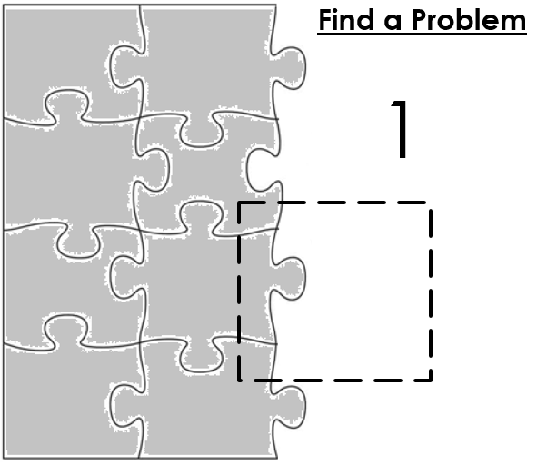The first step is to find a problem based on Frame and Perception (Figure 1). In Popper’s view, problems or new problems were the most important thing, in fact far more important that the solutions proposed.

Figure : Scientific Approach (Step 1)

Once a problem is identified, the second step is to propose a hypothesis or proposition outlining an approach to explain the problem with a view toward predicting future outcomes (Figure 2).

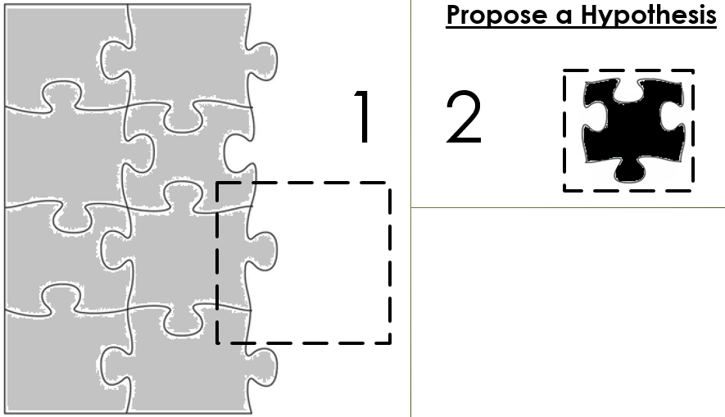

Figure : Scientific Approach (Step 2)

An important feature of a hypothesis is that it must be precise enough to be testable and ultimately falsifiable.

Hypothesis testing, or scientific enquiry then takes place (Figure 3) with methods of testing which include examples such as Galileo’s thought arguments about gravity, blind taste tests and medical trails. The aim of hypothesis testing is not to prove, but rather to disprove or falsify the hypothesis or proposition. Criteria are set prior to testing and are used to establish when a theory is considered falsified or not. This is more commonly referred to as criterion demarcation and includes attributes such as control groups and at least three rounds of testing. If these tests cannot falsify the hypothesis, then it can be developed into a theory.

Figure : Scientific Approach (Step 3)

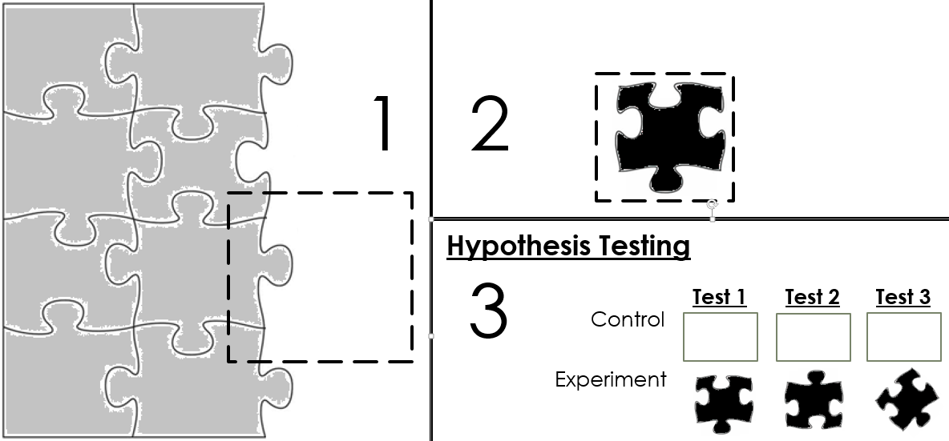

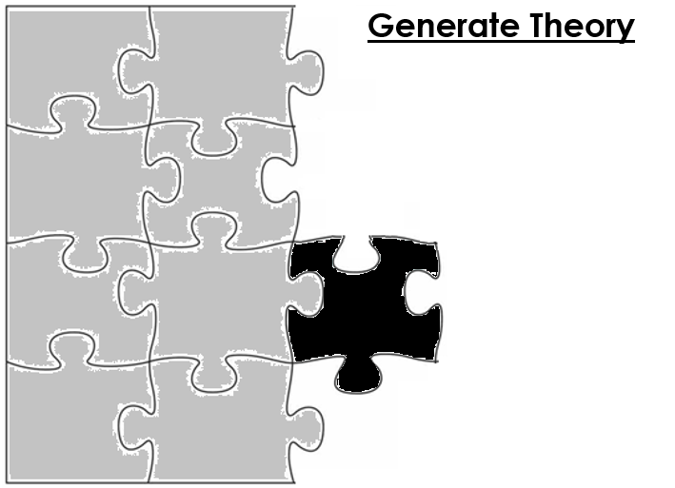The role of theory is to expand on what is currently unable to be falsified in an effort to explain and / or predict some phenomenon or behaviour (Figure 4).

Figure : Scientific Approach (Step 4)

If we focus on the need to falsify then the reason that methodology plays such a pivotal role in scientific enquiry becomes evident. If the goal is to truly refute theories then it becomes necessary to be able to retest to see if the same outcome can be replicated. If so, then other approaches can be undertaken to see if the theory can be falsified (Figure 5).







Figure : Constant Checking for Theory Falsification

If a theory can be falsified (Figure 6), then Popper’s advice is to dispose of the refuted theory and create a new hypothesis that may work with the new knowledge gained. Therefore, for Popper, problems are more important than the theories proposed to solve them because if we have no attachment to theories, then it is easy to dispose of these refuted theories and hypothesize anew.

Figure 6: Falsified Theory



While it is not uncommon for theories to be altered to account for small anomalies, if for any reason a refuted theory is not rejected but altered to account for large anomalies (to the point where it cannot be refuted), it then falls into Popper’s category of ad-hocery or pseudo-science (Figure 7). In these instances, auxiliary hypothesis need to be generated to account for these anomalies.

Figure 7: Ad-Hoc Addition to Theory

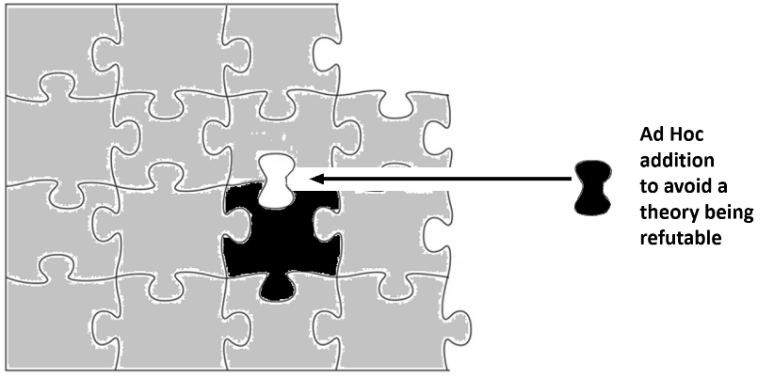

While it may seem reasonable when presented with a strong theory to create ad hoc or auxiliary hypothesis to account for minor outliers or anomalies, Popper established strict criteria in which this could happen. In Meritt’s view, the two most important were:

“…(i) the modified theory must contain ***more content*** than the theory it replaces: that is, it must make some new, testable predictions; and

(ii) at least some of the new predictions should be verified: the more unlikely a prediction in the light of the ***original*** theory, the stronger the corroboration of the ***modified*** theory when the prediction is shown to be correct.” (Merritt, 2017)

It should be noted that for an ad hoc or auxiliary hypothesis to be acceptable, it still needs to be falsifiable, and therefore refutable. Popper argued that the explanatory power of Marxism and psychanalysis lacked the ability to predict outcomes as they account for all behaviours and as they were untestable, they could therefore be classified as unscientific.

One of the driving forces behind Popper’s conceptualisation of a correct scientific approach and the subsequent formulation of his philosophy were his interactions with the philosophies of Marx, Freud, and Adler, and his attendance in Vienna at Albert Einstein’s lecture on relativity theory. In Einstein he saw a theorist who was more interested in the problem than his theory: Einstein was prepared to abandon his theory of general relativity if the results of a solar eclipse in 1914 did not conform with his hypothetical predictions. The critical spirit Popper found in Einstein was in direct opposition to that which he found in the works of Marx, Freud and Adler and proved fundamentally important in his subsequent philosophies.

## Appendix B: Interview guide

(1) Background Information

How did you get into IT?

Tell me about your current job?

What other IT roles have you held?

What other jobs have you done?

What other companies have you worked for?

(2) Personal Culture (Cultural influences predominantly outside of the workplace).

Where did you grow up?

What school did you go to?

After finishing school did you do any courses or study?

Any study in IT?

Tell me about your whānau/family, hapū, iwi?

Do you live close to your whānau/family?

(3) Worker Culture (What do you bring to the workplace and how this is manifested?)

What does it mean to be Māori in your place of work?

Have you had to change how you normally act outside of work to fit in at work?

What keeps you busy outside of work?

(4) Organisational Culture (How the workplace supports your personal and worker culture)

Does your organisation embrace Māori workplace values?

If so, how?

What, if any, Māori values are incorporated into your current workplace?

What, if any, Māori values are incorporated into your department?

Have you noticed any Māori values that have been incorporated into the business since you started?

Were you able to influence any changes of values at your place of work?

Have you worked anywhere where you felt that the workplace values reflected your personal values?

Tell me about it?

Are there any other Māori working there?

What do they do?

Do you know of any Māori that have worked there in the past?

Do you know what their roles were?

Have things changed since they left?

Have your values changed since you started working in IT?

Has the technology you use influenced what you value in the workplace?

Do your values differ from your workmates?