Practicing self-corrective inquiry through the storytelling diamond: the phenomenological applications of Karl Popper’s deductive falsificationist epistemology to antenarrative qualia
Andani Thakhathi
Chief Research Officer, Transcendent Development Ubuntuversity, Department of Knowledge Creation and Advancement, Universal Dignity Unit, Faculty of Ubuntu African Humanism, Transcendent Development (Pty) Ltd, Enterprise K201510799, Pretoria Region, City of Tshwane, Gauteng Province, South Africa, 0083
at.research@pm.me
Received 12 September 2021
Revised Day Month Year
This chapter elucidates the science of business storytelling uniquely applied through the prism of Rosile and colleagues’ Storytelling Diamond. It draws on a nascent study of business venture creation for poverty eradication in an Indigenous South African setting. It is one of the first qualitative single-case studies – to the knowledge of the author as at the writing of this chapter – to apply self-correcting storytelling science using Karl Popper’s deductive falsificationist epistemology. The chapter begins by explicating the newly emerging fourth-wave relational ontology then proceeds to demonstrate the practical applications thereof drawing on this landmark sustainable development study.

Keywords: Antenarratives; Storytelling Diamond; Qualitative Research; Single-Case Study; Falsification Epistemology; Karl Popper; Self-Correcting Abduction; Ubuntu Ontology; Sustainable Development; Poverty Eradication.

Theoretical Foundation

Storytelling Paradigm
A research paradigm is a knowledge claim that consists of “certain assumptions about what the researcher will learn during the inquiry and how she or he will learn [it]” (Bloomberg & Volpe, 2016: 105). The research paradigm can also be referred to as the philosophical worldview which informs the research’s design and methods. In line with the storytelling research approach taken in this Encyclopedia of Business Storytelling, a paradigm is defined “as the confluence of theory, method, and practice” (Rosile, Boje, Carlon, Downs & Saylors, 2013: 558). In this sense, a research paradigm consists of four philosophical assumptions which have an influence on the research design, namely, the research’s epistemology, ontology, axiology, and methodology (Bloomberg & Volpe, 2016).

Ontological assumptions inform the researcher’s understanding of the nature of reality. Epistemological assumptions are concerned with how this reality comes to be known and prescribes specific methods through which this knowledge can be acquired, ranging from empirical observation expressed in categorical numbers to phenomenological narratives apprehended through conversational inquiry. These methodological techniques operationalize the inquiry by stipulating data gathering, processing and analysis techniques which ultimately inform the research’s conclusions. Axiological assumptions are those subjective values, beliefs and viewpoints which characterize the researcher’s disposition thereby coloring the researcher’s perspective. As such, axiological assumptions have an impact on the interpretation of the data and the degree to which inferences can be drawn from the final analysis of the data collected (Rosile et al., 2013).

Qualitative research is often associated with the interpretivist paradigm and social constructivism (Chowdhury, 2014; Boje & Rosile, 2019). However, while social constructivism has proven useful for qualitative social science projects (Bloomberg & Volpe, 2016), it can be vulnerable to the inductive fallacy which reduces knowledge to over-contextualized subjective observations (Boje & Rosile, 2019). As a remedy to the inductive fallacy, Boje (2018a) and Boje and Rosile (2019) introduce the “ontological turn” which is a paradigm shift in theory, method and praxis away from fallacious crude induction towards “Storytelling Science” which pursues “truth” by approximating thereto through reflexive self-correcting theorizing (Popper, 2005).

According to Boje and Rosile (2019: 11), storytelling science “is self-critical, and self-reflexive about the metaphysics of its own assumptions”. In other words, storytelling science is concerned with generating knowledge that solves problems through positing increasingly better explanations about the phenomenon in question (Deutsch, 1997). Given its philosophical inclusivity, how can the fourth wave of grounded theory be actualized by applied researchers in practice and those within the academy at the post-graduate and post-doctoral phases of study? One landmark solution proposed in this chapter is the antenarrative storytelling diamond introduced by Rosile et al. (2013) as discussed next.

Storytelling Diamond
Rosile et al. (2013) developed the storytelling diamond; a model that maps out storytelling’s paradigmatic terrain in terms of its ontological, epistemological, and methodological considerations. The diamond is pragmatic in that it demonstrates how storytelling science work can be achieved in social research whenever there is a need for the gap between social causes and effects to be bridged. The authors developed the model in order “to provide specific paradigmatic guidance to those interested in designing storytelling research” by so helping researchers to choose the best yet coherently robust research design for the research problem being addressed or the exploratory inquiry at hand (Rosile et al., 2013: 558).

In a nutshell, the storytelling diamond enables researchers to “discern clearly differentiated paradigms that represent alternative worldviews and basic beliefs about the narrated nature of the world (ontology), narrative knowledge (epistemology), and narrative inquiry (methodology)” (Rosile et al., 2013: 565–567). In the storytelling diamond, there are four main paradigms of storytelling research design as is depicted in Figure 1.1. These four main paradigms are the “materialist”, “interpretivist”, “abstractionist”, and “practice” paradigms which are linked to both “narrativist” and “living story” storytelling through the mediating “antenarrative process” indicated by the double-headed arrows in Figure 1.1.

Figure 1.1: The storytelling diamond model
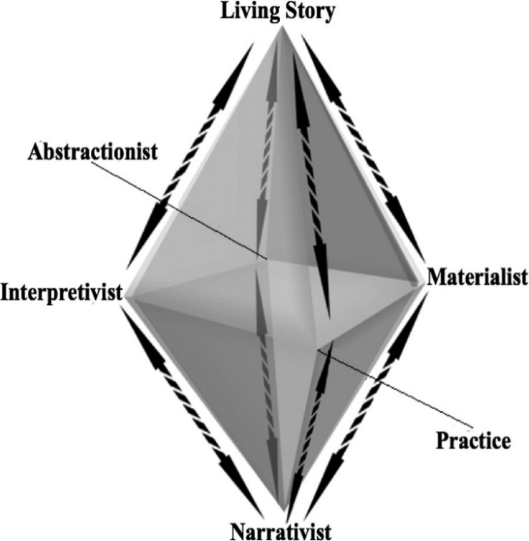
Source: Rosile et al. (2013: 559)

Figure 1.1 shows that there are eight double-headed arrows which connect the four paradigms to the top and the bottom of the storytelling diamond. These arrows represent antenarrative processes which link the different paradigms to the “narrativist” and “living story” orientation to storytelling (Rosile et al., 2013). To understand how antenarratives accomplish this linking, it is important to clarify the concept of “antenarratives” in greater depth before discussing the value of the diamond to contemporary research.

Conceptualizing Antenarratives
“Antenarrative” is a term with a double-meaning. In one sense “ante” means “before” as in “prior to”, and in another sense “ante” refers to “a bet” or “a gamble” as expressed in the common saying “up the ante” (Cambridge Dictionary, 2019a). The term “antenarrative” refers to the space “prior” to the crystallization of narrative cohesion and a “bet” on shaping the future that is prospective-sensemaking (Boje, Haley & Saylors, 2016). The term was invented by Boje (2001: 1) who introduced it as follows:

“Traditionally story has been viewed as less than narrative. Narrative requires plot, as well as coherence. To narrative theory, story is folksy, without emplotment, a simple telling of chronology. I propose ‘antenarrative.’ Antenarrative is the fragmented, non-linear, incoherent, collective, unplotted and prenarrative speculation, a bet”.

Boje (2001) developed antenarrative theory in response to the empirical conditions of the post-modern organization which is fraught with competing sub-cultures, change and complexity giving rise to stories which are composed of many “polyphonic” and oft “fragmented” voices that are collectively produced. Since then, antenarratology adoption by leading researchers in impactful organizational studies publications has grown (Vaara & Tienari, 2011; Humle & Pedersen, 2015; Vaara, Sonenshein & Boje, 2016).

Such storytelling inquiry has also been applied to the entrepreneurship domain and has been found to be valuable for understanding contemporary entrepreneurial behavior, especially the relationship between antenarratives and the exploitation of entrepreneurial opportunities by entrepreneurs (Garud & Giuliani, 2013; Saylors, Boje & Mueller, 2014). More recently, Boje and Rosile (2019: 36) have further developed the idea of antenarratives by distinguishing between the traditional “narrativist” and emergent “living story” perspectives by clarifying that “a ‘living story’ is an ‘Indigenous Way of Knowing’ (IWOK)” whereas a “narritivist” approach relies on “a ‘Western Way of Knowing’ (WWOK) a linear chronology of events, and is not a ‘living story.’ IWOK and WWOK are two [distinct] kinds of storytelling science.”

Hence, antenarrative processes link the four paradigms depicted in Figure 1.1’s storytelling diamond to both the “narrativist” and “living story” orientations in four distinct ways, giving rise to four resultant antenarrative types. These four antenarratives are “linear”, “cyclic”, “spiral”, and “rhizomatic-assemblage” antenarratives (Boje, 2018b). Another useful way of clarifying this catalytic role played by antenarratives in storytelling research was articulated by Rosile et al. (2013: 559) in the following statement:

“Storytelling is defined as the intraplay of grand (master) narratives (epistemic or empiric) with living stories (their ontological webs of relations). Antenarratives make a process connection between narratives and living stories … This definition of story allows for the study of elite narratives that permeate organizations as well as those that are hidden. It also includes the study of marginalized living stories, thus recognizing and giving voice to the voiceless”.

By forging a bridge between present-day “living stories” and the broader “grand linear narratives”, the antenarrative process enables storytelling research to analyze organizational stories from any of the four paradigms depending on the research purpose and context. Stories can thus be understood in terms of how they interact within the turbulent messy reality of everyday life through the antenarrative process (Rosile et al., 2013). The four antenarratives – “linear”, “cyclical”, “spiral”, and “rhizomatic-assemblage” – are different from one another because they give rise to distinct causal patterns (Boje, 2018b) in social phenomena which will be discussed next.

Antenarrative Processes
To reiterate, the term “ante” has two literal meanings which apply to its theoretical significance in this chapter (Cambridge Dictionary, 2019a). “Ante” means “before” as in “prior”, and it also means “bet” as in “gamble” as shown in Table 1.1 which contain the definitions of “ante” drawn directly from the Cambridge Dictionary (2019a).

Table 1.1: The semantics of “ante” in antenarratives
Ante as “Before” | Definition | Before or in front of or prior to narrative completion
 | Examples | “Antenatal” i.e.; before birth, during pregnancy  “Ante merīdiem” i.e. a.m.; before midday, morning
Ante as “Bet” | Definition | An amount of money that each person must risk in order to be part of a game that involves gambling
 | Examples | “Ex-ante” i.e. before or prior to the event  Start with a $50 “ante” then up the “ante” during play
Source: author’s own design

Antenarratives are not just forms of storytelling; they are causal modes of discourse which affect organizational life and the way that the individuals therein make sense of it. Therefore, antenarratives have a bearing on how social actors behave either proactively in anticipation of events to come or how they react to events that have already occurred as shown in Figure 1.2.

Figure 1.2: Four antenarrative causal patterns
Retrospective-Prospective Sensemaking
Features: | Linear Antenarrative | Cyclical Antenarrative
- Map overlaid  - Automaton  - Memory  - Certain  - Repetitive  - Predictive  - Scripted drama | 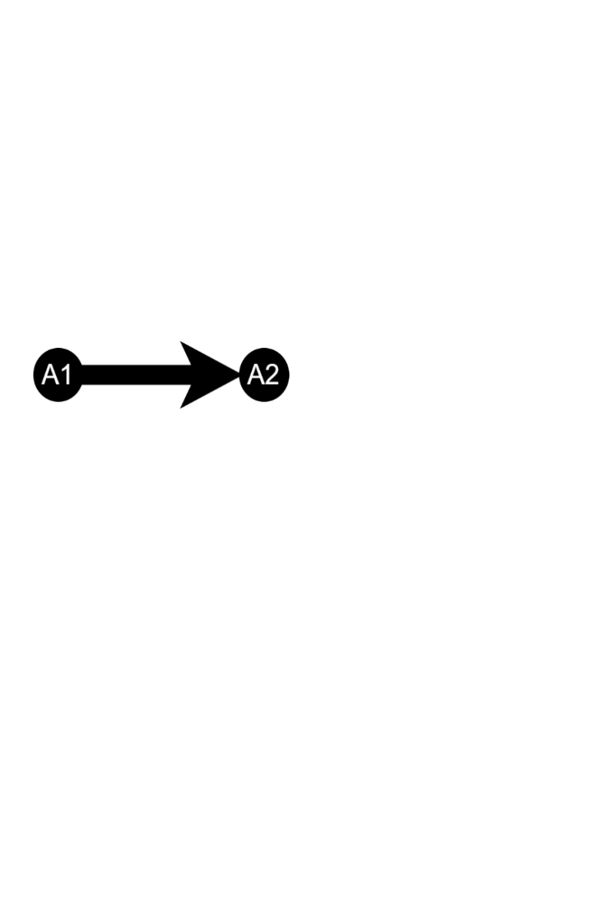 | 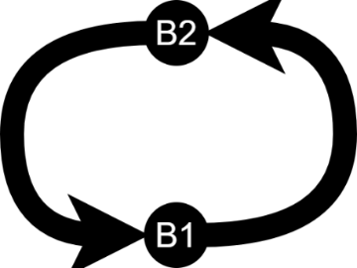
Immediate Emergence-Prospective Sensemaking
Features: | Spiral Antenarrative | Rhizomatic Antenarrative
- Updatable map  - Agent  - Imagination  - Uncertain  - Morphs  - Unpredictable  - Improvised drama |  | 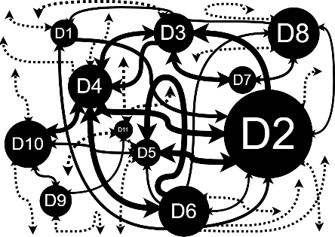
Source: author’s own design

As depicted in Figure 1.2, the “linear”, “cyclical”, “spiral” and “rhizomatic-assemblages” are the four antenarrative process types which can be distinguished according to their expected causal manifestations (Boje, 2011a). These antenarrative processes are discussed in more detail in the following sub-sections.

Linear antenarratives
The first antenarrative is the linear antenarrative process where the social actor expects and relies on a linear causation logic to make sense of their world. As Figure 1.2 shows, the cause (A1) gives rise to the effect (A2) in a linear fashion. This antenarrative type is characterized by a rigidity based on past experience which tries to make sense of the future by structuring the past or a given historical series of events into a fossilized narrative with an oversimplified plot consisting of a beginning, middle and an end (Boje, 2011b; Boje & Saylors, 2014).

The emphasis of this first antenarrative is on prediction as it tries to forecast a fixed scenario which the social actor(s) concerned work towards bringing about. This antenarrative process is “ante” because it “bets” on an anticipated future based on past experiences and it is “linear” because it transposes expectations onto the future based on past directional cause-effect occurrences which it anticipates will recur in the same manner in the future.
It relies on mental models which are static, fixed, presumably unchanging and limited in helping the actor navigate organizational reality.

In the linear antenarrative, a series of retrospective narratives are expected to unavoidably come to bear on the prospective future in a linear fashion. Past and future are connected by way of retrospection-prospection (backwards-forwards) sensemaking, i.e. the past is superimposed onto the already determined future (Boje, 2011b; Boje, 2018b). Examples of this type of antenarrative are sales targets or revenue growth targets which predict future organizational performance based on past performance and are promoted throughout the organization as static fixed objectives to be reached repeatedly.

Cyclical antenarratives
The second antenarrative is the cyclical antenarrative. It is a slightly augmented version of the linear antenarrative because the social actor(s) in question expect a series of causes and effects to occur successively in a cyclical manner. In other words, past occurrences are expected to form a repetitive closed-loop train of causation which may have more than one linear cause-effect relationship, but the sequence of which is expected to circle around in a predictable and repeating cyclical fashion (Boje, 2018b). This closed-loop causation pattern anticipates different variations of past experiences to repeat cyclically and to eventually come back to their genesis before repeating the process again. Cyclical antenarratives are “ante” because they try to predict or “bet” on a series of repetitive cyclical reiterations of past events (Boje, 2011b). An example of this is the business cycle narrative which is often employed to articulate antenarratives of a future market, industry or organizational environment that is expected to follow these cyclical patterns in the same sequence (Boje & Saylors, 2014).

These linear and cyclical antenarrative processes have a set of seven features shown in Figure 1.2. These features are analogous to a (1) “map that’s overlaid” on actual terrain which it both oversimplifies and obscures. Due to their deterministic outlook, these antenarrative processes (2) reduce the social actors in question to “automatons” which have path-dependent behavioral patterns that follow fixed expectations. These linear and cyclical antenarratives are informed by their respective (3) linear or cyclical “memory”, which superimposes memories of the past which are expected to be relived in a forthcoming (4) certain future. In both their linear and cyclical forms, “Retrospective-Prospective” or “Backwards-Forwards” or “Past-to-Future” sensemaking antenarratives are (5) “repetitive” and (6) “predictive” and tend to be deployed much like how a playwright expects a “scripted drama” to unfold in the same way each time it is performed. The script is written and determined beforehand, and each performance of the script is expected to be acted out as outlined by the playwright by directors, actors and the audience regardless of where or when the play is performed.

Figure 1.3 shows how cyclical processes may have different events which occur – A, B, C and D – but ultimately circle back to the beginning and repeat the cycle. On the other hand, spiral processes do not only have a given trajectory (up or down), but they also expand into new spaces as indicated by T1, T2, T3 and so forth.

Figure 1.3: Cyclical versus upward and downward spiral trajectories
Cyclical Process | 
Spiral Process
Source: author’s own design

The next sub-section will explain spiral and rhizomatic antenarratives and distinguish them from linear and cyclical ones.

Spiral antanarratives
The third antenarrative is the “spiral” antenarrative which occurs when social actors expect to experience an organizational trajectory which is either moving upwards or downwards depending on the circumstance. However, unlike circular antenarrative processes which come full circle and repeat the same expected train of causation, spiral antenarrative processes evolve such that each recursive cycle moves through space and time in the same direction, but still expands beyond the previous cycle and manifests new possibilities (Boje, 2011b). With spiral antenarratives, social actors experience cycles which evolve rather than remain the same while still maintaining a general directional upward or downward trajectory.

In this sense, spiral antenarratives are transformative and they are “ante” because social actors draw on these narratives to make “bets” on augmented futures they want to shape or create which may be different while stemming from their current reality (Boje, 2018b). The spiral-antenarrative causality is neither linear nor cyclic. Rather, it is dialectical and can experience amplification “meaning that, unlike cycles, that which is part of the new spiral may be made up of, and utilize things unrelated to, the previous iteration” all-the-while following a given trajectory (Boje & Saylors, 2014: 205).

Rhizomatic antenarratives
The fourth antenarrative category is the rhizomatic antenarratives. These antenarratives have a unique manifestation. They follow an “assemblage” causality logic which forms complex connections among disparate aspects of social life and material reality. “Assemblage” occurs when different materials combine to form new realities altogether (Cambridge Dictionary, 2019b). The assemblage causal pattern is quite different from the first three antenarratives because social actors can neither rely on prediction to generate expected scenarios of the future nor on a broader directional trajectory. One cannot discern where rhizomes begin, where they’re going, and where they’re likely to end. Rhizome assemblage antenarrative processes are therefore also referred to as “relational” or “mutually recursive” antenarratives which engage in a relational type of causality where effects are caused by the interrelationships of phenomena and not by any individual phenomenon in the system itself (Boje, 2011b).

Rhizomes do not stem from a single isolated point and yet, divergent as they may seem to the observer, there is an integrative unity bringing the various intricate and complex sub-connections together. The reason this fourth type of antenarrative process is referred to as having rhizomatic-assemblage causation is that, like plant rhizomes in nature, social rhizomes are visibly and invisibly complex because they possess both seen and unseen aspects (Boje, 2018b). In other words, rhizomes are causally combinatory (Boje & Saylors, 2014). The complex nature of rhizome assemblage antenarratives was well described by Cabrera and Roland (2014: 3) who stated that:

“Rhizomatic philosophy attempts to explain knowledge using the comparison of a rhizome and a tree. While the tree is ruled by hierarchy, linearity and a meaningful pattern; the rhizome is an unbounded, distributed, semiotic and interconnected scaffold … As abstract as it looks, rhizomatics appears to explain ecosystems, brain neural networks, the internet and social media quite accurately”.

What makes rhizome assemblage antenarratives unique is that they are non-linear and non-hierarchical, being distributed rather than having an obvious center. They have multifarious entry and exit points and co-exist in interpenetrating web-like networks within multiple terrains and in a self-sustained manner. Indeed, these rhizomatic assemblages are “ante” because a portion of the assemblage can be cut from the rhizome yet still be able to reconnect or even regrow independently of its source rhizome. Rhizhome assemblage antenarratives are nomadic, and their seeming direction or orientation can change, often counter-intuitively, in the middle of this relational unfoldment.

Figure 1.4 shows an example of how rhizomatic assemblages differ from typical predictable plant structures.

Figure 1.4: Identifying and visualizing rhizome-assemblages
Tree Pattern Causation | Rhizomatic Assemblage Proliferation
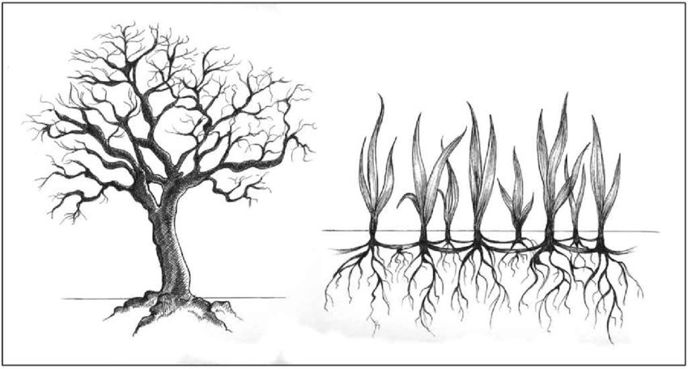
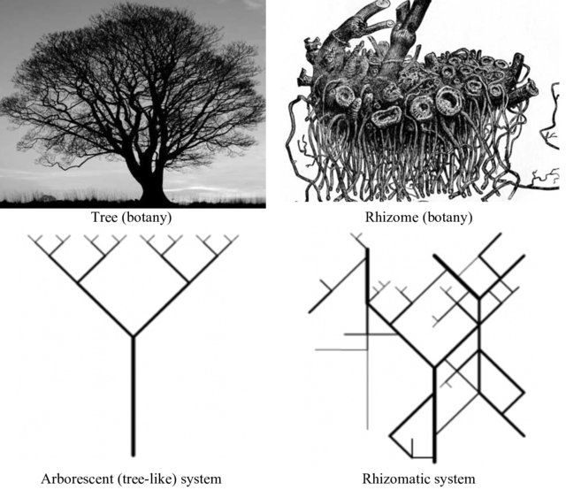
Source: Gough (2010) & Teuben (2018)

Unlike other botanical systems such as trees, rhizomatic assemblages are interspersed both above and below ground. Everyday examples of natural rhizomes include strawberries and potatoes which can mushroom in both above ground (overt) and below ground (covert) interconnected enmeshments (Boje, 2011a). When a narrative is in flux, still forming and its directionality or trajectory cannot be ascertained, then it is a rhizomatic antenarrative which is morphing into assemblages of future potential (Boje, 2018b; Boje & Saylors, 2014).

All antenarrative processes can have both positive and negative causal outcomes; however, rhizome antenarratives can be particularly insidious and startling because they have hidden dimensions which can “spring up” unannounced. For example, consider forensic auditors who are trying to detect bank fraud. With respect to these forensic auditors, Boje (2011a: 12) explains that:

“Auditors using linear [antenarrative] analyses could not detect an already escaping present. Policy prescriptions could not corral the continuous movement of fraud into the future … There was a bank fraud panic in the 1890s and a stock-market rhizome in the 1920s, the Enron rhizome of 1990s, and our most recent as-we-speak crisis—mortgage-banking crisis … In each of these examples a rhizome formed with a set of covert transactions whose detection even by experts came too late to prevent crisis and tragedy”.

Indeed, these latter two – spiral and rhizome assemblages – of the four antenarrative processes have a different causation logic and they resemble the paradoxes that constitute daily lived ontological experience. In other words, spiral and rhizomatic antenarrative processes approximate to what it means to actually “be” in an ever-changing and unpredictable world as an individual subject or group of subjects with a shared yet evolving understanding of reality.

Thus, looking at their key features, these spiral and rhizome-assemblage antenarrative processes are characterized by (1) “updatable maps” whose accuracy can be improved as social actors traverse the actual territory of lived experience and correct for discrepancies between the “map” and the “territory”. The second feature of these antenarratives is (2) agency, where social actors participate in the emergent reality through active engagement in antenarrative articulation or even by passively allowing an antenarrative that they themselves did not author to unfold unabated.

Given their emergent nature, these spiral and rhizomatic antenarratives require (3) creative imagination to deal with the (4) uncertain and continuous (5) morphosis which emerges in (6) unpredictable unfoldment. It is for this reason that these antenarratives can be conceived of as (7) improvised drama, where actors come together with neither a script nor a pre-arranged consensus of how the play or dramatic act will unfold. Rather, in improvised drama, all actors are expected to show up with sheer present-moment awareness and openness which enables them to co-create antenarrative assemblages of rhizomes which emerge as each actor feeds off the other in a manner that makes sense and yet which, paradoxically, even the actors themselves cannot predict or foretell though they may try to do so.

In summary, storytelling research is designed within the boundaries of a multidimensional storytelling diamond which has ontological, epistemological and methodological orientations which are different yet linked by any of the four causal antenarrative processes.

Pragmatic Application
Having outlined the theory underpinning the storytelling diamond model and its composition in general, the next step will be to discuss how the storytelling diamond applies to this chapter. Figure 1.5 shows how this chapter is guided by the Abstractionist Living Story (ALS) paradigm of the storytelling diamond through spiral antenarratives. The living story of Indigenous research participants is studied through the ALS paradigm which is interested in developing potentially generalizable explanations (Rosile et al., 2013). This interplay of paradigm and storytelling type is depicted in Figure 1.5 which shows how the storytelling science paradigm from Figure 1.2 has been applied in this chapter.

Figure 1.5: The storytelling diamond model applied
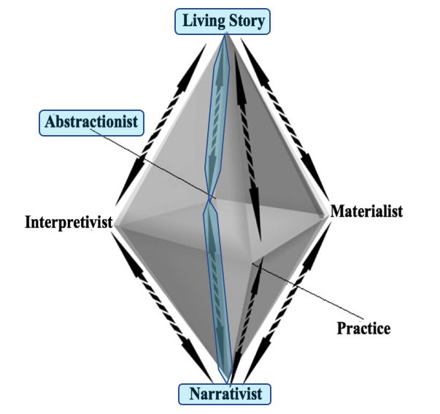
Source: adapted from Rosile et al. (2013: 559)

The focus on the “living story” (at the top of the diamond) enabled the research to understand the living story of the Indigenous participants’ antenarrative. The Indigenous participants’ living story is a fundamentally new antenarrative emerging from their constrained village which is challenging the notion that impoverished rural contexts in the developing world are doomed to stagnation because they are under-resourced. The Indigenous participants’ “living story” stands in stark contrast to the cycle of poverty perpetuation’s “dominant narrative” which asserts that South Africa’s rural Indigenous communities are helpless and apathetic groups stuck in the poverty trap which and are dependent on welfare handouts for their basic survival.

Table 1.2: Abstractionist Living Story (ALS) Paradigm Summary
Living Story | Key Features | Includes living story, lived story, and life story approaches. Multiple perspectives and multiple voices are presumed to offer greater depth of understanding.
 | Researcher’s Role & Goal | Seeks connections with personal experience and lived experiences of others. Seeks differentiation, possibilities, and the “road not taken”.
 | Key Benefits | Prefers story in situ, which more closely approaches lived experience. Focus on the interplay of story webs.
 | Limitations | Tends to be biographical and can miss the wider historical trends, such as in historical materialism. Tends to be oral based and may be difficult to integrate with textual approaches.
Antenarrativist Processes | Key Features | Focuses on in-between processes to better understand how lived experience is shaped, reified, and assimilated into narratives. Focuses as well on ways living stories turn into dominant narratives, struggle with counter narratives, and more micro living stories.
 | Researcher’s Role & Goal | Seeks the marginalized or forgotten voices (microstoria) missing from the “grand narratives”. Seeks to question the “status quo”.
 | Key Benefits | Seeks to trace processes of transformation in between organizational storytelling paradigm incommensurabilities (i.e., parallax gaps).
 | Limitations | Identifies only the four types of antenarrative processes (linear, cyclic, spiral, and rhizomatic). Difficulty in conveying nonlinear aspects of spirals and rhizomes.
Abstractionist | Key Features | Analyzes narrativist or living story elements to aid empirical testing of existing theory by looking at linguistic or semiotic patterns.
 | Researcher’s Role & Goal | Is usually an outsider who applies usually narrativist research in the service of theory building. Seeks the presumed underlying reality beneath the narratives.
 | Key Benefits | Can be a subset of narrativist and materialist paradigms.
 | Limitations | The essentialist and universalistic approaches are challenged by materialist and other paradigms for being schematic, separated from grounded experience, not ontologically being-in-the world.
Source: Rosile et al. (2013: 561 – 562)

Thus, as shown in Table 1.2, this chapter. project is located in the ALS paradigm which crisscrosses between ontology and epistemology via antenarratives and their antenarrative processes. This ALS paradigm enables a deeper understanding of social processes of action because it enabled the researcher to trace the “in-betweenness” of the “narrativist” hegemony and the emergent “living story” which resists it, explicating how one affects or interacts with the other (Rosile et al., 2013). Figure 1.6 synthesizes all of the above and depicts this chapter’s storytelling paradigm.

Figure 1.6: The Abstractionist Living Story (ALS) storytelling paradigm
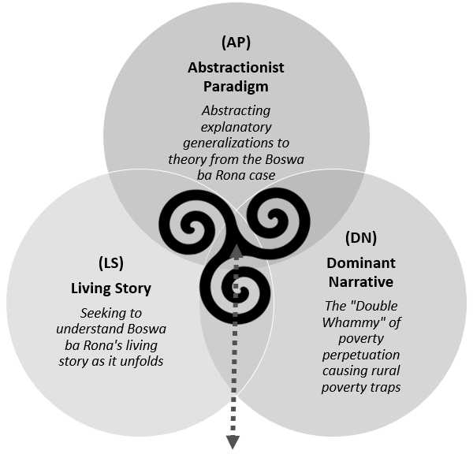
Antenarrativist Processes Link the three as follows:
- The LS is challenging the DN (LS → DN)
- LS → DS process translates into abstractions (AP)
- Generalize qualitative case evidence AP to theory
Source: author’s own design

Abstractionist Living Stories
The storytelling paradigm demonstrated by this chapter is the Abstractionist Living Story (ALS) paradigm. It is important to note that while “living stories” are quite different from “abstractions”, the “antenarrative” processes enable us to reconcile the two in order to build explanatory theory without losing the importance of the socially situated realities of lived experiences in indigenous contexts. This ALS paradigm was explained as follows by Rosile et al. (2013: 570):

“Abstractionist Living Story. The antenarrative process works between quantitative and qualitative and between epistemology and ontology. By using an antenarrative perspective, the link between living story (the necessary method for many research questions) and abstractionist (the epistemological home for many Western scholars) can be brought together… If there are questions that can only be understood emicly, such as a deep description of process that must be experienced to be understood, then research should be designed around living story. If the audience with whom the scholar wishes to converse is in need of abstractions in order to value the findings, then the deep descriptions of living story should be turned into abstracted categories. It is through a tracing of the potential in between singular narratives and the living stories that antenarrative can link the potential abstractions with the lived experiences. This sort of research will go beyond the monologist categorizations of most abstractionist responses while still providing the usable, but now contextually valid and logically consistent, categorizations that appeal to the scientific assumptions of scholars…”.

As the quote above clarifies, the ALS paradigm enables researchers to develop deep descriptions of living stories which are unfolding in practice by turning them into abstracted categories which are beneficial for theory development. One powerful way of enacting this abstraction in a manner that advances knowledge with causal power is by means of Karl Popper’s self-correcting falsificationist (also referred to as “fallibilism”) epistemology.

Self-Correcting Falsification
In unfolding the Abstractionist Living Story (ALS) storytelling science paradigm, this chapter draws upon self-corrective reasoning with specific regards to the qualitative single-case study research method using Yin (2014) case study design as the core framework of inquiry. Boje and Rosile (2019) endorse Yin’s (2014) epistemological approach to research design as being in line with self-correcting reasoning even though he does not explicitly refer to it as such. In this vein they call on scholars to “notice in Robert Yin’s (2014: 37) work, that there is a role for self-correcting” even though “he does not call it that” (Boje & Rosile, 2019: 58).

To do strong case study research, it is important to link the case study data to theory by segmenting the collected data and then combining or re-assembling the case study data with specific regards to the extant theory (Yin, 2014). Without this regard to theory, scholars risk engaging in boundless description and interpretivist exploration which isn’t conducive to the development of scalable and cross-contextually transferrable global solutions for the worlds pressing sustainable development challenges. In operationalizing this analytic strategy, case study researchers can draw on five analytic techniques, namely, pattern matching, explanation building, time-series analysis, logic models and cross-case synthesis (where multi-case studies are concerned).

This chapter argues that such self-corrective reasoning may be deployed through “fallibilistic” or “falsificationist” explanation building made in relation to extant theory thus fostering the growth of knowledge (Deutsch, 1997; Popper, 2005; Yin, 2014). The notion of “falsificationism”, adopted in this chapter holds that all human beings are “fallible”, that is, capable of making mistakes or being wrong (Popper, 1947). Popperian fallibilism is important for storytelling science because it helps develop theory whose findings have greater explanatory power (Deutsch, 1997; Boje & Rosile, 2019). This is because, as Popper (1999: 13) explains:

“We are always learning a whole host of things through falsification. We learn not only that a theory is wrong; we learn why it is wrong. Above all else, we gain a new and more sharply focused problem; and a new problem, as we already know, is the real starting point for a new development in science”.

Popperian falsificationist epistemology claims that “knowledge, especially scientific knowledge, progresses through conjectures (i.e. tentative solutions to problems) that are controlled by criticism, or attempted refutations (including severely critical tests)” (Lam, 2007: 432). Therefore, the analytic and interpretive foundation of this chapter is the idea that knowledge of how to solve the poverty and inequality problem among the world’s Indigenous peoples will improve by falsifying or criticizing existing related theories and thereby developing improved theory which offers better explanations of how the problem can be meaningfully addressed (United Nations, 2019). This epistemological disposition is what Popper (1999) referred to as “critical rationalism”.

Critical rationalism is an approach to scholarly reasoning which critiques competing theoretical ideas in search of the best and most useful explanation, relying neither on authority nor on defensively untested justifications (Deutsch, 2011). This type of critical rationalism is based on Popper’s principle of “falsification” which is a deliberate attempt to prove theories wrong in order to improve them and, in this sense, it is constructive and progressive. Popper (1999: 10) explained this as follows:

“My main thesis is that what distinguishes the scientific approach and method from the prescientific approach is the method of attempted falsification. Every attempted solution, every theory, is tested as rigorously as it is possible for us to test it. But a rigorous examination is always an attempt to discover the weaknesses in what is examined. Our testing of theories is also an attempt to detect their weaknesses. The testing of a theory is thus an attempt to refute or to falsify the theory”.

Therefore, the critical rationalism advocated by Popper (1999), Deutsch (1997; 2011) and Boje and Rosile (2019) provides the analytical lynchpin offered in this chapter. Unfortunately, this critical rational falsificationism has often been erroneously cordoned off as belonging exclusively to the realm of positivism and quantitative inquiry which is a mistake. In Qualitative Research in Psychology, a leading qualitative journal, Holtz and Odağ (2018: 1) made a contribution entitled “Popper was not a positivist: why critical rationalism could be an epistemology for qualitative as well as quantitative social scientific research” wherein these authors argued that “Popper was a staunch anti-positivist and that his approach is much closer to the epistemological beliefs that seem to underlie most of qualitative research”. In this contribution, Holtz and Odağ (2018: 1) clarified this error in context in by stating the following:

“In contrast, we argue that Popper was a staunch anti-positivist and that his approach is much closer to the epistemological beliefs that seem to underlie most of qualitative research. Beyond a mere pragmatism in doing whatever is useful, critical rationalism could serve as a guiding epistemology for all social scientific research as long as all aspects of the methodological approach are open to pertinent criticism themselves”.

Therefore, when conducting critical rationalist qualitative inquiry, “researchers should try to formulate their theories in as wide reaching and general a form as possible, until they are proven wrong by time” (Holtz & Odağ, 2018: 13). In this vein, Deutsch (1997: 7) argues that research should strive to develop explanatory theory because “understanding does not depend on knowing a lot of facts as such, but on having the right concepts, explanations and theories”. Indeed, it is not enough for research to merely list descriptive facts because merely summarizing facts does not result in understanding but only the accumulation of data. As explained by Deutsch (1997: 7):

“Facts cannot be understood just by being summarized in a formula, any more than by being listed on paper or committed to memory. They can be understood only by being explained. Fortunately, our best theories embody deep explanations as well as accurate predictions”.

From an antenarrative perspective, this critical rationalism is fundamental to all antenarrative research which is part of the storytelling science approach developed by Boje and Rosile (2019). From this storytelling science viewpoint, researchers are encouraged to wholeheartedly pursue the development of sound explanations their phenomena of interest. Scholars should neither be naively deluded by the inductive idea that all reality is socially constructed and relative, nor the deductive positivist idea that there is an unalterable objective manifest truth which simply needs to be apprehended (Popper, 1962). Drawing on Karl Poppers’ work, Boje and Rosile (2019: 6) clarify the importance of reflexive and critical explanatory theory-building using a qualitative antenarrativist storytelling paradigm as follows:

“…there is no method of finding a true story, and no praxis of finding (an ‘absolutely’ true story. Rather ‘scientific method’ in theory-method-praxis consists of ‘kind of criticism’ with ‘critical conversation’ to refute or disconfirm the fake-stories, the fake-news’ the fake-frameworks, and the ‘system of assumptions’ and all the “isms” such as ‘positivism’ and ‘inductivism’ … That is why Popper does ‘critical metaphysics’ testing conjecture after conjecture that is a kind of self-correction to get ‘closer approximation to the truth’ by ‘critically discussing’ to show what is ‘not true’”.

As such, falsificationist critical rationalism is valuable for qualitative inquiry and it is a mistake to think that the Popperian viewpoint is the special preserve of positivistic quantitative deductionism. Rather, falsificationist critical rationalism helps to strengthen phenomenological qualitative research without succumbing to the inductive social constructivist fallacy and without trying to forcefully bend itself to the deductive positivistic and soft-positivistic quest to prove and legitimize theory in the name of statistical population-oriented generalizability. Indeed, Holtz and Odağ (2018: 1) support the possibilities that falsificationist critical rationalism offers qualitative inquiry in the following assertion:

“…despite the fact that Popper has, for the most part, been associated predominantly with the quantitative research tradition. … We will argue that Popper is in fact much more in line with the qualitative, constructionist approach than often portrayed. Critical rationalism could indeed serve as guiding epistemological theory for most researchers, independent of their quantitative versus qualitative standpoints.”

This chapter will now proceed in this spirit of Popper which is clarified in Deutsch (1997: 2011), Holtz and Odağ (2018), and Boje and Rosile (2019). In other words, the chapter will show how doing high-quality impactful research requires scholars to subject their theories to severe criticism in search of the best theories that explain phenomena and are, therefore, worthy of retention and further application. As Popper (1999: 11) stated:

“My main thesis, then, is that the novelty of science and scientific method, which distinguishes it from the prescientific approach, is its consciously critical attitude to attempted solutions; it takes an active part in attempts at elimination, in attempts to criticize and falsify. Conversely, attempts to save a theory from falsification also have their methodological function, as we have already seen. But my thesis is that such a dogmatic attitude is essentially characteristic of prescientific thinking, whereas the critical approach involving conscious attempts at falsification leads to science and governs scientific method”.

Having established these foundational roots to self-corrective storytelling science inquiry, the next section will exemplify how this may be applied to extant research within the context of Indigenous entrepreneurship.

Inquiry-Based Exemplification
This section will now demonstrate the contribution advanced in this chapter by drawing on a theoretical “absractionist” proposition stated by Lindsay (2005) in an article entitled Toward a cultural model of Indigenous entrepreneurial attitude in light of the aforementioned nascent study entitled Creative start-up capital raising for inclusive sustainable development: A case study of Indigenous participants’'s self-reliance developed by Thakhathi (2019). Both studies lay in the province of Indigenous entrepreneurship in order to demonstrate how this epistemology can be applied to the advancement of domain-specific knowledge longitudinally. A common thread in these successive contributions – separated by more than a decade of time – is their insight regarding Indigenous entrepreneurial attitudes as quoted in the following two bullet points respectively:
- Abstract Theoretical Proposition: “There will be a relationship between culture and the entrepreneurial attitude of Indigenous entrepreneurs” (Lindsay, 2005, p. 5).
- Empirical “Ubuntu” Living Story: “Equitable inclusiveness ensures the broader deep involvement of the marginalized” (Thakhathi, 2019, p. 118161).

Let us know look at each how of these insights were developed and justified by each author in context respectively:

- Lindsay’s (2005) Abstraction: Culture and Entrepreneurial Attitude – Indigenous entrepreneurship is different from non-Indigenous entrepreneurship (Hindle and Lansdowne 2005). Self-determination and the preservation of heritage are integral parts of Indigenous entrepreneurship. If heritage and culture do not feature as important issues in the development of Indigenous ventures, then this may not be Indigenous entrepreneurship – even if there is Indigenous ownership and/or involvement (Hindle and Lansdowne 2005). Indigenous values and thinking are holistic; thus, Indigenous success is measured in terms of various interrelated economic and non-economic dimensions (Dumont 1993; Foley 2003). Individual autonomy, also, is overshadowed by the range of Indigenous stakeholders who must be accounted to (Hindle and Lansdowne 2005). The family, the extended family, Indigenous elders and leaders, community opinion, as well as other Indigenous cultural values and practices all play a role in influencing individual attitudes. For these reasons, Indigenous entrepreneurship must be viewed within an Indigenous cultural context and Indigenous culture will shape Indigenous entrepreneur attitudes.
  - Theoretical Proposition: “There will be a relationship between culture and the entrepreneurial attitude of Indigenous entrepreneurs” (Lindsay, 2005, p. 5).

- Thakhathi’s (2019) Living Story: “This story of self-reliance is supported by the story of equitable inclusiveness. The point of departure for the self-funding model was to ensure that as many members of the community as possible were included in this corporation regardless of income level or social status as shown at the top of Figure 2. As such, the initiative was designed to be inclusive from the onset. The aim was to ensure that all participants in the corporation become joint shareholders who will benefit from the business equally. As one participant stated: ‘It's so community focused because the idea is to ensure everyone benefits from it’ (Gift). Therefore, the shareholdership was limited to one share per person to the value of R5,000.00 ($400.00). This upheld the communitarian spirit of the company resembling what is referred to in South Africa as Ubuntu or Vhuthu, an African humanistic philosophy of interdependence which is translated as ‘I am because you are’ or ‘One is because others are’. The deliberate limitation of one share per shareholder was outlined as follows by Kopano: ‘Nobody can pay more than R5000 because everybody has to have the same powers of voting [in terms] of making decisions, that's number one because if we are one community and one people no one needs to be stronger than any one so no one will be allowed to have more than one share which comes at the value of R5,000.00’ (Kopano).
  - Empirical Non-Falsification: “Equitable inclusiveness ensures the broader deep involvement of the marginalized” (Thakhathi, 2019, p. 118161).

Taking both insights into consideration, beginning the most recent one, if Thakhathi (2019, p. 118161)’s qualitative single-case study is read in isolation, one of the key findings therein as listed in the second bullet point becomes apparent: “Equitable inclusiveness ensures the broader deep involvement of the marginalized”. Reading this finding in isolation without linking it to extant theory and contrasting it thereto constitutes the inductive fallacy of the old grounded theory paradigm. Thus, it is only in light of extant theory that the finding becomes useful which is where Lindsay (2005) comes in. A thorough literature review of the Indigenous entrepreneurship field would reveal that previous positivistic research conducted by Linsday (2005) asserted the theoretical proposition that culture shapes Indigenous entrepreneurial attitudes significantly. Knowing this preceding theory and acknowledging it in light of Thakhathi’s (2019) contemporary research findings creates greater analytic depth and helps to advance knowledge pragmatically.

Hence, when contrasted to Lindsay’s (2005, p. 5) “Abstract Theoretical Proposition” that “there will be a relationship between culture and the entrepreneurial attitude of Indigenous entrepreneurs”, Thakhathi’s (2019) empirical “Ubuntu Living Story” antenarrative finding goes beyond mere description and accomplishes Yin’s (2014) analytic generalization even though it is based on single-case qualitative phenomenological data. This is because the ALS linking doesn’t only tell “what” the living story antenarrative are descriptively, but also “why” they are so theoretically too. The ALS linking reveals that the Indigenous African relational ontology commonly referred to as “Ubuntu” gives voice to the marginalized peoples and foster inclusive sustainable development because culture – according to Lindsay’s (2005) theoretical proposition – shapes Indigenous entrepreneurial attitudes.

In essence, Lindsay (2005) established the form of the abstract relationship between culture and the entrepreneurial attitude of Indigenous entrepreneurs and Thakhathi (2019) added new insight thereto by confirming this relationship to be the case indeed through living story content. Ubuntu, which is an indigenous communal relational ontology, caused the new business venture creation process to be broad-based and inclusive thereby failing to falsify – i.e., confirming – Lindsay’s (2005) theory. This ALS linking allows Thakhathi’s (2019) living story antenarrative insight to be while also advancing the existing body of knowledge beyond the specific single case at hand. In this sense, a valuable contribution is made to the literature without needing to solely defer to positivistic reductionism by way of statistical generalization yet analytic generalization is accomplished by linking abstract theoretical narratives with living story antenarratives without committing the inductive fallacy either (Boje & Rosile, 2019).

This is how Rosile et al.’s (2013: 570) Abstractionist Living Story (ALS) paradigm which seems antagonistic on the surface is reconciled coherently and cohesively while advancing knowledge without slipping into deference to provincialist qualitative versus quantitative authoritarian reasoning. Knowledge is thusly advanced and grown for the betterment of humanity. In this present day and age, when sustainable development problems are rife, the world requires a Transcendent Development which is possible through the prism of the storytelling diamond.

References
Bloomberg, L.D. & Volpe, M. 2016, Completing your qualitative dissertation: a road map from beginning to end, Sage Publications, Thousand Oaks, California.
Boje, D. & Rosile, G. 2019, Doing ‘storytelling science’ with ‘self-correction’, 12 June 2019 Revision edn, World Scientific Publishing, New Jersey, United States of America.
Boje, D. 2018b, All about spirals: I want to know about Spirals [Webpage of davidboje.com], [Online]. Available: https://davidboje.com/448/spirals.html [2019, 06/25].
Boje, D. (ed) 2018a, Organizational Research: Storytelling in Action, Routledge Studies in Management, Organizations, and Society edn, Routledge, New York.
Boje, D. 2011b, "The Cycle and the Spiral-Antenarrative: a quantum-ontology-system manifesto", [Online]. Available: https://business.nmsu.edu/~dboje/655/anteriority_and_antenarrative_spiral.html [2019, 06/25].
Boje, D.M. 2011a, "Introduction to agential antenarratives that shape the future of organizations" in Storytelling and the Future of Organizations: an antenarrative handbook, ed. D. Boje, 1st edn, Routledge, London, United Kingdom, pp. 1-19.
Boje, D. 2001, Narrative methods for organizational & communication research, Sage Publications, Thousand Oaks, California.
Boje, D., Haley, U. & Saylors, R. 2016, "Antenarratives of organizational change: the microstoria of Burger King’s storytelling in space, time and strategic context", Human Relations, vol. 69, no. 2, pp. 391-418.
Cabrera, D. & Roland, D. 2014, 17 December 2014-last update, How do we structure knowledge? … Enter the rhizome [Webpage of Medium Corporation], [Online]. Available: https://medium.com/@cabreraerdr/how-do-we-structure-knowledge-enter-the-rhizome-e80fdcef99a2 [2019, 06/27].
Cambridge Dictionary 2019a, ante, https://dictionary.cambridge.org/dictionary/english/ante edn, Cambridge University Press, Cambridge, United Kingdom.
Chowdhury, M. 2014, "Interpretivism in aiding our understanding of the contemporary social world", Open Journal of Philosophy, vol. 4, no. 03, pp. 432-438.
Deutsch, D. 1997, The fabric of reality: the science of parallel universes and its implications, Allen Lane the Penguin Press, New York, United States of America.
Deutsch, D. 2011, The beginning of infinity, Penguin Books, London, United Kingdom.
Garud, R. & Giuliani, A. 2013, "A narrative perspective on entrepreneurial opportunities", Academy of Management Review, vol. 38, no. 1, pp. 157-160.
Gough, N. 2010, "Performing imaginative inquiry: narrative experiments and rhizosemiotic play" in Imagination in educational theory and practice: a many-sided vision, eds. T. Nielsen, R. Fitzgerald & M. Fettes, Cambridge Scholars Publishing, Newcastle, United Kingdom, pp. 42-60.
Holtz, P. & Odağ, Ö. 2018, "Popper was not a positivist: why critical rationalism could be an epistemology for qualitative as well as quantitative social scientific research", Qualitative Research in Psychology, DOI: 10.1080/14780887.2018.1447622, pp. 1-24.
Humle, D. & Pedersen, A. 2015, "Fragmented work stories: developing an antenarrative approach by discontinuity, tensions and editing", Management Learning, vol. 46, no. 5, pp. 582-597.
Lam, C. 2007, "Is Popper's falsificationist heuristic a helpful resource for developing critical thinking?", Educational Philosophy and Theory, vol. 39, no. 4, pp. 432-448.
Lindsay, N. 2005, "Toward a cultural model of Indigenous entrepreneurial attitude", Academy of Marketing Science Review, vol. 2005, no. 5, pp. 1-17.
Popper, K. 2005, The logic of scientific discovery, Taylor & Francis e-Library edn, Routledge, Oxfordshire, United Kingdom.
Popper, K. 1947, The open society and its enemies, volume i: the spell of plato edn, Routledge, London, United Kingdom.
Popper, K. 1999, "The logic and evolution of scientific theory" in All Life is Problem Solving, Routledge, Abingdon Oxon, United Kingdom, pp. 3-22.
Popper, K. 1962, Conjectures and refutations: the growth of scientific knowledge, Routledge, London, United Kingdom.
Rosile, G., Boje, D., Carlon, D., Downs, A. & Saylors, R. 2013, "Storytelling diamond: an antenarrative integration of the six facets of storytelling in organization research design", Organizational Research Methods, vol. 16, no. 4, pp. 557-580.
Saylors, R., Boje, D. & Mueller, T. 2014, "Entrepreneurial storytelling in moments of friendship: antenarratives of business plans, risk taking, and venture capital narratives", Tamara: Journal for Critical Organization Inquiry, vol. 12, no. 4, pp. 3-15.
Teuben, R. 2018, 21 June 2018-last update, Gilles and Deleuze concept of rhizome. The idea that knowledge need not be hierarchical, but may be spread a way which resists organization. No rankings. Contrast w/ tree (the traditional model of knowledge) which defines beginning, middle, end. [Webpage of Twitter], [Online]. Available: https://twitter.com/i/web/status/1009805137437749248 [2019, 06/27].
Thakhathi, A., 2019. "Creative start-up capital raising for inclusive sustainable development: A case study of Indigenous participants’'s self-reliance". Journal of Cleaner Production, vol. 241, 20 December 2019, p.118161.
Vaara, E., Sonenshein, S. & Boje, D. 2016, "Narratives as sources of stability and change in organizations: approaches and directions for future research", Academy of Management Annals, vol. 10, no. 1, pp. 495-560.
Vaara, E. & Tienari, J. 2011, "On the narrative construction of multinational corporations: an antenarrative analysis of legitimation and resistance in a cross-border merger", Organization Science, vol. 22, no. 2, pp. 370-390.
Yin, R. 2014, case study research: design and methods, 5th edn, Sage Publications, Thousand Oaks, California, United States of America.

Author Bio: Andani Thakhathi is the Chief Research Officer of the Transcendent Development Ubuntuversity. He serves at the helm of the Ubuntuversity’s knowledge creation and advancement agenda and holds a PhD in Ethics and Responsible Leadership in Business. Andani is the pioneer of the Transcendent Development, Ubuntu African Humanism and the Ubuntu Universal Dignity schools of thought.

