**Dr Russ Barnes, Colonel, USAF (ret), PhD, MBA, MS**

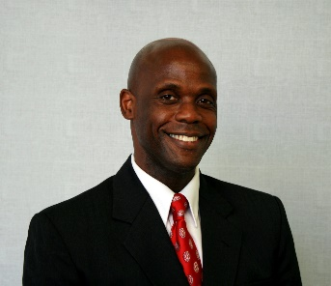Dr Russ Barnes is Chief Strategist for Systro Solutions. He received his Bachelors Degree from Manhattan College (NY), MBA from Embry-Riddle Aeronautical University, Master of Science in Strategic Studies from Air University, and PhD in Organization Development from Benedictine University.