SOCIOECONOMIC Business Piloting Logbook
This is also Business Consulting Report and Your Very Own Training Manual to Edit and Share with Your Client
PLEASE REPLACE ALL YELLOW ITEMS WITH YOUR OWN FIELD NOTES & INFO THANK YOU You can keep parts of the Manual as is to help your Client Learn SEAM Tools
[YOUR STUDENT NAMES GO HERE]
Management 448/548 Fall 2018
Place Colorful IMAGE or PHOTO OF THE BUSINESS, & Your TEAM HERE
Client: name of business, client name, phone, and address
This report was Prepared For Professor David M. Boje

Table of Contents (if you use WORD HEADING 1 AND 2 you get this; Right click anywhere on table to update it seamlessly ).
PART I.
Part I: Executive Summary of Spiral Consulting (1-2 pages limit) 6
Three Main Consultant Recommendations 6
Figure 1: Put your own Spiral Drawing here, this is just example, that you delete Bingo-Spirals has Saturday & Monday WHORLS of different REPETITION proportion and substantive DIFFERENCE (© D. M. Boje 2017) 7
Socioeconomic Approach to Management (SEAM) Intro for the Client 8
Figure 2: Rhizomatic Multiplicity of SEAM's 4-Leaf Clover Field 8
Figure 3: Caring in Advance for ‘Mother’ and ‘Daughter rhizomes in my Grandmother’s Bearded Iris Garden 9
Figure 4 - The A-B-C TRIPLES SPIRALS OF Transformation of the business to achieve human potential (Adapted by Boje from p. 26 of Savall et. al 2008 book) 10
Figure 5 – 6th Extinction from Ignoring 9 Planetary Boundaries 11
The SEAM Client and Student Consulting Team Picks some of the 17 UN Sustainable Development Goals to TRANSFORM SMALL BUSINESS with True Storytelling and SEAM 12
Figure 6: True Storytelling and 17 UN Sustainability Development Goals 12
PART II. Report is organized in 23 Consulting Steps: 12
Step 1 - DIAGNOSTIC (A-spiral) and your Team’s 1st round of PNAC 12
PNAC (Periodically Negotiable Activity Contract) TOOL 12
FIRST TOOL to IMPLEMENT - PNAC (Periodically Negotiated Activity Contract) 13
Introduction to SEAM 14
Table 1 - SIX DOMAINS OF DYSFUNCTIONS CONSTITUTE FAMILIES of Themes & Sources of Quotes 14
Figure 7: TFW Virus and relation of Storytelling Listening to 4-Leaf Clover Diagnosis 16
Figure 8- The SEAM Diagnostic Clover with Root Causes of Financial Situation of the Business 17
Figure 9 –Student Consultants will be doing Three D-P-I-E Cycles (aka whorls) that become an Upward Spiral A of Momentum Continuous Improvement - Drawing by Boje July 6 2012 18
Table 2 – Report for MIRROR EFFECT Meeting (Required Summary Table of Costs of Keeping Going the Way its Going) 19
Sustainable Development Goals 20
MIRROR EFFECT SEAM VERBATIM NOTES (required for any grade above C) 21
Figure 10 - The death spiral from socioeconomic view© David Boje Aug 6, 2017 27
Step 2 Time Management Tool: Spiral B’s first tool 30
Figure 11 – The Five Aspects of Time (click on the figure above to change the image) 31
Figure 12 – The Adjusted Time Results of diagnosis of 1st DPIE (Note the wedge on the pie chart should be resized to reflect your client’s situation) 32
Time Management Tool Diary Questions (ask and answer only ones that apply) 33
Step 3 - Direction (C-spiral), which is also the 1st D-question (Directionality) of D-Spiral. DO NOT OTHER ANSWER QUESTIONS HERE – this is only to give to CLINET AS OVERVIEW. ONLY DO answer to Directionality 34
Table 3 – 11 D’s of ‘D-SPIRAL’ Questions (note these occur along the 23 steps (Note this is list of the D’s, they are covered in the individual steps so do not ask them all at once) 34
Step 4 - Project planning (A-spiral) done collaboratively with your client. 36
Step 5 - Strategic Piloting Logbook tool [THIS REPORT] (B-spiral) 36
Step 6 – CHANGE PROCEDURES to change Rules of the game - (C-spiral) 37
Step 7 - D2 – Datability (D-Spiral): What are the most important datable moments in the life story of the business? 37
Step 8 - Mirror Effect meeting with client (A-spiral, part of D-P-I-E cycle) 38
Step 9 - Implement project (DPIE 1) in collaboration with your client (A-spiral) 42
Step 10 - Priority Action Plan tool (B-spiral) 42
Table 3 – Priority Action Plan Tool (adapted from Savall et al, 2008: p. 100). 42
2nd DPIE BEGINS ABOUT HERE Step 11 – Evaluate results of 1st DPIE and begin DIAGNOSIS 2 for 2nd DPIP Resource Deployment (C-spiral) 43
Step 12 - D3 and D4 (Q-Spiral: Durability and Disclosability) 43
Step 13 – DPIE 2 MIRROR EFFECT # 2 (A-spiral) – and detail your metrics, the Logbook tool (B-Spiral) indicators you have documented to date 43
Table 4 – reporting 2nd MIRROR EFFECT Diagnosis (each DPIE begins with Mirror Effect) 43
Step 14 - Competency Grid (B-spiral) 44
Step 15 - D5, D6, D7 (Spiral: Destining, Deployment, & Dwelling) 44
Step 16 – Evaluation of 2nd DPIR – (A-spiral) Evaluate Project # 2, Diagnostic, Project plan for 3rd DPIE project, and includes 3rd MIRROR EFFECT meeting with client 45
Step 17 - I/E SP (Internal/External Strategic Plan) (B-spiral Tool 5) 45
I/E SP (Internal/External Strategic Plan TOOL) 45
Step 18 - More D's (Spiral: Deseverance & Drafts) 46
Step 19 - Complete the Evaluation (A-spiral) of the 3rd project 46
Step 20 - PNAC (Periodically Negotiable Activity Contract) 46
PNAC (Periodically Negotiated Activity Contract TOOL) 47
Step 21 - technological, product market, management systems, and develop human resources C-spiral 48
Step 22 - Last D's (Spiral: Dispersion & Detaching) 48
Step 23 - Draw amazing spirals for the draining of dysfunctions and hidden cost (downward spiral) and the upward spiral momentum from the 3 DPIEs that generated revenues 48
Virtue Ethics SECTION OF REPORT 49
Figure 13 – Annotated Double Spiral from a previous report (please do your own drawings) 50
Figure 14 – Two Vortex Spirals are intertwined, one with upward spiral momentum (more revenues, less hidden costs, less risks) and one a downward spiral, spinning out the dysfunctions and hidden costs. 51
Figure 15- the Strategy Path of a double spiral with upward (gold) and downward (purple) death whorling movement from A to B along green dotted pathways of intervention on three dimensions of space (Landscape), Time (Timescape), and Materiality (Materialscape). 52
Notice how this one annotates the date-abilities, has the 3 DPIE’s in it 54
Figure 16: Annotated DPIE spiraling (Boje, 2014) - Summary of 3 DPIES done with annotation of dates of each DPIE implementation steps (again this is example of spiral you can draw and annotate for yourselves) 55
Conclusions and Recommendations 56
APPENDICES 56
Copy of Client Application 56
Copy of Confidentiality Agreement (you sign it, client does not) 56
In sealed envelop your Client’s Confidential Evaluation of your Project 56
In sealed envelopes, 360 Peer review rating of you and your teammates 56
REFERENCES you used in the report 58
Website References 59

Part I: Executive Summary of Spiral Consulting (1-2 pages limit)
WRITE 2-3 PAGE ECECUTIVE SUMMARY (this is an example of 3 recommendations, and summary, read it, delete it and put in your own:
Here is an example: change it out for your own:

Three Main Consultant Recommendations
1. My first recommendation – Develop a marketing plan to regain market share of Las Cruces Bingo. It is in intervention into a Problem Multiplicity that allows us to uncover deeper Rhizomatic root causes, Financial Consequences of the Surface Level Dysfunctions, Structures, Behaviors, and Hidden Costs
2. Second recommendation – Find and train Legion members to be ‘callers’ at bingo, since if there is not a qualified and certified caller, bingo is cancelled, and it takes time for the Bingo-Spiral to regenerate customers, after that
3. And finally the most important Recommendation –find a transition team of bingo managers to train and do apprenticeship with the current bingo managers. If there is no succession planning then the Bingo-Spiral will wind down, and become dissolution (out of business).
SUMMARY: We study spirals and how they work in small business success and failure. American Legion Post 10 has a business, called ‘Bingo’ and it’s spiraling. Keeping the bingo-spiral in control, in order, in cadence, and not out of control, in disorder is the job of every Legionnaire! Out of control spirals, move downward, into a death spiral, not only does Legion lose money, it can lose its primary source of income to have a big hall, which it uses for many inspiring purposes, like stand down, or celebrations of Vietnam veterans, like myself.
To be a SEAM Consultant, Listen to and Observe the 'living stories', and Directly Participating in the Clover Field. Then you will understand what the ensemble of multiplicities is all about, caring for the entire Clover Field.
Our problems with the Bingo-Spiral concern the nature of difference and repetition. It is a matter of studying why so many Legion members are indifferent to ‘making the difference.’ It is a matter of understanding how a limited concept of spiral, a weak concept of it, is not good for business. Bingo, twice a week (Saturday and Wednesday) does form a Bingo-Spiral, throughout the year, with ups and downs in the repetition of that event. For the good of the Legion, it’s time to learn about how Bingo-spirals operate in ‘difference and repetition’.
Consider the difference in repetition of successive Saturday and Wednesday bingo events throughout the year, and from year to year. We could err and draw a simple spiral line of attendance, resource uses, personnel expenses, supply purchases, and the final net profit line. It would be a shallow representation that would tell us very little about how to ‘make the difference’ in a bingo business.

Figure 1: Put your own Spiral Drawing here, this is just example, that you delete Bingo-Spirals has Saturday & Monday WHORLS of different REPETITION proportion and substantive DIFFERENCE (© D. M. Boje 2017)
Spirals have repetitions of the whorls (2 Bingo events a week) and differences (between whorls, some larger, others smaller) in three dimensions. Above I show five whorls of a dynamic spiral that has the dimensions of space in marketplace (landscape), time in a timescape, and materials in a materialscape. The three dimensions are inseparable, but let’s pretend we can tell them apart.

Socioeconomic Approach to Management (SEAM) Intro for the Client
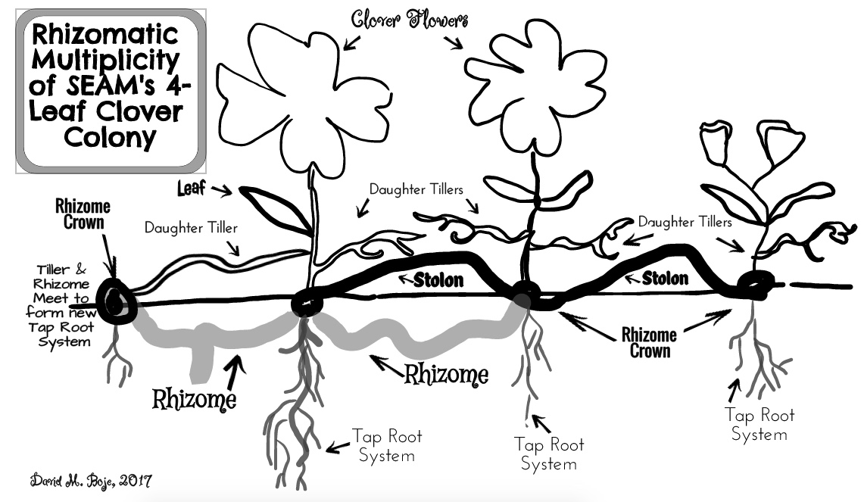

Figure 2: Rhizomatic Multiplicity of SEAM's 4-Leaf Clover Field
Above ground are Daughter Tillers, and Stolon (vines) connecting the Rhizome Crown. You cannot be a SEAM consultant without understanding the Science of Rhizome Multiplicities. 4-Leaf clovers are never alone because the are mart of the Positive Multiplicity of the Clover Field, which has many Rhizome Crowns, many underground Rhizome connections, and many above ground Stolon Vines and Daughter Tillers of a 4-Leaf plant trying to plant a new Rhizome Crown. Rhizome Crowns can also sprout form the Rhizome underground connectors. I learned all this form Grandma Catherine Boje, who used to tend clover flowers called Bearded Iris, an entire field of them (Boje, 2018a book).
Daughter Tillers and the Old Mother Rhizome.
"You will find five hearts’ with a B-concept, and a Fore-concept: Forecaring (becoming a gardener of Mother rhizomes), forehaving (before narrative & story), forestructure (between narrative & story), foreconception (beneath narrative & story), and foresight (making good bets, choosing the future of your garden, and bringing it about). Can you find the three flower blossoms? Notice how each is more than just a narrative and its counternarrative" (Boje, 2018a, Globalization book).
Narrative and Counternarrative are in a dialectical relationship, but the multiplicity of Living Stories are what Bakhtin (1981) calls polyphonically dialogical (Boje, 2008).The Antenarratives are their own multiplicity processes (Before, Between, Becoming, Beneath, and Bets).

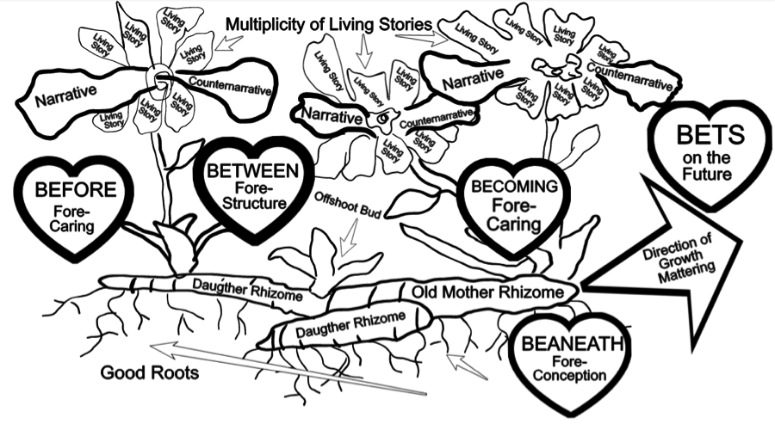Figure 3: Caring in Advance for ‘Mother’ and ‘Daughter rhizomes in my Grandmother’s Bearded Iris Garden
SEAM-Consulting is the competence to discern the difference between the cover-up of Narrative-Counternarrative Dialectics (negation of the negation thought to be Illusion by Deleuze and by Savall) and the Positivity of Living Story Multiplicity, positively connected and grounded to the Situation and Context. And deeper still are the Antenarrative Processes (the 5 B's in the Figure).
SEAM is a consulting intervention to unleash human potential to transform all the dysfunctions into positive financial consequences. Three forces of change occur as the small business consulting intervention winds its way through the spiral-axes: SPRIAL A three D-P-I-E interventions in 16 weeks, SPIRAL B six Management Tools taught to client, SPIRAL C Strategic Decisions to change six Financial Consequences, and a SPIRAL D (which we will introduce to you below).
The consulting project has three spirals: A, B, and C.
- A is the three DPIEs (Diagnosis, Project, Implementation, & Evaluation).
- B is the 6 tools of SEAM you are to train your clients to perform
- C is the 5 Strategic Decisions in the Order they may arise.
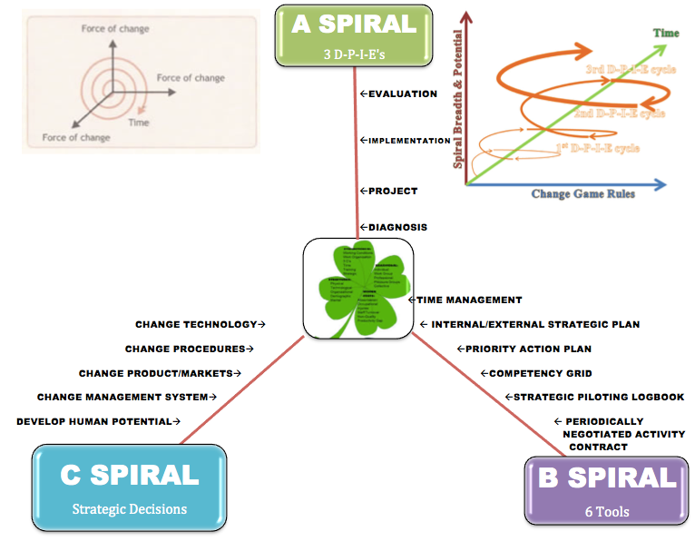

Figure 4 - The A-B-C TRIPLES SPIRALS OF Transformation of the business to achieve human potential (Adapted by Boje from p. 26 of Savall et. al 2008 book)
A business consultant tries to help the client create better processes, and those processes are spiraling, in good ways, and in bad ways. This is done by implementing 3 D-P-I-E cycles of improvement.
A-spiral. This is at several levels. It is a PNAC between consultant and client, so expectations stay eye-to-eye over course of the 3 projects. Second, it is a PNAC training that you do with the client so PNAC's are used in the business with all the employees. And it is about compensation. If the employee helps move the firm into updraft, into more money, more customers, more revenue, less waste, etc, then what is going to be the reward, the payout for them. How do they participate in the good times? Yes it is profit-sharing, but also accountable for any of those six root-stems under the 4-leaf. By now the client should be familiar with all 6 tools and using them to pilot their business on the upward spiral-antenarrative path. If they are just repeating the same old business cycle, then your consulting has not worked. (Savall et al, 2008: pp. 108-112). This is the student consultant’s 3 main goals, action plans, and indicators for one semester. Teams can use the format of Table on p. 110 of Savall et al., 2008.
SEAM Small Business Consulting must be within 9 Planetary Boundaries to prevent 6th Extinction Event
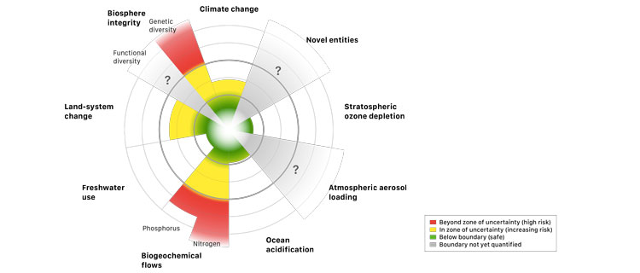

Figure 5 – 6th Extinction from Ignoring 9 Planetary Boundaries

NINE PLANETARY BOUNDARIES | _ Boundary 1. Climate Change | _ Boundary 2. Biodiversity Loss | _ Boundary 3. Biogeochemical (phosphorous change | _ Boundary 4. Ocean Acidification
_ Boundary 5. Land Use Crisis | _ Boundary 6. Fresh Water Crisis | _ Boundary 7. Ozone Depletion | _ Boundary 8. Atmospheric Aerosols | _ Boundary 9. Chemical Pollution by Plastics & Heavy Metals

The SEAM Client and Student Consulting Team Picks some of the 17 UN Sustainable Development Goals to TRANSFORM SMALL BUSINESS with True Storytelling and SEAM
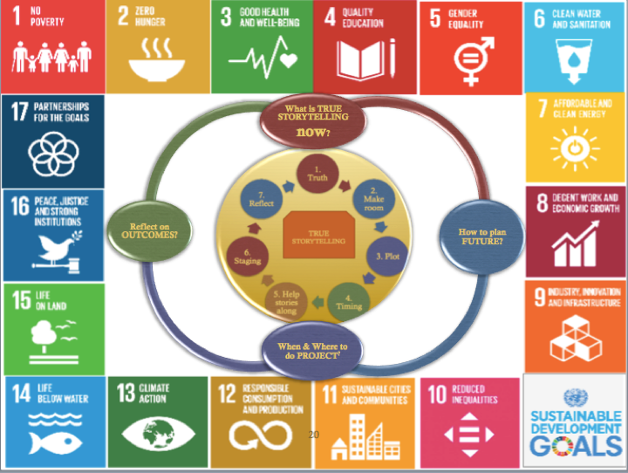
Read more about each goals and subgoals

Figure 6: True Storytelling and 17 UN Sustainability Development Goals

PART II. Report is organized in 23 Consulting Steps:

Step 1 - DIAGNOSTIC (A-spiral) and your Team’s 1st round of PNAC

PNAC (Periodically Negotiable Activity Contract) TOOL
PNAC is between student consultants and client change over course of the term. Be sure to manage expectations between all parties. The job of the student consultant is to coach and mentor, not to be a slave or assistant to the client. You don’t do the work for the client, and you consult by listening, observing, and working with client to generate solutions.

FIRST TOOL to IMPLEMENT - PNAC (Periodically Negotiated Activity Contract)
PNAC (Periodically Negotiated Activity Contract) Date of Contract____/____/2018
STUDENTS NAMES:
NAME OF CLIENT’S BUSINESS:
INSTRUCTIONS: First check ☐ particular Goals and Boundaries Team & Client are most interested in. Then fill in the Client’s Main Business Development Objective, and Outline 3 DPIE’s with your client.
☐ Goal 1. End poverty in all its forms everywhere |  | ☐ Goal 2. End hunger, achieve food security and improved nutrition and promote sustainable agriculture |  |  | ☐ Goal 3. Ensure healthy lives and promote well-being for all at all ages |  | ☐ Goal 4. Ensure inclusive and equitable quality education and promote lifelong learning opportunities for all
☐ Goal 17. Strengthen the means of implementation and revitalize the global partnership for sustainable development |  | CLIENT’s MAIN OBJECTIVE:  TEAM’s 1st DPIE:  - When  - Where  - Who is involved  - What resources  - Why  TEAM’s 2nd DPIE:  - When  - Where  - Who is involved  - What resources  - Why  TEAM’s 3rd DPIE:  - When  - Where  - Who is involved  - What resources  - Why |  |  |  |  | ☐ Goal 5. Achieve gender equality and empower all women and girls
 |  |  |  |  |  |  | ☐ Goal 6. Ensure availability and sustainable management of water and sanitation for all
☐ Goal 16. Promote peaceful and inclusive societies for sustainable development, provide access to justice for all and build effective, accountable and inclusive institutions at all levels |  |  |  |  |  |  | ☐ Goal 7. Ensure access to affordable, reliable, sustainable and modern energy for all
☐ Goal 15. Protect, restore and promote sustainable use of terrestrial ecosystems, sustainably manage forests, combat desertification, and halt and reverse land degradation and halt biodiversity loss |  |  |  |  |  |  | ☐ Goal 8. Promote sustained, inclusive and sustainable economic growth, full and productive employment and decent work for all
☐ Goal 14. Conserve and sustainably use the oceans, seas and marine resources for sustainable development |  |  |  |  |  |  | ☐ Goal 9. Build resilient infrastructure, promote inclusive and sustainable industrialization and foster innovation
☐ Goal 13. Take urgent action to combat climate change and its impacts |  | ☐ Goal 12. Ensure sustainable consumption and production patterns |  |  |  | ☐ Goal 11. Make cities and human settlements inclusive, safe, resilient and sustainable | ☐ Goal 10. Reduce inequality within and among countries
NINE PLANETARY BOUNDARIES: | ☐ Boundary 1. Climate Change |  |  | ☐ Boundary 2. Biodiversity Loss |  | ☐ Boundary 3. Biogeochemical (phosphorous change | ☐ Boundary 4. Ocean Acidification
☐ Boundary 5. Land Use Crisis | ☐ Boundary 6. Fresh Water Crisis |  | ☐ Boundary 7. Ozone Depletion |  |  | ☐ Boundary 8. Atmospheric Aerosols | ☐ Boundary 9. Chemical Pollution by Plastics & Heavy Metals

Introduction to SEAM
(Select what you leave in report so Client knows what you are doing; Put your own numbers and verbatim field notes in report and take out the examples in yellow). Why does a business continue to get poor results? The accounting and management information system has HIDDEN the ‘real story’ from the decision makers and is handing over a very shallow narrative in the income statement and traditional accounting storytelling. Therefore, the consulting approach is to LISTEN to the current face-to-face, and in-action storytelling, in-order-to unearth the DYSFUCTIONS, asking questions about the HIDDEN COSTS, and the UNTAPPED REVENUE POTENTIAL so the client can LOOK In the MIRROR and see the ‘real story.’ The REAL STORY is in 6 FINANCIAL CONSEQUENCES that drive HIDDEN COSTS and RESULT FROM all the DYSFUNCTIONS.

Table 1 - SIX DOMAINS OF DYSFUNCTIONS CONSTITUTE FAMILIES of Themes & Sources of Quotes
1. What are the Working Conditions? Your activities? Your resources? Rewards? Work Space? Routinized? Chaotic? Poorly assigned tasks? Degree of multi-tasking? What improvements would you like to see? What are the sustainable and unsustainable practices?
2. What is your Work Organization? Bureaucratic? Mechanistic? Top-Down? Political? Flexible? Distribution of tasks? Promotion options? Lateral movement? What improvements are needed? How Green is this organization?
3. 3C's (Communication, Coordination, Cooperation). How is the communication? What are the concrete problems that result when 3C breaks down? What kind of formal contact exist (meetings, appointments, written communication, emails, screens)? What are existing circuits of informal contact? What improvements do you suggest? Current procedures that pose problems for delegation? Coordination? Scheduling?
4. Time Management? What is your typical work schedule at the moment? What constraints trouble your time management? Do you regularly schedule ahead of time? What concrete problems are encountered? What would your ideal time schedule be like?
5. Training? What are the tasks for which you experience lack of training? What are your competencies that are not being used? Is there Green training?
6. Strategic Implementation? For you what are the priority areas of general policy? Who decides what they will be? Would it be necessary to clarify certain objectives? If you notice a discrepancy between objectives and accomplishments, what do you do?
Business Sustainability Indicators- Include detailed storytelling, living stories of sustainability and any interventions made to implement sustainability logbook indicators
Each interview that lasts about an hour should generate at least 10 pages of hand-written verbatim notes. Please record full sentences, put quotes around each verbatim statement. Do not put things in your words, use theirs. These notes and observations of hidden casts (untapped revenues) are basis for doing your Mirror-Effect meeting with your client. Please develop qualitative and quantitative LOGBOOK metrics of SUSTAINABILITY?
The Diagnosis is 3 to 4 weeks of just listening to the stories the client tells about the 4-leaf clover. You are listening to the storytelling as your diagnosis. It is called ‘conversational interviewing.’ You ask for history, how it all began, where it is going in the future? You mostly listen and don’t ask questions about the specific working conditions, work organization, Weberism, Taylorism, etc. That would be lame. Rather, use the TFW Virus and 4-Leaf as baskets (categories) into which you sort your stories and observations (fieldnotes).
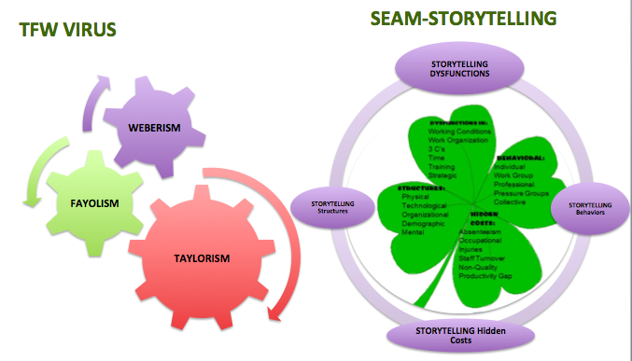

Figure 7: TFW Virus and relation of Storytelling Listening to 4-Leaf Clover Diagnosis
You are listening for hidden costs (costs not reported in the regular accounting system or info system of the client. When you encounter a hidden cost, ask ‘how often does it occur?’, and ‘approximately what is costing in his/her time to fill in, or in lost revenue, etc.’ Do not get shunted off to an account. We are looking for the owner’s managers, employee’s own approximations. If they don’t know what things cost, there are some major training needs.
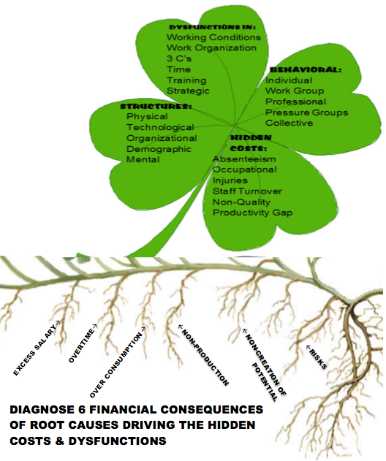

Figure 8- The SEAM Diagnostic Clover with Root Causes of Financial Situation of the Business
Notice that the SEAM Diagnostic Clover has 6 Financial Consequences of Root Causes that are driving the Hidden Costs and the Dysfunctions. This is the below-ground, the rhizomatic financial roots you are looking for in your diagnosis. Do not get side tracked. If client says, I need a marketing plan (maybe that is the SURFACE issue, and not the ROOTE CAUSE below ground).
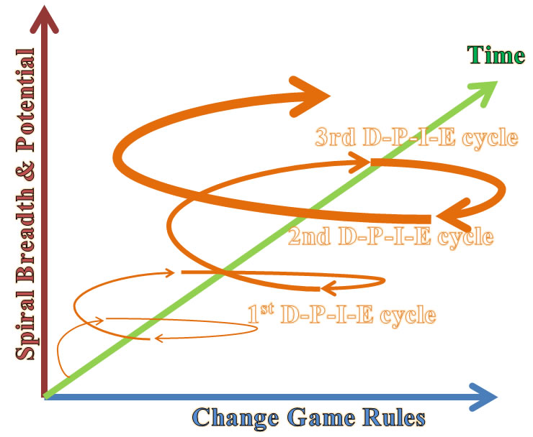

Figure 9 –Student Consultants will be doing Three D-P-I-E Cycles (aka whorls) that become an Upward Spiral A of Momentum Continuous Improvement - Drawing by Boje July 6 2012
Your challenge is to complete 3 DPIE’s in 16 weeks. With 3 to 4 weeks of listening to storytelling and sorting them into hidden costs and financial root causes, you will need to manage your time. That probably means about two to three weeks for each of the SMALL intervention PROJECTS, the IMPEMENTATION, and the EVALUATION. Each evaluation is a new MIRROR EFFECT (with its own verbatim diagnosis fieldnotes, hidden cost chart, and 3 student consultant recommendations for next project done in collaboration with client).
We will now introduce to the client, key consulting concepts, SEAM 4-leaf, A-B-C SPIRAL Model, and 3 D-P-I-E ‘s to create spiral of momentum for implementing SEAM, and summarize results of 3 mirror effect meetings (one for each D-P-I-E).
“Every system is perfectly designed to get the results it gets” (Hanna, 1984,1988).
DPIE stands for the cycle of Diagnosis, Project Design, Implementation of Project with the Client, and Evaluation of the Project. DPIE begins with a DIAGNOSIS – using 4-leaf clover categories: This begins by you asking the 6 Domains of Dysfunction, which you are to listen and make verbatim field notes OR you are to tape-record or video-record and then meticulously transcribe the verbatim answers in your Midterm and Final Report.
The Diagnosis covers the 4-Leaf Clover, beginning with the dysfunctions in upper leaf, the structures and behaviors. You are listening for areas of improving the ‘release of human potential’ and generating ‘untapped revenue potential.’ When you hear about a ‘hidden cost’ ascertain, the approximate cost of each occurrence, how many times a week, month, and year this happens, so you can generate your table of the MIRROR EFFECT.
Mirror Effect is the actual face-to-face meeting all team members have together with their client. The Mirror Effect has three components (1) your verbatim field notes, organized into types of dysfunction, structure, hidden cost observed, the root-tem associated with each; (2) the Table below where you report the individual and total combined HIDDEN COSTS & UNTAPPED REVENEUES, and (3) your three student consultant ‘expert’ recommendations.

Table 2 – Report for MIRROR EFFECT Meeting (Required Summary Table of Costs of Keeping Going the Way its Going)
Dysfunction, Structure, Behavior, Hidden Cost OBSERVED | Frequency of Each | Estimated Cost of each Occurrence | SUBTOTAL of Cost & or Untapped Revenue per person | Reasons for Each in the Narratives told | IDENTIFY ROOT-STEM: DOWNWARD ECONOMIC PERFORMANCE Downward SPIRAL of NMUS & Las Cruces
1. HC: Absenteeism & Turnover of NMSU janitors | 3 times a week | $50 | $150 | Had to have owner do job of absent printer | Excess Salary because upper level doing jobs of missing lower level people
2. Dysfunction: Time Management of Collection of Recyclables | 1 time each week | $100 | $100 | Printers wasting time | Overtime of the 2 remaining Facilities & service employees when there were once 6
3. Behavior: Conflict of Plastic Life style & Zero Waste Life style | 2 times a week | $50 | $100 | Behavior: two operators are fighting | Overconsumption of Waste to Land Fill, under performance of recycling
4. HC: nonquality of the Communication form Top of a Zero Waste commitment | 2 times a week | $500 | $1,000 | Dysfunction: the communication of specs for the job from clerk to printer was wrong | Nonproduction of Zero Waste since if top cares less, so does the bottom, if faculty care less so do students care less
5. Behavior: Professional Categories | 1 time a week | $400 | $400 | Dysfunction: Work organization | Noncreation of Human and Loss of potential Revenue of Zero Waste Arrowhead business development
6. Dysfunction: Integrated Training in Zero Waste | Once a year | $1,000 | $3,000 | New people just dump contaiminates into blue bins, and janitors untrained dump it to trash | Risk Spiral: THERE IS NO PLANET B, but we now need 1.7 planets of natural resources to keep up; Risk of Plastic Contamination to Water, Air, and Soil of Las Cruceans
TOTALS:  WEEK  MONTH  YEAR TOTAL |  |  | $ 1,750  $ 7,000  $87,000
Please include an analysis of the particular UN Sustainability Goals the client and Team are including in the project. Include how these are being measured in terms of Evaluation in each DPIE.

Sustainable Development Goals
- Goal 1. End poverty in all its forms everywhere
- Goal 2. End hunger, achieve food security and improved nutrition and promote sustainable agriculture
- Goal 3. Ensure healthy lives and promote well-being for all at all ages
- Goal 4. Ensure inclusive and equitable quality education and promote lifelong learning opportunities for all
- Goal 5. Achieve gender equality and empower all women and girls
- Goal 6. Ensure availability and sustainable management of water and sanitation for all
- Goal 7. Ensure access to affordable, reliable, sustainable and modern energy for all
- Goal 8. Promote sustained, inclusive and sustainable economic growth, full and productive employment and decent work for all
- Goal 9. Build resilient infrastructure, promote inclusive and sustainable industrialization and foster innovation
- Goal 10. Reduce inequality within and among countries
- Goal 11. Make cities and human settlements inclusive, safe, resilient and sustainable
- Goal 12. Ensure sustainable consumption and production patterns
- Goal 13. Take urgent action to combat climate change and its impacts*
- Goal 14. Conserve and sustainably use the oceans, seas and marine resources for sustainable development
- Goal 15. Protect, restore and promote sustainable use of terrestrial ecosystems, sustainably manage forests, combat desertification, and halt and reverse land degradation and halt biodiversity loss
- Goal 16. Promote peaceful and inclusive societies for sustainable development, provide access to justice for all and build effective, accountable and inclusive institutions at all levels
- Goal 17. Strengthen the means of implementation and revitalize the global partnership for sustainable development

(Also please see SEAM BOOK: p. 55 Figure 5.2, p. 58-9, Figure 5.23 & 5.24 through p. 62 Figure 5.25.c; and in Chapter 6, p. 86 Figure 6.7, Appendix 3 & 5 for several other examples of Creation of Potential and Hidden Cost Calculation forms as templates to use in Mirror Effect if they are more appropriate).

MIRROR EFFECT SEAM VERBATIM NOTES (required for any grade above C)
Here are some examples of how to insert transcribed answers to questions and observations into your report from Charmayne Thomas’ 2011 report:
Direct Quotes:
Tara: “The shop just isn’t busy enough to stay open all those hours; I don’t miss but maybe one customer if that.” Also, “If I have something come up like my child needs cookies for class or help on a big project, I’ll close the shop to go home because that is more important to me than the one or two orders that I might miss.”
Mary Ann: “People will call me at work and ask if the shop has closed down or when we will open again because it is closed every time that they go there.”
Merri: “The flower shop is just a family business that barely makes enough money to support itself. When a family member needs a job for some extra money, they can get a job there. It only pays minimum wage, which is probably less than you deserve, but it usually is helping both parties regardless. Tara started working in 1996 as the only employee except during holidays or busy seasons when the rest of us would be there working along with her. She didn’t like the minimum wage, however. In 2006, she quit because it didn’t pay enough, so I took over her job and started doing the daily orders. In 2007, Tara came back to work, but Mary Ann (the owner) and her have always been a little on edge since then. Mary Ann is afraid to tell Tara anything because she doesn’t want her to quit again or to cause family problems.”
Merri: “We used to advertise at the high school and have deals for students around Prom and other formal dances. We’d get around 100 orders for each dance. Now, we are lucky to get 10 orders.”

Here is student example of Mirror Effect from a 2011 report by Alyssa Reynolds

The first dysfunction is described in the following question:
Seems like your biggest issue is a productivity gap?
At the office, everyone always comments on my organization, but at home my office is a mess.
How much time do you feel that you waste to the mess?
It’s more of an energy drain not to be neat and clean.
I believe that time spent thinking about, or avoiding the mess could be better allocated to productive activities. The upfront cost of this process would be worth the long term addition to productivity.
The second dysfunction:
Are there ways that you could improve the effectiveness of your assistant?
Give her more hours. As my business level and income increases she will be doing more of what she is doing already. There is not much else I want her to do right now. She’s very efficient, and we’re working on creating a listing checklist for all the new listings to ensure that ALL of the steps are taken care of.
Is she going to be maintaining those lists?
I’m creating them, and she will maintain it and be thorough. Most of the tasks involved she is doing. Sometimes there is confusion about what things she is expected to do, because if I take a listing on Friday, I will go through and do some of the things I otherwise would expect her to do.
Is there a centralized place you could keep these lists?
We keep them in the office in a file. We do need to create a centralized online storage system for files like this. I trust her to do it, it’s just a matter of communicated to her that it needs to be done. –Something else I’m going to check in to is a team software called Top Producer. They have a centralized storage place for information. I’d actually like to be able to use the E-edge software.
This indicates that communication could be improved through the addition of new technological structures which would enable effectiveness of both Laura and her assistant.
The third dysfunction is a lack of organizational structures that result in an inability to seek and embrace growth:
What is your biggest fear of increasing your effectiveness?
This is a business where you cannot afford to let things slip through the cracks. You cannot make mistakes. This is the biggest financial decision in a person’s life, and it is emotional. I cannot afford to be so effective in gaining clients that I mess things up.
If you were to increase your clients, it would affect the quality of your business?
I am more concerned about legal issues. In fact, you can wreck your business.
The fourth dysfunction is a need to step up the impact of the website in order to better utilize a new tool:
Do they have additional tools you have considered investing in?
I pay an 8% franchise fee. They are creating a virtual agent service that will make it easier for people to get all of my information.
This new tool, will allow people to access listing information directly from Laura’s site, using a smartphone. If she is on the forefront of this technology, she could attract new listings and buyer clients.
The fifth dysfunction encountered is as a result of a failure to block time. As described by Laura below:
Describe your time management practices:
“How would I describe it? The first thing that comes to my mind is my Top Gun coaching class that I took. One of the classes is time blocking which is something I want to do. People who are self-employed tend to do this. I’d like to set up my time to spend this hour doing phone calls, this hour doing e-mails, but part of the reason I got in to this business was to have a flexible schedule for my kids.
“Disjointed with room for improvement, but effective
“Being a mom has always been my priority, as long as I have kids at home.”
The sixth dysfunction is a focus on listings for clients. Though listings create a REALTOR’s ® solidification in the market, not acquiring investors trying to capitalize on the downturn in the market is a loss. Also, these investors could create valuable referral possibilities.
Right now what are you looking to do or working on to improve your business?
Taking more listings. List to exist
What are some of the ways you are doing that?
Calling on expired’s, referrals, For Sale By Owners
Out of those techniques, which is most effective?
Referrals.
Part of Mirror Effect is the Structures and Behaviors. Here is a good example from the KLMX consulting report:
Right Leaf: Atrophied Behaviors:
Individual- “Everyone works individually when they are performing their job duties. The DJ is busy playing the music, I am working the daily logs, and the manager is working the bills, and working with our clients.”-Geoffrey Maestas
Work Group- “No matter what, at some point the employees have to work together. The radio station can’t run, without team work. There aren’t many employees, so it’s not that difficult to work together.” –Geoffrey Maestas
Professional Categories- The categories within KLMX are owner, manager, music/production director, and DJ.
Pressure Group- There is no organized groups within or external to KLMX.
Collective- Facebook.
Left Leaf: Atrophied Mental Structures:
Physical- There is one location from which all business activities are conducted. “There’s an office for the manager. There’s a control room where the DJ sits. We have a production room where we record everything and its sound proof. And then we have an open office with two different desks for operations.”- Geoffrey Maestas
Technological- “We upgraded our systems a couple years ago. In a way it’s good, but in a way it’s bad. It’s good, because during the night we can put the program in and leave it. Then music just plays till we get back in the morning, but it’s also bad because it has become overly used. We don’t do as many live shows as we used to. For instance we have lost that fun aspect of the business…….So if the internet goes out with the new system, we have no radio, because with the new system and the radio runs in unison with the internet.” - Geoffrey Maestas
Organizational- The employees that work at KLMX work together, but each employee plays a significant role in the operations of the radio station. The radio station only has three employees. The manager is responsible for handling bills, selling advertising, and marketing. The music/production director handles the day to day activities. These activities being the music being played throughout the day, the recordings and making sure the radio station is staying on schedule. The DJ is responsible for the news and the weather, as well as, direct interaction with the community.
Demographic- Clayton, NM and its surrounding areas only have one radio station, KLMX. Therefore the demographics for the station are all ages. The community as a whole tunes into KLMX to hear local news, local games, and music.
Mental- A grass-in-the-head person, writes Boje, has "a desire to be an assemblage of animal herds, family clan, orchards, beehives, and crafts." A tree-in-the-head person, he says, "can only think from beginning stage to end stage, from root to branches in developing strategy, plans, designs..."”( http://www.huffingtonpost.com/mike-bonifer/cenk-uygur-has-a-tree-in-_b_946062.html ).
We believe KLMX to be on its way to being a “grass-in-the-head person” because of their desire to work more closely with the community. They want to be the force with which brings the people of the community together and helps find value within each individuals business. In a sense they want to bring each unique family of the community together and make it one big bright herd with which will become a shining example of how a community should run.
- SPACE (Landscape) IN THE MARKETPLACE OF COMPETITORS - St. Genevieve has the same $1,199 blackout as the Legion; Elks’ blackout is $800’; Three Crosses blackout is $700. There is also market space for Knights of Columbus and Tortugas (Mesilla). Legion is vying for top market share in the Landscape.
- TIMESCAPE – Saturday and Wednesday events all year round, and the preparation for the events, the managing of the events. Bill and Fred start work at noon and leave at 9PM (or later), and then put in about 5 or more additional hours doing accounting, supply runs, and passing out flyers to boost attendance. They supervise 3 cashiers (none of whom are Legion members), 1 caller (not Legion), 4 cleaners working to empty baskets from each table 4 times each evening (1 is Legion), and 4 food people (none are Legion).
- MATERIALSCAPE – Material things like money, supplies, utilities, the hall, tables, chairs, and bodies (workers, managers, caller, clean up crew, food crew, Legionnaires there and not there, and customers there and not there), and any profit once bills are paid. A sizeable number of customers are families, some with children. Bingo materiality is not just the elderly. About 12 players are handicapped, and have reserved places in the materialscape of other players. I think if you counted the number of Fred and Sam’s relatives, playing, it’s what keeps attendance excelling.

If they are in a Death Spiral please let them know
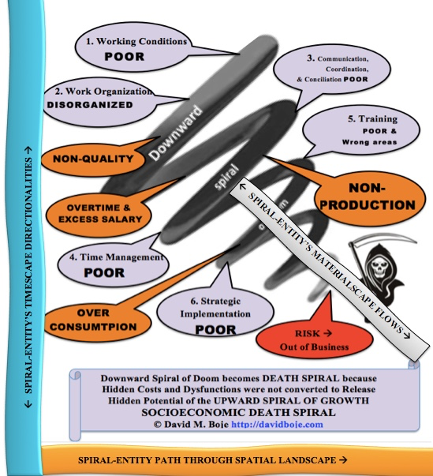

Figure 10 - The death spiral from socioeconomic view© David Boje Aug 6, 2017
FINANCIAL ROOT STEM CONSEQUENCES OF THE WAY IT IS NOW (the result of all the dysfunctions and the hidden costs):
- Excess Salary
- Overtime
- Over Consumption of Resources
- Non-Production of goods and services
- Non-Creation of human potential
- Risks that things will get worse and worse
PRINCIPLE 1: Upward Spiral momentum is generated and accelerated by doing 3 DPIEs, one after the other, building upon one another. Here is an example of combining 3 DPIE loops (also known as whorls).
You enter the client's 'Death Spiral' of accumulated dysfunctions, hidden costs, and conflicts are escalating (maybe manifest outbreaks). Co-construct an organic matrix whorl-by-whorl, one DPIE at a time, until a Spirally Coiled rate of growth takes on momentum. The rate of growth per whorl (each DPIE) is around a coiling axis, in shape of a generating spiral curve that has 'ontologic growth changes' as the small business reaches socioeconomic health. Then you do you 1st DPIE (whorl) and get a little movement, then your 2nd (whorl) gets a bigger upward spiraling, and you top it off with the 3d DPIE (whorl). Think of 3 momentum growth phases. Phase 1: you encounter and document all the dysfunctions (enter Death Spiral (if its there)). In Phase 2, co-construct with the client (never for them), 3 DPIES in a succession, building upon one another (not 3 objectives, you pre-design at get-go, that won't do the turnaround). Then in 3rd Phase you leave the client prepared to carry out their own DPIE, because they know the tools (Spiral B) and they have made Strategy moves (Spiral C).
PRINCIPLE 2: The Double Spiral of flushing out Hidden Cost Downward Spiral converting savings to the Upward Spiral of revenue generation 3 DPIEs. The three dimensions form the space (landscape) timescape, and materialscape. Part of this principle is the inseparability of space, time, and materiality, that is called spacetimemattering. We implement 6 tool with (not for) the client along the B-Spiral. You will have three MIRROR EFFECT meetings showing the client the hidden costs and untapped revenues that can come with the implementation of the first or next DPIE (3 in all).
PRINCIPLE 3: The Double Spiral of flushing out Hidden Cost Downward Spiral converting savings to the Upward Spiral of revenue generation 3 DPIEs. The three dimensions form the space (landscape) timescape, and materialscape. Part of this principle is the inseparability of space, time, and materiality that is called spacetimemattering. We implement 6 tools with (not for) the client along the B-Spiral. You will have three MIRROR EFFECT meetings showing the client the hidden costs and untapped revenues that can come with the implementation of the first or next DPIE (3 in all).
PRINCIPLE 4: 3 Spirals, A (3 DPIEs), B (6 Tools), and C (Strategic Decisions) form the basic TRIPLE SPIRAL, which revolves around the 4-Leaf Clover model at the center.
PRINCIPLE 5: The worst consultants work on the symptoms of the problem. The best consultants dig deep into the financial 'root stems' beneath the hidden costs.
PRINCIPLE 6: Follow the 23 steps and you will succeed
The student consultants do three Mirror Effect meetings, one for each DPIE. It includes a face-to-face meeting with client, reading back verbatim notes categorized by the 4-Leaf categories, and a Table showing the hidden costs, untapped revenues. Mirror Effect is holding this mirror up to client so they see how to save hidden costs and get at untapped revenues by doing the 3 DPIE cycles.
Implementing the mirror effect in an actual face-to-face meeting with the client where direct quotes from manager, employees, customers, and suppliers are displayed and discussed to diagnose areas that made need fixing, particularly stem-roots which are the cause of surface problems that the client is talking about. You report on this meeting at mid-term. With the mirror effect, you are able to use this diagnosis to come up with solutions and recommendations. Using direct quotes from the client, you can tell them reference them back to the problem and then what the underlying cause may be. This is helpful when giving recommendations because they are better able to see why you are recommending that solution. There are three components to mirror effect: presentation of direct ‘storytelling’ quotes (verbatim) sorted by managers, employees, customers, & suppliers; (2) a table of hidden cost and revenue calculations, and (3) the student consultant observations and recommendations.

Step 2 Time Management Tool: Spiral B’s first tool
Purpose of Cycle Time Redesign - The whole purpose of cycle time is to reduce the variances in-order-to decrease production time cycle, which in turn lowers personnel, inventory, and order costs (decreases returns), and up to a threshold, will increase product quality, increase production, and thereby increase goods available for sale. It is important to notice the variances, those disturbances, delays, and human errors that extend cycle time beyond what it could be. Reducing variance gets rid of non-value-added (NVA) tasks and steps, to streamline the production cycle.
First part of Time Tool - inventory every cycle in the business, and this will get you to an understanding of how from cycle-to-cycle, each time there is a difference, and that difference can be good, an improvement, such as upcycling, a value-added time, a quality time. Or time cycles can be very bad, lots of dysfunction, something at variance such as low quality, non-production, wasteful materials, higher costs, non-sustainability, such as downcycling. You will have to observe, cycle after cycle, not just measuring time on the clock, but the value-added of activities in a production cycle, a marketing cycle, inventory cycle-turns, cash-to-cash cycles (see Boje’s 2001 book, Quantum Spirals for Business Consulting).
Second part of Time Tool - based on your observations and interviews with lots of folks, figure out how management is using their time. Fill in the following chart, and put in quotes, stories you wrote down or recorded in the answers to D-questions. The last two D-questions and the one on Datability are good ones for this part of your report.

Figure 11 – The Five Aspects of Time (click on the figure above to change the image)
For example, the new time management after 3 interventions could look like this

Figure 12 – The Adjusted Time Results of diagnosis of 1st DPIE (Note the wedge on the pie chart should be resized to reflect your client’s situation)
1st DYSFUNCTION: (Shift in Function) REDIRECT EXCESS TIME that is definitely not adding value to the business (its sales or services, its strategic outcomes); tasks or functions that need to be abandoned, transferred, DELEGATED, or eliminated. The client’s answers to D-questions (Dispersion & Detaching processes no longer needed) can be included here. This is where you get the time needed to do 3 to 5.
2nd DYSFUNCTION: (Regulation of Dysfunction) DEFICIENCY TIME – Time spent correcting mistakes such as rework, due to dysfunctions that could be resolved in production, marketing, cash-to-cash (i.e. time it takes to convert inputs to cash flows), inventory, ordering time, etc.. This includes lack of good habits of action. This is also where by resolving deficiencies in quality and productivity you get more time to do 3 to 5. 1st and 2nd Dysfunctions get resolved so that ...
3rd is More Value Added Time is available: Savall et al., (2008) calls it ‘Day to Day Management’– Time that adds value to the production of goods and services, to necessary functions. Teach clients to maintain these value-added habits of action.
4th is Prevention of Dysfunctions by pro-active use of tools (Time management, logbook of indicators, PAP, I/ESP, PNAC, & Spiral Updraft) and making the strategic and political choices (main directions, rules of the game, etc.) so 1st and 2nd dysfunction do not happen. Distracted owners who forget to prevent 1 (excess dysfunction) and 2 (deficient dysfunction) are spinning their wheels, putting out fires instead of preventing them. This also needs to become a habit of action.
5th is Creating Revenue Potential – Time on the Middle Path: This is two things. First, it is tending to the stem-roots of the business (Excess Salary, Overtime, Risks, Non-production, Over-consumption, & Non-creation of Potential Revenue). Second, it is the C-spiral, shaping the future with strategies that enhance revenue potential: main directions, rules of the game, expand the market, build capacity, advertise, market, etc. It is an investment of time in the future that a small business cannot do without, if 1 and 2 and 4 are out of control, or no #3 (value-added) is consistently happening. It is oftentimes the most neglected area, because there is no time left to do it, if 1-4 are out of control. Again, this needs to become a habit of action. Practice the reducing 1 & 2 in your own life so you have more time for 3, 4, and 5. Then teach it to your client.

Time Management Tool Diary Questions (ask and answer only ones that apply)
1st DYSFUNCTION: EXCESS TIME ON WRONG STUFF
- How much time do you spend putting out fires?
- How much time do you spend doing things others could be taught to do?
- How much time do you spend doing other people’s jobs that don’t show up?
2nd DYSFUNCTION: DEFICIENT TIME
- How much time do you spend correcting mistakes other make?
- How much time do you spend because materials are not right?
- How much time do you spend in rework?
3rd More Value Added Time
- How much time do you spend that is adding value in the long-term?
- How much time do you spend expanding your market?
- How much time do you spend innovating?
- How much time do you spend implementing strategic moves?
4th PREVENTING DYSFUNCTIONS
- How much time do you spend training so dysfunctions do not happen?
- How much time do you spend creating systems that work well so dysfunctions don’t keep happening again and again?
- How much time do you spend listening to people you work with so you learn together to stop dysfunctions before they happen?
5th CHANGING THE STRATEGIC DECISION TIME
- How much time do you spend changing the direction of this business, so you get results you want to get?
- How much time do you spend changing the rules of the game (procedures, policies)?
- How much time do you spend reploying resources needed to get job done right?
- How much time do you spend developing new technology processes to get it done right every time?
- How much time do you spend developing the kind of flexible, agile management system that stops the bureaucracy, so you getting to success?
- How much time do you spend developing human potential?
- How much time do you spend developing a sustainable business (profit, people, & planet)?

Step 3 - Direction (C-spiral), which is also the 1st D-question (Directionality) of D-Spiral. DO NOT OTHER ANSWER QUESTIONS HERE – this is only to give to CLINET AS OVERVIEW. ONLY DO answer to Directionality

Table 3 – 11 D’s of ‘D-SPIRAL’ Questions (note these occur along the 23 steps (Note this is list of the D’s, they are covered in the individual steps so do not ask them all at once)
11 D's | Q to ask your client | Where it helps you Client Consultation
Directionality | 1. What is the directionality of the business processes; to what future are they headed? | Axis C: Direction. This is not compass direction; it is strategic direction, arriving from the future-->present.
Datability | 2. What is the datability of the business process developments? | 4-Leaf Structures: Important pivotal dates where technical processes, physical and other structures were acquired
Duration | 3. What is the duration of various business processes? | Axis C: Strategic Choices - helps sort out how long various strategies have been in effect
Disclosability | 4. What is the disclosability of the future business processes revealed to you? | Axis A - projects that disclose a future, Axis B - PAP and I/ESAP; SI in top leaf. The future is arriving into the present, presenting a set of potential futures, in the choice points in Axis C
Destining | 5. What is the destining of the processes unfolding in ways you can foretell? Follow up, in fore-caring, fore-structuring, fore-having, fore-conceiving. | Axis B: PAP & I/ESAP; Axis C - all items. This is weak destiny, where even where the is momentum and carved channels in the market, there are also choice-points among futures
Deployment | 6. What is the deployment of business processes, in-order-to, for-the-sake-of? | Axis B: PAP & I/ESAP; Axis C - all items. Look at existing processes of production, distribution, & consumption. How are these processes deployed. How could they be?
Dwelling | 7. What is the dwelling, in-place in the world of business processes? | Knowing place in the market, in the state, etc. lets them sort out Axis B: PAP & I/ESAP; Axis C - all items
De-severance | 8. What is the de-severance (de-distancing) of space-time-mattering? | De-severing space is bringing something far close. De-severing time can be bringing a future potential into the path of SAP and I/ESAP and the Axis C choice-points.
Drafts | 9. What are the drafts, updraft, and downdraft, into tighter (down) orbits, or into more open outer orbits (up), and the turning points from one draft to another? | Axis A, B, & C. This is where the client and consultant sort out strategic choice points, moving into more updraft spiral-antenarratives, ascending into more potential
Dispersion | 10. What is the dispersion of processes, too diverse, or consolidating them? | This can free up resources to invested in more strategic processes, letting go of low-value added activities
Detaching | 11. What is the detaching from being drawn into they-ness, they-relations, they-self and finding a path of ownmost authentic potentiality-for-Being-a-whole-Self? | Following the they-crowd is not great strategy. Developing into whole-Self potentiality fits well with Axis C
There are places in the steps that follow for you to include transcriptions of the D questions. For transcribed examples of answers to D questions, please see Boje's YouTube film on blacksmithing businesses. Put the transcribed answer here. Keep in mind your consulting focus: to help your client move out of many dysfunctions and poor root-stems, and using the savings and income potential, construct step-by-step an Updraft-Spiral. This means sorting out direction in the C-spiral, asking about choice-points, when at the cross-roads, which way will the client be turning? Ask about the directionality, not from the past to present, but from the future. Strategy foretells the future. It is not a repetition of the past (that is aimless). Think strategically, and act it. Ask: How is the future arriving, and what is the array of futures that are potentially available? There is never just one future, except in linear/cyclical thinking. The cycle never just repeats itself exactly. Silly rabbit. Even the continuous cycle time and quality improvement folks know the cycles do NOT really repeat, instead they spiral. It is time to notice how the last cycle is not the same as this one, to note the differences, so you notice the choices. It is all about the differences. It is noticing differences just arriving, like the customer coming in wanting a slightly different product or service configuration. Noticing the flows of action, that is the second sort of storytelling. That is what choice-making is all about. What? The action-storytelling, where there are no words said at all. So you will need to observe the direction, not just talk about it. Look at the processes in place, unfolding, and the direction of their transformation, and what transformations are arriving.

Step 4 - Project planning (A-spiral) done collaboratively with your client.
You are not to do the Project yourself. You are working with your client as their consultant team. What project can the client implement quickly, without a lot of resources, by freeing up the time you found in Step 2. Teach the D-P-I-E of A-spiral, and get ready to do three of them. Each should last about 2 to 3 weeks, wo you have time for three.

Step 5 - Strategic Piloting Logbook tool [THIS REPORT] (B-spiral)
Please begin creating indicators with your client so you can measure progress (qualitative, financial, and quantitative indicators help to pilot the direction). Indicators are as simple as deadlines, mileposts, number of new customers, number of web hits, etc. Add in some sustainability indicators: power usage (a simple indicator is the electric bill, the water bill), power waste (lights left on, water wasted), power sources (find some sustainable ones), and cut the waste by recycling, reducing, reusing, etc. You won't know where you are going or if you have arrived, unless you create some indicators. Don't leave it to the accountant. Do some ABC or your own (Activity Based Costing) by figuring out the hidden costs of the business doing as it has been doing on all those four leaves of the clover. Your storytelling notebook has entries about how to track things and serves as your SPILB. Develop 5 types of indicators (include qualitative & quantitative) for IESAP, PAP, etc. pp. 126-129 in Savall et al (2008) book. The piloting of a small business depends on reading indicators to know if the spiral is upwards or downwards, if the business is making or losing money, if customer returns and rework is decreasing or increasing, and so forth.
Type 1: EVERYDAY PERFORMANCE INDICATORS for SPL:
  - Internal Activity - e.g. volume of activity in a given day, week, month, or year. Examples: number of products, deliveries, repairs, amount of waste, delays, and each of the root-downsurge-spirals (excess salary, overtime, overconsumption, nonproduction, non-creation of potential, & risks) (see p. 33).
  - External Activity - e.g. scanning the business environment, being vigilant about competitors and the quality of materials from suppliers, new technologies, and other items on Axis C.
  - The Immediate Results - Quantitative indicators like costs, revenues, direct sales revenue, costs of repairs, dysfunction costs (absenteeism, occupational injuries/diseases, staff turnover, nonquality, & direct productivity gaps) (see. p. 33).
Type 2: CREATION OF POTENTIAL - INDICATORS for SPL:
  - Evolution Activity - e.g. Two lists: First a list of actions that implement the IASAP in this period of PAP by specifying schedule and who will do what when, and why. Second, a list of dysfunctions to be prevented based on Axis A Diagnostic. There is a multi-skilling going on here where people in the small business are learning to identify dysfunctions and root-stem-downsurge-spirals and to implement value-added TM, and to be vigilant with SPL. This relates to the CG tool, since some of these competencies must be learned. It it relates to Axis C, which is all about evolution activity of scanning the environment and making changes.
  - Activity Linked to PAP - e.g. Make a list with your client of developmental actions (above evolution activity list and dysfunction list_ and specify what is to be implement by whom, when, and why on the PAP chart (see chart below).
  - Activity directly Creating Potential - e.g. indicators of qualitative or quantitative nature of how potential is being created, how dysfunctions are being prevented, how downsurge-spirals are being up-rooted, and how employees are being multi-skilled in SEAM tools, including TM, SPL, and PAP.

Step 6 – CHANGE PROCEDURES to change Rules of the game - (C-spiral)
Business is a game and it is time to change the 'rules of the game.' There are choice points in the political and strategic decision making of every business. What game is being played in action, in the weaving of actions among the actors and the actants (things, technologies, equipment, mattering)? Who is making the game rules? How can rules be changed (ethically, See Aristotle 350 BCE, Virtue Ethics on line)? Are the rules of the game ecologically sustainable?

Step 7 - D2 – Datability (D-Spiral): What are the most important datable moments in the life story of the business?
Student consultants transcribe and put here those living stories of what is emerging, unfolding in the Now, not just the rote narrative of the past. Record them by tape and or video. This can be done on the first field visit. Most students don't pay attention to the first set of life stories the client says in that first interview. I think students have been trained not to pay attention to living stories, and look instead for the quick solution, and thereby miss the spiral altogether. A life story is primordial, from birth to death, and you are in the middle of yours, not dead yet, still alive, and already born, on some sort of pathway, even if you never thought about it. There are datable moments in your future, such as graduation, the next job, perhaps a wedding, children, etc. Datable moments are happening in your future, and arriving in your present, just as much as the datable moments from the past are arriving in the Present. People always capitalize the Present, but not the past nor the future. I think they know that with each newness in the Present, that emergence opens up a rehistoricizing of datable moments past, and opens up futuring so what you think will be the milestones shift in your landscape, and new ones are beckoning you to approach.

Step 8 - Mirror Effect meeting with client (A-spiral, part of D-P-I-E cycle)
Where you feedback the living stories and quotes sorted by stakeholders, present a hidden costs and untapped potential revenues chart based on questions asked in the 4-leaf diagnosis; and make 3 consultant observations and recommendations. This is a long meeting, a meeting about the text, the scripts you collected from employees, clients, suppliers, and whomever you could access. And it is your observations put into field notes on all those visits. Not a note taker? OK, get a good tape recorder, one with dual microphones (stereo microphones), and start recording conversations, in meetings, in interviews, wherever you have permission. By the time your mid-term arrives, you are advised to have the Mirror Effect face-to-face meeting with your client. It is where you point out the costs and lost revenues of behaving, structuring, etc. and how much dough they can have, and peace of mind, if they find what Aristotle (350 BCE) calls the middle path, the one between excess and deficiency, which is by the way the definition of all those dysfunctions you analyzed in the upper leaf of the 4-leaf.
Mirror Effect (Diagnosis) – And it is most important section in mid-term & final report where you put in all your posted entries from your [team] LOGBOOK (5 by mid-term, 5 more by final). Please use storytelling standpoint methodology. You collect the stories (verbatim dialogue) and you tell the stories in a Mirror Effect meeting with your client. They listen because you also share the costs and lost revenues that are happening by continuing to do just as they are doing, and all the lower costs and untapped revenue potential that comes from doing a project with you. Mirror Effect (Savall et. al, 2008: pp.66, 149) is defined as the direct quotes and the storytelling recorded from stakeholders (copied out of your individual Notebook interview & observation verbatim quotes), your own Expert Opinions (ibid, p. 66), & hidden revenue/hidden cost. I will give two examples.

It’s all about repetition and difference: The whorls occur in repetition but the whorls are each full of difference. Spiral is a concept, a representation of the shape and form of the whorls. Spiral is also an Idea, what and how it does ‘difference and repetition’ of the spiral happen? Concept and Idea of spiral are not independent, and do interact. To manage and organize Bingo you have to understand the concept of spirals. And you also have a really good Idea of how whorls are repetitions of the event twice a week that can be quite different if you know what to observe.
Making a Difference is Opposed by Overcoming Indifference: There are two types of indifference among our Legion members. Type one is the Abyss of Legionnaires who will have nothing at all to do with bingo. You hear them saying “I hate bingo” or “I never play bingo” or “I have nothing to do with bingo.” Type two indifference is the scattered Legion members who only see the calm waters of bingo events, pay some lip service to bingo being important to fund the Legion’s other events and keep the hall open, but are no less indifferent than Type one.
The Difference that ‘Makes All the Difference’: The abyss of indifference and the surface indifference are in relation to how many people from the Legion Post 10 actually promote, participate, and send their friends and relatives to play bingo. The ‘difference’ that ‘makes the difference’ is the determination of the Bingo-Spiral moving upward into profit, or it becoming a downward ‘death spiral’ into bankruptcy. Bingo-spiral is not a hobby, it’s an actual business. Nothing to play around with. Its not a game, when its life or death of a post.

An example of what to observe about Bingo spirals: Observe the weather difference. A few weeks a heavy rainstorm that flooded the streets interfered with ago Bingo at the American Legion Post 10 in Las Cruces New Mexico, and kept may people home. Instead of the usual 115 to 150 customers, there were 80 committed souls who turned up at the Legion’s Bingo Hall. Bingo happens on Wednesdays and Saturdays throughout the year. But every Bingo night is different.
Observe back to school season differences: Next Saturday it’s 13 August, a time period when parents and grandparents shop for school clothes and supplies for the young ones. This is an external event (school starting up) that will predictably lower attendance at Bingo.
Observe the backup players. One Saturday the ‘caller’ (reads off the bingo numbers) was away dealing with an illness, and the only Bingo manager, certified by the New Mexico Gaming Commission to be a caller was out of town. So Bingo was cancelled, and instead of 115 to 150 customers, there were none. This sent ripple effects spiraling into the future attendance, until customers regained confidence that, ‘yes, Bingo still exists at American Legion, Post 10.’
There is a process of learning how to manage the internal and the external causes of spiral changes. For example, now the Legion knows it needs two back ups for the ‘caller’, a second Legionnaire (thanks Bruce) has completed training, filled paperwork with the state and is awaiting certification. If the main ‘caller’ of Bingo is absent, then there are two backup Legionnaires, ready to step in.
The same is true for having backup people to work the trash cleanup, every third game, during a Bingo night. I volunteered to do trash cleanup 9 August (Wednesday) and learned a whole lot about Bingo-spirals, and how to manage them. It takes four people to collect all the stubs and used cards, soda cans, and food wrappers, placed in little white or blue baskets, about three to a table, and not be walking about when the calling of the numbers resumes in the next game. It takes backup people, should one or more of the food workers be absent. Without food, people leave to get their own food elsewhere, and many don’t come back.
Observe the rules and laws of the Gaming Commission. It takes three staff plus two Bingo managers (Johnny & Cling), to handle the paperwork, help customers buy their cards and dabbers, and do it quick enough that people do not wait in interminable lines. The Gaming Commission must certify each staff person before they can handle the money.
Observe the supplies. When a type of card games or pull-tab game, runs out, a customer may never come back. If there are no more dabbers, those in need of a dabber, are disappointed, and may not return. They head to one of the four other main Bingo competitors in Las Cruces, and they spread the word, “Legion let its supplies run out. Don’t go there!” Rumors send ripple effects into the future spiral-whorls, for a long time, until forgetting sets in.
Bingo-Spirals have Symmetry and Dissymmetry: Bingo-spirals are dynamic systems, and each whorl is different in its repetition than the next one, or the one before. Bingo attendance, how the regulars come back and set in same seats is part of symmetry. Johnny, for example, sets out signs for some of the disabled regulars to have a particular seat at a particular table that they like. This required planning, going to Gaming Commission, with some forms for each handicapped person, wanting this service. Its what I call fore-caring, in advance, preparing for the whorl, so it has some stability and sameness, one night of bingo to the next. There is dissymmetry in and between the spiral-whorls, such as when there is no back up caller available, or no backup to clean up the litter baskets, or backup for an absented cashier. Sometimes this can shutdown the system, and other times just throw it into temporary disorder.
Bingo-Spiral Needs Effective Communication between the Elements: Communication takes place within and between whorls, and the social as well as the material elements express positive symmetry, or cancel each other out in dissymmetry. The communication of what is happening within the sociomateriality of the Bingo-Spiral-System is both the external signals (weather, back to school season, holiday, competitor increases Blackout payout), and the internal signals about the real movements of the spiral in attaining support and legitimacy as a central activity center of the Legion Post 10 (for example, executive post members working the event, members bringing entire family to the event, promoting the event by handing out flyers and talking it up as best in the city, etc.).
The Bingo-Spiral is a Network Fabric, a Snake’s Skin Stretched Upon the Wholly Shape of Internal Organs: The outward appearance, the skin of the Bingo-Spiral has its material repetitions (whorl-by-whorl) and the internal aspects of the snake are hidden from view, more secret, as the snake constitutes itself and sheds its skin. Outwardly the Bingo-spiral is a variable performance curve that has two dissymmetrical aspects, a spiral that can move up and down in profitability. However, to understand how it is moving profitably or losing money requires learning about the internal repetition within difference. The Bing-managers and the American Legion Post 10 executive committee must work together, to monitor the external (weather, competition, gaming trends), and manage the profit/loss curve by attending to the spiral signals. It is like swimming in the ocean, where there are currents and waves (back to school, actual stormy weather, etc.). You learn to swim with the current, crossing the waves, or flowing with the waves. You need practical familiarity with wave-signs and current-signs to manage Bing-spiraling. Some leaders say ‘do as I do” and others say, “do with me” and we work together to negotiate the waves of ‘difference and repetition’ (Deleuze, 1994: 23). Waves are different and they have repetition, whorl after whorl, the ocean spirals.
Rumors are Deadly Signs: When a customer does not get the seat they want, or the house runs out of the gaming card they prefer, it can create a bad wave, with consequence to the movement of the spiral, and to Bingo-spiral fortunes. Competing Bingo establishments gain the rumormonger, but perhaps to their own disadvantage. Still there is a lot to be said about paying attention to customers’ complaints, and dealing with difference instead of doing indifference to the feedback.
In sum, the difference that makes a difference is not being indifferent to the Bingo-Spiral. It takes a whole Legion to have a successful Bingo-Spiral, one that competes with St. Mary’s, Elks, and The Border Bingo. I was amazed at Fred and Sam, how much dedication, lots of hours, putting out flyers, stepping up and making a difference. I observed the indifference of most of us legion members, who don’t show up to bingo, don’t work the event, don’t invite friends and relatives, don’t make the difference.

Step 9 - Implement project (DPIE 1) in collaboration with your client (A-spiral)
Good advice, but many a student consultant has ignored it. Implementing a Project that the client is not on board with will lead to many headaches, even hard feelings. Clearly the spiral updraft is tugging you in a more amenable directionality. You did the Diagnostic, the Project plan, and now it is time to Implement and collaboratively, please. You are not here to be a slave. You are consulting, so they can do this on their own, with their own resources. This is first of three Projects (check your PNAC, and may be time to renegotiate, so you have three small changes in projects that are doable).

Step 10 - Priority Action Plan tool (B-spiral)
Please lay out three goals and action plan and who implements what for the next year (Savall et al, 2008: pp. 95-98). Goal 1 could be the first project, you have some basis for setting the PAP in motion. Doing (by workers) and Thinking (by owners) can become separated. The result of this sort of division of labor is a deterioration of “intellectual… virtues” of workers (Marx, 1867, Vol. 1, Chap 14, P. 362). As Marx puts it “division of labor … is an effect of past, and a cause of future progress” (ibid, p. 363). We don’t want linear PAPs. We want spirals of uplift of profits and revenues. Savall et al (2008) recommend involving workers in the PAP process, which in turn sharpens their Planning and Thinking in relation to their Doing. This way the spiral starts uplift by involvement by the ‘spurring of energy, decentralization, synchronization, while of course, enhancing vigilance.

Table 3 – Priority Action Plan Tool (adapted from Savall et al, 2008: p. 100).
STRATEGIC AXES | OBJECTIVES | PRIORITY ACTIONS | PEOPLE CONCERNED | JAN | FEB | MAR | APR | MAY | COMMENTS
 | 1. Crowd Funding proposal Lucky Ant's Crowdfunding for Small Businesses; RocketHub.org - The Community for Creative Crowdfunding
 | 2.
 | 3.
PRINCIPLES: | Spurring Energy |  | Decentralization | Synchronization |  |  |  |  | Enhancing Vigilance

2nd DPIE BEGINS ABOUT HERE Step 11 – Evaluate results of 1st DPIE and begin DIAGNOSIS 2 for 2nd DPIP Resource Deployment (C-spiral)
This will come from making priorities, cutting back here, and expanding in the implementation of project (step 9). PAP gets implemented with the cost savings and enhanced revenues you promised in the Mirror Effect meeting. Deployment is part of the Q-Spiral set of questions, so go back and listen to your recording.
Please include drawing of you 1st DPIE and how it affects the whorl-by-whorl spirally momentum co-creation of growth with your client

Step 12 - D3 and D4 (Q-Spiral: Durability and Disclosability)
Ask about durability of the various processes of production and distribution. Then ask about disclosability of the future arriving at their doorstep, to tell what sort of processes need to be fore-structured.

Step 13 – DPIE 2 MIRROR EFFECT # 2 (A-spiral) – and detail your metrics, the Logbook tool (B-Spiral) indicators you have documented to date
Then renew the Diagnostic, and Project # 2 gets planned, and implemented. And do 2nd Mirror Report for Project # 2 as part of that diagnostic.

Table 4 – reporting 2nd MIRROR EFFECT Diagnosis (each DPIE begins with Mirror Effect)
Dysfunction, Structure, Behavior, Hidden Cost OBSERVED | Frequency of Each | Estimated Cost of each Occurrence | SUBTOTAL of Cost & or Untapped Revenue | Reasons for Each | IDENTIFY ROOT-STEM: DOWNWARD ECONOMIC PERFORMANCE SPIRALS
1. Dysfunction:  Work conditions | 3 x/wk | $25 | $75 | Time and energy spent accessing items in disorganized office | Overtime (extra time spent doing non-value producing activity)
2. Dysfunction: Communication-coordination-cooperation | 4 x/wk | $20 | $80 | Failure to or miscommunication of expectations to assistant | Excess salary (time is spent clarifying or communicating instead of producing)
3. Dysfunction: Work organization | 3 times a year | $3,000 | $9,000 | Not having enough staff to increase client volume | Nonproduction (potential clients lost due to lack of staff)
4. HC:  non-quality | 2 times a year | $3,000 | $6,000 | Website needs to be dynamic in order to catch people’s attention | Nonproduction (potential clients lost due to refined image)
5. Dysfunction: Time management | 10 x/wk | $10 | $100 | Time spent transitioning between unrelated tasks | Nonproduction (time spent doing nonrevenue creating activities)
6. Dysfunction: Strategic implementation | 2 times a year | $4,000 | $8,000 | Failure to capitalize on investors looking to buy very low priced housing | Nonproduction (loss of potential buyers)
TOTALS:  Weekly  Annual  YEAR TOTAL |  |  | $ 255  $ 23,000  $36,260

PUT YOUR VERBATIM FIELD NOTES HERE FOR 2nd DIAGNOSIS, and REPORT ON 2nd MIRROR EFFECT MEETING RESULTS

Step 14 - Competency Grid (B-spiral)
It is time to assess existing competencies of each person in the firm, and do a second grid of what competencies are needed to get the business in uplift to their PAP and 2nd Project Implementation. This also gets them set for the longrange strategy coming up. (Savall et al, 2008: pp. 98-100). Develop a grid of people by their existing competencies, and a second one show the competencies needed to implement the PAP and IESP.

Step 15 - D5, D6, D7 (Spiral: Destining, Deployment, & Dwelling)
Time to ask the big quantum questions: What destining are they courting? How are they deploying to meet it? What is their place (dwelling-in-the-market-place and in sustainability with the Natural environment)?

Step 16 – Evaluation of 2nd DPIR – (A-spiral) Evaluate Project # 2, Diagnostic, Project plan for 3rd DPIE project, and includes 3rd MIRROR EFFECT meeting with client
And get into Implementation where the client is implementing and you are doing quite little activity.

Step 17 - I/E SP (Internal/External Strategic Plan) (B-spiral Tool 5)
Now that you have 2 projects completed, and a 3rd underway, it is time to take a turn in the path (Savall et al, 2008: pp. 93-5). Make a chart similar to PAP but over longer time horizon. This is a five year strategic plan with three long term objectives, action plans, who does what when, with more logbook indicators set up to measure their progression. The PAP was one year of the 5 years. This is the big game change, and it’s a way to get things to spiral instead of repeating same old stuff. Objectives are about sustainability, products, technology, developing human potential, market expansion, etc.

I/E SP (Internal/External Strategic Plan TOOL)
OBJECTIVES | 2016 |  | 2017 |  | 2018 |  | 2019 |  | 2020
 | Spring | Fall | Spring | Fall | Spring | Fall | Spring | Fall | Spring | Fall
OBJECTIVE 1:

Actions to fight against depletion of resources

OBJECTIVE 2:

Actions to increase human potential

OBJECTIVE 3:

Actions that create SUSTAINABILITY

Step 18 - More D's (Spiral: Deseverance & Drafts)
OK the de-severance removes distance so the far in space and time and mattering are near (ready-to-hand in the business processes). Drafts are force fields in the upon the spiral-antenarrative. It is like a glider-plane, where you float looking for new updrafts, and avoid the downdrafts. If the business has been in a downdraft, descending, then they will welcome the updraft. Your job is to help the client find the updrafts, and make the moves in the processes to get in place, to take that uplift pathway.

Step 19 - Complete the Evaluation (A-spiral) of the 3rd project
Adjust the Logbook indicators, PAP, and Competency Grid, so there is a smooth passageway to the I/E SAP. E.g. The three main recommendations are the organization of the home office, the development and implementation of integrated lists for organization as well as implementing time blocking so Laura can better utilize her time. By implementing these strategies, the Laura Reynolds Group has access to more time that is spent assisting current clients and developing relationships with potential clients. The hidden costs and unrealized revenues of these three activities are around 13,260 dollars a year, and if Laura and her assistant lost one average sized commission enacting these changes, their net gain would still be roughly 10,260 dollars.

Step 20 - PNAC (Periodically Negotiable Activity Contract)
A-spiral. This is at several levels. It is a PNAC between consultant and client, so expectations stay eye-to-eye over course of the 3 projects. Second, it is a PNAC training that you do with the client so PNAC's are used in the business with all the employees. And it is about compensation. If the employee helps move the firm into updraft, into more money, more customers, more revenue, less waste, etc, then what is going to be the reward, the payout for them. How do they participate in the good times? Yes it is profit-sharing, but also accountable for any of those six root-stems under the 4-leaf. By now the client should be familiar with all 6 tools and using them to pilot their business on the upward spiral-antenarrative path. If they are just repeating the same old business cycle, then your consulting has not worked. (Savall et al, 2008: pp. 108-112). This is the student consultant’s 3 main goals, action plans, and indicators for one semester. Teams can use the format of Table on p. 110 of Savall et al., 2008.
It is likely time to fill out a new PNAC (in case the workload expectations of client are different than when project begain).

PNAC (Periodically Negotiated Activity Contract TOOL)
PNAC (Periodically Negotiated Activity Contract) Date of Contract____/____/2018
STUDENTS NAMES:
NAME OF CLIENT’S BUSINESS:
INSTRUCTIONS: First check ☐ particular Goals and Boundaries Team & Client are most interested in. Then fill in the Client’s Main Business Development Objective, and Outline 3 DPIE’s with your client.
☐ Goal 1. End poverty in all its forms everywhere |  | ☐ Goal 2. End hunger, achieve food security and improved nutrition and promote sustainable agriculture |  |  | ☐ Goal 3. Ensure healthy lives and promote well-being for all at all ages |  | ☐ Goal 4. Ensure inclusive and equitable quality education and promote lifelong learning opportunities for all
☐ Goal 17. Strengthen the means of implementation and revitalize the global partnership for sustainable development |  | CLIENT’s MAIN OBJECTIVE:  TEAM’s 1st DPIE:  - When  - Where  - Who is involved  - What resources  - Why  TEAM’s 2nd DPIE:  - When  - Where  - Who is involved  - What resources  - Why  TEAM’s 3rd DPIE:  - When  - Where  - Who is involved  - What resources  - Why |  |  |  |  | ☐ Goal 5. Achieve gender equality and empower all women and girls
 |  |  |  |  |  |  | ☐ Goal 6. Ensure availability and sustainable management of water and sanitation for all
☐ Goal 16. Promote peaceful and inclusive societies for sustainable development, provide access to justice for all and build effective, accountable and inclusive institutions at all levels |  |  |  |  |  |  | ☐ Goal 7. Ensure access to affordable, reliable, sustainable and modern energy for all
☐ Goal 15. Protect, restore and promote sustainable use of terrestrial ecosystems, sustainably manage forests, combat desertification, and halt and reverse land degradation and halt biodiversity loss |  |  |  |  |  |  | ☐ Goal 8. Promote sustained, inclusive and sustainable economic growth, full and productive employment and decent work for all
☐ Goal 14. Conserve and sustainably use the oceans, seas and marine resources for sustainable development |  |  |  |  |  |  | ☐ Goal 9. Build resilient infrastructure, promote inclusive and sustainable industrialization and foster innovation
☐ Goal 13. Take urgent action to combat climate change and its impacts |  | ☐ Goal 12. Ensure sustainable consumption and production patterns |  |  |  | ☐ Goal 11. Make cities and human settlements inclusive, safe, resilient and sustainable | ☐ Goal 10. Reduce inequality within and among countries
NINE PLANETARY BOUNDARIES: | ☐ Boundary 1. Climate Change |  |  | ☐ Boundary 2. Biodiversity Loss |  | ☐ Boundary 3. Biogeochemical (phosphorous change | ☐ Boundary 4. Ocean Acidification
☐ Boundary 5. Land Use Crisis | ☐ Boundary 6. Fresh Water Crisis |  | ☐ Boundary 7. Ozone Depletion |  |  | ☐ Boundary 8. Atmospheric Aerosols | ☐ Boundary 9. Chemical Pollution by Plastics & Heavy Metals

Step 21 - technological, product market, management systems, and develop human resources C-spiral
Time to make some choices, some are political and others are strategic. To change C-spiral is also lead Q-Spiral (which is also the 11th D of Quantum Storytelling) is quite the accomplishment.

Step 22 - Last D's (Spiral: Dispersion & Detaching)
As the business enters new up-paths then there is dispersion of processes, some of which are not all that helpful in the road ahead. And you as a consultant are detaching, getting ready to end your gig with the client. And the client is achieving potentiality-for-Being-a-whole-Self, not imitating competitors, not doing the ‘they-self’ walk. Fining that unique sense of freedom in the updraft, is a major result that you and your client can be proud of.

Step 23 - Draw amazing spirals for the draining of dysfunctions and hidden cost (downward spiral) and the upward spiral momentum from the 3 DPIEs that generated revenues
Student consultants submit their final Report to client and instructors. What value-added did your work with the client lead to in terms of updraft-Spiral? You are done. Make your presentation; get along on your pathway. Be sure to draw some Spirals with bridges, off-shoot-fractals, and not those lame looking f-spirals with single line looping this way and that.

Virtue Ethics SECTION OF REPORT
In this section I relate observations and examples of Aristotle’s (350 BCE) virtue ethics. Here is an example from Joe Padilla and Ashley Sexton’s 2011 report:
“For without friends no one would choose to live, though he had all other goods; even rich men and those in possession of office and of dominating power are thought to need friends most of all; for what is the use of such prosperity without the opportunity of beneficence, which is exercised chiefly and in its most laudable form towards friends?”

Virtue ethics as it applies to KLMX is having friends within their community who support and help keep the radio station thriving. KLMX would be non-existent if it wasn’t for the relationships KLMX has formed with friends of the community and the surrounding areas.

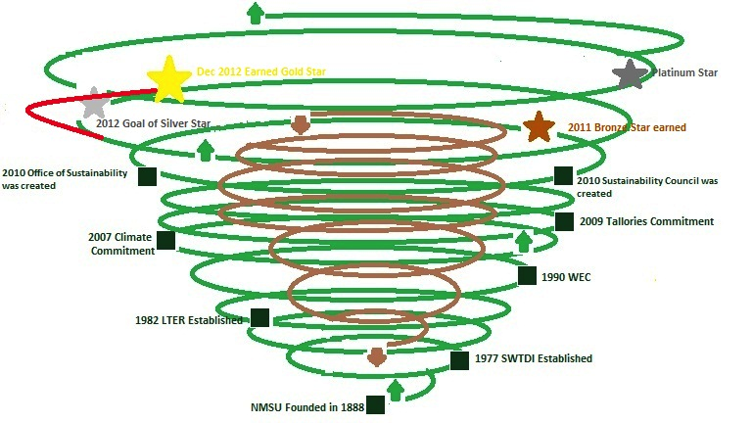

Figure 13 – Annotated Double Spiral from a previous report (please do your own drawings)

Draw something like this and annotate the upward and downward spiral whorls.

Figure 14 – Two Vortex Spirals are intertwined, one with upward spiral momentum (more revenues, less hidden costs, less risks) and one a downward spiral, spinning out the dysfunctions and hidden costs.
Show how your client moved the spirally coiled shell through the socioeconomic landscape, timescape, materialscape.

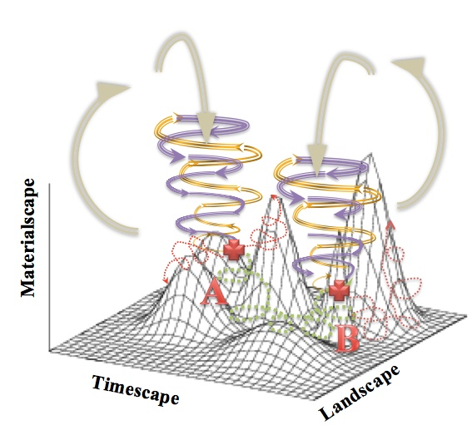

Figure 15- the Strategy Path of a double spiral with upward (gold) and downward (purple) death whorling movement from A to B along green dotted pathways of intervention on three dimensions of space (Landscape), Time (Timescape), and Materiality (Materialscape).
It’s all about consulting a small business to move their double spiral (vortex) into a better strategic position. Explain how you have succeeded or not.

Again your challenge is to make your own drawing and make it amazing!

Notice how this one annotates the date-abilities, has the 3 DPIE’s in it
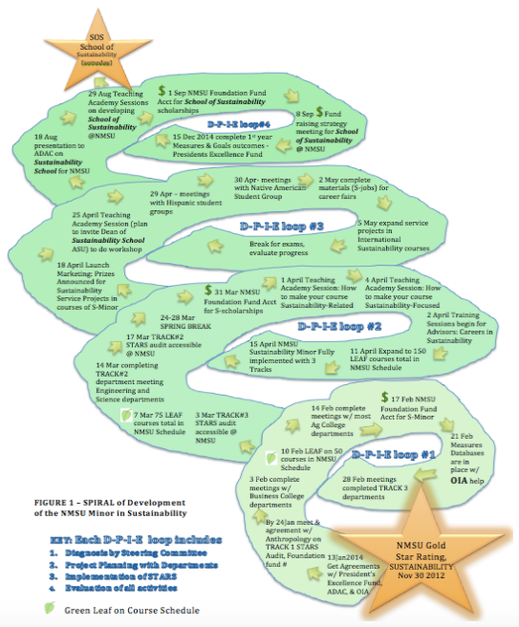

Figure 16: Annotated DPIE spiraling (Boje, 2014) - Summary of 3 DPIES done with annotation of dates of each DPIE implementation steps (again this is example of spiral you can draw and annotate for yourselves)
These next virtue ethics quotes and summaries are from a 2011 report by Britani Balkwin and Leslie Sanchez:
- 1st Book “action and pursuit is thought to aim at some good” Katia’s aim is to better the general public’s health. She has both a short term goal as well as a long term goal. The short term goal is to expose the idea of better health to NMSU students as well as young adults. The long term goal is to have at least 1000 health coaches in the El Paso area.

- 2nd Book “if then there is some end of the things we do, which we desire for its own sake, and if we do not choose everything for the sake of something else clearly this must be the good and the chief good.” Although Katia markets Take Shape for Life, she genuinely cares about getting people healthier and helping them make better decisions to improve their health.

- 3rd Book “Now each man judges well the things he knows, and of these he is a good judge. And so the man who has been educated in a subject is a good judge of that subject, and the man who has received an all-around education is a good judge in general.” Not only is Katia educated in both midwifery and public health she also has experience in both field.

- Certified professional midwife
- Licensed midwife in Texas and New Mexico
- CPR, Neonatal Resuscitation Certified
- Bachelor of Arts Degree in Linguistics (UTEP)
- Master of Public Health in Maternal child health and International Health (Tulane University school of public health)
- Completed Midwifery program (Maternidad La Luz)
- Permaculture and Massage Training
- Nursing program
- Traveled abroad to Europe, Mexico, and east Africa (training village health educators)
- Attended about 500 births since 1990

- 4th Book “It is not easy for the liberal man to be rich, since he is not apt either at taking or at keeping, but at giving away, and does not value wealth for its own sake but as a means to giving.” Katia has drastically improved her health as well as lost 130 pounds with Take Shape for Life. She coaches her clients as they also go through the program; this helps because she has already been successful with the program so she can answer many questions her clients may have. She has found a way to lose weight, keep it off, and also get healthier in the process; now she is able to spread the word and help others do the same.

5th Book “And it is complete virtue in its fullest sense, because it is the actual exercise of complete virtue. It is complete because he who possesses it can exercise his virtue not only in himself but towards his neighbor also; for many men can exercise virtue in their own affairs, but not in their relations to their neighbor.” As mentioned before Katia has been through the Take Shape for Life Program and it was one of the only programs where she reached her health/weight loss goals. She chooses to reach out and help other people with their goals with a program that she knows firsthand that will work.

Conclusions and Recommendations
Wrap up your report in a few pages and talk about the spiraling processes you did to bring about change and the small business’ spiraling-antenarrative development, as you see it.
Please put in original spiral drawings to close out your report, showing what has been accomplished, and what might be the future. Here are a few examples from previous reports.
Spiral diagrams of prior reports. The examples are of f-spirals; please develop D-spiral drawings for your reports this semester.
You need to put in your own original Spiral Drawings This is a good program to use https://sketch.io/sketchpad/

APPENDICES

Copy of Client Application

Copy of Confidentiality Agreement (you sign it, client does not)

In sealed envelop your Client’s Confidential Evaluation of your Project

In sealed envelopes, 360 Peer review rating of you and your teammates

Finally, please include references to material used to write your report.

REFERENCES you used in the report
Aristotle (350 BCE). Nicomachean Ethics. Translated by W. D. Ross. On line version http://classics.mit.edu/Aristotle/nicomachaen.html or use 456k text-only version is available for download.
Bakhtin, M. M. (1993). Toward a Philosophy of the Act. Written as unpublished notebooks written between 1919–1921, first published in the USSR in 1986 with the title K filosofii postupka; 1993 English V. Liapunov, Trans.; V. Liapunov & M. Holquist, Eds.). Austin, TX: University of Texas Press.
Benjamin, Walter. (1928/2016). One-way Street. Original 1928, this edition with Preface, 2016. Translated by Edmund Jephcott, edited with intro by Michael W. Jennings, and preface by Greil Marcus. Cambridge, MA, London: The Belknam Press of Harvard University Press. Vol. 966. Penguin UK.
Benjamin, Walter. (1936/1968). The Storyteller: Reflections on the Works of Nikolai Leskov was first published in 1936 (Orien Und Okzident); 1968 is the English translation included in Hannah Arendt (ed.), Walter Benjamin Illuminations (pp. 83-109). In referencing, I use section numbers. See http://ada.evergreen.edu/~arunc/texts/frankfurt/storyteller.pdf
Boje, David M. (1991). The storytelling organization: A study of story performance in an office-supply firm. Administrative Science Quarterly, 106-126.
Boje, David M. (1995). Stories of the storytelling organization: A postmodern analysis of Disney as “Tamara-Land”. Academy of Management Journal, 38(4), 997-1035.
Boje, David M. (2001). Narrative Methods for Organization and Communication Research. London: Sage.
Boje, David M. (2008). Storytelling Organizations. London: Sage.
Boje, D. M. (2011). Storytelling and the Future of Organizations: An Antenarrative Handbook (Routledge Studies in Management, Organizations and Society). London: Routledge.
Boje, David M. (2012). Reflections: What does quantum physics of storytelling mean for change management? Journal of Change Management, 12(3): 253-271.
Boje, David M. (2014). Storytelling Organizational Practices: Managing in the quantum age. London: Routledge.
Boje, D. M. (2016). Organizational Change and Global Standardization: Solutions to the Standards and Norms Overwhelming Organizations. London/NY: Routledge.
- Boje's (2018a) new book TRUE STORYTELLING THE RISE AND FALL OF GLOBALIZATION

- Boje's (2018b) new Routledge book draft on STORYTELLING RESEARCH METHODS: Storytelling in Action (on line until the August 2018 publication of the book)
Boje, David M.; Ford, Jeffrey; Oswick, Cliff. (2004). Language and organization: the doing of discourse. Academy of Management Review, 29.4: 571-577.
Boje, D. M., Haley, U. C., & Saylors, R. (2016). Antenarratives of organizational change: The microstoria of Burger King’s storytelling in space, time and strategic context. Human Relations, 69(2), 391-418.
Boje, D. M., & Henderson, T. L. (Eds.). (2014). Being quantum: Ontological storytelling in the age of antenarrative. Cambridge Scholars Publishing.
Boje, D. M.; Larsen, Jens; Brunn, Lena. (2017). ‘True Storytelling. How to succeed with your implementation’, working paper. http://oldfriendsindustries.com/?page_id=1048
Boje, D. M., Svane, M., & Gergerich, E. M. (2016). Counternarrative and antenarrative inquiry in two cross-cultural contexts. European Journal of Cross-Cultural Competence and Management, 4(1), 55-84.
Boundas, Constantin V. (2010). Virtual/Virtuality. Pp. 300-302 in in Adrian Parr (ed.). The Deleuze Dictionary Revised Edition (1st edition 2005). UK: Edinburgh University Press.
Davis, Gerald F. (2016), The vanishing American corporation: Navigating the hazards of a new economy. Oakland CA: Berrett-Koehler Publishers.
Deleuze. Gilles. (1990). Logic of Sense. NY: Columbia University Press. French 1969 (Les Editions de Minuit).
Deleuze, Gilles. (1991). Bergsonism, Hugh Tomlinson and Barbara Habberjam (trans.), New York: Zone Books.
Deleuze, Gilles. (1968/1994). Difference and Repetition, Paul Patton (tr. From French 1968), English in 1994. NY: Columbia University Press.
Deleuze, Gilles. (1997). Essays critical and clinical, trans. D.W. Smith & M.A. Greco. Minneapolis: University of Minnesota Press.
Deleuze, Gilles; Guattari, Felix. (1987). A Thousand Plateaus: Capitalism and Schizophrenia. Translation & foreword Brian Massumi. University of Minnesota Press.
Deleuze, Gilles; Guattari, Felix. (1994). What is Philosophy. Translated by Hugh Tomlinson & Graham Burchell. NY: Columbia University Press.
De Landa, M. (1999). Immanence and transcendence in the genesis of form. Pp. 119–34. in I. Buchanan (Ed.), A Deleuzian century. Durham, NC: Duke University Press.
Henderson, Tonya L.; Boje, David M. (2016). Managing Fractal Organizing Processes. NY/London: Routledge.
Roffe, Jonathan. (2010). Multiplicity. Pp. 181-2 in Adrian Parr (ed.). The Deleuze Dictionary Revised Edition (1st edition 2005). UK: Edinburgh University Press.
Rosile, G. A., Boje, D. M., Carlon, D. M., Downs, A., & Saylors, R. (2013). Storytelling diamond: An antenarrative integration of the six facets of storytelling in organization research design. Organizational Research Methods, 16(4), 557-580.
Sartre, Jean-Paul. (1986).'Critique of Dialectical Reason' Vol. I, Theory of Practical Ensembles (Chicago: University of Chicago Press).
Savall, H., Zardet, V., & Bonnet, M. (2008). Releasing the untapped potential of enterprises through socio-economic management (No. halshs-00780720). Online at http://davidboje.com/448/SEAM_BOOK/SEAM_BOOK_2008.pdf.
Savall, H., Zardet, V., Bonnet, M., & Péron, M. (2010). Contribution of qualimetrics intervention-research methodology to transorganizational development (No. halshs-00749946).
Savall, H., & Zardet, V. (Eds.). (2011). The qualimetrics approach: Observing the complex object. IAP.
Savall, H., Zardet, V., & Péron, M. (2011). 22 The Evolutive and Interactive Actor Polygon in the Theater of Organizations. Storytelling and the future of organizations: An antenarrative handbook, 366.
Savall, H., Zardet, V., Péron, M., & Bonnet, M. (2012). Possible Contributions of Qualimetrics Intervention-Research Methodology to Action Research. International Journal of Action Research, 8(1), 102-130.
Savall, H.; Péron, Michel; Zardet, Veronique; Bonnet, Marc. (2018). Socially Responsible Capitalism. With Preface by D. M. Boje. London: Routledge. (No. hal-01140272).
Sele, K., & Grand, S. (2016). Unpacking the dynamics of ecologies of routines: Mediators and their generative effects in routine interactions. Organization Science, 27(3), 722-738.
Stubbs, W., Higgins, C. and Milne, M. (2013), “Why do companies not produce sustainability reports?”, Business, Strategy & the Environment, Vol. 22 No. 7, pp. 456-470.
Worley, C. G., Zardet, V., Bonnet, M., & Savall, A. (2015). Becoming agile: How the SEAM approach to management builds adaptability. NY: John Wiley & Sons.

Website References
Boje - Double Spiral images https://davidboje/448/double_spiral_for_final.html

Boje – Quantum Energy Works http://davidboje.com/shamanic/quantum_world.htm

Boje – Fractal study guide for Henderson and Boje (2016) and Boje (2016) http://davidboje.com/fractal/ and https://business.nmsu.edu/~dboje/690/What_is_Fractal_Storytelling.htm

Boje All about Spirals https://davidboje.com/448/spirals.html

