CURRENT SERIES OF SESSIONS: 7 Chakra Energy Centers and Shamanic Meditation by David M. Boje
Nov 26 2020
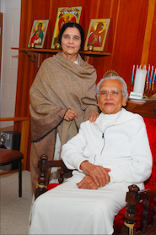
Click for larger image
Gurudev Chitrabhanu, a Jain Monk who walked with Gandhi in decolonizing India from British rule, practiced Ahimsa (Sanskrit for Non-violence) that was adopted by Gandhi. Above photo with his wife Pramodaben, who leads the Vegan movement in India. I a a practitioner of Jain Philosophy and I am a Core Shamanism practitioner.
The following is based on the books written by Gurudev Chitrabhanu who in 1995 gave me my Jain name, Arihant, which I took to mean, 'conqueror of my inner enemies'. There are also biographical accounts.
I came back to Gurudev 10 years later, very exhausted from meditating daily on my inner enemies, and asked for a new name. He said, 'you misheard me, Arihant means You Have No Enemies, Everyone is Your Friend.' This changed the way I meditated ever since. He gave me a coin, with Sanskrit writing on both sides, and said, "You and I will meet next time and I will explain the Sanskrit words." He died and we did not have that conversation. So now I journey with drumming to Upper World to have those conversations.
Gurudev Shree Chitrabhanu. (1978). Realized What You Are: The Dynamics of Jain Meditation. NY: Dodd, Mead, and Company.
Gurudev Shree Chitrabhanu. (1979a). The Philosophy of Soul and Matter. Ahmedabad, India: Published by Dhanjibhai P. Shah.
Gurudev Shree Chitrabhanu. (1979b). The Psychology of Enlightenment: Meditations on the Seven Energy Centers. NY: Dodd, Mead, and Company.
Gurudev Shree Chitrabhanu. (1980). Twelve Facets of Reality: The Jain Path to Freedom. NY: Dodd, Mead, and Company.
Dr. N. P. Jain. (no date). Ahmedabad, India: Published by Swadhyay Mandir Charitable Truest.
Clare Rosenfield. (1982). Gurudev Shree Chitrabanu: A Man With A Vision. Ny, NY: Published by Jain Meditation International Center.
November 12 2020 FIRST ENERGY CENTER, EARTH
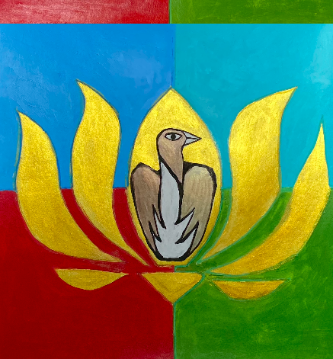
1st Energy Center EARTH (ROOT)
Art by Claudine DesRosiers
The symbol of first energy center is the Golden Lotus on a square, symbolic of the four elements: Water, Earth, Fire, and Water.
Question: Who Am I?
Is my energy in 'I am' of a family, or I am 'my position' in society, or I am NATURE (the Earth, Water, Air, & Fire elements of the BODY). I sit on Earth foundation, and stand on Earth, in balance. I set on the four elements:
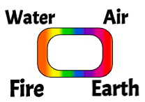
The answer to 'Who Am I?' begins our exploration of the grounding in the Root Chakra energy.
Question: What is Earth-Balance of Root Energy?
Answer: Harmony and Balance of Microcosm and the Macrocosm. Body is 37.2 trillion living cells, in CONTACT with environment. Body is composed of earth, water, air, and fire in CONTACT with environment of these elements. A teaspoon of soil, has 10000 living organisms, millions of fungi and bacteria, and all the nutrients of earth, plus air and fire.
When we are in Earth Health, our Body can be Healthy.
For My son, Raymond:
The snake is in contact with the ground, the energy of the Earth.
The snake is a common shamanic power animal.
The snake does not have fear of the future.
A snake does not hoard, is not greedy, is not attached, is no insecure.
A snake does not acieve security by accumulation of things or wealth, etc.
A snake is grounded in their truth.
The task for Level 1: Root, is let go of insecurity, let go of hoarding stuff, and let go of emotional programming of desire for stuff.

November 19 2020 2nd Energy Center, WATER
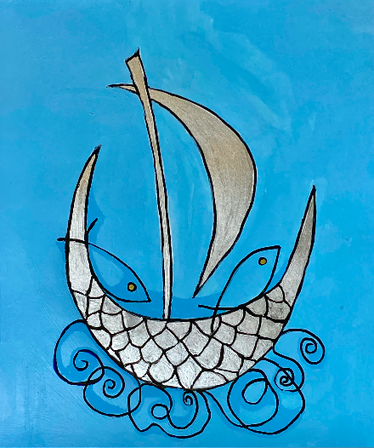
2nd Energy Center WATER
Art by Claudine DesRosiers
Gurudev describes the 2n Energy Center symbols as the Silver Crescent Moon, that becomes a boat. This is about water element, and how to watch the waves and feel the currents, and the floods, debris, and pollutants that affect the Lake of Tranquility. This relates well to Shamanic Drumming Meditation Journeys to Lower World. Then, to manage the five Water Gates. Paddle your Silver Crescent Moon Boat to inspect the Streams of inflow into the lake. There is a gate on each of the five inflow streams.
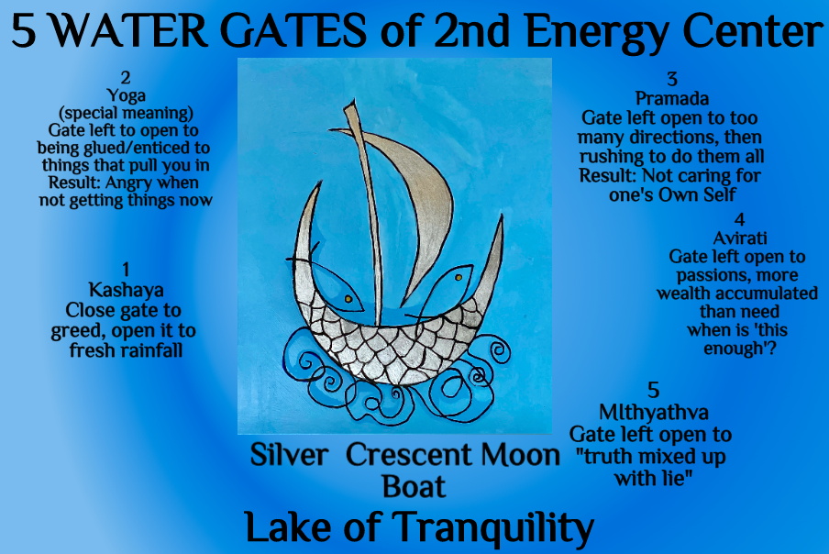
The symbol of 2nd Energy Center, Water, is the Silver Crescent Moon Boat and 5 Gates (Sanskrit words) and meanings
Art by Claudine DesRosiers.
The Five Water Gates (summary from 12 Facets book):
1. Kashaya Gate (Sanskrit) - means inner passions, attachments of anger, greed, deceit, enter this gate. The EGO becomes more powerful, Greed of collecting somethings, essking higher posts, and getting angry when its not happening. Open this gate to fresh Rainfall, close it to the debris floating into the Lake of Tranquility.
2. Yoga Gate (Sanskrit) - a special context of Yoga, getting glued to enticing things, that pull you in. Example window-shopping, then getting anxious to or frantic to get the $$$$ to buy more and more stuff. Anger if cannot have it now. Lots of collecting $$$ to get more and more stuff, when this gate left open.
3. Pramada (Sanskrit) - means indecisive, wishy-washy, and lethargy consciousness, of going in all directions, push and pull in conflicting ways. "There is never enough time" so tasks get rushed to keep up with so man directions of the waves and currents across the lake. Result" Not caring for one's own Self.
4. Aviratai (Sanskrit) - failure to limit things one needs and using in life. This gate places a limit on possessions. Our body needs 3 hours to digest anything. Limit food intake. Take in water, 8 to 10 times a day. Balance spices on foods, to not overwhelm taste buds. Make a limit on your wealth. When is enough enough? "This is enough" (p. 90 12 Facets).
5. Mithyathva (Sanskrit) - means "Truth mixed up with lies" (p. 90 12 Facets). Lust taken to be love. Right undifferentiated from wrong. This is ability to discriminate between compassionate and hurtful thought and action. "Truth... is all light, it frees you" (p. 90).

November 26 2020 3rd Energy Center, FIRE, the Empowerment Meditation
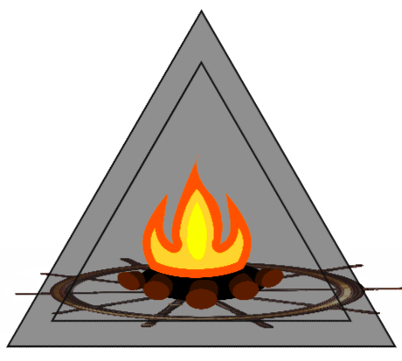
I invite Claudine DesRosiers to do a wondrous image of this.
The symbol is fire (red and yellow flames) that burn the logos of Ego. The fire and logs are on a 10 spoke wheel emitting and radiating rays of light and heat. This is enclosed in a Triangle. Today I drum for fire energy of empowerment. The Sanskrit word for it is Manipura. Mani means Jewel and Pura is City. The 'Jewel City' where the Indweller, the Invisible Self of Hidden Em-power-ment dwells. It dwells in the Body, in the region of the Navel, where the umbilical cord fed us air, water, earth, and fire for nine months, in the womb. The element of Fire, is moving every upward, spiraling, radiating light and energy, called Agni. Agni does not allow the Intellect of this professor to set lmits on ideas of possibility.
Why 10 spokes. In Jain Philosophy, Chakra means 'energy wheel. Each of the 7 energy centers has a chakra with different number of rays of light and heat emanating from each spoke.
- 7th Chakra - 1000 rays
- 6th Chakra - 64 rays
- 5th Chakra - 16 rays
- 4th Chakra - 12 rays
- 3rd Chakra - 10 rays
- 2nd Chakra - 6 rays
- 1st Chakra - 4 rays (aka the cardinal directions of Medicine Wheel in Indigenous Ways of Knowing, IWOK)
Third Energy Center (with its 10 rays of light and heat) Imagine a small flickering flame. Yogis do this to raise or lower the heat of their body, to make it warm let the fire grow upwards. Bring your attention to the navel (Manipura), the Jewel City (mani and puram) of inner empowerment. See the fire flickering, and burning more brightly, sending out streaks of red and yellow light, and radiating heat through the spokes, with more rays of light.
It is how to realize your life's mission by not escaping your own answerability (responsibility) for your participation in the world. Empowerment is possible by buring the ego logs of desires, greed, insecurity, attachment, and all the drives for power-over, the controlling and manipulating to get one's way. The 3rd Energy Center is about consciousness that can be trapped in a valley of ego-fog, so the empowerment of peace, tranquility, serenity cannot be seen. In Intellectual Shamanism, I burn away the intellect in the fire, in my particular practice. The Intellect is still there, I am just on a journey of Self-Empowerment, while buring away the ego-Intellect, in illuminating fire.
We can drum in shamanic mediation to burn away the power-over, by being quiet, sensing the inner Being. These are some questions to help with this meditation:
- What is my true need?
- Am I copying what others are doing?
- Am I seeking to impress others"
- Are my mental states, the actions I swe, a way to impress a circle of friends?
- Do I fear others' opinion?
- How do I free myself from power-over influences?
- How do I experience an empowerment, higher state of Being-in-the-World?
- Am I stuck in the past, and being dragged downward, spiraling away from Self-Empowerment?
Shamanic Drumming is a way to experience the surge of empowerment energy spiraling upward, a way to go between several worlds. As you mediate and drum on your intention, your attention to self-empowerment, can melt the fog and let you experience the Indweller, and let you sense the Highest State of Inner Clarity, as a storyteller. Taking the path of the upward empowerment spiral, is a journey out of bottom level confusion, indecision, and irresponsibility, to the Do-Be-Do-Be-Do, of answerability, in spontaneity.
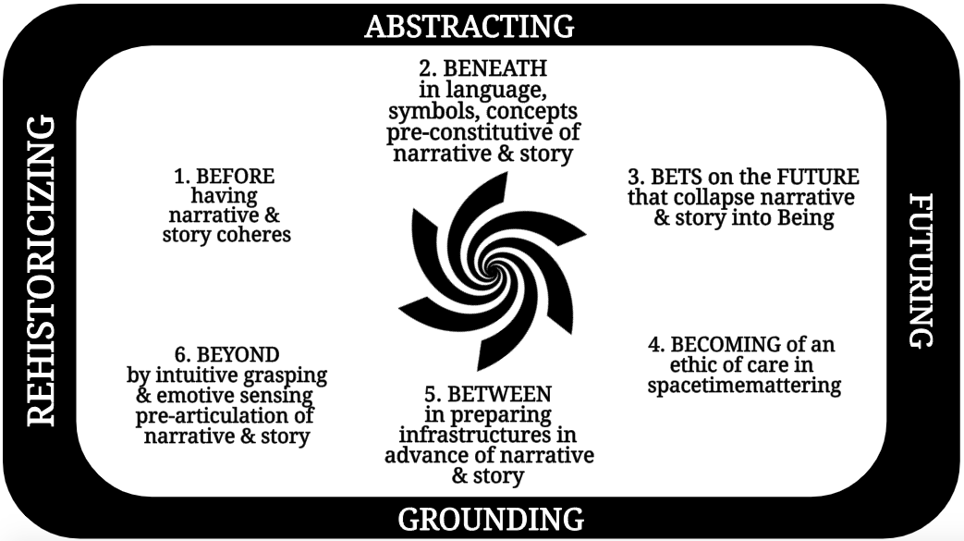
Antenarrative On the empowerment spiral upward path, you can drum to see the end of the road BEFORE you started this journey, and the goal-beforehand, with clarity. This is about a prospective sensemaking (by the five senses, plus a 6th sense, the BEYOND, an intuitive-world sense). It is possible you have already traveled this future path, now arriving (BECOMING of Care in spacetimemattering) and its BETS on the FUTURE (choice among so many futures arriving here & now). You can have an antenarrative sense of deja vu, that the BETWEEN of this networking has been traveled again and again. BENEATH the words and thoughts, a senseing of a spiral-upwards to Self-Empowerment, learning to rise to a level of awareness of the spiritual path, by embracing the whole of consciousness, you may see your own living story has been evolving.
Who animates this body? Could it be the Indweller? Who leaves my body when I die? Is it the Indweller doing in the planning, organizing, and managing, all the Do-Be-Do-Be-Do?
- 4th Energy - Air - the beating heart orb that expanse in limitless ways of caring
- 3rd Energy - Fire - Burning ego logs of power-over, and the worry, anxiety, and fear go up in smoke
- 2nd Energy - Water - the Silver Moon boat on Sea of Tranquility
- 1st Energy - Earth - the Earthly Body, on foundation, ground of 4 elements.
I have a Jain name, Arihant. and this mantra 'Om namo arihantnam' which means "I bow to those souls who have conquered their inner enemies" because everyone is my friend, and I have no enemies (p. 25, Gurudev, 7 Energy Center).
Example of Finding Common Ground of Empowerment-With For the East Mesa Trails (EMT) project, I did this morning meditation today (Nov 26 2020). As I approach the many organization participants and neighbors in a state of peace, joy, love, and serenity, with a caring heart, then by Self-Empowerment the Indweller who by Shamanic Drumming, journeys to Upper World and Lower World, and Between is there. My Invisible Self, the Indweller, remains after my body decomposes and the living cells die away.
This is the common ground of Core Shamanism and my Eastern Philosophy of Jainism: the indestructible energy of the Indweller, Mike ThreeBears named 'Surrenders to Spirit' and Gurudev names 'Arihant'.
I have annotated the triangle to re-imagine the usual Triple Bottom Line (3BL) from a Terrestrial Ethics and True Storytelling approach to bringing about habitat restoration of 'East Mesa Trails' where I live. It is something I am considering to present for the Intellectual Shaman presentation I give on December 4th 2020. It extends from the Water conference presentation Sabine Trafimow and I gave on 18 November 2020, on moving from story of separation to story of conjoining. The Triple Bottom Line resituation was presented with Grace Ann Rosile to Kenneth Jorgenson's conference in Aalborg, on Storytelling and Sustainability, on Tuesday 24 November 2020. And Professor Mogens Sparre and I (2020) just published an article on Organizational Development Journal on how to revitalize habitat using a reconstructed Triple Bottom Line approach to participative action research. The image I integrated in today's meditation:
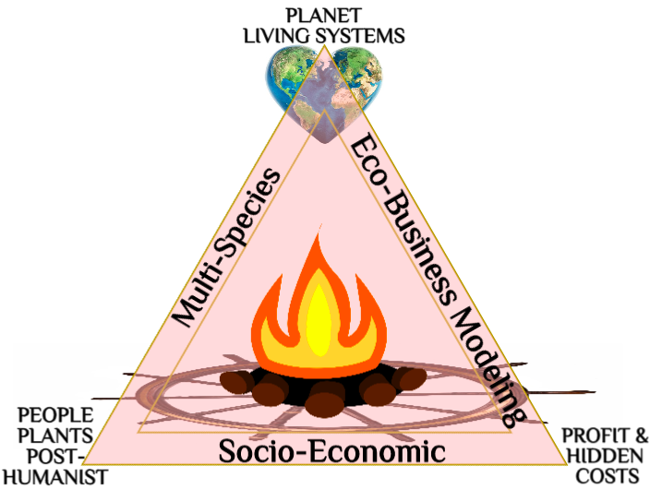
I had a dream Nov 26 2020 AM, about how to approach the East Mesa Trails (EMT) habitat restoration project. It could be a transorganizational development network of many agencies, non-profit organizations, and neighbors bringing about a transformation using a process, Michael Jones (folklore & mythology professor) I call ICEND (Interactive, Communicative, Experiential Network Development). ICEND is something I worked on as a professor at UCLA between 1979 and 1986. ICEND is a process of transformational restoration to habitat cycles, in what Latour calls the 'critical zone' (that Earth's crust, water, and atmosphere where life takes place). My name 'surrenders to spirit' now means energizing meditation practices to be a change agent for critical zone restoration in New Mexico.

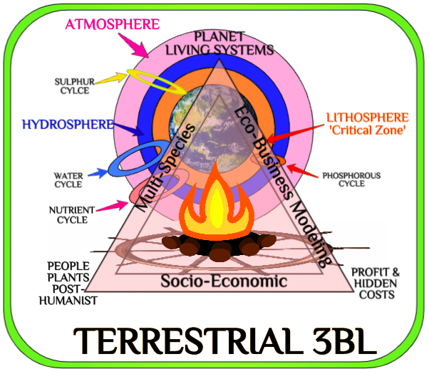
The Critical Zone for Restoration of East Mesa Habitat is the Lithosphere, Hydrosphere, and Atmosphere. The Water Cycle is interpetetrating with the Nutrient, Sulphar, and Phosphorous Cycles that interconnect the Critical Zone spheres so Life Happens on the Desert of New Mexico
I keep working on it for 40 years, including how Transorganizational Development (TD) is part of a gameboard of so man large system change interventions, that relates the socio-economic, multi-species, and recently the eco-business modelling (see 2020 article Jorgenson & Boje; & chapter by Mohammed & Boje, 2020.. I see it now as something relatable to True Storytelling (Larsen, Boje, & Bruun, 2021, https://true-storytelling.com).
- I - Interactive - Share stories around issues
- C- Communicative - Stories of the collective
- E-Experiential
- N-Network
- D-Development
ICEND goes back to my earliest work in storytelling systems change. It involves three phases.
Subsystem One: Outside Process Consultation Cycle
- I. Diagnosis
- II. Involvement
- III. Active Intervention
- IV. Support
- V. Evaluation
Subsystem Two: Internal Problem Solving & Networking Cycle
- I. Issue Crystallization (issues that bring form community)
- II. Locate Stakeholders
- III. Expanded Stakeholder Involvement
- IV. Search Conferences & Focus Group Intervention
- V. Convene Temporary Organization
- VI. Withdrawal of Temporary Organization (before bureaucracy sets in)
- VII. Assessment & Evaluation
Subsystem Three: Extended Network Involvement Cycle
- I. Issue Perceived More Widely in the Extended Network
- II. Initial Organizational Involvement beyond Temporary Organization
- III. Discovery of Under-employed Resources
- IV. Breakdown of Status Quo Response Patterns (Subsystem II Interventions in Extended Field)
- V. Demand Builds for Greater Organizational Involvement
- VI. Breakdown of Status Quo Responses.
My point is I have been meditating on large system Transorganizational Development (TD) change networking approaches for about 40 years. The three subsystems have to be mapped out (see example).

December 3 2020 3rd Energy Center, AIR and Heart
This is breathing In and Out Air between Self/Body and Nature, in an ever expanding energy of Love, in Mauve color. An orb at the center that we expand outward Loving energy. I will invite Claudine DesRosiers to do a wondrous image of this.

Love is eternally creative because it has no end. “It is always moving toward eternity”, “Real love is peaceful”, “Real Love does not end” (Chitrabhanu, p. 16, 7 Energies). “Love is a coming together on a level beyond all these external labels” (Chitrabhanu, p. 51, 7 Energies). In love’s unfolding present we are not stuck clinging to the past.

Drumming circle is led by a consistent facilitator: Facilitator, David M. Boje has completed FSS basic workshop and has assist 3 times with instructor Charles W. Conaster. Boje has also completed the Dying and Beyond, Extraction Healing, Creativity, Divination Training, Power Soul retrieval workshops with Charles Conaster cwconatser@aol.com or cell 806-790-4128

