Independent single-author study.

Manuscript.

Vladimir Dmitrievich Nuzhny,
Physician-psychotherapist, Doctor of International Scientific Activity, Director of the Institute of Psychological Education and Social Technologies, official teacher and supervisor of OPPL practice, regional representative of OPPL in the Perm Krai.

The Phenomenon of Representative Perception in Systemic Family Constellations

(Theory and Evidence-Based Research Practice).
submitted in support of an application for the status of Professor of Scientific Psychotherapy at MANP.

Monograph

2025
Contents
INTRODUCTION
Chapter 1. The Phenomenon of Representative Perception: Interpretation and Explanatory Models.
(Previous achievement level).

Historical and scientific prerequisites of the method of systemic family constellations: development, principles and structure.
    - Systemic Family Constellations in Contemporary Psychotherapy.
Core Concepts of Constellation Work (constellation, family system, systemic order, dynamics, and loyalty).
    - Historical development of the method:
- Basics of System Paradigm in Psychotherapy Culturally Historical Concept (Vygotsky L.S.);
- System-activity approach (Leontiev A.N.);
- System approach (Lomov B.F.);
- Humanistic-Existential Psychotherapy;
- Systemic psychotherapy (L. Bertalanffy M. Bowen);
- System-phenomenological approach (G. Weber, Burnyashev M.G.);
- Multimodal approach in general (A. Lazarus);
- Polymodal approach (Makarov V.V.);
- Polymodal express psychotherapy (Katkov A.L.).
    - Concepts of the system field, resonance empathy, replacing sensitivity.
    - The main phenomena of the systemic family arrangement and the justification of professional interest in the phenomenon of representative perception.

Studies of representative perception as a phenomenon of systemic family constellations in psychotherapeutic practice.
    - Representative perception as a phenomenon: approaches to description and interpretation; definition and characteristics of the phenomenon of representative perception.
    - Theories of Perception. Neuropsychological and Psychophysiological Aspects of Perception. Theories of Perception in the Context of Representation.
    - Comparative analysis of the phenomenon of representative perception and related phenomena.
    - Features of representative perception in the participants in the arrangements.
    - Explanatory models of the phenomenon of representative perception.
    - The phenomenon of representative perception within trans-temporal psychoplasticity. The phenomenon of psychoplasticity.
  - Summary conclusions on Chapter 1
Chapter 2: Methodology of research
  - General and special research methodology
    - Research Aim and Objectives.
    - Subject and object of study.
    - Hypotheses Submitted for Defense.
    - Scientific novelty.
    - Theoretical and practical significance.
    - Research design.

Research methods.
    - Method of epistemological analysis: a systematic review of a research topic.

Method of psychotechnical experiment.
      - A system of fundamentally comparable parameters and indicators: bodily, behavioral, emotional, figurative and verbal manifestations.
      - Specificity and content of generic carriers of information of significant events in the "big system".
      - Information verification (comparison of data of the client, representatives, leader, relatives).
    - Methodology of psychotechnical experiment.
Two constellation formats: experimental and modified (using the phenomenon of temporal plasticity in the client). Session protocol, the facilitator's role, and control of conditions.

Research tools.
    - Summary table of the data of a psychotechnical experiment.
    - Questionnaire.
    - Semi-Structured Interview Methods and Participant Reports.
    - Methods that record the state of hyperplastic.

Sample Description (Clients, Representatives, Observers, Facilitator).
Criteria for the selection of clients and representatives.

Methods of statistical data processing.
  - Ethical principles of research.
Chapter 3: Results of research
  - Justification of the phenomenon of representative perception: the definition of its basic essential characteristics.
The phenomenon of representative perception as a manifestation of the “targeted” trans-temporal activity of the psyche in subjects of the psychotherapeutic process, in the conditions of actualization of the temporal plasticity of the psyche (hypothetical explanatory model).
  - Description of the results of a series of experimental sessions of systemic family constellations with a parallel questionnaire procedure in two formats A) experimental B modified (use of the phenomenon of temporal plastic in the client)

The results of an empirical study of the relationship of indicators and indicators of the phenomenon of representative perception with indicators of the phenomenon of psychoplasticity.

Results of the psychophysiological study (EEG, GSR, PPG).
  - Findings from the study.
    - Conclusion based on the results of epistemological research.
    - Conclusions from the experimental study.
    - Conclusions on the results of psychophysiological research.

CHAPTER 4. PRACTICAL RECOMMENDATIONS AND PROSPECTS FOR FURTHER RESEARCH
  - The practical significance of the results for systemic therapy and counseling.
  - A System of Practical Recommendations for Modified Formats of Systemic Family Constellations.
  - Methodological Guidelines for Systemic Constellation Facilitators.
  - Limitations and Risks in Interpreting Representative Perception.
  - Possibilities of integrating the method into other psychotherapeutic approaches.
  - Promising directions of interdisciplinary research.
  - Description of the structure of the scientific and practical community of professionals continuing research in line with the systemic approach of psychotherapy (systemic-phenomenological, systemic strategic) and developing new directions (poly-systemic, and system-field) description of the base and opportunities for further research.

Conclusion

Literature

Annexes
INTRODUCTION
Systemic family constellation has taken its place in psychotherapy and counseling, becoming an effective, short-term and versatile tool in dealing with personal and family conflicts. It is attractive to practitioners because it allows them to quickly identify the deep connections, internal tensions and hidden dynamics that affect the client’s current life difficulties, and the procedure itself often does not require deep preliminary analysis from the client, which makes the method especially valuable when dealing with queries that are initially difficult to verbalize or comprehend.
One of the central elements and the main therapeutic mechanism of constellation work is the phenomenon of representative perception - a special mental state in which the participants of the placement, chosen by the client as the "substitutes" of significant members of the client's family (and often other members of the group - "observers") who do not have knowledge about a particular family history, begin to experience specific emotional, bodily and cognitive states, presumably reflecting the internal experience of the members of the client's family system and the hidden dynamics of the client's family relations, often rooted in the past several generations.
For practicing therapists, this provides unique opportunities: access to unconscious family information; rapid identification of key points of tension; and investigation of relationship dynamics and recurring painful, stress-related protective-confrontational patterns in the client's family and ancestral systems. This, in turn, makes it possible to formulate a systemic hypothesis and use it to develop a therapeutic strategy leading to positive changes in intrapersonal and interpersonal communication.
However, in actual practice, specialists face a number of serious difficulties: there are no scientifically validated criteria for reliably distinguishing representative perception from personal projections of representatives, their emotional involvement, inculcated reactions to group dynamics, which creates the risk of interpretive errors, unreliable hypotheses and, in some cases, maladaptive consequences for the client.

Relevance
Thus, the relevance of this study is determined by the following issues and difficulties that have not been solved to date, preventing the method of systemic family constellations from becoming a scientifically based psychotherapeutic practice:
- The multiplicity and often multidirectionality of explanatory models of the phenomenon of representative perception, without any correct scientific and evidence substantiation of these models.
2. the uncertainty of the differential boundaries between the phenomenon of representative perception and the following probable forms of mental activity:
individual protective mechanisms of the psyche:
- projection, identification, projective identification;
- emotional, empathic and informational resonance;
- reaction to group dynamics;
- suggestive reactions;
- Other "reactive" manifestations of the psyche.
- The absence of standardized features and criteria that allow to reliably recognize the true manifestations of representative perception.
- Insufficient theoretical and scientific-practical integration of the arrangement method with modern scientific psychology and psychotherapy.
- The lack of evidence-based effective methodological and psycho-technological tools necessary for the practical activities of specialists implementing the method of systemic family constellations, and other specialists using the phenomenon of representative perception in practice.

Purpose of the study
Substantiation of the theory and methodology of using the potential of the phenomenon of representative perception in the practice of systemic family constellations on the basis of evidence-based research practice.

Research Objectives.
- Conduct a systematic review (with the necessary components of epistemological analysis) on the research topic.
- To develop an explanatory model of representative perception within systemic family constellations that is adequate from the standpoint of the frontier sciences of the psyche.
- To carry out differential diagnosis with related phenomena of mental activity, possible in the course of implementing the method of systemic family constellations:
- individual protective mechanism psyche (Projection, identification, projective identification)
- emotional, empathic and informational resonance;
- response to group dynamics; suggested responses;
- Other “reactive” manifestations of mental activity.
- Develop a methodology and conduct a correct psychotechnical experiment, including:
  - To develop five sufficiently independent information channels for obtaining data on significant events in the client's ancestral family history;
  - Development of a system hierarchy of studied and fundamentally comparable parameters, indicators for each differentiated sector of information acquisition;
  - Distributions based on understandable hierarchical features
- information obtained in this way on the main parameters and indicators in order to study the significant statistical regularities obtained in this case;
  - To clearly define the principal characteristics to be considered—the nature and content of ancestral information carriers and the dates on which significant events manifested in the client's ancestral family history along each information channel—so that the information can be processed as needed and compared correctly;
  - Development of a methodology for semi-structured interviews for the client, and “substitutes” (1) and (2) with the possibility of obtaining verified information, as well as for relatives of the client with the aim of obtaining real facts from the history of the family;
  - To select diagnostic methods that record the state of hyperplasticity during classical and modified systemic family constellations (the latter using the phenomenon of temporal plasticity in the client) in the client, the facilitator, and two representatives;
  - Selection of an experimental group of clients, “representatives” and implementation of this psychotechnical experiment in the correct conditions, in full, taking into account the standard components of the preparatory stage, with a parallel questionnaire procedure in two formats in the number of at least 40 sessions for each format:
Series A, experimental: implementation of the representative trans-temporal perception procedure traditionally used in systemic family constellations, without the group facilitator's participation.
Series B, modified: use of the phenomenon of temporal plasticity in the client, with the group facilitator's participation.
- To conduct a correlational statistical and mathematical analysis of the studied parameters and indicators, including the relationship between the overall correlation coefficient (Chaddock scale) and the degree of psychoplasticity among the participants involved (client, representatives, and facilitator);
- Derivation of a system of scientifically based evidence of objectification of the phenomenon of representative perception, as an illustration of the function of temporal plasticity in the structure of the general phenomenon of mental hyperplasticity, in the process of carrying out systemic family constellations;
- Drawing scientifically based, practical recommendations for improving the method of systemic family constellations in relation to a modified version of their implementation and development, in particular - recommendations for accelerated development of specialists implementing a modified version of this method, the resource personal status of "I-Professional", updating the phenomenon of psychoplasticity in the course of the psychotherapeutic process.

Hypotheses Submitted for Defense.
The phenomenon of representative perception is a regular manifestation of a specific trans-temporal interaction between the conscious and nonconscious domains of the psyche in persons involved in psychotherapy using systemic family constellations, enabling a subject to perceive and reproduce information not contained in their personal biographical memory.
In the presence of certain conditions in the preparation and implementation of the psychotherapeutic process using a modified methodology of systemic family constellations, it is possible to:
- Interaction among the active participants in this process—the facilitator, client, and representatives—in a state of psychoplasticity, with activation of the phenomenon of temporal plasticity of the psyche in every participant involved;
- Formation of a coordinate system with an emphasis on the study of the temporal vector of the past - as a program of therapeutic (i.e. temporal-plastic) activity of the psyche in the involved participants (in the author's interpretation of B. Hellinger we are talking about the formation of a special informational "field");
- Previously hidden information about significant events in the client's ancestral family system is obtained by all active participants in the therapeutic process, not only the representatives, through the activated trans-temporal interaction of the fundamental domains of the psyche.

Scientific novelty
For the first time, the interpretation of the phenomenon of representative perception through the prism of the trans-temporal function that manifests in the actualization of the general phenomenon of psychoplasticity has been proposed and justified. Parameters and indicators that adequately characterize the phenomenon of representative perception have been developed and tested during a correct research experiment.
The conditions for the stable manifestation of this phenomenon in the course of the psychotherapeutic process are determined and verified.
On the basis of the obtained results, the theoretical model of the phenomenon of representative perception is described, on the basis of which the psychotechnological tools necessary for the correct, effective and environmentally friendly use of the therapeutic potential of this phenomenon in the practice of psychotherapy and counseling are developed.
The idea of the possibilities of the human psyche to access information beyond the scope of individual experience has been expanded.

Theoretical and practical significance:
An experimental design of a psychotechnical experiment was developed and tested, which allows obtaining empirical data in favor of proving the existence of the phenomenon of representative perception in the process of psychotherapy.
We found a statistically significant relationship between the phenomenon of representative perception and the phenomenon of hyperplasticity of the psyche, and based on the results, we developed a system of practical recommendations for modified options for conducting systemic family constellations.
The phenomenon of representative perception is described on the basis of empirical data obtained as a result of a psychotechnical experiment.
The necessity of developing a sustainable resource personal status of “I-Professional” among specialists is substantiated, which organizes its safe and effective use in the practice of psychotherapy and counseling.
A scientific and practical community of professionals has been established to continue research within systemic approaches to psychotherapy (systemic-phenomenological and systemic-strategic) and to develop new directions in psychotherapy. A foundation for further research has been created.

Object of study
Persons directly or indirectly involved in the process of systemic family constellations, participants in a psychotechnical experiment, distributed according to the main research specifications: “client”, “leading” “substitutes”, “group participants”.

Subject matter
Identified and differentiated characteristics of the phenomenon of representative perception arising from the actualization of trans-temporal plasticity of the psyche in direct participants of the psychotherapeutic process in the experimental research group.
Research methods:
1. epistemological analysis (elements);
2. Genetic and constructive;
3. Psychotechnological experiment;
Questioning;
5. Experimental-psychological (PICAP);
6. statistical and mathematical analysis;
7.System approach (at all stages of the organization and implementation of the research project and, in particular, in the development of a system hierarchy of studied and fundamentally comparable parameters, indicators);
8 Computer EEG (in some cases).

Research tools
Original semi-structured questionnaires for the client, "substitutes" (1) and (2).
Original semi-structured questionnaire for senior relatives of the client.
PICAP Subjective Control Scales:
Scale (1) assessment by the client of the severity of demoralization syndrome.
Scale (2) of the client's assessment of the degree of involvement in the psychotechnological space.

Logistical stages (design) of the research project: In the first stage, a systematic review (with components of epistemological analysis) was conducted on the research topic, the phenomenon of representative perception was substantiated and its main essential characteristics were determined.
The structure, nature and dynamics of the phenomenon of representative perception as a manifestation of the targeted trans-temporal activity of the psyche, in the conditions of actualization of the temporal plasticity of the psyche, are described.
A theoretical explanatory model of the phenomenon of representative perception in the practice of systemic family constellations is developed.
The place and role of the phenomenon of representative perception in the structure of the method of systemic family constellations is determined.
According to the key hypothetical provisions, the phenomenon of representative perception should naturally manifest itself with the “on” and verified phenomenon of hyperplasticity in all participants in the arrangement process (client, host and representatives).
At the second stage, the methodology of correct psychotechnical experiment was developed.
A systemic hierarchy of the studied and fundamentally comparable parameters and indicators was developed. The characteristics and content of ancestral carriers of information about significant events in the 'larger system' were defined. A methodology for standardized semi-structured interviews was developed for the client, representatives, and the client's relatives. Diagnostic methods for recording the state of hyperplasticity were selected.
At the third stage, two series of experimental sessions of systemic family constellations with a parallel questionnaire procedure were conducted, in two formats with a number of 40 sessions for each format:
Series A: Experimental (implementation of the traditional trans-temporal substitution technology for system family constellations, with no lead team involved).
Series B modified (using the client's temporal plasticity phenomenon, accompanied by a lead team).
At the fourth stage, the procedure of correct static-mathematical (correlational, factor, cluster) analysis of the obtained systematized indicators was carried out. Using the methods of mathematical statistics, reasonable empirical data were obtained (a statistically significant correlation was obtained for all the indicators and indicators taken into account) in favor of “scientific objectification” of the phenomenon of representative perception, as a particular manifestation of the general phenomenon of trans-temporal hyper-plasticity of the mental.
In the last (fifth) phase of the study, the results were interpreted and summarized into final conclusions, and a system of practical recommendations for modified options for conducting systemic family constellations was developed.

Approbation
The main results of the study were presented in articles and theses:
- “representative perception and comparative analysis of the phenomenon of representative perception from related phenomena”;
- “Method of systemic family constellations in modern psychotherapy”;
- “The relevance of the study of representative perception in the method of systemic family constellations”;
- “Practical recommendations in conducting systemic family constellations”;
- “Results of an empirical study of the relationship of indicators and indicators of the phenomenon of representative perception with indicators of the phenomenon of psychoplasticity”;
- Method of psychotechnical experiment as a tool for researching the phenomenon of representative perception.
- “representative perception and comparative analysis of the phenomenon of representative perception from related phenomena”;
- “Design of the study of the phenomenon of representative perception as a targeted trans-temporal activity of conscious and unconscious institutions of the psyche”;
- “Promising research directions in the space of the system approach with the integration of the method into other psychotherapeutic approaches”;
- Results of a series of experimental sessions of systemic family constellations in an experimental and modified version using the phenomenon of temporal plastic in the client.
In the reports:
In the International Association of Social Psychotechnologists, Psychologists, Psychotherapists, at the round table "Innovative Psychotherapy", within the framework of the Association of Systemic Strategic Therapy. 02 October 2025.
All-Russian scientific and practical conference "Individuality in Education": training, upbringing, development, within the framework of the International Scientific and Methodological Forum "Educational and educational technologies of a sovereign education system", Perm, October 9, 2025
International Conference “Psychotherapy and Psychological Counseling in the Modern Age” Almaty (Kazakhstan)
17-18 October 2025.
Reports on the topic “The phenomenon of representative perception in the method of systemic family constellations (theory, evidence-based research practice)”.
Chapter 1: Theoretical and methodological bases for the study of the phenomenon of representative perception
  - Historical and scientific prerequisites of the method of systemic family constellations: development, principles and structure
    - The method of systemic family constellation in modern psychotherapy, as a method of family systemic therapy. Basic concepts of constellation work (placement, family system, systemic order, dynamics, loyalty)
The method of systemic family constellations, developed by the German psychotherapist Bert Hellinger, has become established in contemporary psychotherapy. The method understands family systems as complex, multilayered structures shaped by historical, cultural, personal, and social factors. Work with family constellations can reveal hidden dynamics within a family system and address problems that may be transmitted from generation to generation.
Before turning to the method of systemic family constellations, it is necessary to dwell on the definition of the family system and the characteristics of family therapy.
The family system is a multi-level structure, where each member of the system influences others, and the therapist's main task is to identify the hidden dynamics and conflicts within the system to help the participant find ways out of difficult situations.
The family system is an open system in constant exchange with its environment. It is also a self-organizing system: its behavior is purposeful, and the source of its transformation lies within the system itself (ibid.). Thus, family members act under the influence of their needs and motives. The system is primary in relation to the elements that comprise it. It is therefore appropriate to work with the entire family system rather than with only one of its elements (Varga, 1996).
The family system is a group of people connected by a common place of residence, a common household and, most importantly, relationships. What happens in the family is often independent of the intentions and desires of the people in the family system, because life in the family is regulated by the properties of the system as such. This psychotherapeutic approach argues that people's intentions and actions are secondary and subject to the laws and rules of the family system.
The family system, however, assumes a systemic order that refers to the principles that help the family maintain a balance between stability and development, which includes hierarchy in relationships, shared time to communicate, support and respect for family history, and an understanding of the systemic order reveals where violations have been committed and how they can be repaired.
B. Hellinger's systems are the laws by which the German psychotherapist believes the family system is built, laws he called "The Orders of Love."
Three basic laws of systems orders according to B. Hellinger:
The law of belonging. Every member of the system has a right to a seat, no one can be excluded. If someone is excluded (physically or psychologically), the system will unconsciously restore balance.
The law of hierarchy. Those who entered the system earlier rank higher. Parents rank above children, and older siblings above younger siblings. Earlier partners are more important to systemic order than current partners.
The Law of Balance: In peer relationships (partnerships, friendships), it's important to balance that if one gives and the other only takes, there's tension and distance. There has to be an exchange of gifts, care, attention, even pain in the pair to keep the relationship alive. (Hellinger, 2003)
According to B. Hellinger, due to the violation of these laws, the balance in the family is lost, which means that the condition of each of its members worsens.
The dynamics of family systems are the sequence of events and stages that any family goes through, and the main stages of a family's life change for certain objective reasons, such as:
- Age, birth, death, etc.
There are the following types of dynamics in family systems:
  - Exclusion and confusion in membership
  - Loyalty and interweaving:
- It's intertwined with the parents, and the child can go into the place of one of the parents (often absent) and live and show their feelings.
- It's intertwined with the parents' feelings. The child, out of love for the parents, carries their feelings.
  - Breaking the balance of exchange (give and take in a relationship):
- Parenting: The child adopts the parental position and replaces one or both parents for his or her parent, seeking to give him or her what he or she did not get from his or her parents.
- Reluctance to take resources from their parents. When a child judges their parents, thinks they're weak, unable to deal with their lives, they don't want to take anything from them.
  - Replacement:
- If the parent doesn't care about the children from the first marriage, the child, out of unconscious loyalty to the brother or sister, will also not take the resources from the parents.
- Parental ex-partner replacement: If the parents had first partners who had strong feelings about them, died or were unfairly treated and forgotten, the child would equalize the injustice with some symptom.
  - Repeat Destiny (transgenerational scenarios) - unresolved traumatic situations or difficult fates of ancestors are expressed by descendants in order to restore the integrity and order of the system.
  - Family dynamics includes the ways in which family members interact with each other, the roles they assume, and the overall emotional atmosphere in the family. This dynamics is influenced by many factors, including cultural origin, socio-economic status, parental behavior and individual characteristics of the individual, in this case we can draw a parallel and rely on the scientific basis in the domestic psychological school, in particular, on the “Cultural and historical concept” Vygotsky L.S.
“System-activity” approach of Leontiev A.N., as well as a systematic approach to studying the personality of Ananyev B.G.
Loyalty is also important in the family system: a subconscious attachment and sense of obligation toward family members, often expressed through guilt, duty, or gratitude. These emotional bonds may lead a person to repeat particular patterns even when they are harmful. Becoming aware of such loyalties can help a person break free from recurring conflicts or painful patterns.
Loyalty is an important aspect of constellation work and concerns individuals' fidelity and attachment to their ancestors and family. Even when loyalty produces negative or self-destructive patterns of behavior, it continues to influence current relationships. Recognizing and working through these loyalties can bring significant changes to clients' lives.
Ronald F. Levant notes that in the years since the advent of family therapy, the process of constructing the theory has occurred in response to the abundance of new data and experiences that have emerged from working with family systems.
  - Approaches focused on family history;
  - Approaches focused on the structure or process of the family;
  - Experience-oriented approaches. (Levant, 1987) The historical paradigm includes psychodynamic (Wayne, Leeds, Ackerman, Framo, Friedman, Searles, Paul, Beals, and Epstein); multigenerational (Bowen) and intergenerational (Boshormeni-Nagy, Spark) family therapy schools. These approaches look at the personality within the system. By integrating systemic concepts, analysis can include elements of interpersonal interaction and the problem of transmission of patterns across generations. Psychodynamic categories are widely used. In general, an approach to the individualization of therapy in 2001, an over-emphasizing approach to the individualization of these schools.
The main ideas of systemic psychotherapy are as follows:
- The family is a system that usually spans three generations, sometimes even seven generations.
- The family system includes people important to it (parents and their partners, blood and half brothers and sisters and their children), regardless of the place of residence, common household, regular communication and even information about each other.
- What happens in the family often does not depend on the intentions and desires of the people in the family system, because life in the family is regulated by the properties of the system as such.
- Problems in the family arise because the family system itself does not function properly. This is the way it functions. (Kashlyakov, 2015) Modern society faces many psychological problems that are most acute in families. High levels of stress, divorce, loss of connection between generations, traumatic events and unfinished stories can negatively affect the mental health of individuals and entire families. The systemic family constellation method offers a unique approach to solving these problems, allowing clients to see their relationships in a new light and restore balance.
It is important to understand from the outset that the person in this approach is not the target and the client: the client is the whole family, the whole family system, it is the object of psychotherapeutic influence. (Varga, 2001).
Setup is particularly relevant in today’s social and economic environment, where families are under pressure from multiple external and internal dynamics and changes, a method that is accessible to a wide audience and can be used in both individual sessions and group formats.
As M. Burnyashev points out, “System alignments were originally created exclusively as a psychotherapeutic method, based on well-known and internationally recognized psychotherapeutic methods (Burnyashev, 2013):
  - Life Scenario Analysis by Eric Berne.
  - Primary Therapy (Primary Scream Therapy) by Arthur Janov.
  - Psychodrama by Jacob Moreno.
  - Family sculpture and family reconstruction of Virginia Satir.
  - Kurt Levin's group dynamics.
  - Conceptual Therapy and Principles of Systemic Balancing by Ivan Buzormeni-Nadya, Schools of Classical System Family Therapy, Mara Selvini Pallazolli et al. (School of Milan), Helm, Stirlin, Gunthard Weber et al. (Heidelberg School).
  - Hypnotherapy and Family Therapy by Milton Erickson.
  - Frank Farrelly's provocative therapy.
  - Classical Family Constellations. Thea Schönfelder, Les Kadis, Ruth McClendon, Bert Hellinger, and Gunthard Weber.
  - Short-term solution-oriented therapy (Milwaukee model) by Steve de Shazer and Inzu Kim Berg.
There are several theories as to how the constellations were discovered, and whether this discovery was as such, or whether it was an evolutionary development and the combination of several approaches listed above. Since their widespread adoption, the settings have evolved and transformed intensively, and this also gave rise to new versions of where Hellinger could get the ideas he brought to the settings later. (Veselago, 2010).
One version, the “therapeutic” – the settings originate from methods such as Jacob Moreno’s psychodrama and the family sculpture of Virginia Satir, and also use ideas from transactional analysis, systemic family therapy of Salvador Minuchin, therapists of the Italian school and other directions. (Veselago, 2010).
Arrangement is a process in which the participant (client) demonstrates his or her family system through other people, imagining his or her family members, as if putting them in space, which allows you to see how different participants interact with each other and how system orders affect their relationships.
Bert Hellinger's Systemic Psychotherapy explores the order of love: the kind of inner loyalty that exists within the family. It's the act or act of acknowledging someone close to you. It's something that exists by itself, outside of our conscious perception and behavior. When we forget it, or deny our connections, there's an inner conflict, both within the person and within the family. (Hellinger, 2003).
Bert Hellinger’s therapy helps to identify and recognize the truth, express respect for family members and put all participants in the family history in their places.
The basic laws of systemic therapy B. Hellinger:
- The order of 'giving' and 'taking.'
Relationships between partners can go well, if I give you something, you give you a little more as a thank you, and then I give you a little more, and so the relationship cycles. If I give you too much and you can't give me that much, the relationship breaks up. If I don't give you anything, they break up too. Or on the contrary, you give me too much and I can't give you that much back, then the relationship also breaks up.
The balance between "give" and "take" is only possible between equals. It's impossible between parents and children. Because it looks different. Although parents get something from their children, it does not restore balance, it only alleviates its complete absence. Children can not return anything of equal value to their parents. Children are always indebted to their parents for their lives. (Hellinger, 2003)
- Affiliation order.
Members of the same family lineage, regardless of whether they are alive or have already died, usually include:
- The child and his brothers and sisters;
- Parents and their brothers and sisters;
- Grandparents;
- Great-grandparents;
- Except of parental system may belong to stillborn children, unborn children due to miscarriage or abortion;
- Beneficiaries.
All members of the same family lineage have an equal right to affiliation, and no one can or has the right to deny it (Hellinger, 2003).
- Love and order
Order is the principle on which everything is built and does not allow itself to be replaced by love. Love is part of order. Order was established before love, and love can only develop within the framework of order. Order is the original principle. Every time a person tries to reverse this order and change the order with love, he fails. This is inevitable. Love fits into a certain order - where it can develop, just as the seed enters the soil - a place where it can germinate and develop. (Hellinger, 2003).
System settings help to find solutions to a difficult situation in life. With the help of a consultant, the client determines what changes he or she wants in life. The consultant identifies what shapes should be placed to find a solution.
In the group, the client/participant selects alternates from the group members and arranges his or her internal picture of the family or difficulty.
The first picture reflects the image of the problem, but it contains steps that can be taken to effectively solve it.
The bodily sensations and comments of the representatives explain the prevailing dynamics and intricacies in the family union, and the representatives can convey the situation surprisingly accurately despite the fact that they do not know the family and have no information.
When connections are thus realized, the first steps to solution and healing can be found: by reshuffling the representatives and uttering permissive sentences and rituals for each one, a place will be found in the system that fits him and gives him strength; the heavy and burdensome will be recognized and given away. (Hellinger, 2003).
Action of the arrangement:
The settings work very deeply. They give us a glimpse into a hidden but enriching reality. A new world can emerge when your own place shines out. A new picture will emerge and unfold in your soul, revealing a new reality. Even being "only" as an observer expands and enriches your understanding of your own life.
At first glance, constellations may appear similar to magic or shamanism. However, as noted above, they are grounded in philosophical roots (phenomenology) and in the extensive scientific and practical experience of psychotherapists and psychologists (psychoanalysis—S. Freud; neo-Freudianism—A. Adler and C. G. Jung; body-oriented therapy—W. Reich; Gestalt therapy—F. Perls; family therapy—V. Satir). The phenomenological method foregrounds perception.
This process of perception is based on a primordial order, where you feel interdependencies, and you don't explain why.
The solution comes from finding and recognizing belonging, finding and restoring the original order and balance, facilitated by saying permissive phrases and performing certain rituals (such as bowing).
Burt Hellinger’s therapy directly engages and releases hidden forces, the intensity of which is rarely seen in psychotherapy, which is especially astounding to those who are already familiar with other methods of group work.
The Family Systems Method offers powerful tools for understanding and transforming complex family relationships; it allows you to see not only visible problems, but also hidden mechanisms that affect personal well-being and human connections. In an environment of increased social instability and increased conflict in families, this method remains relevant and important in modern psychotherapy.
In today's society, understanding the role of the family system in shaping personality, psychological health, and interpersonal relationships is increasingly important. Many psychological and emotional problems - anxiety, depression, interpersonal conflict - find their explanation in deep systemic structures handed down from generation to generation. Family setting techniques reveal and change these hidden destructive scenarios without resorting to prolonged work with symbols or interpretations, which makes them especially relevant.
In addition, family placement is widely used not only in family and couple counseling, but also in individual therapy, group sessions and corporate training, which confirms its versatility and effectiveness. In today’s rapidly changing world, it helps people find balance, restore relationships and strengthen internal harmony.
The systemic family constellation method is a powerful tool of modern psychotherapy aimed at identifying and correcting the hidden system hierarchies and dynamics that affect the psycho-emotional state of a person. The relevance of this method is due to its ability to work with deep programs and transmissions from generation to generation, contributing to the harmonization of family and personal relationships. Basic concepts - placement, family system, systemic order, dynamics, loyalty - allow you to systematize and understand the functioning of family structures, and modern psychotherapists continue to develop and implement this effective method in practical psychology.

1.1.2. Historical development of the method: Fundamentals of the systemic paradigm in psychotherapy humanistic-existential psychotherapy, cultural-historical concept of Vygotsky L.S. system-activity approach Leontiev A.N., systemic approach Lomov B.F. Systemic psychotherapy (L. Bertalanffy M. Bowen). System-phenomenological approach (G. Weber, Burnyashev M.G.)
The relationship of the method with multimodal and polymodal approaches (A. Lazarus, Makarov V.V. Katkov A.L.)
The method of systemic family constellation, developed by Bert Hellinger, has roots in many theoretical and practical areas of psychotherapy. In this section, we will consider the main stages of the historical development of the method, including the systems that influenced its formation: humanistic and existential psychotherapy in general and in particular the systemic approach, systemic psychotherapy by L. Bertalanffy and M. Bowen, the cultural and historical concept of L.S. Vygotsky, the system-activity approach by A.N. Leontiev, the systemic approach by B.F. Lomov, as well as a multimodal approach, which will mark a new view on the emergence of the method of systemic family constellation, and also form a methodological basis based on scientific methods of psychology and psychotherapy.
Systemic paradigm in psychotherapy is based on the understanding that human behavior and thinking cannot be considered in isolation, but must be studied in the context of social interaction and the systems in which they are, as L.S. Vygotsky wrote, focusing on the social situation of human development, in his concept it is the driving factor of development that is necessary for the individual. Systemic paradigm focuses on the mutual influence of system members, which is the fundamental aspect of family constellations.
Humanistic and existential psychotherapy, based on the principles of respect for individuality and freedom of choice, requires taking into account the cultural contexts in which individuals develop. In this light, L.S. Vygotsky’s cultural and historical concept, which emphasizes the influence of the sociocultural environment on human development, is an important aspect for understanding psychotherapeutic practice.
Thus, the study of the foundations of the systemic paradigm in psychotherapy is carried out through the prism of humanistic, existential psychotherapy and the cultural-historical concept of L.S. Vygotsky. It is important to analyze how these approaches can be integrated for a deeper understanding of mental health and personal development of a person, as well as the relationship with the method of systemic family constellations.
Humanistic and existential psychotherapy, which developed in the mid-twentieth century, contributed to the formation of a systemic approach. The humanistic approach focuses on the individual, his needs and internal experiences, emphasizing self-realization and personal growth. Existential psychotherapy addresses questions of the meaning of life and human freedom. These areas have created the theoretical framework on which the methodology of placement was subsequently built, focusing on the personal context and the deep connections between the individual and his environment. (Alieva, 2019)
Humanistic and existential psychotherapy are areas that focus on the uniqueness of each person, their subjective experiences, the desire for self-realization and the search for meaning in life. They emphasize the importance of personal responsibility, autonomy and a deep understanding of the inner world of the client.
Key figures influencing this subject include Carl Rogers and Abraham Maslow in humanistic psychology, Viktor Frankl in existential psychotherapy, and Lev S. Vygotsky, whose ideas about cultural context and social interaction remain relevant to contemporary psychotherapy. Their works emphasize the importance of considering cultural and historical factors in psychotherapy.
The relevance of the topic is manifested both in the Russian context, where cultural traditions and historical characteristics form unique approaches to psychotherapy, and on a global scale, where the diversity of cultures requires flexibility and adaptability of psychotherapeutic methods.
The existential approach in psychotherapy is based on the principles of humanistic psychology, which recognizes the freedom and responsibility of the individual, the paramount importance of his subjective experience, as well as the reality of human life. In addition, the existential approach is associated with psychoanalysis, because it analyzes the level of awareness of the problem by the client, the levels of interpersonal interaction and communication between the client and the therapist, and the degree of convergence of the topic of conversation, feelings, the scope of conversation and the locus in which it is carried out.
Existential psychotherapy is based on the phenomenological model of existence and aims to develop the ability of a person to be alive (to exist), that is, at every moment of his life to be himself. The person has a unique existence, while the person is part of the world and this expresses the idea of the connection of all people living in this world. The phenomenology of existence is that we should describe it, not judge it. (Korablina, 2010)
Existential therapy is a life-affirming therapy, and its basic concept is that subjectivity in a person is an experience of his living being. The main purpose of this therapy is to help a person answer the fundamental questions of life. The deeper the problem is solved, the more deeply one needs to go into subjectivity; it does not make life easier, but it helps him feel more and capable of something more, making deliberate conscious choices and taking responsibility for them. (Korablina, 2010)
Within the framework of the theory of existential analysis and logotherapy, Viktor Frankl considered his task to help a person in the search for the meaning of life.
He wrote that doubts about the meaning of life should not be attributed to manifestations of mental pathology, since they reflect true human experiences. (Frankl, 1990)
The goal of logotherapy is to help a person achieve maximum concentration on his life task, in the case of the systemic family constellation method, we can talk about solving a difficult life situation in life through immersion in the family system, where both the values of this system and the deep meanings of each of its members are manifested.
Responsibility is the foundation of human existence. W. Frankl believed that spiritual problems cannot be described as symptoms because they express the level of meaning that the patient has achieved or wants to achieve (Frankl, 1990).
Belief in supersense has enormous psychotherapeutic and psychohygienic implications, and that belief makes people more resilient, and we find these supersenses in family systems.
Patients need to explain the richness of the world of values and help them develop flexibility and the ability to switch to another value group if they lose interest in the present (Frankl, 1990).
Frankl emphasized that people are not prisoners of their feelings or environment, but they can rise above egocentrism and look at their situation from a different perspective (Frankl, 1990).
Thus, drawing a parallel between the existential-humanistic direction in psychology and the method of systemic family constellations, it can be noted that the latter relies in its work on the paradigm of the existential-humanistic direction, which is reflected in the very therapeutic process of family constellations, namely, on the development of the ability of a person to be alive (exist), i.e. at every moment of his life to be himself.

Cultural and historical concept of L.S. Vygotsky
Vygotsky’s cultural-historical concept emphasizes social context and cultural factors as determining elements of personality development. Vygotsky believed that development occurs on the basis of an individual’s interaction with the environment, and this interaction shapes his mental processes. This concept emphasizes the importance of the family system in the formation of the psychology of its individual members, which underlies the methods used in systemic therapy.
The fundamentals of the systemic paradigm in psychotherapy include understanding the person as part of a system where all elements are interconnected and affect each other, and in this approach, the important idea is that change in one part of the system causes change in the whole system.
The cultural and historical concept of L. S. Vygotsky influenced psychotherapy, in particular through the idea of speech thinking as the core of the development of human consciousness.
Orientation toward 'treatment' rather than merely acting on symptoms. Vygotsky noted that many manifestations of psychological problems are related not to the cause of the 'illness' but to one of its consequences (Vygotsky, 1983).
Of course, communication in the therapeutic process is important, as a condition for the creation of a certain environment, and the interaction between the therapist and the patient depends on the success of the work, the correct psychological diagnosis and understanding of each other by the participants in the psychotherapeutic process.
Vygotsky L.S. explained why the word is able to produce changes in the patient’s psyche, and the awareness of certain life situations through various methods of psychotherapy allows you to reach the deep meanings and further solve life problems.
Understanding psychotherapy F. E. Vasilyuk allowed to realize the idea of L. S. Vygotsky, to consider a single plan of the external and semantic field. In understanding psychotherapy, the work goes simultaneously with the consciousness and life world of the client. At the same time, the approach arose at the junction of the domestic psychological tradition (cultural and historical concept of L. S. Vygotsky, the theory of A. N. Leontiev’s activity) with the existential and humanistic direction of psychotherapy.
The central concept is experience as an internal activity of restructuring the psychological world, which a person performs to cope with a critical situation. (Vasilyuk, 1984)
If we turn to the basis of the method of systemic family constellation, one of the main tools is representative perception - the phenomenon of the subject's inclusion in the perceptual field of another person or system unit (family, organization, symptom) with the emergence of alien (or related to the system) bodily, emotional, behavioral and cognitive reactions. (Sparrer & Varga von Kibéd, 2008; Chernikov, 2012). The substitute not only "represents" the other person, but experiences what does not belong to him. Thus, the method is also central to the experience of the family system, which appears in the process of the process of restoration.
L.S. Vygotsky developed the experimental-genetic method, the main method of cultural-historical psychology, which allows modeling the processes of human mental development, two factors must be taken into account.
The first is the relationship between the psychologist and the one or those whose development he is modeling. Given the two-subject position of the psychologist, he is simultaneously identified with the one whose development is modeling, and in some way opposes him. This position assumes that in the process of design, not only the one whose development is being designed, modeled, corrected, etc., but also the one who carries out this process. In other words, the design method allows the development (change, adjustment, rehabilitation, etc.) not only of the person to whom this method is implemented, but also the one who uses the conditions in 2008.
The second factor concerns the understanding of the logic of mental development represented in the cultural-historical concept. According to L.S. Vygotsky, the mental development of a person is associated with the mastery of his own psyche. Cultural functions are conscious, mediated and arbitrary compared to natural ones. In this context, the design method is aimed not at increasing the memory capacity or increasing the speed of reading, but, first of all, at ensuring that the subject acquires the means of controlling both various activities and his mental functions and processes. (Kravtsova, 2008)
This means that the main result of using the design method is the ability of the subject to control himself. This, according to L.S. Vygotsky, is the meaning of cultural development. (Kravtsova, 2008)
Actually modeling and designing the family situation and occurs in the process of systemic family constellations.
Lev Semyonovich Vygotsky's cultural-historical concept is based on the idea, as mentioned above, that human development occurs in interaction with the socio-cultural environment. In the systemic family constellation method, as well as in the cultural-historical concept, a huge role is assigned to interpersonal interaction, during which the process of development occurs through dialogue and joint activity. Culture as a means of development - the use of cultural artifacts, language and social experience to form psychological functions, as we can also see in the method of systemic family constellation.
These ideas emphasize the importance of social context and culture in mental development and are used in psychotherapy to understand and support the growth and change of the client through his social interactions and cultural resources.

System-activity approach of A.N. Leontiev
Leontiev’s system-activity approach also influenced the development of the method of arrangement in the space of domestic psychological and psychotherapeutic practice. Leontiev emphasized that activity is the main source of mental development, and that any behavior should be perceived in the context of activity and the social environment. This idea of the interconnectedness of activity, personality and context is also relevant for understanding relationships within the family system.
The system-activity approach of Anatoly Leontiev is a theoretical concept that considers the development of man and his mental processes through the prism of activity in a socio-cultural context.
Personal development is related to the set of socially significant activities in which a person participates, which form the structure of the psyche and serve as the basis for the acquisition of new knowledge, skills and social roles.
The system of activities distinguishes various levels:
- General system of activities (for example, educational activities, labor, activities aimed at raising children...).
- Specific actions within these activities.
- (Sokolova, 2007) The motivational sphere determines the content and direction of activity, which contributes to the formation of mental functions and personal characteristics. (Leontiev, 1975)
The use of tools, symbols, and language are tools that help to realize activity and form new psychological formations (Leontiev, 1975).
Considering this approach in the framework of the systemic family constellation method, it is undoubtedly possible to notice that certain activities occur in the process of placement, which involves the presence of motivation, specific actions and operations, as well as the exchange of emotional, behavioral and cognitive reactions.
The individual develops within the framework of interpersonal interactions, where knowledge, experience and cultural values are exchanged.
For psychotherapy, this approach emphasizes that it is not only the internal structure of the personality that is important, but also its active participation in social activities, which emphasizes changing his behavioral reactions, expanding his capabilities and developing new ways of interacting with the world around him.

Systemic approach of B.F. Lomov
In this work, B. F. Lomov's systems approach is relevant as one of the foundations of systemic family constellations in the Russian school of psychology. It is a theoretical and methodological framework based on applying systems analysis and synthesis to psychological processes. Lomov developed it within didactics and psychological science to explain the complexity of systems, personality, and their interaction.
Mental phenomena should be perceived and analyzed from several sides: as a qualitative unit, an internal condition of the interaction of the object with the environment. (Drummerschikov, 2007)
Mental phenomena are multidimensional and must be considered in different systems of measurement.
The system of mental phenomena consists of several levels: the psyche is divided into cognitive, communicative, regulatory, each of which is also divided into levels.
Human properties are organized into a single whole, resembling a pyramid: at the top are the basic mental properties, at the base are the properties that reveal them, and the faces symbolize different categories of mental properties. (Lomov, 2011)
Holistic cognition of a mental phenomenon implies taking into account the multiplicity of its determinants: causal relationships, general and special prerequisites, various external and internal factors.
Mental phenomena are studied in their dynamics and development: the integrity and differentiation of mental phenomena arise, are formed or destroyed during the development of a person as their carrier. (Drummers, 2007)
The main provisions of the system approach of B.F. Lomov:
- Activity as a system, it is considered as a complex open system that includes various components: goals, content, methods, means, subjects and conditions, the interaction of these elements provides an effective result of activity.
- Each system is characterized by structure, functions, connections and processes that allow you to trace their interaction and dynamics. The use of systems analysis helps to identify the causes and conditions of success or failure in various activities.
- Structural components of the system:
  - Object and subject of activity.
  - Means and methods of organizing the process.
  - Goals and results.
These components are connected by an internal organizational structure and interact with each other.
- The principle of integrity and universality implies that the study of the parts should go in conjunction with the whole, and the understanding of the system is achieved through the analysis of its components and the relationships between them.
- Multidimensional analysis is important: structural, functional, procedural, system-dynamic, which allows you to comprehensively understand the structure of activity and optimize its processes.
- The system must be capable of self-regulation, adaptation to change and development, which ensures the effectiveness of activities. (Lomov, 2011)
B.F. Lomov’s systems approach has broadened the understanding of interactions at the group and system level, focusing on interactions, the roles of the various members of the system, and the connections between them. These ideas influence the approaches used in systemic therapy and placement, where attention to systemic order and relationship dynamics is an important aspect.

General Theory of Systems (L. Bertalanffy)
As L. Bertalanffy wrote, physical systems differ from living entities in that they are closed in relation to the external environment, while living organisms are open (Bertalanffy, 1969).
The life process of organisms involves the presence of a flow of matter entering from the environment, the type and volume of which is determined according to the system characteristics of the organism.
Thus, organisms provide themselves with additional energy, and also ensure the stability of the system in relation to the environment. (Bertalanffy, 1969) L. Bertalanffy distinguishes between closed systems (they do not enter and do not emit matter from them; only the possibility of energy exchange is taken into account) and open systems in which both energy and matter are constantly input and output. (Bertalanffy, 1969)
L. Bertalanffy’s ideas formed the basis of systemic therapy, emphasizing the universal principle of the interrelationship of elements within the system and the importance of their interaction for maintaining balance and functioning of the whole. In systemic psychotherapy, L. Bertalanffy’s ideas are presented through the concept of system organization and the need to view the client in the context of his family and social structures, as well as from the position of an open system and the way of interaction with the outside world, as well as his influence on the family system.
In this approach, the family is considered as an integral system, the participants of which are interconnected and mutually influence each other, changes in one part can cause changes in others.

Basic principles of systematicity:
- Integrity, which allows to consider both the system as a whole and at the same time as a subsystem for higher levels.
- Hierarchical structure, that is, the presence of many (at least two) elements located on the basis of the subordination of elements of the lower level to elements of the higher level.
- Structurality, which allows you to analyze the elements of a system and their relationships within a particular structure. Generally, the process of functioning of a system is determined not so much by the properties of its individual elements as by the properties of the structure itself.
- Emergence, the property of an object has features different from those of its constituent elements.
- Multiplicity, the system can be described using different models and approaches.
- The interdependence of the elements of the system, all the elements of the system are connected with each other by a system of direct and feedback relations that create mutual influence and interdependence.
- Interconnection, connections create a system of communication and exchange, which contributes to the development of the system as a whole.
- A contextual view of problems, any system of interrelationships, events, situations, or phenomena can be considered in different contexts for, research and discovery of significant differences, which helps to determine the system-forming factor and model the options for the development of the system.
- The need to work with the whole system, not just a single element.
- The study of historical factors in the development of systems and patterns of interaction and movement is necessary to understand current problems.
Importantly, in the systemic constellation method, the family is also seen as a single system, where changes in one part affect the entire structure, according to this approach, relatives are interconnected, and unresolved past events can be reflected in the lives of descendants.
Thus, the general theory of systems, proposed by L. Bertalanffy, is a methodological basis for the development of the method of systemic family constellations, while the theory of family systems of M. Bowen also had no less influence on the nago.

Family Systems Theory (M. Bowen)
The psychological theory proposed by Murray Bowen, which describes the systemic processes of the family that affect the emotional behavior of its individual members, is undoubtedly one of the main foundations of the method we study.
The emotional response of an individual family member depends on the excitation force of the entire system: if the system is highly excited, the reaction is automated and emotional; if the excitation of the system is weak, the reaction is more meaningful and less automatic. Family systems theory consists of eight propositions that are theoretical hypotheses. (Bowen, 1978)
M. Bowen, who created his own theory of family therapy, focuses on genealogical systems and the role of emotional intersections in family relationships. His work has created a basis for understanding the dynamism of family systems and their influence on individual behavior. (Khamitova, 2001)
Systemic psychotherapy is a system-based approach that views a person’s mental and behavioral problems as the result of interactions within holistic systems, such as family, community, or other social contexts.
M. Bowen developed the concept of emotional differentiation, which allows to reduce the familial attraction to emotional reactivity and increase the autonomy of the individual, and also introduced the technique of genograms for the analysis of family ties, for B. Hellinger this can be attributed to the law of hierarchy. M. Bowen believed that diagnoses and problems of a person should be considered within his family system, understanding the dynamics of family ties and historical patterns, which also corresponds to the postulates put forward in the method of family systems.
Systemic psychotherapy, based on the work of Bertalanffy and Bowen, is a comprehensive approach to understanding and treating psychological problems through the analysis of the systemic structures and interactions in which the person is.
Systemic and phenomenological approach
The “systemic-phenomenological approach” refers to the integration of two methodological orientations:
Systemic approach – that is, considering the personality, its behavior and symptoms in the context of broader systems (family, clan, collective, organization).
And the phenomenological approach — focusing on subjective experiences, experiences, and what is given in the client's mind, rather than just the "why"-causes or pathological interpretations, so the system-phenomenological approach addresses how a person experiences himself, his system, his connections, and at the same time how he is included in the larger system and what systemic dynamics affect his situation.
Burnyashev M.G. develops a system-phenomenological approach through the direction of “systemic work with the unconscious and client-centered placements”.
Application of short-term psychotherapy and counseling, focused on deep personal and systemic scenarios that affect the emotional and physical state of the client.
“Client-centered placements” are based on the tradition of family and systemic constellations, adapted to work with the unconscious, with symptoms, with the client system. The main emphasis is on phenomenological disclosure: not so much figuring out linear reasons, but giving the client an intuitive and experiential experience of how he is in the system (kind, family, organization), and what the dynamics are in this system.
The central principle is systemic context: the client is viewed not as an isolated self but as part of a system that may contain hidden or unconscious rules, such as belonging, order, and exclusion. The method helps identify and resolve these dynamics.
Example: his article “System-phenomenological psychotherapy and client-centered placement” emphasizes that the method combines the principles of family systemic therapy, phenomenology, client-centeredness and other approaches.
Gunhard Weber, a German psychiatrist, system therapist and consultant, one of the pioneers of the application of systemic (and system-phenomenological) arrangements in organizations and families, was one of the first to adapt the method of family constellations (family system) for organizational systems - the so-called "organizational arrangements" In organizational arrangements, the organization is considered as an integral system: not just gathering people, but a system with its own "soul", history, implicit dynamics that affect efficiency, culture, development.
The method of representation (arrangement) uses a phenomenological perspective: participants/representants in space reflect “native” system dynamics that are often not conscious, but affect personal or collective experiences.
Weber emphasizes that it is important to work with system laws and orders (e.g., belonging, order, give-take balance) and how the organization, as a system, reflects those laws. For example, an organization may have an "excluded" employee who doesn't want to be remembered - and this affects the entire system.
Thus, shifting the focus of systemic alignments from family therapy to business and organizational consulting significantly expands the system-phenomenological approach to new contexts.
Burnyashev’s works create a well-founded and constantly developing methodological field: they are focused on helping a person or organization to see and experience their systemic position, their hidden connections, their involvement in the system.
Main features of the approach:
- Systemic perspective: Not everything that happens to a person can be understood outside the context of his system.
- Phenomenological orientation: attention to the experience, to how a person perceives himself, how he “happens” in the system.
- Transformation practice: through placements, through visualization, through representation, the system becomes visible, and the client can rethink it, free himself from unconscious interweaving and transform heavy dynamics.
Applicability in different contexts:
- in individual therapy, in family work (Burnyashev),
- Organizational Consulting (Weber).
The main focus of the method is “why does this happen” replaced by “how does it happen” and “where do I stand in the system”.
Thus, the system-phenomenological approach in general, and client-centered placements in particular, focus on helping the client (or organization) to acquire a resource, transforming recurring scenarios, realizing their role and unique place in their system, and the opportunity to become more aware of themselves as the author of their lives and their systems.

Multimodal approach
The founder of the multimodal approach is Arnold Allan Lazarus (1932–2013). Multimodal psychotherapy is the application of principles and techniques (based mainly on data from social, cognitive and experimental psychology, as well as clinical experience) to reduce human suffering and increase the adaptability of life. The tasks solved by this branch of psychotherapy can be described as educational, and the main focus is on intrapersonal functioning, processes and interpersonal interactions (social and family systems). To achieve sustainable change, a wide range of skills is necessary, allowing an individual to cope with life difficulties.
Because the focus is on learning and building coping skills, figuring out symbolic meanings or perceived repressed complexes, social learning theory, in its most complete and most developed form (Bandura), provides a theoretical framework based on psychological research in several areas, preferring techniques that have proven themselves in practice (e.g. modeling, observational learning, social behavior training, “sweeping exposure” techniques, self-regulation techniques, psycho-regulation techniques, and psycho-regulation techniques), but requiring effective psychostructuring, in addition to effective cognosis, and psycho-regulation. (Lazarus, 2022)
The focus of the multimodal approach is alternately the individual, then his social environment.
The main provisions of the multimodal approach continue to develop the system approach in a philosophical, structural, diagnostic and functional way:
- Man is a multimodal system;
- Behavior, emotions, thinking, physiology, etc. are all related, and change in one area affects others.
- The seven basic modes of personality (BASIC ID model) B - Behavior.
- What a person does, his actions and habits:
A - Affect;
Emotional reactions and feelings S - Sensation
Bodily sensations: pain, tension, comfort I - Imagery
Inner Images, Memories, Fantasies C - Cognition
Beliefs, thoughts, attitudes, self-esteem;
I - Interpersonal relationships (interpersonal relationships) Interaction style, communication;
D - Drugs/biology (Biology and Medicines)
Biological factors: nutrition, sleep, medicine, health.
- Therapist as a "psychological nutritionist"
Lazarus believed that there is no one universal method - you need to select an individual combination of techniques for the client.
The therapist builds a profile of the client’s modalities and works closely with those with the most pressing needs.
- Integration of methods
Multimodal therapy uses different techniques from behavioral, cognitive, bodily, emotional and humanistic therapy, depending on the request and the actual task.
This is not a mixture, but a purposeful system integration based on the diagnosis of modalities.
The ideal goal is to ensure adequate “coincidence” client responses, minimal affective distress, capacity for sensual pleasure and joy, positive self-image, rational beliefs, loving and rewarding interpersonal relationships, and healthy lifestyle habits (e.g., good nutrition, exercise, and rest). (Lazarus, 2022)
The main goal is the transition of the client from self-doubt to the perceived effectiveness of his own self. The functioning of the individual, which we call competent, requires not only certain skills and abilities; the individual must also believe in his ability to use them effectively. (Lazarus, 2022)
The multimodal approach is very much in line with the requirement put forward by Milton Erickson: “Everyone is unique. Therefore, psychotherapy should be carried out in a way that suits the needs of that particular person, rather than trying to adapt the individual to the Procrustean bed of some hypothetical theory of human behavior.” (Erickson, 2000)
The multimodal approach refers to the eclectic (multimodal) version of short-term psychotherapy.

Polymodal approach
Based on the multimodal approach, in accordance with the requirements of the time, and the cultural and historical features of the “post-Soviet psychotherapeutic space”, it became natural that the desire for the fullest, effective use of the complex of psychotherapeutic factors, to achieve the best and lasting effect, for a minimum time, determined the opportunity to designate and develop, on the basis of all the above, a new integrative approach to psychotherapy, called polymodal psychotherapy (Makarov V.V., Makarov G.A., Zavyalov V.Y., Katkov A.L., 2008, 2009, 2012, 2011, a new theoretical model of psychotherapy).
The development of this system follows one of three options: eclectic, integrative, or systemic.
In the light of this work, we are focusing more on the systemic version of polymodal psychotherapy, which uses techniques and methods of working with a person, group, family, united by one goal. Psychotherapy becomes one system. This concept not only does not contradict, but significantly complements, expands and continues the development of the existential-humanist direction in general, as well as in the systemic approach and in the systemic family constellations, as one of the particular practical expressions, principles of systematicity in psychotherapy and practical psychology.
A single psychotherapy is synthesized from many approaches, since it is important to have a holistic understanding of a person. At this level of polymodality, the ideas of secular humanism, secular spirituality become the main, system-forming ones. (V. Makarov, 2010)
In his works, V.V. Makarov (2008, 2009, 2010, 2011) says that polymodality is the main, main path of psychotherapy development.
Polymodal rapid psychotherapy Katkov A.L., continuing the development of the polymodal approach in psychotherapy, strengthening the structural and systemic components in psychotherapeutic communication, allows you to significantly increase the efficiency, due to the inclusion of the super-resource status, the possibility of predicting results and “stop in motion”, anticipating and transforming them, thanks to the included phenomenon of hyperplasticity of the psyche, activated on the basis of an adaptive-creative strategy of interaction of conscious and unconscious institutions of the psyche, (therapist and client) beginning to act in a synergetic strategy in space and the desired effect.
Rapid psychotherapy refers to the practice of using sufficiently specific techniques and means of professional psychotherapy in order to achieve significant, sustainable and ongoing constructive changes in clients in limited time periods (1-3 therapeutic sessions).
The theoretical and practical foundations of the method of polymodal rapid psychotherapy are:
- The concept of the adaptive-creative cycle (described and structured according to certain functional types, stages and phases - the process of adapting the subject to any, problematic situations, circumstances, states for him) allowing to solve the pragmatic problem of determining the system of adaptive coordinates functionally understandable for the specialist-psychotherapist and effectively counteract the manifestations of demoralization syndrome (D. Frank).
- The concept of psychoplasticity: a phenomenon seen as the aggregate potential of temporal plasticity of the psyche-whole, providing, on the one hand, the mobility and speed of changes in the information characteristics of reality, and on the other, the necessary stability of these characteristics. These two vectors of dynamics-sustainability are directly related to the basic ways of cognition and adaptation of the subject in the model of volumetric reality - the gnosis and the logos - and in our case are combined into a consistent system of updated adaptive coordinates of modern man.
- The concept of three-level psychotherapy communication.
In accordance with this concept, the manifestation, development and full use of the functional resource of the core phenomenon of psychoplasticity is provided by the interaction of three differentiable levels of psychotherapeutic communication and the process. psychotherapy in general Macro-technological, meta-technological and structural-technological, which significantly complements the most common explanatory models of interaction in the client-psychotherapist system, one way or another present in the theoretical constructions of the directions and methods of professional psychotherapy, and specifies the mechanisms for ensuring the effectiveness of the psychotherapeutic process.
- Demoralization Syndrome (D. Frank)
- Key mechanisms of change (C. Gravet)
Further, the above theoretical components are supported by the corresponding psychotechnical constructions: functional classification of targets developed within the framework of polymodal psychotherapy; systematics of basic technologies used within the framework of the polymodal approach. (Katkov A.L. Polymodal Express Psychotherapy 2021).
The method of systemic family constellations, being an independent, decorated method, is also a synthesis of many approaches and theories in psychotherapy, practically formulated in line with the systemic approach, implements the main philosophical ideas, principles and tools of the existential and humanistic direction in psychotherapy.
The historical development of this method is inextricably linked with the concepts proposed by such great thinkers and practitioners as L.S. Vygotsky, A.N. Leontiev, B.F. Lomov, L. Bertalanffy and M. Bowen, M. Erickson, G. Weber, developing a systemic and system-phenomenological approach in which systems of interrelations and interactions form the basis for a deep understanding of the family as a living system.
Being an effective express method, in its practical execution, continues the main ideas and vectors of development of multimodal, integrative approach (A. Lazarus, V.V. Makarov, A.L. Katkov) meeting the basic requirements of the present time - "maximum of positive, stable and lasting changes in the minimum time."
It also creates conditions for the implementation of effective and constructive interaction of conscious and non-conscious authorities of the psychic client and the psychotherapist, which is, apparently, the trigger factor for the phenomenon of representative perception, as a key and necessary component of diagnosis, transformation and healing (restoration of integrity), in the practice of systemic family constellations.
The accessibility and versatility of the method make it a particularly valuable and relevant tool in the effective transformation of modern intra-psychic, family and systemic crises.

1.1.3 Principles of the system field, resonance empathy, substituting sensitivity, intuitive perception and field hints.
Systemic family constellation is a technique that explores and reconstructs the dynamics of family and system relationships through visual settings. It is based on the understanding that the system can manifest unconscious connections, scenarios and behavior patterns that are passed down from generation to generation. Simple but effective techniques that not only clarify the nature of hidden family-system intertwinings and their permissions, but also provide therapy for the interrupted movement of a child's love for his mother or father. (Hellinger, 2003)
In systemic family constellations, developed by B. Hellinger, the focus is on interactions within the system, usually the family, and on how these interactions affect the mental and emotional states of its members. Important aspects of the method include representative perception, resonant empathy, the principles of the systemic field, and representative sensitivity.
The main phenomena of the method of systemic family constellations include:

System field principle
Each system has a continuous field space in which all the relationships and connections between the participants and the elements of the system are manifested, and this field is driven by informational connections that "remember" relationships, traumas, and scenarios transmitted across generations.
The system field is a metaphor for the dynamics and connections that exist in each system. In family constellations, this field is the structure of relationships where each family member has his or her roles and connections with others. System field principles reveal hidden dynamics where problems and conflicts in the family may be hidden and not easily understood.
The system field allows you to determine the place of each member, and an important aspect is that each member of the system occupies its metaphorical "place", and violation of these positions can lead to dysfunction. (Veselago, 2010)

Resonance empathy
The participant's ability to sense and perceive the emotional state of the other person as he or she is immersed in his or her experiences, and in the settings, this is manifested in the ability of the arranger and participants to "feel" and intuitively perceive the hidden connections and actual energies of the system.
Resonance empathy is the ability to understand and deeply feel the emotions and states of others while in their position. It is a key element in the arrangement process. It allows participants to develop an emotional connection, where participants representing family members in the arrangement can feel the emotions and states of these members, even if they do not know the details of their lives.
Thus, the process of exploring through empathy creates an opportunity for participants to “see” and “feel” the dynamics of existing relationships and perceptions. (Veselago, 2010)

Representative sensitivity
The ability to perceive the fields, feelings, statuses and destinies of people, participants, through “replacement” – that is, the experience of emotions and sensations that do not belong to them personally, but to the system as a whole or to other members of the system. A participant who “substitutes” another can capture his internal conflicts without words, which helps to reveal hidden relationships and scenarios.
Representative sensitivity acts as a mechanism that allows participants to experience the emotions and states of family members without being directly associated with them, a phenomenon that can be seen as an indirect connection where the participant can “accept” the feelings and experiences of the other person, allowing them to better understand their state and motivation.
Therapeutic process is a response to substitute feelings, and participants can begin the process of healing and becoming aware of what is happening in the system. (Veselago, 2010)

Intuitive perception and “tips” of the field
In the arrangement, not only logic and verbal explanation are important, but also intuitive perception, “reading” the field, which can prompt hidden aspects and alternative solutions.
The phenomena of systemic family constellation reflect the complex dynamics of interactions in systems through unknowable conventional means of the field. representative perception and the principles associated with it allow us to penetrate the deep layers of this system, remove barriers between the conscious and the unconscious, helping us to understand and change patterns that have long been invisible. These phenomena are key to the effectiveness of systemic therapy methods and increase the ability to understand the internal and external dynamics of the person.
The method of family constellations and its principal phenomena—representative perception, resonant empathy, and the principles of the systemic field—play a key role in therapy and in understanding family systems. Engaging with these phenomena enables therapists and participants to work more effectively with family relationship dynamics and opens new possibilities for healing and understanding. Systemic constellations therefore offer a powerful means of gaining insight into the complex interrelationships that shape a family system.

1.1.4 Basic phenomena of systemic family arrangement and substantiation of interest in the phenomenon of representative perception
One of the central elements and the main therapeutic mechanism of constellation work is the phenomenon of representative perception - a special mental state in which the participants of the placement, selected by the client as "substitutes" of significant members of the client's family (and other members of the group - "observers") who do not have knowledge about a particular family history, begin to experience specific emotional, bodily and cognitive states, presumably reflecting the internal experience of the members of the client's family system and the hidden dynamics of the client's family relations, often rooted in the past of several generations.
Representative perception is a natural manifestation of a specific trans-temporal interaction of conscious and unconscious mental authorities in the involved persons in the course of psychotherapy by the method of systemic family constellations, allowing the subject to temporarily perceive and reproduce information not contained in his personal biographical memory.
Importantly, representative perception is a manifestation of intersystem attunement, where a substitute functions as a temporary element of another personality-system, and through this phenomenon, the levels of integration of the subject and context beyond individual functioning are investigated.
The psyche is a hyperplastic system capable of instant adaptation, activation of multiple levels (bodily, emotional, figurative, semantic, etc.). (Katkov, 2024)
Representative perception is a special case of ultrafast perceptual and figurative tuning, activating multimodal channels of the psyche.
In terms of Katkov A.L., the representative demonstrates the implementation of a synergistic adaptation strategy that goes beyond biographical conditioning.
Thus, the model of representative perception is based on integrative approach combining psychophysiological, phenomenological and information field concepts.
representative perception is a complex phenomenon that occurs as a result of the interaction of all the above principles.
Unconscious perception, participants may unconsciously perceive the feelings, thoughts, and emotions of other members of the system through symbolic representation.
Co-feeling, this phenomenon allows participants to feel not only their emotions, but also what is associated with the replaced members of the system, which allows a deeper understanding of family problems.
The interest in the phenomenon of representative perception is explained by its important role in creating a therapeutic process that is driven by deep empathy, in which representative perception allows participants to better understand their feelings, and the feelings of others, which is an important part of healing and self-awareness.
Through a representative perception, it is possible to better understand and identify the hidden dynamics in the family that may be causing the current problems.
At the same time, a safe space is created during therapy, where the perception adapts to the individual experiences of the participants, which creates a safe context for the disclosure of feelings and experiences.
The phenomenon of representative perception in the method of systemic family constellations plays a key role in therapy and understanding of family systems, and immersion in this phenomenon allows therapists and participants to work more effectively with the dynamics of family relationships, opening new horizons for solving clients' problems.
Thus, it is relevant to study this phenomenon in more detail, to substantiate and describe the term representative perception, to describe theories of perception in the context of substitution, to conduct a comparative analysis of representative perception and related phenomena, as well as to highlight the features of perception in participants in systemic family constellations, to consider the phenomenon of representative perception in the space of trans-temporal hyperplasticity.

Studies of representative perception as a phenomenon of systemic family constellations in psychotherapeutic practice.
    - Rationale and description of the term representative perception: representative perception as a phenomenon: approaches to description and interpretation; definition and characteristics of the term representative perception.
The theoretical development of a conceptual understanding of the phenomenon of representative perception and its justification is an important task at the present stage of development of domestic psychotherapy.
Representative perception (RP) is the phenomenon in which a subject enters the perceptual field of another person or a systemic unit (a family, organization, or symptom) and experiences bodily, emotional, behavioral, and cognitive responses that belong to the other person or system (Sparrer & Varga von Kibéd, 2008; Chernikov, 2012). The representative does not merely 'represent' the other person but experiences within themselves something that does not belong to them.
In this section, it is proposed to conduct a theoretical study of approaches to describing the phenomenon of representative perception from the point of view of different psychological schools and trends, to determine the key characteristics of the term.
The relevance of the study of the phenomenon of representative perception is determined by 1) the need for scientific confirmation, detailing or refuting the methods of parapsychological express assistance that are widely distributed at the present time (A.L. Katkov, 2023), 2) the tendency to increase the background readiness for transpsychic processes in clients, 3) the tendency to increase the frequency of requests for help in the systemic solution of difficulties, and not only situational, 4) the general increase in uncertainty, both in modern social life and in individual mental space.
Throughout the course of the development of scientific psychotherapy, masters of various psychological schools described the observed phenomena through the prism of their own understanding of the structure of the psyche, and their empirical findings began to form a language describing the phenomenon of representative perception that interests us in this work.
The emergence of psychoanalysis in the late nineteenth and early twentieth centuries (S. Freud, C. G. Jung, M. Klein) introduced concepts such as transference, countertransference, and projective identification into psychological science. These categories were the first attempts to describe the phenomena in which someone else's feelings become experienced by another subject.
Especially significant is the contribution of Melanie Klein (1946), who described the mechanism of projective identification as a way of unconsciously regulating anxiety. For the first time, it was the idea that another person can literally experience what the subject has put into it - which brings this closer to a representative perception, but also anchors the phenomenon within intrapsychic defense rather than systemic interaction.
In the second half of the twentieth century, the development of body-oriented therapy (A. Lowen, W. Reich, A. Mindell) and phenomenological psychotherapy (K. Rogers) gave a new look at perception: how the body-mediated, empathic, procedural experience of the other. The concepts of bodily empathy, “relationship fields” and “felt sense” (felt sense, according to Jendlin) became the forerunners of systemic forms of work with substitution.
In particular, in the bodily phenomenology approach, the therapist and the client find themselves in a common perceptual field, where bodily impulses and images acquire diagnostic significance (Gendlin, 1962).
L.S. Vygotsky made a great contribution to understanding the role of multifactorial relationships in the organization of social relations systems. Family, group, culture in which a person appears and lives, have a significant influence on its formation. Thanks to the works of L.S. Vygotsky, we can recognize the importance of self-determination and self-perception of an individual personal position in the context of social and cultural environment, as well as the need to develop psychotherapy models based on the ideas of joint construction of meanings and the role of the therapist as an accompanying participant in the process of change.
In the 1980s and 1990s, B. Hellinger developed a method of systemic family constellation (Hellinger, 2004) in which, in this method of psychotherapeutic intervention, the phenomenon of representative perception became central. B. Hellinger argued that the “substitute” can sense the feelings and physical states of the person whose position he occupies, without prior information, through access to so-called “field knowledge” or “morphogenetic field.” (Sheldrake, 1981)
Early observations showed that:
- substitutes accurately reproduce the positions, tensions and emotions of family members;
- Symptoms (e.g., pain, fatigue, anxiety) coincide with the client’s history.
- images, information and behavior of representatives in the context of the constellation process, quite often reproduces the real event series and the temporal sequence of significant events in the ancestral space of the client;
- The subjective perception of the substitute has high validity and therapeutic value.
Since the late 1990s, the method has been developed in Germany, Austria, Russia, Poland, the Czech Republic, and then in the English-speaking world, and scientific publications and the first empirical studies confirming the reproducibility of CW began to appear (Weber, 2006; Langlotz, 2011).
At the turn of the twenty-first century, the phenomenon of RP began to develop within the framework of integrative systemic therapy (Insa Sparrer, Matthias Varga von Kibéd, Gunthard Weber), where constellation practice acquired a logical, philosophical and phenomenological basis. The use of logical categories (including “second-order observer positions”) allowed to analyze RP not only as a “feeling”, but as an act of structuring the system through differences (Sparrer & Varga von Kibéd, 2008).
representative perception is also embedded in clinical practice as a tool for the diagnosis of trauma, especially in the work with complex trauma and dissociation. (Franz Ruppert, 2012; Schneider, 2021)
In Russia, the phenomenon of representative perception has been actively studied since the early 2000s. Among the most famous researchers - M.G. Burnyashev A.V. Chernikov, V.E. Klochko, O.M. Krasnoradtseva, E.V. Galazhinsky, E.E. Krieger, G.A. Mishin. Chernikov in his Integrative Model of System Diagnostics (2012) builds an understanding of RP as the result of field participation organized around “misssent differences” (according to Bateson). Krieger and Mishina, in their paper “The phenomenon of representative perception: a philosophical-psychological substantiation” (2020), conclude that “to date, there are all the necessary theoretical-methodological grounds for explaining the phenomenon of representative perception, and it becomes possible to explain this phenomenon based on the theory of psychological systems developed in modern psychology.”
Thus, in modern psychotherapeutic science, thanks to historical premises and innovative research, there is a shift from the “esoteric” interpretation of representative perception to the epistemological and system-humanistic description: representative perception is considered as a perceptual technology based on reflexive openness and multilayered tuning.

Perception theories: Neuropsychological and psychophysiological theories of perception; theories of perception in the context of substitution.
Perception, as a fundamental psychophysiological and mental process that provides orientation of the subject in the environment, is a subjective mental reflection of objects and phenomena of objective reality. Unlike sensations that reflect only individual properties of objects and phenomena, perception reflects an object or phenomenon as a whole, in a set of properties. (Mendelevich V. D., Medical Psychology, 2008). The description of the mechanisms of perception is less verifiable than other processes of mental activity, which is associated largely with the subjective nature of the experience of the process itself.
Prix this interpretation stages, mechanisms and objectification of subjective processes meaningful synthesis image With their active reflection, the laws of information transformation from the senses to a qualitatively new level of the image and its awareness, significant attention is paid to various scientific paradigms: from physiology and psychophysics to systemic psychology and neuropsychotherapy.
Of particular interest in the study of the properties of the resulting image are the mechanisms of 1) the formation of objectivity, that is, the ability to perceive the world not in the form of a set of unrelated sensations, but in the form of separated objects that cause sensations; 2) the restoration of integrity, that is, the internally conditioned process of mental completion of an incomplete image to a holistic form; 3) the retention of constant, that is, the ability to perceive objects constant according to various parameters (form, color, consistency, size), regardless of changing physical conditions of perception; 4) the possibility of categorical differentiation as the ability of human perception to generalize, that is typical of the object perceived by a certain characteristics in a certain class.
Immersing in the study of theoretical concepts of perception in general on the basis of the works of classical and modern scientists on the psyche, we can also trace the contribution of various scientists to the development of the premises and foundations of the theory of representative perception.

Physiological basis of perception
I. M. Sechenov was the first to define the physiological nature of perception as a form of reflection of the external world through the reflex activity of the brain and spinal cord and peripheral receptors. He emphasized that even “higher” mental acts have a material, reflex basis (Sechenov, 1863).
He formulated the idea of indirect reflection in the central nervous system: perception is always preceded by interpretation in the nervous system, which means that it is already partially subordinate to the laws of the system that perceives. He wrote about the “internal mediation” of the brain in the processing of stimuli that precedes awareness (Sechenov, 1863), about the formation of associative chains that determine subsequent perception. “Very often, if not always, dark muscle, olfactory, or some other, second or very weakly noticed, to a clear association, for example. Nevertheless, it exists, and it is enough to be conscious for a moment, and then there is a combination of visual and auditory; however, and in most cases, with a person’s attention to himself, the external influence that caused this series of representations can always be noticed (pp. 148-149).
Thus, just as a person learns to group his movements by frequently repeated associated reflexes, he acquires (and by the same means of reflexes) the ability to hold them back. Hence the vast series of phenomena in which psychic activity remains, as they say, without external expression, in the form of thought, intention, desire, etc..”
Thus, Sechenov laid the idea of the biological basis of indirect perception and the physiological basis that perception is not a direct representation, but the result of a multi-stage mediation by the nervous system.
Academician I.P. Pavlov, the first Russian Nobel laureate, developed this idea by considering perception as the result of the dynamic interaction of conditioned and unconditional reflexes formed in the cerebral cortex. He also introduced the concept of temporal communication as a basis for the perception of signal relations in the environment (Pavlov, 1951).
His theory of temporal connections (conditional reflexes) showed how the body can perceive a neutral stimulus as meaningful through a substitute bond, and this is how perception is formed through signaling systems, where one stimulus replaces another.
Thanks to his work, the beginning of studies of the physiology of sign-substituting and symbolic perception (the second signal system) and ways of creating and transmitting meanings that affect perception by creating certain conditions was laid.
V. M. Bekhterev, the founder of objective psychology, interpreted perception as an active functional system, in which the key role is played by the “reflex arc” and associative fields (Bekhterev, 1928).
He proposed the concept of reflex complexes, in which perception is always associated not only with the current stimulus, but also with previous experiences, emotions and context.
The "pure" object and its psychic model.
In addition to active perception, much of the world around us is perceived passively, without any involvement of our ego. This happens when attention is occupied by something, for example, when focusing on a thought, or when attention is weakened, as is observed, for example, in a state of absent-mindedness.
Thus, we see the observation of multi-level perceptual processes that depend on the involvement of active consciousness and volitional control in the processes that occur. Nevertheless, all the data that are perceived are interpreted in a special way (in his hypothesis, based on associative cellular ensembles) and form a holistic view of the object or situation. His undoubted contribution to the development of ideas about the phenomenon of representative perception is that the role of the physiological mechanisms of signal systems, regulated by their functional state, is important for perception as a substitute system.
The concepts of I. M. Sechenov, I. P. Pavlov and V. M. Bekhterev lay the foundation for understanding the biological basis of perception, direct scientific thought into detailing and clarifying the processes under study. What anatomical and histological complexes and according to what laws interact with each other to form complex and multilevel perception, how perception will determine human behavior, his experience and subsequent perception, how all this and according to what laws in the aggregate will create an individual psychological space and social field.

1.2.2.2 Cybernetic theories and psychophysical theories of perception
Modern instrumental research, based on fundamental works on neurophysiology, open interesting for the study of the phenomenon of representative perception details of the propagation and grouping of signals from external and proprioreceptors that constitute the biological basis of direct and representative perception.
The practical application of knowledge about how perception occurs and how it can be transformed in order to ultimately better help clients adapt to changing environments.
William Powers summarized his research by creating the Perceptual Control Theory (1973), which treats behavior as perceptual control rather than as a generalized response to stimuli. It's important to note that this demonstrates a different view of internal processes: the system forms a goal (reference perception) and adjusts actions to match the input signal to the installation.
A hierarchical structure with controllers at various levels (from spatial orientation to complex goals) provides flexible and autonomous behavior, and the therapeutic emphasis in this concept is on reflexive rearrangement of reference values and reconfiguration of the controller hierarchy.
Contemporary neuropsychological approaches, particularly predictive coding, are delving deeper into the importance of the internal system and its laws of information processing, versus the importance of perceived stimuli, for the formation of complex perception. Raja Rao and Dana Ballard (1999), Rick Grush (2004), and others view the brain as a Bayesian engine, as a tool for analyzing data based on Bayesian principles. It integrates preliminary knowledge of a parameter with new data to obtain a subsequent distribution - an updated view of the value of a parameter. A key concept of this theory is Bayes's theorem, which describes the probability of its prior knowledge of events.
Thus, in modern neuroscience, perception is defined as the result of actively matching top-down predictions with upward sensory flow and the process of minimizing prediction error. Based on von Helmholtz's observations ("unconscious inference") and the McClelland & Rumelhart algorithms (1981), this theory is at the center of modern scientific debate.
Active prediction involves more than sensory analysis: through proprioceptive feedback, the brain controls movements in an effort to bring applied signals into line with its own model of the world.
McClelland and Rumelhart in the 1980s proposed the idea of implementing parallel-distributed processing of input data from receptors in the brain, where perception is the result of the interaction of downstream and upstream. Rao and Ballard (1999) later formalized this as a probabilistic neural network model of predictive coding, explaining the activity of neurons as a reflection of prediction errors.
Predictive coding successfully explains the phenomena of interoception - perception of internal signals of the body. Barrett & Simmons (2015) showed the neurophysiological mechanisms of prediction in the interoceptive system. The higher levels of the hierarchy make predictions about sensory information that comes from the lower levels. These predictions are compared with real sensory data coming to the lower levels, and the discrepancies between the forecast and the real data form prediction errors.
Prediction errors are then sent back to higher levels to update and refine predictions, a process that allows the brain to continually adapt its internal models of the world to minimize prediction errors, so perception becomes a fundamental system for constructing the body self and the emotional background, and depends on the coordinate system in which the perception process takes place, and in parallel with this process, a prediction-driven simulation of reality occurs, where the circuits are corrected through a prediction error.
Daniel Yon's research describes perception as a "controlled hallucination": the brain constantly interprets insufficient sensory information based on expectations. Experiments with the presentation of ambiguous stimuli have shown that with a fuzzy visual characteristic ("blurred picture"), perception depends not only on the physical signal, but also on the expected model.
Such views do not contradict the biological foundations described in the fundamental works, but allow a new emphasis in understanding the laws of the phenomenon of perception as a whole, to determine and substantiate the neurobiological possibility of the phenomenon of representative perception and to outline valuable targets in terms of therapeutic intervention.
Along with the processes of predictive coding, modern researchers F. Mann, J. M. Parrel, D. Denham and others (2007) describe the process of information simplification through the mechanisms of “outgoing copies” (efference copy) and correlary rarefaction.
Their experiments and scientific conclusions are based on the works of Hermann Helmholtz on the laws of energy conservation and the dynamics of impulses in nerve fibers, allowing us to talk about energy-saving and optimization processes in the processing of perceived stimuli and the formation of the constant of the perceived image.
The phenomenon of perceiving one’s own movement with the eyes is illustrated by the theory of subsequent discharge, and a copy of the motor signal is used to suppress vision during one’s own movements to avoid false sensations of movement.
Neuropsychological disorders of corellar circuits lead, for example, to illusory motion syndrome or "wandering" perception in disorders of the oculomotor control. The medial superior temporal area is considered a key area of comparison - this is where a "consistent" response is formed that complements or inhibits movement.
We can assume that some of the mechanisms that we've studied in the observation of correlary thinning, or similar mechanisms in other parts of the brain, work to consolidate experience and create global patterns of perception, and we can trace the background of this thought, which is important for understanding the possibility of processing large amounts of information in the system and the emergence of the phenomenon of representative perception.
In the late 1940s and '50s, the theory of electric fields (Köhler) was actively developed, suggesting that gestalts exist as special electric fields, but there was no experimental evidence. Donald Hebb (1949) reformulated this model by proposing cellular ensembles: when we perceive images, we activate the associated sets of sensory and motor neurons that form and strengthen during training. The physiological units of perception are cellular ensembles that combine sensory and sensory-motor connections of cortical neurons. This process of complex, figurative perception, the formation of higher-level ensembles, Hebb called phase sequence, for complex perception after motor and sensory synchronization.
As a follow-up to his research, Hubel & Wiesel (1962) showed that traits -- orientation, movement, contrast -- were isolated in a hierarchical cortical system. The concept of "channel" was formulated: sequentially connected cells whose receptive fields reflect the stages of isolating complex and hypercomplex traits. A large number of neurophysiological models have been proposed to take into account how past experience alters or complements the process of detecting basic traits provided by innate mechanisms. The facts accumulated in the psychology of perception (the influence of context, the role of setting, grouping effects, constant and positional stability, perceptual learning and adaptation to sensory distortions) convince us, however, that the perceived image cannot be reduced only to the detection and logical processing of the characteristics of the perceived object. In the new generation of models, more attention is paid to the dynamic characteristics of neural activity, their historicity and involvement in a specific cognitive or behavioral act (Arbib, 1976; Edelman, Mauncastle, 1981; Shevelev, 1977).
Summarizing the foregoing, we can state the presence in the multilevel organization of the human body of biological and physiological mechanisms for complex processing and integration of incoming signals and the formation of an image of perception from directly influencing external and internal stimuli involving experience and creating the most likely dynamic conscious prototype of the surrounding reality.
As a result of the process of perception, an internal system image is formed, the most identical to the external system in the maximum possible number of features.
The relationship between physiological processes and mental images is explained through the postulated relationship of isomorphism between them, that is, the mutually unambiguous correspondence of brain neurodynamics to the content of our perception. Thus, the physical laws of the formation of perception images are reduced in psychophysiology to the physiological laws of brain activity - the laws of the electromagnetic field that govern the distribution of electrical charges in the brain as a volumetric conductor.
Data indicating the presence of bioelectric activity of the brain naturally follow from the anatomical-physiological device of nervous tissue and are indisputably confirmed by instrumental methods of EEG and fEEG. Also in the literature and in open Internet sources, there are conclusions that blood and lymphatic vessels have signs of conductors along which the cellular and plasma substrate carrying a charge moves at different speeds, and creates a unique dynamic electromagnetic pattern of each person, perceived by high-precision analyzers and complementing the integrity of the perceived images.
Psychophysiologists around the world have been researching the electromagnetic field created and perceived by humans, conducting independent experiments to determine the susceptibility of a controlled electromagnetic field. Of particular interest is the experiments conducted by Joe Kirshvink (2001) of the California Institute of Technology in Pasadena, who demonstrated reproducible changes in the brain waves of volunteers who sat in a room with controlled magnetic fields. In other words, he proved that a person has a sense of a magnetic field. He and his research team built a Farah cell (which is completely electromagnetized by a well-blocked material). Inside this cell was a system that creates a local electromagnetic field, and in this special space you could fit one person. Every person sitting in a chair in this room had an electroencephalogram taken by the apparatus, which was recording alpha brain waves. Kirschvink told a meeting of scientists that he recorded measurable, and more importantly, reproducible, changes in the alpha wave activity of the human brain caused by a controlled change in the magnetic field around him. And he did so with a Faraday cell in two different places in California and two different labs.
Thanks to such studies at the junction of electromagnetic physics and psychology, we can tend to recognize that in the formation of the final image of perception, a person unconsciously takes into account data on the relationship of the elements of the system through the analysis of electromagnetic field relationships created between them.
From this point of view, the works of the Anglo-American psychologist, cybernetics, ethologist and systems theorist Gregory Bateson (1972, 1991) and his development at the intersection of psychology and cybernetics, especially concerning the theory of systems, are interesting. Comparing relationship patterns and their symmetry and asymmetry, identifying differences with his proposed method of abduction, allows us to conclude about the encoded versions of systems that preceded them. Thus, the processes of predictive coding and correlary rarefaction from the plane acquire a holistic nature and a tendency to spread in time.
The discovery in the 1990s by neuroscientists Giacomo Rizzolatti, Giuseppe Di Pellegrino, Luciano Fadiga, Leonardo Fogassi and Vittorio Gallese of the University of Parma of mirror neurons and a series of independent and complementary experiments by different researchers on the localization and concentration of mirror neurons in the brain tissue of animals and humans, on the characteristics of the information transmitted and functions allow us to draw logical conclusions that through the mechanism of mirror transmission can be transmitted from one person to another perceived integral images collected according to the laws of perception described earlier.

1.2.2.3 Cognitive and neuropsychological approaches
A.R. Luria described perception as an integrative neuropsychological function realized through the joint work of three functional blocks of the brain: energy, sensory and regulatory. Perception disorders (agnosia) in local brain lesions confirm its systemic organization (Luria, 2006).
He described the transformation of perception in patients with focal disorders: in agnosia, for example, patients interpret incomplete images using guesses, assumptions, social markers. This illustrates how the brain complements the missing parts with replacement structures.
By studying agnosia, Luria showed that when the brain is damaged, perception is restored through guesswork and expectations - in fact, the building blocks of the whole image.
His contribution to understanding the patterns of perception formation consists in empirical confirmation of the presence in the brain of mechanisms for reconstructing experience.
More recently, Norman Doidge's research into the reconstruction of brain functions that influence perception has shown significant potential for neuron-to-neuron interchange and migration of typical functional zone localization.
R. Penrose in the interdisciplinary concept of consciousness proposed the idea of the indeterministic quantum nature of perception, suggesting that the human brain is capable of nonlocal processing of information and “intuitive grasping” of meaning beyond the framework of classical neurophysiology (Penrose, 2003).
He postulated that perception involves non-local and non-classical processes, and awareness is the result of indirect quantum processing, which cannot be reduced to a linear stimulus-response model.
Thus, he formed a hypothesis about the presence of deeply substituted (nonlocal) perception, expanded the representative perception to the edge of science and philosophy, developing a theory of perception of quantum abstraction.
S. Schechter and D. Singer introduced the theory of cognitive interpretation of emotional states, according to which perception of an emotional state depends not only on physiological reactions, but also on cognitive evaluation of a situation, which became the basis for cognitive models of affect perception and self-observation (Schachter & Singer, 1962).
Their theory of emotions shows how physiological arousal is interpreted and perceived not directly, but through a cognitive assessment of the situation – that is, the emotion is not given, but “perceived” through substitute cognition.
Their discovery (emotional theory) was to interpret physiological states through cognitive analysis:
physiological arousal + cognitive interpretation = emotional experience.
Thanks to their work, we understand that emotion is perceived indirectly through cognitive evaluation, and not directly, linking the perception of emotions with the physiological response that comes in visceral (afferent) ways.
That is, perception is regarded not only as sensory registration, but as a biologically realized, bodily-emotional formation of experience - important for therapeutic understanding of psycho-functions and emotional regulation.

Psychological, cultural and historical concepts
L. S. Vygotsky emphasized the importance of cultural-mediated perception, arguing that the perception of an adult is the result of the internalization of external sign systems. Thus, each act of perception bears traces of socio-historical context (Vygotsky, 1999).
He introduced the concept of mediated activity and argued that perception in culture and speech is always replaced - through a sign, a symbol, speech, a model, even facial expressions or a picture - forms of a representative perception of the world, because the viewer enters the context of the author and begins to feel the emotions and meanings that the author put into the work.
Vygotsky introduced the key concept of the mediation of higher mental functions: “The central fact of our psychology is the fact of mediation...” He investigated the ontogenetic development of perception, and believed that from the moment of birth the child is already characterized by the integrity of perception. “... the higher mental functions arise first between people, then inside the child.” Only in the early stages of development, perception is directly associated with motor skills and only gradually, with years, begins to acquire independence and detach itself from this connection, thanks to the mediation of higher mental functions: “in artificial memorization... instead of a direct connection A-B-X-X are established...”
His undoubted contribution is that he formulated the theoretical framework of perception as substituted through cultural sign systems, instrumentally and socially mediated.
W. James proposed the theory of functionalism of perception, according to which perception is subordinated to the task of adaptation and survival. He also co-authored the James-Lange theory, according to which emotional perception arises as an interpretation of bodily changes (James, 1890; Lange, 1885).
Their theory of emotion says that we don't feel fear, and then we shake -- we perceive trembling as fear -- that is, emotional perception -- replacing bodily sensation with mental content.
The conclusion of their theory is that the emotional perception of bodily changes is a classic example of replacing one form of sensation with another.
V. I. Vernadsky, in his theory of the noosphere, argued that the perception of reality by a person changes with the complication of the cognitive environment and the development of scientific consciousness, which makes perception not only a biological but also a planetary function. (Vernadsky, 1991)
In his theory of the noosphere, perception of the world occurs through 'scientific-symbolic optics'—models, maps, and sign systems. A person perceives not nature as such but an intellectually mediated representation of the world, recognizes their place within it, and identifies the course of action best suited to adaptation.
His concept of the noosphere emphasizes that man perceives the world through abstractions, models and culture, artificially shaping perceptions conditioned by a scientific and symbolic filter.
Thanks to his work, we extend the idea of representative perception to the level of cultural and semantic construction.

Gestalt and systems approaches
W. Wundt, the founder of experimental psychology, considered perception. how structural linkage elementary The senses that form whole images - "perceptual gestalts" (Wundt, 1874). his psychophysiological school he studied perceived sensation form apperception - subjectively meaningful perception.
His contribution is mainly to understand perception as a dynamic substitute for sensory inputs, and his research conceptually lays the foundations for perception as a reconstruction of meaning rather than reflection.
Understanding the uniformity of external processes, internal ideas about them and the neurophysical activity associated with transformations in the process of perception led to conclusions about the isomorphity of these systems.
Gestalt psychologists (Wertheimer, Köhler, Koffka) formulated the law of triple isomorphism (1933). Gestalt theory states that the spatial configuration of perception is isomorphic to the spatial configuration of the corresponding excitation in the brain.
Isomorphism is not a topographical correspondence, but a topological correspondence. It's not shape, it's order.
Stimulus-object and peripheral excitation are isomorphic. Perception and stimulus-object are also isomorphic. If perception and cortical excitation are isomorphic, then cortical and peripheral excitation must also be isomorphic, since the two configurations that are isomorphic to any third are isomorphic to each other. It follows that the constituent elements of what a person lives in the moment (the phenomenal field) have the same relationships as in the systems perceived and the resulting systems.
According to Gestalt psychology, perceptual energy acts in the phenomenal field, which creates binding forces between the elements of the field.
The source of these forces lies within the field itself: similar processes attract each other, and this interconnection of similar processes is the basis of the binding forces of the phenomenal visual field.
There are also restraining forces in the field, whose function is to separate the elements of this field, and any final perception is interpreted in Gestalt Therapy theory as the result of finding a balance between these forces.
In systems theory, perception is a self-regulating model of the environment, rather than comparing information directly, and any object is viewed as a system - a complex of interconnected elements and a set of interacting objects.
L. von Bertalanffy introduced the concept of open systems, in which perception is understood as a dynamic interaction of the organism and the environment with constant self-regulation and restructuring of structures (Bertalanffy, 1969).
J. Calhoun, studying the phenomena of overpopulation and social disorganization in animals, showed how the distortion of perception of the environment affects behavioral deviations and psychosocial adaptation, laying the foundation for existential models of human perception in conditions of social isolation (Calhoun, 1962).
In experiments with “behavioral crowding,” he showed that distorted perceptions of the social environment (not by real threats, but by internal models) affect the psyche; the individual responds not to the objective environment, but to its image substituted in the mind.
Research on “social crowding” indicates that people react to a replaced (shortened or distorted) social environment, leading to psychological maladjustment.
He demonstrated the role of potential mechanisms of representative perception in psychosocial and adaptation processes.
Contemporary understanding of perception relies on the integration of biological, cognitive, systemic, and cultural levels of analysis; in psychotherapeutic practice, this allows us to take into account both the physiological basis of sensory integration and the socio-semantic contexts of interpreting perceived information.
The theoretical foundation of understanding the phenomenon of representative perception is formed at the intersection of various theoretical concepts of perception:
- modern neuroanatomy, neurohistology, neurophysiology and neuropsychology,
- Cybernetic theories and psychophysical research
- cultural and semiotic models,
- system models,
- cognitive evaluation and bodily interpretation,
- And also through symbolic mediation models.
1.2.3 Comparative analysis of representative perception and related phenomena.
The phenomenon of representative perception (hereafter RP) is a psychotherapeutic category in which an observer (representative) temporarily and phenomenologically takes on the internal states, feelings, impulses, and even bodily symptoms of another person (usually a member of the family system), often without possessing cognitive information about that person. RP is based on the premise that a field of systemic information exists and is accessible through resonance and bodily-emotional engagement (Sparrer & Varga von Kibéd, 2008; Hellinger, 2004).
The key characteristic of RP is perceptual translation: the subject perceives and manifests the dynamics and tension of the family system outside his own volitional activity, which is confirmed in observations of group constellations (Chernikov, 2012; Ulsamer, 2005).
In the previous sections, we have considered that RP is not an isolated phenomenon, but borders on a number of related phenomena that have both common and distinctive features.
Differential Diagnosis of Representative Perception and Related Phenomena

A phenomenon. | Similarities to Representative Perception (RP). | Differences from Representative Perception (RP).
A. Group of psychodynamic phenomena (transference, projection, countertransference, projective identification)
Transference / In Freud's psychoanalysis, transference is described as the transfer to the therapist of feelings, attitudes, and expectations formed through early experience (Freud, 1912). | - In both cases, emotional induction occurs: one subject develops states related to another person's inner world. This can occur outside conscious control and within psychotherapy. | - Transference is based primarily on the internalization of the client's past experience. It belongs to the dyadic patient–therapist structure, whereas RP occurs within a system and has a systemic-field character. RP manifests primarily through sensory and bodily experience, whereas transference operates in the affective-cognitive domain. RP does not necessarily require a previous significant relationship.

Projection is a psychological defense mechanism through which a person attributes their own experiences and thoughts to another person or object. | It can occur outside of conscious control and in the psychotherapeutic space. | Communication comes through the distortion of the image of the other, and not through the exact coincidence of sensations and feelings.
Counter-transference is the therapist’s emotional responses related to the client’s reactive perception, including unconscious aspects (Heimann, 1950; Racker, 1968).  Most often, it occurs in response to a client transfer, but sometimes it can be primary in the system.  therapist-client. | - It is manifested by feelings and bodily sensations not originally belonging to the subject.  - It usually has a primary impulse of unconscious origination. | - It is based on the therapist's history or projections rather than on systemic information. It is activated in dyadic interaction. It is directed toward the client, whereas RP concerns systemic dynamics. It requires analytic processing within psychotherapy. It may destabilize therapy, whereas RP is used as a tool for diagnosis and correction.
Projective identification (Melanie Klein, Bion, Ogden) is an unconscious mechanism through which a subject places parts of their personality into another person, who then begins to experience the imposed states as their own (Klein, 1946; Bion, 1962). | - Described.  transference  from one subject to another.  Accompanied by psychosomatic and emotional reactions in the receiving party. | - Within the mental defense mechanism, while the CF is realized externally and consciously, within the framework of therapeutic practice.  - With RP, the subject is not a carrier of projections, but acts as a receiver of system information.  - In projective identification, a “splitting of the ego” is possible, the phenomenon occurs at the early levels of the ego, while the RP occurs at a higher level of mental organization, in mature and empathically sensitive personalities.  - The unconscious purpose of projective identification is to get rid of the disturbing, unbearable aspect.  Or control an external object by re-creating an internal drama outward, the emergence of the RP phenomenon to interpret, understand, expand the boundaries of perception.  - Projective identification is difficult to reverse: the other person often does not realize that he is containerizing someone else's projection, but feels pressure or changes in his internal state.  - representative perception is used as a temporary adjustment and does not infringe on the autonomy of the other.  Thus, RP  closer to a form of intuitive empathy than pathological projection

- Symbolic phenomena (archetypal images, collective unconscious, symbolic representation)

Archetypal images are universal, unconscious structures of the psyche that manifest through mythological, cultural, and personal symbols (Jung 1919; von Franz 1997). | There is an activation of hidden emotional and bodily patterns.  The representative may experience intense emotional responses upon contact with the archetype.  Passive “feeling” into the structure of an image or system is possible.  Information is perceived outside of personal experience, affecting the unconscious layers.  Events and experiences associated with archetypes can suddenly manifest through bodily or emotional reactions. |  | The archetypal images have a universal and cultural context, the RP carries an individual-empirical phenomenon of a particular system.  Their manifestation can be consciously interpreted by the therapist, the CW is almost completely unconscious.  The main goal of working with archetypes is the integration of mental patterns, the RP is the identification of systemic dynamics.  Inclusion in archetypal images is not always associated with specific family or social systems.  Bodily sensations when working with archetypes are less specific and do not always coincide with the experiences of another person.
The collective unconscious is a layer of the psyche common to all humans, comprising archetypal structures and universal patterns (Jung 1919). | Both phenomena go beyond individual experience and consciousness.  The representative may receive information not accessible through rational perception.  Activation occurs on an emotional and bodily level.  Incorporation can occur suddenly and spontaneously.  The process is perceived as a “natural” sense of connection to something greater than personal experience. |  | The collective unconscious is universal in nature, and the collective unconscious reflects a specific systemic representation of another person or group.  Incorporation into the collective unconscious is more often symbolic and metaphorical, and the RP manifests itself phenomenologically through bodily and emotional response.  The main goal of working with the collective unconscious is integration and awareness of archetypal patterns.  The collective unconscious is not always associated with a particular system (e.g., a family), a system-oriented system.  Manifestations of the collective unconscious can be localized in less detail in the psyche of the observer than the RP.
Symbolic representation is a way of displaying unconscious or difficult-to-articulate processes through symbols, images, metaphors, and rituals (Jung, von Franz, Hellinger). | Helps to identify hidden emotional and bodily patterns.  It can cause intense emotional reactions and bodily sensations in the observer.  Transfer information beyond personal experience.  Allows you to unconsciously feel the dynamics of the system or image.  Activates internal processes of perception through symbolic inclusion. |  | Symbolic representation presupposes a cultural-symbolic context, RP reflects a specific system context.  The perception of the symbol can be conscious and interpreted, the RP occurs as an unconscious process.  - The main purpose of working with symbols is the integration of symbolic content, the purpose of working with RP is to identify the dynamics of the system.  Symbolic work does not always cause coincident bodily sensations with the experiences of another person.  Incorporation through symbols is more often cognitively reflexive than direct bodily incorporation of the RP.
C. Psychoenergetic phenomena (participant energy field, vibratory resonance, synchronicity)

The energy field of participants is the concept that each individual possesses an energy field capable of interacting with the fields of others in the group or system (Meneghetti, 1994). | The representative receives information about the state of the other participant outside of rational consciousness.  Bodily and emotional reactions can be intense and immediate.  Including in the field contributes to “feeling” in the dynamics of the system.  It is possible to transfer states through invisible, intangible channels.  The field influences group dynamics and interpersonal relationships. |  | The main mechanism of working with energy fields through energy resonance, not system position and representation.  Often, sensitivity to fields is turned on through conscious exercises to adjust the field, RP occurs spontaneously.  It is difficult to quantify the resonance process, RP - partially fixed through bodily and neurophysiological markers.  Perception is focused on the energy configuration rather than the system roles of the participants.  The main goal of working with fields is the harmonization of the energy field, the tasks of the RP are the diagnosis of systemic dynamics.
Vibrational resonance is a phenomenon in which participants' emotional, bodily or mental states resonate in their energy fields, enhancing mutual influence (Hübner, 2001). | Bodily and emotional reactions can be instantaneously transmitted from one participant to another.  An almost unconscious, automatic adjustment to the state of another is at work.  There is an integration of sensations through the group field.  Can activate hidden emotional and bodily patterns in a substitute.  Inclusion is often accompanied by an intense sense of “connection” with another or something more. |  | The phenomenon of vibratory resonance is based on physical and energy characteristics, not on the system position.  Vibration is often universal, not tied to a particular person or role in the system.  Conscious interpretation of resonance is not necessary; resonance requires observation and awareness of system dynamics.  Vibrational resonance is difficult to capture and measure, RP can be partially observed through bodily reactions.  Vibrational resonance is not always structured in a generational or systemic context.
Synchronicity, a term coined by Jung (1952), describes meaningful coincidences that have no causal relationship but are perceived as meaningful or symbolically significant. | Both phenomena go beyond the classical causal interaction.  Both reflect the workings of the implicit information field or the collective unconscious (Jung, 1960).  They may occur in a therapeutic or systemic context.  Related to experiencing a special quality of meaning and significance.  In both cases, there is sensitivity to “invisible” connections between subjects or events. |  | Synchronicity is a coincidence of events, and RP is a phenomenon of physical and emotional perception of another subject.  Synchronicity does not necessarily include psycho-emotional identification; it requires intense empathic and bodily involvement.  Synchronicity has the character of symbolic significance, RP - diagnostic and experiential.  Synchronicity is not associated with a specific therapeutic technique, RP is methodically activated (for example, in family constellations).  Synchronicity reflects the qualitative nature of time and space, RP - the specific state of the subject in the system field.
D. Intersubjective phenomena

Daniel Norman Stern (1985) described this as a phenomenon of affective alignment – the ability of one person to capture and reflect another’s emotional states through micromotion, facial expressions, tempo of speech, and breathing.  Colvin Trevarthen (1979) introduced the concept of primary intersubjectivity: an infant from the first months of life is able to feel the rhythms and emotional impulses of the mother.  Allan Shor (Schore, 2003) showed that such processes are associated with the predominant activity of the right hemisphere, especially in the early age period, regulating emotional expression and perception of the face and socio-emotional information in general.  In constellation work, similar processes occur when a substitute spontaneously feels the emotions and bodily impulses of another person, without receiving direct information about his life. | In both RP and intersubjectivity, central is the phenomenon of “embedding” into the emotional state of another without conscious effort (Stern, 1985).  Both models rely on bodily sensitivity and activation of the brain's mirror systems for emotion recognition (Schore, 2003).  Experience occurs in the presence of another, in emotional contact - without visual or verbal explanation, as in the field of arrangement.  In both phenomena, there is synchronicity of reactions: a change in the posture, breathing, or gaze of one participant causes the other to rearrange in response (Trevarthen, 1979).  representative perception and intersubjective alignment occur automatically, without volitional control, through intuitive neural patterns of interaction. |  | Intersubjectivity is observed in natural dyads (mother-infant, therapist-client), whereas RP occurs in an artificially created structured system.  In RP, inclusion is conditioned by symbolic positioning; in intersubjective processes, by actual interpersonal contact and exchange of nonverbal signals.  Intersubjectivity is confined to direct contact, and RP goes beyond it to allow information about non-present members of the system to be perceived.  In therapeutic intersubjectivity, the process can become the object of reflection; in RP, perception is more often phenomenologically meaningless until the host is interpreted.  Psychological orientation: Intersubjective phenomena serve the formation of empathy and affective regulation, and RP - a tool for systemic understanding and conflict resolution.
E. Neurophysiological phenomena of mirror systems (empathy, bodily resonance)
Modern neuropsychological studies of empathy (Decety & Jackson, 2006; Gallese, 2003) describe the phenomena of affective and sensorimotor resonance, realized through mirror neurons. Empathy is the ability to experience and understand the feelings of another, while maintaining awareness of the differences between oneself and another (Rogers, 1961; Decety & Jackson, 2006). | - Based on emotional and bodily alignment.  - It arises spontaneously and semiconsciously. |  | - With empathy, the cognitive boundary “I – the other” is maintained (Rogers, 1961), with RP, a temporary totality occurs.  "feeling."  - Occurs in the interpersonal structure, sometimes outside of any relationship (to the characters of books, movies, other characters), and not in the system field.  - In empathy, there is no physical identification with another.  - An important role belongs to the cognitive component.  - Requires verbal or non-verbal cues that can be  not be in RP.
Bodily resonance: the spontaneous reproduction of another person's postures, intonations and facial expressions, which promotes recognition of states and their complex internalization. |  | - They show physical involvement and awareness.  It is recognized as a primary sensorimotor reaction. |  | - Response to visual or auditory stimuli.  - The difference of sensations  “I’m copying,” not “I feel like I’m mine.”  - An automatic, short-term phenomenon.  - There is no diagnostic or therapeutic focus.  It occurs in any conditions that do not require a special technique.
F. Phenomena of group dynamics, group methods (for example, gestalt groups, etc.)
The phenomenon of group dynamics initiation  Group dynamics is the process of mutual influence of participants, arising in the framework of collaborative interaction, including emotional, cognitive and social aspects (Yalom, 2000, 2007). |  | Participants perceive each other’s emotional states, physical and emotional reactions are possible.  Spontaneous emotional inclusions and responses appear.  The group field affects the behavior and experiences of each participant.  System patterns can become apparent through observation of interactions.  Inclusion occurs on an emotional level without full conscious control. |  | Emphasis is placed on collective interaction and awareness of one’s own emotions, RP – on the systemic representation of another participant.  Reactions of participants are more often initiated by verbal or nonverbal signals, RP - passive perception of system dynamics.  The process is aimed at personal development and understanding of the group, RP - at diagnosis and identification of systemic patterns.  Group dynamics does not always involve instant physical identification with another participant.  The process is interactive, whereas the CW can occur independently of the active participation of others.
Emotional awareness is the ability of participants to recognize and verbalize their own and others' emotional states that arise in group interaction (Perls, 1973). |  | A physical and emotional reaction to the other person’s feelings is possible.  Incorporation can occur spontaneously, without prior control.  Like RP, internal emotional processes are activated.  The process contributes to understanding the relationships between participants.  There may be a feeling of “feeling” in the emotional state of another. |  | There is a conscious verbalized recognition of emotions, RP is almost completely unconscious process.  Focus on personal experience and reflection, RP - on system information and structural dynamics.  Reactions are often a response to external stimuli (words, actions), RP - an internal experience of someone else's position.  The main goal is awareness of one’s own and group emotional patterns, RP – diagnosis of systemic relationships.  Awareness of emotions does not require physical identification with another person, unlike RP.
Feedback exchange is a process in which participants express observations, interpretations, and impressions about behavior and emotional state (Yalom, 2007). |  | Allows to identify emotional and bodily reactions of participants.  May activate hidden patterns of behavior or experience.  Similar to RP, it gives information about the influence of one person on another.  Participants may feel an emotional resonance to feedback.  The process promotes “feeling” into the group dynamics. |  | The main feedback mechanism is verbal interaction and conscious response, RP - passive perception of the system position.  Feedback is structured and controlled, RP is a spontaneous phenomenon.  - There is an exchange between specific participants, RP - the inclusion of the entire system in the system field.  - The main purpose of feedback exchange is personal correction and development of communication skills, RP - identification of system dynamics.  In the exchange of feedback, bodily identification with the experiences of the other is often absent, RP includes bodily reactions.
The process of revealing hidden emotions, beliefs or impulses of participants through group interaction and joint exercises (Perls, 1973). |  | Sudden emotional and bodily responses are possible.  Spontaneous inclusion reflects internal mental processes.  Participants may temporarily “experience” the feelings of another.  The process reveals the hidden dynamics of a group or individual.  Creates potential for therapeutic work and self-knowledge. |  | Actualization is more often initiated by external tasks or exercises, RP - spontaneously through the position of a representative.  The main emphasis is on individual experience and self-awareness, RP - on systemic representation.  Updating may not involve bodily matching with the states of other participants.  The goal is personal development and emotional discharge, RP - diagnosis of systemic patterns.  It arises mainly in a group situation, while RP can also manifest itself in individual work with the system.
Induced experience in the group field  Within the framework of group psychotherapy (for example, in Irvin Yalom and Wilfred Bion) the phenomena of induced psychotherapy are described.  Feelings: Participants begin to experience  condition  group dynamics.  Bion describes it as  group influence  psyche  (Bion, 1961). |  | - Experiences are formed in the group field and reflect systemic dynamics.  - Participants may not be aware of the origin of their condition. |  | - In classical group therapy, the experiences are undifferentiated, whereas the RP allows the source of the condition to be localized (e.g., “this feeling” or “this feeling”).  - from the excluded father).  - RP is purposefully activated through  - representative position  - induced  - experience  - spontaneously.  - - Emerging in  - group-field  - has no experience  - single-minded  - system element.  - - Normally not.  - verbalized  - diagnostic  - meaning.  - - When induced.  - group-experience  - possible mass  - affective phenomena, not  - tech-related.
G. Psychodramatic phenomena
Psychodrama I. Moreno.  Role-playing and engagement.  The participant assumes the role of the other person, including his feelings and behavior, which allows him to experience and reflect internal states (Moreno, 1946). |  | There is a significant involvement in the experiences of another subject.  There is an emotional and physical inclusion of varying degrees of brightness.  The experience of another person’s feelings takes place in the present moment.  It is important to actively adopt the position of the representative.  Both phenomena are based on systemic relationships and relationships. |  | Role-playing in the psychodrama is conscious and controlled by the participant, RP is spontaneous and unconscious.  In psychodrama, the subject initiates “induction” through action, in the RP perception is passive.  Psychodrama accentuates the symbolic and play structure, RP - phenomenological experience.  Psychodrama is aimed at changing the internal state through expression, RP - at diagnosing systemic processes.  In psychodrama, the external scene and actions are used, the RP occurs in the body and emotions without external play.

Catharsis-- | - Both times. | - Catharsis - purposeful.
process | Perhaps intense. | purification through expression, when
emotionally | emotional | RP occurs passively
on | Anxiety. | process-watching
release | - Bodily reactions and | fluctuation
through | emotional | worry.
expression | manifestations | - Catharsis suggests active
depressed | significance. | participation and discharge, RP -
senses | - Both techniques are connected. | empathic inclusion.
conflict | therapeutically | - Catharsis linked to completion
psychodramatic | impact. | Emotional conflict, RP - with
u |  | The process of system dynamics.
action |  | Catharsis is possible without participation
(Moreno, 1946).  Expression of strong feelings is understood as a stage on the way to emotional  Healing. |  | The system field is inextricably linked to it.  Catharsis is possible individually, RP - in the context of family and group systems.

Improvisation  creative action or expression that arises  “on the fly” in response to a situation, interaction or internal state; in psychodrama, it is the playing of roles and scenes without a pre-prepared script (Moreno, 1946). | - It involves the instantaneous and unpredictable manifestation of emotions and behaviors that shape a new scenario or course of events.  - It can be accompanied by physical and emotional responses.  - Both practices involve openness to external and internal impulses. | - Improvisation - an active, externally expressed action;  - internal, perceiving state.  - Improvisation is about communication and making sense, RP is about experiencing the other.  - Improvisation requires interaction with the external environment, RP can occur in a contemplative state.  - Improvisation is associated with control and intention (even if unconscious), RP is a phenomenon of almost complete lack of control and maximum plasticity of the psyche.
H. Transpersonal Psychology and the Experience of Energy Empathy
(Expanded consciousness, transcendental states)
Expanded consciousness is a state in which an individual transcends ordinary subjective perception and temporarily embraces a broader perspective of experience, including systemic or collective aspects (K. Wilber, 2000; A. Tart, 1986). | The emotional and bodily states of other participants may be perceived unconsciously. Experiences may arise suddenly, without rational analysis. They are often accompanied by bodily and emotional responses similar to those of a representative. As with RP, this can facilitate entry into the system's 'field.' It may support therapeutic effects through awareness and integration of experience. | Focus on the subjective expansion of consciousness, RP - on the systemic structure of relationships.  Inclusion in expanded consciousness can occur individually, without reference to a specific system (family, organization).  In the expanded consciousness, spiritual or mystical components that are not the main ones in the RP may appear.  The process of expansion of consciousness is often accompanied by experiences outside of time and space, the RP is always localized in a particular system.  The main purpose of expanded consciousness is personal and spiritual development, not the diagnosis of systemic dynamics.
The experience of transcendental states is the experience of going beyond ordinary perception, of being one with others, with the world, or with the “collective field” (Wilber 2000; Grof 1985). | It may involve a sudden awareness of the emotional and bodily states of others.  Experiences are accompanied by physical and emotional reactions.  Promotes a sense of connection to a system or “field.”  It can activate hidden emotional patterns.  Has therapeutic potential through the integration of experiences. | Inclusion is often unrelated to a particular family/group system or structure.  States can be spiritual or mystical, which is not in the RP.  The main focus is on the subjective extension of experience, RP - on objective system representation.  The process is more often individual, RP requires the position of a representative in the system.  - The goal is personal and spiritual development, RP - diagnosis and identification of systemic dynamics.

This observation of related phenomena helps to better understand the significance and role of CW in shaping psychotherapeutic change. representative perception is a unique phenomenon at the intersection of phenomenological field, empathic bodily resonance, and systemic transactions. It differs from psychodynamic phenomena in its contextual focus, systemic nature, and purposeful use in therapeutic practice. While at the neurophysiological level, CW may correlate with the same resonance and mirror-reflection mechanisms, its structural and target parameters make it a distinct category of psychotherapeutic analysis and intervention.
Thus, the inclusion of the phenomenon of representative perception in the conceptual apparatus of systemic psychotherapy allows to expand the understanding of perception as a multilevel process, including not only individual, but also family, intergenerational and cultural contexts.

Features of perception of participants in the arrangements.
In family systemic psychotherapy, “substitution” refers to a psychological and perceptual phenomenon in which the substitute person perceives and reflects the non-verbal, emotional, bodily states of another person, a real or symbolic member of the family system. In the technique of systemic constellations (family and organizational), the representative intuitively takes a posture and begins to experience feelings and bodily manifestations corresponding to the client’s system.
This kind of "embedding" and perception works even without information about the true experience - the phenomenon is activated due to the complex operation of the mechanisms of perception described above, including through the "information field" of the system and the unique electromagnetic-psychophysiological parameters and interconnections of all participants in the system under consideration.
According to Murray Bowen’s concept, an “identified patient” is someone who carries a symptom of the system. Replacement removes symptoms from the individual and treats them as manifestations of the dynamics of the entire family or system. The representative draws a perceptual “portrait of the system” – he perceives, through a mirror, family emotional patterns.
Replacement is realized through the placement of participants in space, reflecting the hierarchy and dynamics of relationships. Conflicting positions (for example, excluded family members) give a powerful perceptual signal through the absence or “place of emptiness”.
Capturing the feelings of the representatives is the basis for understanding family dynamics, through which you can reveal hidden conflicts, incomplete emotional processes, tasks taken over.
As noted by Bateson and Chernikov, therapy involves the introduction of
Replacement makes this difference, it introduces a new perceptual reality into the system that triggers restructure.
When the therapist and substitutes recognize and discuss the perceptual effects of substitution, they create a meta-perception of the system, which leads to changes not only in the participant's behavior, but also in the interpretation and structuring of the relationships of the whole family.
Substitution is realized in the group dynamics of the arrangement, where the therapist does not directively create a model of behavior, but organizes a space where the manifestations of the system become perceived and analyzed.
The participants of the arrangement - clients, representatives, observers - find themselves in a special phenomenological space, where bodily-emotional, symbolic and archetypal perception is activated (Sparrer & Varga von Kibéd, 2008; Chernikov, 2012).
Perception is not limited to sensory information: it includes unconscious impulses, bodily sensations, resonance feelings, and images that arise in response to a particular systemic position.
A participant who enters space on behalf of another person or element of the system (e.g., father, grandmother, symptom, firm) is called a representative. Research and empirical observations (Langlotz, 2011; Weber, 2006) show that the representatives begin to perceive not only emotional states, but also bodily sensations and impulses associated with the system they represent.
Key features of perception of representatives:
- Body resonance: Representatives describe the appearance of heaviness in the chest, compression in the throat, abdominal pain, changes in breathing - sensations that are not typical for them in ordinary life.
- Emotional involvement: may suddenly experience feelings of guilt, shame, fear, resentment without having a personal basis for these emotions.
- Changes in spatial well-being: Some participants describe that they “want to move away,” “unbearable to stand next to,” or vice versa, are drawn to a particular person.
- Limited volitional control: Most perceptual reactions are perceived as involuntary, highlighting the phenomenological nature of the experience.
These features suggest that the representative enters the perceptual space of the family or organizational system, becoming a temporary carrier of its unconscious information.
In the process, the client (customer of the arrangement) also activates special forms of perception:
- Intuitive Recognition: The client often says, “Yes, that’s how my mom feels” or “That’s right about my brother,” even if the representative doesn’t know the facts of the biography.
- Emotional outbursts: in the process of placement, tears, body clamps, feelings of panic, guilt that arise against the background are possible
"Recognition" of system dynamics.
- Expanded perception of the structure of the system: the client sees the system for the first time in outer space, which causes an externalization effect. This changes the attitude to traumatic themes: what was "inside" becomes observable and shared.
- Rethinking personal experience: in the process of changing positions or participating in the final arrangement, the client reports that the perception of the situation changes - tension goes away, there is sympathy for previously rejected figures (for example, to the aggressor parent), acceptance comes.
Thus, client perception is a process of deep cognitive-emotional reorganization triggered by the bodily-spatial metaphor of system work.
Even those participants who are not directly involved in the arrangement often experience induced states that can be described as
"complicit substitution." They report:
- bodily sensations (tension, trembling, yawning, fever),
- emotional reactions (inexplicable empathy, irritation), insights about your own system when watching someone else.
This confirms that the perceptual constellation field has a group character and can be a source of resonance information even for third parties (Bion, 1961; Chernikov, 2012).
Special attention should be paid to the dynamics of changes in perception among participants during the arrangement:
- At the start - feelings of confusion, pressure, heaviness;
- Wo time unfolding systemic structure - activation of bodily and emotional reactions, conflicts;
- After the resolution of the arrangement - a decrease in bodily tension, the appearance of relief, clarity, emotional peace.
This emphasizes that perception is procedural and changes as systemic order is restored and excluded elements are recognized.
Studies show that the specific role in which the participant stands, sets not only the type of experience, but also the characteristics of perception of the world:
- substitute "excluded" - participant maybe feel cold, loneliness, lack of space;
- in the position of "parent" - there is a sense of responsibility, gravity;
- into position "baby" - frequent fear dependence anxious anticipation.
Thus, perception in the arrangement is functionally dependent on the system role, and can serve as a diagnostic tool.
Participants' perceptions in the settings are highly sensitive, systemic, and phenomenologically valid. It goes beyond ordinary sensory experience, including the bodily, emotional, spatial, and symbolic levels. The formation of this particular perception is statistically reliable when initiating and maintaining psychoplasticity (Katkov A.L., 2023), which makes it not only a valuable diagnostic source, but also a transformative tool embedded in the context of systemic psychotherapy.

    - Explanatory models of the phenomenon of representative perception.
Replacement, or representational, perception is a phenomenon in which a representative or representative begins to sense and reproduce the feelings, emotions, and inner states of a significant member of the system, such as a relative or colleague, which allows system participants and the client to access information that is not available to ordinary consciousness, and thereby provides diagnostics of hidden dynamics in the system.
Currently, there are models that explain the origin of this phenomenon, each of which has considerable phenomenological persuasiveness and internal logic, but usually provides insight into one side of the phenomenon.
In our opinion, the development of a comprehensive explanatory model of the phenomenon of representative perception, combining the strengths of each methodological approach and having sufficient scientific validity, is relevant.
Consider the most important, in our opinion, explanatory models identified on the basis of epistemological analysis.
Theoretical and methodological model of the phenomenon of representative perception in systemic constellations. (by M. G. Burnyashev and G. Weber)
The phenomenon of representative perception is one of the key elements of the systemic constellation, providing the possibility of direct contact of participants with the unconscious dynamics of the family or organization. Despite many years of practice of the method, the nature of this phenomenon remains a subject of scientific debate. In the works of G. Weber (2000) and M. G. Burnyashev (2012, 2020), theoretical approaches have been formed that allow us to consider representative perception as a process of phenomenological reading of system information, occurring in stages and mediated by field mechanisms of interaction.
In the theoretical and methodological model of M. G. Burnyashev, the phenomenon of representative perception is interpreted as a result of the entry of the consciousness of the representative into the system field - a special state in which individual perceptual filters weaken, and attention is directed to "field perception."
Mikhail Burnyashev emphasizes that the representatives do not have prior knowledge about the members of the system, but are able to intuitively and bodily reflect their states:
“Representatives in the settings do not know how the client’s grandmother felt or behaved, for example, they tune in to the perception of this and say / move according to what they feel. This setting also helps to “catch” in the area of perception of figures about which the client also does not have information” (Family constellations – psychotherapy or philosophy, art.
This quote highlights two fundamental aspects:
1. immediacy of perception - the representative does not need cognitive data, the phenomenon manifests itself spontaneously.
2. information completeness of the field - the placement activates a layer of system information accessible to the participants' perception.
These statements echo the phenomenological tradition (Husserl, Merleau-Ponty), where perception is seen as the discovery of “meaning in experience itself.” In systemic work, phenomenological perception acquires a bodily-perceptual dimension through which the representative becomes sensitive to the structure of the system.
M.G. Burnyashev in his model relies on the idea of physical inclusion:
"Every living person enters a multitude of systems, and often their problems are not so much an individual as a systemic effort to hold onto something that belongs to another person, and in the arrangement, this transmission feels like a movement of the body, like a feeling of "I'm holding your place" (without a mask, electronic fragment).
Thus, bodily response becomes the primary indicator of systemic connections, and representative perception is manifested at the level of kinesthetic, emotional and cognitive resonance.
From the point of view of psychotherapeutic logic, this phenomenon can be considered as a process of temporary transfer of the focus of identification, in which the subject partially perceives the experience of another as his own.
This mechanism explains why the representatives are able to experience feelings, thoughts or bodily states corresponding to the stories and fates of people unfamiliar to them: within the constellation field, a process of perceptual fusion occurs, analogous to the state of empathic resonance, but beyond its limits.
The contribution of Gunhard Weber to the development of the theory of representative perception is associated with his desire to give the phenomenon of systemic constellations practical reproducibility and scientific observability. He proposed that the process of perceiving representatives be viewed as an empirically observable channel for obtaining system information, requiring a strict organization of the context of perception, emphasizing the need to minimize cognitive influence at the time of the initiation of the arrangement, Weber stressed that purity of perception is possible only if the representatives enter the process without preliminary interpretations and long descriptions of the problem.
“I do not allow long descriptions of a problem or a professional situation so that the perception of the substitutes is not too strongly influenced by such stories; the substitutes should, as far as possible, stand in their places without the influence of the ideas and judgments of the presenter” (Weber G., Organizational Constellations: Basics and Special Situations, 2000, p. 6).
This approach is based on the premise that the representative becomes part of the system field and begins to perceive the impulses emanating from it. Weber defines this state as "access to information about the system" that arises outside of rational analysis:
“Those who do not participate in the arrangement often misjudge what the representatives are going through... Representatives gain access to information about the system... by sharing their feelings and perceptions, all present receive additional information previously unavailable.” (ibid., p. 8-9)
Thus, Weber describes representative perception as a phenomenological perception of the system field, not reduced to empathy or imagination. The representative becomes the sensory conductor of the field information, and the host creates the conditions for this information to manifest and be aware of the system.
Russian researcher-practitioner M. G. Burnyashev develops an understanding of representative perception, introducing into it an emphasis on the internal adjustment of the representative. In his interpretation, the representative is not just an observer, but a resonator capable of capturing the internal states of the system at the bodily-emotional level.
Burnyashev emphasizes that the process begins with the representative's willingness to "enter into someone else's state without evaluation or interpretation, allowing feelings and impulses to manifest through the body." In his book "Without a mask: A book-immersion in the system world and the subconscious world" (2020), he writes:
"When I become a representative, I don't play a role. I let the body feel what it feels. Sometimes there's pain, sometimes there's emptiness, sometimes there's tears - and I realize that this is not my thing. This is the response of the system" (Burnyashev M.G., 2020, page 214).
In the article "Family constellations - psychotherapy or philosophy" (2012), Burnyashev points out that such states can not be attributed either to suggestiveness or to sympathetic infection:
“In the arrangement, there are processes that are not reduced to suggestion. The representative can feel something that no one in the group knows: this is the knowledge of the body, the manifestation of systemic information that seeks expression” (Burnyashev M.G., 2012, p. 63).
Thus, he describes the mechanism of representative perception as a manifestation of deep resonance - the coordination of the body-emotional frequencies of the representative with the vibration of the system field in which the emotional memory of the system is stored.Stage structure of representative perception
Synthesizing the approaches of Weber and Burnyashev, it is possible to present the theoretical and methodological model of the phenomenon in the form of five consecutive stages (see Table 1).

Table 1: Stage structure of the phenomenon of representative perception
(composed according to: Weber G., 2000; Burnyashev M. G., 2012; 2020).
№ | Phase | Content of the process | Main authors
1 | Preparation | The representative enters the system without the influence of preliminary descriptions and assessments, which ensures phenomenological purity of perception. | Weber (2000)
2 | Attunement. | The representative internally attunes to another person's position and to the perception of that person's sensations and feelings, including bodily signals. | Burnyashev (2012, 2020)
3 | Expression | The representative expresses sensations, images, and emotions that are not part of their usual state but reflect the content of the systemic field. | Weber (2000), Burnyashev (2020)
4 | System awareness | Through the representative's manifestations, the client and observing group gain access to information previously hidden from awareness: unconscious patterns in the family or organization. | Weber (2000)
5 | Resolution / integration. | The system integrates manifested information through recognition, acceptance, gratitude, or ritual, leading to a reduction in stress and a change in systemic dynamics. | Burnyashev (2020)

This model allows us to consider representative perception not as a mystical or parapsychological phenomenon, but as a step-by-step process of manifestation and integration of system information occurring in a special communicative-field space, where bodily and emotional signals serve as carriers of meaning.

The model of representative perception in the context of the theory of morphogenetic fields by R. Sheldrake.
The phenomenon of representative perception observed in systemic constellations invariably raises questions about the nature of the information accessed by representatives. As G. Weber notes, “representatives gain access to information about the system... by sharing their feelings and perceptions, everyone present receives additional information previously unavailable” (Weber, 2004, pp. 8-9). However, the question remains: where and how this information becomes available if participants do not have actual knowledge of the client system.
One possible explanation for this phenomenon is the theory of morphogenetic fields by British biologist and philosopher Rupert Sheldrake (Sheldrake, 1981; 1990; 2009), who proposed the concept of morphic resonance as a mechanism for transmitting information between systems without physical contact.
If we correlate the described steps with R. Sheldrake’s conception of morphic fields (1981, 1988), it becomes obvious that the observed processes correspond to the principle of morphic resonance: the representative, entering the constellation field, adjusts to the frequency of the system field and becomes its “receiver”.
In Sheldrake terms, representative perception can be seen as a local manifestation of the morphic field of the family, where emotional and behavioral information accumulated over generations becomes available to consciousness.
Rupert Sheldrake proposed that all living, mental and social systems are organized not only through material structures, but also through immaterial morphogenetic fields, which contain information about the forms, patterns of behavior and ways of interaction of the elements of the system.
According to him, 'each system has its own memory, which is preserved not in its physical structures but in a morphic field that unites the past and present states of similar systems' (Sheldrake, A New Science of Life, 1981). This memory is collective rather than individual and manifests through morphic resonance, a phenomenon in which similar systems attune to one another through the field and exchange information.
Thus, the morphogenetic field has three functions:
1. forms the structure and dynamics of the system (biological, mental or social);
2. stores information about the past states of the system - a kind of "form memory";
3. Allows the exchange of information through resonance, not limited by space and time.
As Sheldrake writes, “New forms and patterns of behavior are repeated not because they are encoded in genes or the brain, but because they resonate with similar forms that existed before” (The Presence of the Past, 1988).
Within the framework of systemic constellations, such logic allows interpreting the phenomenon of representative perception as a resonant interaction of participants with the morphogenetic field of a family or organization.
A family or organizational system creates its own information field, in which the emotional, cognitive and behavioral patterns of all its members are preserved, including previous generations, and this field functions as a single organism, where information does not disappear, but continues to exist as systemic traces, "memory traces."
When the representative enters the arrangement and takes the place of a particular member of the system, he becomes part of that field, acting as a resonator, and his body and psyche begin to tune into the patterns stored in the field, which manifests itself as bodily sensations, emotions, images or spontaneous thoughts.
The representative does not "think" or "imagine" these states - they manifest phenomenologically as perception from the field, without the mediation of logical thinking. This reflects the desire to preserve the purity of phenomenological perception, free from cognitive projections, so that the representative can perceive not his own fantasies, but real data, manifested through morphic resonance.
representative perception as a System Field Resonance Phenomenon
According to Sheldrake’s interpretation, representative perception is the receptivity of the representative’s consciousness to morphic field information; this receptivity is not related to empathy in the psychological sense, since it transcends personal experience and often includes experiences unparalleled in the individual biography of the representative.
Thus, the phenomenon can be described as follows:
- The field of the system contains the memory of its emotional and behavioral patterns.
- The representative is embedded in the field, occupying the position of one of the elements.
- The resonance between the morphic representative field and the system field causes the manifestation of information in the form of bodily and emotional sensations.
- Manifestations are fixed phenomenologically and become an instrument of awareness of hidden dynamics.
As Sheldrake notes, “The morphic field provides a connection between parts of a system, even if they are separated by space and time, so that each part bears the imprint of the whole” (The Rebirth of Nature, 1991).

Transmission and awareness of system information.
Through these manifestations of the representative, the client and the host gain access to previously unconscious aspects of the systemic relationship, which can be unreacted ancestral pain, family conflict, mystery, or repressed guilt, all of which persist in the morphic field as an “uncompleted emotional trail.”
As the representative expresses bodily or emotional states, what happens becomes the material for systemic awareness. The mere fact of observing and recognizing these states in the group field contributes to the restructuring of the system field - in the same way that observation in quantum physics changes the state of the system (cf. Pribram, 1991; Laszlo, 2007).
Integration and restoration of systemic equilibrium.
When the participants in the arrangement become aware of and accept the patterns they have discovered, they integrate previously isolated fragments of experience. In Sheldrake terms, the field of the system is renewed, and new behaviors can be reinforced by resonance with the updated morphic pattern.
This process corresponds to what is described in the psychotherapeutic context as insight and processing of traumatic material, but in systemic therapy it is not individual processing, but a change in the configuration of the whole field, which is consistent with Sheldrake's idea of self-organizing systems through morphic fields.
Integration and Importance for Family Systems.
Thus, the models of Weber and Burnyashev do not contradict, but expand the interpretation of Sheldrake, specifying how a person is able to physically and emotionally perceive the field of another system.
Combining the phenomenological approach of G. Weber, the bodily-emotional aspects identified by M. G. Burnyashev and the theory of morphogenetic fields of R. Sheldrake, we can offer an integrative definition:
Representative perception is the phenomenon of bodily-emotional and cognitive resonance of a subject with a system field, as a result of which information previously hidden in the unconscious structures of family, organizational or cultural systems becomes available.
This understanding allows you to work with deep layers of information that do not require verbalization or reconstruction of events, and in this sense, representative perception is the key to phenomenological access to the collective memory of the system.
Along with the high practical reproducibility of such a model, it faces a number of theoretical questions that remain open:
1 Uncertainty of the nature of the field - the phenomenon is explained in the field of phenomenological description, without specifying the mechanisms of information transmission.
2.Dependence on group dynamics - purity of perception is possible only with high internal discipline of participants and neutrality of the host.
3 Lack of experimental verification - the phenomenon is described reproducibly, the empirical basis is limited only by qualitative observations.
Psychodynamic and symbolic model of the phenomenon of representative perception.
The psychodynamic and symbolic model sees representative perception as a manifestation of the archetypal and collective unconscious activated in the context of group or family work. Unlike neurophysiological, quantum informational, or psychoenergetic models, this concept focuses on the symbolic and archetypal structure of the psyche through which hidden emotional and bodily patterns manifest.
The concept builds on the work of Jung (1981), M.-L. von Franz (1993), and B. Hellinger (1994), which describe the human psyche as a system in which collective archetypes form emotional, bodily, and behavioral responses accessible through symbolic representation.
The main provisions of the model:
1 Collective unconscious and archetypes.
Jung introduced the concept of the collective unconscious as a system of universal symbols and behavior patterns that are inherited and present in all members of a culture or family. In the constellation field, representatives, taking positions, activate these archetypal structures.
Archetypes are hereditary elements of the unconscious that manifest through symbols and images, evoking emotional and bodily reactions, regardless of individual experience (Jung 1981, 51).
2. The Representative as Carrier of an Archetypal Figure. The representative does not merely 'empathize with' or 'represent' another member of the system. The representative becomes the carrier of an archetypal figure through which the system's emotional and bodily patterns manifest.
“In the arrangement, participants become carriers of archetypal images through which unconscious family or group dynamics are activated” (von Franz, 1993, 102).
Symbolic activation
The patterns in the arrangement function as symbolic representations of past and present system patterns. The representative responds to these symbols bodily and emotionally, allowing it to "calculate" hidden information without direct knowledge of the events or feelings of others.
“The symbolic field of alignment activates archetypal images, resulting in emotional bodily responses that cannot be explained by rational consciousness” (Hellinger 1994, 68).
4. Awareness and integration process
After exhibiting archetypal patterns, participants can voice and become aware of emotional and bodily responses, a process that allows:
- Identify hidden system dynamics;
- integrate emotional experiences;
- Correct behavior patterns fixed at the unconscious level.
Mechanisms of psychodynamic representative perception:
1.Archetypal resonance - the inclusion of a representative in the system field activates universal patterns located in the collective unconscious.
2. Symbolic representation - figures, arrangement and movements of representatives are carriers of symbols through which information about the system is manifested.
3. Body-emotional transformation - the emotional and bodily responses of the representative reflect the internal patterns of the system and activate the integration process for all participants.
Model deficits:
Subjectivity of interpretation - the interpretation of archetypal symbols depends largely on the experience of the presenter and participants.
2 Lack of quantitative evidence - the phenomenon of representative perception through archetypes cannot yet be strictly measured by experimental methods.
3.Empirical complexity - it is difficult to isolate archetypal activity from cognitive and emotional factors affecting the perception of the representative.
Nevertheless, the psychodynamic and symbolic model organically complements other models (neurophysiological, psychoenergetic, information-quantum), providing a deep understanding of the unconscious and symbolic processes occurring in the arrangement work. Conclusion:
The psychodynamic and symbolic model shows that:
- representative perception can result from activation of collective unconscious and archetypal structures.
- The representative functions as a carrier of symbols and archetypal figures through which the emotional-body patterns of the system manifest.
- Awareness of these patterns facilitates the integration of hidden information and the adjustment of system dynamics.
Neurophysiological model of the phenomenon of representative perception: mirror neurons and mechanisms of neuroresonance.
Modern research in the field of neuropsychology and cognitive sciences allows us to consider the phenomenon of representative perception through the prism of neural mechanisms of interpersonal resonance - primarily through the work of mirror neurons, systems of interoceptive empathy and sensorimotor co-presence.
This model is based on the concepts of J. Rizzolatti, V. Gallese, A. Damasio, J. Coan and other authors who have studied the neural foundations of social perception and shared experience.
Historical backgrounds and the discovery of mirror neurons.
Mirror neurons were first described in the 1990s in Parma, Italy, by a team of neuroscientists led by Giacomo Rizzolatti. In studying the motor activity of macaques, researchers found that some neurons in the prefrontal cortex (region F5) are activated not only by performing an action by the animal itself, but also by observing the same action performed by another (Rizzolatti et al., 1996).
Similar structures have been found in humans in the ventral prefrontal cortex, lower parietal lobe, islet and cingulate zones (Gallese et al., 2004), which are activated by observing, imagining, and sympatheticly experiencing another person's action or emotion.
Thus, the mirror system provides an internal modeling of the states of the other, creating a basis for empathy, understanding of intentions and bodily response.
The principle of neural mirroring as the basis of representative perception.
The phenomenon of representative perception, observed in the systemic constellations, can be interpreted as a deep involvement of the mirror and empathic systems of the brain in conditions of a special social and emotional attunement of the group.
When a representative is a member of the system, his or her brain activates the internal circuitry associated with perceiving someone else's state.
Premotor cortex, inferior parietal lobule: A substitute may involuntarily assume the poses, movements, or micromimic expressions of the person he represents (Gallese, 2009).
Emotional mirror system (insula, anterior cingulate cortex) - forming bodily-emotional resonance with the state of another, including sensations of pain, sadness, anxiety or relief (Keysers & Gazzola, 2006).
3. an interoceptive network (insula, somatosensory cortex) responsible for internal bodily signals, which, when activated by observing other people's emotions, creates the subjective sensation of "I feel it with my body" (Craig, 2002).
The social resonance system (Coan, 2011; Schilbach et al., 2013) is an integrative network that integrates mirror and limbic structures, providing a "shared mind" effect - a joint consciousness or experience.
Thus, when the representative "comes into the role," it does not mimic, but neurophysiologically reproduces the inner state of the other, his emotions and bodily impulses, and this creates the phenomenological effect of representative perception.

Neural resonance and “surges” of brain activity.
Experimental observations from electroencephalography (EEG) systemic constellation studies support the neuronal resonance hypothesis. In a number of pilot series, synchronous bursts of alpha, theta, and delta activity appeared in several participants at the onset of the phenomenon of representative perception, while beta activity remained unchanged.
Such patterns are interpreted as the inclusion of networks of internal attention and bodily self-regulation, consistent with research by Aftanas & Golosheykin (2003) showing that theta activity is associated with emotional empathy and alpha synchronization with states of inner peace and integration.
Therefore, the appearance of such “bursts” can be considered as a neurophysiological correlate of the transition of the consciousness of the representative to a state of systemic resonance – a phase where the boundaries between “me” and “other” become permeable at the level of neural networks.
Interoceptive and body level perception.
A. Damasio (2010) in his works on bodily markers emphasized that the sensation of emotion is always bodily mediated: a person “knows” the state of another when the body reproduces a similar reaction.
In the context of representative perception, this explains the phenomenon of representatives reporting bodily sensations (chest pressure, heaviness, dizziness, etc.) without having a rational explanation for their origin.
At this point, the neural connections between insula – somatosensory cortex – anterior cingulate are activated, forming a subjective sensation of an “alien” state, but lived by “one’s own body,” so the representative perception can be viewed as a neurophysiological analogue of “embodied empathy,” a state in which the emotional signals of another are represented in the observer’s bodily and affective network.
Deficiencies of the neuronal model.
Despite the high explanatory power, the neural model of representative perception has a number of deficits that it is important to pay attention to:
1. Reductionism: The model describes only biological mechanisms without explaining the phenomena of access to information unknown to the participants, which goes beyond empathic response.
2 Lack of systemic context – mirror neurons explain interpersonal, but not intergenerational, information transfer.
Lack of empirical data - although the phenomena of joint neural activity are observed (Singer et al., 2004; Coan, 2011), systematic studies in the context of the arrangements are extremely scarce.
4 The symbolic and phenomenological levels are not taken into account - the model does not cover the subjective and existential meanings that arise in the process of representative perception.
Therefore, the neurophysiological model is appropriate as a partial explanation of the phenomenon, complementing the system-phenomenological and psychoplastic approaches.
Conclusion:
representative perception in systemic constellations can be considered as a complex multilevel process, including neural mechanisms of mirror resonance, interoceptive empathy and phenomenological reading of system information.
The neurophysiological model does not exclude field or system interpretation, but, on the contrary, provides a neurobiological foundation for describing the phenomenon of intersubject resonance, manifested in representative perception.
Psychoenergetic model of the phenomenon of representative perception.
The psychoenergetic model looks at representative perception through the prism of the interaction of the energy bodies of participants in the system, where information about feelings, emotions and dynamics of the system is transmitted not through rational cognitive processes, but through resonant energy fluctuations. This concept is especially close to system-oriented and body-oriented approaches, including group and family therapy practices, as well as art therapy techniques.
The model is based on the works of A. Meneghetti (Meneghetti, 2004), K. Bailey (Bailey, 2010) and B. Hübner, which describe the mental organization of a person as a multilayered structure that includes the physical body, emotional and mental fields and energy levels of consciousness.
The main provisions of the model.
Group energy continuum.
The systemic constellation creates a common energy field, the totality of the energy bodies of all the participants; the representatives, the client and the host form a single continuum in which each energy body is able to vibrate with the others.“A single energy continuum is formed in the field of the group, in which the individual vibrations of each participant interact and create a common dynamic. Through resonance mechanisms, a person accesses the states of others previously inaccessible consciously” (Meneghetti, 2004, p. 112).
Resonance representative setting.
The representative, occupying the position of a member of the system, absorbs the vibrations of the field, which is manifested in bodily sensations, emotional reactions and impulses of behavior.“The representative, being in the energy field of the group, captures the oscillations of other members of the system and reproduces their internal states as its own” (Bailey, 2010, p.45).
Transmission of system information.
The phenomenon of representative perception in this model is interpreted as the transfer of information through energy fluctuations, rather than through cognitive or rational mechanisms, so that the participant “feels” the emotions and motives of others, even if he does not know about them.“Information is transmitted through vibrational frequencies, reflecting the emotional and psychological states of the members of the system, which allows the representative to sense what he knows nothing about at the cognitive level” (Meneghetti, 2004, p. 118).
4. Body-emotional integration.
Resonance experiences are integrated into the subjective experience of the representative.
- physical sensations (tension, heaviness, internal impulses);
- emotional reactions (anxiety, joy, sadness);
- spontaneous movements and gestures.
This process allows you to visualize, voice and integrate hidden systemic patterns, which facilitates subsequent therapeutic work.
Mechanisms of psychoenergetic resonance.
The model involves several key mechanisms:
1.Vibrational resonance is the interaction of participants’ energy fields, in which the frequencies of one person’s emotional and mental states cause comparable activity in the energy body of another.
2. Energy susceptibility is the ability of a representative to accept field fluctuations and transform them into subjective sensations.
3. System integration - through voice, movement and awareness of resonance sensations, there is a redistribution of energy and emotional stresses in the group.
Empathic amplification - the higher the concentration and presence of a representative, the more accurate the reading of energy information becomes.
Model deficits:
Despite its explanatory power, the psychoenergetic model has the following limitations:
1.Empirical unproven – vibratory fields and energy bodies do not yet have direct quantitative confirmation in classical neuroscience.
Data Subjectivity: The perception of a representative may be driven by expectations or cultural scenarios.
3. Inadequacy for the analysis of cognitive processes - the model explains only the bodily-emotional and energetic aspects, without covering logical thinking and conscious interpretations.
However, in combination with phenomenological and neurophysiological models, the psychoenergetic concept provides a holistic understanding of the mechanisms of representative perception, especially in the context of group and systemic therapy.
Conclusion:
The psychoenergetic model of representative perception emphasizes that:
- information about the state of other members of the system can be transmitted through energy and resonance channels;
- The representative actually becomes the “resonator” of the system, feeling the hidden patterns.
- Therapeutic work through conscious living of these vibrations makes it possible to correct systemic stresses and integrate emotional patterns.
Information-quantum model of the phenomenon of representative perception
The information-quantum model considers the phenomenon of representative perception through the prism of the holographic and quantum-informational approach.
Unlike neurophysiological or psychoenergetic models, this concept assumes that participants’ consciousness and the system’s field function as information waves that exist simultaneously in time and space.
This model builds on the work of Carl Pribram (1991), David Bohm (1980), and Eric Laszlo (2004), who proposed the interpretation of cognitive and system processes as a holographic structure of information, where each part of the field contains information about the whole system.
The main provisions of the model:
1. Holographic structure of consciousness and system field
Each consciousness is both a local and a global reflection of the system. Pribrama (1991) showed that the brain processes information as a hologram, where each part contains holistic information.
“The brain functions as a holographic processor, encoding and decoding information through wave patterns, allowing access to the system’s holistic information even with limited local experience” (Pribram 1991, p.78).
2. synchronization of participants through a quantum field.David Bohm, in his concept of the Implicate Order (1980), argued that all elements of the system are integrated through a hidden, "implicit" order. The representative, entering the arrangement, is synchronized with this order, which manifests itself as an instantaneous "understanding" or bodily reaction.
“The hidden order contains information about all events and states of the system, which can manifest as synchronous responses of participants” (Bohm, 1980, p. 112).
3. Coexistence of the past, present and futureThe model assumes that the holographic field contains information about past generations, current dynamics, and possible future scenarios, and the representative perceives this information as a collection of patterns, which explains the “sudden knowledge” of events or emotional states of which he was not aware.
“The representative does not extract information rationally; it perceives it as a structured field of events in which the past, present and future are instantaneously related” (Laszlo, 2004, p.90).
4. Projection and integration of informationThrough the holographic field, the representative experiences feelings, movements, and bodily impulses that correspond to systemic patterns. The information manifests in the body and consciousness, and the subsequent awareness of the participants allows the correction and integration of system dynamics.
Mechanisms of information-quantum perception
The model includes the following key mechanisms:
1. Wave encoding of information - consciousness and the system exchange information through immaterial waves that synchronize emotional and cognitive states.
2 Holographic projection - each part of the system reflects a holistic structure, which allows the representative to perceive system patterns even without full knowledge of the context.
3 Instant synchronization - through the implicit Bohm order, coordination of perception occurs, ensuring the accuracy of bodily and emotional reactions.
4 Field reflection of the history of the system - the representative gains access to emotional and behavioral patterns of past generations, which is consistent with systemic theories of family constellations.
Model deficits.
Despite its theoretical appeal, the information-quantum model has a number of limitations:
Absence of direct empirical evidence - the hypothesis of instantaneous transmission of information through a holographic field has not yet been confirmed experimentally.
High abstractness and complexity in operationalization - the difficulty of translating the concept into specific therapeutic techniques or quantitative studies.
3 Does not explain local neurophysiological processes - the model does not disclose how the participants' brains and bodies respond to the information received at the neural network level.
Nevertheless, it organically complements the system-phenomenological, psychoenergetic and neurophysiological models, allowing to interpret the phenomenon of representative perception as a multilayered process involving cognitive-emotional, bodily and information-field aspects.
Conclusion:
The information-quantum model emphasizes:
- The representative accesses system information through the holographic and quantum information field.
- Information manifests itself instantly in the body and mind of the substitute, explaining the accuracy of bodily reactions and sudden knowledge.
- The model serves as a theoretical complement to the neurophysiological, psychoenergetic and system-phenomenological explanations of representative perception.
Thus, the study and description of existing explanatory models of the phenomenon of representative perception, shows the need for well-grounded models that complement the existing and fill this deficit.

    - The phenomenon of representative perception in the space of trans-
The organization of the psyche as an adaptive-creative structure. The phenomenon of psychoplasticity.
The term "hyperplasticity" was first used in neuroscience to refer to the high sensitivity of neural networks to learning and changes in sensory-deficient or traumatic conditions (Merzenich et al., 2003). However, in modern psychotherapeutic literature, it has acquired a metaphorical-psychological meaning: it is about expanding the ability of the subject to integrate new experiences, even if he transforms the old patterns of self.
Hyperplasticity can be situational (transient) - for example, in a state of crisis, transformation, trauma, deep therapeutic process. But some approaches (particularly body-oriented, neuropsychology and systemic therapy) also discuss the trained layer of hyperplasticity - as a form of mental readiness for adaptive novelty (Gendlin, 2001; Schore, 2012).
A phenomenon.psychoplasticity,specificfor psychotherapeutic communication in general and for work by the method of systemic constellations in particular, it is based on the fundamental laws of interaction of the statuses of volumetric reality, which also includes the following main phenomena (consciousness, space-time, information, differentiated statuses and poles of reality).
and fully corresponds to the core idea of the updated theory of adaptation. (Katkov A. L., 2023)
In this section, we will focus on the theoretical aspects of the relationship between psychoplasticity and the emergence of the phenomenon of representative perception.
Identified informative Characteristics of the synergistic strategy of interaction of conscious and extra-conscious authorities, the most demanded in psychotherapeutic communication, include: plasticity of circumstances and contexts, temporal plasticity, plasticity of the "I", multiple hyperplasticity.
In the General Theory of Psychotherapy, the main function of the psyche is generative. The derivation of the generative function of the psyche suggests that the phenomenon of the psyche itself participates in the most complex “information cycle” that ensures the development of the general field of volumetric reality.
Further, there is a complex algorithm for generating structured parameters of reality, which includes the following interdependent and interacting components:
Generative activity of the mental - fixed impulse of consciousness activity (FIAS) - the phenomenon of subjective time - primary information - memory - personality - actual plans of "objective" and
"subjective" reality (secondary information) - modification of FIAS - generated attributes of "volume" reality.
At the same time, the following basic phenomena are generated in synchronous mode - components of volumetric reality:
- the phenomenon of consciousness - dissociating impulses of FIAS;
- The phenomenon of “objective” time and space.
- differentiated statuses and poles of reality, forming a complex construction of volumetric reality;
- the phenomenon of information - as the main "product" of mental activity;
- The phenomenon of psychoplasticity, including plastic categories of time, space, reflective characteristics of the subject - as the possibility of super-efficient, "instant" interaction and transformation of the statuses and poles of volume reality.
“Ideas about the pragmatic functions of the phenomenon of psychoplasticity are formed in full accordance with the fundamental assumptions of the first matrix level of the NPN.
“Psychotechnologies.” In particular, the core thesis that the psyche in the very first approximation is an instrument for generating and formatting categories of space and time (that is, the psyche is the true “time machine”). And that it is the psyche that forms the informational, the main level of reality for all living things. And the special emergent function of the psyche – the ability to control the plastic parameters of consciousness-time – underlies the phenomenon of psychoplasticity, and justifies the possibility of managing time and, accordingly, flexible spatial formats of the generated reality, at least in the field of the psychic.”
General Theory of Psychotherapy, Time Management in Psychotherapy, 2024
Proceeding from this, the psyche acts not only as a repository of reactions, but as a space for the generation of meanings, in which both reaction and anticipatory modeling of possible scenarios occur.
Thus, the phenomenon of psychoplasticity is a fundamental property (potential) of the mental, the actualization of which significantly increases the adaptive condition of the subject due to the possibility of interaction with reality in the mode of temporal plasticity.
The “heart” of the phenomenon of psychoplasticity contains characteristics of a special temporal (trans-temporal) activity of the mental, the functional significance of which goes far beyond psychotechnical tasks.
All the processes that occur in the conditions of manifestation of the phenomenon of psychoplasticity in client work are characterized by a transition to a new mode of functioning of individual mental institutions:
- The speed of assimilation and generation of relevant information increases significantly,
- the mode of dialogized consciousness is activated, susceptibility to conscious and unconscious instances of the psyche is increased,
- tension is relieved and there is a general revival of the client,
- often discharge of tension is accompanied by a "vegetative wave": short-term rapid breathing, redness of the skin, the appearance of a special shine in the eyes,
- The vector of emotional reactions changes from negative to positive-adaptive manifestations.
- increased intellectual activity of customers,
- There are communicative “synchronisms” between the therapist and the client (I understand what you are telling me, etc.).
After the manifestation of psychoplasticity in client work, more complex and plastic manifestations of mental activity, mentioned earlier, arise: the perception of the circumstances in which the subject is located changes; his idea of himself becomes available for therapeutic transformation; the ability of nonlinear perception of time appears.
The plasticity of time is of particular importance for the study of the phenomenon of representative perception in the concept of psychoplasticity. In the conditions of synergistic activity of conscious and unconscious authorities, the possibility of retrospective and prospective travel in time, achieving age regression and progression is significantly facilitated, which allows the representatives to live the states of those people or components of systems in the arrangements that were long before the present moment or are in the probable future.
This perception does not fit into the classical linear model of time; it assumes that the body of the substitute and the consciousness of the client become mediators between the time layers of the system under consideration, where the past can manifest in the present as a perceptual fact (body pain, panic, sudden “knowledge”), and the future as a movement towards resolution (Katkov A. L., 2023).
This means that the perception of a substitute or client in the arrangement can:
- Reproducing affective and bodily states of the past, including unconscious traumatic experiences of ancestors;
- correlate with current tensions in interpersonal relationships and bodily tensions in intrapersonal space, reflecting hidden systemic dynamics;
- include potential impulses for future change, sometimes manifesting as bodily insights, images, and archetypal movements
The state in which a representative perception arises requires a special type of neuropsychological attunement from the subject, which can be defined as perceptual psychoplasticity, i.e. the ability to:
- temporarily abandon habitual subjective coherence (removal of ego filters);
- Resonate with other forms of experience, including content not available in ordinary awareness.
- to perceive not as if, but literally - that is, not to symbolize, but to experience directly.
In this sense, hyperplasticity is contrasted with protective rigidity or suppressed susceptibility.
When the representative is included in the arrangement, a “soft window of perception” opens through which configurations of the system that do not depend on personal knowledge begin to pass, and there is the effect of experiencing the past as the present: the representative can feel events (for example, exclusion, loss, violence) that occurred 2-3 generations before him, but in his body this is recorded in real time.
In this way, the representative body becomes the assemblage point of intertemporal information, and systemic hyperplasticity becomes the condition for perceiving and processing it.
Working with representative perception in the concept of psychoplasticity requires a special philosophy of observation from the therapist:
- Rejection of linear causal thinking;
- Ability to hold multiple time levels as coexisting
- Accepting that perception in such states is a form of knowledge equivalent to rational knowledge.
From a therapeutic point of view, RP allows:
- detect recorded trauma which not It is understood by the customer, but passed down through generations.
- restore broken systemic linkage (for example, Expelled or forgotten family member
- Integrate time levels of experience, promoting personal and systemic integrity.
Thus, a representative perception in the space of trans-temporal hyperplasticity can be defined as an integrative mode of cognition that allows the organism and consciousness of the subject to literally live multiple temporal configurations of systemic experience.
Modern approaches to understanding the psyche abandon its interpretation as a fixed or static structure, interpreting it as a dynamic, multilevel, self-organizing system. In continuation of these theoretical conclusions, based on the updated theory of adaptation developed by Alexander Lazarevich Katkov, as well as on the results of large-scale research projects in the field of determining the effectiveness of integrative approaches in psychotherapy, the concept of the adaptive-creative cycle was developed. (Katkov A.L., 2022)
Under the adaptive-creative cycle is understood structured - by certain functional types, stages and phases - the process of adaptation of the subject to any problematic situations, circumstances, states.
Based on the updated theory of adaptation and the concept of the adaptive-creative cycle, it is determined that the leading function of the psyche is not so much reflection as the generation of reality.
Proceeding from this, the psyche acts not as a repository of reactions, but as a space for the generation of meanings, in which both reaction and anticipatory modeling of possible scenarios occur.
This means that the representative perception and phenomenological accuracy of the representative are possible only in a state of psychoplasticity - when the subject's system allows temporary inclusion in another perceptual field.
Thus, psychoplasticity is a condition for the emergence of substitution, and representative perception is one of the tools for the creative adaptation of the psyche to systemic stresses and therapeutic transformations.
The organization of the psyche as an adaptive-creative structure offers a perspective for understanding the deep processes of perception, not as a reaction, but as the active creation of new forms. The phenomenon of psychoplasticity in this context acts as a time window of neuropsychic readiness for transformation, in which representative perception, symbolic processing of experience and integration of fragmented system information are possible.

Brief conclusions on Chapter 1
In connection with all the above, a more detailed study of the phenomenon of representative perception, a detailed description of the theory of perception in the context of substitution, highlighting the features of perception in participants in systemic family constellations, analyzing the phenomenon of representative perception as manifestations of “targeted” trans-temporal activity of the psyche in the subjects of the psychotherapeutic process, in the conditions of actualization of temporal plasticity of the psyche.
The study of the possibilities of psychoplasticity, as the main condition for the emergence of substitution, and representative perception - as one
Mechanisms of creative adaptation of the psyche to systemic stresses and therapeutic transformations.
Defining the organization of the psyche as an adaptive-creative structure opens the door to understanding the deep processes of perception not only as reactions to current and past events, but as the active creation of new forms of interaction with shared reality. The phenomenon of hyperplasticity in this context acts as a time window of neuropsychic readiness for transformation, in which representative perception, symbolic processing of experience and integration of fragmented system information are possible.
However, to date, the following issues that create epistemological deficits and obstacles have not been solved: bringing the method of systemic family constellations into the status of scientifically based psychotherapeutic practice:
- The multiplicity and often multidirectionality of explanatory models of the phenomenon of representative perception, without any correct scientific and evidence substantiation of these models.
- Differential boundaries between the phenomenon of representative perception and the following probable forms of mental activity are unclear:
- individual protective mechanisms of the psyche:
- projection, identification, projective identification;
- emotional, empathic and informational resonance;
- reaction to group dynamics;
- suggestive reactions;
- Other "reactive" manifestations of the psyche.
- The absence of standardized features and criteria that allow to reliably recognize the true manifestations of representative perception.
- Insufficient theoretical and scientific-practical integration of the arrangement method with modern scientific psychology and psychotherapy.
- Ethical risks associated with possible suggestibility of participants, possible retraumatization and uncertainty of the boundaries of the therapist's responsibility.
- Lack of evidence-based effective methodological and psychotechnological tools necessary for the practical activities of specialists implementing the method of systemic family constellations, and other specialists using the phenomenon of representative perception in practice.
- As a result of all the above, the lack of generally accepted standards for training specialists (professional education and supervision), which leads to heterogeneity of practice.
This study complements the existing models.

Chapter 2: “Research methodology”
Research methodology and structure
Objectives and objectives of the study

Purpose of the study
Substantiation of the theory and methodology of using the potential of the phenomenon of representative perception in the practice of systemic family constellations on the basis of evidence-based research practice.

Challenges of the study
- Conduct a systematic review (with the necessary components of epistemological analysis) on the research topic.
- To develop an adequate, from the position of the avant-garde sciences of the psyche, explanatory model of the phenomenon of representative perception in the structure of the method of systemic family constellations.
- To carry out differential diagnosis with related phenomena of mental activity, possible in the course of implementing the method of systemic family constellations:
- individual protective mechanisms of the psyche (projection, identification, projective identification);
- emotional, empathic and informational resonance;
- reaction to group dynamics; indoctrinated reactions;
- Other “reactive” manifestations of mental activity.
- Develop a methodology and conduct a correct psychotechnical experiment, including:
  - Development of five sufficiently independent information channels for obtaining data on significant events in the customer’s ancestral history;
  - Development of a system hierarchy of studied and fundamentally comparable parameters, indicators for each differentiated sector of information acquisition;
  - Distribution - on the basis of understandable hierarchical features - of the information obtained in this way on the main parameters and indicators in order to study the significant statistical regularities obtained in this case;
  - Clear definition of the main features to be considered - specificity, content, generic carriers and date of manifestation of significant events in the customer's ancestral history for each information line - with the possibility of the necessary processing and correct comparison;
  - Development of a methodology for semi-structured interviews for the client, and “substitutes” (1) and (2) with the possibility of obtaining verified information, as well as for relatives of the client with the aim of obtaining real facts from the history of the family;
  - Selection of diagnostic methods that record the state of hyperplasticity in the course of classical and modified (using the phenomenon of temporal plastic in the client) technology of systemic family constellations at the client, the lead and two representatives;
  - Selection of an experimental group of clients, “representatives” and implementation of this psychotechnical experiment in the correct conditions, in full, taking into account the standard components of the preparatory stage, with a parallel questionnaire procedure in two formats in the number of at least 40 sessions for each format:
A) Experimental
Modified (using the phenomenon of temporal plastic in the client)
- Conducting statistical and mathematical analysis (correlational) on the studied parameters and indicators, demonstrating, among other things, the interdependence of the total correlation coefficient (Chaddock scale) with
- characteristics of the degree of psychoplasticity in the participants involved (client, “substitutes”, lead);
- Derivation of a system of scientifically based evidence of objectification of the phenomenon of “Representative perception”, as an illustration of the function of temporal plasticity in the structure of the general phenomenon of mental hyperplasticity, in the process of carrying out systemic family constellations.
- Drawing scientifically based, practical recommendations for improving the method of systemic family constellations in relation to a modified version of their implementation and development, in particular - recommendations for accelerated development of specialists implementing a modified version of this method, the resource personal status of "I-Professional", updating the phenomenon of psychoplasticity in the course of the psychotherapeutic process.

Subject and object of research Object of research
Persons directly or indirectly involved in the process of systemic family constellations, participants in a psychotechnical experiment, distributed according to the main research specifications: “client”, “leading” “substitutes”, “group participants”.

Subject matter
Identified and differentiated characteristics of the phenomenon of representative perception arising from the actualization of trans-temporal plasticity of the psyche in direct participants of the psychotherapeutic process in the experimental research group.

Hypothetical provisions for protection
The phenomenon of “representative perception” is a natural manifestation of a specific trans-temporal interaction of conscious and unconscious mental authorities in involved persons in the course of psychotherapy by the method of systemic family constellations, allowing the subject to perceive and reproduce information not contained in his personal biographical memory.
In the presence of certain conditions in the preparation and implementation of the psychotherapeutic process using a modified methodology of systemic family constellations, it is possible to:
- Interaction of active participants of this process - facilitator, client, "substitutes" - in the mode of psychoplasticity. with the actualization of the phenomenon of temporal plasticity of the psyche in all involved participants;
- Formation of a coordinate system with an emphasis on the study of the temporal vector of the past - as a program of therapeutic (i.e. temporal-plastic) activity of the psyche in the involved participants (in the author's interpretation of B. Hellinger we are talking about the formation of a special informational "field");
- Receiving previously hidden information about significant events in the ancestral system of the client by all active participants in this therapeutic process (and not only by “representatives”) due to the actualized trans-temporal interaction of the basic authorities of the psyche.

Scientific novelty
For the first time, the interpretation of the phenomenon of representative perception through the prism of the trans-temporal function that manifests in the actualization of the general phenomenon of psychoplasticity has been proposed and justified. Parameters and indicators that adequately characterize the phenomenon of representative perception have been developed and tested during a correct research experiment.
The conditions for the stable manifestation of this phenomenon in the course of the psychotherapeutic process are determined and verified.
On the basis of the obtained results, the theoretical model of the phenomenon of representative perception is described, on the basis of which the psychotechnological tools necessary for the correct, effective and environmentally friendly use of the therapeutic potential of this phenomenon in the practice of psychotherapy and counseling are developed.
The idea of the possibilities of the human psyche to access information beyond the scope of individual experience has been expanded.

Theoretical and practical significance:
An experimental design of a psychotechnical experiment was developed and tested, which allows obtaining empirical data in favor of proving the existence of the phenomenon of representative perception in the process of psychotherapy.
We found a statistically significant relationship between the phenomenon of representative perception and the phenomenon of hyperplasticity of the psyche, and based on the results, we developed a system of practical recommendations for modified options for conducting systemic family constellations.
The phenomenon of representative perception is described on the basis of empirical data obtained as a result of a psychotechnical experiment.
The necessity of developing a sustainable resource personal status of “I-Professional” among specialists is substantiated, which organizes its safe and effective use in the practice of psychotherapy and counseling.
A scientific and practical community of professionals has been created, continuing research in line with the systemic approach of psychotherapy (systemic-phenomenological, systemic strategic) and developing new directions of psychotherapy.

Research design:
At the first stage, a systematic review (with components of epistemological analysis) was conducted on the research topic, the phenomenon of representative perception was substantiated and its main essential characteristics were determined.
The structure, nature and dynamics of the phenomenon of representative perception as a manifestation of the targeted trans-temporal activity of the psyche, in the conditions of actualization of the temporal plasticity of the psyche, are described.
A theoretical explanatory model of the phenomenon of representative perception in the practice of systemic family constellations is developed.
The place and role of the phenomenon of representative perception in the structure of the method of systemic family constellations is determined.
According to the key hypothetical provisions, the phenomenon of representative perception should naturally manifest itself with the “on” and verified phenomenon of hyperplasticity in all participants in the arrangement process (client, host and representatives).
At the second stage, the methodology of correct psychotechnical experiment was developed.
A systemic hierarchy of the studied and fundamentally comparable parameters and indicators was developed. The characteristics and content of ancestral carriers of information about significant events in the 'larger system' were defined. A methodology for standardized semi-structured interviews was developed for the client, representatives, and the client's relatives. Diagnostic methods for recording the state of hyperplasticity were selected.
At the third stage, two series of experimental sessions of systemic family constellations with a parallel questionnaire procedure were conducted, in two formats with a number of 40 sessions for each format:
Series A: Experimental (implementation of the traditional trans-temporal substitution technology for system family constellations, with no lead team involved).
Series B, modified: use of the phenomenon of temporal plasticity in the client, with the group facilitator's participation.
At the fourth stage, the procedure of correct static-mathematical (correlational, factor, cluster) analysis of the obtained systematized indicators was carried out. Using the methods of mathematical statistics, reasonable empirical data were obtained (a statistically significant correlation was obtained for all the indicators and indicators taken into account) in favor of “scientific objectification” of the phenomenon of representative perception as a particular manifestation of the general phenomenon of trans-temporal plasticity of the psyche.
In the last (fifth) phase of the study, the results were interpreted and summarized into final conclusions, and a system of practical recommendations for modified options for conducting systemic family constellations was developed.

Research methods.
Method of epistemological analysis.
Pursuant to objective 1, a systematic review was conducted with epistemological analysis components on the research topic, which helped to identify and systematize the current epistemological deficit, which is mainly expressed by:
The absence of explanatory models of the phenomenon of representative perception, with any correct scientific evidence.
The absence of standardized features and criteria that allow to reliably recognize the true manifestations of representative perception.
Uncertainty and uncertainty of differential boundaries between the phenomenon of representative perception and related phenomena
mental activity:
- individual protective mechanisms of the psyche: projection, identification, projective identification;
- emotional, empathic and informational resonance;
- reaction to group dynamics;
- suggestive reactions;
- Other "reactive" manifestations of the psyche.
Insufficient theoretical and scientific-practical integration of the method of arrangement with modern scientific psychology and psychotherapy.
Ethical risks associated with possible suggestibility of participants, possible re-traumatization and uncertainty of the limits of responsibility of the therapist.
The lack of evidence-based effective methodological and psychotechnical tools necessary for the practical activities of specialists implementing the method of systemic family constellations, and other specialists using the phenomenon of representative perception in practice.

Method of "Psychotechnical experiment"
Developed the following five, quite independent information channels - lines, obtaining data on significant events in the ancestral system of the client:
First line - Facilitator Second line - client Third line - Representative Fourth line - Representative 2
The fifth line is an in-depth study of the archival materials of the client's family - with the involvement of older relatives - with the identification (if possible) of significant events in the ancestral history of the client.

A system hierarchy of studied and fundamentally comparable parameters, indicators for each differentiated channel of obtaining information has been developed.
Parameters taken into account
1.criteria of psychoplasticity (on the subjective scale 2 PICAP);
2. the time lag of the recorded event (indicators considered:
generation; approximate time with an accuracy of 10 years; exact time - a specific year; fixed time of year;
- universal parameter of the first level - SIGNAL (a clear change in the state of the subject during the passage of the "road map of the analyzed vector of the past");
This parameter is distributed on the differentiable time lag of the recorded event - "Yes" is placed opposite the corresponding indicator;
- Second level parameters distributed
- information specificity of the signal;
- signal clarity levels.
These parameters in the relevant questionnaires are presented as follows:

Signal-feeling
(differentiated levels: 4.1.1. foreboding; 4.1.2. clear feeling)
4.1.2.1. the designation of the feeling, which is encoded by the following sign: anxiety - 4.1.2.1.1. fear - 4.1.2.1.2. horror - 4.1.2.1.3. panic - 4.1.2.1.4
Sadness - 4.1.2.2.1. pain - 4.1.2.2.2. grief - 4.1.2.2.3.
Anger - 4.1.2.3.1 Anger - 4.1.2.3.2 Anger - 4.1.2.3.3.
Powerlessness 4.1.2.4.1. Helplessness 4.1.2.4.2. Desperation 4.1.2.4.3.

SIGNAL Sense
(differentiated levels: 4.2.1. premonition; 4.2.2. clear sensation; 4.2.2.1. indication of sensation, which is encoded by the following sign: cold - 4.2.2.1.1. heat - 4.2.2.1.2.
shivering - 4.2.2.1.3. severity - 4.2.2.1.4.
compression-4.2.2.1.5. weakness-4.2.2.1.6. indefinite foreign sensation - 4.2.2.1.7.

Signal-image
(differentiated levels: 4.3.1. foresight; 4.3.2. clear image (vision); 4.3.2.1. image designation, which is encoded by the following sign:
fragment of a significant event - 4.3.2.1.1. panorama of a significant event - 4.3.2.1.2. panorama and details of a significant event - 4.3.2.1.3

Signal information
(differentiated levels: 4.4.1. pre-knowledge (hunch); 4.4.2. clear-knowledge (confidence); 4.4.2.1. the designation "information-knowledge", which is encoded by the following sign:
The general vector meaning of a significant event is 4.4.2.1.1.
participants, details and sequence of significant event - 4.4.2.1.2. the exact location of the significant event - 4.4.2.1.3.
The need for such codification is associated with the possibility of conducting a correct static and mathematical analysis.
The indicative values obtained in this case for each of the indicated parameters are necessarily correlated with the position 2. time lag of the recorded event.
For the fifth sector (an in-depth study of the archival materials of the client's family - with the involvement of older relatives - with the identification (if possible) of significant events in the ancestral history), the following evaluation parameters are provided:
- content specificity of a significant event in the client's ancestral system: this event (if possible), correlates with a specific content (in this case, it is possible to codify a significant event with a second sign:
  - severe illness and death of one or both relatives;
  - suicide of one of the progenitors;
  - violent death of a close relative;
  - Dekulakization, condemnation and loss;
  - participation in WWII and injuries;
  - Physical and mental violence;
And then, using the third sign – a comparison of a particular event with the emotional feeling and sensation that this event causes in the interviewed relatives – for the purpose of subsequent comparison with similar indicators in the first four respondents and conducting a correct static and mathematical analysis.
- The fixed time lag of the recorded event (indicators considered:
generation; approximate time with an accuracy of 10 years; exact time - a specific year; fixed time of year
This is the main parameter of comparison and correlation analysis for all five groups of respondents.

Methodology of psychotechnical experiment.

In the third phase:
Two series of experimental sessions were held in two formats: Experimental - implementation of the technology of substitution trans-temporal perception traditional for systemic family constellations with fixation of emerging ones. At the same time sensations-experiences-images of information.
Modified implementation of the innovative technology of moving the client along temporal coordinates into the projection of the distant (in early childhood and beyond his own birth) past with the fixation of the sensations that arise at the same time - experiences of images and information.
Before each experimental session, a pre-test counseling procedure was conducted for the main groups of respondents of the present study, describing the general goals and objectives of the experiment, detailing the procedure of the experiment, without specifying the size of the time lag of the trans-temporal scale. Clients were made aware of the presence of a significant event in a significant relative, with the possible specificity of a significant event, separately from other participants and without the exact specifics of the event (the presenter also did not know the information about the event), both in the first and in the second series of experiments.
Clients and representatives were informed about the possibility of holding a client extended session of the system-family placement, if necessary, when updating and difficulty in living independently the state that arose during the experiment.
The experimental sessions were conducted with the participation of at least six people (average number of participants in the experimental groups of 10 people), including the client, the facilitator, observers and two “representatives”, each of whom was a representative of a significant relative of the client who had a significant (tragic) event. The client had knowledge of a significant event that occurred in the third or fourth generation in his family, while the rest of the participants did not know this information initially. The facilitator was responsible for coordinating the process and interaction of all participants, and participated in the experiment. The role of the “representatives” is to perceive and transmit signals from the client.
Clients were specifically selected based on the presence of a difficult family event in the third or fourth generation (grandparents or great-grandparents).
The sequence of participation in the procedure is strictly regulated: first the facilitator acts, then the client, then the representatives. Before participating in the session, each participant is located outside the room where these procedures are performed, separately from the others.
The content received from participants in the process highlights key information related to one of the following groups:
- Anxiety, fear, terror, panic. The group combines states characterized by increased nervous system arousal, fear and response to threat.
- Sadness, pain, grief. The group reflects deep inner experiences associated with loss, disappointment, or loss. It focuses on subjective inner suffering, feelings of inner discomfort, and grief.
- Anger, anger, rage: This is a collection of feelings-states that relate to the aggressive expression of emotions that arise in response to injustice, humiliation or obstacles.
- Powerlessness, helplessness, hopelessness: The group includes passive states of consciousness arising from the inability to influence a situation, overcome an obstacle or change circumstances.
- Cold, heat, trembling, heaviness, compression, weakness. The group describes primarily bodily sensations that accompany strong emotional states.
- Group of images foresight, vision, details and participants of a significant event
- Group of information - pre-knowledge and clear knowledge of the event, the nature, details and development of the event.
- Description of the pilot sessions held in pilot format (A):
The Facilitator is one of the members of the group performing a functional role (results fixation), sessions were held in offline and online formats in different groups with different facilitators (accompanying the process).
- These were not the leading groups, but the usual participants of the group, in some cases having psychological and medical education, in some cases having specialization in the field of systemic family constellations;
- before the sessions, there were no practices aimed at including psychoplasticity (neuroplasticity, deep vision);
- The condition and image of a significant relative experiencing a significant event was conveyed through gaze and touch.
Each pilot session was conducted sequentially according to a clear protocol consisting of the following stages:
- Transmission by the client of the state (experiences, images, thoughts), through touch and glance to substitute participants and facilitator.
- Experimental arrangement: the movement of participants in space, determining the place where they want to stop and describing the sensations, feelings, images and information about the event, as well as the estimated year of the event, later coded in a special way for correct statistical and mathematical analysis, participants were given the right to choose the form of expression of their experiences, which allowed to collect a detailed picture of the phenomena studied.

Description of the experimental sessions conducted in modified version (B):
Facilitator - Group leader, specialist in psychotherapy and systemic family constellations
Prior to the experiments, participants underwent preliminary practices including neuroplasticity techniques and deep vision practices.
Each pilot session shall be held sequentially according to a clear protocol consisting of the following stages:
- Transfer by the client of the state of a significant relative (experiences, images, thoughts), through touch and look to substitute participants and the host
- Trans-temporal progression: participants move along time tags (stickers on the floor) spanning the past, marking key moments related to the client's family event; time lag is 10 years from the second point (the date of birth of the client); between lags, it was possible to determine the year of occurrence of the signal by the degree of deletion or approaching one of the time tags.
Information about the size of the time lag was not known to the participants.
- By moving along the timeline into the past, there was a determination of the point on the timeline at which the most vivid and distinct signals (feelings, sensations, images, thoughts) arose, the registration of these moments was carried out by describing their experiences.
The information obtained was recorded by recording the experiences, feelings, images and information about the event, in a questionnaire of semi-structured interviews and later coded in a special way for correct statistical and mathematical analysis. Participants were given the right to choose the form of expression of their experiences, which allowed to collect a detailed picture of the phenomena studied.
Experiments in modified variant (B) were carried out in various formats:
- Normal offline format
- Online format
- Various leaders of their groups (specialists in the field of systemic family constellations) - 8 different leaders
- In a number of cases (12) it was possible to fix the coincidence of experiences (feelings, feelings, images, information) on the characteristics and time of appearance of the client (during the passage of the time scale) and representatives (1i2) during waiting outside the experimental space.

Methods for collecting empirical data:
A summary table of psychotechnical experiment data was developed, which included data from semi-structured interviews for each group of respondents: for the client, “substitutes” (1) and (2) and the host.

Summary table of data of psychotechnical experiment

Case 3. | criteria and PP | time-lag  signal | feeling | sensation | image | information | Representatives outside the room.
1. Client / Tatiana, age 42 (Cr). | PP criterion. | 8 7 6 54 3 2 (DR) 1  23 33 43 53 63 73 | 4.1.2.2.2.  4.1.2.1.2.  4.1.2.4.3. | 4.2.2.1.1.  4.2.2.1.4.  4.2.2.1.5., | 4.3.2.1.3. | 4.4.2.1.2.
 |  | 1983–present.
 |  | yes
 |  | pain. fear tears
 |  | despair,
 |  | chest spasm
 |  | a rope around the neck; being led like
 |  | a dog.
2. Representative 1. | 555555 | 8 7 6 5 4 3 2 (DR) 1 | 4.1.2.2.2. | 4.2.2.1.1. | 4.3.2.1.3 | 4.4.2.1.2. | 4.1.2.2.2.
 |  | 23 33 43 53 63 73 | 4.1.2.1.2. | 4.2.2.1.4. |  |  | 4.1.2.1.2.
 |  | 1983–present. | 4.1.2.4.3. | 4.2.2.1.5. |  |  | 4.2.2.1.1.
 |  | yes |  |  |  |  | 4.2.2.1.4.
 |  | pain. Fear. tears
 |  | despair,
 |  | chest spasm; dark
 |  | field.

 |  | many people; robbery; violence.
3. Representative 2. | 555555 | 8 7 6 5 4 3 2 (date of birth) 1 / 23 33 43 53 63 73 / 1983–present; yes / pain; fear; tears; hopelessness / chest spasm; room; bed / loneliness; imprisonment. | 4.1.2.2.2.  4.1.2.1.2.  4.1.2.4.3. | 4.2.2.1.1.  4.2.2.1.4.  4.2.2.1.5. | 4.3.2.1.3 | 4.4.2.1.1. | 4.1.2.2.2.  4.1.2.1.2.  4.2.2.1.1.  4.2.2.1.4.
4. Facilitator. | 55555 | 8 7 6 5 4 3 2 (date of birth) 1 / 23 33 43 53 63 73 / 1983–present; pain; fear; tears; hopelessness / chest spasm; image of many people / being taken away; dekulakization. | 4.1.2.2.2.  4.1.2.1.2.  4.1.2.4.3. | 4.2.2.1.1.  4.2.2.1.4.  4.2.2.1.5. | 4.3.2.1.3 | 4.4.2.1.2.
5. Event / significant relative. | 55555 | Great-grandfather; dekulakization / Point 7; 1930. | 5.4.2.2.2. | 5.4.2.1.4. |  |  | Signals from the representatives outside the room coincide, to within one minute, with the time at which the client undergoes the process.

Developed a questionnaire for senior relatives of the client

Questionnaire for senior relatives of the client
Client (FIO: Date of birth, place of residence, city)
- A significant relative (full name, place of residence Years of life)
- Significant event (content, specifics)
- Event year (time of year)
- Documents on event (questions, historical publications, mentions in family archives, photographs
- Stories. nearest senior relatives on this Events (recorded on a sheet or audio)
- Feelings and feelings of older relatives when telling about this event
- Additional necessary information
Sample description (clients, representatives, observers, host)
A total of 80 experimental sessions were held with 75 clients (70 women and 5 men).
22 to 67, median age 44, with the same level of education (higher education), urban residents, with average social status and average income, clients were selected based on the presence of a severe event with a significant relative in 3-4 generations, in the group of experimental sessions conducted in a modified format, the age range of clients is 35 to 60, the median age is 43 years, in the group of experimental sessions conducted in a classical format, the age range of clients is 22 to 67 years, the median age is 45 years.

Methods of statistical data processing
To identify the correlation between the time points selected on the temporal scale in Series B, or reported by the participants themselves in Series A, and the calculated questionnaire-based indicators, Spearman's rank correlation coefficient (ρ) was used. Differences between the correlation coefficients of the experimental series were tested using random permutations and bootstrapping with 10,000 iterations.
Comparisons between experimental series were made using the Mann-Whitney method, and the effect size was estimated using the median difference and the Hodges-Lehmannn median shift.
The significance of the time-label deviations established by the participants relative to the reference values given by the questionnaire data was tested for significance using the non-parametric Friedman criterion. Post-hock analysis of significant differences was carried out using the Dunn test, taking into account the corrections for plurality of comparisons by the Benjamin-Krieger-Yekuteli method.
The connection between the appearance of signals was verified using Fisher’s exact criterion.

Ethical principles of research.
During the experimental sessions, the basic principles of group training were observed.
- the principle of confidentiality.
All information remained in the group, some information about a significant event was reported only to the host, the questionnaires do not indicate the personal data of the participants in the experiment.
- The principle of voluntary participation.
Participation in the experiments was voluntary throughout the experiment, informing about the possibility of further clarification and support in important emerging issues.
- the principle of respect.
The presenter and participants created a favorable, protected atmosphere, where they respected the manifestations of feelings, questions and wishes of customers and other participants.
- the principle of trust.
The experiment was conducted in groups in which confidence was formed in the lead and organizer of the process.
- the principle of consent.
All participants were provided with complete information about the goals and objectives of the experiment, the entire logic and sequence of steps in the experiment were illuminated, all the necessary meanings of the experimental sessions during the conversation before and after the experiment.
The experiments were conducted in an atmosphere of trust and the ability to communicate with the host before, during and after the experiment.
- the principle of responsibility.
Solving important questions about their condition in all participants with the possibility of a therapeutic session, if necessary, was a prerequisite for the experiment, and the participants were necessarily informed about this before the start of its active phase.
In experimental sessions (both classical and modified), in some cases, the client’s deep (heavy, painful, tense) state was raised and actualized – in such cases, the client’s arrangement was further conducted in order to live important feelings, meet significant relatives in the soul, restore the connection, order and movement of the flow of love in the soul during meetings and dialogues.
Many participants in the experimental groups reported new information and data about significant relatives, the birth system and the changed state of mind in the direction of understanding, calmness, lightness, clarity and strength.

Chapter 3 Results of the study.
  - The phenomenon of representative perception as a manifestation
"targeted" trans-temporal activity of the psyche in subjects of the psychotherapeutic process, in the conditions of actualization of temporal plasticity of the psyche. (hypothetical explanatory model).
The conducted systematic review (with the necessary in this case components of epistemological analysis) on the research topic, helped to identify the deficit of all previous explanatory models, expressed mainly:
- Lack of correct scientific and evidence substantiation of these models.
- The absence of standardized features and criteria, clearly measurable and fundamentally comparable parameters that allow to reliably recognize the true manifestations of representative perception.
- Ambiguity and uncertainty of differential boundaries between the phenomenon of representative perception and related phenomena of mental activity.
- Dependence, as a result of the above, on the interpretation of the phenomenon on the basis of subjective experience (both client and substitutes, and leader).
And on the basis of the existing definition and the main hypothesis of this study, it was possible to develop an adequate, from the position of the avant-garde sciences of the psyche, explanatory model of the phenomenon of representative perception in the structure of the method of systemic family constellations, complementing existing models and substantially eliminating this deficit.

Results of task 2.

Representative perception (RP) is a key empirical and heuristic element of the systemic constellation method first described by B. Hellinger.
The phenomenon of inclusion of a subject in the perceptual field of another person or a system unit (family, organization, symptom), manifested as a special mental state in which participants in the constellation process, selected by the client as "substitutes" of significant members of the client's family (and often other members of the group - "observers") who do not have knowledge about a specific family history, begin to experience specific emotional, bodily, figurative and cognitive states reflecting the internal experience of members of the client's family system and the hidden dynamics of the client's family relations, often rooted in the past of several generations.
The phenomenon manifests itself even in the absence of any information about the client’s family history, which excludes the interpretation of the phenomenon exclusively within the framework of projection, empathy, role or projective identification.
The phenomenon of representative perception is a unique form of intersubject and intersystem interaction, in which the psyche manifests the ability to perceive information beyond personal experience and live events in the present.
Taking into account the main definition, the phenomenon of representative perception in systemic family constellations, a key and fundamental feature of this study, there was a theoretical and empirical substantiation of the phenomenon of representative perception as a natural manifestation of the “targeted” trans-temporal activity of the psyche in the subjects of the psychotherapeutic process, in the conditions of actualization of the temporal plasticity of the psyche.
The fundamental ability of the human psyche, functioning in the mode of synergistic adaptation strategy, to high adaptive-creative activity, in which conscious and extra-conscious institutions of the psyche interact in the mode of volume reality, providing, among other things, conscious access to experience (sensations, emotions, images, information) beyond the limits of individual biographical memory.
While the traditional understanding of this kind of activity (regulatory (adaptive), cognitive, communicative, conative, creative, axiological) in our case is supplemented by the following key theses of the General Theory of Psychotherapy.
In the General Theory of Psychotherapy, the main function of the psyche is generative. The derivation of the generative function of the psyche suggests that the phenomenon of the psyche itself participates in the most complex “information cycle” that ensures the development of the general field of volumetric reality.
Further, there is a complex algorithm for generating structured parameters of reality, which includes the following interdependent and interacting components:
Generative activity of mental - fixed impulse of consciousness activity (FIAS) - phenomenon of subjective time - primary information - memory - personality - actual plans of "objective" and "subjective" reality (secondary information) - modification of FIAS - generated attributes of "volume" reality.
At the same time, the following basic phenomena are generated in synchronous mode - components of volumetric reality:
- the phenomenon of consciousness - dissociating impulses of FIAS;
- The phenomenon of “objective” time and space.
- differentiated statuses and poles of reality, forming a complex construction of volumetric reality;
- the phenomenon of information - as the main "product" of mental activity;
- The phenomenon of psychoplasticity, including plastic categories of time, space, reflective characteristics of the subject - as the possibility of super-efficient, "instant" interaction and transformation of the statuses and poles of volume reality.
“Ideas about the pragmatic functions of the phenomenon of psychoplasticity are formed in full accordance with the fundamental assumptions of the first matrix level of the NPN.
'Psychotechnologies.' In particular, the central thesis is that, at the most basic level, the psyche is an instrument for generating and formatting the categories of space and time (that is, the psyche is the true 'time machine'). It is the psyche that forms the informational level of reality, the primary level for all living beings. A special emergent function of the psyche—the ability to control the plastic parameters of consciousness-time—underlies the phenomenon of psychoplasticity and provides a basis for the possibility of controlling time and, accordingly, the flexible spatial formats of generated reality, at least within the field of the psyche' (quoted from A. L. Katkov).
General Theory of Psychotherapy, Time Management in Psychotherapy, 2024
Proceeding from this, the psyche acts not only as a repository of reactions, but as a space for the generation of meanings, in which both reaction and anticipatory modeling of possible scenarios occur.
Thus, the phenomenon of psychoplasticity is a fundamental property (potential) of the mental, the actualization of which significantly increases the adaptive condition of the subject due to the possibility of interacting with reality in the mode of temporal plasticity. That is, in the “heart” of the phenomenon of psychoplasticity, the characteristics of a special temporal (trans-temporal) activity of the mental, the functional significance of which goes far beyond the scope of psychotechnical tasks. All processes occurring in the conditions of manifestation of the phenomenon of psychoplasticity in client work are characterized by the transition to a new mode of functioning of individual instances of the mental:
- The speed of assimilation and generation of relevant information increases significantly,
- the mode of dialogized consciousness is activated, susceptibility to conscious and unconscious instances of the psyche is increased,
- tension is relieved and there is a general revival of the client,
- often discharge of tension is accompanied by a "vegetative wave": short-term rapid breathing, redness of the skin, the appearance of a special shine in the eyes,
- The vector of emotional reactions changes from negative to positive-adaptive manifestations.
- increased intellectual activity of customers,
- There are communicative “synchronisms” between the therapist and the client (I understand what you are telling me, etc.).
After the manifestation of psychoplasticity in client work, more complex and plastic manifestations of mental activity arise: the perception of the circumstances in which the subject is changed; his idea of himself becomes available for therapeutic transformation; the ability of nonlinear perception of time appears.
With this in mind, the phenomenon of representative perception can be considered as a natural manifestation of actualized, trans-temporal activity of the psyche of the subjects involved, expanding the diagnostic and therapeutic potential of systemic constellations.
Manifested as a particular manifestation of the process of psychoplasticity, with the simultaneous natural inclusion of all other phenomena of general reality, due to the generative function of the psyche, which provides, among other things, the conditions for synergistic activity of conscious and extraconscious instances, significantly facilitating the possibility of retrospective and prospective travel in time, the achievement of age regression and progression, which allows the representatives to live the states of those people or components of systems in the arrangements that were long before or are in the probable future.
This means that the representative perception and phenomenological accuracy of the representative are possible only in a state of psychoplasticity – when the subject’s system allows temporary inclusion in the perceptual field.
“This perception does not fit into the classical linear model of time; it suggests that the body of the substitute and the consciousness of the client become mediators between the time layers of the system under consideration, where the past can manifest in the present as a perceptual fact (body pain, panic, sudden “knowledge”), and the future as a movement towards resolution” (Katkov A.L., 2023).
This means that the perception of a substitute or client in the arrangement can:
- Reproducing affective and bodily states of the past, including unconscious traumatic experiences of ancestors;
- correlate with current tensions in interpersonal relationships and bodily tensions in intrapersonal space, reflecting hidden systemic dynamics;
- include potential impulses to future change, sometimes manifesting as bodily insights, images, and archetypal movements.
- The state in which a representative perception arises requires a special type of neuropsychological attunement from the subject, which can be defined as perceptual psychoplasticity, i.e. the ability to:
- temporarily abandon habitual subjective coherence (removing ego filters)
- resonate with other forms of experience, including basic expanded states of consciousness that are not available in the process of implementing a defense-confrontation strategy.
- to perceive not as if, but literally - that is, not to symbolize, but to experience directly.
In this sense, psychoplasticity is contrasted with protective rigidity or suppressed susceptibility.
When the representative is included in the arrangement, a “soft window of perception” opens through which configurations of the system that do not depend on personal knowledge begin to pass, and there is the effect of experiencing the past as the present: the representative can feel events (for example, exclusion, loss, violence) that occurred 2-3 generations before him, but in his body this is recorded and lived in real time.
In this way, the representative body becomes the assemblage point between the temporal information, and the systemic psychoplasticity becomes the condition for its perception and processing.

The basic mechanisms of the model of the phenomenon of representative perception
Based on the definition of the phenomenon of representative perception as a natural manifestation of actualized, trans-temporal activity of the psyche of the subjects involved, creating a temporary inclusion in the perceptual field of the mental other person, it becomes possible to describe the basic mechanism of the functional model with the following steps:
The conscious presence of the therapist-consultant in a state of psychoplasticity, includes him in the space of volumetric reality with the manifestation of all other phenomena of volumetric reality, which is the basic, necessary condition for the inclusion of the state of psychoplasticity in the client and representatives in the space of arrangement, due to the creation of a calm trusting atmosphere, as a result of which the client and representatives (conscious and extra-conscious instances of the psyche also begin to interact with the mode of synergetic adaptive creative strategy generating phenomena of volumetric reality, thus the subjects of the constellation process simultaneously find themselves in a spatial reality, where the phenomenon of conscious and other phenomena are naturally occurring, including the phenomenon of consciousness, and the phenomenon of the phenomenon of consciousness-cons. extra-conscious instances of the psyche of all participants (leader, client, representatives and often observers of the process) in the mode of trans-temporal plasticity, which allows the psyche to move “instantly” on a trans-temporal scale into a projection of the past, as well as a possible variable near future, distant future, eternal-infinite time.
When interacting in the mode of trans-temporal plasticity, differentiated phenomena of volumetric reality (conscious and extra-conscious instances of the client-representative psyche form a temporary, stable, dynamic system with all its system characteristics included, thanks to which feelings of images and information of another as their own are possible).
Thus, the process of interaction of conscious and unconscious mental authorities (therapist, client and representatives) is formed in real time (here and now), in the context of the actual request.
In terms of Katkov A.L., the representative demonstrates the implementation of a synergistic adaptation strategy that goes beyond biographical conditioning.
The presented theoretical model is based on integrative, polymodal an approach combining psychophysiological, phenomenological, and, most importantly, psychoplastic concepts.

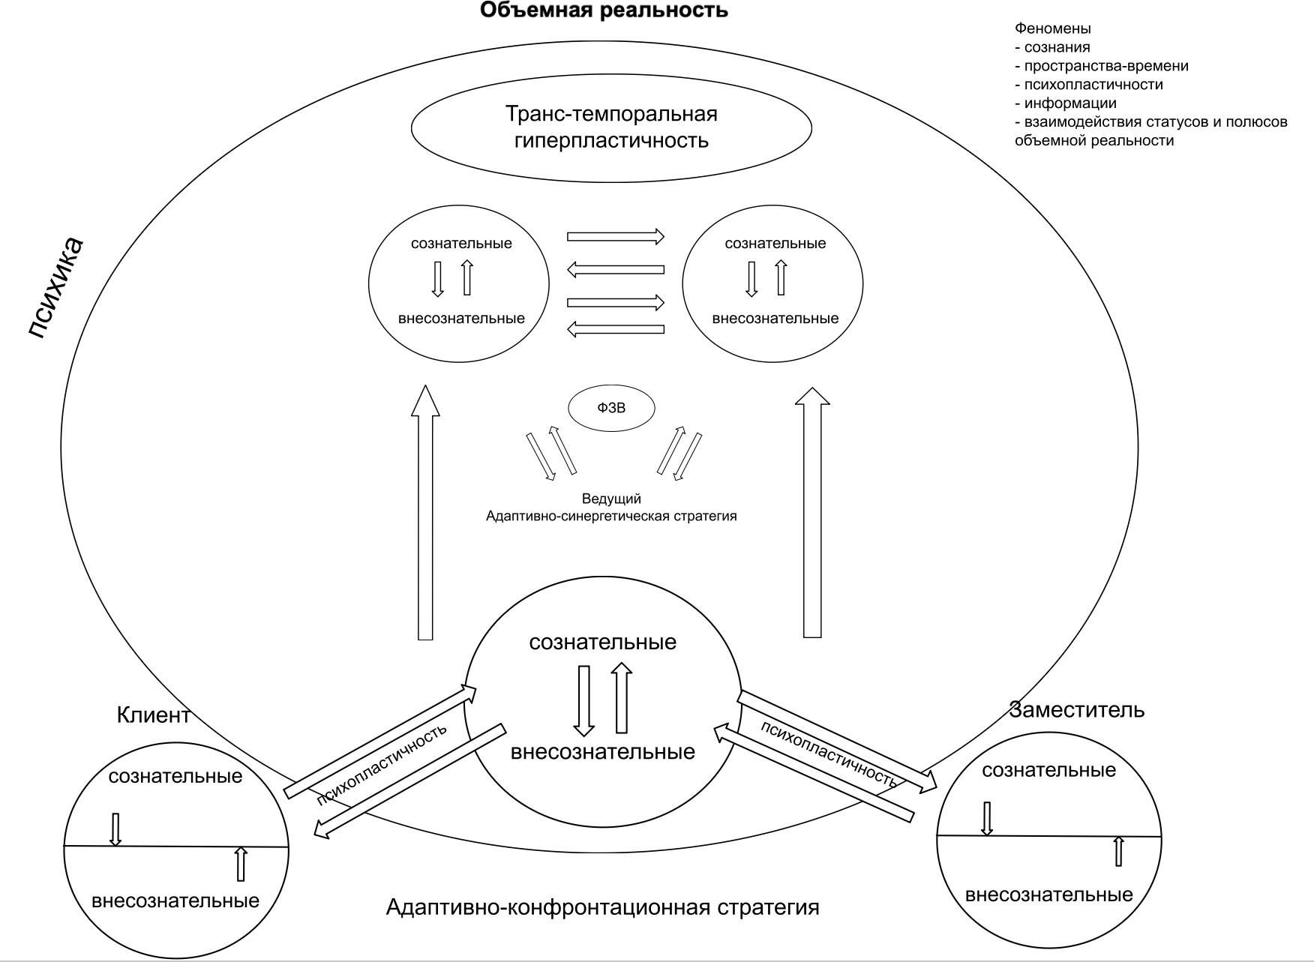

The model is represented by the following characteristics:
Representative perception is a special form of systemic perception, in which the psyche, functioning in the volumetric reality mode, creates a temporary access of the consciousness of one person to: the unmanifested and unconscious family experience of another through the general systemic constellations of the psyche (transgenerational information, experience not encoded in the personal biography of the “receiver”, but “present” in the system of the volumetric whole); impulses, sensations, feelings, figurative experiences associated with the general configurations of the system.

Structural characteristics
The structural model of representative perception includes the following components:
- Lead Facilitator is the initiator of the development of the impulse (energy, emotional charge of the problem situation) coming from the client and accompanying the process of transformation of the impulse from the problem, tense, adaptive-confrontational configuration to the adaptive-synergetic configuration of the solution and ensuring the retention of focus in the process of solving the client's request.
- The client is the source of the request and the carrier of the system dynamics, the necessary conditions are the presence of tension and readiness to solve an important issue.
- Representatives are subjects tuned to significant figures of the client system.
- Significant figures are members of the system with which a phenomenological connection is established (conscious and unconscious instances of general reality).
- The field (the phenomenon of space-time) is a phenomenologically experienced common space of interaction, which has the qualities of an information carrier.
- The included phenomenon of trans-temporal hyperplasticity in all participants of the process (leader, client, representatives, observers (preferably).

Procedural characteristics
representative perception develops as a step-by-step process as a result of the following steps:
Preparation for the process: (initiation of the phenomenon of consciousness) - meeting participants, acquaintance, co-tuning practices (practice of neuroplasticity, deep connection, feeling-feeling of group participants),
- Inclusion of the phenomenon of psychoplasticity;
- Formation of a request from the client (deepening and development of the phenomenon of psychoplasticity);
- Process initiation: the client arranges representatives. (formation of the phenomenon of space-time);
- Immersion in the process: representatives, moving along the trans-temporal scale, fix bodily, emotional and figurative signals, at certain points of systemic tension;
- (formation of the state of trans-temporal hyperplasticity - the initiating appearance of the phenomenon of representative perception);
- Deployment of the process: system stresses, system figures (conscious and unconscious instances) appear in the space of the arrangement, which “speak” and “act” through representatives;
- Understanding: the client "recognizes" - feels and feels a bodily and emotional response to the seen dynamics of the movement of the placement of significant figures, gaining conscious access to previously displaced or unconscious system speakers. Lives to understand and comprehend the image, nature, quality and depth of connections in the system, thanks to which the next stage occurs;
- Transformation of the process: with the help of words, actions, psychotechnical "rituals" and interaction, order is restored in the system - the transformation of heavy, tense, confrontational system dynamics into synergistic, creative, mutually enriching and contributing to the movement of the psyche into the future (the transition of the psyche from the adaptive-confrontational pole to the adaptive-creative pole), which is felt and recognized by all participants in the process;
- Integration: the client takes his place, feels, lives and remembers a new state of his situation (feeling, feelings, image, understanding);
- Completion: removal of the "role-states" by the representatives (dis-identification - dissociation with the image-states (if necessary with observers).
Verbalization of feelings, feelings by the client, representatives, observers, comprehension, recognition of new solutions and strategies. (curtailment of the phenomenon of representative perception in all participants of the process)

Substantive characteristics
The contents of the representative perception Phenomenon are: Emotional component (feelings - fear, pain, shame, anger, longing, anxiety, anger, etc.).
The bodily component (sensation-tension, heaviness, numbness, heat, cold, etc.).
The cognitive component (information, knowledge of events) the figurative component (visual or symbolic images).
Semantic component (intuitive statements reflecting systemic meaning, insights that do not have a rational source in the mind of the representative).

Functional characteristics
The phenomenon of representative perception has a number of functions:
- Diagnostic is the manifestation of hidden systemic conflicts, stress nodes in the system, violation of hierarchies, functions, thinning or interruption (trauma) of relationships, painful system dynamics.
- Therapeutic – restoration of balance and integrity in the system.
- Communicative - symbolic mediation (informational, sensual, motor, semantic) between the elements of the system (client and system figures in the arrangement).
- Regulatory accumulation-reset and redistribution of psycho-emotional and bodily stresses.
- Information-perceptual - access to meta-conscious levels of perception.
Evolutionary-adaptational - expansion of the boundaries of the "I-concept", the development of adaptive-creative strategy of the psyche and the development of systemic sensitivity.

Meaning-based characteristics
The phenomenon of representative perception (RP) expresses the desire of the mental system to realize certain semantic, evolutionary and system-integral tasks. In this aspect, RP can be considered as a tool for the semantic and self-regulating action of consciousness in terms of its inclusion in a broader - family, ancestral, socio-cultural - context. (which does not contradict, but significantly complements the updated theory of adaptation).
Key semantic characteristics of RP:
- The psyche's quest to restore systemic order: RP serves as the mechanism by which the system actualizes broken connections, excluded shapes, forgotten events, a process aimed at restoring integrity and balance, disrupted during transgenerational trauma and disruption of system orders.
- Intent to reveal hidden meaning: RP helps to clarify systemic content that is not directly accessible to the client's mind, a process aimed at discovering what "requires to be seen, learned and transformed."
- Evolutionary-ontological orientation: The psyche, through RP, focuses on the development of the subject through the integration of the experience of the species, the acceptance of fate and the expansion of the boundaries of identity.
Thus, RP acts as a mechanism of existential growth, facilitating the transition from ignorance to recognition, from fragmentation to wholeness.
- The urge to heal and transform. RP is activated only when the system or subject is ready for change; its function is to facilitate the transition from unconscious identification with a family history to conscious choice and liberation from repetitive scenarios; using repetitive scenarios as a "container for meaning and values," it creates the ability, on the basis of them, to create your reality adequate to the present.
- A focus on subjective autonomy: Although RP arises in the context of systemic inclusion, its purpose is to restore the ability of the subject to be himself, free, and yet feel belonging and meaningful connection to the system as a whole.
At the same time, transforming a possible basic conflict of the psyche of “freedom-belonging” into a mutually enriching dynamic system of conscious movement of the whole.
The model described above presents representative perception as a natural manifestation of activated, targeted trans-temporal activity of the psyche in participants in the psychotherapeutic process under conditions in which the temporal plasticity of the psyche is activated. It substantially addresses the identified epistemological limitations of previous explanatory models and significantly expands the diagnostic and therapeutic potential of systemic constellations.
To solve problem 3) on the basis of the described theoretical model, differential diagnosis with related phenomena was carried out. activity mentally possible into course implementation of the method of systemic family constellations:
This observation of related phenomena helps to better understand the meaning and role of the phenomenon of representative perception in the formation of psychotherapeutic changes. Representative perception is a unique phenomenon located at the intersection of the phenomenological field, empathic bodily resonance and systemic transactions.
Bottom line: unique characteristics of RP
- Systemic orientation does not arise as a local response to a particular person or stimulus, but as a phenomenon associated with an entire system (family, organization, intergenerational context) that provides a “reading” of systemic dynamics and structural patterns that symbolic, psychoenergetic, or neurophysiological phenomena do not.
- Passive, phenomenological inclusion is a substitute who perceives the emotional, bodily, and mental states of another person without conscious effort or intention, as opposed to psychodramatic and transpersonal practices where the inclusion is conscious or active.
- Integrating Body and Emotional Experiences with System Information
It combines deep bodily-emotional engagement with an understanding of systemic roles and intergenerational connections. Symbolic and psychoenergetic phenomena can activate emotions or bodily responses, but do not structure them according to systemic logic.
- Diagnostic and therapeutic value
It provides a direct tool for identifying hidden systemic stresses and dynamics, allowing the therapist or representative to work with them practically, which distinguishes it from neurophysiological reactions (empathy, mirror neurons) and synchronicity, which describe a mechanism or coincidence rather than give practical direction.
- Instantaneity and reversibility
It manifests itself spontaneously and instantaneously in a particular situation, but unlike pathological projections or projective identification, its phenomenological inclusion is reversible: the representative can emerge from the state while retaining autonomy.
- Lack of mandatory cognitive or symbolic interpretation
Unlike archetypal, transpersonal, and psycho-energetic phenomena, the meaning and structure of the RP is determined by the systemic position and experience of the representative rather than by the cultural or spiritual context.
Key feature:
The phenomenon of representative perception is a systemic-structural, bodily-emotional phenomenon that arises spontaneously, passively and reversibly, with direct diagnostic and therapeutic value, integrating the perception of other people's states in the context of the family, ancestral and social systems.
Thus, the inclusion of the phenomenon of representative perception in the conceptual apparatus of systemic psychotherapy allows to expand the understanding of perception as a multilevel process, including not only individual, but also family, intergenerational and cultural contexts.

Results of a series of experimental sessions of systemic family constellations with a parallel questionnaire procedure in two formats A) experimental B modified.
To solve Task 5. The procedure of statistical correlation analysis, according to the parameters and indicators studied, and the interdependence of the total correlation coefficient (Chaddock scale) with the characteristics of the degree of psychoplasticity in the participants involved (client, “representatives”, lead) was investigated.
To identify the correlation between the time points selected on the temporal scale in Series B, or reported by the participants themselves in Series A, and the calculated questionnaire-based indicators, Spearman's rank correlation coefficient (ρ) was used. Differences between the correlation coefficients of the experimental series were tested using random permutations and bootstrapping with 10,000 iterations.
Comparisons between experimental series were made using the Mann-Whitney method, and the effect size was estimated using the median difference and the Hodges-Lehmannn median shift.
The significance of the time-label deviations established by the participants relative to the reference values given by the questionnaire data was tested for significance using the non-parametric Friedman criterion. Post-hock analysis of significant differences was carried out using the Dunn test, taking into account the corrections for plurality of comparisons by the Benjamin-Krieger-Yekuteli method.
The connection between the appearance of signals was verified using Fisher’s exact criterion.
To analyze the relationships between binary variables (signals), the study used a Yates correction φ coefficient in cases where the observed frequency in individual cells of the conjugation table was below 5. Confidence intervals (95%) for the φ coefficient were estimated using a non-parametric bootstrap with 1000 repeat samples.
The data were presented - where possible and justified - as a median and interquartile sweep, for a number of measures the 95% confidence interval (CI) is indicated.
These statistical tests are performed using GraphPad Prism 8 software, bootstrap procedures and random permutation method are implemented in Python programming environment.
Events considered in the Series A experimental sessions occurred 3 years later by the observed difference, or 7 years later by the Hodges–Lehmann estimate, than events in the Series B sessions (p < 0.05; Figure 1). The calculated temporal coordinates also differed: Series A values were 0.5 units lower than Series B values (p < 0.05). Client age did not differ significantly. In both series, events were unevenly distributed along the timeline.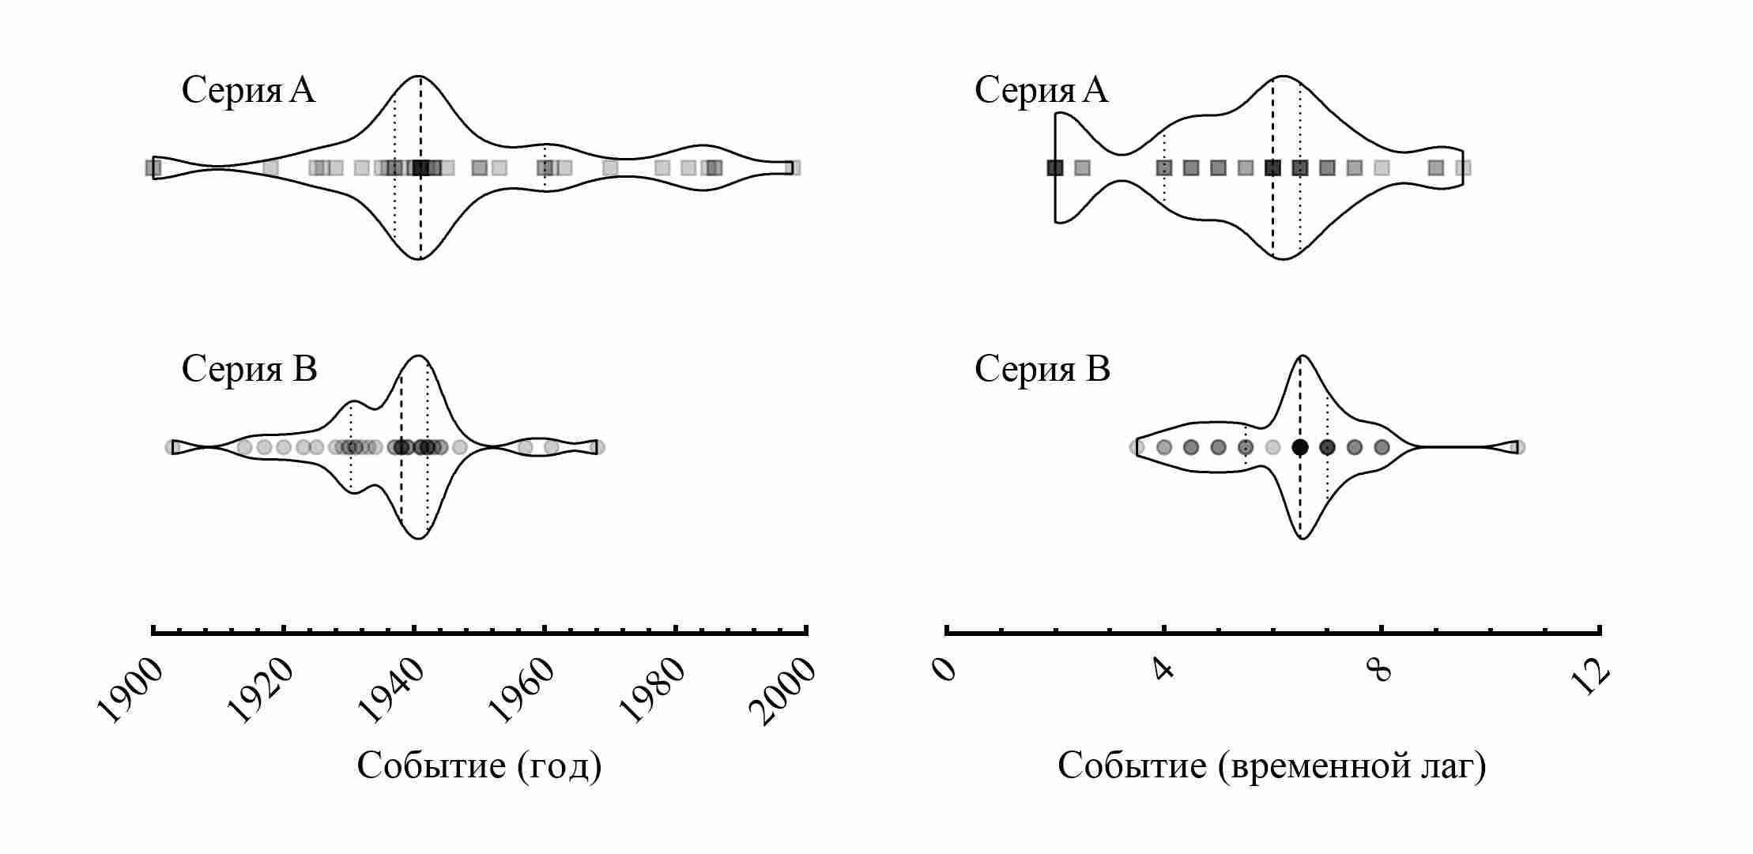
Figure 1 - Distribution of session events by year (left) and time lag (right).

The time points indicated by the participants in the B-series sessions were significantly correlated with the questionnaire data (Figure 2). At the same time, the statistical relationship between the signal values indicated by the participants in the same series was even higher (ρ = 0.85-0.88).
The situation for the A-series sessions was different: the questionnaire data strongly correlated with the responses of clients (ρ = 0.85-0.88) and did not show a statistical relationship with the responses of other participants.
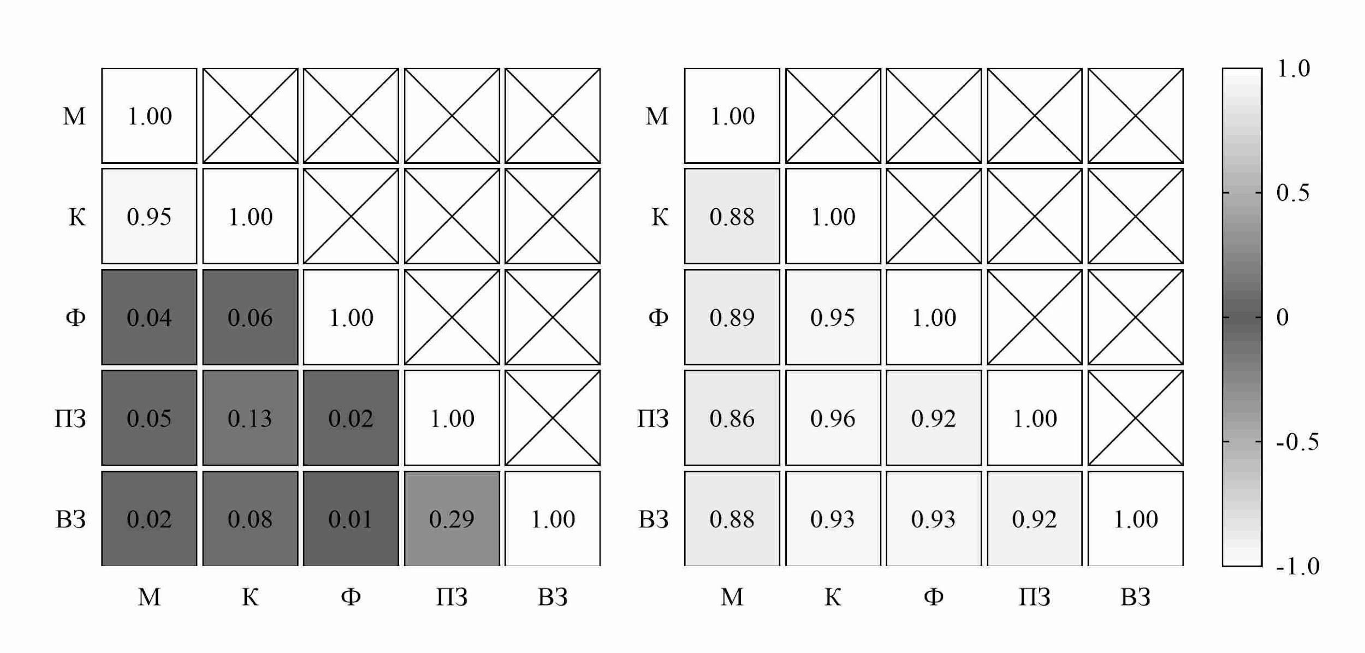

Figure 2 - Spearman's rank correlation coefficient between data specified by participants in the A series (left) and the B series (right) formats; M - materials, K - client, F - facilitator, PZ - first representative, VZ - second representative.
Note that significantly the series differed in almost all pairs of the correlation matrix (p < 0.001).
"client materials", the difference between the series for which was -0.07 (95% CI: -0.20 - 0.02; p> 0.05) units.
The absolute values of the time lag deviation indicated by the session participants from the questionnaire differed significantly between the series for facilitator and representatives (table 1). Within the series-B, there was no difference between the roles on this indicator, while the clients of the A series differed significantly from other values indicated by other roles.

Table 1 - Absolute deviation of the time lag of a significant event from the time lag associated with the appearance of a signal (by roles).

Role | Series A | Series B | p-value
Client | 0 [0; 0,375] | 0,5 [0; 0,5] | 0,054
Facilitator | 1,5 [1; 3] * | 0,5 [0; 0,5] | <0,001
First representative | 1,5 [0,5; 3] * | 0,5 [0; 0,5] | <0,001
Second representative. | 2 [1; 3,5] * | 0,5 [0; 0,5] | <0,001
*p <0.001 with respect to absolute time lag deviations shown by clients of the same series.

Each participant determined the value of the time point, then calculated the difference between the real lag and the value indicated by the participant, hypothesizing that one of the roles could demonstrate higher accuracy (for example, the client - more accurately than the other participants).
The results do not support this assumption for series B, but support it for series A. In particular, all participants in series B experiments demonstrated comparable accuracy, as evidenced by high correlation coefficients. However, for series A, the hypothesis was confirmed: customers showed significantly smaller deviations compared to the facilitator and representatives, which, in turn, showed significant deviations.
Conclusion: In the modified format of the experimental sessions, participants in the process significantly more often accessed the temporal point of the recorded event, which is a manifestation of the specific, trans-temporal interaction of conscious and unconscious mental authorities in the involved persons during the experimental arrangement, and also provides increased accuracy and consistency of time points, reducing the risk of projective distortion.
The connection of the signals of the participants of the experiment and personal data in relation to the lag of a fixed event.
The results of the study of signal communication within each series are presented in Tables 2 and 3.
Table 2 - Coefficient φ of communication between signals of different roles (C-A)

Signal. | C-R1 | KVZ | KF | C-M | PZ-WZ | R1-F | R1-M | R2-F | WZM | FM
IN-11 | 0,07 | 0,1 | 0 |  | 0,37 | 0,66* |  | 0,16
OB-11 | 0,18 | 0,11 | 0,07 |  | 0,05 | 0,11 |  | 0,11
G-11 | 0 | 0 | 0 | 0,01 | 0,21 | 0,12 | 0 | 0 | 0 | 0,06
G-13. | 0,21 | 0 | 0 |  | 0,03 | 0 |  | 0
G-14 | 0,04 | 0,05 | 0,13 | 0,26 | 0,2 | 0,04 | 0,03 | 0,16 | 0 | 0
G-15. | 0,04 | 0,04 | 0,14 | 0,18 | 0,06 | 0,08 | 0,13 | 0 | 0,02 | 0,06
G-16. | 0,18 | 0,02 | 0 | 0,05 | 0 | 0,01 | 0,11 | 0 | 0,03 | 0
J-11 | 0 | 0 | 0,08 | 0 | 0 | 0,27 | 0 | 0,04 | 0 | 0
Ch-12 | 0,24 | 0,15 | 0,13 | 0 | 0 | 0,1 | 0 | 0,1 | 0 | 0,02
J-21 | 0,03 | 0,39 | 0,45* | 0,07 | 0 | 0,1 | 0 | 0 | 0 | 0
J-22 | 0 | 0,43* | 0 | 0,14 | 0,15 | 0,3 | 0 | 0,03 | 0,09 | 0,11
J-23 |  | 0 | 0 | 0 |  |  |  | 0 | 0 | 0,06
J-31 | 0 | 0,18 | 0 | 0,24 | 0 | 0 | 0 | 0 | 0 | 0
J-41 | 0,1 | 0,1 | 0 |  | 0 | 0 |  | 0
J-43 | 0 | 0 | 0,01 | 0 | 0 | 0,14 | 0 | 0,42* | 0 | 0
G-17. | 0 |  | 0 | 0 |  | 0 | 0,31 |  |  | 0
G-21. | 0,15 | 0,31 | 0,32 | 0,06 | 0 | 0,09 | 0 | 0,23 | 0 | 0

*p <0,001

Table 3 - Coefficient φ of communication between signals of different roles (C-B)

Signal. | C-R1 | KVZ | KF | C-M | PZ-WZ | R1-F | R1-M | R2-F | WZM | FM
IN-11 | 0,2 | 0,03 | 0,43* |  | 0,65* | 0,42* |  | 0,25
IN-12 | 0,34 | 0,24 | 0,43* |  | 0,44* | 0,7* |  | 0,52*
OB-11 | 0,24 | 0,16 | 0,45* |  | 0,5* | 0,41 |  | 0,51*
OB-12 | 0,18 | 0,06 | 0,35 |  | 0,37 | 0,37 |  | 0,31
OB-13 | 0,62* | 0,37 | 0,62* |  | 0,47* | 0,77* |  | 0,47*
G-11 | 0,28 | 0,32 | 0,32 |  | 0,37 | 0,37 |  | 0,43*
G-12. | 0,51* | 0,38 | 0,51* | 0,46* | 0,44* | 0,51* | 0,51* | 0,44* | 0,38 | 0,51*
G-13. | 0,41 | 0,54* | 0,4 | 0,32 | 0,31 | 0,32 | 0,26 | 0,32 | 0,26 | 0,35
G-14 | 0,51* | 0,74* | 0,59* | 0,58* | 0,52* | 0,59* | 0,58* | 0,59* | 0,56* | 0,61*
G-15. | 0,22 | 0,47* | 0,32 | 0,2 | 0,42* | 0,06 | 0,01 | 0,28 | 0,29 | 0,51*
G-16. | 0,29 | 0,32 | 0,35 | 0,5* | 0,17 | 0,22 | 0,22 | 0,25 | 0,43* | 0,47*
J-11 | 0,49* | 0,58* | 0,5* | 0,58* | 0,32 | 0,25 | 0,32 | 0,5* | 0,31 | 0,25
Ch-12 | 0,57* | 0,4 | 0,55* | 0,37 | 0,35 | 0,39 | 0,3 | 0,44* | 0,04 | 0,3
J-13 | 0,15 | 0,15 | 0,31 |  | 0,21 | 0,37 |  | 0,37
J-14 | 0 | 0 | 0 |  | 0 | 0 |  | 0
J-21 | 0,58* | 0,32 | 0,32 | 0 | 0,32 | 0,17 | 0,25 | 0,26 | 0,25 | 0,1
J-22 | 0,6* | 0,55* | 0,55* | 0,65* | 0,5* | 0,61* | 0,5* | 0,47* | 0,45* | 0,47*
J-23 | 0,5* | 0,35 | 0,45* | 0,41 | 0,5* | 0,39 | 0,36 | 0,23 | 0,11 | 0,33
J-31 | 0,3 | 0,4 | 0,18 | 0,31 | 0,55* | 0,35 | 0,03 | 0,3 | 0,28 | 0,05
J-33 | 0,37 | 0,37 |  |  | 0,48*
J-41 | 0,31 | 0,32 | 0,35 | 0,11 | 0,49* | 0,15 | 0 | 0,1 | 0,01 | 0,31
J-43 | 0,39 | 0,42* | 0,42* | 0 | 0,7* | 0,32 | 0,11 | 0,45* | 0,16 | 0
*p <0,001

Conclusion: Series A showed few significant role relationships within a single signal.
More significant relationships were observed for series B. For example, within several signals, all roles are significantly related to each other.
Figure 3 — Occurrence of feeling signals (left) and sensation signals (right) among participants in the experimental sessions; *p < 0.001.
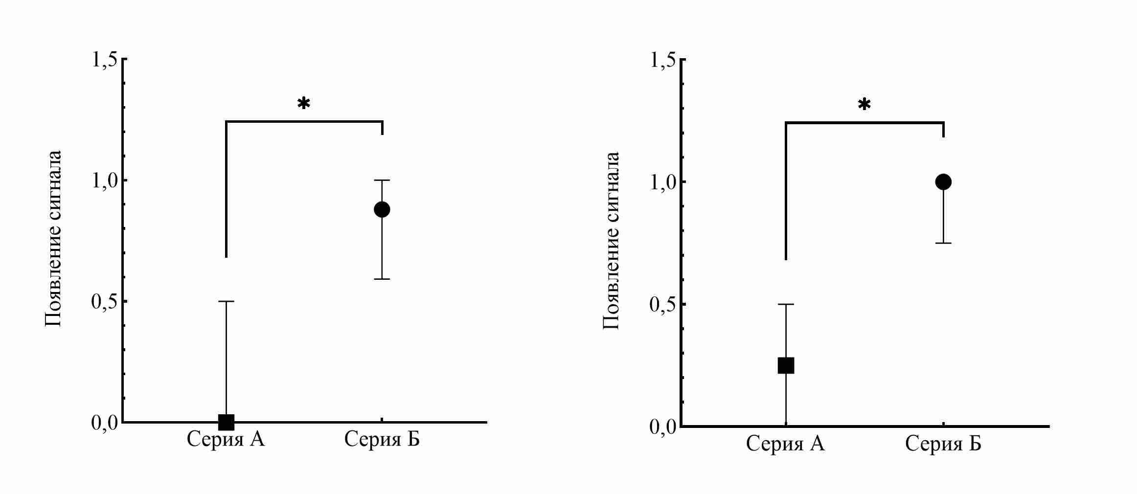

Table 3. Occurrence of feeling signals and sensation signals among experimental-session participants, by role.
Role | Series A | Series B | p-value
Feeling signal.
Client | 0 [0; 1] | 1 [1; 1] | <0,001
Facilitator | 0 [0; 0] | 1 [0,5; 1] | <0,001
First representative. | 0 [0; 0] | 1 [0,5; 1] | <0,001
Second representative. | 0 [0; 0] | 1 [0,5; 1] | <0,001
Sensation signal
Client | 0 [0; 1] | 1 [1; 1] | <0,001
Facilitator | 0 [0; 0] | 1 [1; 1] | <0,001
First representative. | 0 [0; 1] | 1 [1; 1] | <0,001
Second representative. | 0 [0; 1] | 1 [1; 1] | <0,001
Recorded from the participants' words, the signals (feelings, sensations, images, information) were significantly related to each other to a greater extent in series B, compared with the signals of series A.

Table 4: Results of the study of the coefficient of association between signals for complete experimental groups in series A and B.
Signal. | Series A | Series B | p-value
Feeling. | 0 [0; 0,5] | 0,88 [0,59; 1] | <0,001
Sensation. | 0,25 [0; 0,5] | 1 [0,75; 1] | <0,001
A significant statistically significant association was also found in the study of the complete experimental group (Table 4).
Of particular interest is the issue of consistency of the received signals by participants with personal data.
Separately. examined association emergent signal between roles (Figures 4-7).

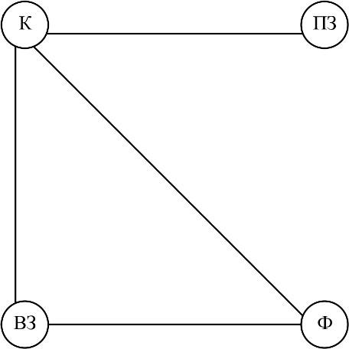
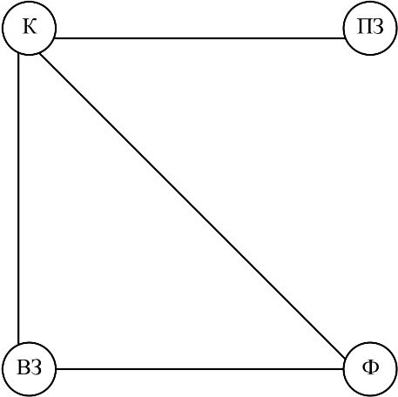
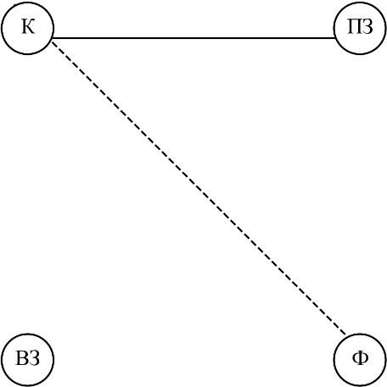
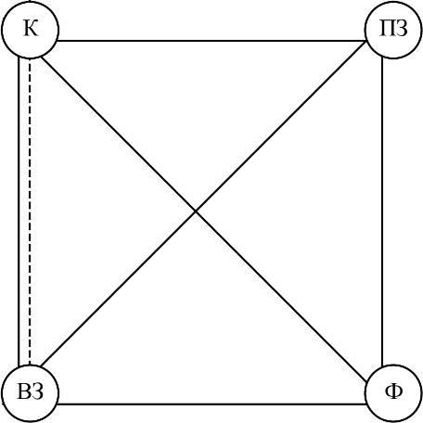

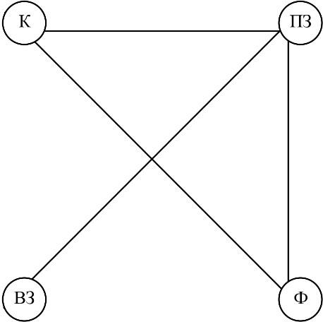
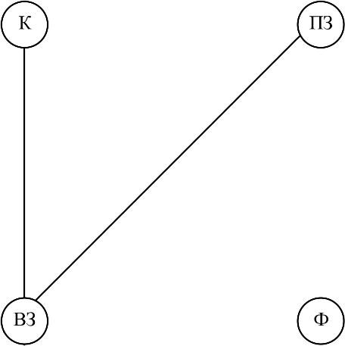
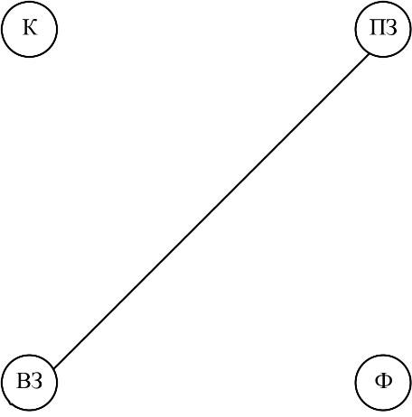
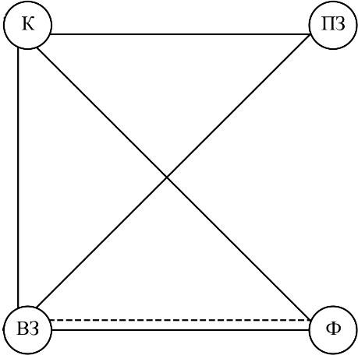

Figure 4 - Association of the occurrence of feeling signals between roles: (left-to-right) 4.1.2.1.1., 4.1.2.1.2., 4.1.2.2.1., 4.1.2.2.2., 4.1.2.2.3., 4.1.2.3.1.,
4.1.2.4.1., 4.1.2.4.3. A dotted line is the joint appearance (or non-appearance) of a signal between its connected roles for a series A, a solid line is the same for a series B.

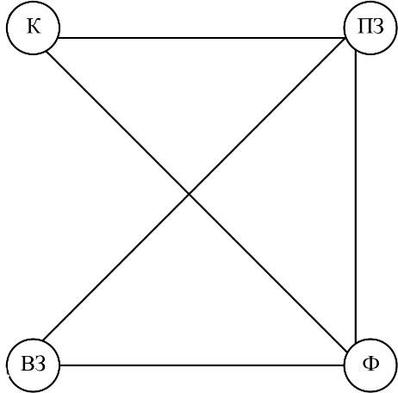
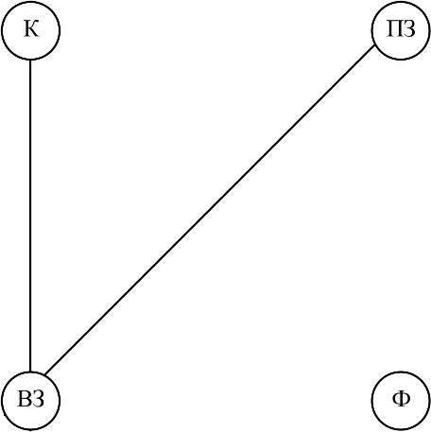
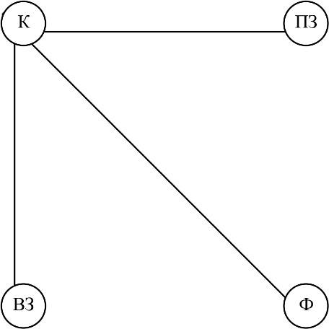
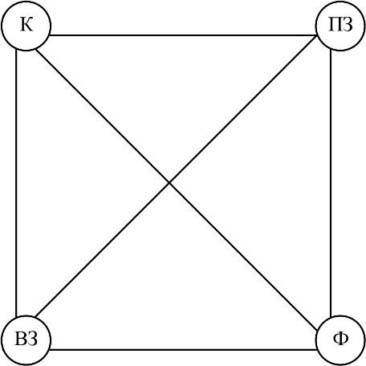

Figure 5 - Association of the occurrence of sensory signals between roles: (left-right) 4.2.2.1.2., 4.2.2.1.3., 4.2.2.1.4., 4.2.2.1.5.
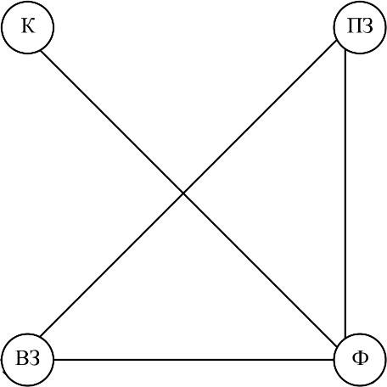
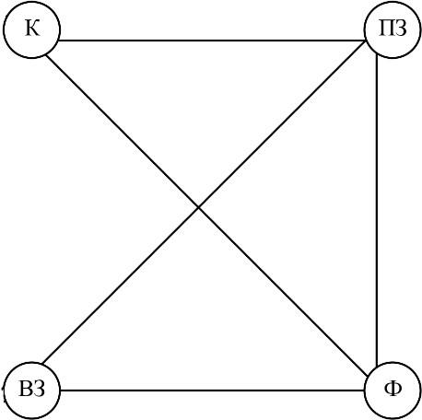
Figure 6 - Association of the origin of imagery signals between roles: (left-to-right) 4.3.2.1.1., 4.3.2.1.3. Dotted line - the joint appearance (or non-appearance) of a signal between its connected roles for series A, solid line - the same for series B.

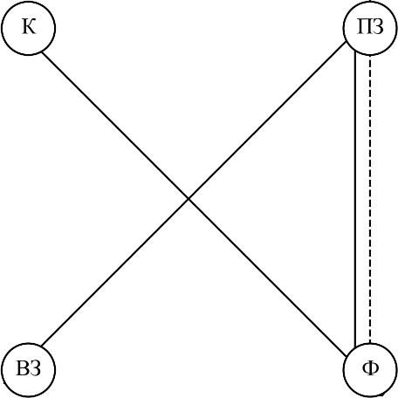
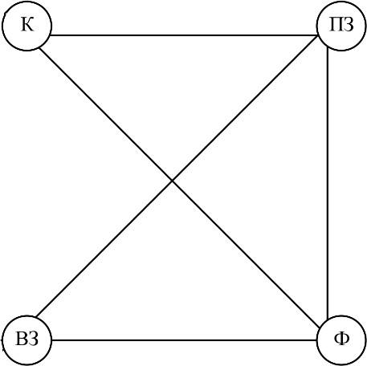

Figure 7 - Association of the origin of information signals between roles: (left-to-right) 4.4.2.1.1., 4.4.2.1.2. Dotted line - the joint appearance (or non-appearance) of a signal between its connected roles for series A, solid line - the same for series B.
Participants in Series B sessions identified the feeling and sensation signals reported in the questionnaires (the feelings of the client's older relatives) significantly more often than participants in experimental Series A (Figure 3). The signals also showed greater agreement. This pattern held both for the full experimental group (Table 4) and at the level of participant roles (Table 3). Within each stage, the frequency of successful signal acquisition was not associated with the participant's role.
Conclusion: We can assume that in the experiments of series B, a single field of perception is formed, in which all participants significantly more often demonstrate similar signals in all the studied parameters and indicators of the phenomenon of representative perception (signals: feeling, sensations, image, information in relation to the time lag of the recorded event).
In experimental series A, the host and representatives are actually less “involved” in the space of volumetric reality and as a result are “disconnected” from information about the significant relative of the client and the nature of the significant event.
Thus, for therapeutic and research practice, the modified format may seem more reliable, since the results do not depend only on the client, but consist of a set of information about a significant event in the client’s birth system, obtained by all active participants in this process through trans-temporal interaction in the system of “conscious-unconscious mental instances”, which is more reliable and contributes to the mutual verification of the data obtained.

The experimental series also differed in the "clearness" of the signal.
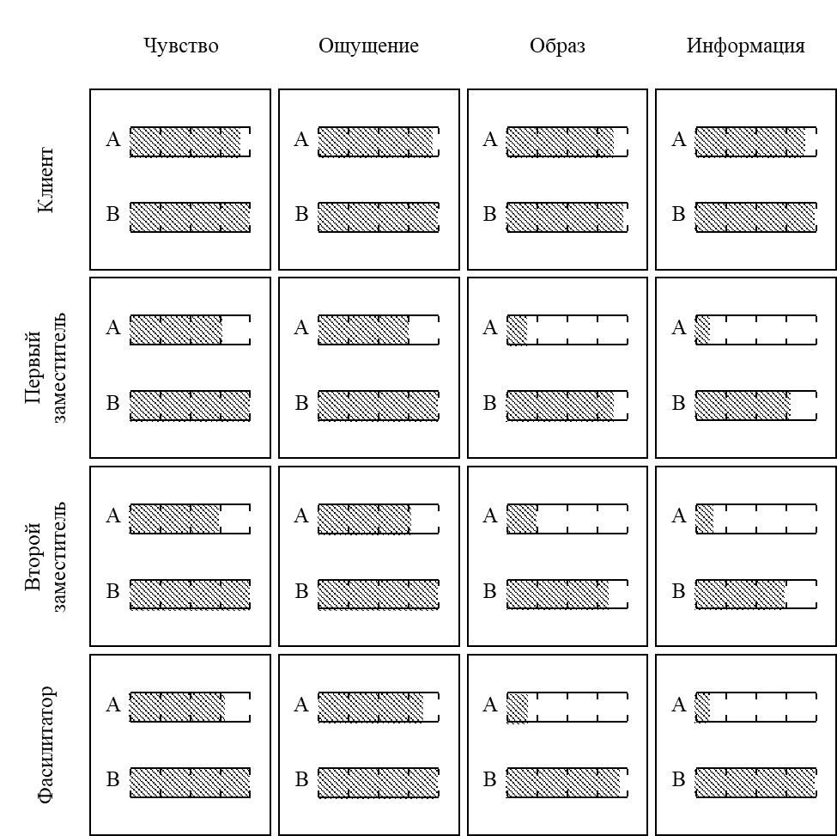
Figure 8 - The number of explicit signals for series A and series B experiments.

Facilitators and representatives of series B reliably (p <0.05) received explicit signals more often than participants in the same roles of series A with a small exception in the form of a signal-sensation for facilitators, the difference between which in series was at the trend level (p = 0.086).
Clients in the series did not differ in this respect, while Series A clients differed significantly from other roles in the same series, especially for image signals and information signals.
Participants in the modified-format experimental series showed little difference, and it can be noted that the representatives in this series received significantly less explicit information than facilitators and clients.
Conclusion: In Series A, the signals were concentrated mainly in the client, the representatives and facilitator showed a low degree of involvement in the psychotechnical space, which apparently does not reveal the potential of psychoplasticity and does not include the manifestation of the phenomenon of representative perception.
In a series of experiments B, signals were recorded more often and were more clearly expressed (especially signals of feelings and sensations), which creates reliability and multichannel verification of signals, as well as signals were more consistent in all participants of the experiment, which indicates a high degree of involvement of participants in the psychotechnical space and is one of the key criteria for the reliability of the phenomenon of representative perception.
The results of an empirical study of the relationship of indicators and indicators of the phenomenon of representative perception with indicators of the phenomenon of psychoplasticity.
Psychoplasticity was measured using the PICAP test (Subjective Control Scales 1 and 2).

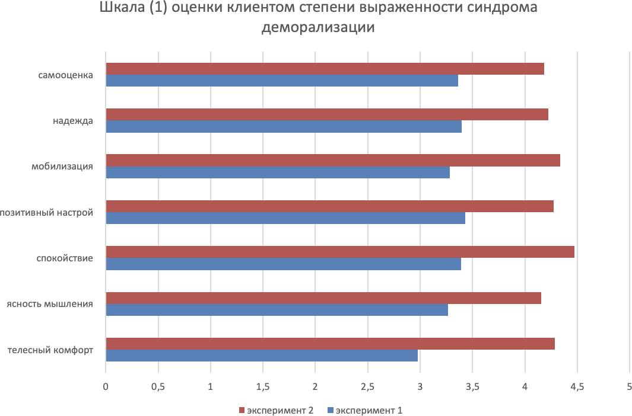

Table 4: Evaluation of the severity of demoralization syndrome Scale (1).
Experiment | bodily comfort | clarity of thinking | calmness | positive attitude. | mobilization | hope | self-esteem
Series A | 2,97619 | 3,288136 | 3,377551 | 3,494915 | 3,277966 | 3,376271 | 3,332203
Series B | 4,24953 | 4,139596 | 4,4304 | 4,20103 | 4,30204 | 4,2035 | 4,14964
(p <0,001).
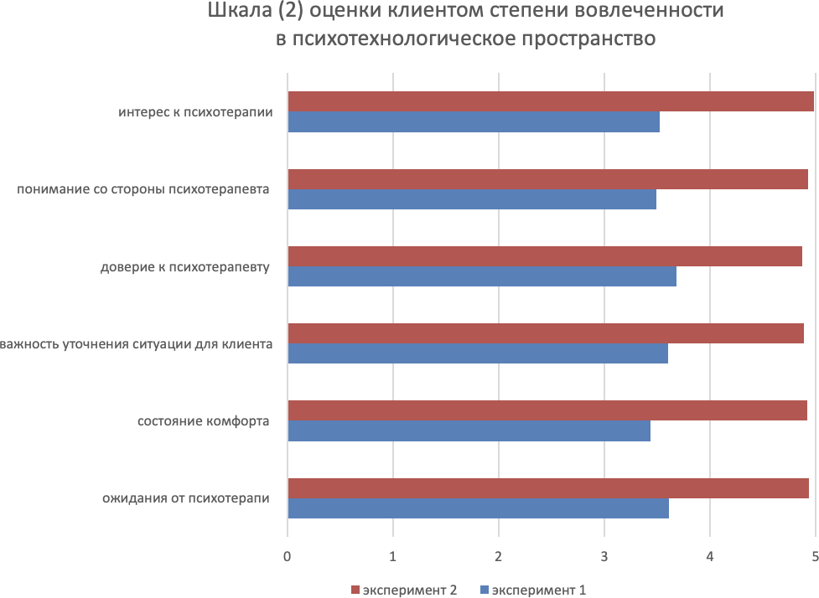

Table 5: Evaluation of the degree of involvement in psychotechnical space, Scale (2).
Experiment | expectations regarding psychotherapy | state of comfort | importance of clarifying the situation for the client | trust in the psychotherapist | feeling understood by the psychotherapist | interest in psychotherapy
Series A | 3,608 | 3,436735 | 3,603175 | 3,677291 | 3,491263 | 3,521913
Series B | B4,931972789 | 4,915254237 | 4,888135593 | 4,86779661 | 4,928813559 | 4,983050847
(p <0,001).

Through the severity of indicators of the presence / absence of demoralization syndrome, as well as the severity of the degree of involvement in the psychotechnical space, the inclusion and degree of manifestation of the phenomenon of psychoplasticity were checked. High degree of involvement and absence of demoralization syndrome indicate the presence of participants in the included phenomenon of psychoplasticity.
The participants of the experimental sessions differed in their scores (Figure 9).
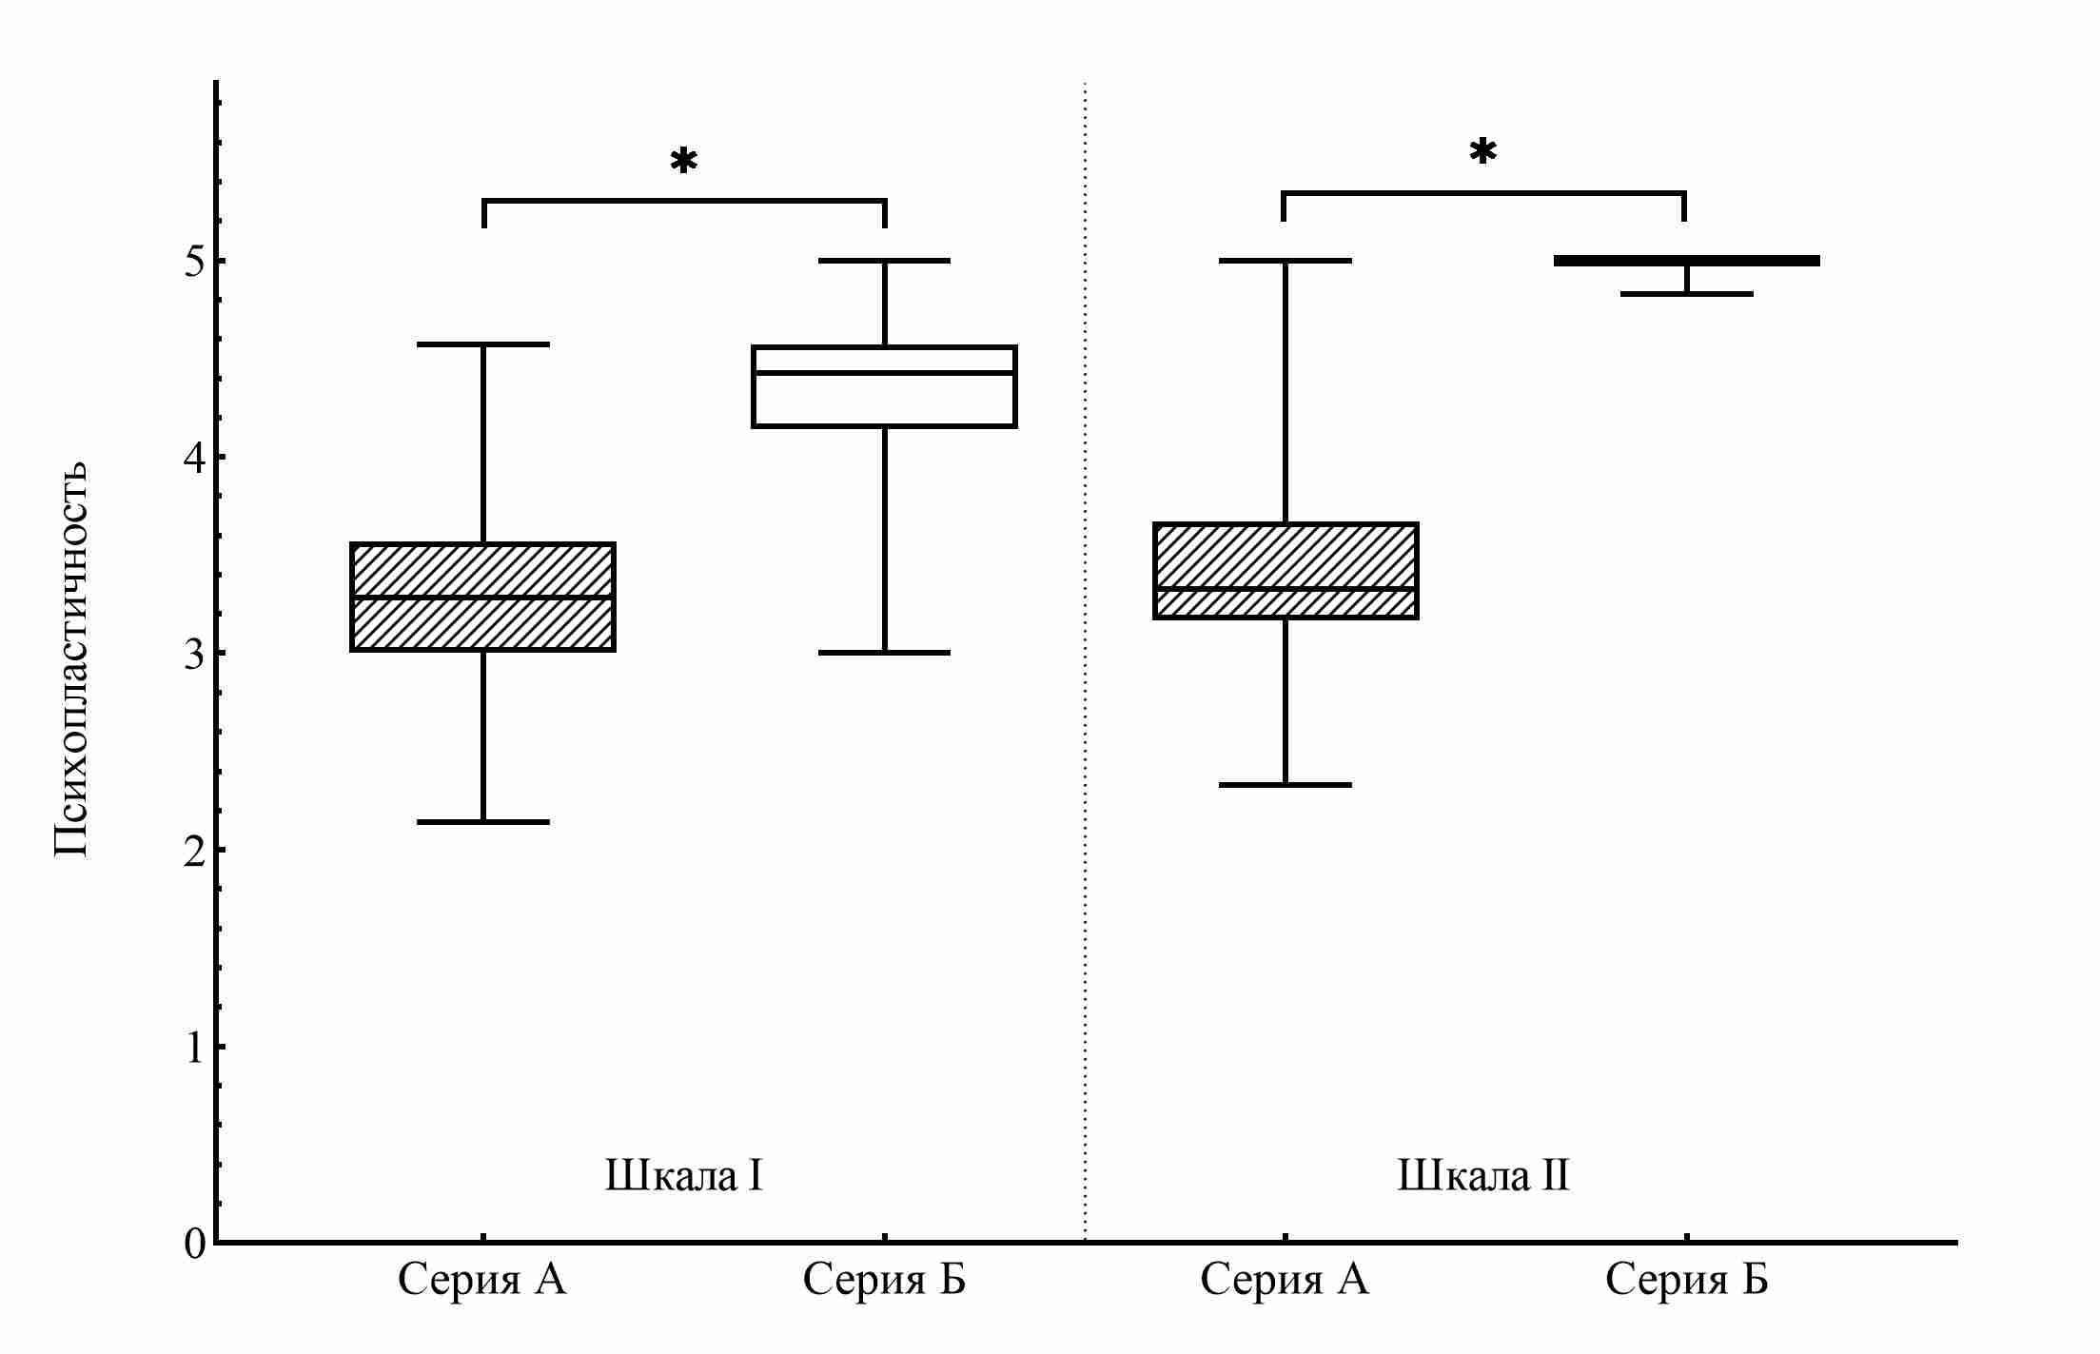
According to the PICAP SK-2 Scale test, Series A participants scored 1.67 (95% CI: 1.50 - 1.67) points less than Series B participants.
Figure 9 - Psychoplasticity of participants of experimental sessions (A) and (B) formats; K - client, PZ - first representative, VZ - second representative, F - facilitator; *p < 0.001.

The analysis revealed a statistically significant correlation between the level of psychoplasticity and the parameters of subjective perception (the proportion of signals indicated in the questionnaire). Indicators of psychoplasticity showed a positive association with the proportion of signals indicated in the questionnaire, both in the category of feelings (ρ = 0.47; 95% CI: 0.38-0.56; p < 0.001), and in the category of sensations (ρ = 0.46; 95% CI: 0.36-0.54; p < 0.001), which indicates a tendency to increase in the number of people with higher levels of psychoplasticity. In addition, a negative correlation was found between the indicators of psychoplasticity and the absolute deviation of the time lag from the questionnaire values (ρ = -0.32; 95% CI: -0.42 - - -0.21; p<0.001), which indicates a more accurate reproduction of time intervals by participants with high rates of psychoplasticity.
Multiple linear regression also showed a connection.
ρ = 0.31. (95 % CI: 0.03 - 0.57; p < 0.001) between psychoplasticity and determination coefficient for the proportion of correctly defined questionnaire-feeling signals, sensation signals and absolute deviation of the time lag selected by session participants from the questionnaire.
When using the parameters, it is possible to conclude that the aggregate (average value for the case) of error in determining the sensory signals correlates with the aggregate of “thought clarity” for both series:
ρ = 0.35 (95% CI: 0.03 - 0.60; p < 0.001) for the A series
ρ = 0.36 (95% CI: 0.04 - 0.61; p <0.001) for series B.
The same can be said for signal-feeling and clarity of thought ρ = 0.39 (95 % CI: 0.07 - 0.64; p < 0.001) for the A series
ρ = 0.36 (95% CI: 0.04 - 0.61; p < 0.001) for series B
and "comfort" of 0.35 (95% CI: 0.02 - 0.60; p < 0.001), respectively.
Conclusion: Correlation analysis demonstrates a statistically significant relationship of psychoplasticity indicators, with an absolute deviation of the time lag and the proportion of signals that have arisen according to the studied parameters and indicators of the phenomenon of representative perception, in all involved participants of the experiment (client, “substitutes”, lead).

Results of analysis of psychophysiological data (EEG, GSR, PPG), in relation to the indicators of the PICAP test

Results of electroencephalography (EEG) data analysis
(Red marked artifacts, green marked spikes, “fading”, wave activity).
Series A results
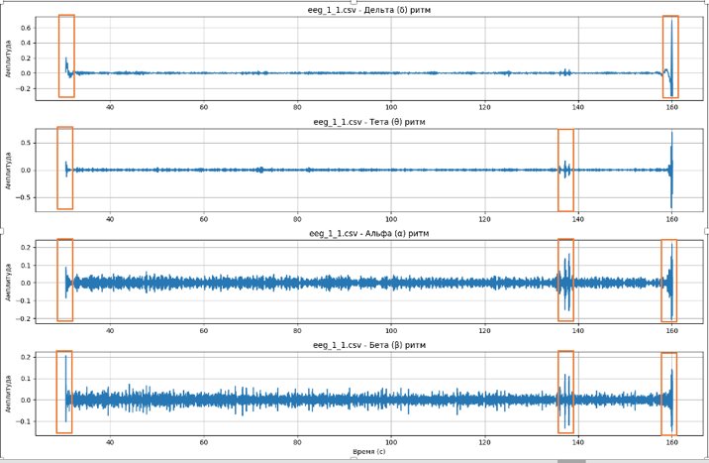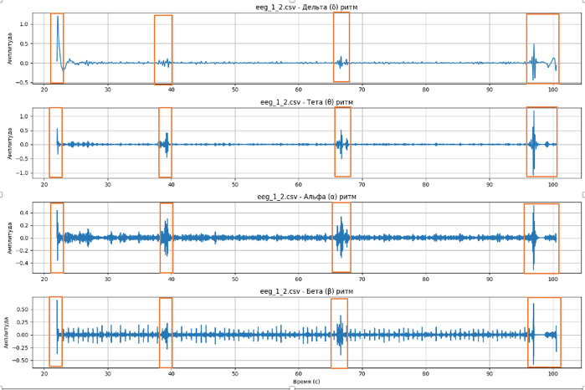

Series B results
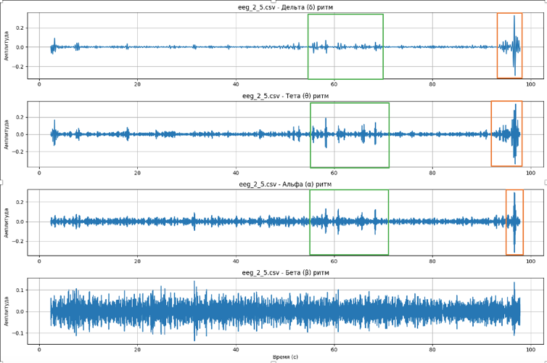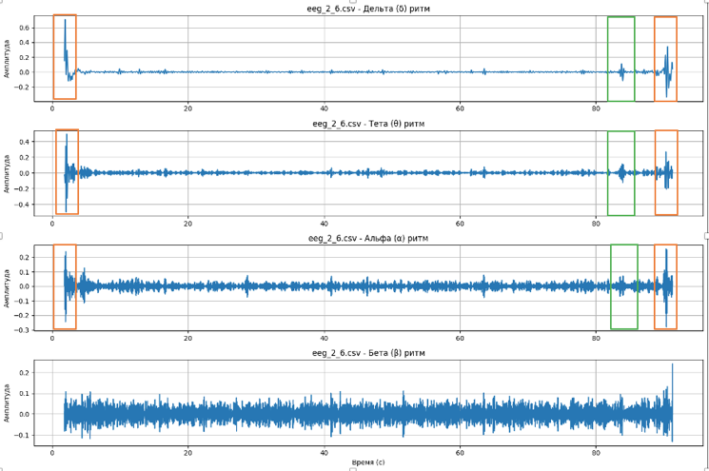
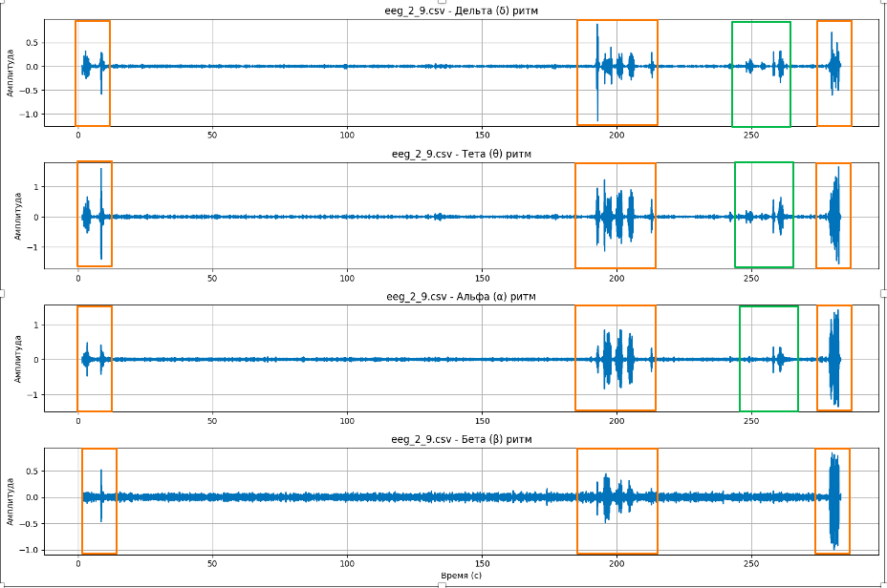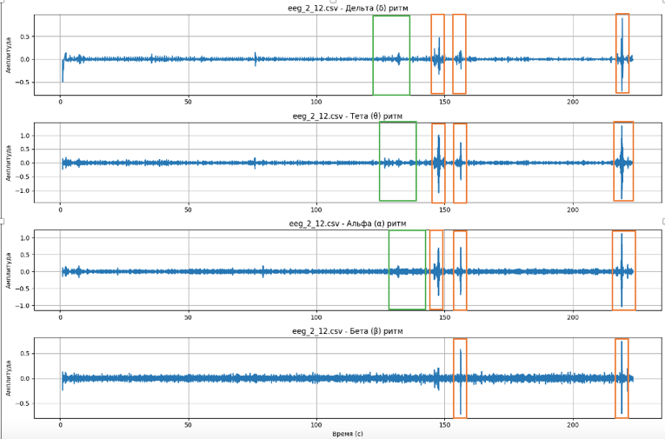

Qualitative electroencephalogram (EEG) analysis revealed clinically relevant patterns of brain activity that, despite no statistically significant differences in the spectral power of the main rhythms, formed an internally consistent and meaningful picture. A key difference between the groups was in the dynamics of the neurophysiological response when approaching the point of significant event. This suggests that their brains were already in a state of “readiness” – a kind of working mode in which the traumatic event material is perceived not as an unexpected threat, but as information to be uniformly processed, in other words, their nervous system was already involved in the process without requiring additional mobilization.
In contrast, a control group that plunged into the event (probably unknowingly, because the timing is much less matched with the questionnaire data) experienced a vivid response in the anterior cortex, a classic neuromarker of the orientation response, where the brain signals, "Stop, this is important!", requiring immediate focus on the stimulus. Simultaneously observed signs, activation of memory processes and "inward immersion" are similar to the "fading" response, in which a person internally freezes, concentrating on the experience.
Thus, the findings clearly demonstrate how pre-immersion in a state of psychoplasticity can change the very nature of perception of emotionally significant material: not causing an acute stress response “in the forehead”, but allowing the nervous system to process it in an already prepared, integrated mode. This is a valuable observation indicating a potential mechanism for buffering acute stress response, which can have direct practical applications in therapeutic work.

Results of galvanic skin reaction (GSR) 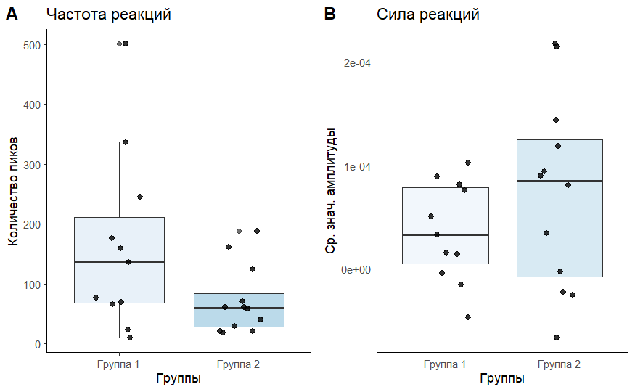
Figure 2: The results of differences in the indicators of kg in frequency and strength of reactions in the group of series B (1 group) and group of series A (2 group).
The study demonstrates the application of modern GSR signal processing methodology and statistical analysis: the Savitsky-Golei filtering method allowed to qualitatively isolate the characteristics of the signal, and the correct use of non-parametric statistics made it possible to estimate intergroup differences in a small sample.
The main finding was the tendency to differ in the frequency of psychophysiological reactions in the absence of differences in their strength.

Results of analysis of photoplethysmography (PPG) data
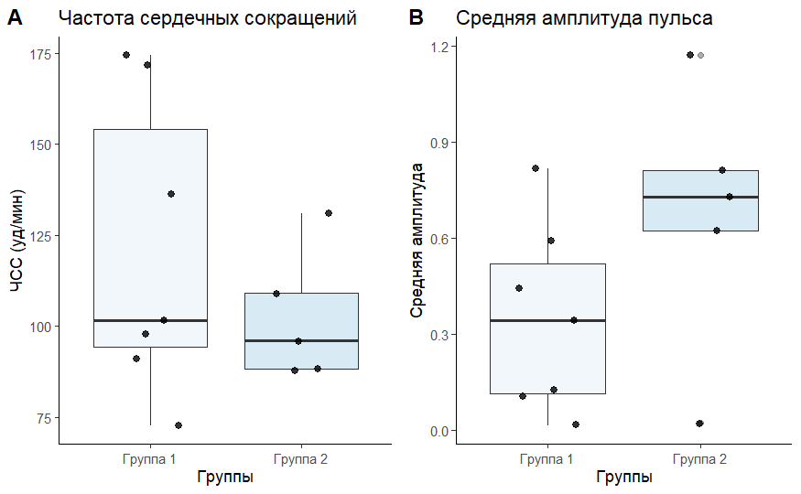
Figure: Results of differences in heart rate and amplitude of photoplethysmograms in series B (group 1) and series A (group 2).

Conclusion: a significant downward trend in pulse wave amplitude in one group is potentially consistent with a change in peripheral vascular tone against a background of psychophysiological load. Thus, the findings do not disprove the effect of the practice, but rather indicate a complex, multicomponent nature of this influence, which is not captured by a simple comparison of averages in a small sample, but sets a clear direction for further research with stricter control of recording conditions.

Results of the study of indicators of the phenomenon of psychoplasticity.

Table: Evaluation of the severity of demoralization syndrome, Scale (1).

experiment | bodily comfort | clarity of thinking | calmness | positive attitude. | mobilization | hope | self-esteem
Series A | 2,7 | 3,4 | 3,2 | 3,5 | 3,1 | 3,5 | 3,4
Series B | 4,3 | 4,4 | 4,4 | 4,5 | 4,3 | 4,2 | 4,3

Table: Evaluation of the degree of involvement in psychotechnical space. Scale (2).
Experiment | expectations regarding psychotherapy | state of comfort | importance of clarifying the situation | trust in the psychotherapist | feeling understood by the psychotherapist | interest in psychotherapy
Series A | 3,7 | 3,3 | 3,6 | 3,2 | 3,1 | 4,1
Series B | 4,9 | 4,9 | 4,8 | 4,8 | 4,7 | 4,8

Conclusion: According to the PICAP SK-2 Scale test, participants in Series A scored on average 1.48 points less than the participants in Series B.

The results of the study of signal indicators in relation to the point of time lag of the recorded event:
Participants in the series B experiments were significantly more likely to name the sense signals and sensation signals indicated in the questionnaires, and significantly more likely to access the temporal point of the recorded event than participants in the series A experiments.
General conclusions on the analysis of psychophysiological data
The study, based on the simultaneous recording and comparative analysis of EEG, GSR, PPG, and PICAP data, revealed a set of consistent psychophysiological trends associated with the use of practices aimed at developing psychoplasticity. The convergent picture, consisting of qualitative patterns and trends in the size of the effect, suggests a systemic impact of intervention on the processing of emotionally significant information.
Two qualitatively different profiles of the vegetative and central response were formed, clearly corresponding to the conditions of the experiment:
- In the series B group (modified format), a pattern characteristic of the state of “neuroplastic readiness” was observed: it was expressed in a high-frequency but low-amplitude pattern of GSR (active processor), indicating perceptual sensitivity and active scanning of internal experience, and stable EEG activity when faced with a traumatic event, indicating the integration of the experience without the need for acute stress mobilization.
- In Series A (the experimental format), a pattern of an initial response to novelty and threat was recorded. It was characterized by a low-frequency, high-amplitude galvanic skin response (GSR) pattern (deep immersion), together with a pronounced orienting response and signs of freezing in the EEG. This pattern reflects the classical response to a sudden, emotionally significant stimulus.
2. PPG data, although not statistically significant, supplement the overall picture of vegetative response. A significant tendency to decrease the amplitude of the pulse wave in one group is found to be potentially consistent with changes in peripheral vascular tone against the background of psychophysiological load.
3.The key conclusion is to demonstrate that prior interaction does not “disable” the stress response, but changes its quality.The results suggest that pre-immersion contributes to the transition from a reactive, defensive response model (expressed in group A) to a model of adaptive synergistic activity, in which the nervous system does not block the experience, but processes it in a prepared, more efficient mode.
Thus, a comprehensive analysis of the EEG, GSR, PPG and PICAP data confirms that the inclusion and development of the phenomenon of psychoplasticity has a regulatory effect on the brain-body system, optimizing the process of interaction with traumatic experiences. The trends found can be of high practical value, as they indicate specific neurophysiological and vegetative markers that in the future can be used to monitor the effectiveness of therapeutic interventions and individual selection of psychological techniques.

Conclusions from the research results.
Conclusion from epistemological research: A systematic review of the topic of the study revealed epistemological deficits, previous explanatory models of the phenomenon of representative perception and on the basis of the currently existing definition of the phenomenon and hypothesis of this study, and allowed to describe the model of the phenomenon of representative perception, significantly eliminating these deficits.
On the basis of the core thesis of the General Theory of Psychotherapy, the main function of the psyche - the generative and the psyche in the very first approximation is the tool for generating and formatting the categories of space and time. And it is the psyche that forms the informational, the main level of reality for all living things. And a special emergent function of the psyche - the ability to control the plastic parameters of consciousness-time - underlies the phenomenon of psychoplasticity, and justifies the possibility of managing time and, accordingly, flexible spatial formats of the generated reality, at least in the field of the mental.
The phenomenon of psychoplasticity is a fundamental property (potential) of the mental, the actualization of which significantly increases the adaptive condition of the subject due to the possibility of interaction with reality in the mode of temporal plasticity.
That is, the “heart” of the phenomenon of psychoplasticity contains the characteristics of a special temporal (trans-temporal) activity of the mental.
The phenomenon of representative perception is considered as a natural manifestation of actualized, trans-temporal activity of the psyche of the subjects involved, manifesting as a private manifestation of the process of psychoplasticity, with the simultaneous, natural inclusion of all other phenomena of overall reality, thanks to the generative function of the psyche.
This provides, among other things, the conditions for the synergistic activity of conscious and extra-conscious instances, significantly facilitating the possibility of retrospective and prospective travels in time, achieving age regression and progression, which makes it possible for representatives to live the states of those people or components of systems in the arrangements that were long before the present moment or are in the probable future.
This means that representative perception and phenomenological accuracy of the representative are possible in a state of psychoplasticity.
Thus, the phenomenon of representative perception is considered as a natural manifestation of actualized “targeted” trans-temporal activity of the psyche in the subjects of the psychotherapeutic process, in the conditions of actualization of temporal plasticity of the psyche, expanding the diagnostic and therapeutic potential of systemic alignments.

Conclusions from the pilot study
A successful experimental study allowed to reliably verify the main indicators of the phenomenon of representative perception that occurs during the actualization of trans-temporal activity and to detect statistically significant relationships between this phenomenon and the phenomenon of psychoplasticity: correlation analysis demonstrates a statistically significant relationship of psychoplasticity indicators, with the proportion of signals that have arisen and the absolute deviation of the time lag, in all involved participants of the experiment (client, “substitutes”, lead).
The study results indicate that the modified systemic-constellation format, Series B, differs significantly from Series A across all key parameters:
- On the phenomenon of psychoplasticity of participants and its relationship with the share of signals and personal data;
- Accuracy of access, process participants, to the temporal point of the recorded event;
- The degree of consistency of data (signals received from participants and personal data);
- Number and clarity of signals.
The findings indicate that representative perception is neither random nor exclusively subjective. In the modified format, it manifests as a regular, stable, and reproducible process arising from the psychoplasticity of all participants, which in turn arises from the facilitator's hyperplasticity. Psychoplasticity is a necessary condition for the emergence and stable manifestation of representative perception; its activation increases signal accuracy (sensations, feelings, images, and information), strengthens agreement across roles, and reduces the risk of subjective distortion. The findings also reveal a staged unfolding of representative perception, from the bodily level to the informational level. This process is realized most reliably in the modified format.
The modified format of experimental sessions, statistically significant, creates the participants of the process, access to the temporal point of the recorded event, which is a manifestation of the specific, trans-temporal interaction of conscious and unconscious mental authorities in the involved persons during the experimental arrangement.
As a result, a single field of perception is formed, in which all participants demonstrate similar signals in all the studied parameters and indicators of the phenomenon of representative perception (signals: feeling, sensations, image, information in relation to the time lag of the recorded event).
This suggests that in the presence of certain conditions in the preparation and implementation of the psychotherapeutic process using a modified methodology of systemic family constellations, it is possible:
- interaction of active participants of this process - facilitator, client, "substitutes" - in the mode of psychoplasticity. with the actualization of the phenomenon of temporal plasticity of the psyche in all involved participants;
- formation of a coordinate system with an emphasis on the study of the temporal vector of the past - as a program of therapeutic (i.e. temporal-plastic) activity of the psyche in the involved participants
- obtaining previously hidden information about significant events in the ancestral system of the client by all active participants in this therapeutic process, due to the actualized trans-temporal interaction of the basic instance of the mental;
The main parameters of the experiment are a system of scientifically based evidence of objectification of the phenomenon of representative perception, as an illustration of the function of temporal plasticity in the structure of the general phenomenon of psychoplasticity, in the process of carrying out systemic family constellations:
  - psychoplasticity of participants
  - the relationship of the phenomenon with the share of signals and personal data;
  - accuracy of access, process participants, to the temporal point of the recorded event;
  - degree consistency data (signals) received from participants and personal data,
  - quantity and clarity of signals;
  - reproducibility of the phenomenon (in different formats (online and offline), as well as in different groups with different leaders);

Which is the solution to problem 6.
Chapter 4: Practical recommendations and prospects for further research.
(To implement Task 7), a system of scientifically based, practical recommendations has been created to improve the method of systemic family placements in relation to a modified version of their implementation and development, in particular, recommendations for accelerated development among specialists, resource personal status.
“I am a professional”, actualizing the phenomenon of psychoplasticity in the course of the psychotherapeutic process.

Practical significance of the results
A comprehensive study of the phenomenon of representative perception has demonstrated its practical importance in psychotherapeutic and consultative work.
A statistically significant relationship between the phenomenon of representative perception and the phenomenon of psychoplasticity was found, based on the results obtained, and a system of practical recommendations was developed for modified variants of carrying out systemic family constellations:
The data showed that the phenomenon can be used as a diagnostic and therapeutic tool, subject to a number of mandatory conditions:
The key provisions are:
- use of a modified format with an emphasis on the temporal plastic of the client;
- step-by-step introduction of participants to a state of psychoplasticity by
included, conscious, managed resource personal status "I-Professional", as the main necessary factor for the inclusion of the state of hyperplasticity in the leading and general state of psychoplasticity in all participants of the arrangement process and the development of this state with the help of structured psychotechnologies (the practice of tuning and co-tuning: "neuroplasticity", "deep vision"):
- mandatory verification of the received data (multi-channel verification through sensations, feelings, images and information);
- strict rules of conducting sessions;
- analysis of participants' status through the PICAP test
- correct preparation of participants, including information about the goals and rules of work;
- structural organization sessions, determining framework prevent the chaotic course of the process;

The practical importance of the modified format of placements.
Comparative analysis of two series of experiments (A - experimental format and B - modified format) revealed a statistically significant difference in the frequency of coincidences of signals, in the modified settings there was a greater number of coincidences along the channels of "sensation" and "feeling", which suggests a more "body-emotional" input into the process.
Thus, we conclude a gradual, step-by-step algorithm for incorporating the phenomenon of representative perception:
- first manifests the body component (heat-cold, heaviness-lightness, compression-expansion, change in breathing),
- further emotional component - actualization of feelings (anxiety-calmness, sadness-joy, anger-inspiration, powerlessness, hopelessness-hope, trust, confidence, faith),
- further motor component - impulses to movement (approach - removal) and stop (fading, dead end - collection, accumulation) are manifested,
- On their basis, an emotionally-shaped component develops (the appearance of images of events of people, symbols, metaphors),
- The informational and semantic component is included last, on the basis of all the previous ones (knowledge about the event and the general vector or the specific meaning of the event).
It is important to take into account that it is at the fourth and fifth levels of the inclusion of the components of the phenomenon that the most common occurrence of “embarrassing-distorting” activity of individual, protective mechanisms of the psyche (such as projection, projective identification, regression) and reactions to group dynamics (tension, compression, fear, aggression), as well as transfer and countertransference in the dyads “therapist-client”, “lead-group”, which in turn indicates the presence of a protective-confrontational adaptive strategy (in the lead, client and in the group), that the lack of the status of psychotherapeutic participants in the “safety” process.
Based on these data, it is recommended that:
- Before the session of placements, it is important to add to the basic components of the beginning of group training (acquaintance, general information and rules of work of the group with a clear designation of semantic, target, temporal, structural and procedural frameworks), to add practices that include and develop psychoplasticity in all participants in the process of placements (neuroplasticity, “connectivity”, practices including the bodily and sensual component (for example, “family sculpture” V. Satir, “Roy Council” Katkov A.L.), as well as practices of working with images (practices from EOT, NLP or coaching).
- Based on the basic principle of work in the placements - "the placement with the participation of representatives is not an individual format of work in a group, but is a form of group psychotherapy."
The above conditions for starting the group process create an atmosphere of trust and calm confidence, thanks to clear contracts and the inclusion of awareness in the cognitive, emotional and behavioral spheres of the psyche based on the position of “present presence”.
- conduct pre-launch testing that determines the degree of psychoplasticity (scales 1 and 2 PICAP), which allows you to determine the involvement in the group process and readiness for therapeutic changes.
- During a therapeutic interview with the client, it is important to contribute to the formation of the primary resource state, and if possible, a stable resource state in the client (as well as representatives and participants), even before the start of the arrangement, checking with the indicative signs of hyperplasticity (according to Katkov A.L.):
The “vegetative wave” is a feeling of sudden relief.
"Revival" - growth of energy, interest, productivity,
"Synchronisms" - the coincidence of gestures, breathing, tempo of speech,
Switching the basic strategy is the transition from reproductive/confrontational to synergistic.
- Proceeding from this, it is highly desirable, before the arrangement, during the interview, to move according to the ABC algorithm (basic in system strategic therapy) based on the stages and phases of the adaptive-creative cycle (Katkov A.L.) and including 8 consecutive steps:
- Definition of the present point (A) on a person’s “reality map”
- Definition of the point of the desired future (B), on the “map of reality” of a person.
- Determination of the point of the extended, continuing future (point C), awareness of the meaning of this result and the formation of the “over-resource” state.
- The beginning of the formation of the transition from point B to point C, on the “map of reality” of a person.
- Identification of the main resources of the “actual state and formation of the transition from point A to point B, on the “reality map” of the client
- Awareness, disclosure and recognition of a deep need.
- “Organizing a process of mutually enriching cooperation with oneself.
- The constellation process
  - During the placement session itself, pay attention primarily to the relationship between the representative's feelings, the client's feelings and the leader's feelings. Noting the coincidence of the main characteristics of sensations, determining the systemic relationship between the client's state, the significant situation of the client with a significant event in the client's birth system. Next, based on this relationship of sensations, pay attention to the root, central feelings experienced by all participants (the client, the client's representatives and the leader), and then proceed to analyze the images and information received from the representatives, observing and analyzing how this information and images affect the state (feelations-feelings) of the client.
  - Moving step by step and checking with the state of the client and his perception of what is happening in the arrangement, after each significant change in the dynamics of the process, checking with the definition of phases and stages of the Adaptive Creative Cycle, as well as on the basis of three-level therapeutic communication.
  - At the end of each placement session, the procedure for removing role-states and high-quality feedback from all interested participants is important:
- At the level of feelings-feelings (what was felt during and after the arrangement).
- At the level of values and meanings (what do you realize for yourself?)
The basis for what is more, maybe this value?
- At the level of understanding yourself and decisions (possible discoveries about your current situation and possible solutions).
  - At the end of the training, conducted in the format of arrangements, the practices of integrating experience and dissociation-dissociation with possible residual phenomena (feelings of sensations by images of information) from participating in the arrangements of others as a representative are desirable (for example, repeating the practice of “small royal council” to remove undesirable residual phenomena).
  - At the end, conduct repeated testing of the participants’ condition (subjective control scales 1-3 of the PICAP test).
  - After completing the group work, conducting a leading group of professional self-analysis and analysis of the effectiveness of the psychotherapeutic process (based on 5-9 scales of the PICAP test).

For the lead settings.
The effectiveness of the method, along with the correct levels of psychotherapeutic communication, is largely determined, preserved and broadcast through the professional position of the leader.
The key factor in the effectiveness of this position is the development of a sustainable, resourceful, personal status of “I-Professional”, which organizes the safe and effective use of the method of arrangement in the practice of psychotherapy and counseling.
Including:
- "I-technique" as meta-technology.
One of the contextual meta-technologies of polymodal rapid psychotherapy, including:
Developed professional consciousness;
Special skills formed through long-term practice of development of personal status "I-professional";
The ability to instantly give the client the feeling that he is “with a professional, calm, confident, who can be trusted without any risk.”
- Psychotechnical reflection and analysis of professional activity and condition.
The ability of a specialist to analyze his own work: to extract training experience, compile documentation, adjust his professional path.
- Macro-, meta- and structural-technological preparedness.
The basis for the formation of identity is the conscious possession of different levels of technological approaches:
Macro-technologies: strategic planning of the whole process.
Meta-technologies: flexible management of the interaction process.
Structural and technological techniques: specific psychotechnical tools adapted to the situation.
- Resource mobilization.
The ability to activate internal resources—calmness, confidence, resilience, crisis preparedness, and the ability to act effectively in situations of uncertainty—incorporate, develop, and further sustaining self-discovery of the resource and super-resource state of “I am a Strong, Confident Almighty.”
The leader of the arrangements and groups in line with the system-phenomenological approach with the use of constellation practices in the training process, it is highly desirable to be able to observe, determine and record the manifestations of representative perception, consciously manage their state, and the dynamics of the group process. Notice and determine the manifestations of the defensive-confrontational adaptive strategy during the entire constellation process from the preparatory to the final stage.
To conduct a differential diagnosis of the phenomenon of representative perception and related phenomena of “embarrassing-distorting” activity of the psyche, with the development of skills and competencies for their resource reversal and transformation into resources, mainly through adaptive-creative meta-communication strategy.

Limitations and risk interpretation substitute
Despite the high practical value of the phenomenon of representative perception, we note the following possible limitations and risks:
      - Suggestive influence of the host or participants;
      - hyperbolization of the effect and attribution of “special knowledge” to the representatives with a claim to the truth;
      - distortion of data received from representatives at the level of images and information;
      - influence of group dynamics;
      - Ethical risks when dealing with family history
      - incorrect interpretations of the manifestation of the phenomenon by the presenter and participants;
Therefore, it is highly desirable:
- Implementation placement professionals, have received the appropriate specialization, faithful to the ethical code and the protocol of placements, with a qualitatively developed personal status "I am a Professional".
- Distinction of metaphorical descriptions and interpretations of the process by participants and representatives, and ascertaining the appearance of signals-markers of the phenomenon of representative perception used in practical work, verified in a research psychotechnical experiment.
The modified format of the sessions demonstrates the high coherence of signals and the severity of psychoplasticity of participants. The step-by-step algorithm for incorporating the phenomenon of the phenomenon of representative perception (body, emotional, motor, imagery, information-semantic) allows minimizing distortions associated with the defense mechanisms of the psyche. The presenter acts as a moderator of psychoplasticity, requiring the development of a sustainable resource status of “I-professional”, multilevel technological training and diagnostic competence.
Thus, the phenomenon of representative perception is a reliable psychotechnical tool that expands the diagnostic and therapeutic potential of systemic constellations, and can be implemented in the practice of other approaches and directions.

Prospects for further research
    - Prospects for further research in the space of the system approach
The phenomenon of representative perception is described on the basis of empirical data obtained as a result of a psychotechnical experiment.
The developed and tested experimental design of the psychotechnical experiment, which allows obtaining empirical data in favor of proving the phenomenon of representative perception in the process of psychotherapy, can also be further applied in in-depth studies of related phenomena such as synchronicity, empathy, spontaneity, projective and role identification, group and other systemic dynamics.
The trans-temporal scale, as a tool that not only manifests the presence of the included phenomenon in the participants of the arrangement process, but also develops and enhances it, based on the trans-temporal activity of the psyche, can be directed not only to the projection of the past, but also to the projection of the near, distant and possible future, for a more accurate prediction of the results of the psychotherapeutic and psychotechnical process, based on clear, structured algorithms of the process, certain and verified characteristics of the result, as well as certain and refined indicators of related phenomena affecting the process.
And also to simulate the necessary and desired states, processes, events with precise definition of signals through four channels (sensations, feelings, images, information), followed by verification through the formation of a docking scenario with the point of the present, to create a route for the implementation and embodiment of these states, processes, events in subjective and objective reality.
In the same way, the phenomenon of representative perception, as a natural manifestation of the general phenomenon of psychoplasticity, can be implemented in projects to search for and create alternative options for the development of events and implementation of solutions.
And also for the scientific substantiation of the phenomenon of “field”, as a combined dynamic interaction of the phenomena of “space-time” and “conscious and unconscious instances of the psyche”, while simultaneously including all other phenomena of universal reality.

    - Possibilities of integrating the method into other psychotherapeutics
approaches
Within the framework of cognitive behavioral therapy, the use of representative perception as a technique for reassessing past experiences.
In the context of existential psychotherapy - interpretation of the phenomenon of representative perception as a resource for working with personal and generic meanings and existential tasks of the client.
In body-oriented approaches, the study of the relationship of the phenomenon with bodily memory and psychophysiological regulation is promising.
In coaching and counseling, a verified phenomenon helps to see, explore, and access the system resources of a family, community, or organization.
In art therapy and EOT, it is possible to apply the phenomenon of representative perception in therapeutic work with images and symbols in an extended, volumetric arrangement format.
In the psychodynamic approach: an in-depth study of the phenomena of unconscious processes as a system and the creation of new and tools and ways of transforming the protective mechanisms of the psyche.
In transpersonal psychotherapy - an in-depth study of the structure and patterns of manifestation of archetypal phenomena, in the process of sessions and the relationship of these phenomena with manifestations in the space of the subjective and objective reality of the client.
In family therapy, it is a tool for gently working out birth histories that are difficult to discuss directly.

Promising directions of interdisciplinary

research
In this section, we briefly discuss the most important of them:
      - In dialogue with philosophy, we can explore the phenomena of memory, time and collective experience more deeply.
      - Joint project on neuropsychologists check out how The brain responds to the process of the switched-on phenomenon of representative perception.
      - Social psychology: the study of group dynamics processes in the actualization of the phenomenon.
      - Anthropology: cross-cultural differences in the manifestation of the phenomenon and the peculiarities of interpretation of its manifestation in different cultures.
      - Artificial intelligence: modeling processes of “conscious access to unconscious information.”

Structure of the scientific and practical community
As a result of practical activities, training and research programs, a community of specialists in the field of innovative psychotherapy has been created and continues to be formed.
The community was formed within the Association of Systemic Strategic Therapy. The association is a member of the International Association of Social Psychotherapists, Counselors, and Psychotechnologists.
It unites practicing psychologists, psychotherapists and other specialists of helping professions, implementing including theoretical and practical research in the following areas:
Systemic and phenomenological (deepening of the classical method).
Systemic and strategic (orientation to solve specific problems of the client).
Polysystemic (polysystem synthesis in psychotherapy) Systemic-field (the study of the phenomenon of space-time).
It operates in a mode of constant cooperation and interaction with the Perm regional branch of the All-Russian Professional Psychotherapeutic League, through annual, traditional practical conferences (decads of OPPL) on practical psychology and psychotherapy.
And with the International Academy of Scientific Psychotherapy, through scientific and practical conferences of international and all-Russian level.
“Innovative Psychotherapy: Science, Practice, Experiment” is a traditional and annual conference.
The Institute of Psychological Education and Social Technologies has been created, which combines all the above areas of activity, as well as forms a database of empirical data, which is expanding due to ongoing research projects and in turn is the basis for new ones.

Conclusion
Summing up the results of the study, the following results can be noted:
Results of solving problem 1. A systematic review (with the necessary in this case components of epistemological analysis) was conducted on the research topic.
representative perception (RP) is a key empirical and heuristic element of the systemic constellation method, first systematically described by B. Hellinger.
The main definition of representative perception, on which most researchers agree, is the phenomenon of inclusion of a subject in the perceptual field of another person or a system unit (family, organization, symptom), manifesting itself as a special mental state in which participants in the process of placement, chosen by the client as “substitutes” of significant members of the client’s family (and often other members of the group – “observers”) who do not have knowledge of a specific family history, begin to experience specific emotional, corporeal, figurative and cognitive states reflecting the internal experience of the members of the client’s family system and the hidden dynamics of family relations, often rooted in the past generations.
The phenomenon manifests itself even in the absence of any information about the client’s family history, which excludes the interpretation of the phenomenon exclusively within the framework of projection, empathy, role or projective identification.
Thus, the phenomenon of representative perception is a unique form of intersubjective and intersystem interaction, in which the psyche manifests the ability to perceive information beyond personal experience and live events in the present.
Given the principal definition of representative perception in systemic family constellations, a key feature of this study was the theoretical and empirical substantiation of representative perception as a regular, specific manifestation of the 'targeted' trans-temporal activity of the psyche in subjects of the psychotherapeutic process under conditions in which the temporal plasticity of the psyche is activated (Katkov, 2021). A fundamental capacity of the human psyche, when functioning through a synergistic adaptive strategy, is its high adaptive and creative activity: the conscious and nonconscious domains of the psyche of all constellation participants, especially the facilitator, interact within a multidimensional reality, providing, among other things, conscious access to experience (sensations, emotions, images, and information) beyond individual biographical memory. This constitutes a basic functional activity of the psyche that generates the phenomena of consciousness-time and first- and second-order information (Katkov).
Thus, the phenomenon of representative perception, as a manifestation of targeted trans-temporal activity, manifests as a process of psychoplasticity, with the simultaneous natural inclusion of all other phenomena of volumetric reality, thanks to the generative function of the psyche, which provides, among other things, the conditions for synergistic activity of conscious and extra-conscious instances, significantly facilitating the possibility of retrospective and prospective travel over time, achieving age regression and progression, which allows the representatives to live the states of those people or components of systems in the constellations that have been in the long before or are in the likely future.
'Such perception does not fit within the classical linear model of time. It presupposes that the representative's body and the client's consciousness
become mediators between the temporal layers of the system under consideration, where the past can manifest in the present as a perceptual fact (bodily pain, panic, or sudden 'knowledge'), and the future as movement toward resolution' (Katkov, 2023).
This means that the perception of a substitute or client in the arrangement can:
- Reproducing affective and bodily states of the past, including unconscious traumatic experiences of ancestors;
- correlate with current tensions in interpersonal relationships and bodily tensions in intrapersonal space, reflecting hidden systemic dynamics;
- include potential impulses for future change, sometimes manifesting as bodily insights, images, and archetypal movements
- The state in which a representative perception arises requires a special type of neuropsychological attunement from the subject, which can be defined as perceptual psychoplasticity, i.e. the ability to:
- temporarily abandon habitual subjective coherence (removal of ego filters);
- to resonate with other forms of experience, including basic expanded states of consciousness that are not available in the process of implementing a defense-confrontation strategy;
- to perceive not as if, but literally - that is, not to symbolize, but to experience directly.
In this sense, psychoplasticity is contrasted with protective rigidity or suppressed susceptibility.
When the representative is included in the arrangement, a soft window of perception opens through which configurations of the system that do not depend on personal knowledge begin to pass, and there is the effect of experiencing the past as the present: the representative can feel events (for example, exclusion, loss, violence) that occurred 2-3 generations before him, but in his body this is recorded and lived in real time.
The representative's body thus becomes an integration point for intertemporal information, while systemic psychoplasticity provides the condition for its perception and processing. Such perception cannot be described as memory; it is a perceptual embodiment.

Results of task 2.
An adequate, from the position of the avant-garde sciences of the psyche, explanatory model of the phenomenon of representative perception in the structure of the method of systemic family constellations has been developed.
The conscious presence of the therapist-consultant in a state of psychoplasticity brings the therapist into the multidimensional reality in which the other phenomena of that reality manifest. This is a basic and necessary condition for activating psychoplasticity in the client and representatives within the constellation. As a result, the conscious and nonconscious domains of the client's and representatives' psyches also begin to interact through a synergistic adaptive-creative strategy and generate the phenomena of multidimensional reality. The constellation participants thus simultaneously enter this multidimensional reality, where its other phenomena—including space-time and information—are activated. This creates a synergistic, conscious interaction among the conscious and nonconscious domains of all participants' psyches (the facilitator, client, representatives, and often observers) in a mode of trans-temporal plasticity. It allows the psyche to move 'instantaneously' along the trans-temporal scale into a projection of the past (in this case), as well as into possible near, distant, and eternal-infinite futures.
When the participants interact in a mode of trans-temporal plasticity, the differentiated phenomena of multidimensional reality—the conscious and nonconscious domains of the client's and representative's psyches—form a temporary yet stable dynamic system with all of its systemic characteristics. These characteristics make possible not only the temporary experience of another person's sensations, feelings, images, and information as one's own, but also the restoration of systemic order, hierarchy, and connections among significant elements. This produces a meaningful, stable, and lasting result for the client.
Thus, the very process of targeted trans-temporal psychoplasticity, the interaction of conscious and unconscious institutions of the psyche (therapist, client and representatives) in real time (here and now), in the context of an actual query and is designated by us as a phenomenon of representative perception.
In terms of Katkov A.L., the representative demonstrates the implementation of a synergistic adaptation strategy that goes beyond biographical conditioning.
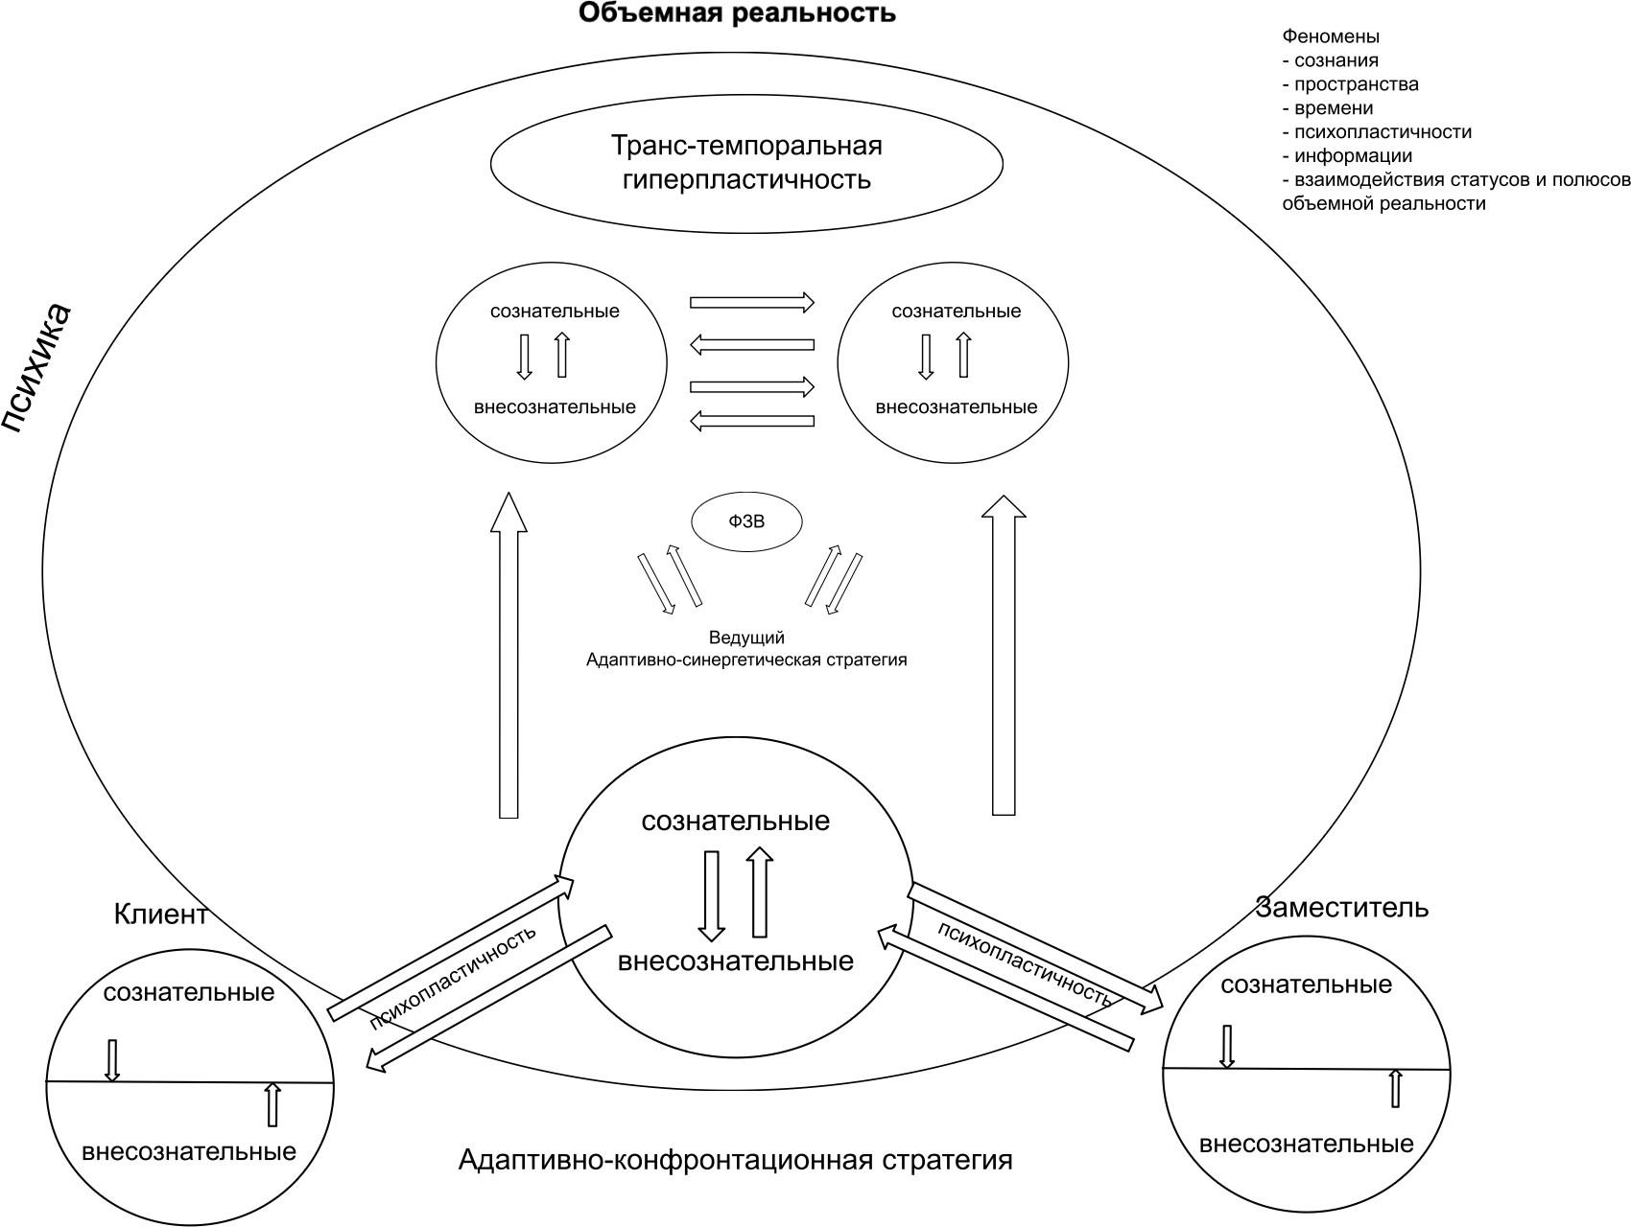

The presented theoretical model is based on integrative, polymodalan approach combining psychophysiological, phenomenological, and, most importantly, psychoplastic concepts, which allows us to substantiate the phenomenon of representative perception as a form of targeted trans-temporal activity of synergistic perception in the space of temporal plasticity of the psyche.
The model is represented by essential, structural, procedural, substantive, and semantic characteristics.
The results of solving problem 3 carried out differential diagnosis with related phenomena of mental activity, possible in the implementation of the method of systemic family constellations:
- individual protective mechanisms of the psyche (projection, identification, projective identification);
- emotional, empathic and informational resonance;
- reaction to group dynamics; indoctrinated reactions;
- other "reactive" manifestations of mental activity. (Table of differential diagnosis is presented in Chapter 3).

The results of solving problems for the implementation of the research project:
In accordance with the hypothesis, the goal and the tasks set, the experimental study was designed, and two series of psychotechnical experiments were conducted as part of the study. To solve problem 4.7, an experimental group of clients, "representatives" were selected and the psychotechnical experiment was implemented in the right conditions, in full, taking into account the standard components of the preparatory stage, with a parallel questionnaire procedure, in two formats in the number of 40 sessions in each format:
A) Experimental
B) Modified
In the experimental version (A) - the implementation of the traditional systemic family constellation technology of substitution trans-temporal perception in all participants of the experiment, with the fixation of the sensations-experiences-images that arise at the same time.
In the modified version (B), the implementation of an innovative technology for the movement of all participants in the experiment along temporal coordinates into the projection of the distant (in early childhood and beyond their own birth) past with the fixation of sensations-experiences-images that arise at the same time.
A total of 80 experimental sessions were conducted with 75 clients (70 women and 5 men). The clients ranged in age from 22 to 67 years, with a median age of 44.
People with the same level of education (higher education), urban residents, middle class and middle income.
Clients were selected based on the presence of a difficult event in a significant relative in 3-4 generations.
In the group of experimental sessions conducted in a modified format, the age range of clients is from 35 to 60, the median age is 43 years.
In the group of experimental sessions conducted in the experimental format, the age range of clients is from 22 to 67 years, the median age is 45 years.
To solve this problem correctly, all the planned tasks of the preparatory stage were consistently implemented:

Results of objective 4.1.
Based on the methodology of systemic family constellations, five sufficiently independent information channels for obtaining data on significant events in the client’s ancestral history have been developed:
First line - Facilitator; Second line - client; Third line - Representative 1;
Fourth line - Representative 2;
The fifth line is aimed at an in-depth study of the archival materials of the client's family - with the involvement of older relatives - with the identification (if possible) of significant events in the ancestral history of the client.

Results of problem 4.2.
Based on the created model of the phenomenon of representative perception, the developed theoretical construct was operationalized into a system of standardized indicators represented by a hierarchical system of studied and fundamentally comparable parameters, indicators for each differentiated sector of information acquisition:

Parameters taken into account
- Criteria of psychoplasticity (subjective scale 2 PICAP);
- the time lag of the recorded event (taken into account indicators: generation; approximate time with an accuracy of up to 10 years; exact time - a specific year; fixed time of year);
- universal parameter of the first level - SIGNAL (a clear change in the state of the subject during the passage of the "road map of the analyzed vector of the past");
This parameter was distributed along a differentiable time lag of the recorded event - a "Yes" signal was displayed opposite the corresponding indicator;
- Second level universal parameters distributed:
- information specificity of the signal;
- signal clarity levels.
  - Signal-feeling;
  - signal-feeling;
  - signal-image;
  - signal-information;
Such codification is associated with the possibility of carrying out correct statistical and mathematical analysis.
The indicative values obtained in this case for each of the indicated parameters were necessarily correlated with the position.
2. the time lag of the recorded event.
For the fifth sector (in-depth study of archival materials of the client's family - with the involvement of older relatives - with the identification (if possible) of significant events in the ancestral history) with the following evaluation parameters:
- content specificity of a significant event in the client's delivery system: this event was correlated with a specific content (with the codification of a significant event by a second sign:
  - severe illness and death of one or both relatives;
  - suicide of one of the progenitors;
  - violent death of a close relative;
  - Dekulakization, condemnation and loss;
  - participation in WWII and injuries;
  - Physical and mental abuse.
And then, using the third sign – a comparison of a particular event with the emotional feeling and sensation that this event causes in the interviewed relatives – for the purpose of subsequent comparison with similar indicators in the first four respondents and conducting a correct static and mathematical analysis.
- The fixed time lag of the event being recorded (indicators considered: generation; approximate time with accuracy)
up to 10 years; exact time is a specific year; fixed time of year.
This is the main parameter of comparison and correlation analysis for all five groups of respondents.
4.3 - 4.5. With the help of the developed methodology of semi-structured interviews for the client, presenter, "representatives"
(1) and (2), and for relatives of the client.
4.4. the indicators of the main considered features (specificity, content and dates of manifestation of significant events in the generic history of the client) were determined and recorded, for each information line (client, host, representatives), with the necessary processing for correct comparison.
  - Verified information was obtained, real facts from the history of the family lineage, which made it possible to carry out the process of distribution (based on understandable hierarchical features) of the received information on the main parameters and indicators in order to further study the obtained, significant statistical patterns.
To diagnose the state of psychoplasticity during experiments in two classical and modified formats (with the actualization of the targeted trans-temporal activity of the psyche),
client, leading and two substitute was used Methods of psychotechnical and complex analysis (PICAP):
Scale. (1) valuation client degree pronouncement Demoralization syndrome.
Scale. (2) valuation client degree engagement In the psychotechnological space.
A high degree of involvement and the absence of demoralization syndrome indicate the presence of psychoplasticity in the participants.
What? statistically more was manifestly at Participants in the experimental series B.

Results of objective 5.
(detailed in chapter 3)
The successful study allowed, on the basis of the model of the phenomenon of representative perception and the description of its main characteristics, to develop a system of comparable and measurable parameters and indicators, on the basis of which, the developed and conducted psychotechnical experiment allowed to detect and describe statistically significant relationships between this phenomenon and the phenomenon of psychoplasticity.
Based on the results of the study, we can say that the modified format of system layouts (experimental series B) statistically significantly demonstrates differences from the classical format (experimental series A), in all key parameters:
- on the phenomenon of psychoplasticity of participants and its relationship with the share of signals and personal data;
- accuracy of access, process participants, to the temporal point of the recorded event;
- the degree of consistency of data (signals received from participants and personal data), as well as the number and clarity of signals;
The findings indicate that representative perception is neither random nor exclusively subjective. In the modified format, it manifests as a regular, stable, and reproducible process arising from the psychoplasticity of all participants, which in turn arises from the facilitator's hyperplasticity. Psychoplasticity is a necessary condition for the emergence and stable manifestation of representative perception; its activation increases signal accuracy (sensations, feelings, images, and information), strengthens agreement across roles, and reduces the risk of subjective distortion. The findings also reveal a staged unfolding of representative perception, from the bodily level to the informational level. This process is realized most reliably in the modified format.
The modified format of experimental sessions, statistically significant, creates the participants of the process, access to the temporal point of the recorded event, which is a manifestation of the specific, trans-temporal interaction of conscious and unconscious mental authorities in the involved persons during the experimental arrangement.
As a result, a single field of perception is formed, in which all participants demonstrate similar signals in all the parameters and indicators of the phenomenon of representative perception (signals: feeling, sensations, image, information in relation to the time lag of the recorded event).
The main parameters of the experiment are a system of scientifically based evidence of objectification of the phenomenon of representative perception, as an illustration of the function of temporal plasticity in the structure of the general phenomenon of psychoplasticity, in the process of carrying out systemic family constellations:
- the included state of psychoplasticity of participants;
- the relationship of the phenomenon with the share of signals and personal data;
- precision access participant process toward temperature point of the recorded event;
- degree consistency data (signals) received from participants and personal data,
- quantity and clarity of signals;
- reproducibility of manifestation of the phenomenon (in different formats (online and offline), as well as in different groups, with different leaders);

That was the solution to problem 6. Results of problem 7.
Based on the results obtained, a system of scientifically based, practical recommendations for improving the method of systemic family placements in relation to the modified version of its implementation was described and the prospects for further research were determined.
(The system of recommendations is described in detail in chapter 4).
Based on the results of the study, we can conclude that:
In the presence of certain conditions in the preparation and implementation of the psychotherapeutic process using a modified methodology of systemic family constellations, it is possible to:
- interaction of active participants of this process - facilitator, client, "substitutes" - in the mode of psychoplasticity, with the actualization of the phenomenon of temporal plasticity of the psyche in all involved participants;
- formation of a coordinate system with an emphasis on the study of the temporal vector of the past - as a program of therapeutic (i.e. temporal-plastic) activity of the psyche in the participants involved;
- obtaining previously hidden information about significant events in the ancestral system of the client by all active participants in this therapeutic process, due to the actualized trans-temporal interaction of the basic instance of the mental;
Thus, the hypothesis that the phenomenon of “substituting perception” is a particular natural manifestation of the general phenomenon of psychoplasticity, through the actualization of the specific trans-temporal interaction of conscious and unconscious mental authorities in all involved persons in the course of psychotherapy by the method of systemic family constellations (modified format), which allows temporarily to perceive and reproduce information not contained in personal biographical memory, was confirmed.

REFERENCES
1. Adler A. Understanding the Nature of Man: Essays on Individual Psychology / A. Adler - AST Publishing House, 1927 - (Thinkers and Ideas) ISBN 978-5-17-161165-1
2.Alieva A.A. Humanistic psychology as one of the directions of psychotherapy // World Science. 2019. No5 (26). URL: https://cyberleninka.ru/article/n/gumanisticheskaya-psilogiya-kak-odno-iz-napravleniy-psihoterapii (date of appeal: 10.07.2025).
3. Ananyev B.G. Selected psychological works: In 2 volumes T. 1, 2. 1968.
4. Drumschikov V. A. Systemic study of the psyche // Bulletin of RUDN. Series: Psychology and Pedagogy. 2007. No1. URL: https://cyberleninka.ru/article/n/sistemnoe-issledovanie-psihiki (date of appeal: 18.07.2025).
5. Drummerschikov V. A., Nosulenko V. N. Systemicity. Perception. Communication. - M.: Institute of Psychology of RAI, 2004, - 480 p.
6. Drummashchikov V.A. The principle of systematicity in modern psychology // Psychology. HSE Journal. 2004. No3. URL: https://cyberleninka.ru/article/n/printsip-sistemnosti-v-sovremennoy-psihologii (date of appeal: 31.07.2024).
7. Bateson G. Mind and Nature: Necessary Unity / translation from D.Y. Fedotova. - M.: URSS, 2006. - 256 p.
8. Bateson G. Steps in the direction of the ecology of the mind / eng. D. Y. Fedotova. - M.: URSS, 2005. - 512 p.
9. Bateson G. The ecology of the mind: essays on the cybernetics of behavior / trans. from the English D. Y. Fedotova, M. P. Papush. - M.: URSS, 2000. - 416 p.
10. Bertalanffy L. von. General Systems Theory - Overview of Problems and Results. // Systems Research Yearbook. - M.: Science, 1969. - 203c Archived September 15, 2016 at the Wayback Machine, pp. 34-35.
11. Bertalanffy L. von. General Systems Theory: A Critical Review // Research on General Systems Theory. – M.: Progress, 1969 – P. 23–82 9.
12 Bertalanffy L. von. General Systems Theory: An Appendix to Psychology // Social Scientific Information. – 1967. – Volume 6. – No. 6. – P. 125–136.
13 Bekhterev V. M. Objective psychology. - St. Petersburg: Type. M. M. Stasyulevich, 1907. - 276 p.
14. Bion V. Experience of the group. Researches in psychoanalysis / translation from English. - SPb.: Speech, 2005. - 240 p.
15 Bohm, D. Integrity and the Hidden Order, D. Bohm, Moscow: Canon+, Rehabilitation, 2008. - 316 p. (Original: Bohm D. Wholeness and the Implicate Order, London: Routledge, 1980.)
Bowen M. Family therapy in clinical practice, New York: Aronson, 1978.
17 Burnyashev M. G. Without a mask. Book-immersion in the systemic constellations and the world of the subconscious / M. G. Burnyashev. - Moscow: Exmo, 2020. - 320 p.
18 Burnyashev M.G. Rules for representatives. 2007.
19. Burnyashev M.G. family constellations - psychotherapy or philosophy [Electronic resource] // Professional psychotherapeutic newspaper. - 2012. - October. - P. 63. - Access mode: https: //constellations.ru (date of appeal: 23.10.2025).
20. Burnyashev M. family constellations - psychotherapy or philosophy? 2013 [Electronic resource]. URL: http://rasstanovka.ru/stati/semejnye-rasstanovki-psihoterapija-ili-filosofija (Date of appeal: 14.07.2025).
21. Bailey A. Energy dynamics in system work / A. Bailey // Constellations Journal. - 2010. - No 4. - P. 25-34.
Varga A. Ya. Systemic family psychotherapy. A short lecture course. SPb.: Speech, 2001. - 144 p.
23. Varga A. Y. Theory of family systems of Murray Bowen // Counseling psychology and psychotherapy. – 2005. – Vol. 13. – No. 2.
24. Varga A. Ya. Systemic family psychotherapy / Samara, 1996–44 p.
25. Vasilyuk F.E. To the Problem of the Unity of General Psychology // Questions of Philosophy. 1986 No. 10 - P. 76-86.
26. Vasilyuk F.E. Methodological analysis in psychology. M.: Publishing house of MSUPE; Smysl, 2003. 240 p.
27. Vasilyuk F.E. Psychology of experience. - M.: Moscow State University, 1984
28.Weber, G. Organizational arrangements: basics and special situations / G. Weber. - Visloch: Carl-Auer Systeme Verlag, 2000.
29 Weber, Gunthard, Crises of Love: Systemic Psychotherapy of Bert Hellinger / Gunthard Weber; [Per. with him: I. Belyakova]. - Moscow: From the In-Tha of Psychotherapy, In-t Integrative. Family Therapy, 2001. - 297, [1] p.: 21 cm - (Golden Fund of Psychotherapy). - ISBN 5-89939-032-8.
30 Vernadsky V. I. Scientific thought as a planetary phenomenon. - M.: Science, 1991. - 282 p.
Veselago E. V. systemic constellations by Bert Hellinger: history, philosophy, technology. // Psychotherapy. No 7, 2010. No 1, 2011.
32. Vorobyeva L. I. Philosophy of humanitarian practice // Proceedings on consultative psychology and psychotherapy. Issue 2: Psychology. Consciousness. Culture / Edited by F. E. Vasilyuk. M.: MSUPE; PI RAO, 2009. P. 105-143.
33. Vygotsky L. S. Thinking and speech. - M.: Labyrinth, 2000. - 352 p.
34. Vygotsky L. S. The problem of consciousness. - M.: Pedagogy, 1982. - 320 p.
35. Vygotsky L. S. Collection of works: B-T. Z. Problems of the development of the psyche / Edited by A. M. Matyushkin.-M.: Pedagogics, 1983.-368 p, Il.- (Academic Ped. Sciences of the USSR).
36. Gendlin E. Focusing: Discovery of Bodily Meaning / translation from English. - M.: Institute of Humanistic Psychology, 2004. - 196 p.
37. Grinshpoon I.B. History of Psychotherapy Lecture 2. Prehistory of Psychotherapy (Part I) // Consultative Psychology and Psychotherapy. 2015 Vol 23. No 3. P 161-182. doi: 10.17759/cpp.2015230314
38. Grinshpoon I.B. History of psychotherapy. Lecture 3. Prehistory of psychotherapy (part 2) // Consultative psychology and psychotherapy. 2017. T. 25. No 1.
39 Grof, S. Outside the Brain, S. Grof, 2002, 528 p.
Grof, S. Holotropic Consciousness: The Man Beyond the Ego, S. Grof, Moscow: AST, 2021, 384 p.
41. Jendlin Y. Focusing / trans. from English. - SPb.: Class, 2001. - 208 p.
42 Doidge, Norman Plasticity of the Brain: Stunning Facts on How Thoughts Can Change the Structure and Function of Our Brain / Norman Doidge; Translated from E. Vinogradova. - Moscow: Bombora: Exmo, 2021. - 539, p.
J. Kannabih, History of Psychiatry L.: State Medical Publishing House, 1928
Katkov A.L. Hyperplasticity of the psyche: an introduction to express psychotherapy. - M.: Institute of Counseling and System Solutions, 2018. - 224 p.
Katkov A. L. Intensive short-term psychotherapy: a system-semantic approach. - M.: Smeaning, 2021. - 312 p.
46. Katkov A. L. Polymodal rapid psychotherapy. - M.: Ridero, 2023. - 286 p.
47. Katkov A. L. Polymodal express psychotherapy // Professional psychotherapeutic newspaper. – M., 2011. – No 11 (107). – P. 18.
Katkov A.L. Time management in psychotherapy, Professional Psychotherapeutic Newspaper, Issue 12, 2024
Kashlyakov A. “System methods in psychotherapy”, Moscow: Moscow State University Publishing House, 2015.
50. Shipina E.P. Phenomenological methods in psychological and pedagogical practice // News of the A.I. Herzen RSUPU. 2010. No128.
51. Cowan E. Brain hyperplasticity: how our brain learns and changes. - M.: Exmo, 2019. - 288 p.
52. Kravtsova E. E. Psychotherapy from the perspective of cultural and historical approach // Bulletin of RSUH. Series "Psychology. Pedagogy. Education." 2008. No3. URL: https:///cyberleninka.ru/article/n/psihoterapiya-s-pozitsiy-kulturno-istoricheskogo-podhoda-1 (referral date: 10.07.2025).
Lazarus Arnold, Short-Term Multimodal Psychotherapy, Practical Guide/Translation: I.S. Gureev/Publisher: Publisher I.L. Bazenkov, 2022 – 214c ISBN: 978-5-6046794-6-3
54. Lazarus K.N., Lazarus A.A. Multimodal therapy // Handbook of Integration Psychotherapy. – 2019. – Vol. 2.
E. Laszlo, 55: Science and the Akashic Field: The Integral Theory of Everything, by E. Laszlo, Moscow: Sofia, 2008, 240 p. (Original: Laszlo E. Science and the Akashic Field, Rochester: Inner Traditions, 2004).
56 Levant R.F. Family therapy: a comprehensive review, Prentice Hall, 1987. ISBN 978-0-13-302885-0
57. Leontiev A. N. Activity. Consciousness. Personality. M.: Politizdat, 1975
58. Leontiev D., Lebedeva A., Kostenko V. Ways of personal development: according to the installations of L. S. Vygotsky // Issues of education. – 2017. – No 2 (English). – P. 44–54.
59. Leontiev D. A. Essay on the psychology of personality. M.: Smeaning, 1993.
Litvak M. “Personal Development and Family Therapy”, Moscow: Alpina Pablisher, 2012.
61. Lomov B. F. On the System Approach in Psychology // Questions of Psychology, 1975. No 2.
62. Lomov B. F. Systematicity in psychology: op.psychol.t. Edited by V. A.Barabanshchikov, D. N. Zavalishina, V. A. Ponrmarenko. 3rd ed. M., MPSI; Voronezh, MODEK, 2011. – 424 p.
63. Luria A. R. Higher cortical functions of a person and their disorders in local brain lesions. - Moscow State University, 1962. - 498 p.
64. Luria A. R. Essays on the psychophysiology of writing. - M.: Enlightenment, 1975. - 232 p.
Meneghetti A. Ontopsychology and ontology of personality / A. Meneghetti; translation from it. - Rome: Ontopsychology Press, 2004. - 228 p.
66 Pavlov I. P. Twenty years of objective experience in the study of higher nervous activity (behavior) of animals. - L.: Science, 1951. - 392 p.
67 Perls F., Hefferlein R., Goodman P. Gestalt Therapy: Arousal and Growth in the Human Personality / F. Perls, R. Hefferlein, P. Goodman; translated from English. - Moscow: Institute for General Humanitarian Studies, 2012. - 592 p.
Brain and Perception: Holonomy and Structure in Figural Processing / K. Pribram. - Hillsdale, NJ: Lawrence Erlbaum Associates, 1991. - 457 p.
Puzyrey A.A. The cultural and historical theory of L.S. Vygotsky and modern psychology, M., 1986.
70. Rizzolatti J., Sinigalya K. Mirrors in the brain. Mechanisms of joint action and empathy / J. Rizzolatti, K. Sinigalya; translation from English. - Moscow: Languages of Slavic cultures, 2012. - 304 p. (Original: Rizzolatti G., Sinigaglia C. Mirrors in the Brain. Oxford University Press, 2008.)
Rogers, K. On group psychology, M., 1994.
72 Rogers, K., A Look at Psychotherapy: The Making of Man, 1994.
Rudestam Kjell, Group Psychotherapy, M., 1993.
Satire V., How to Build Yourself and Your Family, M., 1992.
75 Sechenov I. M. Reflexes of the brain. - M.: Science, 1997. - 215 p.
E. E. Sokolova School of A. N. Leontiev and its role in the development of an activity approach in psychology // Bulletin of Moscow University. Series 14. Psychology. 2007. No2. URL: https://cyberleninka.ru/article/n/shkola-a-n-leontieva-i-ee-rol-v-razvitii-deyatelnostnogo-podhoda-v-psihologii (date: 10.07.2025).
77. Spaarer I., Varga von Kiebed M. Introduction to system structural arrangements / translation with him. - M.: Class, 2008. - 232 p.
Teplov B. M. Selected works. T. 1, 2. M., 1985.
Teplov B. M. Selected works. T. 1, 2. M., 1985.
80 Wilber K. Spectrum of Consciousness, K. Wilber, Moscow: Amrita, 2013, 320 p. (Original: Wilber K. The Spectrum of Consciousness, Quest Books, 1993).
Frankl W., Man in Search of Meaning, M., 1990.
Frenkel E.N. Concepts of modern natural science: physical, chemical and biological concepts: a textbook. - Rostov N/D: Phoenix, 2014. - 246 p.
83. Khamitova I.Y. Theory of Family Systems by Murray Bowen // Journal of Practical Psychology and Psychoanalysis, No. 3, 2001.
Hellinger B. Orders of Love: Resolution of Family-System Conflicts and Contradictions. - M.: Publishing House of the Institute of Psychotherapy, 2003. - 400 p.
Chernikov A.V. Systemic family psychotherapy: an integrative model of diagnosis. - Yekaterinburg: URSPU, 2012. - 328 p.
Chernikov A.V. Systemic Family Therapy: An Integrative Diagnostic Model. - 3rd ed., Spr. and Supplementary M.: Independent firm "Class", 2001 - 208 p. - (Library of Psychology and Psychotherapy, issue 97).
87. Sheldrake, R. A New Science of Life: The Hypothesis of Formative Causation / R. Sheldrake; translated from English. Moscow: Sofia, 2006. 304 pp. (Original: Sheldrake, R. A New Science of Life: The Hypothesis of Formative Causation. London: Blond & Briggs, 1981.)
Von Franz M.-L. Psychotherapy: Experience and Practice of Analytical Treatment / M.-L. von Franz; translation from English: Moscow: Class, 1998. - 224 p. (Original: von Franz M.-L. Psychotherapy. Shambhala, 1993.)
Hellinger B. Orders of Love: Resolution of Family-System Conflicts and Contradictions / B. Hellinger; trans. with him. - Moscow: Institute of Psychotherapy, 2007. - 232 p.
90. Hellinger B. Orders of assistance. / B. Hellinger; trans. with him. - M.: Institute of consulting and systems solutions, 2006.
Schechter S., Singer D. Cognitive, social and physiological determinants of the emotional state // Psychological Journal. - 1962. - Vol. 69. - P. 379-399. (in authorized translation).
Schneider K. Psychotrauma and recovery: the practice of systemic constellations / trans. with him. - M.: Institute for Counseling and System Solutions, 2021. - 248 p.
Jung K. G. Archetypes and the Collective Unconscious / K. G. Jung; trans. with A. Chechin. - Moscow: AST, 2024. - 576 p.
Jung K. G. The Divine Child: / Education: Sb. - M.: O. AST-LTD, 1997. - 400 p.
95. Yalom I. D. Theory and practice of group psychotherapy / I. D. Yalom; translation from English. - Moscow: Exmo, 2019. - 704 p.
96. Arnheim R. Art and Visual Perception: A Psychology of the Creative Eye. - Berkeley: University of California Press, 1954. - 508 p.
97. Calhoun C. Social Identity. - New York: Wiley-Blackwell, 2002. - 256 p.
98. Cannon W. B. Bodily Changes in Pain, Hunger, Fear and Rage. - New York: Appleton, 1927. - 404 p.
99. Decety J., Jackson P. L. The Functional Architecture of Human Empathy // Behavioral and Cognitive Neuroscience Reviews. - 2004. - Vol. 3(2). - P. 71–100.
100. Freeman W. J. How Brains Make Up Their Minds / W. J. Freeman. - New York: Columbia University Press, 1999. - 191 p.
101. Gallese V. Embodied Simulation and the Neural Correlates of Social Cognition // Phenomenology and the Cognitive Sciences. - 2005. - Vol. 4. - P. 23–48.
102. Gallese V. The Shared Manifold Hypothesis: From Mirror Neurons to Empathy // Journal of Consciousness Studies. - 2003. - Vol. 8. - P. 33–50.
103. Gibson J. J. The Ecological Approach to Visual Perception. - Boston: Houghton Mifflin, 1979. - 332 p.
104. Hanson N. R. Patterns of Discovery: An Inquiry into the Conceptual Foundations of Science. - Cambridge: CUP, 1958. - 251 p.
105. James W. The Principles of Psychology: In Two Volumes. - New York: Dover Publications, 1950. - Vol. 1. - 689 p.
Lange C. Om Sindsbevægelser. – København, 1885. (translation of the edition in the collection with James: The Emotions)
107. Merleau-Ponty M. Phenomenology of Perception. - London: Routledge, 1962. - 466 p.
108. Merzenich M. M., Jenkins W. M. Cortical Plasticity, Learning and Learning Disabilities // In: Developmental Behavioral Neuroscience. - Cambridge, MA: MIT Press, 2003. - P. 399–427.
Mitikhin V., Solokhina T., Tiumenkova G. Modern system approach to the diagnosis, therapy and rehabilitation of mental disorders // European Psychiatry. – 2021. – Vol 64. – No. S1. – P. S508-S508.
110. Mosak H., Maniacci M. Primer of Adlerian psychology: The analytic-behavioural-cognitive psychology of Alfred Adler. – Routledge, 2013.
Penrose R. 111: The King's New Mind: On Computers, Thinking, and the Laws of Physics, 2001. - 480 p.
Perrotta G. Strategic psychotherapy and the “decagonal model” in clinical practice // Annals of Psychiatry and Treatment. – 2021. – Vol. 5. – No. 1. – P. 028–035.
Petzold, H. Modelle und Konzepte zu Integrativen Ansatzen der Therapie, Integrative Therapie, 6, 1980, pp. 323-350.
Pietrabissa G. et al. The brief strategic treatment of cardiophobia: A clinical case study //Journal of Contemporary Psychotherapy. – 2021. – Volume 51. – P. 125-133.
Popescu O. M., Drobot L. I. Integrative Strategic Psychotherapy–the Four-Self Model//Theoretical and Applied in Psychology SICAP23. – 2016. – P. 143.
Pytell T. Transcending the angel beast: Viktor Frankl and humanistic psychology // Psychoanalytic Psychology. – 2006. – Vol. 23. – No. 3. – P. 490.
Rasmussen B., Salhani D. Resurrecting Erich Fromm // Smith College Studies in Social Work. – 2008. – T. 78. – No. 2-3. – P. 201-225.
118. Rizzolatti G., Fadiga L., Gallese V., Fogassi L. Premotor cortex and the recognition of motor actions // Cognitive Brain Research. - 1996. - Vol. 3(2). - P. 131–141.
Rosenbaum R. Strategic psychotherapy //Handbook of the brief psychotherapies. – Boston, MA: Springer US, 1990. – pp. 351-403.
120. Sheldrake R. Morphic Resonance: The Nature of Formative Causation / R. Sheldrake. - Rochester, VT: Park Street Press, 2009. - 392 p.
121. Schore A. N. The Science of the Art of Psychotherapy. - New York: Norton, 2012. - 384 p.
122. Siegel D. J. The Developing Mind: How Relationships and the Brain Interact to Shape Who We Are. - New York: Guilford Press, 2012. - 506 p.
123. Stadler C. Psychodrama. – Ernst Reinhardt Verlag, 2022.
124. Titchener E. B. Experimental Psychology: A Manual of Laboratory Practice. - London: Macmillan, 1901. - Vol. I. - 408 p.
Törestad B., Magnusson D., Oláh A. Coping, control, and experience of anxiety: An interactional perspective //Anxiety Research. – 1990. – T. 3. – No. 1. – P. 1–16.
Trzesniewski K. H., Donnellan M. B., Robins R. W. Development of self-esteem //Self-esteem. – Psychology Press, 2013. – pp. 60-79.
Turayevich Y. J. Music Therapy // International Journal on Economics, Finance and Sustainable Development. – 2023. – Vol. 3. – No. 3. – P. 128–131.
128. Varela F. J., Thompson E., Rosch E. The Embodied Mind: Cognitive Science and Human Experience. - Cambridge, MA: MIT Press, 1991. - 328 p.
129. Von Ameln F., Gerstmann R., Kramer J. Psychodrama. – Heidelberg: Springer, 2009.
130. von Bertalanffy L. General System Theory: Foundations, Development, Applications. - New York: George Braziller, 1968. - 295 p.
131. Watzlawick P., Bavelas J. B., Jackson D. D. Pragmatics of human communication: A study of interactional patterns, pathologies and paradoxes. – WW Norton & Company, 2011.
Weiland S. Erik Erikson: Ages, stages, and stories //Generations: Journal of the American Society on Aging. – 1993. – Vol. 17. – No. 2. – P. 17–22.
Wenzel A. Basic strategies of cognitive behavioral therapy //Psychiatric Clinics. – 2017. – Vol. 40. – No. 4. – P. 597–609.
Wong P. T. P. The Frankl cure for the 21st century: Why self-transcendence is the key to mental health and flourishing // The International Forum for Logotherapy. – 2021. – Volume 41. – No. 2. – P. 33–50.
135. Wundt W. Grundzüge der physiologischen Psychologie. - Leipzig: Wilhelm Engelmann, 1874. - 872 S.

