The Contributions of Savall's Socioeconomic Double Spiral and Multiplicity to Change Management
David M. Boje, Ph.D.
Regents Professor, New Mexico State University
Contact Info: dboje@gmail.com Address: 4700 Dunn Drive, Las Cruces, New Mexico 88011 USA 575-532-1693
Jun 2 2018 version

ABSTRACT Savall and colleagues contribute a management science of intervenor-research experimentation that goes beyond the inductive fallacy of ‘no ground’ and ‘no theory’ in Grounded Theory (GT) and the ‘no action’ and ‘no research’ in Action Research (AR). Savall’s 1975/2010 double spiral and Savall and Zardet’s trilectic, hidden cost, and qualimetrics approaches are explained in this presentation. Their contribution can become a new methodology and praxis of Organization Development and Change (ODC) that needs to be embraced by the 10 consultancy firm giants that make both SEAM and ODC in Academy of Management (AOM) the little David’s facing Goliath. A viable alternative is the IAELyon PRME business school model that implements the 17 UN sustainability goals.

Keywords: Dialectic, Savall, Spiral, Change Management, Action Research, Grounded Theory, ODC

Introduction
At last ODC International Meeting in Lyon I made two assertions and today I will make two more:

1. Grounded Theory has ‘no ground’ and ‘no theory’!
(Boje, 2018a, in press)
2. Action Research has ‘no action’ and ‘no research’!
(Boje, 2018b, in press)
3. ODC and SEAM are the minority compared to the 10 Giants of Consultancy $65.5 billion industry!
(Boje & Sanchez, 2018a, in press)
4. Martin Parker (2018 a, b) is right! It is time to ‘bulldoze’ business schools to make room for IAELyon PRME and True Storytelling (http://truestorytelling.org) (Boje, 2018a, in press)

The solution to these four problems is to be found in Savall's and colleagues contributions to scientific consulting and to a new business school model.

Table 1: ODC and SEAM are minority compared to 10 Giants of Consultancy
10 Largest Consultancy Firms exhibit TFW VIRUS: Neo-Taylorism time & motion &/or reengineering neo-Fayolism administrative focus on span of control & scalar hierarchy, and neo-Weberian bureaucratic hierarchic structures | Revenue $/Billion ($65.6 combined) | Revenue Growth % | Market Share % | Enterprise Resource Planning (ERP) | TFW Virus Evident
1. Deloitte Consulting | 14.7 | 6.0 | 11.7 | ✔ | ✔
2. Strategy& (part of PwC Network) | 12.7 | 10.0 | 10.2 | ✔ | ✔
3. Ernst & Young Consulting Practice | 12.1 | 12.7 | 9.6 | ✔ | ✔
4. KPMG | 10.7 | 5.2 | 8.6 | ✔ | ✔
5. Accenture | 4.1 | 4.4 | 3.3 | ✔ | ✔
6. IBM | 4.0 | 2.1 | 3.2 | ✔ | ✔
7. McKinsey & Company | 2.3 | 5.5 | 1.9 | ✔ | ✔
8.Booz Allen Hamilton | 2.1 | -2.9 | 1.6 | ✔ | ✔
9. CGI "Conseillers en Gestion et Informatique" | 1.5 | 3.4 | 1.2 | ✔ | ✔
10. CSC “Computer Sciences Corporation” | 1.4 | -3.6 | 1.1 | ✔ | ✔
Table is adapted from Boje & Sanchez (2018a, In press)

Abbreviated Chronological List on Savall Contributions:

Savall, Henri. (1975/2010). Work and People: An Economic Evaluation of Job-Enrichment. 1975 book "Enrichir le trail human dans les enterprises et les organizations".

Savall, H. (1983). Germán Bernácer. La heterodoxia en la economía (No. halshs-00783092).
Savall, H. (2003). An updated presentation of the socio-economic management model. Journal of Organizational Change Management, 16(1), 33-48.
Savall, H. (2001). interview with the SEAM Faculty (Henri Savall, Veronique Zardet, Marc Bonnet and Michel Péron), conducted by Grace Ann Rosile and David M. Boje, taped and transcribed, from, 2.
Savall, H. (Ed.). (2004). Crossing frontiers in quantitative and qualitative research methods: first international co-sponsored conference, Research Methods Divsion, Academy of Management (USA); March 18-20, 2004, Lyon, France. 1 (2004). ISEOR.
Savall, H., & Zardet, V. (2005). Tétranormalisation: défis et dynamiques (No. halshs-00783085).
Savall, H., & Zardet, V. (Eds.). (2013). The dynamics and challenges of tetranormalization. IAP.
Péron, M., & Savall, H. (2007). Raising the Curtain on Business Operation Theatrics. Revue Sciences de Gestion, (58).
Savall, H., & Zardet, V. (Eds.). (2008). Mastering hidden costs and socioeconomic performance. IAP.
Savall, H., Zardet, V., & Bonnet, M. (2008). Releasing the untapped potential of enterprises through socio-economic management (No. halshs-00780720).
Savall, H., Zardet, V., Bonnet, M., & Péron, M. (2010). contribution of qualimetrics intervention-research methodology to transorganizational development (No. halshs-00749946).
Savall, H., & Zardet, V. (Eds.). (2011). The qualimetrics approach: Observing the complex object. IAP.
Savall, H., Zardet, V., & Péron, M. (2011). 22 The Evolutive and Interactive Actor Polygon in the Theater of Organizations. Storytelling and the future of organizations: An antenarrative handbook, 366.
Savall, H., Zardet, V., Péron, M., & Bonnet, M. (2012). Possible Contributions of Qualimetrics Intervention-Research Methodology to Action Research. International Journal of Action Research, 8(1), 102-130.
Worley, C. G., Zardet, V., Bonnet, M., & Savall, A. (2015). Becoming agile: How the SEAM approach to management builds adaptability. John Wiley & Sons.
Savall, H., Péron, M., & Zardet, V. (2015, September). Human Potential at the Core of Socio-Economic Theory (SEAM). In Decoding the Socio? Economic Approach to Management: Results of the Second SEAM Conference in the United States(p. 1). IAP.
Savall, H., & Zardet, V. (2015). Reflecting on SEAM in the 21st Century. The SocioEconomic Approach to Management Revisited: The Evolving Nature of SEAM in the 21st Century, 1.
Savall, H. (2016). TFW virus concept history. In Decoding the socio-economic approach to management: Results of the second SEAM conference in the United States.
Savall, H., Péron, M., Zardet, V., & Bonnet, M. (2018). Socioeconomic Approach to Management. Socially Responsible Capitalism and Management, 73(90), 18.

Savall and Zardet take a scientific approach to organizational intervention, based on diagnostic, joint planning, project implementation, and evaluation of results based on qualitative, quantitative, and financial (qualimetrics, itself a trilectic, rather than dialectic). What is unique about SEAM is (1) the triple-multiplicity focus (financial-, numeric-, and qualitative-multiplicities entangled 'qualimetric'), (2) not just positive dialectical intervention but it is actually trilectic, (3) the multiplicities are rhizomatic-antenarrative formations, and (4) some rhizomatic-multiplicities form 'double spirals' to transform 'implosive-death spiral' into 'explosive-spiral' of human- and socioeconomic-potential by flushing out dysfunctions and hidden costs.

I would like to offer some connections between their socioeconomic approach and quantum storytelling. I have been teaching this approach at New Mexico State University for twenty years, with a special Memorandum of Understanding (MOU) between our university and Lyon III and the ISEOR Institute in Lyon, France. Savall's is the 7th stream of ontological-organizational research methods in a book I am doing for Routledge, due March 2018.
Henri Savall's 'positive' scientific dialectical process of socioeconomics (1975/2010: 27) began in 1975 (rereleased 2010) as a system-wide approach to organization-environment intervention research that goes way beyond the traditions of socio-technical systems to develop a socially responsible capitalism. Savall and Peron (2016) developed a socially responsible capitalism (Boje, 2016 Preface to Savall & Peron's Socially Responsible Capitalism; Boje & Hillon, 2017). There is also a good deal of qualitative-multiplicity interventions to control dysfunctions and make organizations functional. Amandine Savall is co-author (Worley, Zardet, Bonnet, & Savall, 2015) of a book on Agileness in socioeconomics.
The positive dialectics of reason (as opposed to fiction) is not driven by suspicion,is radially anti-platonism, and against the ideological consolation that false generalities confer ((Savall & Zardet, 2008: 74). The work of self-critical reason consists in surmounting its own unreasonable projections. This is a positive dialectics, similar to Follettian dialectic, that is the interplay of practical findings from application with academic canons in a “conflict-cooperation dialectical system” to sort a zone of convergence (Savall & Zardet, 2008: 80)
Diagnostic Model In the diagnostic (See next figure), and alternating “moments of introspection with periods of exteriorization of production… this dialectic plays a role in the production of cognitive value-added, thanks to inter-researcher dialogue in particular” (Savall & Zardet, 2008: 145)
The diagnostic is represented in this 4-Leaf Clover model, that shows (in blue) the main Theory (big X->Y) cause-effect relations, and the six stem roots of economic and financial consequences of understanding or controlling hidden costs. These are 'hidden costs' because they are not being picked up in the regular accounting reports management receives, and without heavy investment in activity based accounting, you don't know what hit you.
“It therefore seems more relevant to base the level of objectives for a given person, in dialectical fashion, on both the level currently attained by that person and the level expected by the firm (strategic objective)” (Savall & Zardet, 2008: 237, Hidden Costsbook).
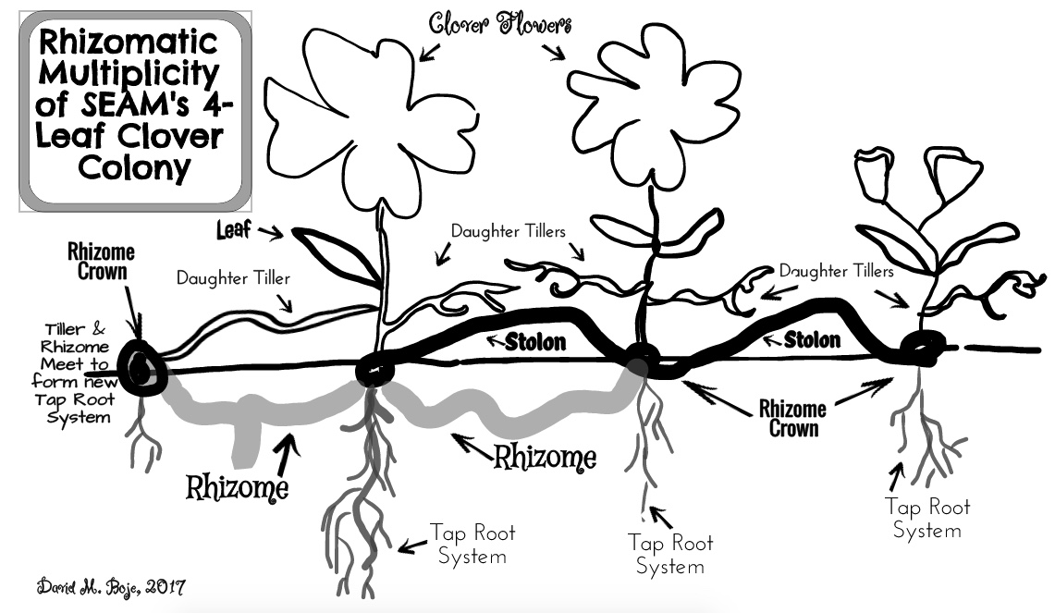
Figure 1: The Rhizomatic-Multiplicity of the Socioeconomic Clover Field of Organizational Transformation (© Boje, 2017)

SEAM cultivates and cares for a rhizomatic-multiplicity that is both qualitative-multiplicity and numeric-multiplicity. A clover plant is a rhizome. It has tillers that are above ground and can meet up with a below ground rhizome shoot to form a Rhizome Crown. Rhizome Crowns can allso for by above ground runners called 'Stolons.' Stolons are horizontal-reaching, above-ground, growths, that can touch into soil and form a Rhizome Crown, that is induced to bud and then flower. Where a stolon and a rhizome shoot or'daughter tiller' meet up (in pairs or triplets), they can form a taproot system. Once a rhizome crown forms, then it can go independent and break away from the parent clover-colony, or just stay attached, reciving and giving nutrients and life forces. This is one way to understand how the many projects that SEAM implements with its client, use the 4-leaf clover as diagnostic, but works to develop healthy taproots, and healthy stolons, daughter tillers, and more 'crown rhizomes'. In this double system, rhizomatic growth can occur above- and below-ground.You can get some sens of how some 'crown rhizomes' break away and form their own new clover-colony by a process of reproductive growth-multiplicity.
Triple Multiplicity What is unique about SEAM is that it is both positive-dialectic aimed at integration, and it is a triple-multiplicity (qualitative-, financial-, and numeric-multiplicities entangled). The premise is that the interventions can make an organization decidedly more democratic, and this dialectic of objectives is accomplished by doing negotiated contracts, in relation to individual outcomes achieved, known as 'Periodically Negotiated Activity Contract' (PNAC) and a program of experimental research (diagnosis of dysfunctions, hidden costs, financial outcomes).SEAM enters a client system, and often finds the roots and mainstream of their clover plants are infected by the Taylor-Fayol-Weber (TFW) virus.
In SEAM, there is a contagion, a sort of virus, called TFW virus that prevents spiraling from achieving more than minimal performance outcomes.
Quantum storytelling is a science of multiple-multiplicity, change, and our inseparability from embodying the world and being embodied-in-the world. It is possible to ounteract downward implosive spiraling of dysfunctions and hidden costs of the TFW virus contagion with the explosive upward sprialing, using the socioeconomic method of successive triple D-P-I-E’s.
Trilectic Qualimetric is the qualimetric of qualitative-multiplicity, financial-multiplicity, and quantitative-multiplicity. This Trilectic is fed back to client so they can review qualitative field notes, financial consequences, and quantified metrics of the various kinds of hidden costs calculated from the field interviews and observations of the intervenor-consultants.
In short the positive dialectic is based on democratic implementation, negotiated incentives from results contracted, and carefully planned experiments (Savalll & Zardet, 2008: 306p. 306) change interventions done in teams) to develop quality, efficiency, and performance (outcomes).
Storytelling in SEAM In Amandine Savall's presentation at she made the point that storytelling is very integral to socioeconomic diagnosis. Clearly storytelling as research methods is a growing movement across many social science disciplines.
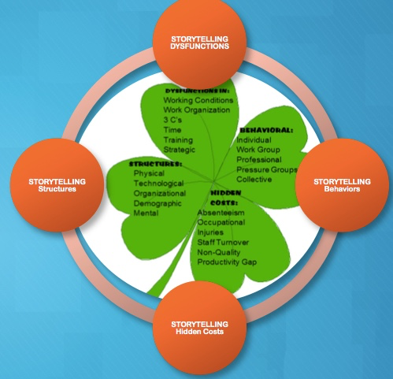
Figure 2: Role of Storytelling in Socioeconomic Diagnosis of Dysfunctions and Hidden Costs
I intertwine quantum storytelling with Savall's socioeconomic approch. I look at the socioeconomic approach to management (SEAM) to keep the business 'agile' and students read Amandine's book (Worley, Zardet, Bonnet, & Savall, 2015 and the Hidden Costs book (Savall & Zardet, 2008). Savall (1975/2010: 205) began working on a double spiral model, which I have incorporated into my teaching of socioeconomic storytelling in New Mexico. This is of great interest to me, given my own interest in developing antenarrative spiral theory (Boje, Baca-Greif, Intindola,& Elias, 2017).
The SEAM Double Spiral
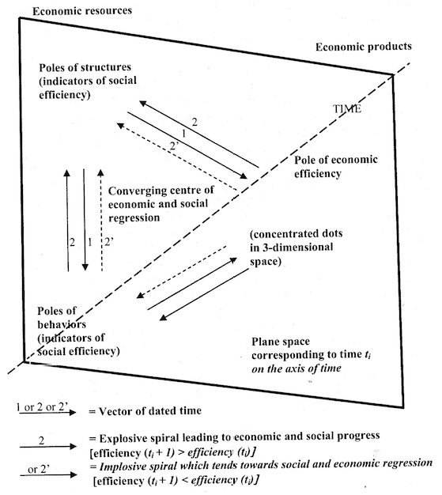
Figure 3: Savall's original depiction of Socioeconomic Dialectics of a Double Spiral Theory (Savall, 1975/2010: 205)
Double Spiral in relation to Trilectic (not just Dialectical) Development and Change Trilectical development and change is not just dialectical; rather it includes the interplay between qualitative, quantitative, and financial. There is an important, and non-researched, double spiral that is theorized by Savall (1975/2010) which is dialectical relation between and explosive (upward) spiral and an implosive (downward) regressive {death} spiral. Savall's socioeconomics approach of the explosive(upward) spiral in opposition to the implosive (downward) spiral is not the same dialectical methodology as the negation dialectics by Plato, Hegel, or Zizek nor is it a Marxian historial dialectic. Henri Savall and Veronique Zardet (2008: 7) focus on the [positive] dialectic movement of reality in scientific progress, but attempts to avoid errors of realism and perception, as well as reductionism of empiricism by the qualimetrics of trilectic interplay of qualitative, quantitative, and financial measures (Boje, 2003). Savall and Zardet (2008: 21) cite Peirce’s (1955) logics of induction, deduction, and abduction, but prefers to move from abductive hypothesis selections from many possible ones, to deduction, and finally inductive reasoning. This is seen as a dialectical synthesis of the Peircean three logics of reasoning (Savall & Zardet, 2008: 20). It is seen as an ovulating wave or flow of collected and disseminated qualimetrics in alternating series of deduction, induction, deduction, induction, and so on, a dialectical movement of knowledge structuration (Savall & Zardet, 2008: 206).
Their work is a positive scientific approach to dialectics.
There is a positive dialectics in qualimetrics of two movements: the movement of rational analysis (analytic & deductive reasoning), and the second movement of (inductive-type) synthesis, with descriptive hypotheses, explicative hypothesis, and prescriptive hypothesis (Savall & Zardet, 2008: 186). The positive dialectics has a proposition for a synthetic framework that is 'trilectic' that combines qualitative, quantitative (& financial) approaches with general concepts and contextual knowledge (Savall & Zardet, 2008: 199):

"The socio-economic approach to management (SEAM) is designed, through its formal characters, to modify the conflict-cooperation dialectics in the organization, enlarging the zone of convergence among actors (e.g., executive directors, management, shop floor personnel, labor representatives” (Savall & Zardet, 2008: 208, Hidden Costs book).

The result is a scientific approach called research-intervention in the socio-economic method of intervention research (that is neither Action Research, nor the inductive fallacy of Grounded Theory, in first three waves) [See Boje, 2018a, 2018b in press books]/
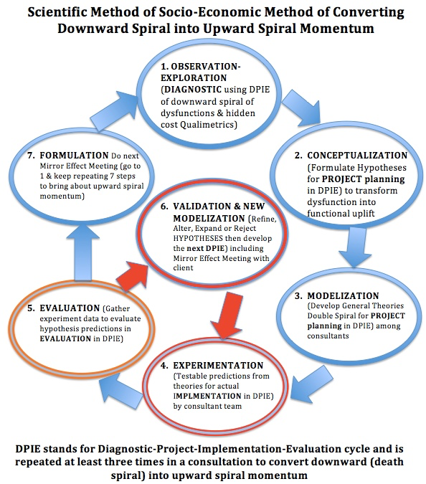
Figure 4: Depiction of Savall's Positive Dialectic Scientific Method in Relation to Diagnosis-Project-Implementation-Evaluation (DPIE) and Double spiral
SEAM is a continuing “quest for truth” and “progression of individual scientific work is accelerated when researchers oblige themselves (or are obliged) to exteriorize themselves in dialogue or in writing (principle of cognitive interactivity” (Savall & Zardet, 2008: 145, 148, note I reversed order of last two steps, and changed wording of the steps):
  - Exploration in Diagnostic phase of DPIE
  - Conceptualization In-Depth Observation
  - Modelization
  - Experimentation by implementing co-created projects (horizontally and vertically, in HORIVERT).
  - Evaluation
  - Formulation of relevant and knowledge to be disseminated
  - Validation
In taking verbatim field notes, making observations (& transcribing interviews & meetings) the researcher-intervenor is able to detect just how disorganized the theatrics of the organization have become. The SEAM Mirror Effect, lets the client confront the organizational dysfunctions and hidden cost situation before the project planning. In this way the client can spend a moderate amount on the change intervention in-order-to save a major and significant amount in achieving greater socio-economic and financial performance, improving working conditions, and developing a democratic participation of project teams.
In Henri Savall's (1975/2010: 204, boldness, mine) 'general theory' [i.e. Big (X->Y) cause-effect that Structure->Behavior], in the search for economic efficiency and tapping human potential, there is a deeper underlying principle called "the dialectics of progress" that is linked to experiments and measurements [i.e. Little (x->y) program->observations] that has major impact on all kinds of validy:
- CONSTRUCT VALIDITY: Does (little x->y) measure adequately tap (Big X->Y) deductive theory? The Copernican Revolution in Construct Validity changes all remaining kinds of validity, and gives science a new storytelling of the empirical world.
- FACE VALIDITY (1st Wave Grounded Theory): Does test/experiment/observation (little x->y) ‘resemble’ (inductive inference) of the real world ‘actual’ phenomenon in its spacetimemattering? (This is the epistemic [inductive] fallacy of assuming theory of Idea subsumes the ontological without actually doing falsification of a1 and a2auxiliary assumption set).
- CONTENT VALIDITY: Does (little x->y) measure adequately accomplish inquiry into (Big X->Y) deductive theory? (Without committing epistemic fallacy)
- DISCRIMINANT VA:IDITY: Does (little x->y) measure diverge from measures of other groups that (Big X->Y theory) does not predict?
- NOMOLOGICAL VALIDITY: Does the prior theory and research on (Big X->Y theory) match the abductive inference (little x->y) program & observations? This applies to 2nd & 3rd Waves of Grounded Theory (GT). Here I am workong for 4th Wave GT O-ORM.
- CONVERGENT VALIDITY: Do 2 or more (little x->y) measures both purporting to measure (Big X->Y) theory have high empirical correlation?
- CONCURRENT VALIDITY: Do (little x->y) test results, at the same time, match results of an accepted measure of (Big X->Y) theory?
- PREDICTIVE VALIDITY: Does past (little x->y) result predict future repetitions of performance?
- CRITERION VALIDITY (combines concurrent & predictive validities): Does measure (little x-y) measure relate to an outcome?

This is called the Socio-Economic Principle (in other words, Big [X-Y] cause-effect general theory). And this a Measurement Principle we will call little (x->y) program->observation experiments and metrics. The Measurement Principle says that production goes hand-in-hand with high quality social-performance if and only if organizational change is actually measured in economic terms. There are two sets of Copernican Revolution auxiliary assumptions (auxiliary hypotheses) in SEAM:
a1 (assumption set one of auxiliary hypotheses) is that Underestimating the socio-economic tensions results in reduced economic performance, and losses in profits (this is called the Hidden Cost/Performance Principle).

a2 (assumption set two of auxiliary hypotheses) is that if socio-economic loop is ignored, the hidden costs will overwhelm economic performance and there are actual negative economic performance losses (i.e. what we call here death spiral of accumulated financial deeper roots). This is called the Economic Performance Principle.
Professor David Trafimow (2003, 2009, 2014) has declared both p-value and null hypothesis to be invalid. “As the standard null-hypothesis significance-testing procedure does just that, it is logically invalid” (Trafimow, 2003” 526). One reason, in “Bayes’ theorem yields p(HoF), but in practice, researchers rarely know the correct values for 2 of the variables in the theorem” (IBID.). In their editorial, Trafimow and Marks (2015: 1) banned authors from submitting null hypothesis significance testing procedure (NHSTP), decline it invalid, and therefore authors would no longer be required to perform the test. Articles performing p-value tests would not be automatically desk rejected, “but prior to publication authors will have to remove all vestiges of the NHSTP (p-values, t-values, F-values, statements about ‘significant’ differences or lack therefor, and so on” (p. 1). In additions NHSTP, since it fails to provide the probability of the null hypothesis, confidence intervals cannot be used to accept or sect the case for samples are capturing population parameters.
The Science of Change Management This incorporation of scientific methodology into change management is a positive dialectical intervention to working conditions by introducing democratic modes of participation in unleashing human potential while bringing about quality and efficiency improvements. It is perhaps the only organizational change intervention that uses actual scientific measurement of results, and a priori diagnosis of structural and behavioral dysfunctions generating hidden costs and there deeply rooted financial consequences.
Some organization theorists only see Upward spirals "Then there are authors who have focused on upward spirals of managing and organizing without paying any attention whatsoever to downward-spiral forces (Hostager, Neil, Decker, & Lorentz, 1998; Franken & Braganza, 2006; Nonaka, 1988a, b, 1990, 1991a, b, 1994; Nonaka, Byosiere, Borucki, Komno, 1994; Nonaka, & Kenney, 1991; Nonaka & Takeushi, 1995; Nonaka & Toyama, 2003l Nonaka, Toyama, & Konno, 2000; Nonaka & Yamanouchi, 1989; Nonaka, Umemoto, & Senoo, 1996; Nonaka, Toyama, & Konno, 2000; Nonaka, Toyama, & Byosièr, 2001; Nonaka, Konno, & Toyama, 2001; Inkpen, 1998; Inkpen & Dimur 1998; Hildreth & Kimble, 2002). Hostager, Neil, Decker, & Lorentz (1998), for example look at efficacy and performance in an upward-spiral" (As cited in Boje, 2012: 62-63, Quantum Spirals, online book). For example, one of the most popular upward spiral models in management is known as the 'knowledge spiral.'
This is akin to an Archimedes Spiral (threaded bolt, or staircase with equal cycles [or whorls] only going up. In Knowledge Management Spiral systems model (by Nonaka and colleagues there are alternating cycles (whorls) of socialization, externalization, combination, and internalization (SECI). Socialization and Externalization are considered Tacit Knowledge, while Internalization and Combination are said to be Explicit Knowledge. People in organization systems have shared person-to-person direct experiences (Socialization), which they only begin to externalize (Externalization) to articulate tacitly in small groups (in antenarrative and 'living story' storytelling, in Bojean terms). After these two cycles, the Externalization enters upward Combination Cycle of systematizing the knowledge into explicit knowledge that is done group-to-group (in storytelling terms, by coherent narratives of explicit concept formation that is collectable and transferable), which can then by training become ways new folks are internalize knowledge practices (Internalization) embodying the now explicit knowledge into their daily tacit knowledge practices. If spirals of knowledge creation is a disguised linear model then it suffers from unrealistic assumptions in part due to their sequential approach to SECI phases. “Writers in knowledge management have favored a more linear approach also, seeing knowledge in terms of reducing it to its informational attributes, e.g. database creation, knowledge banks” (Kane & Ragesdell, 2003: p. 5).
"The argument proposed by Gourlay (2003) and expanded in Bourlay & Nurse (2005) is that the evidence for the processes described by Nonaka is weak or non-existent which thus calls into question the SECI [socialization, externalization, combination, internalization] model itself. Since this remains at the heart of the overall theory, flaws in the SECI model will also affect the wider theory” ... "Tyler and Boje (2008) and Tsoukas (2003) critique is that the upward knowledge spiral literature has a very questionable understanding and interpretation of Polanyi’s (1966) 'tacit knowledge' theory" (Boje, 2012: 64, online).
The upward knowledge spiral is a one way, street, where knowledge is colonized (captured, conceptualized, optimized, and disseminated in [inter-]organizational systems), by managerial systems, and systematized. What is not shown is the other side of the dialectical process, the downward spiraling.
Here is my rendition of downward 'death' spiral. I have alsobeen studying the ways to reverse the death spiral of family business with Ivan and Mariana.
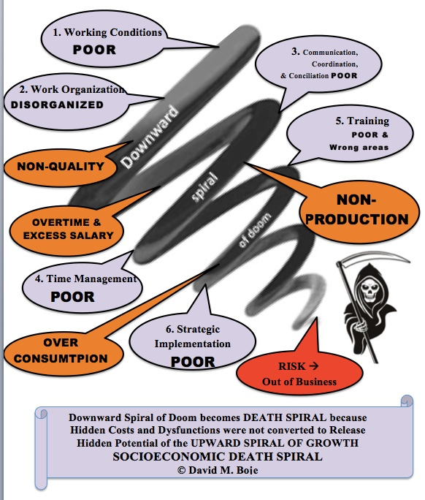
Figure 5: Socioeconomic Death Spiral of Business Diagnosis
I teach socioeconomic students to diagnose the death spiral of the current dysfunctions and hidden costs that are prevalent in the organization's current way of organizing. I then teach the student consultants the socioeconomic (SEAM) intervention of three successive Diagnostic-Project-Implementation-Evaluation (D-P-I-Es) to create a counter-force of upward spiral momentum in the client's organization to expand the spiral whorl's breadth and petntial during the time of the intervention as a way to change the strategy game rules being enacted by the client.

I have been particularly interested in Deleuzian spiral antenarratives, as well as rhizomatic antenarratives, in their territorialization, deterritorialisation, and reterritorialization. "Deleuze makes the point that cyclical repetitions of same stages, with same events is countered by repetitions of difference, and it is the differences that turn most every cyclical process into a spiralling one. What defines a spiral, is how the twirls of repetition amplify the differences, or counter-act them, in ways that makes cyclic, reoccurrence of sameness quite unlikely in socioeconomic systems" (Boje, 2012: 81, An online book download in Word). Deleuze (1991) adds 'difference and repetition', spiralling as a move we can utilize in informing our organizational systems thinking, and its a spiralling move away from Hegel/Marx/Follett historical dialectic to a Nietzechean reversal of Platonic dialectic into the Eternal Return (will to power) that incorporates Freudian & Lacanian psychoanalysis. Deleuze (1994: 6), says, "What I most detested was Hegelianism and dialectics." Deleuze adds he was stuck in a "kind of dialectics" in his early writing and had to work out of it (1994: 18).
Deleuze and Guattari (1987 & 1991/1994: 89) create a language and theory of spirals and rhizomes that forms the basis for antenarrative systems theory. In this example, I am working out the kinds of deterritorializations and reterritorializations taking place in business schools around the world. My visual diagram for how the 'Implosive' Downward Death Spiral and the 'Explosive' Triple D-P-I-E Upward Spiral constitute a Savallian double spiralis rendered as a double helix, as follows:
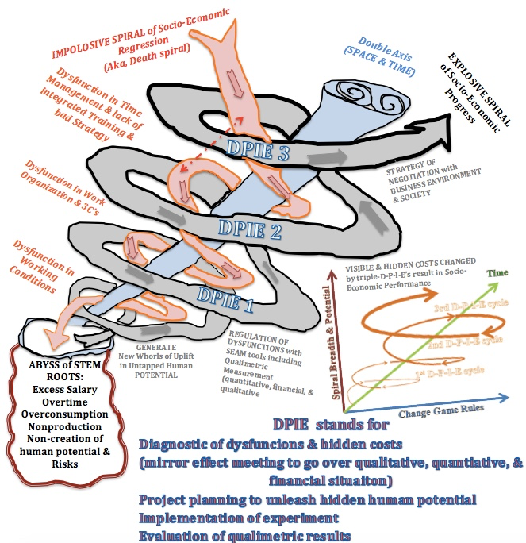
Figure 6: Boje's Rendition of Savall (1975/2010: 210) double-spiral-helix, dialectical-trilectical (qualimetrics) model (original drawing © Boje Oct 30 2017)
The above double-spiral-helix is the Trilectical relation between Implosive Spiral of Socio-Economic Regression (known here as 'death spiral) and the Explosive Spiral of Socio-Economic progress (known here as uplift spiral) and the qualimetric results (qualitative, quantitative, & financial). The double axis is three dimensions of space, and the fourth dimension, time. The upward spiral has to keep producing more whorls to avert entropy. The downward spiral has its whorls and must create move of them to create its own entropy. The double spiral has upward and downward forces (down to abyss in death spiral, and upwards to uplift). The orange dotted lines are storytelling interpretative development in both up and down spiral directions, telling interpretations between whorls, linking whorls.
Deleuze (1994: 221) theorizes a dialectical half of differenTiation (action or process of differentiating) and the French "la différentiation" aesthetic spatio-temporal actualization, differenTiation, which he combines as 'differT/Ciation': "The entire idea is caught up in the mathematico-biological system of different/ciation. I have added my theory of antenarrative process of pre-qualitative and pre-quantitative dramatizations into the diffCiation and diffenTiation of a potentization spiral, 'differT/Ciation.' Deleuze's project is to reverse the negative dialectic of Plato and Hegel, and transform it into a diffCiation dialectical of differential relations and process of positivity and an aesthetic actualization in spacetime, diffenTiation.
How does the socioeconomic appraoch relate to quantum storytelling?
The mattering of quality and economic performance in what Barad (2007) calls the inseparability of 'spacetimemattering'. The conversion of dysfunctions, untapped human potential, and negative economic (& financial) performance is accomplished by converting the Implosive (downward) spiral into resources for the Explosive (upward) spiral of socio-economic progress.
Quantum means a very small quantity, such as an atom and subatomic particles. Quantum mechanics is all about the observer [apparatus] effect on the existence of waves or particles in an experiment. The double spiral is an observer apparatus and an organizing of the change interventions. Students of socioeconomics, in New Mexico, are taught how to collect and interpret storytelling by the client, and the basics of quantum storytelling.
What we call indigenous living story is declared a valid and reliable research method for Native Science (Cajete, 2000) and qualitative methods (Smith, 2007; Denzin & Lincoln, & Smith, 2008). Antenarrative has become an organizational research method (Rosile, Boje, Carlon, Downs, & Saylors, 2013). Antenarrative is acknowledge by Karl Weick (2012) as an method to develop prospective sensemaking as research method. Boje, Haley, and Saylors (2016) use antenarrative as research method to study Burger King strategic changes. Vaara and Tienari (2011) use atnatnarrative to research Nordic bank mergers. Boje, Svane and Gergerich (2016) look at narrative and counternarrative in relation to antennarratives in research with veterans and in mergers and acquisitions. Bülow and Boje do antenarrative analysis of the purge of humanities, and negotiations of survivors in Denmark higher education. Svane, Gergerwich and Boje (2016) use antenarrative to research organizing fractals. Then there is our conference work in Being Quantum in our storytelling methods (Boje, 2014; Boje & Henderson, 2014).
'Quantum storytelling' happens in waves with momentum, and collapses into narrative convergence. Quantum storytelling is defined as the dynamic behaviour of a storytelling organization and its science is that of the dynamics of somiomaterial multiplicities (Boje, 1991, 1995, 2008) that exhibits quantum entanglement, observer effects, and spacetimemattering (Boje, 2006, 2014, 2016; Boje & Henderson, 2014; Henderson & Boje, 2016).

Quantum storytelling is ontological, with Being-in-the-world in-space and in-time in the uncertain task environments of organizations (Heidegger, 1962). Boje (2017a) assets the ecosystem world is embodied in us, and our bodies are inseparable from Being-in-the world of our storytelling:
Our biological body is 37.4 trillion living cells, an ecosystem of microorganisms and microbes, all living cells, most are symbiotic settlers.... The living cells make heat, energy, and do all kinds of things to keep us alive and in attunement with the energy all around us. Our body is trillions of living critters, interacting with all communities of plants, microorganisms, spiritual community, and so on... A group of scientists (Bianconi et al., 2013) estimate there are over 37 trillion living ‘human cells’ in the human body, which is 65% water ecosystem. Besides the 37 trillion living human cells, there are ten times as many symbiotic microorganisms, microbes, molecules, and so on, that keep us healthy and fight off disease invaders. All these trillions of cells is what Paula Gunn Allen (2008: 138) calls 'energy becoming energy' in a transformation of a 'Mandelbrot set', a kind of fractal of recurring self-sameness (Henderson & Boje, 2016)".
Tonya Henderson and I have been working on fractality as dimension of quantum storytelling (Boje & Henderson, 2014; Henderson & Boje, 2016; Boje, 2016). The theory is that there are combinations of fractals called multifractals that are entangled in complex organizations. In quantum storytelling terms, there are fractal narratives, fractal living stories, and fractal antenarratives. In their combination they are in mutlfractality. Jeff Noon’s (1993) novel, Vurt, is all-out narrative and story fractals that interact multiracially in the Manchester’s social economy. Deleuze and Guattari’s (1987) rhizomatic capitalism features the Mandelbrot fractal. Fractals are used to study system dynamics in finance, accounting, ecology, and organization behavior.
American Pragmatist, John Dewey (1925, 1929) was influenced by several quantum physicists (Maxwell, LaPlace, Heisenberg) to develop a more ontological approach to experience within nature. Dewey foresaw the how quantum mechanics would be its own Copernican Revolution in challenging to Newtonian physics. “The realization that the observation necessary to knowledge enters into the natural object known cancels this separation of knowing and doing. It makes possible and it demands a theory in which knowing and doing are intimately connected with each other. Hence, as we have said, it domesticates the exercise of intelligence within nature” (Dewey, 1929: p. 205)
Quantum storytelling is a kind of discourse entangled with materiality to constitute sociomateriality. Therefore Karen Barad (2007) intra-activity of materiality with discourse (i.e. storytelling) is a quantum phenomenon. Anete Strand’s (2012) dissertation on ‘material storytelling’ is influenced by Barad as well as my own work in storytelling. I do material storytelling in work with veterans.
Quantum storytelling means fragment of living story that produce strange socioeconomic behavior or contagion in a complex system. This is because of multiplicity, how living stories happen in webs of relationships and in series. Wherever and whenever we encounter one living story, we encounter multiplicity in an entire web of living stories happening in different locations simultaneously. The multiplicity of living stories take on a life of their own. Unlike empirical, the processes are not linear, and the living stories are happening, unfolding in the middle, without beginning or end.
To tell one living story is to be entangled with the entire living story web, all in-the-middle, rather than in the linear structure of narrative beginning-middle-end emplotment. This is quantum superposition, how a living story can be in more than one place at once. Quantum tunnelling occurs when a living story passes through barriers, through walls, between lands. Waves of storytelling get collapsed by choices about which of several waves arriving to attend to, to forecare for the futures that are arriving in advance. Instead of just one future, multiple futures are in arrival, and we collapse one into Being by the care and attention we give it. The other waves of future are potentialities for becoming, and those un-pursued are opportunity costs. Waves of different living stories can pass through one another or cancel each other out. In organizations, we are chasing storytelling from room to room but we can only be in one room at once.
Chasing a a living story from one place to another group is a TamaraLand problem since there is a multiplicity of living stories happening simultaneously across the rooms and hallways, as well as digital pathways of any complex organization (Boje, 1995). If there are just ten rooms in an organization, each with a storyteller, and you can enter only one room at a time, your pathways in a ‘storytelling organization’ are ten factorial (3,628,800). Depending upon the sequence of storytelling rooms you have when you enter a given room, that will be the meaning you use to frame a present living story. The pattern of living stories happening in spacetimemattering is occurring in every complex organization.
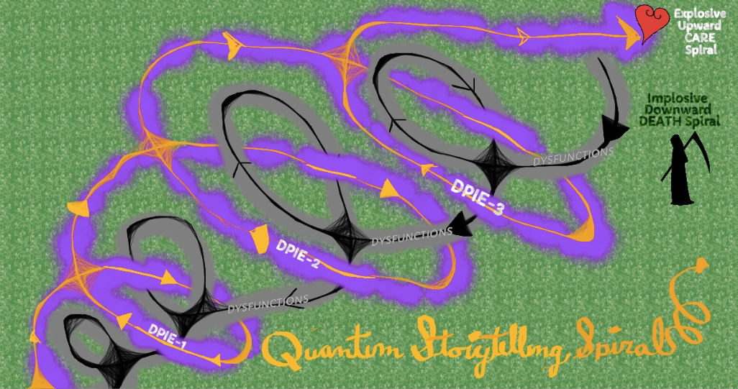
Figure 7: Quantum Storytelling Double Spiraling (drawing by Boje 2017)
Living story webs are self-organizing spirals, with waves of upward explosive contagion (in black and grey, above) that have a life all their own, and implosive downward contagion (in orange and purple, above). Some storytelling contagions are energizing in productive ways, in explosive upward and uplifting spiraling. Others are called miasma by storytelling theorist, Yiannis Gabriel (2008). For example, in the throws of miasma, people begin cutting each other down for no good reason, and no one is good enough or excellent enough. Quantum storytelling is about dynamic self-organizing complexity that itself is agential. Viral storytelling is a kind of living story virus, and can be the kind of jumping to conclusions, of a rumour mill. Narrative plays its role in storytelling virus, such as the narrative, ‘there is no alternative’ (TINA), the TINA narrative is common in organizations encountering change, turbulence, downsizing, restructuring, and so on.
Markus Hege asks, 'Do upward spirals always imply a simultaneous downward spiral? example: recent development of automation & globalization were an upward spiral for some, but also a downward spiral for many, creating a situation in which the world is continuously becoming more instable and unpredictable.' For me, entropy is a downward implosive force of randomness, chaos and chance, and organizing is a way to counter it with negentropy, things coming into more socioeconomic functional order through higher levels of democratic participation.
Hege asks, 'Is an upward spiral only good if self-generated by the organization (link to personal development)? Is Self-awareness the key? This awareness can be obtained through various means: SEAM audit (Savall), deconstruction of dominant narrative(Boje) which always have the danger of incorporating false upward spirals which eventually lead to death. The impulse given by self-awareness (from the mirror effect) can create a self-generated upward spiral with the potential of creating a antenarrative based on Theory W (free choice, human dignity). I really like the concept of integrating antenarrative theory into SEAM, which lacks the idea of using the human projection capabilities into the future to orient current behaviors.' I agree with Hege, that it is through social reflexivity that there is an impulse of generative human potential. We can begin to strategize spiral movements in spatial landscpe and timescape to search out better performance potentialities.
Charles Minahen (1992) has written an amazing history of spirals in literature. His appendix makes distinctions and interplay between spirals, vortices, helices, and gyres. Many people use these terms interchangeably, but there are important differences. And if we are to develop a spiral-antenarrative theory, get it to become method, and apply it to organization systems then the differences matter.
SPIRALS - Spirals have continuous curves moving around a fixed point on a two dimensional plane, like a coil of rope, an Archimedes coiled line, or a whorl of a vine plant. Archimedes spiral has The radius r(t) and the angle t are proportional for the simplest two-dimensional spiral. The Fibonacci spiral (aka a golden spiral is also two-dimensional, is a logarithmic spiral whose growth factor is φ, the golden ratio, found by adding up the two numbers before it. Starting with 0 and 1, the unending sequence goes 0, 1, 1, 2, 3, 5, 8, 13, 21, 34, and so forth. Shellfish and snails can have this Fibonacci spiral, uncoiling from center to periphery. "The fact is that two-dimensionality can exist only as an abstraction in a three-dimensional (or four-dimensional) reality, so a structure is spiralic only to the degrees the third dimension approaches or conforms to a plane, relative to the rest of the structure's distribution of parts" (Minahen, 1992: 152). In other words Spiral is an abstraction, a theory (Big X->Y) to hypothesize that organization systems have spiral form, , spiral turns in its range of behaviors, and on a spiralic path, like a spider making a web to ensnare its prey. To come up with measures (little x->y) is quite a stretch of organizational research.
HELICES - The Helix is three-dimensional extension of spiral-form. There can be repetitions of 'static' motion, at constant rate, about a central axis, that yields a helical shape (vector). The helice with successive generation of coils (whorls) can be equidistant from the axis, and tightly wound to produce a cylinder (cylindrical helix), or of conical variety(upward and downward coiling cones of repeated revolutions of two-dimensional circular motion). Heidegger is accused of being two-dimensional in his ideas of the helix revolutions, something I wrote about in Boje (2014), as updraft of outer whorls, and the downdraft into the abyss. The helical repetitions (cycles) of an organizational system, about an axis (paradigmatic and/or syntigmatic; if both its double axis that Deleuze writes about). Paradigmatic themes, such as the shift from the p-value significance testing to Trafimow's a priori significance procedure constitute a major paradigm shift in statistics. The syntagmatic axis is different, defined as relationship among storytelling elements (narratives, living stories, & antenarratives) in the spiralling sequence of storytelling (& other discourse elements, metaphors, tropes, and so on). If thee double axis (paradigmatic/syntigmatic) are discursive, then the spiralling around it is sociomaterial, or Baradian spacetimemattering. The helical whorls are progressive (or regressive) and persistent (upward and downward in double helix spiral), with revolutions (whorls) along a continuum, "Like the breaking of a wave at the seashore in a horizontal, cylindrical-helical progression" (Minahen, 1992: 154). The waves or poly-rhythmic action (as Deleuze calls it) has many implications for organizational systems. Helice waves, when poly-rhythmic, in living organizational systems, curl in tendrils, at the smallest level, and are not like the spiral coils or spiral staircases of two-dimensional abstractions. Helical organizational systems reduced to the corkscrew or drill bit (Archimedes types of screw-spiral) is useful, but nothing akin to the tripal-spiral-helice of a Mother's connection to child by umbilical cord (IBID., p. 155).
GYRES - Instead of static, abstract theories of spirals or helices, we need the 'gyre' because it is technically, as Minahen puts it, a more dynamic whirling phenomena of turbulence. And if there is anything true about system dynamics of complex organizational systems; they are turbulent. Heidegger (1962) says humans have an attunement to the turbulence in which they exist. People in organizations are attuned to the turbulences of spiral-helices and vortex. The motion of double- and triple-spiral-helices affects the body. Our body feels the vibrations of the turbulence of an organization and its environment. We certainly are affected bodily by the winding down or the New Mexico economy, and its vibrations throughout systems of higher education.
VORTICES- The Vortex of turbulence is not all mere random vorticity. Around the double spinning axis (paradigmatic/syntagmatic) of socioeconomic politics of the State of New Mexico, the velocity of change, the poly-rhythms of change is a free falling vortex, a tornado, a waterspout kind of turbulence. Two opposing forces, the centripetal (centring movements) and the centrifugal (decentring movements). The two movements are simultaneous in the velocity diminishing higher education, in its free falling double-spiral vortex, the downsizing of the land grant missions of higher education, the rapid translations of the business model(academic capitalism) into the educational system. Big (X->Y) cause-effect theory of spiral-gyres, its vortices, is complex, and difficult to translate to Little (x->y) tests. Finding peace in the eye of the maelstrom, a spacetime for festival, such as going to a Halloween festive costume event, is superposition of a tranquility, to calm the body in the midst of high turbulence. High velocities of change are near to the center of the gyre of higher education, and these are changes of great intensity. The evidence of the unscathed, untouched areas of higher education are infrequent, localized, like houses left standing in the path of a tornado or a tidal wave. Can we find some vortex wings, with manifestations of full actualization, of educational for all (as the Musketeers put it, 'all for one and one for all' in the time of Cardinal Richelieu, consecrated as a bishop in 1607, Cardinal in 1622, and chief minister to King Louis XIII in 1624, and this relationship, during the Thirty Years War (1618–1648), when Cardinal Richelieu, censored the press and did other authoritarian things. Peace in midst of war, is being able to find the eye of the storm, and rest there, a brief while.
In sum, the Spiral, Gyre, Helices, and Vortices are entangled. In sum, the Spiral, Gyre, Helices, and Vortices are entangled. Spirals are usually 2-dimensional renditions (a coil of rope), but Gyres, and Helices have one axis, and Gyres are 3-dimensions, and the Vortices of Turbulence need a 3-D Spiral Vortex to depict socio-economic change and performance interventions. I therefore propose Double-Spiral helix rendition. Sometimes these four (Spiral, Gyre, Helices, & Vortices) forms are in symmetrical-complementarity relations, and other times quite asymmetrical (enantimorphism, technical term, for co-existence of two or more forms), and they can have a handedness (left-handedness and/or right-handedness) that is anthropomorphic (because spirals don't have hands). Does a spiral have a left and right side, as Deleuze (1994, Difference & Repetition) suggests? Are the forces of rotation and motion moving left and or right? Are spirals symmetrical or more asymmetrical, or perhaps both at once? A human body has symmetric right and left side, but asymmetric front and back. My hypothesis is following the theory of Enantiomorphism, the organizational systems have asymmetrical structures and also symmetrical structures. They are both left and right-handedness helices of momentum more than single momentum or single rhythm, or just an upward without some downward. The double-spiral helix is in several directions of gyration, depending on the turbulence of the situated environment. There is double-spiral movement within, and the movement along a path that is hermeneutical, a change in paradigmatic and storytelling trajectory from here-and-now to then-and-there. For Deleuze this is not about thesis and antithesis, its about multiplicity of symmetrical and asymmetrical forces, as the periphery changes in relation to centripetal movement by some center (axes). I theorize the double spiral as having opposing dynamical vortical manifestations, spins in opposite directions give the type of turbulence affecting centripetal and centrifugal interplay.
Measurement before and after, each and every change intervention experiment, is fundamental to Savall's socioeconomic approach to management, known as, SEAM. It is not only quantitative and financial, the researcher-intervenor (Savall does not use terms like action researcher or change agent). The qualitative component includes the researcher-intervenor collecting verbatim qualitative field notes and direct observations, then entering them in a SEAM diagnostic computer data bank, that can be analyzed for each 'Mirror Effect' meeting with the client, when the quantitative (hidden costs), financial data, and qualitative quotes from all stakeholders is 'mirrored back' to the client, so they can see what it is costing the organization to remain dysfunctional, not converting hidden costs and revenues into realizable economic performance. When Grace Ann Rosile and I and interviewed Henri Savall and wrote an article about it we discovered something important, not in any of the Savall books. That is, that Savall looks at the qualitative discourse of an organization as a theater-script that is all disorganized and dysfunctional. We call this the 'Theatrics of SEAM' (Boje & Rosile, 2003).
References
Allen, Paula Gunn. (2008). "She is Us: Thought Woman and the Sustainability of Worship". Pp. 138-144 in Melissa K. Nelson (ed.) Original Instructions: Indigenous Teachings for a Sustainable Future. Rochester, Vermont: Bear & Company.
Barad, K. (2003). Posthumanist performativity: Toward an understanding of how matter comes to matter.” Journal of Women in Culture and Society. Vol. 28 (3): 801-831). On line at http://www.kiraoreilly.com/blog/wp-content/uploads/2009/06/signsbarad.pdf
Barad, K. (2007). Meeting the Universe Halfway: Quantum Physics and the Entanglement of Matter and Meaning. Durham/London: Duke University Press.
Bianconi, E., Piovesan, A., Facchin, F., Beraudi, A., Casadei, R., Frabetti, F., Vitale, L., Pelleri, M.C., Tassani, S., Piva, F., Perez-Amodio, S., Strippoli, P., & Canaider, S. (2013). An estimation of the number of cells in the human body. Annals of human biology, 40(6), 463-471. (See online text).
Boje, D. M. (1991). The storytelling organization: A study of story performance in an office-supply firm. Administrative Science Quarterly, 106-126.
Boje, D. M. (1995). Stories of the storytelling organization: A postmodern analysis of Disney as “Tamara-Land”. Academy of Management Journal, 38(4), 997-1035.
Boje, D. M. (2001). Narrative Methods for Organization and Communication Research. London: Sage.
Boje, D. M. (2003) Qualimetrics Contributions to Research Methodology: Preface to RECHERCHE EN SCIENCES DE GESTION: OBSERVER LOBJET COMPLEXE APPROACHE QUALIMETRIQUE by Henri Savall and Veronique Zardet, Lyon 3 & ISEOR, June 19, 2003; Revised June 26, 2003. Online prepublication draft.
Boje, D. M. (2008). Storytelling Organizations. London: Sage.
Boje, D. M. (2011a).Storytelling and the Future of Organizations: An Antenarrative Handbook (Routledge Studies in Management, Organizations and Society). London: Routledge.
Boje, D. M. (2011b). Reflections: What does Quantum Physics of Storytelling Mean for Change Management? Journal of Change Management, Vol. 12 (3): 253-271. Click here for pre-press pdf.
Boje, D. M. (2012b) Quantum Storytelling. Free online book (until it gets finished with its revisions, and a publisher calls).
Boje, D. M. (2012b). QUANTUM SPIRALS for Business Consulting. An online book download in Word. July 9..
Boje, D. M. (2014). Storytelling organizational practices: Managing in the quantum age. London/NY: Routledge.
Boje, David M. (2016a). Preface to Savall and Peron. “Global Capitalism is Unsustainable". Click here for pdf And click here for the final version of the Preface in Savall, H., & Peron, Michel. (2016). Socially Responsible Capitalism. London: Routledge. (No. hal-01140272).
Boje, D. M. (2016b). SEAM’s ‘Storytelling Dialectical Method’ and the Failure of Appreciative Inquiry as a Scientific Method of Organizational Development and Change. Click here for pdf of paper.
Boje, D. M. (2017a). The Principle of Surrender: Collapsing Waves of Quantum Storytelling. January 17, 2017; Revised April 28, 2017. Online working paper.
Boje, D. M. (2017b). Theaters of Capitalism: Creating Conscious Capitalism. Las Cruces: TamaraLand publishing.
Boje, D. M. (2018a, in press). Storytelling Research Methods: Storytelling In Action. London: Routledge.
Boje, D. M. (2018a, in press). How Storytelling can Restory Globalization to Save Humanity from its own Extinction? Hackensack, NJ: World Scientific Publishing Pte. Ltd
Boje, D. M.' Baca-Greif, H.; Intindola, M; Elias, Steve. (2017). The Episodic Spiral Model: A New Approach to Organizational Processes. Journal of Organizational Change Management.
Boje, D. M., Haley, U. C., & Saylors, R. (2016). Antenarratives of organizational change: The microstoria of Burger King’s storytelling in space, time and strategic context. Human Relations, 69(2), 391-418
Boje, D. M., & Henderson, T. L. (Eds.). (2014). Being quantum: Ontological storytelling in the age of antenarrative. Cambridge Scholars Publishing.
Boje, David M., & Hillon, Yue C. (2017). The Fifth Epoch: Socio-Economic Approach to Sustainable Capitalism. Markets, Globalization & Development Review, 2(1): 1=20. Click here for online pdf.
Boje, D. M.; Hillon, Yue; Mele, Tara M. (2017). 21st Century University and the Failure of Business Process Reengineering. Accepted Jan 6 2017, will be published in Organization Development Journal, Spring 2017 – Volume 35, Number 1. Click here for pre-press PDF.
Boje, D. M. & G. A. Rosile (2003).Theatrics of SEAM. Journal of Organizational Change Management. Special issue Socio-Economic Approach to Management, Henri Savall (Guest Editor). Vol. 16 (1): 21-32. Pre-publication PDF of this article; Workshop manual at http://business.nmsu.edu/~dboje/theatrics/manual/THEATRE OF SEAM 27JUNE02.DOC
Boje, D. M.; Sanchez, Mabel. (2018a, Eds. In press). Quantum Storytelling Consulting Handbook. London: Emerald Press. Click here fore pre-press of PREFACE pdf. Chapter 1: Ensemble Leadership by Boje, D. M. Click here fore PDF
Boje, D. M.; Sanchez, Mable (2018b, Eds. In press). New Directions in Management and Organizational Inquiry: A history of Standing Conference for Management and Organizational Inquiry. London: Emerald Press.
Boje, D. M. & Strevel, Hank (2016).Feature Choice: Using Quantum Storytelling to Bridge Appreciative Inquiry to Socio-Economic Approach to Intervention Research. AI Practitioner: International Journal of Appreciative Inquiry. Vol. 18 (# 3): pp. 79-89
Boje, D. M., Svane, M., & Gergerich, E. M. (2016). Counternarrative and antenarrative inquiry in two cross-cultural contexts. European Journal of Cross-Cultural Competence and Management, 4(1), 55-84.
Bülow, A. M., & Boje, D. M. (2015). The antenarrative of negotiation: On the embeddedness of negotiation in organizations. Journal of Strategic Contracting and Negotiation, 1(3), 200-213.
Cajete, G. (2000). Native science: Natural laws of interdependence. Clear Light Pub.
Cunliffe, A. L., Luhman, J. T., & Boje, D. M. (2004). Narrative temporality: Implications for organizational research. Organization Studies, 25(2), 261-286.
Deleuze, Gilles.(1994) Difference and Repetition.Translated by Paul Patton. NY: Columbia University Press. 1968 French (Press Universsitaires de France).
Deleuze. Gilles. (1990). Logic of Sense. NY: Columbia University Press. French 1969 (Les Editions de Minuit).
Deleuze, G. & F. Guattari (1987) A Thousand Plateaus: Capitalism and Schizophrenia. Translation & foreword Brian Massumi. University of Minnesota Press, is on line. On line free pdf.
Denzin, N. K., Lincoln, Y. S., & Smith, L. T. (Eds.). (2008). Handbook of critical and indigenous methodologies. CA: Sage.
Dewey, John. (1925). Experience and Nature. Open Court, Chicago, 1925.
(Revised):London: George Allen & Unwin. Currently in print: New York: Dover, 1958. Also in: The Later Works, Volume 1, Carbondale, 1981, with an introduction by Sydney Hook. Page numbers here refer to the 1929 edition. See online text.
Dewey, J. (1929). The Quest for Certainty, The Later Works: 1925–1953 Vol. 4. Jo Ann Boydston, Carbondale: Southern Illinois University Press. My citations are from 1925 edition of The Quest for Certainty, available on line.
Gabriel, Y. (2008). Organizational miasma, purification and cleansing. Pp. 53-73 in In A. Ahlers-Niemann, U. Beumer, R. Mersky, & B. Sievers (Eds.), Socioanalytic thoughts and interventions on the normal madness in organizations. Bergisch Gladbach: Andreas Kohlhage. Available online.
Gourlay, S. N. (2003).The SECI model of knowledge creation: some empirical shortcomings, in F. McGrath, and Remenyi, D., (Eds.), Fourth European Conference on Knowledge Management, Oxford, 18-19 September, pp. 377-385 http://myweb.tiscali.co.uk/sngourlay/PDFs/Gourlay%202004%20SECI.pdf
Gourlay, S. N. and Nurse, A. (2005). Flaws in the “Engine” of Knowledge Creation: A Critique of Nonaka’s SECI Model, Chapter 13 in Challenges and Issues in Knowledge Management, Buono, A. F., and Poulfelt, F. (eds) Research in Management Consulting Series, Volume 5, Greenwich, Connecticut: Information Age Publishing, pp. 293-315 (ISBN 1593114192). http://myweb.tiscali.co.uk/sngourlay/PDFs/Chap%2013%20GourlayNurse.pdf
Haley, U. C., & Boje, D. M. (2014). Storytelling the internationalization of the multinational enterprise. Journal of International Business Studies, 45(9), 1115-1132.
Hambrick, D.C., Li, J., Xin, K., Tsui, A.S. (2001). Compositional gaps and downward spirals in international joint venture management groups. Strategic Management Journal, 22: 1033 – 1053.
Heidegger, M. (1962). Being and Time. Translated by John Macquarrie & Edward Robinson. NY: Harper Row.
Henderson, T., & Boje, D. M. (2016). Organizational development and change theory: Managing fractal organizing processes (Vol. 11). Routledge.
Lindsley, D.H., Brass, D.J., Thomas, J.B. (1995). Efficacy-performance spirals: A multilevel perspective. Academy of Management Review, 20: 645 – 678.
Minahen, Charles D. (1992). Vortex/t: The Poetics of Turbulence. University Park, PA: The Pennsylvania State University Press.
Nonaka, I. (1988a). ‘Creating order out of chaos: self-renewal in Japanese firms’. California Management Review, Vol 15, No.3, pp 57-73.
Nonaka, I. (1988b). ‘Toward middle-up-down management: accelerating information creation. Sloan Management Review, Vol 29, No.3, pp 9-18.
Nonaka, I. (1990). ‘Redundant, overlapping organization: a Japanese approach to managing the innovation process’. California Management Review, Vol 32, No.3, pp 27-38.
Nonaka, I. (1991a). ‘The knowledge-creating company’. Harvard Business Review, NovemberDecember, pp 96-104.
Nonaka, I. (1991b). ‘Managing the firm as an information creation process ‘. In Meindl, J.R., Cardy, R.L. and Puffer, S.M. (Eds), Advances in information processing in organizations. Greenwich, Conn., London: JAI Press Inc, pp 239-275.
Nonaka, I. (1994). A dynamic theory of organizational knowledge creation. Organization Science, Vol. 5:14 – 37.
Nonaka, I.; Byosiere, P.; Borucki, C.C.; Konno, N. (1994). ‘Organizational Knowledge Creation Theory: a first comprehensive test’. International Business Review, 3, 4, pp 337- 351.
Nonaka, I.; Kenney, M. (1991). ‘Towards a new theory of innovation management: a case study comparing Canon, Inc. and Apple Computer, Inc.’. Journal of Engineering and Technology Management, Vol 8, No.1, pp 67-83.
Nonaka, I.; Konno, N.; Toyama, R. (2001b). ‘Emergence of “Ba”. A conceptual framework for the continuous and self-transcending process of knowledge creation’. In Nonaka, I. and Nishigushi, T. (Eds), Knowledge Emergence. Social, technical and evolutionary dimensions of knowledge creation. Oxford, New York: Oxford University Press, pp 3- 29.
Nonaka, I.; Takeuchi, H. (1995). The Knowledge-Creating Company: How Japanese Companies Create the Dynamics of Innovation. Oxford University Press, New York. Nonaka, I.; Toyama, R. (2003). ‘The knowledge-creating theory revisited: knowledge creation as a synthesizing process’, Knowledge Management Research & Practice, Vol 1, pp 2-10.
Nonaka, I.; Toyama, R.; Byosière, P. (2001a). ‘A theory of organizational knowledge creation: understanding the dynamic process of creating knowledge’. In Dierkes, M., Antel, A.B., 107 Child, J. and Nonaka, I. (Eds), Handbook of organizational learning and knowledge. Oxford: Oxford University Press, pp 491-517.
Nonaka, I.; Toyama, R.; Konno, N. (2000). ‘SECI, Ba, and leadership: a unified model of dynamic knowledge creation’. Long Range Planning, 33, pp 5-34.
Nonaka, I.; Umemoto, K.; Senoo, D. (1996). ‘From information processing to knowledge creation: a paradigm shift in business management’. Technology in Society, Vol 18, No.2, 203-218.
Nonaka, I.; Yamanouchi, T. (1989). ‘Managing innovation as a self-renewing process’. Journal of Business Venturing, Vol 4, pp 299-315.
Nonaka, Imai K.; Takechi, H. (1985) Managing the new product development process: How Japanese companies learn and unlearn. Pp. 337-375 in K. B. Clark and C. Lorenz (Eds.) The Uneasy Alliance: Managing the Technology-Productivity Dilemma. Boston: Harvard Business School Press.
Noon, Jeff. (1993). Vurt. Ringpull Press. 2014 edition MacMillan publishing.
Parker, Martin (2018a). Why we should bulldoze the business school. Guardian, Op Ed 27 Apr, accessed Jun 2, 2018 at https://www.theguardian.com/news/2018/apr/27/bulldoze-the-business-school.
Parker, Martin. (2018b). Shut Down the Business School: What's Wrong with Management Education. London: Pluto Press
Rosile, G. A., Boje, D. M., Carlon, D. M., Downs, A., & Saylors, R. (2013). Storytelling diamond: An antenarrative integration of the six facets of storytelling in organization research design. Organizational Research Methods, 16(4), 557-580.
Savall, Henri. (1975/2010). Work and People: An Economic Evaluation of Job-Enrichment. 1975 book "Enrichir le trail human dans les enterprises et les organizations". 2010 English version is Translated from French by M. A. Woodhall. Charlotte, NC: Information Age Publishing, Inc.
Savall, H., & Peron, Michel. (2016). Socially Responsible Capitalism. London: Routledge. (No. hal-01140272).
Savall, H.; Zardet, V.; Bonnet, M. (2008). Releasing the Untapped Potential of Enterprises Through Socio-Economic Management. ISBN 978-2-917078-12-9 2nd Revised edition, 2008. London: International Labor Organization and Socio Economic Institute of Firms and Organizations.
Smith, L. T. (2007). On tricky ground. The landscape of qualitative research, 1, 85-113.
Strand, A. M. C. (2012). The between: On dis/continuous intra-active becoming of/through an apparatus of material storytelling. Dissertation, Aalborg University, Denmark. Volume 1; Volume 2.
Svane, M. S., & Boje, D. M. (2015). Tamara land fractal change management-in between managerialist narrative and polyphonic living stories.Proceedings paper presented to Las Vegas meeting of Standing Conference for Management and Organizational Inquiry, Sc'MOI click for PDF.
Svane, Marita, Erika Gergerich, and David M. Boje. (2016). Fractal Change Management and Counter-Narrative in Cross-Cultural Change. In Counter-narratives and Organization, pp. 129-154. Taylor & Francis, 2016.
Trafimow, David. (2003). Hypothesis testing and theory evaluation at the boundaries: surprising insights from Bayes's theorem. Psychological review, 110(3), 526. https://www.researchgate.net/profile/David_Trafimow/publication/10641210_Hypothesis_Testing_and_Theory_Evaluation_at_the_Boundaries_Surprising_Insights_from_Bayes%27s_Theorem/links/0c960535c04070840c000000/Hypothesis-Testing-and-Theory-Evaluation-at-the-Boundaries-Surprising-Insights-from-Bayess-Theorem.pdf
Trafimow, D., & Rice, S. (2009). A test of the null hypothesis significance testing procedure correlation argument. The Journal of general psychology, 136(3), 261-270. https://www.researchgate.net/profile/David_Trafimow/publication/26712874_A_Test_of_the_Null_Hypothesis_Significance_Testing_Procedure_Correlation_Argument/links/00b7d535c0427575e1000000.pdf
Trafimow, David. (2014). Considering quantitative and qualitative issues together. Qualitative Research in Psychology, 11(1), 15-24.
Trafimow, David. (in review). An A Priori Solution to the Replication Crisis.
Trafimow, David; Marks, Michael. (2015). Editorial. Basic and Applied Social Psychology Volume 37, 2015 - Issue 1: 1-2.
Vaara, E., & Tienari, J. (2011). On the narrative construction of multinational corporations: An antenarrative analysis of legitimation and resistance in a cross-border merger. Organization Science, 22(2), 370-390.
Weick, K. E. (2012). Organized sensemaking: A commentary on processes of interpretive work. Human Relations, 65(1), 141-153.
Worley, C. G., Zardet, V., Bonnet, M., & Savall, A. (2015). Becoming Agile: How the SEAM Approach to Management Builds Adaptability. NY: John Wiley & Sons.

