QUANTUM SPIRALS
For Organization Consulting

David Boje
New Mexico State University
Business
© David M. Boje
QUANTUM SPIRALS
For Organization Consulting
July 9, 2012; Revised August 1, 2012
Table of Contents
Preface to Quantum Spirals for Organization Consulting 3
Chapter 1: Linear Planning with PERT and Storytelling 13
Chapter 2: Cyclic Planning and Storytelling 17
Chapter 3: What is Spiral-Antenarrative 25
Chapter 4: What is Quantum Spiral? 29
Chapter 5: Applications of Q-Spiral to Socio-Economic Approach to Consulting 42
Chapter 6: 23 Steps to Implement Q-Spirals in Business 53
Chapter 7: Prior Spiral Theory Dualizes Upward versus Downward 62
Chapter 8: What is Landscape in the Quantum Spiral? 69
Chapter 9: What is Timescape in the Quantum Spiral? 74
Chapter 10: What is Materialscape in the Quantum Spiral? 75
Chapter 11: What are Three Dimensions of Quantum Spiral? Landscape, Timescape, & Materialscape 76
Chapter 12: How to Study Q-Spirals in Business? 79
Chapter 13: Spirals and Clovers? 82
Chapter 14: Wrap Up of Quantum Storytelling? 86
Chapter 15: Storytelling Standpoint Methodology 92
References 100

Preface to Quantum Spirals for Organization Consulting
A Quantum Spiral is defined from the heart aspects of its spatial landscape, its temporal timescape, and its mattering materialscape
Quantum Spirals (hereafter Q-Spirals) are all around us. We just don’t notice them because we have been trained only to see straight lines. Organizations can learn a thing or two from studying the Q-Spiral of our very material existence. Simple spiral examples are all around us, in snail shells, sea shells, the centers of sunflowers, the way the water drains, and dust devils rotate in one direction in the northern hemisphere and the opposite direction in the southern. Q-Spirals are much more complex. They can have multiple radial spiral arms, where space is a part of landscapes. Clocktime is only one of many times in timescapes, and matter is moving on waves not just particles in materialscapes. Any type of organization (business, university, non-profit, government, volunteer, etc.) can learn about Q-spirals by looking at everyday life. Q-spirals are in part geometrical storytelling, part material storytelling, and mostly it is quantum storytelling.
A storytelling organization (Boje, 1991, 1995, 2008a) is defined here as any organization that relies on storytelling as is primary mode of sensemaking currency.
In this book, three kinds of ‘storytelling organization’ ontologies (geometric, material, & quantum) are put into relationship to each other and to different sorts of antenarrating (linear, cyclic, spiraling, & rhizomatic) and their environs: landscape, timescape, and materialscape. Rather than dualize living story and narrative, I invented the construct of ‘antenarrative’ to look at ways living story bridges into the narrative, and narrative into living story, in a triadic model of storytelling (Boje, 2001).
Boje’s Theory of Triadic Storytelling
My own theory of storytelling, for some years now has been to treat storytelling as the domain in which narrative, living story, and antenarrative processes interact in ‘storytelling organizations’ (Boje, 1911, 1995, 2008a, 2011). A starting storytelling definition (Boje, Jørgensen, & Strand, expected 2013: 3):
"Storytelling, here, is defined more broadly, as something agential such as the iterative intra-active-material-storytelling domains of "living stories‟ and "antenarratives‟ in the theatre of action, which go beyond the classical narrative focus on structuralist and representationalist elements and retrospection (Boje, 2001, 2008a)."
My approach to storytelling looks at relations among three genres: narrative, living stories and antenarrative bridges between them. Some history will help put the definition into context. I have been studying and theorizing storytelling for thirty five years. I have evolved my own storytelling philosophy. My early work and middle and late work are quite different. Over the years I moved from being mythic (Boje, 1979; Boje, Fedor, & Rowland, 1982), to folkloric conversation analysis of ‘storytelling organizations’ (Boje, 1991), to postmodern ‘storytelling organizations’ (Boje, 1995), to being rebelliously dualistic, seeing narrative as oppressive, and living stories as liberatory (Boje, 1999), on to antenarrative aspects of ‘storytelling organizations’ (Boje, 2001, 2007, 2008a, 2011) and even poetically Aristotelian Enron downward spiraling ones (Boje & Rosile, 2002, 2003; Boje, Rosile, Grant, & Luhman, 2004). As my ‘storytelling organization’ approached aged, I became more Bakhtinian dialogic with answerability ethics (Boje, 2008a, b) then more ontological (Jørgensen & Boje, 2010), and today I am doing quantum storytelling (Boje 2012a to f). It’s not a straight line, or cyclic journey, rather it’s what I call a spiral-antenarrative which is in relation to other sorts of antenarrative (linear, cyclical, & rhizomatic).
My purpose in this book is to situate something I will call ‘geometric storytelling’ in relation to ‘material storytelling,’ and ‘quantum storytelling.’ And within that project, I want to look carefully at Q-spirals as something helpful to consulting organization processes.
Defining Key Concepts of Storytelling Organizations
An antenarrative is defined as ‘living story’ stuff going on ‘before’ (ante’s 1st meaning) narrative, and ‘bets’ (ante’s 2nd meaning) on the future made by looking at ‘living stories’ in relation to narrative. The three storytelling approaches treat what TwoTrees (1997, 2000), Tyler (2010, 2011), Vizenor (1998), Cajete (2000), and I (Boje, 2001, 2005, 2006, 2007a, 2008a, 2011, 2012e) separately call ‘living stories’ with their own space, time, and mind/aliveness/transmotion/spirit/mattering (3rd term each of us respectively uses in our admitted vitalism).
Living story is defined here as a material aliveness, without beginning or end, in the middle of unfolding, and in a web of relations to other living stories. Our ways of living story are in relationship to classic deadly retrospective Western narrative. A narrative has been defined since Aristotle (350 BCE) as having a beginning, middle, and end, a plot and thematic coherence, as a whole that is expressed in a shorter time and in a more limited theatre space than is story or history. In short, storytelling is constituted by the subdomains of narrative, living story, and four kinds of antenarrative bridging (linear-, cyclic-, spiral-, and rhizomatic).
Table 1- Question Matrix for Storytelling Organization Inquiry
QUESTIONS MATRIX | LIVING STORY | NARRATIVE | ANTENARRATIVES
LIVING STORY | Describe in detail all the webs of living stories? | What are all the ways living stories are organized by narratives and counter-narratives? | What are all the ways living stories are transformed by antenarratives (linear, cyclic, spiral, rhizomatic)?
NARRATIVE | What are all the ways narratives and counter-narratives generalize from living stories? | Describe in detail all the narratives and counter-narratives? | What are all the ways narratives and counter-narratives are linked to antenarratives (linear, cyclic, spiral, rhizomatic)?
ANTENARRATIVES | What are all the ways antenarratives (linear, cyclic, spiral, rhizomatic) are related to living stories? | How are antenarratives (linear, cyclic, spiral, rhizomatic) linked to narratives and counter-narratives? | Describe in detail all the antenarratives (linear, cyclic, spiral, rhizomatic) linking living story webs with narratives and counter-narratives?
We can expand the Question Matrix by looking at space, time, material, episode and telos.
Table 2: Expanded Question Matrix for Storytelling Organization Inquiry
QUESTION MATRIX | SPACE | TIME | MATERIAL | EPISODE | TELOS
SPACE | Describe in detail all the places? | What spatial changes occur over time? | What are all the ways space is organized by material? | What are all the ways space is organized by episodes? | What are all the ways space is related to telos (goals, ends)?
TIME | Where do time (duration) periods occur? | Describe in detail all the time (duration) periods? | What are all the ways time affects materiality? | How do episodes fall into time duration (periods)? | How is telos (goals, ends) related to time (duration) periods?
MATERIAL | Where are materials located? | How are materials used at different times? | Describe in detail all the materials? | What are all the ways material is used in episodes? | How are materials used in seeking telos (goals, ends)?
EPISODE | Where are all the places episodes occur? | How does sequencing of episodes occur in time? | What are all the ways episodes incorporate materials? | Describe in detail all the episodes? | How are episodes related to telos (goals, ends)?
TELOS | There is telos (ends, goals) sought & achieved? | Which goals (telos) are schedule for which times? | What are all the ways telos (goals, ends) incorporate use of materials? | What are all the ways material is linked to telos (goals, ends)? | Describe in detail all the telos (ends)?

Table 3: Comparing Different Storytelling Approaches
QUESTIONS MATRIX | HUMAN Storytelling | ANIMAL Storytelling | GEOMETRIC Storytelling | MATERIAL Storytelling | QUANTUM Storytelling
HUMAN Storytelling | Describe in detail all the human storytelling | What are all the ways human storytelling organizes animal storytelling? | What are all the ways human storytelling organizes geometric storytelling? | What are all the ways human storytelling organizes material storytelling? | What are all the ways human storytelling organizes quantum (spacetimematter) storytelling?
ANIMAL Storytelling | What are all the ways animal storytelling organizes human storytelling? | Describe in detail all the animal storytelling | What are all the ways animal storytelling organizes geometric storytelling? | What are all the ways animal storytelling organizes material storytelling | What are all the ways animal storytelling is organized by quantum (spacetimemattering) storytelling?
GEOMETRIC Storytelling | What are all the ways geometric storytelling organizes human storytelling | What are all the ways geometric storytelling organizes animal storytelling? | Describe in detail all the geometric storytelling? | What are all the ways geometric storytelling organizes material storytelling? | What are all the ways geometric storytelling is organized by quantum (spacetimemattering) storytelling?
MATERIAL Storytelling | What are all the ways material storytelling organizes human storytelling? | What are all the ways material storytelling organizes animal storytelling? | What are all the ways material storytelling is depicted in geometric storytelling (charts, images) ? | Describe in detail all the material storytelling? | What are all the ways material storytelling is used in quantum (spacetimemattering) storytelling?
QUANTUM Storytelling | What are all the ways quantum (spacetimematter) storytelling organizes human storytelling? | What are all the ways quantum (spacetimematter) storytelling organizes animal storytelling? | Where are all geometric storytelling places where quantum (spacetimemattering) storytelling occurs? | What are all the ways quantum (spacetimemattering) storytelling incorporates material storytelling? | Describe in detail all the quantum storytelling?

Applying Merleau-Ponty (1962), each of storytelling organization ways (human, animal, geometric, material, & quantum) several have a first preference for a type of sense in its sensemaking: tactile in geometric-, visual in material-, and heart in quantum-storytelling. I will give a general overview of each, then provide some additional background on my own triadic approach to storytelling, and then do the fundamental socioeconomic critique of each geometric, material, and quantum storytelling approaches. We will examine how spirals and spiraling are treated in each.
First, geometric storytelling is visual representation of space and time that cannot be seen with the eyes, or sensed by the usual sensemaking modalities, while ignoring the material storytelling and the quantum storytelling. Geometric renditions of spiraling, for example, reduce particulars of ‘living story’ in favor of narrative-coherence-generalizing, and to preserve symmetry axes, so any random spirals are rendered by line drawings and textual references, as either Archimedean spiral (e.g. knowledge management upward spirals, such as Imai Nonaka’s 1988a, 1988b, 1990, 1991a, 1991b, 1994 and with his colleagues) which are dualized as always upward Archimedean spirals, or in the cases of the Logarithmic spirals are always downward such as, incivility spirals (Andersson & Pearson, 1999); inefficacy spirals (Lindsley, Brass, & Thomas, 1995), and joint venture conflictful – downward spirals (Hambrick, Xin, & Tsui, 2001). The upward knowledge spirals are depicted as Archimedean, while the downward incivility, inefficacy, and joint-venture spirals are drawn as Logarithmic. Both are conformed to symmetrical lines, triangles, and circles to calculate depth and breadth, relying on linear-, cyclical-and geometric-spiral-antenarrative, never allowing for random-spirals. We will look at the example of PERT (Programmed Evaluation & Review Technique) in the next chapter, to give you a background on how the linear model (with its linear-antenarrating of arrows) cannot see spirals in its geometric storytelling. Then in the following chapter we look at how the cyclic geometric storytelling models (life cycle, product cycle, cash-to-cash, inventory, ordering, brand and other cyclic-antenarratives) can also not see spiraling. I think this has something to do with a basic incompatibility of geometric storytelling with material storytelling. We will endeavor in this book to resolve this incompatibility, but a schizophrenic move: to see both the geometric storytelling and the material storytelling.
Second, is material storytelling is tactile. Strand (2011, 2012; Boje, Jørgensen & Strand, expected 2013) defines ‘material storytelling’ as a multi-modal (with visual and auditory as secondary spatial fields) particularizing and diffracting of differences. She has a different reading of my own storytelling triad (narrative, living story, & antenarrative). Strand (2012: 168) accuses me of being a rebel in the Academy, resisting the Academy of Management’s linear narratives, and eschewing narrative’s retrospective-reduction of ‘living stories’ to discern and preserve variability, relying on rhizomatic-antenarrative more than others sorts. Strand (2012: 168) says she had to exorcise some of my demons to make triadic storytelling of narrative, living story and antenarrating to work. I am accused of following Heisenberg’s quantum theory, instead of Bohr’s. I will sort this out when I get to chapters about material storytelling.
Finally, quantum storytelling is from the heart, not the head, and is defined as an iterative constitutive process of heart’s attunements to process-encounters by locomoting to and fro, to get at primordial ‘living storied’ experience of organization and its environments, one liberated from narrative reductions. As for spirals, geometric or the visually-material, in what I call ‘Quantum-spirals’ (Q-spirals) is not going to be captured in a simple bent-line drawing. Geometric storytelling, reduces Q-spiral to simplistic lines, in an overly symmetrical visual representation. Here Q-spirals are about spiral-antenarratives bridging living stories in their heartfelt attunement with movements and mobility including radical spirals with multi-directional, multi-armed, with fractal-off-shoots, and bridges between whorls. The geometrical and material storytelling, are somehow relatable to Quantum Storytelling (Boje, 2012a, b, c, d f), which is what this book on Q-Spirals is all about.
We live on a spiral, among other spirals. We live in a rotating spiral galaxy of 200 to 400 billion stars and interstellar matter called the Milky Way that is expanding inter-spiral-galactic universe. From this we learn that we are in an expanding Q-spiral that has a certain structure and process. The Milky Way, for example, is a ‘barred spiral’ galaxy with 2 to 4 hundred billion stars that has a diameter of 100 to 120 thousand light-years, and the Milky Way is only just one of 150 to 200 billion galaxies swirling about in the universe. Form this we learn that Q-Spirals can have processes called bars that move matter center to exterior and from spiral arms to periphery. Bars are thought to channel matter (gas, particles, etc.) inwards from the spiral arms of the spiral galaxy through a process called ‘orbital resonance.’ Bars in the barred-spiral galaxies affect the stars, interstellar matter, and the spiral arms. From this we learn that Q-Spirals can be structured into several spiral arms, where matter is moving this way and that on waves. Density waves are thought to be resonating from the center of the Milky Way to create this bar process. According to Bratt (2005), “the bar is embedded in the center of the galaxy's spiral arms and cuts across the heart of it all where a supermassive black hole resides.” This spiral galaxy rotates once over 100 billion years or so. The structure of the spiral galaxy is in its four spiral arms (axes). From this we learn that a Q-Spiral with multiple spiral arms and bars is rotating and moving. The barred spiral and three spiral arms processes are also self-structuring (click for image), something that any business can learn about. Earth is in one of the lesser spiral arms called Orion–Cygnus (click for image). From this we learn that a business could be participating in one of several Q-Spiral arms in its context. The Sun does not revolve around the Earth. The Sun is not the center of the Milky Way. The Earth is neither the center of the Milky Way spiral galaxy, nor is it the center of the universe. Estimates are that there are 100 to 120 billion galaxies in the universe. From this we learn that a business is not the center of the environment, much less the center of this galaxy, and is a spec in the entire spiraling universe.
An everyday example can be basis for business to learn about spiral structures and processes of action. The quarterback throws a parabolic or wobbly spiral pass to the tight end. The football spiral path trajectory is not in a straight line. From this a business learns that its path is not a straight line trajectory. The football follows wither the parabolic or wobbly trajectory path. A right handed quarterback will throw a spiral path that veers to the right. A left handed quarterback’s spiral passes veer to left. From this we learn that a business spiral can move in a left or right, and upwards or downwards trajectory. The football interacts with air molecules we cannot see, deflecting air downward, in accord with Newton’s 3rd law, as an upward force acts on the football giving it lift while gravity pulls it downward. From this we learn that a business Q-Spiral is more complex than throwing a spiral-football-pass because the business is not only moving, it is interacting with an environment constituted by landscape, timescape, and materialscape forces.
Our economy has downward disaster spirals. Business can learn to avoid the economic death spiral by creating an upward spiral structure of continuous improvement production-operation-marketing-personnel-innovation-accounting-strategy cycles. business’ willingness to evolve from downward or rut-cycles into upward spirals of continuous improvement is a strategic choice-point. The upward spiral of continuous improvement cycles creates ripple wave effects that can improve costs and enhance revenue potential. Upward spirals have downward spirals in them, and vice versa. Rather than say there is just a downward-spiral-maelstrom, or an upward-spiral-of-expansion-and-profit, I will propose that Q-spirals are by definition, multi-directional, with both upward and downward swirls, as well, as left and right rotating, and amplifying and contracting orbits called ‘twirls.’
Astronomers have simulated numerically what happens in a close encounter between two spiral-arm-structures. It is an interesting phenomenon. Here I will theorize how two-spiral-arm-structures behave in an interorganizational environment. Next I will develop some spiral systems theory and apply it to an example of horse ranches and housing development tracts on the East Mesa of Las Cruces.
Each spiral-arm of the spiral structure is populated by a number of organizations vying for competitive positions in an environmental force field of inter-related landscapes, timescapes, and materialscapes. Spiral-arm perturbations affect and are affected by both interorganizational behavior and the overall wave densities of the environmental force field. Wave Density Theory (WDT) can help to explain how and why a spiral-arm structure of several spiral arms sustains a long-lived structural form, and does not succumb to the ‘winding problem’ (arms winding tightly about the center axis of the spiral-structure until the arms meld and lose their distinctive form. The wave-particle understanding from Quantum Mechanics can help us understand the spiral-arm structure and behavior within the wave-particle densities and collapses of environmental force fields.
Organizations seek more optimal locations in a spiral arm of a spiral-arm-structure. In a two, three, four, or n-arm structure, each arm has an array of organizations in its landscape that changes over the timescape, and has material resonances (resources exchanged, gathered, expended in that arm and between arms). Waves of different frequency, amplitude, length, and duration course through the environmental force field, affecting the spiral-arm structure (the perturbation of arms, their winding and unwinding, and their segmentation).
When two spiral-arm structures approach one another, the wave trains of the environmental energy fields are interfering with one another. In Quantum-Spiral Theory (QST), as it applies to organizations and environments, the hypothesis is the two spiral-arm structures found in different environmental force fields of wave densities is a merger of absorption between both the spiral-arm structures and their environmental force fields. Trailing spiral material wave resonances and leading spiral wave resonances interact in ways that affect the merger or absorption process. For example, when a 3-armed spiral structure with its rotational velocities and its environmental force field has a close encounter with another 4-spiral-arm structure with a counter-rotational structure, and its own environmental force field, there are going to be some rather dramatic changes to both spiral systems and to both environments. If the energy waves of one spiral system are dominating the counter0waves of the other spiral system, then stages of their adjoining one another will be most problematic for the lesser one. However the impact of the acquisition of the lesser spiral system by the more dominant and powerful spiral system will affect the outer stage of its spiral arms, perhaps extending them, or resulting in fractures and branching in one or more spiral arms, in-order-to to integrate the organizations and environmental wave patterns of the other spiral system. The spiral-arms may grow in length and in inter-connectivity, such that a larger populations of organizations can be sustained by particular spiral-arms. The inner core of the spiral-arm system may change.
The core of a spiral system is a turning-point where incoming and outgoing wave densities (of different frequency, amplitude, length, and duration) meet up, morph, change direction, forming the connections in feedback loops. This also occurs in less intense and slower moving ways at the peripheral edges of the spiral system. In other words the in-out and out-in waves meet up and change direction at the center as well as at the periphery to constitute the feedback loops of the spiral system.
The stability of a two or three-armed spiral structure, its central core, and its peripheral arm behavior can be theorized in a radical approach to organizational and environmental theory. Instead of just saying the environment of an organization is turbulent (Emery & Trist, 1965) we can now begin to observe and measure spiral-arm stability and change properties. The outstanding problem of organizations and environments dynamics can begin to tackle space-time-mattering using a Quantum Storytelling Theory (QST) approach. Attraction between two or more spiral-arm systems can now be theorized. The multi-armed spiral systems of multiple organizations populating each arm of the spiral system can be theorized as situated in wave density force field environments.
Two-armed spiral structures in environmental force fields have feedback cycles of incoming and outgoing (upward, downward_ density waves. These density waves have low or high frequency, short or long wave lengths (between cycles) and differing amplitude signatures. When spiral-arm systems are long-lived there is something important going on that needs to be studied empirically. What are the stabilizing and destabilizing mechanisms in long-lived spiral-arm systems?
For example, there is a two-armed spiral structure among the horse ranches on the East Mesa. Indeed, as I map the locations of the horse farms on the Earth’s landscape, there are several multi-armed spiral structures strewn out across the East Mesa of Las Cruces, New Mexico. We applied to Dona Ana County for a variance in the rules to allow a 4 acre property to be rezoned for horses. We did this by showing the number of adjacent co-located horse properties in the area. As more horse farms are added to the East Mesa, they situate in one of the arms of the resident spiral structures. In this case, our horse ranch is situated in the lesser arm of a two-armed spiral structure, and there are more spiral-armed structures with three and four arms, as one moves from our location, East to the Organ Mountains, where due to the mountain terrain, there are no more, until one gets past not only the mountains, but the White Sands Missile Range, that extends many miles to the North and East. While it is easy to map the horse farms along spiral-arms on two dimensions, it gets more difficult to think in three and four or more dimensions. With three dimensions of space, and a fourth of time, we can look at the evolution of the spiral-arm structures on the East Mesa.
The East Mesa is being invaded by housing tract developers. As the two- three- four-arm spiral structures are invaded by suburban housing patterns, then the long term viability of horse ranches is threatened. It becomes more difficult as the leading pattern and trailing patters of housing development reach peak amplitudes, increase in frequency, and wavelength. At some point in time, a threshold is reached and exceeded, and the housing development tracts themselves start to be a part of other tracts and become their own two- and three-armed spiral structures. It is also possible for a few hybrids, where an invading arm of a housing tract or trailer park tract co-exists with two arms of horse ranches. Potential uneasy fluctuations and merger, absorption cycles can set in where one type of n-arm spiral structure is absorbed by another (ranchers absorb housing tracts, or vice versa). Ultimately, either one or the other will win out. If history is a guide, the horse ranches will begin to disappear, their land converted to housing tract uses. Just today (July 24th, I joined the newly forming East Mesa Neighborhood Association, because by forming, we must legally be notified of city and county attempts to change the place where we live).
Several years ago, there was a major housing tract developer, proposing to build enough homes to double the population size of the region (from a couple hundred thousand to half million). The extensive plan wound its way through City Council, and had wide support of the construction industry, as well as leaders of the university. We, in the horse community of horse ranches opposed the plan. But as the plan appeared inevitable, we proposed horse use trails in the auroras, which as the only land left so called ‘green’ and ‘general use.’ The plan folded and disappeared when the economy tanked following the misbehavior of Wall Street banking and investment, which resulted in a downward spiral of home foreclosures throughout much of North America and Europe. For now our horse ranch exists in its two-armed spiral structure and landscape, as some smaller developers, put up homes here and there, but no new horse ranches are moving into the spiral arms where we live.

Chapter 1: Linear Planning with PERT and Storytelling
This chapter introduces you to PERT (Program Evaluation and Review Technique), which is one of the linear ways of planning that is popular in business. PERT includes Critical Path Method (CPM), which assess the longest time path through a PERT diagram. These are classic examples of what I call ‘linear antenarrative.’
Background on Antenarratives: An antenarrative (Boje, 2001, 2007, 2011) is defined as a ‘before’ narrative coherence sets in, and as a ‘bet’ on the future. There are four types: linear-, cyclic-, spiral-, and rhizomatic-antenarrative. Each is a way to bridge living stories to narrative, which tends to empty out all the living story content, in-order-to focus on narrative-plot, its monologic, it’s abstraction into a simple Beginning, Middle, End (BME) narrative structure. The linear – and cyclic-antenarrative link living story to narrative, by ‘betting’ the past will repeat exactly so in the future. The spiral-antenarrative begins when the linear- and cyclic-antenarrative links of living story to narrative-theme, breaks down because the cyclic instead of recurring, amplifies and/or counteracts. The rhizomatic-antenarrative returns to the linear, but this time, in lines-of-flight, in all directions. Spiral- and rhizomatic-antenarratives are very different sorts of spatial and temporal understandings. This will become clearer as the chapters unfold. We begin with the linear-antenarrative.
Linear-antenarrative is defined here as a bridge between narrative abstraction and living story in the overall domain of the hermeneutics of storytelling (Boje, 2001, 2011). Linear-antenarrative is ‘before’ narrative coheres and petrifies its plot, and it is a ‘bet’ about transforming the future, into a linear sequence. Linear-antenarratives make the ‘bet’ that a past-narrative will recur exactly so in the future.
PERT (Program Evaluation and Review Technique) would be great, if it worked. PERT is a circle and arrow diagram, and all the geometric storytelling that accompanies it. For example, you take a college course. Before taking the exam, you need to obtain a book, study the book, take lecture notes, etc. Each activity in the line-drawing represents an action that consumers resources (space, time, materials, money, energy, personnel doing stuff, etc.). Each activity is represented by an arrow in the geometrical image. Each event is represented by a circle on either side of the arrows. A tail even begins an arrow, and a head even finishes off the arrow. Multiple arrows can merge into an event, or burst out of an event. For each arrow, a time is written down, that is most likely time for that activity. Some PERT procedures ask you to estimate the best case time, worst case time, and a time in-between that is the most-likely time. In CPM (Critical Path Method), you indicate with or differently colored arrows, the critical path through your PERT diagram. CPM says the critical path is the longest time path through the PERT diagram. One has only to brainstorm all activities in the project, specify which ones can only begin when other arrow-activities have been completed, and lay them out from left (beginning), through (middles), to right (ending). In short PERT and CPM are BME narratives, and all the inquiry one does is about the ‘living stories’ of real people how do ‘real activities’ and know this is just not going to work the way the PERT chart and the CPM path says it will work. And the bridge work between living stories or real people doing real stuff, and the PERT consulting fashioning a geometrical narrative in visual depiction, is what I mean by the linear-antenarrative. PERT is good for many things in an organization, and can help when running stuff by the seat of your pants is not working out well. Yet, PERT (& CPM) has some disastrous consequences, most of the times it is used in consulting.
The problem, of course, is life in not linear, spacetime is curved, and is quantum, so the linear-narrative keeps coming up short. I will illustrate linear-antenarrative by taking one of the most popular, managerial linear-antenarratives that is so taken-for-granted that no one seems to question it at all. I will freely admit, once upon a time, I was under its spell. And yes, thinking through PERT to sort out delays, and likely delivery times of materials, in this or that place, has certain benefits. As these are well known, I will focus on the critique.
My Story of PERT - I began my studies of management, in 1971, when Professor Miller taught me PERT. I thought I had a tool that would change the world. It took me twenty years before I realized the dire socioeconomic consequences of PERT, and the linear logical positivist, idealist, rational planning models. As I began to understand ‘critical postmodern’ approaches (Boje & Dennehy, 1993; Boje, Gephart, & Thatchenkery, 1996), and their debates with Jürgen Habermas about ‘communicative rationality,’ total quality management (Boje & Winsor, 1993), the long-term disastrous consequences of process-reengineering (Boje, Rosile, Dennehy, & Summers 1997), stakeholder participation models always end up implementing power-elite agendas, and the rationalist planning school of operations and engineering-management (Boje, Gephart, & Thatchenkery, 1996), I realized how dangerous PERT tool can be. I wish as an undergraduate someone had counseled me about the socioeconomic risk and usual disasters of blindly using the PERT tool. As they say about guns, PERT doesn’t kill people, people do.
For example, compare all the time paths to complete the following project: put a luggage rack on a motorcycle.

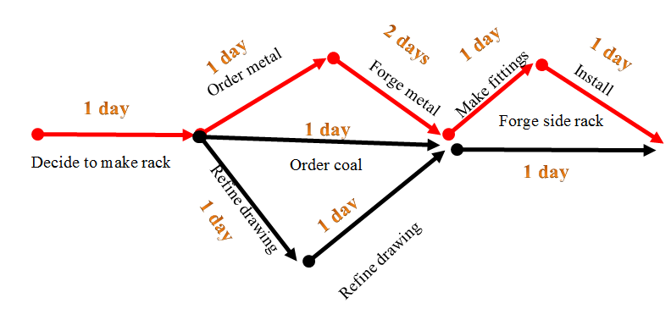
Figure 1 – Example of PERT activities, time estimates, and paths for building a Rack for Boje’s Harley Davidson
What is the longest path time to complete the house? PERT allows you to calculate the critical path. The problem arises, when you try to do this in real life, where materials don’t arrive on time, people are untrained, or late, or just absent. It rains and this delays preparing the lot. The concrete for the foundation is low quality, and the foundation cracks. The code enforcer does not approve the final framing. The linear planning of PERT breaks down.
Fainstein (2000) provides an excellent review of the consequences of rational linear planning models such as PERT. I will pick on PERT since virtually every publication about PERT has no substantive critique, other than PERT takes too much time, there are too many time variables, and one needs larger pieces of paper to do the flow charts. Go to Google Scholar search for critiques of PERT, and test this for yourself. After a few hours of reading articles and books, you would conclude PERT is just perfect. Here is a list of substantive socioeconomic critiques about PERT informed by her thoughtful review:
Ten Unexamined Socioeconomic Problems with PERT
- PERT ignores the socioeconomic power and conflict of stakeholders in the planning process. PERT’s espoused ideal of equality, openness, and diversity inclusion, somehow gets derailed in implemented action. Class, race, ethnic, age, and gender differences in power and historically situated conflicts in place and time, among stakeholder groups gets ignored, so the PERT antecedent-plans never quite live up to their results.
- PERT ignores the relative political power of elites to control the planning process and its outcomes. Since PERT does not look at answerability ethics, this leads to socioeconomic injustice. Answerability ethics (Bakhtin, 1991, 1993) is defined here as the obligation to intervene in once-occurrent event-ness, when you have the knowledge and the means to do something besides being an idle bystander, watching a disaster (See Boje, 2008b).
- PERT is indifferent to environmental sustainability risks and consequences. Since it is all about calculating critical time path, comparing estimates of time to complete for moving materials from place to place, and so forth, the environmental consequences of the plan itself on ‘place’ don’t get analyzed, resulting usually in negative consequences to place.
- PERT defers to top-down planning exerts, such as engineers, operation and production management consulting, who are deploying unexamined Enlightenment discourses of rational planning, and logical empiricism there are unintended socioeconomic consequences. An Enlightenment discourse is defined here as progress through technologies, such as PERT. One only has to look at the outcomes of urban planning models in cities such as Las Cruces New Mexico to see the ideals did not live up to socioeconomic consequences. Almost 40 years later and new round of rational planning consultants is being hired in Las Cruces.
- PERT has an unexamined ‘spatial determinism’ in its visual geometry. PERT model space in visual diagrams that are linear, moving across space from left-to-right, showing paths through a landscape that is symbolic, a sort of map that is not the territory itself.
- PERT has an unexamined ‘temporal determinism’ in its reduction of timescape to linear and visual time charts.
- PERT has what Jürgen Habermas calls ‘communicative rationality” the rationalist proposition that empirical knowledge can guide actions to a successful outcome. It is based on philosophical realism, British empiricism, and the worst aspects of pragmatism (no offense to Dewey).
- PERT lacks what I call a ‘heart-of-care’ defined as the ethics of listening from the heart, not just the head, for the opportunities and consequences of action on people, animals, mountains, water, air, and other living things (Boje, 2012c). PERT is an abstract, reductionist visual narrative of complex communicative planning processes, not a ‘living story’ of place, time, and motion. Ideally PERT planners would listen to people’s living stories of lived experience in a spatial community, and the history of times in that place, to all that aliveness storytelling (Tyler, 2010, 2011) before doing space and time estimates. Instead PERT is either expert-driven or as stated above the stakeholder participation negotiation process breaks down and the resulting social consensus follows the power elite’s agenda, meaning the ‘real’ participation is subverted. In short, the narrative process is reductionistic of the living stories of place, time, and aliveness, so that the socioeconomic and sustainability consequences are easy to ignore.
- PERT is a form of materialism, defined here as a monoist ontology, theory or belief everything in our reality is made of material matter, not only things, but thoughts, feelings, and relationships in a PERT chart. Historically, we can look to Pre-Socratic philosophers (Democritus & Leppitus), advocates of atomism ontology. Atomist held that every large thing was made up of smaller things, atoms. Then atoms were discovered to be made up of many smaller things, such as neutrons, protons, and electrons. In contemporary time quantum theory and string theory began to make atomism, as well as PERT’s materialism look absurd. Above I said PERT was idealism. We can also look at PERT as playing off idealism versus materialism, to create either/or duality. In quantum physics the duality busted, since wave and particle both exist, such as in double-slit experiment, the Copenhagen interpretation, and so forth. In string there, the materiality is some sort of membrane, folded, with layer upon layer.
- PERT, in sum, when it comes to spacetimemattering is a form of reductionism of something highly complex to something way too simple. The monoist reductionism is that a large complex project can be reduced to linear strings of simpler critical paths, and these reduced to simpler and simpler path events. The problem with spatial, temporal, and materialist reductionism is that when you begin to look more closely at simple stuff, it is very complex. Materialism, like space, and time, in PERT ends up reduced, but poorly defined.

Chapter 2: Cyclic Planning and Storytelling
This chapter gives you a basic look at cyclic planning. Before you can learn about spirals, you need to understand how cycles are a part of spirals.
CYCLIC-ANTENARRATIVE
A cyclic-antenarrative has a sequence of stage-by-stage processes linked up to form a cycle. As with the linear-antenarrative, there is a ‘before’ narrative coherence sets in, and a ‘bet’ of transformation that the past stages will recur exactly in the future, in repetitions of sameness, if one can just apply lots of control to the sources of difference. A difference-repetition of a cycle has deviance from the last cycle.
Take the example of variance analysis in a production cycle. Once sets out these visual charts of the steps involved in a process, not unlike the PERT example of linear-antenarrative. The cycle-variance analysts calculate the breakdowns in transport between stations, delays in arrival and departure of materials, lack of quality because of training or in attention, suppliers not providing to specifications, etc. Yet, there are socioeconomic consequences to the cyclic-antenarratives that some from reducing a living story web to a narrative ripper out of its antecedent context, that then has an agential impact on spacetimemattering as it does change things, not always for the better.
Just as with linear-antenarrative, there is this reductionism, trying to reduce everything to cyclic-antenarrative, to sequences of steps, repeated, and rendering them in symmetrically circular drawing that as narratives are supposed to represent and tell us something about reality, but end up changing the reality they describe. Call it the ‘observer effect’ or the ‘self-fulfilling prophecy’ of seeing cycles everywhere.
What if cyclic is not uniform, recurring with sameness, and instead is highly irregular? Then we might notice the devolution of the consequences from the espoused cyclic-antenarratives if we did some ‘actual’ listening to the living stories. We would once again, as with linear-antenarratives, discover that the rational, materialist, and realist ontologies are not holding up too well.
Just as with PERT, there are all kinds of stakeholder participation in the cycle planning process approaches. Cycle participative planning can result in the same burn-out and disillusions, the same sorts of socioeconomic results for age, gender, race, ethnic, and cultural differences.
When I realized that life cycle analysis of space, cycle time analysis, and materiality in production cycle analysis were all coming up short, with a myriad of unintended consequences, I turned to spirals.
Cycles repeat in sameness or difference to constitute the overall Spiral time of a business. The life-cycle of a product is cradle-to-grave, instead of the intelligent sustainability design perspective of downcycling (recycling) to degraded uses, or the upcycling to higher quality material component use streams. The production cycle time is interdependent with the transit cycle between work stations, the work order cycle time, supplier and inventory time cycles, the cash-to-cash cycle times of financials, the innovation cycle time, and the marketing cycle time. The interdependent cycle times are from cycle to cycle of recurrence amplifying and counteracting to constitute f-spirals (single strand, one-direction, fractal spirals), etc. Time cycle is a sequence of process phases of worker-tool-machine. Karl Marx (1867: Vol. 1, Chap 14: p. 345) calls it turning out a “given quantum of production in a given time” and that is “a technical law of the process of production itself.”
How many actual working hours in the 8-hour day? An eight hour day is less than 8 hours of actual production time because of meal and rest breaks, lost time to meetings, training time, rework, absenteeism, lateness, delays, equipment and materials issues, buffer times, etc. After subtracting out the meal and rest breaks, the rest is the actual available time. The other times for training in new equipment or process steps, employee lateness, unclear instructions, time for service and maintenance or repair of tools and equipment, absenteeism, material quality issues, machine breakdown, wait time from other workstations, etc. are called ‘variances.’
Once upon a time, I supervised several crews cutting the grass on a Navy base. We hired a dozen college students, during the summer months to work 8-hour days. An 8-hour day for these students, meant actual work time that was, on average, 4-hours. There was an hour for lunch, and two 15 minutes breaks for rest. That should mean 6 and half-hours of actual time to work. But there were many variances, such as a half hour at the start and again at the close of the day tinkering with the tractors that pulled the gang-mowers, and gassing up the smaller mowers, and checking the oil. Now we are down to 5 and ½ hours. Then, there was the time to get ready for lunch, another 15 minutes, and the time to get back from lunch, after the lunch hour. Now it’s only 5 hours of work time left to do actual work. There was also another hour lost to game-time, the time spent playing a joke on the other crew (hide their gas can, send them to the wrong field), or time spent taking a nap when the supervisor, that’s me, was not looking. So all in all, when I started supervising the crews, I was lucky to get 4 hours of work from each person, which if 6 and half hours was a legitimate work time, then each day I was losing 2.5 hours times 12 students, or a total of 30 hours lost time each day, or 150 hours lost each week, and over 600 hours lost each month. What to do? I decided to implement production cycle time analysis, figure out how much money the enterprise was losing. 600 hours at an average pay rate of $10 an hour, is $6,000 a month. The workers had no stake in doing things better, in improving production cycle times, the number of Navy Base fields of grass we could do, as we made the circuit around the entire base. So I put in some bonuses for meeting our schedule, fired the worker who was clocking the most nap time hours, promoted a worker in each crew to assistant supervisor, and we doubled our production. What I was doing as a leader, was saving money, increasing revenue, and dividing up some portion of the upward spiral increase in profits with the workers. I had turned a downward spiral, near disaster, into an upward spiral. There are many types of cycle times besides production cycle time, and each of these needs its own analysis time analysis.
Schreiner Jr. says in 'Cycleland" that "cycles are at work everywhere and in everything" because cycles are the unifying principle of how the universe works" (p. 2, as cited in Beck & Cowan, 2005: p. 22). I am going to suggest that cycles are part of spirals which are the unifying principle of how the Milky Way galaxy and the universe works.
Types of Cycle Times - There are many types of cycle time: production cycle, transit cycle, work order cycle, innovation cycle, and marketing cycle times. These cycle to cycle times make up the overall ‘spiral time.’ To measure each type of spiral time, it is best to observe the process in person, and how it recurs from cycle to cycle. Look at the variances that occur from cycle to cycle, and from spiral-to-spiral, in-order-to study the overall spiraling effects and consequences.
Purpose of Cycle Time Redesign - The whole purpose of cycle time is to reduce the variances in-order-to decrease production time cycle, which in turn lowers personnel, inventory, and order costs (decreases returns), and up to a threshold, will increase product quality, increase production, and thereby increase goods available for sale. It is important to notice the variances, those disturbances, delays, and human errors that extend cycle time beyond what it could be. Reducing variance gets rid of non-value-added (NVA) tasks and steps, to streamline the production cycle.
What is a variance? A number of variances affect production cycle time: material defects, lack of training, delays from other work stations, etc. Spirals have cycle to cycle variance increase and decrease because they are open loop, connected to supply chains of materials and to workers’ life spaces from outside the shop floor. The production process has a shop floor lay out, such as a U, T, S, or Z design (See YouTube video of cycle time and workflow design layouts).
Job design looks at how to co-locate personnel to control and manage the most important variances, in-order-to improve production cycle times at each work stations, and decrease the transit time of materials, tools, communication, and product components between work stations. Equipmentality (See Quantum Storytelling Film) is the directionality and location of all the tools and equipment in the shop that is ready-to-hand in each production process. Ready-to-hand tools are not broken, are situated in their place in the work station layout. Other tools and equipment may be present-at-hand but not available (in storage), lost, or broken, and not ready-to-use in each production process.
Production cycle time is defined as the start-to-finish time it takes to perform the steps in producing each component of a product or service.
Quality cycle time - Continuous quality improvement of production cycle times. Deming’s Plan-do-check-act (aka Deming Cycle) is the most widely used quality improvement cycle. For example, the four part quality cycle of continuous improvement: Plan Implement Review Improve (PIRI) – is being followed by Charles Sturt University. ProQual-I.T. describes their business as a ‘positive quality spiral.’
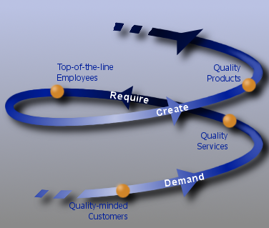
Figure 2 – Positive Upward Quality Spiral
Transit cycle time is the time it takes to move the product being produced through the various work stations.
Order cycle time is defined by phases of designing the order system, paperwork to track each order through its intake, assembly, delivery, billing, and payment. Order cycle time is time it takes from taking an order, to delivering the finished product to the customer. Supply cycle time is time it takes for suppliers to get the materials to the work station (e.g. Just In Time JIT inventory replenishing supply cycles). Innovation cycle time is time it takes to design, prototype, pilot, manufacture, and install an innovation into the production, order, transit, and supple cycles of the business. Marketing cycle is the time-to-market cycle time for a fashion, apparel, or technology change.
Product life cycle is defined as design, introduction, maturity, decline, and rebirth or detaching from that product line. There are many products in most businesses, with products at various stages of their life-cycle. Product life cycle is taking a longer-term, more sustainable direction. Honda, for example, has this
Product Life Cycle for reducing the environmental impact of Honda products from development to end of life.

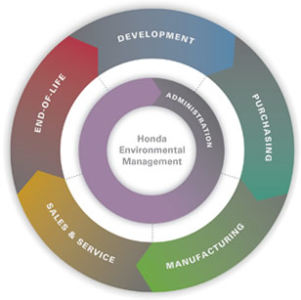
Figure 3 – Corporate Honda’s Quality Cycle
The End of Life refers to “The environmental impact of Honda products extends to the disposal or recycling of Honda and Acura products and service parts at the end of their useful life. This includes service parts received by Honda and Acura dealerships. Honda has undertaken numerous projects in North America aimed at increasing the quantity of recycled and remanufactured parts and materials, and more environmentally responsible means of disposing of unused parts and materials.” See more on End of Life. The claim is that continuous quality improvement is built into Spiral processes.
Marketing cycle time is defined by the stages of idea inception, innovation and development cycles, design and engineering, pilot testing, focus groups, production-cycles, customer ordering cycles, customer delivery, and reorder.
Inventory cycle time is defined orders from customers, approval to order from suppliers, stocking order from suppliers, LIFO or FIFO accounting, and reorder quantities. See example.
Cash-to-cash cycle time is defined as cash spent on producing a product through phases of purchase, delivery, and payment by customer (less any returns, rework, etc.).
Organization life-cycle-time is defined by Larry Grenier (1972) as growth through creativity, direction, delegation, collaboration, and coordination (with a particular leadership crisis for each), see summary and image.
Leadership cycle time approaches. Mission, core values, vision, plan, lead, evaluate or review (See example1; example 2). There are a score of leadership cycle time models, most have some sort of vision, act, review phases in them. There are fewer approaches that look at spirals of leadership. One is Beck and Cowan (2005: 4), drawing on the work of Dr. Clare W. Graves, late professor of psychology at Union College, NY, look at the Spiral leader as having a different mindset or worldview called MEME, for reading and facilitating spiral dynamics. They look at how Spiral Wizards (leaders) "roam over vast landscapes seeing patterns and connections other do not notice because their old paradigm” (ibid, p. 3). "... millions of people are at different levels along the Spiral simultaneously" (p. 64).
The spiral leader is able to appreciate patterns in those landscape, especially in turbulent causal texture environments. Spiral Wizard-leaders are able to look out for flashpoints, hotspots, disporias (migrations), regressions (downshifts to worse conditions), harmonics, gridlock, and cutting edges (awakening) (p. 12). For Beck and Cowan, the spiral is always growing, ascending, except in the chaotic and turbulent times. Still "order lurks in the chaos.... and new meanings in Spiral space, the best place to live and conduct business in the twenty-first century" (p. 17)
"A Spiral vortex best depicts this emergence of human systems as they evolve through levels of increasing complexity. Each upward turn of the spiral marks the awakening of a more elaborated version on top of what already exists. The human Spiral, then, consists of a coiled string of value systems, world views, and mindsets, each the product of it times and conditions" (Beck & Cowan, p. 29). "Still, because our knowledge and experiences are additive, movement along the Spiral is in the direction of greater complexity" (p. 62).
Q-Spirals are more quantum in space-time-mattering, with multi-directional forces (up, down, in, out, amplifying, & counteracting), and can be composed of f-spirals (off-shoots, bridges between twirls in the spiral entity). We will get to these f- and Q-Spirals in subsequent chapters. For now, the place to start in measuring Q-Spirals is with the cycles, those recurring repetitions of cycles (twirls, some call them whorls) of sameness and difference.
In sum, most of the cycles, are actually spirals. We can no longer predict cycle-sameness from cycle-to-cycle over time because it is a spiral process of amplifying or counteracting, with repetitions of difference instead of sameness. The future is moving and arriving in Spirals, made up of cycles of sameness, and cycles of difference-amplification.

Chapter 3: What is Spiral-Antenarrative
A spiral-antenarrative, unlike the linear- and cyclic-antenarratives is about repetitions of difference, that can amplify or counteract, alternative. Here again there is a ‘before’ narrative set in with its abstract, coherence, such that some spirals are quite general, universal, symmetric affairs. The ‘before’ is ‘living story webs’ of much more complex spiral patterns, ones that are asymmetric, fractal, with off-shoots, and bridges between whorls. At some point, this affair morphs into rhizomatic networks, where lines of flight take off to and from black holes (Deleuze and Guattari, 1987; Boje, 2011). As with its brethren the linear-antenarrative, and its sister, the cyclic-antenarrative, the spiral-antenarrative can me a visual spatial modeling of living story, becoming such an abstract narrative, one forgets, that unlike spirals in nature (sea shells, tornadoes, whirlpools, & the whorls of vine leaves), one cannot actually ‘see’ a socioeconomic spiral. One cannot ‘see’ a downward incivility, inefficacy, or inequity spiral such as what happened to Enron, WorldCom, etc. One cannot ‘see’ and upward spiral of knowledge management. And to dualize, downward and upward into two different spirals is a rather dubious move. Instead, I shall try to put them together.
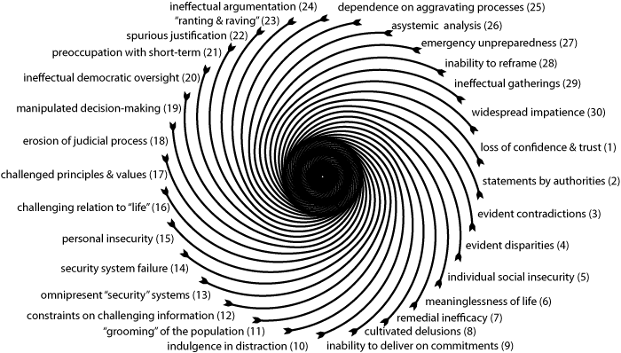
Figure 4: Downward Spiraling: Visual Representation of mutual reinforcement of a system of 30 disabling global trends engendering together a hurricane-like vortex into which society is drawnSource: http://www.laetusinpraesens.org/docs10s/inaction.php
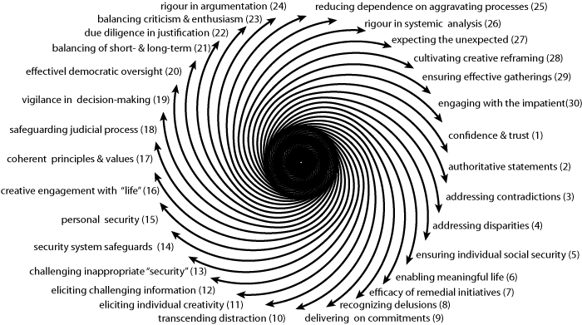
Figure 5: Upward Spiraling Trends: Visual Representation of mutual reinforcement of a system of 30 enabling global trends engendering together an escape from the problematic convergence (ibid).
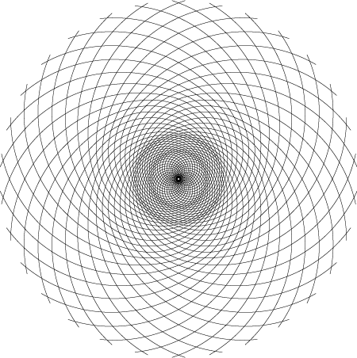
Figure 6 - Superposition of the Upward and the Downward Spiraling
The above spiral is suggestive of the kinds of dynamic connectivity between downward and upward force within the same organization, and its environment.
Next, we turn to looking at a comparison of the three ways of storytelling: geometric, material, and quantum.
Each of the three storytelling approaches is attuned to something different about spirals and their environment. Each uses living stories differently in relation to narrative and antenarrative. Each has a special treatment of living stories. Each is working in what Merleau-Ponty (1962: 286) calls “mythical space” there the directions of space, time, and movement are read by signs and omens. That means that spiral in each mode of storytelling is a phantasm populated by people as actors, and things as actants, and notional meanings of directionality of forces that are unseen. In each type of organizational storytelling we do not actually see spirals, we read signs and omens in the storytelling itself, and then we render a spiral-image. I will explore this thesis in each type of storytelling, starting with geometric where it’s a bit easier to ‘see’ the “existential space” as well as ‘existential time’ and ‘existential change’ (ibid, p. 285).
Merleau-Ponty (1962: 243) says, “Space is not the setting (real or logical) in which things are arranged, but the means whereby the positing of things becomes possible.” Space is not conceived as the ether in which material things float (ibid). Space is not a characteristic all things have in common.

Chapter 4: What is Quantum Spiral?
If we take space-time-mattering to its entanglement at quantum levels, then we have a new way of doing business consulting, which I am calling ‘Quantum Spiral’ (hereafter, Q-Spiral). Prior work on organizational spirals has put them in duality (see Chapter 3), with either an upward-spiral or a downward-spiral. Cycles of a Q-Spiral are of varying breadth (expansion), from narrow orbits to wider orbits. Q-Spirals have offshoots called ‘fractal-spirals.’ Each f-spiral is a simpler, fragile, fractal spiral, with one directionality. Q-Spirals have directions of up, down, in, out, amplification, and contraction.
A Q-Spiral is defined by its spatial landscape, its temporal timescape, and its mattering materialscape.
A business consultant tries to help the client create better processes, and those processes are spiraling, in good ways, and in bad ways.
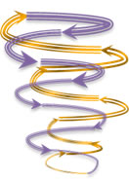
Figure 7 - Basic Q-Spiral model of Business Processes (drawing by D. Boje, 18 July 2012
This is a Q-Spiral Model (Boje, 2012). A Q-Spiral is defined as a 'Quantum'-spiral that has both upward and downward spiraling directions in the same enterprise (indicated by the Gold & Purple arrows). 'Q' stands for Quantum, meaning the spaces, times, and mattering of the business processes. All small businesses have both upward and downward spiraling processes. There are positive upward spirals (gold arrows) in the business processes where continuous expansion and improvement is happening, such as expanding production with higher quality, and hopefully lower costs, bringing on more workers with better training, and having more efficacious communication, coordination, and cooperation (I call this storytelling in words and action). And there are at the same time and place, negative downward spirals from dysfunctions in the business (purple arrows) that we can read from various measures: escalations of costs, more incivility, more conflict, less quality production, more overpayment of salaries and wages relative to production quantities, more injuries, more absenteeism, more turnover of your best people, loss of market share, unsustainable environmental waste, more risks to everyone and everything.
Q-Spiral business processes may be invisible to the business participants and to the consultant. That is because, many folks assume that a business process is a linear affair, a straight line with a bunch of steps that are repeated, the same way, in the say place, by the same people, and the same machines, with the same materials, controlled by supervision and training, and just keeps repeating, into the future, just as it was in the past, and is now.
Yet, research shows most of what is considered linear-process-steps, is really more of a cycle, a bent line. But here again the spiral can be invisible to everyone, since in assuming there are only cycles, no one will see spirals (Abbott, 1988). When a cycle of production, or ordering, or marketing, or strategy, repeats exactly as before, without any deviation it's OK to call it a 'cycle.' But when the steps, materials, workers, the way of working the steps, or a particular new step is added or subtracted, it is no longer the same cycle as before. It is either a move of continuous improvement or a move that is dysfunctional (defined as deficient or excess in some way). A dysfunction is the middle path (or trajectory) between deficient and excess (Aristotle, 350 BCE). When it is deficient the materials, quality, training, competence, etc. is a dysfunction. When it is excessive, then material, time, training, skill, man-hours, money is wasted. If you compare a production or quality or order or marketing or inventory or accounting cycle, to its predecessors, you will find there are differences. Some differences are good, such as continuous improvement, innovation, cost-saving steps, labor-saving steps, better use of materials, more fashionable, etc. Many differences are bad, such as wasted energy, wasted materials, overtime, overcompensation, overconsumption, delays, over-budget, etc.
Differences (good & bad) accumulate, and the cycle becomes a spiral. Most cycles become spirals. 99% of all cycles, from cycle-to-cycle of their repetition, are different, and either amplify or contract, and are more properly called, 'Spirals.' The middle road between deficient and excessive cycle activities is called the 'middle path' of the spiral.
A 'Q-Spiral' is not a Archimedes Spiral (does not have equal distance of each cycle or whorl relative to its axis of rotation). It is not a singular one-armed Logarithmic Spiral (does not have a factor of progressive increase or of decrease in a single direction). It has two inter-twined spiral arms (gold & purple), that are linked at the top and bottom, so its proper type, is a Lorentz Spiral (a spiral that shifts in directionality at two focal points). When we start to notice that Q-Spirals have bridging spirals between whorls, and off-shoot-spiral buds (known technically as fractal-spirals), then we have a more comprehensive model of business processes, that is a more accurate depiction of the actual business processes.

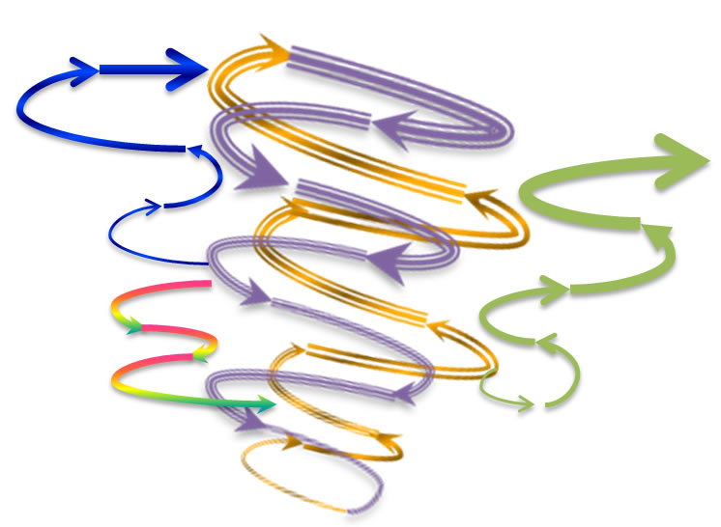
Figure 8 - A Q-Spiral Model of the Processes of a Business with Bridges between Whorls, and a Fractal-spiral off-shoot (Drawing by D. Boje, July 18, 2012)
This is a Q-Spiral with two bridges between the main-whorls. The Blue bridge-spiral allows movement of people, storytelling, and materials between a downward spiral (Purple) and an upward spiral that is more positive (Gold) nearer the top of the Q-Spiral where momentum forces are less severe, and the rides are slower. The Rainbow bridge-spiral allows movement of people, storytelling, and materials between a downward spiral (Purple) and an upward spiral (Gold) near the base where the whirls are at a higher speed and it is more difficult to break free of the momentum. Finally, there is an Off-shoot fractal spiral, such as a new product innovation, a new business location, that is still feeding off the main Q-Spiral.
What are Business Processes? Business processes are modeled as lines (linear step-by-step from point A to point B), cycles, spirals (cycles that became spirals), and rhizomes (networks of lines). Each model is a better or worse approximation of the processes of the business. A business has many different linear-, cyclic-, spiral-, and rhizomatic-processes. For example, in the production process there can be several production lines, assembly lines, and in each materials and parts are worked on by people and machines. This occurs in production and assembly cycles. A cycle is defined by a number of stages that are in a sequence that repeats. The cycle either repeats with sameness (same stages, no deviations), or the cycle repeats with differences (either in continuous improvement, or in continuous dysfunction of excess or deficiency). For example, continuous process improvement means one cycle to the next, there are positive differences. When cycle-to-cycle deteriorates, and has lots of dysfunctions in quality, lateness, out-of-specification, not what was ordered, shoddy workmanship, and so forth, then it is taking a downcycle. When cycle-to-cycle has positive and/or negative differences one to the next round, then it becomes a spiral. There are positive and negative spirals (upward and downward spirals) in the same small business. In the next figure there are positive upward spirals (gold arrows), downward negative spirals (purple arrows).
Every small business operates in an environment with other businesses, suppliers, customers, community where employees live, and material resources.
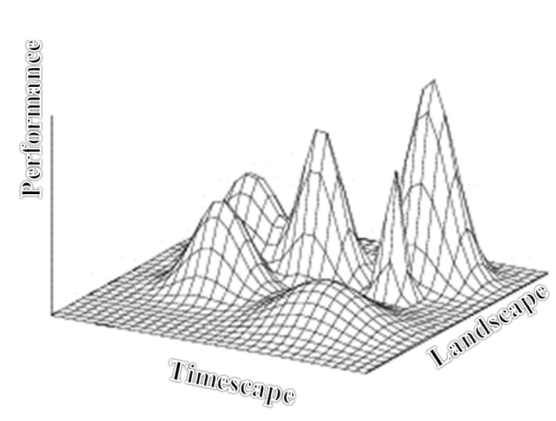
Figure 9 - Three Dimensions of Environment of a Small Business
There are locations in a business environment where the enterprise will get more customers, find more qualified workers, find lower cost materials, and achieve better profits. In this figure the better places are in the peaks, and steeper peaks are more rugged, harder to get to, but more profitable if you can get there and stay there. However, other businesses seek these same locations at the top of the peak areas. Peaks can get crowded. It can take more resources and energy than desired to hold a peak position against rivals. The environment has three key dimensions.
- Performance is defined as the outcomes of strategic moves enacted in the environment. Higher peaks have greater performance opportunities, but steeper peaks have higher costs, and more organizations attempting to get there.
- Landscape is defined as “realistic problem-solving complexity with clarity” (Afuah and Tucci, 2012: p. 357; Kaufman, 1993, 1995). Landscape is spatial in combination of ways: perceptions of space, measured spaces, and meanings of space to participants.
- Timescape is defined as measured time, timing of strategies, retrospective-histories, and anticipated-futures (Adam, 1998)
The larger silver arrows are updraft and downdraft forces in the business environment. For example, in solar energy in New Mexico, in 2010, tax incentives were implemented in the state of New Mexico that give some momentum for customers, suppliers, and businesses in the solar sector of the economy to go Green. It had been a dozen or so years, since there were tax incentives, and that was a downdraft force on the entire solar business sector doing insulation, photovoltaic, and solar water heating.
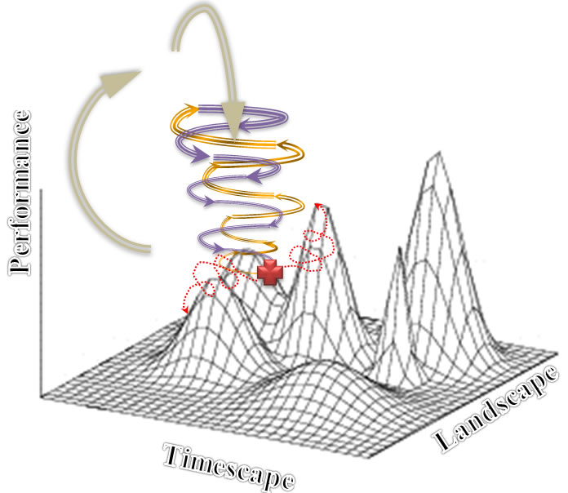
Figure 10- The Q-Spiral Business Processes in its Business Environment (drawing by D. Boje, July 17 2012)

It has path choices indicated by the red lines. The red + is a choice point of which path direction to choose in an environment. The larger silver arrows are the updraft and downdraft forces of the environment, such as the changes in tax incentives in the example just stated.
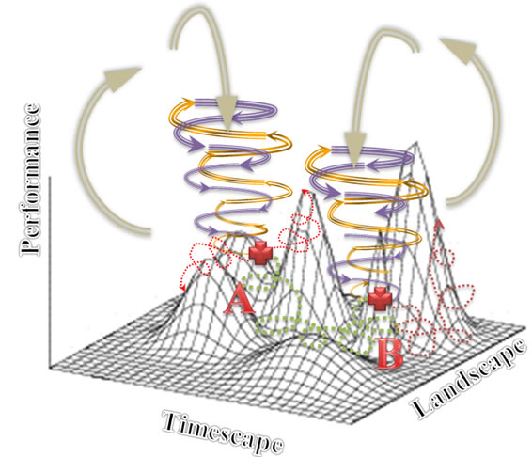
Figure 11 - Q-Spiral Movement from Point A to Point B in its Environment in 3 Dimensions (Boje, 2012).
In this depiction, the Q-Spiral traverses its Environment from Point A to Point B. It is about to climb a lesser steep and rugged peak at Point B. It could have made different choices, and moved along the red dotted lines, in the channels already in the Environment. At the right of position B is a red-dotted pathway leading up a higher peak, a more profitalbe, and higher revenue peak. It could be in a consulting project, the next Quantum Leap the business takes. In this model, there are three inter-related interdepndent dimesions of the Environment: Performance peaks (better revenue, higher quality, lower costs, more expansion, more market share, etc.), timescape (all the different ways time is manifest from clock time, calendar deadlines, timing of stratregy, histories, the future arriving ahead-of-itself in foretelling of strategic moves, etc.), and landscape (all the ways of space, from layout, hierarchy, market place, and places).

A Q-Spiral has both upcycles and downcycles. Upcycle is defined by McDonough and Braungart (2002) as something quite different than recycling. There is a complex of what I am calling ‘materialscape’ things that go into products such as televisions, computers, automobiles, houses. These materialities can be isolated and “upcycled rather than recycled – to retain their higher quality in a closed-loop industrial cycle” (McDonough & Braungart, 2002: 11). A car part, for example, can circulate instead of being downcycled once into recycle or sent to the grave of landfill.
“Henry Ford practiced an early form of upcycling then he had model A trucks shipped in crates that became the vehicle’s floorboards when it reached its destination” (McDonough & Braungart, 2002: 110).
“A more prosperous design would allow the care to be used the way Native Americans uses a buffalo carcass, optimizing every element, from tongue to tail” (ibid, p. 111).
As a blacksmith, I forge like metals such as iron with similar carbon profiles (low and high carbon), copper, brass, stainless steel, and so forth, in-order-to retain the high quality of the metal in new uses. There are many ways to upcycle, in-order-to Deploy sustainable business processes. For example, in my blacksmith artist studio, I make pens and heart-swords out of baling wire that would be otherwise discarded from the horses’ hay-bales. This is an example of upcycling, the making of a higher quality and more valuable product than the initial product. Recycling is called downcycling because the materials go into a lower quality and less valuable reuse-steam. Putting the baling wire into the recycling center would not net a high value-added use.
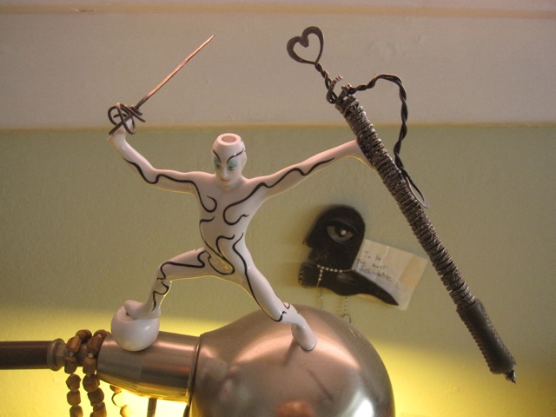
Figure 12– Boje’s Heart-sword and Pen set made of baling wire (White-figure not included; photo by M. Bonifer, used with permission)
The Heart-sword has a spiral handle, a heart at its end, as does the pen. By blacksmithing, cold-forge hammering on the anvil, the baling wire becomes harder, and takes on the properties of a spring. I also upcycle copper from electrical wiring in-order-to make the Heart-sword and Spiral-Pen set. The spring effect of cold-forged iron or copper is used to keep the pen-cartridge in place. The heart part is twisted to just the right tension for the comfort of the user. A complex of materials can have a life beyond the single “cradle to grave life cycle” concept of production and consumption process design (McDonough & Braungart (2002: 103). Disassembling products to allow components to have upcycling uses points out the problems with the traditional life cycle models that assume only a single cycle of use. “This linear, cradle-to-grave life cycle has several negative consequences for both people and industry” such as toxic additives added in recycling processes that degrade the quality of the material (ibid, p. 112). Redesigning the technological life cycles into upcycles can mean multiple consumptive rounds of uses. Instead of recycled, “perhaps it would be more accurate to say downcycled” (ibid, p. 4), since with each recycling, the materialities are degraded instead of improved. Each recycling has hidden costs of the material energies to produce a new use of the recycled material, such as turning scraps of car pumpers, bed springs, and other metals into wrought iron resold at the hardware store. Each manufacturing process of recycling consumes electric-energy, material-energy, and worker’s energy that can offset the net sustainable advantage. Plus the wrought iron of recycled metal is not as high a quality as the component materials, and the wrought iron itself will have variable quality (such as when a weak metal is layered in with higher grade steel, forming fault lines along which it cracks and breaks under can stress).
Imagine if products never end up in a landfill. Such a vision would require radical changes to both production processes and consumerist life styles, where cradle-to-grave life cycles have ruled since the industrial revolution created planned obsolescence. The life-cycle model treats material and energy from acquisition in a landscape by mining or harvesting, and a linear trajectory through one cycle of manufacturing-distribution-use, into the end-of-life in the landfill, or one more cycle in the recycling yard. A spiral-strategy, by contrast, uses intelligent design to reduce the environmental-landscape impact of each cycle of use across a longer trajectory than the cradle-to-grave-life-cycle model. It is time for a material-flows and trajectories spiral-accounting.
THE HANNOVER PRINCIPLES (McDonough, 2002: 6, bold additions mine http://www.mcdonough.com/principles.pdf)
1. Insist on rights of humanity and nature to co-exist in a healthy, supportive, diverse and sustainable condition.
2. Recognize interdependence. The elements of human design interact with and depend upon the natural world, with broad and diverse implications at every scale. Expand design considerations to recognizing even distant effects.
3. Respect relationships between spirit and matter. Consider all aspects of human settlement including community, dwelling, industry and trade in terms of existing and evolving connections between spiritual and material consciousness.
4. Accept responsibility for the consequences of design decisions upon human well-being, the viability of natural systems and their right to co-exist.
5. Create safe objects of long-term value. Do not burden future generations with requirements for maintenance or vigilant administration of potential danger due to the careless creation of products, processes or standards.
6. Eliminate the concept of waste. Evaluate and optimize the full life-cycle of products and processes, to approach the state of natural systems, in which there is no waste.
7. Rely on natural energy flows. Human designs should, like the living world, derive their creative forces from perpetual solar income. Incorporate this energy efficiently and safely for responsible use.

8. Understand the limitations of design. No human creation lasts forever and design does not solve all problems. Those who create and plan should practice humility in the face of nature. Treat nature as a model and mentor, not as an inconvenience to be evaded or controlled.

9. Seek constant improvement by the sharing of knowledge. Encourage direct and open communication between colleagues, patrons, manufacturers and users to link long term sustainable considerations with ethical responsibility, and re-establish the integral relationship between natural processes and human activity.
The materialscape and the landscape are inter-penetrating, rather than independent. It is time to move beyond what Thorsten Veblen called ‘conspicuous consumption’ of our throwaway society, and its dependency on the cradle-to-grave linear cycle-time model of industrial production and wasteful consumption. Instead of LCA (life-cycle-assessment, Epstein, 2008) it is time for Spiral-Cycle-Assessment) SCA. SCA looks at all the hidden costs (internal and external of the impact of technological structures, material usage, management structures, and so forth on the environmental landscape and materialscape associated with production and consumption processes throughout an entire spiral-trajectory over the lifetime of the material components uses and reuses, how they upcycle and downcycle. SCA is a spiral-hidden-cost accounting along the future of each of the material components of a product to assess sustainability impacts of business structures and behaviors. Spiral-Hidden-Costs (S-H-C) or SCA integrates accounting with production process design and all the business structures and behavior processes, by looking at the long-term future internal and external hidden costs to the environmental landscape and to the materialscape. The existing strategic choice-making needs to be looked at in the long term horizon of the impact on future generation instead of the usual short-term horizon of the next balance sheet statement.
Traditional approaches to cradle-to-grave-life-cycle perpetuate linear produce-consume-waste business models, dating to the Industrial Revolution, which creates massive quantities of waste, pollution, and are not eco-efficient (p. 65 Doppelt).
Our materialscape and landscape includes Natural cycles, along with the industrial cycles of extraction of raw materials, manufacturing, distribution, consumption, and recycling once, until materials reach the landfill. Doppelt (2010) says "eco-effectiveness means designing goods and services so that materials produced by society can be safely recirculated back into one or both of these metabolisms" (natural cycles and industrial cycles) [p. 65].
A Q-spiral approach can enhance economic growth because more people are employed to "capture, disassemble and recirculate materials" into the materialscape and landscape using an "eco-effectiveness" approach (Doppelt, 2010: p. 66). Instead of growth by downcycling, growth in the Q-Spiral changes the lifespan of the spiral trajectory of material components from a few years to a score of years, or longer, as the new economy finds more varied uses for those materials than the old cradle-to-grave production-consumption-waste scheme.
There could be a more intelligent design to computers, cars, and homes, where materials are designed from the get go to be disassembled and used again and again in other uses. This means redesigning products so that component materials are managed for many uses beyond the single life cycle of cradle-to-grave capitalism. This means a stewardship by business for managing sustainable materialscapes instead of socioeconomic processes those exploiting and degrading environmental landscapes. It means tracing the long trajectory of material components of products through spirals instead of through the single-loop linear model of a single life-cycle. An ‘upspiral’ is defined here as a long trajectory of increasing value-added of the component materials. A ‘downspiral’ is defined here as the trajectory of decreasing value-added of component materials as they approach the landfill. An upspiral is a trajectory of wider orbits of expansion. A downspiral has tight orbits of life-cycles leading to degradation of the materialscape and the landscape.
Some Ways to move from cradle-to-grave-life-cycle to Q-Spiral materialscape/landscape/timescape approach to hidden cost assessment.
1. Dramatically increase the temporal horizon of life-cycle to the spiral-cycle trajectory of all material components of a product.
2. Shift from cradle-to-grave-life-cycle models to spiral-trajectory-upcycling models.
3. Move to creative product designs that have a long-term future temporal horizon of multiple generations.
4. Invest in spiral-accounting assessments that measure the internal and external hidden costs of the entire spiral trajectory.
A Q-Spiral has off-shoots (new innovations, start-ups) and it has quantum-leaps (bridges) between twirls). On the surface, a Four-Leaf clover diagnostic is a way to start to get at the Hidden Costs of all the dysfunctions, the ways the structures and behaviors work against productive and sustainable outcomes. The root causes of the surface dysfunctions are buried deep and that is why it is necessary to look at the D’s, at Disclosability of what is below the surface, all those Tubers, the root-stems of the business that are causing the surface problems, and causing them again and again. Like the Crabgrass in your lawn, you pull up the surface weeds, but without dealing with the roots, the Tubers just keep growing right back up through the surface all over again. Deleuze and Guattari (1987) call this process by a technical name, ‘rhizomatics.’ A rhizome in nature has above ground (visible) runners or vines, and below-ground root-stems. The six rhizomatic root-stems that Savall et al. (2008) have been addressing in over a thousand businesses, worldwide, are listed in the above figure. What I have done is translate this in the spiral theory, into ways that it is possible to transform cycles in a rut of repeating the same error-variances, and management systems caught in the same dysfunctions and poorly scripted structures and behaviors - and develop what I call Q-spiral organization processes.
Unlike business models designing production, marketing, strategy and other processes in a linear or cyclic recurrence approach, the Upward Spiral Model of Business Development turns cycles of sameness into Q-Spirals. This is a radical change from the brand or marketing lifecycle model of development introduction, growth, maturity, and decline or the organizational or corporate lifecycle which has associated optimal sorts of leaders: birth (entrepreneurs), growth (delegative leaders), maturity (formalizing leaders), decline (bring back the entrepreneur), and death (fire sale leader). The marketing and organizational life cycle models proposed for business, where there is a predictable sequence of stages that recur and again and again, is not very helpful. It is too general, too vague, and anyone who knows anything about cycles, knows the stages do not recur exactly, rather the stages change in content, duration, sequence, and intensity, and veer off in amplification or contracting until they are more accurately called ‘spirals.’ One of the ways to improve cycle models of business development is by including sustainability throughout procurement of materials, training people to do sustainable production, designing for sustainability, waste management, post-consumption recycling, etc. Flows of materials through cycles after Earth, Air, Water, and Fire (energy), and how cycles are handled affects toxics, health, waste, etc. According to McDonough (2000: 9, 11) “Water use must be carefully accounted for throughout the entire design process” and air and water are something in what I call the materialscape that when degraded that we realize the hidden consequences of quantum invisibilities (wave particle degradations) almost immediately, and “Fire is the most dramatic symbol of the human ability to harness natural energy” see Hannover Principles McDonough, 2000: http://www.mcdonough.com/principles.pdf).

Chapter 5: Applications of Q-Spiral to Socio-Economic Approach to Consulting
In Henri Savall, Veronique Zardet, and Marc Bonnet’s (2008) SEAM (Socio-Economic Approach to Management) there is a spiral with three axes, each one a ‘Force of change.’ What I want to do is transform the three axes into spirals: A-spiral of cycles of improvement, B-spiral of tools, and C-spiral of strategic and political choice-points, and then add a D-spiral of D-questions rarely asked of any business.

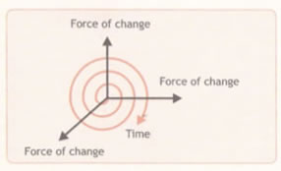
Figure 13 - The single f-spiral of time (indicated by red line in the figure) – Source, Savall et al. (2008: p. 26).
The Red line is a simple ‘f-spiral’ that twirls in only one direction, from the center to the outermost orbits. The Black lines are the A-B-C axes which I want to retheorize into more f-spirals. What I will call the f-spiral in the above figure, which is the sort of minimal red-curved-line in the diagram. The purpose is to create a set of f-spirals in the business, by walking the yellow brick road of implementation so that the f-spirals become a full-fledge Q-Spiral of updraft and downdraft, success in expanding the business in financially-profitable and environmentally-sustainable, by the development of human resource potential. In simple terms, a transformation of the business, by using SEAM to assess its initial dysfunctions (excess & deficient activities) and then transform the business into a Q-Spiral.
Below I have adapted the Savall et al. (2008: p. 26) chart to the needs of business development of Q-Spiral. Spirals are of two types: the f-spiral which is the sort of minimal light-orange-curved-line in next diagram, with very minimal complexity, a very thin and loosely coupled spiral, and the Q-spiral with multiple spiraling arms, interconnections between them, multi-directionality (left-right, up-down, in-out, amplifying-contracting), and situated in an environment (landscape, timescape, materialscape). This is five f-spirals model: f-spirals: A, B, C, & D connected by the E-spiral as client-consultant collaborate to connects A-B-C-D together from center winding out to the outer orbits to create the start of a Q-spiral. I will also add the tool “Spiral-updraft) on the B axis (or as I call it, B-spiral). I inserted the D-spiral with 11 questions that you can ask of your client. Together these can combine into the Q-Spiral.

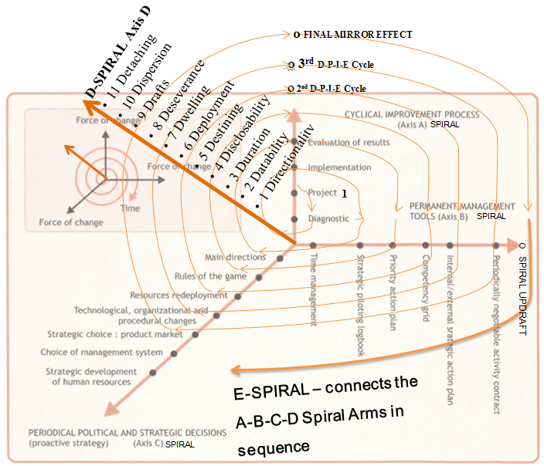
Figure 14- Five dimensions of f-spiral A-B-C-D-E transformation of the business to apprehend the Big 'D'-Spiral-Updraft (Adapted by Boje July 2012 from p. 26 of Savall et. al 2008)
A-spiral of three P-D-I-E cycles
B-spiral of the Socioeconomic Tools (plus one I added, the Updraft Spiral)
C-spiral of choice-points of political and strategic decisions
D-spiral of 11 D-questions to guide your spiral diagnosis
E-spiral that winds through to connect A-B-C-D spirals together enacted by client and consultant in collaboration.
The purpose is to develop the business into a dynamic Q-spiral, with up-leaps between twirls, and off-shoot fractals (i.e. innovations, start-ups, etc.). This is not possible without a radical shift in understanding of space-time-materiality. This is what the 11 D-Questions are for. They shift the perspective from linear (clocktime) pastpresentfuture to how theQuantum futurepresent and futurepast is arriving, making itself a directionality in the business.
How to begin? Ask the 11 D questions, record and transcribe the answers, and analyze the answers using the 4-Leaf Clover categories of dysfunction. Do this in your first and second field visits. In all spend 10 hours in the field. Each dysfunction you find and document in your notebook. A dysfunction is defined as a deficiency or an excess, and according to Aristotle, you are to find the 'middle path' which is the Silver spiraling line you walk with your client to weave together the steps in A-B-C-D. You cannot ask about 'deficiencies'; you will get tossed out. Instead ask about improvements, things that can be made better, etc. For transcribed examples of answers to questions below, please see http://peaceaware.com/lille/Lille_Storytelling_Methodology.pdf. If you find it helpful show your client Boje's YouTube film on blacksmithing businesses, then ask these 11 questions.
Table 2 – 11 D’s of Quantum Storytelling and the Questions asked of Blacksmith artists
11 D's | Q to ask your client | Where it helps you Client Consultation
Directionality | 1. What is the directionality of the business processes; to what future are they headed? | Axis C: Direction. This is not compass direction; it is strategic direction, arriving from the future-->present.
Datability | 2. What is the datability of the business process developments? | 4-Leaf Structures: Important pivotal dates where technical processes, physical and other structures were acquired
Duration | 3. What is the duration of various business processes? | Axis C: Strategic Choices - helps sort out how long various strategies have been in effect
Disclosability | 4. What is the disclosability of the future business processes revealed to you? | Axis A - projects that disclose a future, Axis B - PAP and I/ESAP; SI in top leaf. The future is arriving into the present, presenting a set of potential futures, in the choice points in Axis C
Destining | 5. What is the destining of the processes unfolding in ways you can foretell? Follow up, in fore-caring, fore-structuring, fore-having, fore-conceiving. | Axis B: PAP & I/ESAP; Axis C - all items. This is weak destiny, where even where the is momentum and carved channels in the market, there are also choice-points among futures
Deployment | 6. What is the deployment of business processes, in-order-to, for-the-sake-of? | Axis B: PAP & I/ESAP; Axis C - all items. Look at existing processes of production, distribution, & consumption. How are these processes deployed? How could they be?
Dwelling | 7. What is the dwelling, in-place in the world of business processes? | Knowing place in the market, in the state, etc. lets them sort out Axis B: PAP & I/ESAP; Axis C - all items
De-severance | 8. What is the de-severance (de-distancing) of space-time-mattering? | De-severing space is bringing something far close. De-severing time can be bringing a future potential into the path of SAP and I/ESAP and the Axis C choice-points.
Drafts | 9. What are the drafts, updraft, and downdraft, into tighter (down) orbits, or into more open outer orbits (up), and the turning points from one draft to another? | Axis A, B, & C. This is where the client and consultant sort out strategic choice points, moving into more updraft spiral-antenarratives, ascending into more potential
Dispersion | 10. What is the dispersion of processes, too diverse, or consolidating them? | This can free up resources to invested in more strategic processes, letting go of low-value added activities
Detaching | 11. What is the detaching from being drawn into ‘they-ness,’ they-relations, they-self and finding a path of ownmost authentic potentiality-for-Being-a-whole-Self? | Following the ‘they-crowd’ is not great strategy. Developing into whole-Self potentiality fits well with Axis C
The 11'Ds are concepts explained at the http://peaceaware.com website and in the 'Quantum Storytelling' online textbook and in the YouTube video.
Drafts, in particular are a way of moving from f-spiral to Q-Spiral. The f-spiral is minimal string-line, without much force, without much structure, or complexity. The Q-Spiral has more inter-connections, more force, more structuring, and much more complexity as a robust system that has off-shoots (fractals). Here is a visual example.

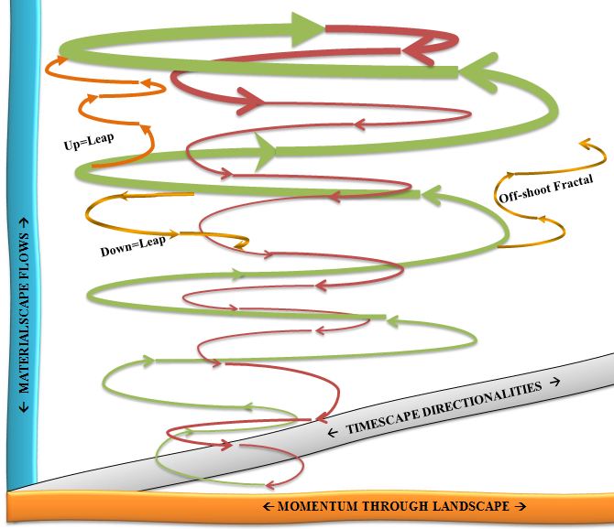
Figure 15 - Q-Spiral with f-spiral off-shoot-fractal, and two f-spirals connecting across the green-to-green and the green-to-red Q-Spiral-twirls (Drawing by D. Boje 5 July, 2012)
How do you transform the simple, minimal f-spirals into a Q-Spiral?
To transform the f-spirals into a Q-Spiral, we add some D's. You know your A-B-C f-spirals. But you need to be able to fore-tell, to fore-see, to fore-structure, to fore-have, and to fore-care for future choice-points to get to Q-Spiral-Updraft. Yes, futures (plural) that are arriving if only you stop the obsessive looking backward while walking forward, and look at the D's arriving, the future-ahead-of-itself is not found in the past. There are some signs in the Now, but you will need the D's to discern the set of potential futures, and then make a wise choice, at a crossroad between pathways. Here is the 4-leaf with its below ground root-stems: 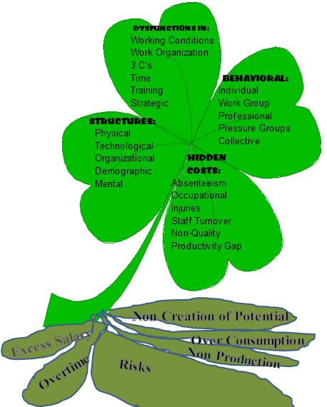
Figure 16 - 4-Leaf-Clover with 6 below-ground tuber root-stems (adapted By Boje from Savall et al., 2008: p. 33 & p. 124)
For a semester project, I am recommending you initiate, with the full collaboration of your client, three D-P-I-E cycles that intervene in the day-to-day living-story-action of the business processes. It is not about building a FaceBook page, or a brochure. It is about observing the action-stories in the space-time-mattering of the business processes, and writing up the action pattern, what I am calling the action-living-story that is pre-vocalized, pre-speech-act, even pre-linguistic. It is the language of action, and process, that is a key and major facet of storytelling.

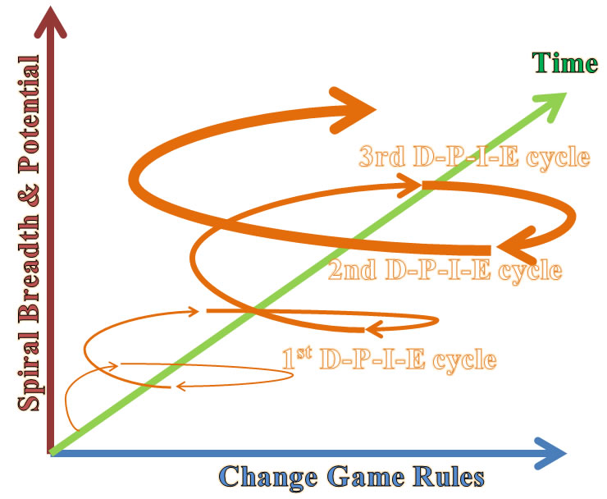
Figure 17 - Three D-P-I-E Cycles become an Upward Spiral of Continuous Improvement - Drawing by Boje July 6 2012
The three cycles of D-P-I-E is an example of what I call an ‘f-spiral.’ If the cycles merely repeat exactly the same phases each rotation, it is not a spiral, it is just a set of cycles. If the cycles are not connected, not building on one another either by successive amplification (expansion) or by counteraction, then it is not a spiral. It is a stack of cycles, and the business is in a rut, not getting better, not getting worse.
The f-spiral has one filament, is quite fragile, and one functional direction to its orbits. On its own it lacks the density of spiral-structure and process that we will call the ‘Q-Spiral’ (Quantum-Spiral). However, the ‘f-spiral’ is an important and quite radical turn in ‘product lifecycle,’ ‘brand lifecycle’ and ‘organization lifecycle’ theory and praxis. There reason is the cycles do not repeat in sameness with each iteration, rather they gain spiral breadth and potentiality, in an upward spiral trajectory and momentum. From 1st to 2nd to 3rd D-P-I-E cycle there is an expanding resonance of the force of change from repetitive sameness to differences that add value.
In sum, Boje’s Upward Spiral approach to Business Development supports continuous D-P-I-E cycles of continuous improvement by turning them into the A-spiral force of change.
SPIRAL “A” - CYCLICAL IMPROVEMENT PROJECTS resulting in f-spiral 'A': This is the D-P-I-E cycle, and keep cycling three projects during one semester, until the intervention takes root, measurable results happen, and the 'f-spiral' (red curvature in diagram) transforms into what I will call a 'Q-Spiral-Updraft." The reason it becomes an f-spiral is with each D-P-I-E cycle there is an amplification of transformation. Rather than a simple repetition of the same cycle, in a spiral there differences that create transformation of the dysfunctions you identify with your client into resources for change of activities.
- Diagnostic (w/ 1st mirror effect meeting) (Ask the 11 D questions, beginning with Datability: the history of how everything came about, and datable significant turns along their path, and some forecasting of where it is going next, and after that. The 4-leaf clover of dysfunctions can be used to interpret and understand the D-question answers from your client so you map the key dysfunctions).
- Project 1
- Implementation
- Evaluation
- Project 2 (D-P-I-E 2nd cycle with 2nd mirror effect meeting)
- Project 3 (D-P-I-E 3rd cycle)
- Final Mirror Effect meeting with client to assess the f-spiral implementation and transition to Q-Spiral
By doing 3 cycles of D-P-I-E projects with your client, you will be able to create an 'f-spiral' and with good work it could become a 'Q-Spiral.' Turn your cyclical improvement processes into a spiral (f-spiral, and hopefully Q-Spiral).
SPIRAL “B” - TOOLS: These tools are taught to your client by you, as you Implement in "A"-spiral.
- Time (This is your most important tool, and the starting point: free up value-added time to do the rest)
- Strategic Piloting Logbook (SPLB)
- Priority Action Plan (PAP)
- Competency Grid (CG)
- Internal/External Strategic Action Plan (I/ESAP)
- Periodically Negotiable Activity Contract (PNAC)
- Q-Spiral Updraft (Draft is also the 9th D question and concept in the Table below)
This f-spiral happens as you begin to do diagnostic (A), then do first tool of 'time' (B), and spiral keeps developing in your intervention as you wind through doing (A) project and more tools, such as PAP, into choice-points (C) and the Quantum Storytelling is what is making the transformations happen (D).
The B-spiral force of change is in the seven tools that the consultant trains the client to use to manage the Upward Spiral. The seven tools we will concentrate on are: time, strategic piloting logbook, priority action plan, competency grid, internal/external strategic action plan, periodically negotiated activity contract, and one I am adding called ‘Q-Spiral updraft.’ Piloting Logbook is the indicators you write down in your notebook, such as the frequency of cycle and waves, the period of time from one cycle or wave to the next, the waste in a cycle, the speed of the cycle time, time it takes from peak-to-peak or trough-to-trough of a wave, Time is short for ‘timescape’ and is not just clocktime, or calendartime, but includes ‘quality’ time tarrying-for-a-while in the ‘duration of time’ Now, the timing of strategies in relation to the moves in the environment others are making, the ‘dateable’ events of business changes, and the time arriving from the future (potentialities). All these sorts of time and their interplay games form what I mean by ‘timescape.’
SPIRAL “C” – "Choice-Points" POLITICAL & STRATEGIC DECISIONS: These are the choice-point-decisions you help your client to make, as you do "A" and "B". For simplicity sake, we add the D's here, however they are implicated in A and B as well (as shown above).
- Main Directions (also 1st of the 11 D's of Quantum Storytelling: Directionality).
- Rules of the Game (games of De-severance of space-time-mattering)
- Resource Deployment (this is the 6th D in Quantum Storytelling)
- Technological, Org, & Procedural processes (6th D - Deployment in Quantum Storytelling)
- Product Market (6th D - Deployment, plus # 7 - Dwelling in new place in market)
- Management System (5th D, Destining, in a radical approach to management system futuring)
- Develop Human Resources (11th of the 11 D's of Quantum Storytelling: Detaching from they-self to develop whole-Self potential of your HR).
There is not too much in your Savall et. al (2008) textbook on this. I have been traveling most every summer to France to learn and teach SEAM from the masters, and the book I wrote on "Quantum Storytelling" and these study guides are ways I am fleshing out the "C" Axis, and developing it into a Spiral. The C-spiraling occurs as you begin to do aspects of "A" and "B" and reach crossroads in "C" which I call 'choice-point' decisions. You meet with your client and discuss the choice-points as they emerge in their spacetime, and the spiraling is a consequence, and it is noticing the spiral already happening that they did not notice before you called attention to it.
The C-spiral force of change has 7 choice-points of periodical political and strategic decisions. Two of which we already looked at briefly, changing Direction of Spiral Trajectory, and changing the Rules of the Game. The others are Resource Deployment, Technological (organizational & procedural) changes, Strategic choice of products, Choice of management systems, and Strategic Deployment of human resources. I capitalized ‘Deployment’ since it is also part of the Q-Spiral which I will introduce next.
The Q-Spiral force of change has 11 D-questions that can be asked as a way to kick off what I call the ‘Q-Spiral.’ The Q-Spiral is dense, multi-directional, interactions with lines, cycles, and a few rhizomatic pathways connecting multiple spiral arms (such as the A-B-C spiral forces of change). Together the A-B-C-D spirals of change can come together, if one is careful and lucky into Q-Spiral updraft.
The first spiral-arm is (A) the D-P-I-E cycles of continuous improvement (Diagnostic-Project-Implementation-Evaluation). By doing three D-P-I-E cycles the A-spiral-arm can be developed. Your job is to create three D-P-I-E cycles that form into an expanding, upward direction A-spiral. D-P-I-E cycles can be about improving production, marketing, strategy, operation, personnel, innovation, accounting, and other processes. The point is to make the cycles continuously improve in cumulative cost and revenue advantages, while resolving risks for each next cycle. This is done with participation with the stakeholders (customers, workers, managers, suppliers, marketers, accountants, engineers, etc.). It is through stakeholder collaboration and communication of storytelling acts of listening, verbalizing, and observing living-story-action that the D-P-I-E cycles become upward spirals. For example storytelling processes of observations of action flows, followed by listening to verbal storytelling, then conversations with all sorts of stakeholders, creates resonance waves and D-P-I-E cycles of change to existing processes, and anticipating the potential of next ones, until a contagion of change yields several cycles to morph into an upward spiral that has a trajectory through the environment in which the business thrives.
At center is a 4-leaf-clover with 6 below-ground roots that you are seeking to re-root, and transform. You cannot read the particulars just yet, but we are still in an aerial view. Be patient.
In Aristotle’s (350 BCE) philosophy, potentiality moves towards its actualization. In Greek Arkhos (the out-of-which) and the Telos (the into-which) get linked together in a process of potentiality. Managing potentialities is what Mike Bonifer (Game Changers) calls a way to change the rules of the game. Production, marketing, accounting, personnel, innovation, and so forth are games played by rules, in rounds (cycles) that improve or decimate potentiality. For example, when a production cycle is improved from its last iteration, the overall effect can be to improve the spiraling trajectory in a series of cycles of production. This is done by broadening the scope of the spiral, and by changing the rules of the game, in time.

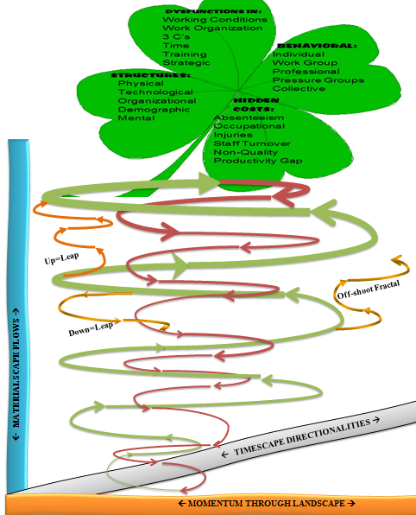
Figure 18 – Q-Spiral with 4-Leaf SEAM Diagnostic in its Landscape, Timescape, & Materialscape Environment

Chapter 6: 23 Steps to Implement Q-Spirals in Business
I teach undergraduate, master, and Ph.D. students to be organizational consultants. Undergrads in particular appreciate steps to follow. It is too linear a process for Ph.D. students and many masters’ students. If linear steps are not your thing, then develop spirals without them.
In the next drawing, there are several inter-twining spirals (A, B, C, & D) that are focused on revitalizing root-stems, into potentialities for more revenue, lower costs, and added upcycle sustainability (defined as better quality, more sustainable use of the resource, rather than down-cycling it into some waste recycling stream).
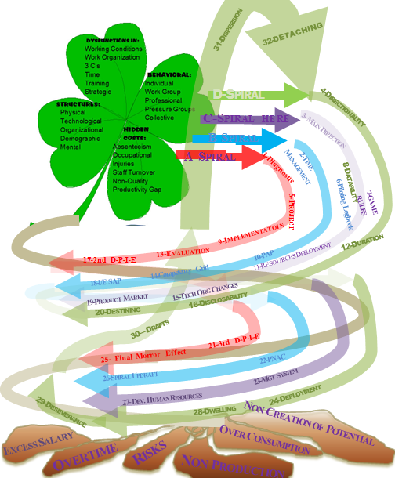
Figure 19 – Map of f-spirals A, B, C, & D (For E-spiral follow the numbered steps)
In this figure the steps to follow for a simple one-semester intervention with a small business, with 3 D-P-I-E cycles that are meant to induce a growth spiral are indicated. The idea is to begin with Diagnosis, move to Time tool, and then on to the Main Direction, and the first D-Question (Directionality) in-order-to break out of any ruts the business may be in.
You are to take 23 simple steps (several numbers are combined in the above map of the interventions, and like all maps, this is not the territory, only a way to start the diagnostic) with your client along the 'Silver' spiral called "E" in the diagram below that will step-by-step help you construct four spirals called A-B-C-D.
Let's zoom in so you can see more of how the Diagnostic works. Diagnostic is part of A-spiral, and it lets you observe and listen to the client's storytelling when you apply the D questions. As you listen, check off the dysfunctions, atrophied structures and behavior, follow up and assess hidden costs, in-order-to assess the below-ground root-stems that no surface Diagnostic can uncover.
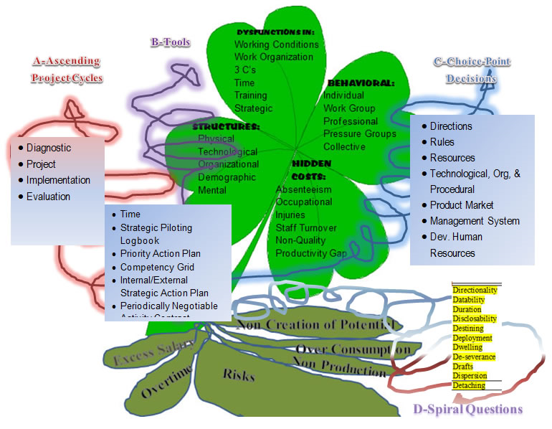
Figure 20 - the 4-Leaf in context of Triple A-B-C little f-spirals
In the midst of three f-spirals (A-B-C red-purple-blue in diagram) is a 4-leaf-clover, a check list for your diagnostic that help you get a reading of the six atrophied root-stem tubers (excess salary, overtime, risks, non-production, over-consumption, & non-creation of potential revenue). These tubers are what we call rhizomes. A rhizome has above ground stuff (like 4-leaf clover leafs) and below ground roots, like the six tubers. That was a might big step but it does not take that long. In clocktime, you can ask the 11 D questions in an hour or two, and since you took my advice and recorded the answers, you have all the storytelling and quotes you would need for your mid-term and final report. Take your second step along the Silver spiral path.
As we proceed we will zoom in so you can see the particulars of A-B-C-D. Socio-Economic-Approach to Management (SEAM) is a triple-f-spiral of A: Ascending-cyclic-projects; B: Blossoming-tools such as time-management and strategy (PAP & I/ESAP); and C: Choice-point-decisions about more strategic and political things such as 'direction', 'rules of the game, etc. I have added a 4th spiral called "D" which is a set of 11 Diagnostic Questions for you use to start your journey of business transformation with your client. In the center of the five-spirals (A-B-C-D-E) is the four-leaf-clover diagnostic (check-list) of the surface rhizome-vines and the consequences for six below-ground rhizomatic-roots.
The 23 Steps to Create and Updraft Q-Spiral
Step 1 - Diagnostic (A-spiral: Diagnostic, Project Plan, Implementation, & Evaluation of Results) begins by you asking the 11 D-questions (spiral D) which you are to tape-record or video-record and then meticulously transcribe the verbatim answers in your Midterm and Final Report. You will also use the Axis B tool (PNAC) to negotiate your consulting contract for three 'A-spiral' Projects each with a D-P-I-E cycle (Diagnostic, Project, Implementation, Evaluation).
Q-Spiral is not just a bent line. You and the client are co-constructing something much more substantial and definite than the flimsy, fragile f-spirals. In a Q-Spiral one can jump from twirl to twirl, and new fractal-spirals always budding, if you want to follow them. Notice how in the next figure the spiral twirls have more density and complexity as you move up the spiral, and are producing larger fractal-spiral off-shoots.
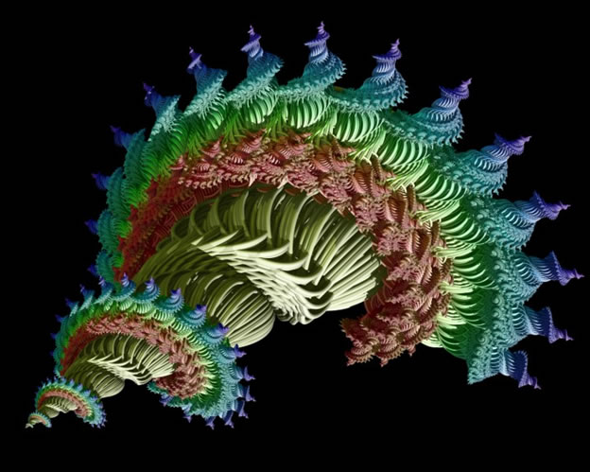
Figure 21 - Mandelbrot Fractal-Spiral that is an example of Boje's Big 'Q-Spiral' with high density of inter-connections, off-shoot fractal spirals being produced.
At some point the Q-Spiral reverts to simpler f-spiral, or to cyclic. Why? Because it takes a lot of energy and resources to be producing off-shoot fractal spirals and the Q-Spiral reverts to a simpler structure and without infusion of energy can become an f-spiral. A Q-Spiral trajectory takes a lot of energy to sustain its complexity. Assuming that time is from left to right, it would appear that the Q-Spiral is becoming more complex, more dense, with larger off-shoots, and more inter-connections through the core of the spiral across the twirls. There is also multiple parallel inter-woven main spiral pathways on the twirls.
Please don't bite off more than you can chew. Three small projects and their changes can have huge ripple impacts if they are f-spirals through A-B-C-D-E. Do not get too locked into the 2nd and 3rd project. You have not even done a diagnostic yet, or played with the new tools (B-spiral). Be prepared to revisit PNAC tool frequently, throughout the semester, and please choose the 2nd and 3rd Projects more wisely than the first ones. Get to the stem-roots of the problem. That is what problem-based-learning is all about. Be prepared to change out the 2nd and 3rd project that your client invited you to engage. You won't know which ones will make the real differences until you get further along the path. It’s about roots, not surface symptoms. You will learn this lesson quite soon.
Step 2 - Time tool (B-spiral). What is 'time?' If you answered 'clocktime or calendar time' then you don't really know too much about what time is all about. Most people assume time runs pastpresentfuture. You asked the 'Duration' question. Now listen to the answer. Time is NOT some sort of straight line. Or that time runs in repeating cycles. I guess if you are in a robotic-rut, doing the same factory job day in and day out, that may be true. However if you want to move beyond the linear and cyclic rut of repeating the same thing again-and-again, then a new 'middle' pathway must be courted, some new channels that spiral upwards sorted out by you and your client, and some Q-Spiral-updrafts located to attract your momentum must be found. Step 2 is about freeing up time, but noticing the time that is not adding value, the time that is spent putting out the same old fires, again and again. Put that time wasted into time that is spent on the future. You asked the Datability question and collected a set of meaningful, highly significant datables. All dates are not equal, some stand out, and are significant in the life path of a business. Time also runs futurepresentpast. Since Einstienian and Quantum physics, not to mention String Theory, we know that time runs in many directions, but for a strategy person like yourself, how is time approaching, arriving, in future-ahead-of-itself?
It is the time by which the future is arriving into the present, making waves in the present. It is a meaningful time of understanding the business and its many directions. It is the 1st tool you will teach your client. Begin simply and use the charts in your textbook (Savall et al, 2008, chapter 7, see pages 111-105). Find and make copies of the 3 Tables and help your client to fill them out. There is a filled out example in the Report Outline in Word, so you can copy the table, change it, and make it your very own. Good time to check out Report Template. It is longer than your report will be because it is packed with examples of A+ papers from prior terms.
Figure 22 - What direction will business take at the cross-roads?
Step 3 - Direction (C-spiral) which is also the 1st D-question (Directionality in Q-Spiral). Keep in mind your consulting focus: to help your client move out of many dysfunctions and poor root-stems, and using the savings and income potential, construct step-by-step an Updraft-Spiral. This means sorting out direction in the C-spiral, asking about choice-points, when at the cross-roads, which way will the client be turning? Ask about the directionality, not from the past to present, but from the future. Strategy foretells the future. It is not a repetition of the past (that is aimless). Think strategically, and act it. Ask: How is the future arriving, and what is the array of futures that are potentially available? There is never just one future, except in linear/cyclical thinking. The cycle never just repeats itself exactly. Silly rabbit. Even the continuous cycle time and quality improvement folks know the cycles do NOT really repeat, they spiral. It is time to notice how the last cycle is not the same as this one, to note the differences, so you notice the choices. It is all about the differences. It is noticing differences just arriving, like the customer coming in wanting a slightly different product or service configuration. Noticing the flows of action, that is the second sort of storytelling. That is what choice-making is all about. What? The action-storytelling, where there are no words said at all. So you will need to observe the direction, not just talk about it. Look at the processes in place, unfolding, and the direction of their transformation, and what transformations are arriving.
Step 4 - Project planning (A-spiral) done collaboratively with your client. What project can you and the client implement quickly, without a lot of resources, by freeing up the time you found in Step 2. Teach the D-P-I-E of A-spiral, and get ready to do three of them.
Step 5 - Strategic Piloting Logbook tool (B-spiral) begin creating indicators with your client so you can measure progress (qualitative and quantitative indicators help to pilot the direction). Indicators are as simple as deadlines, mileposts, number of new customers, number of web hits, etc. Add in some sustainability indicators: power usage (a simple indicator is the electric bill, the water bill), power waste (lights left on, water wasted), power sources (find some sustainable ones), and cut the waste by recycling, reducing, reusing, etc. You won't know where you are going or if you have arrived, unless you create some indicators. Don't leave it to the accountant. Do some ABC or your own (Activity Based Costing) by figuring out the hidden costs of the business doing as it has been doing on all those four leaves of the clover.
Step 6 - Rules of the game - (C-spiral) - business is a game and it is time to change the 'rules of the game.' There are choice points in the political and strategic decision making of every business. What game is being played in action, in the weaving of actions among the actors and the actants (things, technologies, equipment, mattering). Who is making the game rules? How can rules be changed (ethically, See Virtue Ethics book). Are the rules of the game ecologically sustainable?
Step 7 - D2 - Datability - What are the most important datable moments in the life story of the business? Get those living stories of what is emerging, unfolding in the Now, not just the rote narrative of the past. Record them by tape and or video. This can be done on the first field visit. Most students don't pay attention to the first set of life stories the client says in that first interview. I think students have been trained not to pay attention to living stories, and look instead for the quick solution, and thereby miss the spiral altogether. A life story is primordial, from birth to death, and you are in the middle of yours, not dead yet, still alive, and already born, on some sort of pathway, even if you never thought about it. There are datable moments in your future, such as graduation, the next job, perhaps a wedding, children, etc. Datable moments are happening in your future, and arriving in your present, just as much as the datable moments from the past are arriving in the Present. People always capitalize the Present, but not the past nor the future. I think they know that with each newness in the Present, that emergence opens up a rehistoricizing of datable moments past, and opens up futuring so what you think will be the milestones shift in your landscape, and new ones are beckoning you to approach.
Step 8 - Mirror Effect meeting with client (A-spiral, part of D-P-I-E cycle)- where you feedback the living stories and quotes sorted by stakeholders, present a hidden costs and untapped potential revenues chart based on questions asked in the 4-leaf diagnosis; and make 3 consultant observations and recommendations. This is a long meeting, a meeting about the text, the scripts you collected from employees, clients, suppliers, and whomever you could access. And it is your observations put into field notes on all those visits. Not a note taker? OK, get a good tape recorder, one with dual microphones (stereo microphones), and start recording conversations, in meetings, in interviews, whereever you have permission. By the time your mid-term arrives, you are advised to have the Mirror Effect face-to-face meeting with your client. It is where you point out the costs and lost revenues of behaving, structuring, etc. and how much dough they can have, and peace of mind, if they find what Aristotle (350 BCE) calls the middle path, the one between excess and deficiency, which is by the way the definition of all those dysfunctions you analyzed in the upper leaf of the 4-leaf.
Step 9 - Implement project in collaboration with your client (A-spiral). Good advice, but many a student consultant has ignored it. Implementing a Project that the client is not on board with will lead to many headaches, even hard feelings. Clearly the spiral updraft is tugging you in a more amenable directionality. You did the Diagnostic, the Project plan, and now it is time to Implement and collaboratively, please. You are not here to be a slave. You are consulting, so they can do this on their own, with their own resources. This is first of three Projects (check your PNAC, and may be time to renegotiate, so you have three small changes in projects that are doable).
Step 10 - Priority Action Plan tool (B-spiral) lay out three goals and action plan and who implements what for the next year. With the first project, you have some basis for setting the PAP in motion.
Step 11 - Resource Deployment (C-spiral) - come from making priorities, cutting back here, and expanding in the implementation of project (step 9). PAP gets implemented with the cost savings and enhanced revenues you promised in the Mirror Effect meeting. Deployment is part of the Q-Spiral set of questions, so go back and listen to your recording.
Step 12 - D3 and D4 (Q-Spiral: Durability and Disclosability). Ask about durability of the various processes of production and distribution. Then ask about disclosability of the future arriving at their doorstep, to tell what sort of processes need to be fore-structured.
Step 13 - Evaluation (A-spiral) evaluate results of the project using the piloting Logbook indicators you have to date. Then renew the Diagnostic, and Project # 2 gets planned, and implemented.
Step 14 - Competency Grid (B-spiral). It is time to assess existing competencies of each person in the firm, and do a second grid of what competencies are needed to get the business in uplift to their PAP and 2nd Project Implementation. This also gets them set for the longer range strategy coming up.
Step 15 - D5, D6, D7 (Q-Spiral: Destining, Deployment, & Dwelling). Time to ask the big quantum questions: What destining are they courting? How are they deploying to meet it? What is their place (dwelling-in-the-market-place and in sustainability with the Natural environment)?
Step 16 - Evaluation - A-spiral) Evaluate Project # 2, Diagnostic, Project plan for 3rd project, and get into Implementation where the client is implementing and you are doing quite little activity.
Step 17 - I/E SAP (Internal/External Strategic Action Plan) (B-spiral). Now that you have 2 projects completed, and a 3rd underway, it is time to take a turn in the path. This is a five year strategic plan with three long term objectives, action plans, who does what when, with more logbook indicators set up to measure their progression. The PAP was one year of the 5 years. This is the big game change.
Step 18 - More D's (Q-Spiral: Deseverance & Drafts). OK the de-severance removes distance so the far in space and time and mattering are near (ready-to-hand in the business processes). Drafts are force fields in the upon the spiral-antenarrative. It is like a glider-plane, where you float looking for new updrafts, and avoid the downdrafts. If the business has been in a downdraft, descending, then they will welcome the updraft. Your job is to help the client find the updrafts, and make the moves in the processes to get in place, to take that uplift pathway.
Step 19 - Complete the Evaluation (A-spiral) of the 3rd project. Adjust the Logbook indicators, PAP, and Competency Grid, so there is a smooth passageway to the I/E SAP.
Step 20 - PNAC (Periodically Negotiable Activity Contract) A-spiral. This is at several levels. It is a PNAC between consultant and client, so expectations stay eye-to-eye over course of the 3 projects. Second, it is a PNAC training that you do with the client so PNAC's are used in the business with all the employees. And it is about compensation. If the employee helps move the firm into updraft, into more money, more customers, more revenue, less waste, etc, then what is going to be the reward, the payout for them. How do they participate in the good times? Yes it is profit-sharing, but also accountable for any of those six root-stems under the 4-leaf. By now the client should be familiar with all 6 tools and using them to pilot their business on the upward spiral-antenarrative path. If they are just repeating the same old business cycle, then your consulting has not worked.
Step 21 - technological, product market, management systems, and develop human resources C-spiral - Time to make some choices, some are political and others are strategic. To change C-spiral is also lead Q-Spiral (which is also the 11th D of Quantum Storytelling) is quite the accomplishment.
Step 22 - More D's (Q-Spiral: Dispersion & Detaching). As the business enters new up-paths then there is dispersion of processes, some of which are not all that helpful in the road ahead. And you as a consultant are detaching, getting ready to end your gig with the client. And the client is achieving potentiality-for-Being-a-whole-Self, not imitating competitors, not doing the ‘they-self’ walk. Fining that unique sense of freedom in the updraft, is a major result that you and your client can be proud of.
Step 23 - Q-Spiral-Updraft - Submit your final Report to client and instructors. What value-added did your work with the client lead to in terms of up-draft-Q-Spiral? You are done. Make your presentation; get along on your pathway.
OK, now that you have taking a walk on a spiral-pathway, one of your own collaborative creation with your client. You are hereby certified 'spiral-consultant.' Congratulations.
Here is a visual example of a Q-Spiral. Note how much denser, how many inter-connections between the twirls, the fractal-spiral off-shoots budding all along each main twirl, and the inter-twining of multiple spirals together into higher complexity and structuration than the loosely coupled and loosely knit f-spirals.
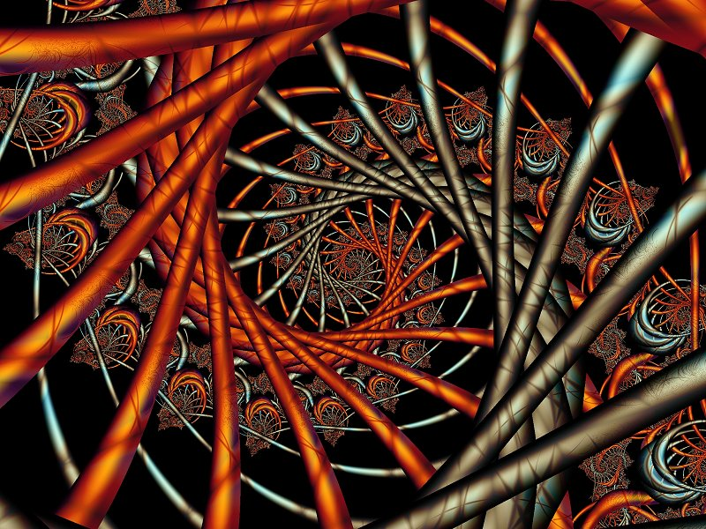
Figure 23 - the Spiral depiction from Berkeley

Chapter 7: Prior Spiral Theory Dualizes Upward versus Downward
Rather than dualize spirals and say they are not linear, and not a cyclical-recurrence, our approach will be to look at ways spiraling involves some linear processes, and some cyclical processes. “The story [more accurately, antenarrative] of business cycles can organize the past, but it contradicts itself when offered as a prediction of the future” (McCloskey, 1990: 95, bracketed insert by Boje). Cycles are part of spirals because the repetition of sameness alternates with repetitions of difference (Deleuze, 1994).
Rather than treat spirals as floating in a vacuum, we situate spiral in a causal texture environmental context (Emery & Trist, 1965) that I would like to extend by giving it three dimensions of space-time-matter, that I will call the landscape, timescape, & materialscape. There is a good deal of science literature on landscape, and some on timescape, but materialscape is a term I invent here.
Spirals are hereby defined as composites of some linear processes, some cyclical processes of reoccurrence-of-sameness, and the emergence of novelty and repetition-of-difference. Spirals we will study and change are of two types: the 'f-spiral' and the 'Q-Spiral.'
The first type is the f-spiral that is a fragile, one-direction, mono-filament, that lacks variety and fragments quite easily when disturbed.
Downward spirals - It was the one that those who are actually theorizing and researching spiral in management studies have had the most to say about (Andersson & Pearson, 1999; Hambrick, Li, Xin, & Tsui, 2001; Lindsley, Brass, & Thomas, 1995; Pearson & Porath, 2005). Lindsley, Brass and Thomas (1995) focus on downward spirals of inefficacy that represent groups and organizations with lack of confidence that are entirely lacking in “self-correcting cycles" (p. 651). Andersson and Pearson (1999) identify downward 'incivility spirals' as synonymous with ‘circular patterns' that escalate aggression in an organization. Pearson and Porath (2005) conducted qualitative data analysis to explore incivility- and aggression-spirals in organizations. Hambrick, Li, Xin, and Tsui (2001)look at two downward conflict spirals in interorganizational relations of joint ventures, highlighting the way in which negative spirals feed off each other, creating further negative spirals.
Upward spirals - Then there are authors who have focused on upward spirals of managing and organizing without paying any attention whatsoever to downward-spiral forces (Hostager, Neil, Decker, & Lorentz, 1998; Franken & Braganza, 2006; Nonaka, 1988a, b, 1990, 1991a, b, 1994; Nonaka, Byosiere, Borucki, Komno, 1994; Nonaka, & Kenney, 1991; Nonaka & Takeushi, 1995; Nonaka & Toyama, 2003l Nonaka, Toyama, & Konno, 2000; Nonaka & Yamanouchi, 1989; Nonaka, Umemoto, & Senoo, 1996; Nonaka, Toyama, & Konno, 2000; Nonaka, Toyama, & Byosièr, 2001; Nonaka, Konno, & Toyama, 2001; Inkpen, 1998; Inkpen & Dimur 1998; Hildreth & Kimble, 2002). Hostager, Neil, Decker, & Lorentz (1998), for example look at efficacy and performance in an upward-spiral.
Imai Nonaka’s (1988a, b, 1990, 1991 a, b, 1994) upward-knowledge-spiral contains four stages: 1) socialization of knowledge, 2) combination of knowledge, 3) knowledge-internalization, and 4) knowledge-externalization. The “spiral” of knowledge creation (Nonaka & Takeuchi 1995: 71-2, 89) is often referred to as the SECI model: Socialization, Externalization, Combination, and Internalization. Inkpen and Dinur, (1998) are among the many knowledge management scholars applying Nonaka’s knowledge spiral to organizations. Inkpen, Dinur, and Kim, for example, describes “as the knowledge spirals upward in the organization, it may be enriched and extended as individuals interact with each other and with their organizations” (1998: 76). Ba is based on the Japanese philosopher Kitaro Nishada’s (1970) work and is defined as “shared context in motion for knowledge creation” (Nonaka, Toyama, & Konno, 2000: 13). It is context-specific knowledge in particular time and place, and is said by Nonaka et al (2000: 13-14) to be contrary to Descartes’ Cartesian view knowledge. “Knowledge needs a physical context to be created” ‘there is no creation without place’” (p. 14).
There are significant critiques of the knowledge management spiral. In particular, it seems to misapply Kitaro Nishada's theory of place (Ba) which is actually rooted in Heidegger's (1962) work, and as seen in the Nonaka et al. (2000) figure, it is not actually a spiral but a cycle.
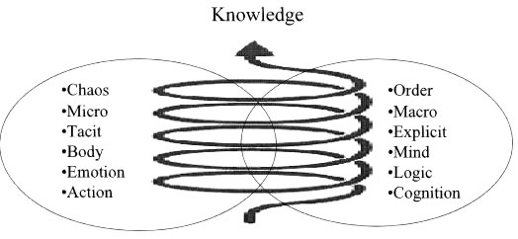
Figure 24 - Upward Knowledge Spiral is actually a Stack of Cycles (adapted Nonaka, et. al, 2000: 6).
Here is some of the critique of the upward-spiral of knowledge management.
“The question is what internal and environmental conditions have to exist for this spiral to function properly, and whether it can be applied universally to all company processes. I do not think so and would argue that in environments that are constantly changing, like global finance or when starting a company, making things too explicit undermines the speed-advantage that the tacit approach brings” (Anard Kishore Raju, http://www.techiteasy.org/category/erp/).
If spirals of knowledge creation is a disguised linear model then it suffers from unrealistic assumptions in part due to their sequential approach to SECI phases. “Writers in knowledge management have favored a more linear approach also, seeing knowledge in terms of reducing it to its informational attributes, e.g. database creation, knowledge banks” (Kane & Ragesdell, 2003: p. 5).
The argument proposed by Gourlay (2003) and expanded in Bourlay & Nurse (2005) is that the evidence for the processes described by Nonaka is weak or non-existent which thus calls into question the SECI [socialization, externalization, combination, internalization] model itself. Since this remains at the heart of the overall theory, flaws in the SECI model will also affect the wider theory” (source: Jasarmi, 2007, bracketed additions Boje, http://editthis.info/jsarmi/Nonaka_SECI_Model).
... The process is linear because it involves time... If we extend the time frame to include more than one phase of SECI processes, the question of the relationship between knowledge produced in former times and ongoing knowledge conversion becomes evident” (Gourlay & Nurse, 2005: 304-305). http://myweb.tiscali.co.uk/sngourlay/PDFs/Chap%2013%20GourlayNurse.pdf
“Recently Bereiter (2002) has identified four important shortcomings in Nonaka’s approach. First, echoing Stacey (2001), he argues that Nonaka’s theory cannot explain how minds produce (or fail to produce) ideas. Second, it overlooks the important question of understanding—in order to learn by doing, one has to know what to observe. Third, while the theory recognizes knowledge abstracted from context, it says little about how it can be managed. Finally, the view that knowledge originates in individual minds prevents Nonaka from conceptualizing knowledge that arises from collective actions, for example, as a product of teamwork. Overall, Bereiter argues that the theory is rooted in a folk epistemology that regards individual minds as full of unformed knowledge that must be projected into an external world, an approach that hinders any attempt to provide a theory of knowledge creation. As such, he suggests that Nonaka’s theory fails both as a theory and as a practical tool for business” (source: Jasarmi, 2007, http://editthis.info/jsarmi/Nonaka_SECI_Model).
Tyler and Boje (2008) and Tsoukas (2003) critique is that the upward knowledge spiral literature has a very quaestionable understanding and interpretation of Polanyi’s (1966) 'tacit knowledge' theory. In particular, it may not be quite so easy to move from tacit to explicit knowledge, nor to internalize and externalize it in the form of either cycles of SECI. Storytelling is usually taken in knowledge spiral methods to be a way to measure tacit knowledge. However, storytelling as we defined it above is both action-living-story and said-and-heard-living-story. To take the tacit only from said-and-heard is only dealing with a small fraction of what is living story.
While the downward-spiral and the upward-spiral authors look at the characteristics of downward- or upward spirals, they do not allow for the up and down forces of momentum to be a part of one spiral, nor do they situate spiral within the causal texture of a changing dynamic environment. One exception is Robert Burgelman (1996), who portrays upward spirals of growth and downward spirals of decline in his analysis of complex organizations. However, this still tends to dualize the spiral as being either upward or downward, rather than having up and down waves, perturbations, and oscillations.
Quantum Spirals
The second spiral is called the 'Q-Spiral' because it is denser, has distributed-strands of inter-connection, and a weave of differentiated fragments, as well as off-shoots that make it more robust and resistance to disturbances from its environment. With the exception of Franken and Braganza (2006) not much work has been done in looking at composite spirals that have upward and downward spirals within them, and adapt their composite to particular causal texture environment situations.
The f-spirals of your consultation work can become Q-Spirals as they couple up with more multiplicity. Time-spiral is one of the key aspects of Savall et al.’s (2008) 3 axes of consulting. The following example has a set of f-spirals, but has not developed into a Q-Spiral.
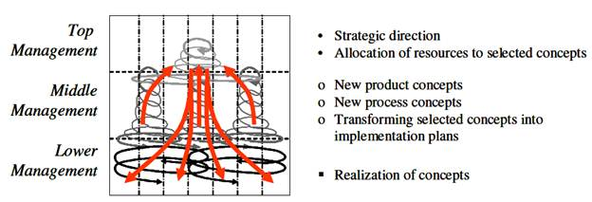
Figure 25 - Multiplicity of f-spirals. The above example (Analyzer) is from Franken & Braganza (2006).
Prospector-, Defender-, and Analyzer spirals (see chart).
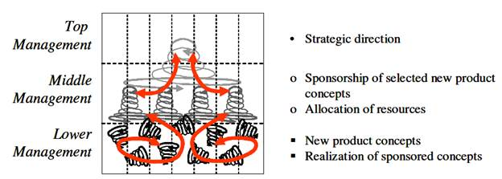
Figure 26: Prospector small business spirals -Source: Franken & Braganza (2006)
Figure 27: Analyzer small business spirals of knowledge creation - Source: Franken & Braganza (2006).

Defender Small Business Spirals
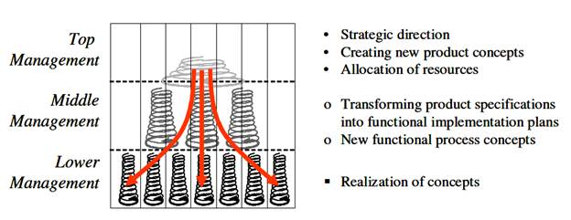
Figure 28 - Defender small business spiral of knowledge creation – Source: Franken & Braganza (2006)

For example, "defender organizational spirals" conform to “hierarchical organizational structure with extensive division of labor, a high degree of formalization, centralized control, and a reward system that favors production and finance” Franken & Braganza, 2006: 21). Defender spirals have top-down nowledge creation, in functionally-separated and isolated silos. Communities of experts (consultants) go through the segregated knowledge silo-spirals to create complementary knowledge (ibid, p. 22). "... Defenders defend their market position by either offering highly competitive priced products and/or services or ones of superior quality. Furthermore, Defenders tend to perceive developments in their niche market as stable, thereby allowing them to disregard developments outside their market domain and direct most of their efforts and investments towards improving their operational domain” (ibid).
Prospector spirals, on the other hand, "perceives their market environment as constantly changing. Therefore, Prospectors either have or develop core capabilities of finding and exploiting new market opportunities by offering pioneering products and/or services. Consequently, Prospectors are more concerned with maintaining their innovator image in the marketplace than serving existing markets as efficiently as possible" (Franken & Braganza, 2006: 10-11).
Analyzer spiral forms, by contrast to defender and prospector-spirals, "... tend to be more cautious and selective in their approach to entering new markets with pioneering products; Analyzers typically follow a “second to market but better” approach. The dual market focus of the Analyzer, a stable portfolio of products for efficiently serving existing markets and a changing portfolio of new products for new markets, makes this strategy potentially difficult to implement due to the opposing operational and administrative requirements.... these problems could be solved by adopting a matrix structure combined with a blend of Defender and Prospector characteristics” (Franken & Braganza, 2006: 14).

Chapter 8: What is Landscape in the Quantum Spiral?
Q-Spiral space has Disclosability, Directionality, and Movement. We take spiral-movement for granted. Yet, we are located on the spinning and orbiting Earth moving along one of three spiral arms called Orion–Cygnus in the rotating Milky Way Galaxy in the inter-galactic-spiral-universe which is itself unwinding.
We can apply space to business process cycles. For example, in the layout of production processes, each process occupies a place in a business, in one or several buildings, including those of suppliers. The processes (in-place) have upcycles and downcycles. A state of a process at rest and one in momentum cannot be differentiated. Inside a process, like a moving electric car, with the windows painted black, you cannot tell how fast or in what direction you are moving. If you accelerate and make a turn, you can tell direction.
In our ordinary understanding of reality, space has three dimensions: length, width, and height. To keep things simple, for your introduction we will explore this 3-D spatial view point without reference to time. Experiential observations since Einstein’s relativity theory and quantum theory do not support the idea that space is absolute sameness. Observers seeing the same event from different place in a business will see different things, due to their spatial frame of reference. If we were to map a business space in coordinate map grids, like a roadmap with letters and numbers, then add topography we would have a 3-D map of the business space.
The Three Scapes: Landscapes, Timescapes, & Materialscapes: The Q-Spiral does not exist in 'empty' space-time-mattering. There is a situated environment with three dimensions: In orange dimension is the spatiality of a 'spiral-entity trajectory momentum through landscape' from place-to-place. In blue dimension is the temporality of a spiral-entity's timescape directionalities. In silver is the mattering of a spiral-entity's materialscape flows, including exchanges with its suppliers, consumption by consumers, welfare (payments of taxes), and the Natural elements (earth, water, air, & fire) organizations treat as resource inputs from local and distant communities.
Landscapes - Several authors write about landscapes (Waddington; Sheldrake, 2008, 2009; Kaufman, 2005).'Landscape’ is a theory created by Conrad Hal Waddington (1905 to 1975), a British biologist and geneticist. The common metaphoric description is that of a ball placed on a 'landscape,' where it's trajectory follows the shape of the landscape and its landscape-channels thus constraining passage-way possibilities.
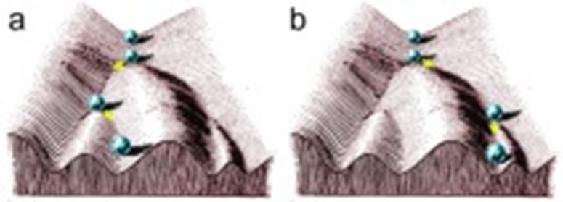
Figure 29 - Waddington's depiction of marbles traveling among channels of a landscape to reach lower regions of optimal development
Waddington (1953, 1956, 1957) cell-biology is depicted by marbles (chreodes) finding ideal paths through a channeled-landscape to some optimal end point, in the future (click here for the math). With multiple marbles the paths deepen, and some marbles are bounced into paths that are less optimal. “The path followed by the ball, as if rolls towards the spectator, corresponds to the developmental history of a particular part of the egg.” (Waddington, 1957, The Strategy of the Genes. London, Allen and Unwin). Waddington's 'landscape' is a metaphor, a model of how gene regulation determines cellular development. The landscape is often depicts as marbles competing to find their way through channels (grooves) on slopes of mountainous regions, to arrive at lowest optimal points on the landscape. If we look at businesses, they operate in a 'landscape' where people are making choices to achieve some desired future state, and these landscapes are populated by other organizations that have already made channels, the deep paths already present, and they compete for more favorable places in their collective landscape. There can be choice-points, choices among the grooved-channels. Those businesses making unwise choices among landscape pathways (channels) are winnowed out, leaving other business enterprises to deepen a previously shallower pathway into a deeper one.
Let's update Waddington's ''landscape" by depicting Q-Spirals situated as two different strategic positions on a common landscape.
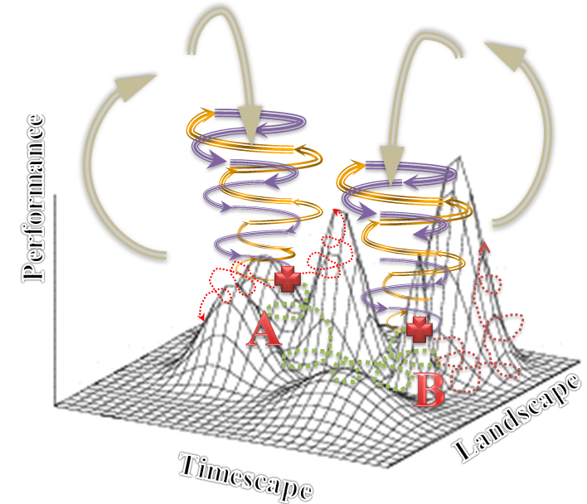
Figure 30 – Strategic Move of a Q-Spiral to new location in its Environment
KEY:
Choice-Points where green is trajectory actually taken by organization from point ‘A’ to point ‘B’, and red dotted lines are trajectories not taken yet still remembered what might have been.
Gold Arrows => Positive directions of organization Spiral Episodes going with flow of environmental updrafts and against the flow of environmental downdrafts
Purple Lines => Negative directions organization Spiral Episodes going with flow of environmental downdrafts, and against the flow of environmental updrafts
Green Dotted line => Trajectory in the fitness environment
Red Dotted lines => Null paths not taken at choice-points
Silver Arrows => Updrafts and downdrafts of the oscillations in the competitive environment

Three Dimensions of Environment:

- Performance is defined as the outcomes of strategies enacted in the environment. Higher peaks have greater performance opportunities, but steeper peaks have higher costs, and more organizations attempting to get there.

- Landscape is defined as “realistic problem-solving complexity with clarity” (Afuah and Tucci, 2012: p. 357; Kaufman, 1993, 1995). Landscape is spatial in combination of ways: perceptions of space, measured spaces, and meanings of space to participants.

- Timescape is defined as measured time, timing of strategies, retrospective-histories, and anticipated-futures (Adam, 1998).
In the above depiction, for example, a business Q-Spiral entity traverses in spacetime from Strategy A location to Strategy B location in its environment. Was this a better move?
In the figure, higher peaks are better locations in the environment. Higher peaks have more fitness advantages, but that means more organizations hear stories that this is so, and orient their strategic moves to go there too. Leaping from one place in a landscape to another more distant one is something we shall call the strategy of Q-Spiral moves in our business consulting. We will assume that some positions have more competitive advantage than others, and are related to different materialscape potential than are others.
Waddington’s (1956, 1957) theory is also the basis for ‘morphogenetic field’ ideas of Rupert Sheldrake (2008) who developed the theory that the previous past morphic fields are adaptive and contributes to the present one.
Waddington’s (1953, 1956) landscape concept becomes different in Sheldrake, than it develops by Kaufman. Whereas Kaufman focuses on the future, Sheldrake focuses on the strategic future. Both define landscape as having time-aspects, but to not develop the full-blown theory of 'timescape.' Locations are more optimal at the peaks of mountainous regions in Kaufman, whereas they are at the lowest valley points in Waddington.
Rupert Sheldrake de-emphasizes actual 'landscape' in favor of a focus on looking at how each past of an entity creates a morphic field, and how the morphic felids only affect from past-to-past, cumulatively into the Present. In other words, time flow only from past-to-past morphic fields, creating a resonance in the Present one.
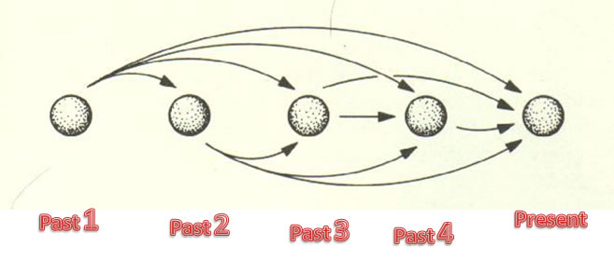
Figure 31 - Sheldrake's attempted integration of Landscape with Timescape (Drawing by D. Boje, adapted from Sheldrake 2009).
Sheldrake (2009: 86) treats the landscape as only being influenced the past morphic resonance fields, and loses interest in the material-landscape features: “morphic resonance takes place only from the past.” Cumulative influences of past timescape for Sheldrake acts on subsequent similar systems, even without direct materialscape, and landscapes itself for him becomes entirely temporal. To me, the solution to timescape is unsatisfactory because, time flows only one way, and the qualities of the situated landscapes and materialscapes of the Q-Spiral are not accounted for.

Chapter 9: What is Timescape in the Quantum Spiral?
Timescapes - Barbara Adam (1998a, b) writes about timescapes. Clocktime and calendartime are a part of the multiplicity of times in the timescape, but there are also other times that important, such as meaningful times of an encounter, timing of a strategy, the duration of time in-the-moment of Being, the datability of an event that makes it more significant than other events, the disclosability of the future arriving ahead-of-itself. One we relax the Newtonian assumption that time only moves pastpresentfuture, the multiplicity of the timescape becomes apparent. This is especially true in what I call 'Quantum Storytelling' where the timescape is quite diverse time horizons: nanoseconds, light-years, cosmic horizon of many millennia. In any organization there are multiple time horizons, and in Quantum Storytelling, time has a more radical directionality: futurepresentpast. With emergence in once-occurrent event-ness of Being (Bakhtin, 1993; Mead, 1932), that novelty-emergence prompts an organization to look at multiple futures now possible choices, and multiple pasts that get re-historicized with each emergence in-the-Present. In short, the timescape has multiple directions, horizons, and perturbations that make 'time management' a very important job, and something not easy to do well. Focusing on the past, while looking only backward, will result in being tripped up by emergence-in-the-Present, and lead to unanticipated risk consequences of not looking forward-as-you-walk such as falling into a hole, not 'seeing' ways the future is arriving into the Present to make for 'risky business.'

Chapter 10: What is Materialscape in the Quantum Spiral?
Materialscapes - I will invent the word 'materialscapes' to deal with the many materialities of an organization. This would include materialities that are Newtonian, and extends to include mattering that is Quantum, such as wave-particle duality, where BOTH wave and particle are possible.
Of course, in reality, landscapes, timescapes, and materialscapes are integrated, intra-penetrating, in our Being-in-the-world.
Complex Adaptive Systems (CAS) evolve in Quantum Field Landscapes (Waddington; Sheldrake, 2008, 2009; Kaufman 2005).

Chapter 11: What are Three Dimensions of Quantum Spiral? Landscape, Timescape, & Materialscape

Rather than dualize the 'f-spiral' and 'Q-Spiral', our focus is on how one can become the other, and how one can exist within the other. We will theorize how the f-spiral, can pick up other f-spirals, become inter-twined and inter-woven until it is a Q-Spiral. Alternatively, a Q-Spiral can degenerate, and not have enough resources or energy to sustain its own complexity in a sparse environment, and will lose its off-shoots, have strands break apart, and dissolve into an f-spiral. Finally, f-spirals can exist within a densely inter-twined and inter-woven Q-Spiral. Let's look at a graphic display of a Q-Spiral and how it interweaves three dimensions: (1) landscape trajectory, (2) multiple timescape directions, and its (3) materiality flows.
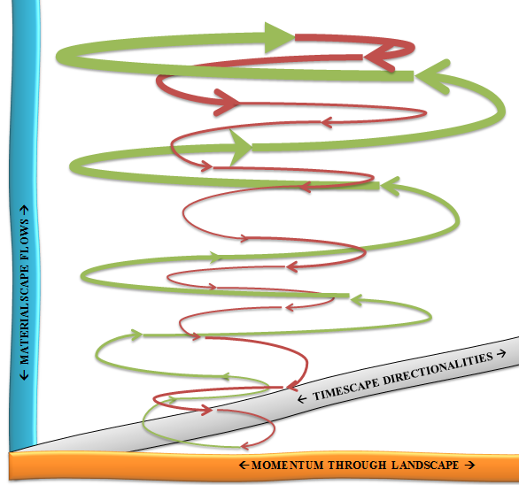
Figure 32 - 3D display of Q-Spiral entity (Drawing by D. Boje July 5, 2012)
Instead of dualizing spiral-entities into either upward-spirals or downward-spirals, the above depicting has both upward and downward directionalities within the same entity. In the depiction, there are green spiral curving lines that are the 'upward' direction, and red curving lines that are the 'downward' directions of the Q-Spiral. At the top and bottom of this particular spiral-entity, there is a directional change: at bottom from downward into upward directionality, and at top from upward into downward directionality. There are some other characteristics worth mentioning. As the momentum, of the upward Green-spiral or the downward Red-Spiral, shifts there the spiral-segments become less pronounced. Wider orbits are denser, and take more resources and energy to sustain. Smaller orbits are faster relative to the speeds at the core. Moving up a Green-spiral the orbits bet wider and wider. Moving down a Red-Spiral, the orbits get tighter and tighter around the central core. The entire whole entity of the Q-Spiral is leaning to the right, and its overall trajectory momentum through a landscape is in that directionality. However, there is more to Q-Spirals than traversing a landscape. There are at least three 'scapes.'
Let's look at some more features of a Q-Spiral before you start working to change or construct one with your business client. There are innovations and novelties emerging in businesses. We will designate these as off-shoot little fragile fragmented f-spirals, and there are 'quantum leaps' between the main twirls of a Q-Spiral, and sometimes these little f-spirals are between the upward Green-spiral-twirls and the downward Red-Spiral twirls. See if you can pick them out.
Figure 33 - Q-Spiral with f-spiral off-shoot-fractal, and two f-spirals connecting across the green-to-green and the green-to-red Q-Spiral-twirls (Drawing by D. Boje 5 July, 2012)
In the above depiction, the Q-Spiral has one f-spiral off-shoot that is still connected. It is known as a fractal, and there can be many of them, some of which spin-off and away, becoming their own independent f-spiral-entity for as long as the resources of the landscape and materialscape sustain their energetic requirements. There are two twirl-to-twirl f-spirals, one a bridge between two green twirls, and the other red-to-green move from upward force into the downward orbits of the Q-Spiral.

Chapter 12: How to Study Q-Spirals in Business?

Focus on studying processes, how they came to be as they are, what is emerging here-and-now, and to what future states are the processes evolving? Begin by noticing all the linear processes of the business, from its production, its marketing, its organizing, its distribution, its accounting, its services, its recruiting, its training, its strategizing, and to its administration.
Look for the linear processes, and notice how often they are non-linear, replete with exceptions, contingencies, changes from last year, or last month, or just yesterday changed again. Perhaps business aspire to implement linear processes, like they observe in much larger factories, or at the university or city bureaucracy. But, often, a business operates far-from-linearity.
Perhaps the business participants assume that their business is just cyclical-processes. Perhaps our models of what is linear and cyclical are so gross and abstract, they ignore the actual reoccurrence of variations.
OK, let's take a look at that. "Repetition of the same" cycles is often used to describe the tenor of life in bureaucratic or slow-changing organizations. Yet, for physicists the "assumption of sameness is highly problematic" (Adam, p. 520).
Why Study Quantum Storytelling in Business Consulting?
Quantum Storytelling makes very different assumptions that what one finds in consulting rooted in the language and assumptions of Newtonian Physics. Newtonian business consulting leads to abstractions that oversimplify complexity, and omit the interconnectivity of the business with context, embedded Nature relationships, and processes of life and death on the planet. In Quantum Storytelling space-time-matter are multi-faceted concepts.
There are important difference between making Newtonian assumptions about space-time-matter, and what I will call 'Quantum Physics' consulting assumptions. The Newtonian business consulting makes the processes into abstraction, decontextualizing and over-simplifying them. The interaction among parts is assumed to be self-contained, without open interactive exchange with the environment. Parts are isolatable, interchangeable and all about function. In our Quantum Storytelling, your consulting is contextual, embedded, parts and whole are not isolatable, parts are not exchangeable, and the entire focus is on relations.
Table 1: Newtonian and Quantum Business Consulting - adapted from Adam and Kutting (1995).
Consulting in Newtonian Physics | Consulting in Quantum Physics
(1) abstraction, decontextualization and simplification; | (1) complex, contextual, embedded, networked connectivity;
(2) interacting parts make up self-contained systems; | (2) open, interactive systems of exchange;
(3) the whole and its parts are isolatable in an absolute way; | (3) part--whole implication with parts not isolatable;
(4) parts are interchangeable and replaceable; | (4) parts not exchangeable without affecting the whole;
(5) focus is not on relations but on function; | (5) focus on relations, interactions and exchange, particularly energy;
(6) emphasis is on efficiency and predictability; | ( 6) emphasis on processes of life and death, as well as energy-intensive regeneration, healing and growth;
(7) Consumption of energy, production of waste, increase in entropy; and | ( 7) Use of energy, production of usable energy, increase in growth and life; and
(8) Mechanical time is associated with reversible motion, abstraction, divisibility, and the standardized, universalized, invariable time of the clock. | ( 8) Organic times are symphonies of lived rhythmicity (repetition not of same but similar) and irreversible, evolutionary change.
A Newtonian business consultant looks at function, efficiency, predictability, consumption of energy, production of waste, and mechanical clocktime, a time that is reversible because it is assumed to universalized and standard (one time event the same as another, the way one measured minute is same as another).
A Quantum Storytelling business consultant looks at energy exchange, process of life and death, the use of energy to increase growth and life, and time is organic, lived, not in repetition of the same, but in irreversible evolutionary change.
My point is not to create a dualism of Newtonian and Quantum business consulting, but to illustrate what is missing.
It is time to challenge the whole Newtonian, mechanistic physics of space-time-mattering, and its presumed sameness, standardized, repetitions.
Even a centrimetre of air is highly unlikely to recur in the same composition, once in every 1- million million million years. Water from different places, and even bottled water will vary in its composition quite widely around the world. Fire is not the same, nor is earth, from one sample to the next. The basic elements air, water, fire and earth do not recur with sameness. Then why should we in organization studies assume that a linear or cyclic process would recur with sameness, repeat the same sorts of social events.
In stead of standard-clock-time, there consultants can help clients take account of short and long-time-scales (from speed of light to millennia). In Quantum Storytelling, time is about tempo-speed, duration, sequence, time-lags, momentum, trajectory, and ways the future, present, and past are interdependent, mutually-implicated, not just your old past-->present-->future calendar-time narrative.
In mattering of environmental and life processes, Adam & Kutting (1995) says "Just as 'green technology' is firmly grounded in Newtonian science and conventional economics so international relations, the political means to deal with the global impact of technological effects, are grounded in mechanistic and therefore inappropriate ways of understanding and relating to environmental processes."
A linear process or a cyclical one, such as a calendar of events, is a result of collective agreements, much negotiation, and variations are rampant. A weekly cycle of work, has absenteeism, changes in schedules, extended and canceled meetings, people late on assignments, and all sorts of variations.
Giles Deleuze (1994: 21) says, "Spirals whose principle is a variable curve and the trajectory of which has dissymmetrical aspects as though it had a right and a left." Deleuze makes the point that cyclical repetitions of same stages, with same events is countered by repetitions of difference, and it is the differences that turn most every cyclical process into a spiralling one. What defines a spiral, is how the twirls of repetition amplify the differences, or counter-act them, in ways that makes cyclic,reoccurrence of sameness quite unlikely in socioeconomic systems.
At first you may be led to assume some processes are linear, others more cyclical, and others spiraling, while some are what those in the process trade call 'rhizomatic.' A rhizome in the Natural environment is a vine and root networking weed or plant-life that extends in all directions until some obstacle is encountered, such as the crab grass in your lawn, or the Trumpet Vines, Mesquite, and Greasewood bushes growing in the desert of New Mexico. This plant-life has some spiraling vines and below-ground root systems, that take lines-of-flight to form new plants (called 'tubers') which in-turn sprout roots, grow runners and vine-lines that seek rooting soil to form more tubers. The rhizome process is everywhere in our natural world. It is also a process that occurs in organizations.

Next, I will give some modules on storytelling, since that is the way that transformation is accomplished.

Chapter 13: Spirals and Clovers?
The triple-spiral in Celtic is called “triscele”. 500 BCE Celtic manuscripts have survived with multi-colored triple-spiral images. Maybe the Celts knew a thing or two about spirals that all those linear planners and cycle-time gurus never learned.

Figure 34 - The Triple-spiral in Celtic history.
There are three spirals that are the basis of your consulting. Your task is to investigate linear- and cyclical-processes of production, organization, structuring, behavior, and action in-order-to transform these processes into spiral-processes. A spiral is defined as a process with amplifying and/or counteracting repetitions. Spirals are upward and downward, move left and right, have possible off-shoots. In this next example, is what I am calling an 'f-spiral', in fact there are three of them below, which are very simple thin single curving lines, amplifying in expansion from points A, B, and C. We cannot tell if it upward or downward since it is only in one dimension display.
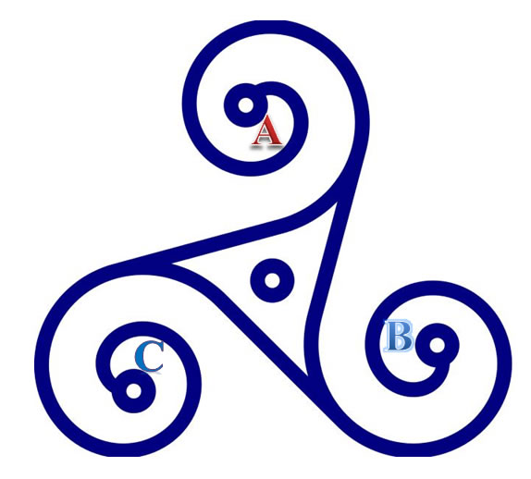
Figure 35 -the Triple-f-Spirals, A-B-C
There are three spiraling forces of change: A-projects, B-tools, and C-choice-point-decisions. The above drawing is three connected f-spirals. An f-spiral has a thin pathway and does not have inter-connective complexity of the Q-Spiral you will soon learn about. Here is another f-example from your Savall et al. (2008) textbook, that I will now call the 'f-spiral.' Again it has one-dimension. It appears to be moving from the center to the exterior across three forces of change. And it is how you will walk your way through A-B-C and D of implementing a transformation of the business from where they are now to where they want to be.
This is your DIAGNOSTIC-chart. Ask the 11 D-questions, focusing on the historical Datable moments of the business developmental path since it began, and getting them to extend into the future with strategic discussion of Directionality, Disclosability, Destining, etc.
Those root stems, are what we rhizome watchers call 'tubers.' Your job as a consultant is to do the 4-leaf-clover diagnosis of surface vines and leaves so you can get some sense of what are those tubers that are very much below ground, i.e. those stunted, atrophied roots, and misdirected root-stems that are wasting costs and revenue potential. Cure the roots and the 4-leaf will prosper because it has more resources to play with. Here is the hard lesson: Cure the symptoms and 'tubers' will just root again because the below ground root-stems are just as they were and your surface changes had no fundamental impact on the business. Year-after-year I make this point, but students take off making the first surface change in the clover leaves they can grasp, and find at the end of the semester, no real or measurable changes occurred. There is a new brochure, a Facebook page, etc., but the tubers are still atrophied, producing just as many dysfunctions as before.
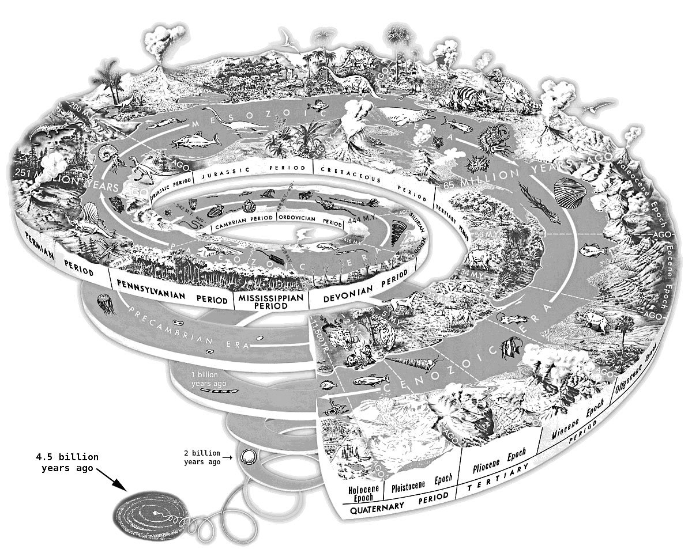
Figure 36 - Illustration of minimal f-spiral evolving and transforming into robust Q-Spiral of higher complexity
This is how it works. You create a spiral-path through the A-B-C axes, beginning with a comprehensive 4-leaf clover diagnostic, and beginning to ask the initial Quantum Storytelling D-questions. You begin to knit together an f-spiral. I have put together a special visual, a kind of a quantum spiral map, and all you need to do is implement, one step at a time.
Here is an animated look at moving from low-density f-spiral to high-complexity Q-Spiral, and back again.
Figure 37 - from simple f-spiral to complex and inter-connected Q-Spiral, and back again

Chapter 14: Wrap Up of Quantum Storytelling?
Storytelling is defined as speech acts, material actions, and is comprised of narratives of the past, living stories unfolding in the Present, and four types of antenarrative bridge between the living stories and the narratives. It is the inter-activity of three modes: (1) narratives of the past, (2) living stories in-the-middle, in the Present, and (3) antenarrative trajectories connecting narrative and living stories in four different ways (linear-, cyclical-, spiral-, and rhizome-antenarratives). Sorting out the future of a business brings you into choices of antenarrative. It is these spiral-antenarratives that is the basis of the Triple-Spiral business consulting model. Your job as a consultant is to record the living stories unfolding in the Present of your client, and how the living story gets emptied out into dominant narratives of the past. Then, you are to look at the spiral-antenarrative connections (A, B, C) in course model that can help the business shack off its stuckness in the 4-leaves of dysfunction and atrophy, and the then grow the below ground root-stems (called rhizome-antenarrative).
- What is narrative? It is backward-looking, and then projects that backward look onto the future as a prediction. You can ask about 'datability' the most significant 'datable' moments from the birth of the business to now. A datable moment is like your birthday, your graduation date, etc. It stands out from all the routine dates you forget about. Narrative, however, is often a linear plot, with a beginning, middle, and end (BME), and most often just does not work. Why? Because we life in a non-linear world, and the past does not always predict the future
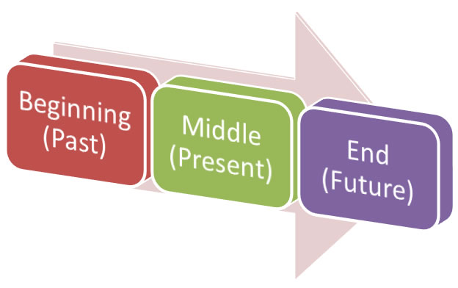
Figure 39 - BME linear narrative
Beginning-middle-end narratives causal chains of the past are predicted by the naive to repeat into the future (a very bad bet as a consultant or business person). We live in a non-linear world, and the next three are about that. The worst consulting persuades clients to do linear processes in a non-linear world.
- What is living story? A living story unfolds in-the-middle, is relational to many other living stories, and living stories are about Being-in-the-world, in a life path of a life. Since it is in-the-middle living story does not always have beginning or the end narrative demands. A living story has a place, a time, and a materiality. Some say it has a spirt, an aliveness. But it is not a place that is Euclidian, nor a time that is clocktime, or a materiality that is Newtonian physics. A living story is about Being-in-the-world of life, it is a time-future arriving into the Present, and a mattering Boje calls 'quantum' where our living stories are intra-active and inter-action with the materiality of living things. Living stories are about the life-path, unfolding, and it can involve futuring.
- What is Antenarrative Boje (2001) created the term and theory. Antenarrative defined as a 'before' narrative coheres, and a 'bet' on the future an how livings stories of your client are related to grander (one-voiced, abstract, monologic) narratives. Four ways of antenarrative bridge living story with narrative:
  - 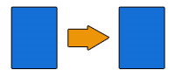Linear-antenarrative process link between living stories emptied out to create a linear-antenarrative of the past that is predicted to repeat into the future. People assume linear causality, but it is rarely so.
  - Cyclic-antenarrative process have stage-by-stage pasts that are predicted to repeat into the future. But most cycles, try as we might to control them, become spirals. If we could predict business cycles, we would all be rich. Instead the veer out of that presumed control, which is why we need two more types. We also live in non-linear, and non-cyclic landscapes, and the next two are about that. The worst consultants do not even realize cycles are not all there is.
  - Spiral-antenarrative process that is from the future into the Present, and into the past. This is a radical approach to spacetimemattering. There are 11 D-questions in Boje's YouTube film on blacksmithing businesses. the 9th question is about Drafts (up and down drafts) of spiral-antenarratives. Spiral-antenarratives can be a good thing or a bad thing. It just depends. An updraft into more innovation, more freedom, and the business becoming its whole Self can be very good. A down-fall into the tighter orbits that plunge into the abyss, not such a good thing. Spiral-antenarratives have trajectories, and each twirl can have choice-points where more spiraling-antenarratives trajectories form cross-roads or pathway choices.
  - 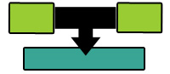Rhizomatic-antenarrative process is also from future into the Present, and into the past. A rhizome has above ground vines, and below-ground (subterranean) roots. Vines and roots are moving, create new rhizomes. 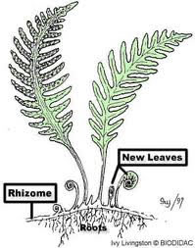(Figure 39) They move any which way in a multiplicity of directions until met by a blockage, and then move up, over, under, or around. We won't do much on this one. Rhizomes can be a good thing, or a bad thing; depends on how you harvest them, what you do with them when they invade your landscape. You already know what a rhizome is. It is those above ground wilting leaves, and vines and runners along the surface, and it is those root-stems below ground making new tubers, six of which are quite common and you know them all too well.
Figure 40 - Rhizomatic movement (source)
  - Composite spirals that have linear-, cyclical-, and rhizomatic-antenarrative processes is what we are focused upon in our business consulting.

The purpose of this next section is to answer your questions as they come up in class or in emails.
Some Answers to questions
What does a SEAM consultant do? They listen, take notes, make observations, and take more notes in their storytelling notebooks. If that does not work out for you. If you can only do lists, and not catch verbatim conversation, then tape record, and transcribe, of better yet, film the D's are they are happening in the business.
These lecture notes and study guide are the basis of Exam questions. You can scribe (but not paste) concepts and answers into your Storytelling Notebook. (Click on Mgt 448 student LaToya Garcia's image for larger size).
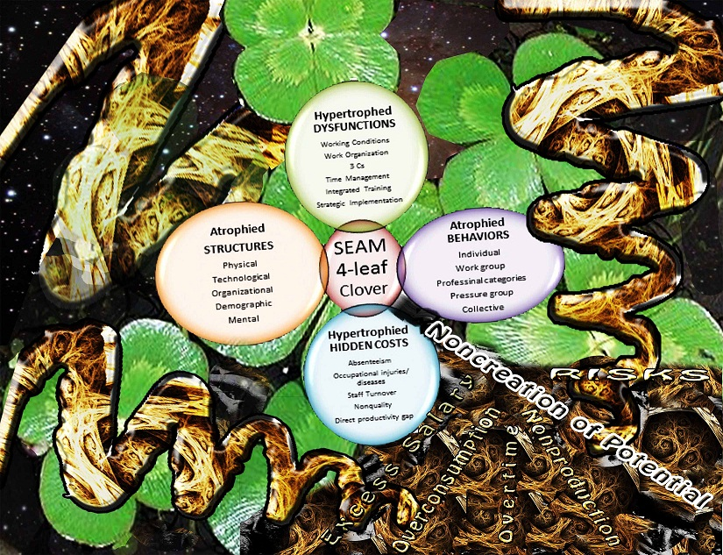
Figure 41 - Tonya Garcia’s graphic of the 4-leaf with spiraling Axes and below-ground tuber root-stems (used with permission of artist).
Click here for larger image |
HOW IT ALL FITS TOGETHER? THE 'ACTION INTERVENTION'
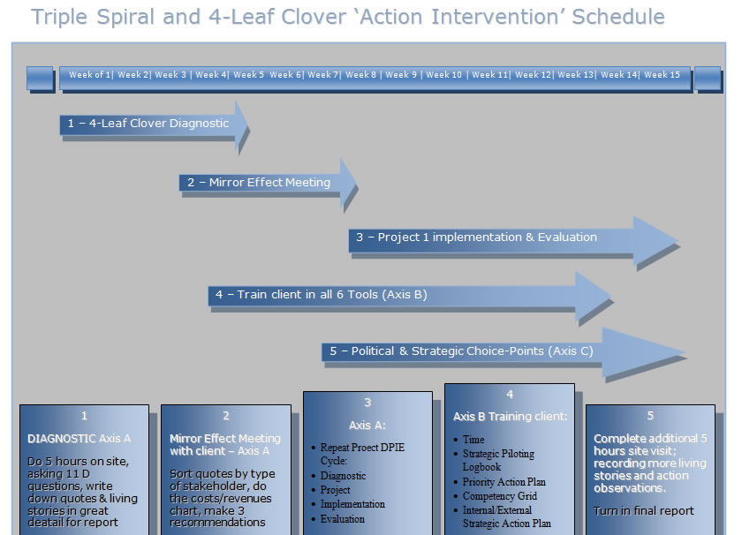
Figure 42 - Implementation Diagram - Boje (2012)

Click here for Word version of this chart to fiddle with for your report.
Yes, it begins as a minimalist f-spiral connecting the A, B, and C f-spirals, and with the 11 D's you and your client are walking that passageway to transformation to Q-Spiral of high structuration and complexity, making that upward-Q-Spiraling-trajectory together, and producing lots of off-shoot fractal-spirals.

Chapter 15: Storytelling Standpoint Methodology
The point of this chapter is that we cannot isolate our ways of Being-in-the-world, from our storytelling standpoints. Human storytelling, geometric storytelling, material storytelling, and quantum storytelling are quite different standpoints when it comes to sustainability. As the consultant, for example, interacts with the client, there are living stories of not only humans, but other storytelling animals, geometric storytelling (lines, cycles, spirals, & rhizomes drawn as images), material storytelling, and quantum storytelling. And when it comes to taking a storytelling standpoint on the sustainability of natural environment, each storytelling standpoint constitutes a different answer to ‘what is sustainability?’
Table 4 – Types of Storytelling Standpoints a
STANDPOINTS: | Type of Narrens | Authors | Main claim
Human Storytelling | Homo narrens | Fisher | Storytelling is from human perspective
Animal Storytelling | Animal narrens | Cajete | Animals have storytelling capabilities
Geometric Storytelling | Geometric narrens |  | Management’s geometric storytelling images substitute for what the senses cannot grasp in spacetime
Material Storytelling | Material narrens | Strand | Material storytelling is a posthumanist approach to intra-penetration of materiality and storytelling privileging Bohr
Quantum Storytelling | Quantum narrens | Boje | Quantum storytelling is a posthumanist approach to intra-penetration of materiality and storytelling privileging Heisenberg

Human Storytelling Standpoint – One of the most dominant storytelling standpoints is ‘homo narrens’ defined here as the narcissistic declaration that only humans are capable of storytelling. In ‘human storytelling’ standpoint we would only look at ‘speech acts’ (verbal acts & text acts of writing), and perhaps some ‘geometric storytelling’ from the human storytelling standpoints. Anyone who has ever been a companion to a dog, cat, horse or other animal, knows each animal has its own storytelling capacity.
Walter Fisher’s (1984, 1985a, b, 1989) Narrative Paradigm Theory (NPT) is an example of ‘homo narrens’ and the human storytelling standpoint. NPT is a rationalistic mental representation narrative-mirror-model of storytelling that argues that people as ‘storytelling animals’ attempt to tell a ‘credible,’ comprehendible, and ‘coherent’ stories in a ‘storytelling world’ that has ample story-listening and story evaluation competencies To me, there is a double move by NPT, first to impose narrative-form onto story stuff, and second to reduce reflexivity to model seeking. According to NPT people (storytelling animals) tell stories by giving them narrative-mental-situation-models of people, objects, actions (events), and places (locations). In short, Fisher’s NPT aims at representationalism.
To me, Fisher’s NPT is incommensurate with Walter Benjamin’s (1936) theory of the death of story competences. Benjamin assumes that such competencies have eroded significantly). Despite protests that NPT is often presented as an alternative to rational choice models, I will argue that Fisher’s theory is nevertheless one of ‘narrative rationality’ that is akin to monologic. People make claims (of cause-effect relations, not as in rational Critical Thinking, but in narrative thinking), giving grounds (evidential reasoning, observations) for their warrants (bridging between grounds and claims). These grounds, claims, and warrant come from renditions of stories with slants of history, attributions, perceptions, values (rooted in cultural context), and character (stereotypes) of other people. For Fisher, there are two tests of ‘narrative rationality’: probability and fidelity of stories that gird decisions about to be made, or already made.
Probability is defined as people’s inherent storylistening skill or competence in evaluating stories and storytellers. Is this story probable or some kind of lie or fantasy?
Fidelity is defined as storylisteners comparing and evaluating what they hear in someone else’s story against their own similar experiences and belief systems.
One critique of the human storytelling standpoint, and NPT in particular, is “not all human discourse follows the story form and his reference to the subtext of the speaker's or writer's own narratives is less than compelling. Further, he fails to specify how critics are to make their choices between narrative probability or fidelity, and provides no criteria for testing narrative probability… Finally, the logic of good reasons is inadequately developed, as it fails to consider how values can be presented in argument and, once presented, how the ‘relative worth’ of one value can be evaluated against that of another.”
My own critique is that NPT does not distinguish between (1) storyable and unstoryable events, such as trauma, or (2) the differences, and possible retrogression of storytelling and storylistening competencies, or (3) the implications of polyphony on a world of stories and storytelling animals that have been somewhat domesticated by narrative-control in late modern capitalism. Finally, I think that probability (believability) and fidelity (coherence) is not the same thing as authenticity and substance.
Animal Storytelling Standpoint - The alternative to ‘homo narrens’ and ‘geometric narrens’ is ‘storytelling animals’ standpoint, which is defined here as declaring humans to be one of many types of animals that are engaged in storytelling. This raises a problem for sustainability. Is ‘human storytelling’ standpoint a break with vital existence of a nature-approach to environmental sustainability? Human storytelling sets up an ontological gap with other ‘storytelling animals’ which native American scholars do not agree to (e.g. Cajete, 2000; Fixico, 2000; Vizenor, 1994, 1998, 1999; Twotrees, 1997, 2000). Cajete (2000) for example, rejects the Western ‘human storytelling’ charge of ‘animism’ as being anthropocentric, because many Native American scholars view nature in a Posthuman storytelling, where humans are only one of many animal species.
Geometric Storytelling Standpoint – The most popular contemporary storytelling standpoint is ‘geometric storytelling,’ defined as constructing visual images (in drawings, or computer screens) of organizational processes (e.g. PERT, product cycles, organizational life cycle, upward civility spiral, upward knowledge spiral, upward spiral of capitalism, downward spiral of capitalist exploitation of Third World, downward interorganizational joint-venture-conflict spiral, downward inefficacy spiral, the integrated directionalities of up and down globalism and organizations in Q-Spirals, the rhizomatic network assemblages). Most of the work in geometrical storytelling in organization consulting creates visual images of the invisible processes of organization and their environment. We cannot see organizational or environmental space, so the visual images are drawn as surrogates. The problem is this sort of ontology, has consequences for how sustainability is treated. There are four types of causal patterns in the adaptation of business to what Emery and Trist (1965) call the causal-texture of their environment: Linear, cyclic, spiral, and mutual (aka assemblage) causality. Here you are looking at all four, but in particular at the spiral causality, and how to create up-surge-spiral of the business within its causal-texture environment. For more on types of causality click here.
Material Storytelling Standpoint – ‘Material narrens’ problematizes the ‘homo narrens,’ ‘geometric narrens,’ and ‘storytelling animals’ standpoints, in declaring a different posthumanist standpoint. In Stand’s (2011, 2012) work on developing ‘material storytelling’ (following Barad’s dismissal of Heisenberg, in favor of Bohr), materials are intra-active with storytelling. Barad (2003, 2007, 2011) looks at the intra-activity of discourse and materiality, was a way to overcome the Cartesian divide. To the point, ‘material storytelling’ standpoint of Strand (2011, 2012) follows Barad (2003, 2007) in declaring a posthumanist quantum perspective rooted in Niels Bohr, and Strand (2012) declared Boje’s work in storytelling privilege Heisenberg.
Quantum Storytelling Standpoint – Therefore, within ‘material narrens’ there is a fundamental disagreement between Strand’s ‘material storytelling’ and Boje’s Boje (2012a, b, c, d, f) ‘quantum storytelling’ standpoints because Strand favors Niels Bohr and Boje, Werner Heisenberg. Boje’s ‘quantum storytelling’ accepts Barad (& Strand’s) intra-activity of storytelling (discourse) with materiality, however Boje reads Heisenberg’s (1958) Physics and Philosophy, as a posthumanist approach that traces an important genealogy of ‘material ontology’ which, from his standpoint, Strand and Bard are denying. Boje (2012d), in the film and the book (2012f) looks at ontology in a Heideggerian way, in the 11 D’s (Heidegger, 1962, 1999, 2003). Heidegger (1962) uses the term, ‘de-severance’ as way of non-dualizing subject and object. Heidegger and Boje give ontological credence to ‘place,’ to ‘Being-there’ (Dasein). The that Niels Bohr and Werner Heisenberg observed, “depending on the experimental conditions, the same quantum of energy could manifest itself either as a particle— that is to say as a discrete, limited, material body – of as a wave – something immaterial and continuous” (Morin, 2008: 71).
There are six key assumptions of Storytelling Standpoint Methodology:
- Human Storytelling is defined by a combination of action and speech-acts. Storytelling is a process of transformation of the social (Arendt, 1957) and the economic (McCloskey, 1990). Storytelling exists in behavioral actions and interactions (living-story-action) and in dynamic structures that is not always able to be articulated verbally or narrated in words and sentences (narrative text) [Boje, 2008, Boje, 2012e What is Living Story]. The action-storytelling without words occurs before the verbal and textual storytelling. Espoused verbal living-story-heard-and-said usually does not keep up with living-story-in-action.
- Animal Storytelling. Gerald Vizenor (1998) refers to the materiality conveyed by native people in storytelling about their generations living on the land, in a place. Stories connote a special sense of materiality, what Vizenor (1998: 15) calls ‘transmotion’ defined as “that sense of native motion and an active presence, [that] is sui generis sovereignty” and “a reciprocal use of nature, not a monotheistic, territorial sovereignty" (as cited in Boje, Jørgensen, & Strand, expected in print 2013). Gregory Cajete (2000) argues that native storytelling is about the environment, the people’s place in the world alive with living things. For Cajete (2000: 27) participation with its material surroundings gives “animism” a modern human sensibility: “indeed all humans are animists" (as cited in Boje, Jørgensen, , & Strand, expected 2013). For Cajete, animism is [posthumanist] attention to interdependence of humans with “elegant cycles of metamorphosis, transformation, and regeneration that form the basis of all life on Earth” (ibid, Boje, Jørgensen, , & Strand).
- Material Storytelling People act towards material-things and each other on the basis of storytelling-in-action and storytelling-in-speech-acts. Strand (2011, 2012) for example, develops her ‘material storytelling’ theory, method, and intervention-praxis by looking at the intra-activity of Boje’s (2001, 2008) storytelling with material things. Living story therefore has agency: “in this sense, community itself becomes a story a collection of individual stories that unfold through the lives of the people in that community” (Cajete, 2000: 95) [ibid. Boje, Jørgensen, & Strand]. Boje, Durant, Coppedge, Marcillo-Gomez, and Chambers (2011) argue that 'storytelling materiality' includes the working conditions and environmental adaptation. Therefore to storytelling being a combination of action and speech-acts, we add now 'materiality' not in its Newtonian mechanistic physics, but in all its quantum-ness Boje, 2012 d, e, f).
- Quantum Storytelling - meanings and interpretations are modified over spacetime in a negotiated process of social-actor structures and behaviors, in the medium of material-actant-actor interaction (Latour, 2007). Living stories have a place, a time, and depending on the theorist a materiality or mind or aliveness (Boje, 2001, 2005, 2006, 2007, 2008a. b, 2009, 2012a, c, d, e, f; Boje & Baskin, 2010; TwoTrees, 1997, 2000; Tyler, 2010, 2011). Kaylynn TwoTrees says living stories have a place, a time, and a mind. Jo Tyler develops argues living stories in organizations have their own aliveness that interacts with social actors Boje stresses how narrative empties out spacetimemattering out of living story by substituting an abstract schemata, a plot with such general event lines that the living quality of story are discarded like scraps on the editing floor. The consequences among the Lakota for not telling a living story straight is death, because the living story is the survivance of the tribe, the boundaries of places lived and cared for, and the ancestors lives in those places. Imagine if telling a living story had such ethical answerability and consequence in the business world.
- Storytelling can be the basis of Socioeconomic Consulting Praxis. With the three assumptions, we can now relate Storytelling Standpoint Methodology to Savall, Zardet, and Bonnet (2008: 124) Four-leaf Clover Socioeconomic Diagnostic of intervention consulting. Obviously storytelling is 3C's and storytelling is strategic impementation, but storytelling permeates every other aspect of the 4-Leaf clover.
Storytelling meanings and interpretations of action in the 4-Leaf Clover Diagnostic pertain to Dysfunctions (Working Conditions; Work Organization; 3C’s: Communication, Coordination, & Cooperation; Time Management, Integrated Training, & Strategic Implementation), in Behavioral Action (Individual, Work group, Professional categories, Pressure group, & Collective action), in Structures (Physical material, Technological processes, Organizational structuration, Demographic, Mental structures), and in Hidden Costs and Economic Performance Consequences of the Enterprise (Excess salary, Overtime, Overconsumption, Nonproduction, Noncreation of Potential, & Risks).
- Geometric Storytelling e.g. PERT line charts and Cycles become spirals, which the storytelling more or less accurately reflects. Many joint interactions get routinized into cycles of behavioral action that are repeated in more-or-less predictable ways. Living-story-action can be at a gap with articulated storytelling in speech acts (verbal or textual). The verbal storytelling may not match the action-storytelling. Living-story-action-cycles repeating over space-time-mattering results in predictions of future cycle processes. As cycles veer out of repetition of same frequency, intensity, and sequence of stages, those cycles is more accurately described as ‘spirals.’
- Quantum Storytelling - the collective enterprise is adaptive to its environment, which is also changing. That environment is comprised of at least three dimensions: landscapes, timescapes, & materialscapes). Storytelling Organizations are intra-active and intra-penetrated with those three environmental dimensions. As Deleuze (1994) argues, the spiral moves to the left and to the right, in its trajectory.
Storytellers (Benjamin, 1937) are interpreters of the complexity dynamics of the socioeconomic enterprise and its direction of trajectory through its environment. Storytellers interpret how the action-flow of spiral, its cycles of sameness and difference is both a continuing and a changing process. As people become familiar with cycles of action, they come to anticipate and predict their future repetitions. Rather than dualize cycle and spiral, our approach is to look at cycles of action that along with lines of action, constitute spirals of action in interaction with the environment.
GRAND TOUR QUESTIONS | HUMAN Storytelling | ANIMAL Storytelling | GEOMETRIC Storytelling | MATERIAL Storytelling | QUANTUM Storytelling
HUMAN Storytelling | Describe in detail all the human storytelling | What are all the ways human storytelling organizes animal storytelling? | What are all the ways human storytelling organizes geometric storytelling? | What are all the ways human storytelling organizes material storytelling? | What are all the ways human storytelling organizes quantum (spacetimematter) storytelling?
ANIMAL Storytelling | What are all the ways animal storytelling organizes human storytelling? | Describe in detail all the animal storytelling | What are all the ways animal storytelling organizes geometric storytelling? | What are all the ways animal storytelling organizes material storytelling | What are all the ways animal storytelling is organized by quantum (spacetimemattering) storytelling?
GEOMETRIC Storytelling | What are all the ways geometric storytelling organizes human storytelling | What are all the ways geometric storytelling organizes animal storytelling? | Describe in detail all the geometric storytelling? | What are all the ways geometric storytelling organizes material storytelling? | What are all the ways geometric storytelling is organized by quantum (spacetimemattering) storytelling?
MATERIAL Storytelling | What are all the ways material storytelling organizes human storytelling? | What are all the ways material storytelling organizes animal storytelling? | What are all the ways material storytelling is depicted in geometric storytelling (charts, images) ? | Describe in detail all the material storytelling? | What are all the ways material storytelling is used in quantum (spacetimemattering) storytelling?
QUANTUM Storytelling | What are all the ways quantum (spacetimematter) storytelling organizes human storytelling? | What are all the ways quantum (spacetimematter) storytelling organizes animal storytelling? | Where are all geometric storytelling places where quantum (spacetimemattering) storytelling occurs? | What are all the ways quantum (spacetimemattering) storytelling incorporates material storytelling? | Describe in detail all the quantum storytelling?

Consulting Steps in Spiral of Action Process Intervention
Step One: Use Storytelling Standpoint Method in Diagnostic of the nature of cycles of action. This begins with detailed description of the complexity dynamics of the cycles of action processes of Q-Spiral by constant probing and noticing the behavioral actions of persons in relation to each other and to material-things. As Anthony Giddens (1984) asserts, people in such cycles may only possess ‘practical’ agent orientation to perform cyclic behavior actions (i.e. ‘action’ knowledge), they may not be able to do verbal-storytelling to others (i.e. ‘discursive’ knowledge) of the meaning. People participate in action-storytelling, in the living stories of their work groups’ and organization’s gestures, doing cyclic routines repeatedly, but can be unable to put that storytelling into words. Therefore the consultant needs to directly inspect the cyclic process, for is behavioral action and interaction assemblage, in its action-living-story-processes. In this way the living-story-action is the gestures and behaviors, before the words of storytelling are articulated verbally.
Step Two: Use Storytelling Standpoint Methodology to Trace ways cycles exist in spirals of action. This begins with noticing how cycles of action. The living-story-behavioral-processes are changing during the timescape of a spiral. Stages are not the same from one repetition of a cycle to the next. The stages themselves can vary, their length, intensity, and sequence can vary from one cycle to the next, which is by definition what makes cycles of sameness become cycles of difference in the life of a spiral. Living story interpretation as action processes are modifying as the Q-Spiral cycles traverses its environment. Environment is constituted by timescape, landscape, and materialscape. In Naturalistic Storytelling Inquiry, the point is not to fly high above the ground, rather to touch down and do grounded observation, interaction, questioning, probing, in an iterative fashion. Analytic schemes that presume cycle stage, frequency, intensity, and sequence from cycle-to-cycle-repetition is sameness may be flying too high, using templates that are gross abstractions, imposing analytic schemata and thematics that are too general.
Storytelling Standpoint Methodology includes you as the Observer-inside-the-Intervention.
"The observer is part of the system of description; his/her language is one among several possible others" (van Foerster, 1981, as cited in Antonacopoulou & Tsoukas, 2002: 858). The 'quantum storytelling' video on blacksmithing business processes is something I presented at Hari Tsoukas' Process Conference (June 2012). Along with the living stories, include yourself, your voice and stance as Observer who is also Intervening. According to the Quantum Physics of Storytelling (Boje), the observer just by observing is intervening in the process, so might as well stand answerable for it, and include that in your living storying. This is know as your personal reflection on what is happening. See Boje's YouTube film on blacksmithing businesses
"Moreover, if it is accepted that the observer is not detached from the system observed, then the observer should indeed get as close to the system as possible, for only in that way, will its internal life an development be properly understood" (Antonacopoulou & Tsoukas, 2002: 859).
As an engaged consultant-observer-intervener, you can take notice of the spiral-temporal-existence of processes making up the business in relation to its environs. The living stories get close to the historicity of the flux of the worldhood-environment of the business. Worldhood means in-Being, you-as-observer in-Being-with-the-client, in the flux of that worldhood, the shaping of that flux, the possibility of radical novelty as it moves out of linearity, out of circularity, into spiral-antenarrative time and space (that is not clocktime, and not the geometry of container within container).
A narrative uses linear chronological time (clock time) and ignores the "experienced time" of what Henri Bergson ( ) calls the Durée, defined as the duration-experience of time in the immediate present, in the Now, and in all the accumulated Nows that have been. Duration, as the film on blacksmithing depicts, is about meaningful time, about events that are dateable because they are significant in the living story of the enterprise.
An antenarrative is about the future (Boje, 2001, 2008, 2012a). A spiral-antenarrative includes something more than reflecting upon history of Now-after-Now, gone by. Rather, a spiral-antenarrative includes what Heidegger (1962) calls fore-telling, and fore-having. A spiral is the future informing the present, being present. It is not just retrospective sensemaking, it is rather quite prospective. There are 'bets' (antes) that are predictions of the future. And there are anteriorities (antes) that are the future in an array of possibilities. It is that anteriorly that is most fascinating to trace in the spiral-antenarrative. The spiral-antenarratives is the dynamics of real-life-organizing-processes, once you can get past the tendency to reduce the flux to an abstract-linear-narrative in your report writing.
You are invited to investigate, document, and intervene in the spiral-antenarrative, with the participants of the business client. Spiral-time is from future to the present, and should not be confused with linear time for past to present to future. As Heidegger puts it, it is future ahead-of-itself, encountered in familiarity. So please have some meaningful encounters with the spiral, be engaged as an intervention-consultant using the SEAM methodology. Immerse yourself in the enterprise's life-world, the worldhood of the business you are consulting also includes the environment surrounding the business, its landscape, timescape, and materialscape. Reflect (with reflexivity) on the spiral path of the business through its environment (in all three dimensions).
Keep in mind that, as Hassard (2000) says "our conception of time are necessarily time-dependent and historically conditioned" such as the clock time so instrumental to Western capitalism, and a crucial instrument of standardization, planning, and control. With the advent of postmodern communication technologies (laptop, cell phone, iBook, etc.) we are witness to the compression of space and time. Your living story experiences of the different conceptions of time (clock time, subjective time, experienced time, compressed time, etc.) will allow you to tune into the ways the business processes are non-linear, occurring in a time that curves, that cycles back on itself, and sometimes is spiral-antenarrative.

References
Adam, B.; & Kutting, G. (1995). Time to reconceptualize `green technology' in the context of globalization and international Relations. Innovation: The European Journal of Social Sciences, Vol. 8 Issue 3, p243-259. Click here if you have EBSCO account for pdf.
Andersson, L.M., Pearson, C.M. (1999). Tit for tat? The spiraling effect of incivility in the workplace. Academy of Management Review, 24: 452 – 471.
Arendt, Hannah. (1958). The Human Condition. Chicago/London: The University of Chicago Press.
Barad, K. (2003). Posthumanist performativity: Toward an understanding of how matter comes to matter.” Journal of Women in Culture and Society. Vol. 28 (3): 801-831). On line at http://www.kiraoreilly.com/blog/wp-content/uploads/2009/06/signsbarad.pdf
Barad, K. (2007). Meeting the Universe Halfway: Quantum Physics and the Entanglement of Matter and Meaning. Durham/London: Duke University Press.
Beck, D. E. &; Cowan, C. (2005). Spiral Dynamics: Mastering Values, Leadership and Change. NY: Wiley-Blackwell.
Benjamin, Walter. (1936/1955/1968). "The Storyteller: Reflections on the Works of Nikolai Leskov." Pp. 83-109 in Walter Benjamin Illuminations, Hannah Arendt (ed.) was first published in 1936 (Orien Und Okzident); again in 1955 in German, and 1968 is the first English translation. NY: Harcourt, Brace, and World, Inc.
Boje, D. M. (1991). Organizations as Storytelling Networks: A Study of Story Performance in an Office-Supply Firm. Administrative Science Quarterly, Vol. 36, pp. 106-126. http://business.nmsu.edu/~dboje/papers/Boje_Storytelling_ASQ_1991.pdf
Boje, D. M. (1995). Stories of the Storytelling Organization: A Postmodern Analysis of Disney as 'Tamara-land.' Academy of Management Journal. Vol. 38(4): 997-1035. http://business.nmsu.edu/~dboje/papers/DisneyTamaraland.html or print out the PDF version
Boje, D. M. (1999). Nike, Greek Goddess of Victory or Cruelty? Women's Stories of Asian Factory Life." Journal of Organizational Change Management, Vol 11 (8): 461-480. http://business.nmsu.edu/~dboje/papers/BojeVol11and6NikeGREEKgoddess.htm
Boje, D. M. (2001). Narrative Methods for Organizational & Communications Research. London: Sage.
Boje, D. M. (2005). Wilda. Journal of Management Spirituality & Religion, Vol 2 (3): Article: 342-364, Epilogue: 399-405. (with accompanying commentaries by Eduardo Barrera, Heather Höpfl, Hans Hansen, David Barry, Gerald Biberman, Robin Matthews & John W. Bakke).
Boje, D. M. (2006).Breaking out of Narrative's Prison: Improper Story in Storytelling Organization. Storytelling, Self, Society: An Interdisciplinary Journal of Storytelling Studies. Vol 2 (2): 28-49.
Boje, D. M. (2007). Chapter 17: Globalization Antenarratives. Pp. 505-549 in Albert Mills, Jeannie C. Helms-Mills & Carolyn Forshaw (Eds). Organizational Behavior in a Global Context. Toronto: Garamond Press (accepted 2005). Click here for older version of this chapter. here is better formatted pdf version.
Boje, D. M. (2007a). Chapter 13 Living Story: From Wilda to Disney, pp.330-354. Handbook of Narrative Inquiry: Mapping a New Methodology. Edited by Jean Clandinin, London: Sage.
Boje, D. M. (2008a). Storytelling Organizations. London: Sage.
Boje, D. M. (2008b, Ed). Critical Theory Ethics For Business and Public Administration (Charlotte, NC: Information Age Press
Boje, D. M. (2009). Excess of history and dance of narrative with living story noticing. Tamara Journal of Critical Organization Inquiry. Vol 8 (1): 80-94.
Boje, D. M. (2010). Sideshadowing Appreciative Inquiry: One Storytellers’ Commentary. Journal of Management Inquiry. Reflections on Experience section of Journal of Management Inquiry, a commentary on “Appreciative inquiry as a shadow process” (Fitzgerald, Oliver, & Hoxsey, 2009). for September issue. View pre-press pdf
Boje, D. M. (2011, Ed). Storytelling the Future of Organizations: An Antenarrative Handbook. NY/London: Routledge.
Boje, D. M. (2012a). Reflections: What does Quantum Physics of Storytelling Mean for Change Management? Journal of Change Management, accepted 7/22/2011, waiting to appear in print in 2012. Click here for pre-press PDF.
- Boje, D. M. (2012b). Boje seminars on Quantum Storytelling in Lille France March 2012. At http://peaceaware.com BBA How to storytelll seminar salle 556 Lundi 8AM - midi Mars 19th
- Doctoral and FacultyFerronnerie d'art seminar salle 623 Mardi 5:15 PM - 7:15 PM Mars 20th
- Advanced Seminar in Storytelling Methodology seminar 623 Jeudi 9AM - midi Mars 22nd

Boje, D. M. (2012c). "The ♥-of-Care of the Life-Path of Organizations through Landscapes of Quantum Fields", working paper on http://peaceaware.com
Boje, D. M. (2012d). , Quantum Storytelling: Blacksmithing Art in the Quantum Age, Film premier at Aalborg University Denmark May 30 2012 lecture to faculty, and was basis of Keynote address took place 23 June 2012 to the 4th International Symposium on Process Organization Studies; Theme: Language and Communication @ Work: Discourse, Narrativity and Organizing, 21-23 June 2012, Kos, Greece. Use either YouTube http://www.youtube.com/watch?v=a7pm_mRwL-0 or NMSU College of Business website at
http://business.nmsu.edu/2012/05/20/quantum-storytelling-blacksmithing-art-in-the-quantum-age/
Boje, D. M. (2012e). What is Living Story. Working paper on http://peaceaware.com
Boje, D. M. (2012f). Quantum Storytelling. Free online book (until it gets finished with its revisions, and a publisher calls).
Boje, D. M. (2012g) Quantum Spirals for Organization Consulting. Online book until it gets a publisher.
Boje, D. M.; Baskin, K. (2010). Dance to the Music of Story: Understanding Human Behavior through Intervention of Storytelling and Complexity Thinking. Litchfield Park, AZ: Emergence Publications.
Boje, D. M.; Dennehy, R. 1993/2008. Managing in the Postmodern World: America's Revolution Against Exploitation. 2008 edition Charlotte, NC: Information Age Press; 1st & 2nd edition, Dubuque, IA: Kendall Hunt Publishing, 1993, 1994 349 pages. 1994 2nd Edition. Kendall Hunt Publisher. Instructional materials online at http://business.nmsu.edu/~dboje/mpw.html
Boje, D. M.; Durant, Ivy; Coppedge, Krisha; Marcillo-Gomez, Marilu; & Chambers, Ted. (2011). Social Materiality: A New Direction in Change Management and Action Research. Pp.580-587 in The Routledge Companion to Organizational Change, Edited by David Boje, Bernard Burnes, John Hassard.
Boje, D. M.; Fedor, D. B.; Rowland, K. M. "Myth Making: A Qualitative Step in OD Interventions," Journal of Applied Behavioral Science, Vol. 18 (1): 17-28.
Boje, D. M.; Gephart, J.; Thatchenkery, T. 1996. Postmodern Management & Organizational Theory. 383 pages. Thousand Oaks, CA: Sage Publications.
Boje, D. M.; Jørgensen, Kenneth Mølbjerg; & Strand, Anete M. Camille. (expected 2013) Towards a postcolonialist Storytelling Theory of management and organization," accepted 9/27/2011 for publication in Journal of Management Philosophy. Click here for pre-press PDF.
Boje, D. M.; Rosile, G. A. (2002). Enron Whodunit? Ephemera Journal, Vol 2 (4), pp. 315-327. On line at http://www.ephemeraweb.org/journal/2-4/2-4bojeandrosile.pdf
Boje, D. M.; Rosile, G. A. (2003a). Life Imitates Art: Enrons Epic and Tragic Narration. Management Communication Quarterly. Vol. 17 (1): 85-125. Pre-publication version at http://business.nmsu.edu/~dboje/theatrics/7/EpicTragicTheatre.pdf
Boje, D. M.; Rosile, G. A. (2003b) Comparison of Socio- Economic and other transorganizational development methods. Journal of Organizational Change Management. Special issue Socio-Economic Approach to Management, Henri Savall (Guest Editor). Vol. 16 (1): 10-20.
Boje, D. M.; Rosile, G. A.; Dennehy, B; Summers, D. (1997). "Restorying reengineering: Some deconstructions and postmodern alternatives." Special Issue on Throwaway Employees, Journal of Communication Research, Vol. 24(6): 631-668.
Boje, D. M.; Rosile, G.A.; Durant, R.A.; Luhman, J.T. (2004) Enron Spectacles: A Critical Dramaturgical Analysis. Special Issue on Theatre and Organizations edited by Georg Schreyögg and Heather Höpfl, Organization Studies Journal ,Vol 25(5), pp 1-24.
Boje, D. M.; Winsor, R. (1993). The Resurrection of Taylorism: Total Quality Management's Hidden Agenda. Journal of Organizational Change Management, Vol. 6, No. 4 1993: 57-70. http://business.nmsu.edu/~dboje/papers/Boje_Winsor_Anti_TQM_1993.htm
Burgelman, R. A. (1996). A process model of strategic business exit: Implications for an evolutionary perspective on strategy. Strategic Management Journal, 17: 193 – 214.
Cajete, G. (2000). Native Science; Natural Lwas of Interdependence. Santa Fe, NM: Clear Light Publishers.
de Certeau, Michel. (1984). Practices in Everyday Life. Translated by Steven F. Rendall. Berkeley/London: University of California Press.
Deleuze, G. (1994). Difference and Repetition. Translated by Paul Patton from French, 1968 text, Difference et Repetition (Presses Universitaires de France). NY: Columbia University Press.
Doppelt, B. (2010). Leading Change Toward Sustainability: A Change-Management Guide for Business, Government and Civil Society (Google eBook).
Emery, F E; & Trist, E L.(1965). The causal texture of organizational environments. Human Relations, Vol. 18:21-32.
Epstein, M. J. (2008). Making Sustainability Work: Best Practices in Managing and Measuring Corporate Social, Environmental and Economic Impacts (Google eBook)
Fainstein, S. B. (2000). New directions in planning theory. Urban Affairs Review, March Vol. 35 (4): 451-478. Accessed July 20 2012 at http://www.oamk.fi/luova/hankkeita/entracop/copack/docs/introduction/theories/literature/Feinstein.pdf
Fixico, D. L. (2003). The American Indian mind in a linear world. NY/London: Routledge.
Gourlay, S. N. (2003).The SECI model of knowledge creation: some empirical shortcomings, in F. McGrath, and Remenyi, D., (Eds.), Fourth European Conference on Knowledge Management, Oxford, 18-19 September, pp. 377-385 http://myweb.tiscali.co.uk/sngourlay/PDFs/Gourlay%202004%20SECI.pdf
Gourlay, S. N. and Nurse, A. (2005). Flaws in the “Engine” of Knowledge Creation: A Critique of Nonaka’s SECI Model, Chapter 13 in Challenges and Issues in Knowledge Management, Buono, A. F., and Poulfelt, F. (eds) Research in Management Consulting Series, Volume 5, Greenwich, Connecticut: Information Age Publishing, pp. 293-315 (ISBN 1593114192). http://myweb.tiscali.co.uk/sngourlay/PDFs/Chap%2013%20GourlayNurse.pdf
Hambrick, D.C., Li, J., Xin, K., Tsui, A.S. (2001). Compositional gaps and downward spirals in international joint venture management groups. Strategic Management Journal, 22: 1033 – 1053.
Haraway, Donna. (1992). “The Promises of Monsters: A Regenerative Politics for Inappropriate/d Others.” In Cultural Studies, ed. Lawrence Grossberg, Cory Nelson, and Paula Treichler, 295–337. New York: Routledge.
Heidegger, M. (1962) Being and Time. Translated by John Macquarrie & Edward Robinson. NY: Harper Row.
Heidegger, M. (1992). History of the Concept of Time: Prolegomena. Translated by Theodore Kisiel. Bloomington & Indianapolis: Indiana University Press.
Heidegger, M. (1999). Ontology – The Hermeneutics of Facticity. Translated by John van Buren. Bloomington & Indianapolis: Indiana University Press.
Heidegger, M. (2003). Four Seminars. Bloomington & Indianapolis: Indiana University Press.
Heisenberg, Werner. (1958). Physics and Philosophy: The Revolution in Modern Science. NY: Harper & Brothers Publications.
Hilary, C.; Kane, M.; & Tagsdell, G. (2003). How might models of innovation inform the management of knowledge. 3rd European Knowledge Management Summer School. 7-12 Sept. Sepastian, Spain. http://www.knowledgeboard.com/download/740/kmss03_29.pdf

Hildreth, Paul. M. and Kimble, Chris. (2002). The duality of knowledge. Information Research, Vol. 8 No. 1, October 2002. On line at http://informationr.net/ir/8-1/paper142.html
Hostager, Todd J.; Neil, Thomas C.; Decker, Ronald L.; & Lorentz, Richard D. (1998). Seeing environmental opportunities: effects of intrapreneurial ability, efficacy, motivation and desirability. Journal of Organizational Change Management, Vol. 11 (1): 11 – 25.
Inkpen, A. C. (1998). Learning and knowledge acquisition through international strategic alliances. Academy of Management Executive, 12: 69 – 80.
Inkpen, A.C.; Dinur, A. (1998). Knowledge management process and international joint ventures. Organizational Science, 9: 454 – 468.
Jørgensen, K. M.;& Boje, D. M. (2010).Resituating narrative and story in business ethics. Business Ethics: A European Review (journal). Accepted January 20, 2010. Click for pre-press pdf.
Kaufman, S.A. (1993). The origins of order: Self-organization and selection in evolution. NY/Oxford: Oxford University Press.
Kaufman, S.A. (1995). At home in the universe: The search for laws of self-organization and complexity. NY/Oxford: Oxford University Press.
Kitaro, Nishida. (1970). Fundamental Problems of Philosophy: The World of Action and the Dialectical World. Tokyo: Sophia University.
Lindsley, D.H., Brass, D.J., Thomas, J.B. (1995). Efficacy-performance spirals: A multilevel perspective. Academy of Management Review, 20: 645 – 678.
McCloskey, D. (1990). On narrative: If You're So Smart: The Narrative of Economic Expertise. Chicago, University of Chicago Press.
McDonough, W. (2000). The Hannover Principles Design for Sustainability Prepared for EXPO 2000 The World’s Fair Hannover, Germany. Accessed July 11, 2012 at http://www.mcdonough.com/principles.pdf
McDonough, W.; Braungart (2002. Cradle to Cradle: Remaking the Way we make things. NY: North Point Press.
Merleau-Ponty, Maurice (1962). Phenomenology of Perception. Translated from the French by Colin Smith. NY/London: Routledge & Kegan Paul.
Morin, E. (2008). On Complexity. Translated by Robin Postel. Cresskill, NJ: Hampton Press, Inc.
Nonaka, I. (1988a). ‘Creating order out of chaos: self-renewal in Japanese firms’. California Management Review, Vol 15, No.3, pp 57-73.
Nonaka, I. (1988b). ‘Toward middle-up-down management: accelerating information creation. Sloan Management Review, Vol 29, No.3, pp 9-18.
Nonaka, I. (1990). ‘Redundant, overlapping organization: a Japanese approach to managing the innovation process’. California Management Review, Vol 32, No.3, pp 27-38.
Nonaka, I. (1991a). ‘The knowledge-creating company’. Harvard Business Review, November-December, pp 96-104.
Nonaka, I. (1991b). ‘Managing the firm as an information creation process ‘. In Meindl, J.R., Cardy, R.L. and Puffer, S.M. (Eds), Advances in information processing in organizations. Greenwich, Conn., London: JAI Press Inc, pp 239-275.
Nonaka, I. (1994). A dynamic theory of organizational knowledge creation. Organization Science, Vol. 5:14 – 37.
Nonaka, I.; Byosiere, P.; Borucki, C.C.; Konno, N. (1994). ‘Organizational Knowledge Creation Theory: a first comprehensive test’. International Business Review, 3, 4, pp 337- 351.
Nonaka, I.; Kenney, M. (1991). ‘Towards a new theory of innovation management: a case study comparing Canon, Inc. and Apple Computer, Inc.’. Journal of Engineering and Technology Management, Vol 8, No.1, pp 67-83.
Nonaka, I.; Konno, N.; Toyama, R. (2001b). ‘Emergence of “Ba”. A conceptual framework for the continuous and self-transcending process of knowledge creation’. In Nonaka, I. and Nishigushi, T. (Eds), Knowledge Emergence. Social, technical and evolutionary dimensions of knowledge creation. Oxford, New York: Oxford University Press, pp 3-29.
Nonaka, I.; Takeuchi, H. (1995). The Knowledge-Creating Company: How Japanese Companies Create the Dynamics of Innovation. Oxford University Press, New York.
Nonaka, I.; Toyama, R. (2003). ‘The knowledge-creating theory revisited: knowledge creation as a synthesizing process’, Knowledge Management Research & Practice, Vol 1, pp 2-10.
Nonaka, I.; Toyama, R.; Byosière, P. (2001a). ‘A theory of organizational knowledge creation: understanding the dynamic process of creating knowledge’. In Dierkes, M., Antel, A.B., Child, J. and Nonaka, I. (Eds), Handbook of organizational learning and knowledge. Oxford: Oxford University Press, pp 491-517.
Nonaka, I.; Toyama, R.; Konno, N. (2000). ‘SECI, Ba, and leadership: a unified model of dynamic knowledge creation’. Long Range Planning, 33, pp 5-34.
Nonaka, I.; Umemoto, K.; Senoo, D. (1996). ‘From information processing to knowledge creation: a paradigm shift in business management’. Technology in Society, Vol 18, No.2, 203-218.
Nonaka, I.; Yamanouchi, T. (1989). ‘Managing innovation as a self-renewing process’. Journal of Business Venturing, Vol 4, pp 299-315.
Nonaka, Imai K.; Takechi, H. (1985) Managing the new product development process: How Japanese companies learn and unlearn. Pp. 337-375 in K. B. Clark and C. Lorenz (Eds.) The Uneasy Alliance: Managing the Technology-Productivity Dilemma. Boston: Harvard Business School Press
Pearson, C.M.; Porath, C.L. (2005). On the nature, consequences and remedies of workplace incivility: No time for “nice”? think again. Academy of Management Executive, 19: 7 – 18.
Polanyi, M. (1966). The tacit dimension. London: Routledge & Kegan Paul.
Polanyi, M. (1969). ‘Knowing and Being’. In Grene, M. (ed.), Knowing and being. Essays. London: Rutledge & Kegan Paul.
Sandberg, J.; Tsoukas, H. (2011). Grasping the logic of practice: Theorizing through practical
rationality. Academy of Management Journal, 36: 338-360.
Savall, H.; Zardet, V.; Bonnet, M. (2008). Releasing the Untapped Potential of Enterprises Through Socio-Economic Management. ISBN 978-2-917078-12-9 2nd Revised edition, 2008. London: International Labor Organization and Socio Economic Institute of Firms and Organizations.
Sheldrake, Rupert. (1988). The Presents of the Past: Morphic Resonance and the Habits of Nature. NY: Random House, Inc. (Times Books). Reprinted by Rochester, VT: Park Street.
Sheldrake, Rupert. (1995). A New Science of Life: The Hypothesis of Morphic Resonance. Rochester, VT: Park Street Press.
Strand, Anete Mikkala Camille. (2011). Presentation on ‘material storytelling’ to 20th anniversary meeting of sc’MOI, meeting in Philadelphia, April.
Strand, Anete Mikkala Camille. (2012). Enacting The Between: On Dis/continuous intra-active Becoming of/through an Apparatus of Material Storytelling. Unpublished Doctoral Dissertation, Aalborg University, Denmark. Books 1 and 2 are online
Tsoukas, H. (1999). David and Goliath in the Risk Society: Making sense of the conflict between Shell and Greenpeace in the North Sea. Organizations, Vol 6 (3); 499-528. http://thomas.reverdy.free.fr/Brent%20Spar.pdf
Tsoukas, H. (2003). ‘Do we really understand tacit knowledge?’. In Easterby-Smith, M. and Lyles, M.A. (Eds), The Blackwell Handbook of Organizational Learning and Knowledge Management. Malden, MA; Oxford: Blackwell Publishing Ltd, pp 410-427.
Twotrees, K. (1997). Presentation at the Organizational Behavior Teaching conference, meeting at Case Western Reserve, Ohio.
Twotrees, Kaylynn. (2000). Seven Directions practice: A Practice for the Crossroads, The Fourth R (Vol. 92, August, Sept, October) published by CRENet (Conflict Resolution in Education Network).
Tyler, J. (2010). Story Aliveness. Chapter 3, Pp. 61-81 in D. M. Boje and Ken Baskin (Eds.) Dance to the Music of Story: Understanding Human Behavior through Intervention of Storytelling and Complexity Thinking. Litchfield Park, AZ: Emergence Publications.
Tyler, J. (2011). Living story and antenarrative in organizational accidents. Pp. 137-147 in Boje (ed) Storytelling and the Future of Organizations: An Antenarrative Handbook. NY/London: Routledge.
Tyler, Jo A.; Boje, D. M. 2008. (Accepted Aug 2008) Sorting The Relationship of Tacit Knowledge to Story and Narrative Knowing. Dariusz Jemielniak, Leon Kozminski and Jerzy Kociatkiewicz (Eds.) Handbook of Research on Knowledge-Intensive Organizations, to be published by Information Science Reference (formerly Idea Group Reference), an imprint of Idea Group Inc., www.idea-group-ref.com, in 2008. Click here for pre-press pdf
Vizenor, Gerald. (1994). The ruins of representations: Shadow survivance and the literature of dominance. Pp. 139-67 in Alfred Arteaga (ed) Another Tongue: Nation and Ethnicity in the Linguistic Borderlands. Durham, NC: Duke University Press.
Vizenor, Gerald. (1998). Fugitive Poses: Native American Indian Scenes of Absence and Presence. Lincoln: University of Nebraska Press.
Vizenor, Gerald. (1999). Manifest Manners: Narratives on Postindian Survivance. Lincoln: University of Nebraska Press. Report of Manifest manners: Postindian Warriors of Survivance. Hanover, NH: Weseleyan UP (1994).
Waddington, C. H. (1953). The Epigenetics of Birds. Cambridge : Cambridge University Press.
Waddington, C. H. (1956). Principles of Embryology. London : George Allen & Unwin.
Waddington, C. H. (1957). The Strategy of the Genes. London : George Allen & Unwin.

In Waddington (1953, 1956) original theory, valley positions are superior, but in Kaufman (1993, 1995), as we depicted it in the figure, the peak positions have more fitness advantages.
http://www.answers.com/topic/narrative-paradigm

