A spiral is not just a bent line, as depicted in the simple f-spiral. There is a way to transform a small business by beginning to intervene to construct simple f-spirals, and then work to construct them in inter-weave into what Boje (2012) calls a ‘Q-spiral.’ A Q-spiral has dense inter-connections, fractal-spiral off-shoots on each of the twirls, and is rich in complexity.
Three Dimensions of the Small Business Environment:
- Performance is defined as the outcomes of strategies enacted in the environment. Higher peaks have greater performance opportunities, but steeper peaks have higher costs, and more organizations attempting to get there.
- Landscape is defined as “realistic problem-solving complexity with clarity” (Afuah and Tucci, 2012: p. 357; Kaufman, 1993, 1995). Landscape is spatial in combination of ways: perceptions of space, measured spaces, and meanings of space to participants.
- Timescape is defined as measured time, timing of strategies, retrospective-histories, and anticipated-futures (Adam, 1998).

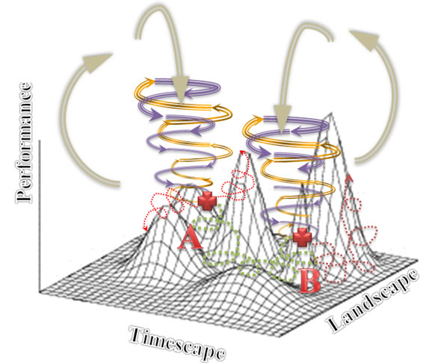
Figure 2 - Strategic moves of Q-spiral in Environment with 3 dimensions (Drawing by D. Boje July 18, 2012)
KEY:
- + Choice-Points where green is trajectory actually taken by organization from point ‘A’ to point ‘B’, and red dotted lines are trajectories not taken yet still remembered what might have been.
- Gold Arrows => Positive directions of organization Spiral Episodes going with flow of environmental updrafts and against the flow of environmental downdrafts
- Purple Lines => Negative directions organization Spiral Episodes going with flow of environmental downdrafts, and against the flow of environmental updrafts
- Green Dotted line => Trajectory in the fitness environment
- Red Dotted lines => Null paths not taken at choice-points
- Silver Arrows => Updrafts and downdrafts of the oscillations in the competitive environment
In the above depiction, for example, a business Q-Spiral entity traverses in spacetime from Strategy A location to Strategy B location in its environment. Move from A to B did not result in better performance (measured by costs & revenue, market share, etc.). There is a dotted red line from positions A and B, that, looking-back would have been better moves. This is the Null Set of paths through a business environment not taken, but still remembered. Boje, “If I would have written down the 8 orders people wanted, my sales would have increased.”

In the Q-spiral there are connections across whirls (or cycles), and one can jump from cycle-to-cycle, and new spirals always budding, if you want to follow them. The Mandelbrot fractal-spiral is a good visual example of the process of off-shoots, and the inter-linking between twirls. I have turned it into an upward spiral. This is a depiction of space-time-mattering that is not 3D space (length, width, and height), not time as clock or calendar measures, and not mattering as Newtonian physics. Rather this is a Quantum-Spiral, a Q-spiral that has dense multi-stranded passageways between twirls, and in its aliveness is generating fractal-spiral offshoots. We must get beyond the simplistic thin line f-spiral depictions because they are not capturing sufficient actual spacetimemattering quantum complexity. If the model is too simplistic, yes it is coherent, but not all that helpful to the day-to-day Being-in-the-world of a small business with work environment, supplier environment, consumption environment, welfare environment, and Natural environment making up that world (Heidegger, 1962; Boje, 2012).
The f-spiral is loosely coupled, easily breaks up and dissolves. The D-spiral is tightly coupled, but takes a lot more energy to maintain and sustain its rich inter-weave and its off-shoot emergences (e.g. innovations, new directions, new ventures). Over time, without influx of more energy and resources the D-spiral can degenerate into the weak f-spiral. It is part of your consultation diagnostic to sort out if you are dealing with an f-spiral that the client wants to become D-spiral, or a tired over-burdened D-spiral that is about to transform into a simpler f-spiral.
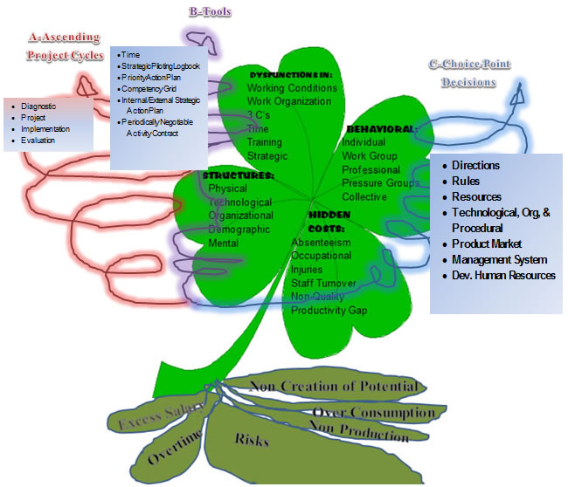
Figure 3 – 4 Leaf Clover SEAM Triple f- Spiral Model – Graphic By David Boje
In your report, please explain the f-spiral and the D-spiral and where you see the client initially and after your three project interventions, and B-tools, and the C-choice-points.

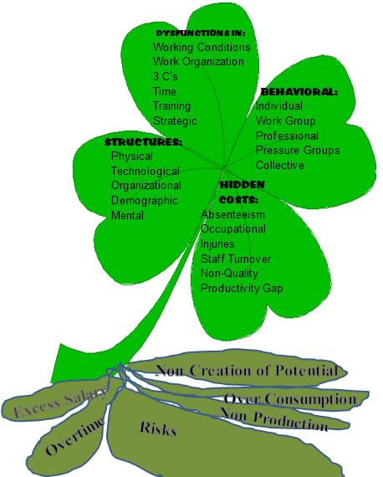
Figure 4 – Close up of the 4-Leaf above ground leaves and the below ground six root-stem rhizome.

4 Leaf-Clover
The Four-Leaf Clover is part of the SEAM diagnostic. It is the force of change in the storytelling consulting. Listening and noting storytelling gives a diagnostic to symptoms of problems, and then the analysis of storytelling quotes digs deeper to the roots and what is the deeper root financial causes of problems (excess salary, overtime, risks, non-production, over0consumption, and overall non-reaction of potential revenues).. By working through the Four-Leaf Clover as clients share their past, present, and future storytelling standpoint, consultants are better able to recognize problems that the client may not have realized were even a problem. The rest of the report will refer back to this concept as it pertains to the business, so it is a good thing to take note of.

SEAM
SEAM is the Socio-Economic Approach to Management. It was developed by Henri Savall as an intervention for businesses. When a business decides to undergo this type of consulting, they are willing to take on a long term commitment to change. SEAM is a way of analyzing the past, hidden issues which have lead to surface problems, and current difficulties of the business in order to find antenarrative future. SEAM implements internal and external strategic planning, and requires a change in policy for the business. The process that MetallicWind has been working through is the SEAM intervention, and by the end they should see more than just a “gain (in) revenue,” but a whole new plan for conducting business in order to combat hidden dysfunctions which was resulting in the low sales previously.
In the midst of three spirals (A-B-C) a 4-leaf-diagnostic can change six atrophied root-stems (excess salary, overtime, risks, non-production, over-consumption, & non-creation of potential revenue). SEAM is a triple-spiral of A: Ascending-cyclic-projects; B: Blossoming-tools; and C: Choice-point-decisions. In the center is the four-leaf-clover diagnostic of the surface rhizome-vines and the consequences for six below-ground rhizomatic-roots. The triple-spiral in Celtic is called “triscele”. 500 BCE Celtic manuscripts have survived with multi-colored triple-spiral images (source: http://www.tattoosymbol.com/celtic.html)
Figure 5 – 4-leaf clover and Triple-f-spirals A, B, and C
QUANTUM STORYTELLING and D-Questions
Table 1 – 11 D’s of Quantum Storytelling and the Questions asked of Blacksmith artists
11 D's |  | Where it helps you Consulting
Directionality | 1. What is the directionality of the small business processes; to what future are they headed? | Axis C: Direction. This is not compass direction, it is strategic direction, arriving from the future-->present.
Datability | 2. What is the datability of the small business process developments? | 4-Leaf Structures: Important pivotal dates where technical processes, physical and other structures were acquired
Duration | 3. What is the duration of various small business processes? | Axis C: Strategic Choices - helps sort out how long various strategies have been in effect
Disclosability | 4. What is the disclosability of the future small business processes revealed to you? | Axis A - projects that disclose a future, Axis B - PAP and I/ESAP; SI in top leaf. The future is arriving into the present, presenting a set of potential futures, in the choice points in Axis C
Destining | 5. What is the destining of the processes unfolding in ways you can foretell? Follow up, in fore-caring, fore-structuring, fore-having, fore-conceiving. | Axis B: PAP & I/ESAP; Axis C - all items. This is weak destiny, where even where the is momentum and carved channels in the market, there are also choice-points among futures
Deployment | 6. What is the deployment of small business processes, in-order-to, for-the-sake-of? | Axis B: PAP & I/ESAP; Axis C - all items. Look at existing processes of production, distribution, & consumption. How are these processes deployed. How could they be?
Dwelling | 7. What is the dwelling, in-place in the world of small business processes? | Knowing place in the market, in the state, etc. lets them sort out Axis B: PAP & I/ESAP; Axis C - all items
De-severance | 8. What is the de-severance (de-distancing) of space-time-mattering? | De-severing space is bringing something far close. De-severing time can be bringing a future potential into the path of SAP and I/ESAP and the Axis C choice-points.
Drafts | 9. What are the drafts, updraft, and downdraft, into tighter (down) orbits, or into more open outer orbits (up), and the turning points from one draft to another? | Axis A, B, & C. This is where the client and consultant sort out strategic choice points, moving into more updraft spiral-antenarratives, ascending into more potential
Dispersion | 10. What is the dispersion of processes, too diverse, or consolidating them? | This can free up resources to invested in more strategic processes
Detaching | 11. What is the detaching from being drawn into they-ness, they-relations, they-self and finding a path of ownmost authentic potentiality-for-Being-a-whole-Self? | Following the they-crowd is not great strategy. Developing into whole-Self potentiality fits well with Axis C
The 11'Ds are concepts explained at the http://peaceaware.com website and in the 'Quantum Storytelling' online textbook. Drafts, in particular, are a way of moving from f-spiral to D-spiral. The f-spiral is minimal string-line, without much force, without much structure, or complexity. The D-spiral has more inter-connections, more force, more structuring, and much more complexity as a robust system that has off-shoots (fractals).

3 Types of storytelling
What is storytelling? It is the inter-activity of three modes: (1) narratives of the past, (2) living stories in-the-middle, in the Present, and (3) antenarrative trajectories connecting narrative and living stories in four different ways (linear-, cyclical-, spiral-, and rhizome-antenarratives).
1) Narrative-past- When a client shares the narrative-past, they are describing where the business has been. This can show actions and ideas that have previously worked or failed, and it can bring to surface hidden dysfunctions of unresolved problems. 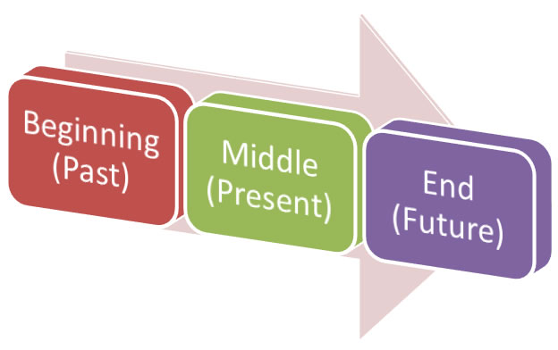
Figure 7 – BME Narrative Linearity
Beginning-middle-end narratives causal chains of the past are predicted by the naive to repeat into the future (a very bad bet as a consultant or business person). We live in a non-linear world, and the next three are about that. The worst consulting persuades clients to do linear processes in a non-linear world.
2) What is living story? A living story unfolds in-the-middle, is relational to many other living stories, and living stories are about Being-in-the-world, in a life path of a life. A living story has a place, a time, and a materiality. But not a place that is Euclidian, nor a time that is clocktime, or a materiality that is Newtonian physics. A living story is about Being-in-the-world of life, it is a time-future arriving into the Present, and a mattering Boje calls 'quantum' where our living stories are intra-active and inter-action with the materiality of living things.
3) What is Antenarrative? Boje (2001) created the term and theory; defined as a 'before' narrative coheres, and a 'bet' on the future and how livings stories of your client are related to grander (one-voiced, abstract) narratives. Storytelling is defined as speech acts, material actions, and is comprised of narratives of the past, living stories unfolding in the Present, and four types of Antenarrative Bridge between the living stories and the narratives:
- 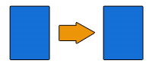Linear-antenarrative process link between living stories emptied out to create a linear-antenarrative of the past that is predicted to repeat into the future. People assume linear causality, but it is rarely so.
- Cyclic-antenarrative processes have stage-by-stage pasts that are predicted to repeat into the future. But most cycles, try as we might to control them, become spirals. If we could predict business cycles, we would all be rich. Instead the veer out of that presumed control, which is why we need two more types. We also live in non-linear and non-cyclic landscapes, and the next two are about that. The worst consultants do not even realize cycles are not all there is.
- Spiral-antenarrative process that is from the future into the Present, and into the past. This is a radical approach to spacetimemattering. There are 11 D-questions in Boje's Youtube film on blacksmithing small businesses. the 9th question is about Drafts (up and down drafts) of spiral-antenarratives. Spiral-antenarratives can be a good thing or a bad thing. It just depends. An updraft into more innovation, more freedom, and the business becoming its whole Self can be very good. A down-fall into the tighter orbits that plunge into the abyss, not such a good thing. Spiral-antenarratives have trajectories, and each twirl can have choice-points where more spiraling-antenarratives trajectories form cross-roads or pathway choices. In the SEAM intervention process you are developing several f-spirals (A-B-C) and using quantum storytelling working the D’s into a D-spiral. You are transforming the f-spirals into D-spirals. If you care dealing with an initial D-spiral, you may be working the reverse process, making the spiral less dense, less inter-connected, and becoming leaner and meaner f-spirals.
- Rhizomatic – Antenarrative - 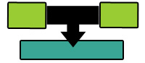Rhizomatic-antenarrative process is also from future into the Present, and into the past. A rhizome has above ground vines, and below-ground (subterranean) roots. Vines and roots are moving, create new rhizomes. An example of a SEAM rhizome-antenarrative is the six conseuqnces of dysfunctions and atrophies in that are hidden below the surface (over salary, etc.)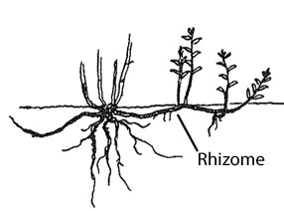
Figure 8 – Rhizome Image - Source
They move any which way in a multiplicity of directions until met by a blockage, and then move up, over, under, or around. We won’t do much on this one. Rhizomes can be a good thing, or a bad thing; depends on how you harvest them, what you do with them when they invade your landscape. You have been working with rhizome-antenarratives already (see the six tubers in the 4-clover diagram).
• Hybrids are possible where some parts of a small business are controlled linear-antenarrative and cyclic-antenarrative recurrence, but other parts are spiraling-antenarratives, and now and again a rhizomatic-antenarrative occurs. Won't do much on this, but if you must, go ahead.
At some point the spiraling-antenarrative reverts to cyclic or becomes full of more multiplicity and the next small business process is manifest. Time-spiral is one of the key aspects of Savall et al.’s (2008) 3 axes of consulting. Depicted is a set of simple f-spirals, but is not yet a D-spiral.
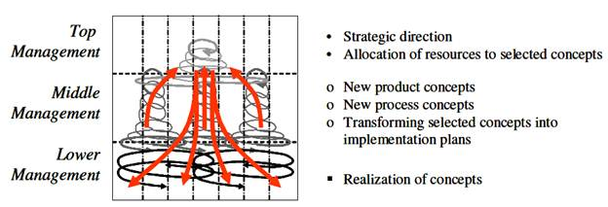
Figure 9 - Multiple interactive f-spiral-antenarratives. The above example is from Franken & Braganza (2006)
In sum, consultants use the narrative-past and the living story to help determine how to create an antenarrative future which is best for the business. A spiral-antenarrative includes something more than reflecting upon history of ‘Now after Now,’ gone by. Rather, a spiral-antenarrative includes what Heidegger (1962) calls fore-telling, and fore-having. A spiral is the future informing the present, being present. It is not just retrospective sensemaking, it is rather quite prospective. There are 'bets' (antes) that are predictions of the future. Your task as a consultant is to create and transform f-spirals (A-B-C) using the D’s into D-spiral. Or, if you are dealing with a robust D-spiral, then the task may be to loosen it up into f-spirals.

