**Seven True Storytelling Solutions to the Narrative Madness of the Global Water Apocalypse**

David M. Boje

Submission to the December 2018 *Quantum Storytelling Conference*

**Abstract**

Can we find possible solutions to the ‘Global Water Crisis’? Any solution must begin with ‘True Storytelling ‘ about the consequences of to humanity and most other life on the planet, if water capitalism goes unchecked. True Storytelling means making spaces respecting the existing water stress and water scarcity, already here and now. It is creating a direction for sustainable future that helps people prioritize water uses. It is about timing because since 1980 New Mexico, in water scarcity for a century, went past the limits of peak water. It is now in water scarcity crisis mode. Studying New Mexico can help with lessons learned, and allow new stories on their way by experimenting with new solutions to ‘Global Water Crisis’. It is about staging Popup events to educate Chihuahuan Desert residents on how overgrazing, and over-mining aquifers, and artifacts like single use plastic has to go away. It is about deconstructing water growth for the sake of economic growth, as a kind of addiction turned to global madness called ‘water capitalism. Its about protection and conservation of the planet’s freshwater.

**Key Words**: Water storytelling, water capitalism, true storytelling, water madness

I will start with a couple paragraphs from my next book (Global Storytelling keeping Water Crisis in the Shadow, World Scientific Press):

I David M. Boje am descended on my dad’s side from Celtic tribes of Prussia when it was part of Denmark, and on my mother’s side from Celtic tribes of Scotland, before the 1700s. I was born in Spokane, along the Little Spokane River. It is called the River of Kings, once holm to King Salmon. They are the biggest salmon. The Chinook Wal-Eyed Silver Salmon grew to weigh 50 to 80 pounds (Kershner, 1995). The Spokane Indian tribal people harvested them. It took less than a century to kill off those King Salmon, entirely. Actually it took two days for the Long Lake Dam to block three fourths of the Spokane River in 1915. It took one day for the Grand Coulee Dam to block the other one-quarter of the river on March 22nd, 1941. By the time I was born in 1947, the Spokane River was no longer alive with King Salmon. Before the two dams, the Spokane Indians could catch 1,700 fish in a fish camp, in the middle of Spokane City at the Spokane Falls, in just one day. 5,000 Spokane Indians would gather and the Nez Perce would join them. The ‘salmon chief’ would oversee the salmon fishing, and make sure every single person, of all ages, got equal share. Their diet was 5/8th salmon. Before the two dams, big hotels were constructed and white folks came and fished the River of Kings for those King Salmon. Before the two damns, in the 1880s, a Canadian cannery came and extracted about all of the Spokane big Chinook salmon. Both dams made hydroelectric energy, but were built without fish ladders, and that was the end of the life the King Salmon provide to the Spokane Indians. The salmon could no longer care for the tribal people. My grandfather and grandmother had a farm on the Little Spokane, where my dad was born, and I spent my early toddler years. It was downstream from a paper mill. My granddad told me, do not swim in the polluted water of the Little Spokane, or you’ll get a bad rash, and probably die. Still I did love the farm, with the bee hives, geese, milking cows, the fruit orchards, walnut tree, iris flowers, the summer tomatoes I could eat of the vine, and strawberry patch. My dad built a house in the pasture next door, but my mom preferred the suburbs, a brick house on Greenwood Lane.

Now I live by the Rio Grande Rive in New Mexico. In Mexico it is called the Rio Bravo. The springtime snowmelt from Colorado Mountains once triggered fish to spawn, such as the Rio Grande Cutthroat trout, and the all but extinct Silvery Minnow. This April 2018, stretches for the river, for miles, around Socorro and down here, went bone dry before it was their time to spawn. Thousands of fish flopping around in the puddles, is a terrible sight to behold. The New Mexico Rio Grande River is in big trouble. The fish and other wildlife are in big trouble. Endangered fish, such as the Silvery Minnow, feed other species, mainly birds such as, the Southwestern Willow Flycatcher and the Yellow-billed Cuckoo. The fresh water Texas mussels are about extinct, since the river is drawing in ocean salt water and the saltwater species are taking over in the lower Rio Grande. Those mussels hatch from eggs about size of a grain of sand, and lodge in fish gills, and grow till they can drop to the river bottom and grow about the size of your palm. There are dams, diversions, and depletions of the Rio Grande River, along its 174 miles. Now six of 33 New Mexico counties are in drought. Habitat fragmentation and extractions of water for crops such as pecans and cotton that do not belong in the arid desert region, the river is one the ten most endangered rivers in the entire world. It took two centuries of western settlement for 90% of trout species that were home to the river, to die out. As the river dies out, the habitat along the entire watershed from Colorado to Mexico, as it wands its way to the ocean, dies out. The border wall Trump is building will cost 25 to 50 billion dollars, and disrupt the Rio Grande’s lifeblood that feeds ecosystems home to plants, 500 bird species, 300 butterfly species, 69 fish species, the Texas mussel, and the ocelot. The Rio Grande River is dying of excessive extraction for agriculture, municipal water, and industrial uses is putting pressure on 355,500 square miles of the Rio Brava/Rio Grande water shed. This is affecting the entire hydrological eco-system of the basin, and the Climate Change is not making the situation for wildlife, or human life any better. Dams, diversions, and droughts combine to deplete the Rio Grande. As the saltwater takes over the freshwater the algae proliferates. You change the whole ecology of the region. Do not get me started on the oil and gas spills, the ruptured pipeline in New Mexico on the Delaware River, a stream nearby Brushy Draw and Rustler Breaks, a ways east of Carlsbad Caverns. 18,000 barrels of produced salt-water in oil and gas well mining, leaked into freshwater, wiping out the mussels. In sum, I grew up by one river that had already died, as far as King Salmon were concerned, and now I live by another river that is said to be among the 10, going extinct in the world. And so this essay is about the emerging global water crisis, I call ‘water apocalypse.’ And it is time for ‘true storytelling’ (Boje, Larsen, & Bruun, 2016) about the water crisis coming into our future.

In New Mexico, “Aquifers, natural underground reservoirs, provide nearly 87 percent of public water supplies, but most areas are pumping water faster than it can be replenished” (Business Water Task Force, 2010: 3). Water withdrawal in New Mexico’s population of two million people, totaled 3,815,945 acre-feet (AF). Surface water withdrawals were 2,041,844 AF (53.5% of total), and groundwater withdrawals, 1,774,101 AF (49.5%). Statewide, Irrigated Agriculture accounted for 3,000,155 AF (78.62%) of the total withdrawals, consisting of:   1,633,940 AF (54.46%) of surface water and 1,366,215 AF (45.54%) of groundwater.   Another 1.05% is total withdrawals for Livestock. The third largest use, is from reservoir evaporation.

**Table 1: Categories of New Mexico ‘Rio Grande River basin watershed uses**

|  |  |  |
| --- | --- | --- |
| **CATEGORY** | **TOTAL WATER Acre Feet** | **PERCENTAGE** |
| Commercial (self-supplied) | 41,727 | 2.35% |
| Domestic (self-supplied) | 18,727 | 1.06% |
| Industrial (self-supplied) | 7,548 | 0.43% |
| Irrigated Agriculture | 1,299,979 | 73.30% |
| Livestock (self-supplied) | 9,795 | 0.55% |
| Mining (self-supplied) | 22,681 | 1.28% |
| Power (self-supplied) | 7,123 | 0.40% |
| Public Water Supply | 220,864 | 12.45% |
| Reservoir Evaporation | 145,078 | 8.18% |
| **River Basin Totals** | **1,773,521** | **100.00%** |
| Self-supplied = pumping groundwater | | |



**Figure 1: Total Water Acre Feet of Rio Grand River basin uses**

I do believe a sort of ***narrative madness*** is actually causing ‘***Global Water Crisis***’, the death of the Spokane King Salmon, the extinction of the Rio Grande River Silvery Minnow. What is narrative madness? As Edward Abbey (1968/1971: 145, boldness, mine) puts it, “**growth for the sake of growth is a cancerous madness**”. What people don’t do is read the rest of the quote, which is about water:

“**There is no lack of water here unless you try to establish a city where no city should be … The Developers, of course-the politicians, businessmen, bankers, administrators, engineers-they see ... a desperate water shortage ... They propose schemes of conspiring proportions for diverting water by the damful ... What for? In anticipation of future needs, in order to provide for the continued industrial and population growth of the Southwest**." And in such an answer we see that it's only the old numbers game again, the monomania of the small and very simple minds in the grip of an obsession. They cannot see that **growth for the sake of growth is a cancerous madness**, that Phoenix and Albuquerque will not be better cities to live in when their populations are doubled again and again. They would never understand that an economic system which can only expand or expire must be false to all that is human” (IBID.).

Before we start to explore the narrative madness, let us define key terms:

* **WATER STRESS** – defined as below 1,700 cubic meters per person per year. 2.8 billion people in world are now in water stress (about 38% of world’s population)
* **WATER SCARCITY** – defined as below 1,000 cubic meters per person per year. By year 2025 UN predicts 1.9 billion people will have absolute water scarcity (25% of world’s population.
* **QUANTUM WATER STORYTELLING** – We need a new paradigm, defined as the nexus of water physics, water chemistry, water history, water archaeology, water hydrology, water sociology, water Ecofeminism, water engineering, water law, water economics, water politics, water ethics, and water metaphysics. We are water bodies, walking climate systems of 37.2 trillion living cells all needing water to remain alive. Quantum water storytelling is about the ways life-giving freshwater that is about ½ of one percent of the Earth’s surface and ground water is being polluted with nanoplastic particles that ingest leach industrial solvents, fertilizers, and pesticides while water capitalism takes a common good and turn it into a commodity.
* **BLUE GOLD** – Blue is the new green. And Freshwater is the ‘blue gold’ rush of our time. It is a blue-gold rush of such as global scale, human kind and every other species now faces the biggest evolutionary crisis since the Great Flood, our climate changed, or an asteroid killed the dinosaurs and brought the Ice Age.

There are three peak water crises unfolding in the Anthropocene. The three peak water events have many storytellers, but not much agreement about the water future of humanity.  The three water peaks: renewable water peak, nonrenewable water peak, and ecological water peak. As these happen the quantity and quality of fresh water on the planet becomes so diverted to water commodification uses, such as big water corporations doing more bottled water for sale in single-use plastic bottles, and to big water companies privatizing municipal water systems, and using up fresh groundwater, and diverting river surface water to big business petrochemical agriculture.

The UN predicts and thousands of scientists agree, half the planet's population will be in water scarcity by 2030.  Climate change promises more frequent and longer periods of drought around the world. Two directions. In one direction water is a commodity for sale to the highest bidder. In the other direction water is essential to all humans, to all living beings on the planet. Water storytelling is dominated by water commodification corporate and imperial interests. The annual Water Forum meetings, for example, since  1998, is the site of Big Water Business interests, the Washington Consensus of International Monetary Fund and World Bank ,pushing for global governance of water by water commodification interests.

Unsafe drinking water is the largest killer of children around the world. Lack of fresh water is a greater threat to human survival than Aids, Climate Change, or warfare. Today half the developing world suffered illnesses from contaminated water supply. The care for fresh drinking water is the story of humanity's future. If drinking water becomes only the story of commerce, then that future will pit the haves against the have-nots. Fresh water that is drinkable is only 3% of water on the planet. Of that 3% about 2.5% is in frozen glacier ice or so deep beneath the ground in aquifers, pumping is not an option. That means the fate of humanity depends on a very minute quantity of water that needs to of sufficient quality to be safe to drink. Humans are about 70% water, more when they are infants.  All 37.2 trillion living cells of the body depend upon water for their life.

There is a history of water on the planet, and how instrumental water was to steam power in the industrial revolution. In recent decades, water stress (living on less than 1,700 cubic meters of water) and water scarcity (living on less than 1,000 cubic meters of water) have become critical result of moving three the three peak water crises.  At some point, and soon by most predictions, there will not be enough fresh water for most of the people, animals, fish, and plants on Earth. Yet, the myth of water abundance is so prevalent, especially in water capitalism that a storytelling of denial of the triple peak water situation means humanity is careening to a future that I am calling 'the water apocalypse.'  If humanity is to have health and well-being then water sharing rather than water capitalism has to become the governing ethic.   As my new book (soon available) claims, there is no Planet B. In this new book for World Scientific Publishing, I want to work in peak water storytelling.

Popular and most scholarly storytelling alike portrays Puebloan tribes as ancient irrigators (Ellis 1970, 1979). However, in point of fact, it was the Spaniards that introduced irrigation by digging ditches (Wozniak, 1998). According to water historian Frank Wozniak (1998), Puebloan groups in the Rio Grande River Basin did not engage in extensive irrigation agriculture before the Coronado expedition (1540-1541). Despite the counternarratives of some academics (Anschuetz, 1984; Cordell, 1979, 1984a) the believe in Puebloans being ancient irrigators is very widespread. Some even suggest that Puebloan irrigation was an idea and technology acquired from the prehistoric Chacoan Anasazi culture of Northeastern New Mexico in 10th, 11th, and 12th centuries (e.g. Ellis, 1979: 2). The Chacoan Anasazi are though to have worked on soil and moisture conservation, making terraces and check dams. But Wozniak (1998) argues that one must be careful to differentiate water or moisture conservation systems from irrigation and water diversion systems that require managerial control of water use. One exception is that in Chaco Canyon, the Anasazi did constructed systems to control and divert rainfall runoff from the mesa tops into the northern side canyons (some say in 10th or 11th century). Ultimately the Chacoan system proved impractical and maladaptive, since resulted in salinization and nutrient depletion of canyon soils. Besides Ellis (1979, 1979) there are no other records of prehistoric irrigation systems. On there other hand, there is ample historical record to show evidence of water and/or soil conservation practices, but no evidence for managed irrigation/diversion systems. No excavation reports substantiate prehistoric irrigation practices.

It is possible that so called prehistoric irrigation practices in the northern Rio Grande River basin were post-Spanish contact acequias, either Indian or non-Indian in origin. By the year 1591, the Texas of the Pojoaque Basin had irrigation ditched. There were extensive soil and moisture conservation systems before 1540 in the northern Rio Grade, rather than diversion irrigation as a substance strategy developed by the Anasazi. Soil and moisture conservation developed in response to the moisture deficiencies and climatic and topographic factors assumed with agriculture in semiarid New Mexico environment. These include contour terraces, grid gardens, check damns, and gravel mulch gardens.

When the Spanish expeditions entered the Southwest, records show irrigation agriculture was a practice of indigenous peoples in the river valleys. Seventeenth century Spanish settlement depended upon Rio Grande water to irrigate agriculture for its economic base, and therefore, and it’s survival. The expansion of irrigation systems was accomplished by introducing community land grants into the Rio Grande River basin, after the Reconquest of 1693-1696. Missionaries and encomenderos imposed an irreversible reliance on irrigation agriculture on the Pueblo Indians during the seventeenth century. This technological change irretrievably undermanned and alters Puebloan subsistence systems and lifeways.

We need a new water paradigm because our ‘water future’ is being antenarrated to us by ‘bottled’ water corporations named, Nestle, Pepsi, and Coca-Cola and by water companies privatizing municipal water systems, with French names like, Veolia Environnement France, Suez Environnement France, and by ITT Corporation US, and United Utilities UK.

I make these antenarrative predictions (called bets on water future of humanity and most other species):

1. The Planet B Narrative of a ‘Water Fix’ to ‘Water Scarcity’ is fantasy that will result in Global Water Apocalypse
2. The ‘Technology Big Fix’ Narrative to water crisis is a grand illusion that will also not prevent Global Water Apocalypse
3. The’ Privatization Big Fix’ Narrative to water crisis by market forces is wishful thinking that will not prevent Global Water Apocalypse
4. ‘Strong Institutions Big Fix by Peace Justice Strong Institutions’ (UN SDG #16) Narrative is overly optimistic, and will not change the governmentality of multinational corporate water or international water companies privatizing the ‘global water system’ while deteriorating freshwater quality
5. Multinational water corporations and water companies are narrating a ‘regime of truth’ of ‘water abundance’ while masking increasing water scarcity, resulting in humankind and most every other living kind, risks a ‘Water Apocalypse’ that is part of the Sixth Extinction.

Nestle, Pepsi, and Coca-Cola, along with Veolia Environnement France, Suez Environnement France, ITT Corporation US, and United Utilities UK are producing grand narratives of water abundance, so that water-business-as-usual, and water-consumption-as-usual happen without much critical review. It’s ‘Fake Storytelling’ masking the most likely consequence, ‘Water Apocalypse.’ Therefore we need some ‘True Storytelling’ (Boje, Larsen, & Bruun, 2016; truestorytelling.org). Basically, ‘there is no Planet B’ we can extract water from, and we won’t fix the global water crisis by hydro-techno entrepreneurship, or by market forces of privatization, or by deferring to the United Nations (UN) to implement sustainable development goals (SDGs). In part I, of this essay, I will define more terms and give some maps and tells some stories. In part I, I will get to examples of my own self-reflections on True Storytelling in my local situation of Water Capitalism. My purpose overall is to ask: What we can do is implement True Storytelling Principles (Boje, Larsen, & Bruun, 2017):

* 1. **Truth: You yourself must be true and prepare the energy and effort for a sustainable future**
  2. **Make room: True storytelling makes spaces respecting the stories already there**
  3. **Plot: You must create stories with a clear plot creating direction and help people prioritize**
  4. **Timing: You must have timing**
  5. **Help stories along: You must be able to help stories on their way and be open to experiment**
  6. **Staging: You must consider staging including scenography and artifacts**
  7. **Reflection: You must reflect on the stories and how they create value**

From these seven principles we can derive several narrative hypotheses:

1. If we do not do True Storytelling of the World Water Crisis, the human species will die, and most every other species will die.
2. The planet will live, but this Extinction Event #6 will be 100 to 1,000 times more severe than the five before it (Boje, *in press* Global Storytelling: There is No Planet B
3. People continue a death grip on 3 narratives even in the face of statistically significant facts.
   * A. TINA narrative (there is no alternative) to the current ‘business-as-usual’ & ‘consumption-as-usual’ Water Capitalism
   * B. A big fix techno solution will be invented by entrepreneurs to continue Water Capitalism

C. Wealthy water billionaires will colonize a Planet B and sell fresh water to back to indigenous people of Planet A (Earth).

**Part I: Quantum Storytelling Hypotheses about the Global Water Crisis**

Quantum storytelling can help us understand why it is that people when faced with a crisis, rearrange the deck chairs, keeping a death grip on their routines. This gives us three more hypotheses to explain what will happen to the Global Water Crisis:

1. People in crisis hang on to the way they have always done it.
2. This privileges the TINA Narrative, business-as-usual Narrative, & consumption-as-usual Narrative.
3. Even faced with significant statistics, people cling to outworn narratives with a death grip.

Therefore what I call the ‘Water Apocalypse’ is an inevitability, and part of the Sixth Extinction (Boje, *in press*). We can summarize the true storytelling so far**.** 2.8 Billion people are in Water Stress (defined as below 1000 cubic meters per person per year) which is about 38% of world’s population. A situation of absolute water scarcity, by UN predictions, will reach 1.9 billion people by 2015 (which is about 25% of the world’s population). We have known this situation from some decades, and the UN SDG solutions are not being implemented fast enough prevent the Water Apocalypse. Despite this knowledge, narratology tells us people will continue to cling to the TINA narrative, business-as-usual narrative, and consumption-as-usual narrative.

I can spout (pun intended) water statistics, but it won’t convince you to change your life style. For example, water is 75% of the earth’s surface, but 2.5 is fresh water. 97% of water on earth is saline, and undrinkable by humans. Hydrogeological ownership (aquifers and ground water” has become a reality (Block & Nelson, 2015: 11), including “Excessive pumping of groundwater from an aquifer has serious consequences for surface features. Pumping creates a drawdown cone… Where the soil structure of the aquifer is wet, extraction can cause collapse and result in ground subsidence.” I can show you the following images of water stress by country and it will not change your water behavior. In fact, it may make you thirsty, and grab some bottled water, just to be on the safe side.

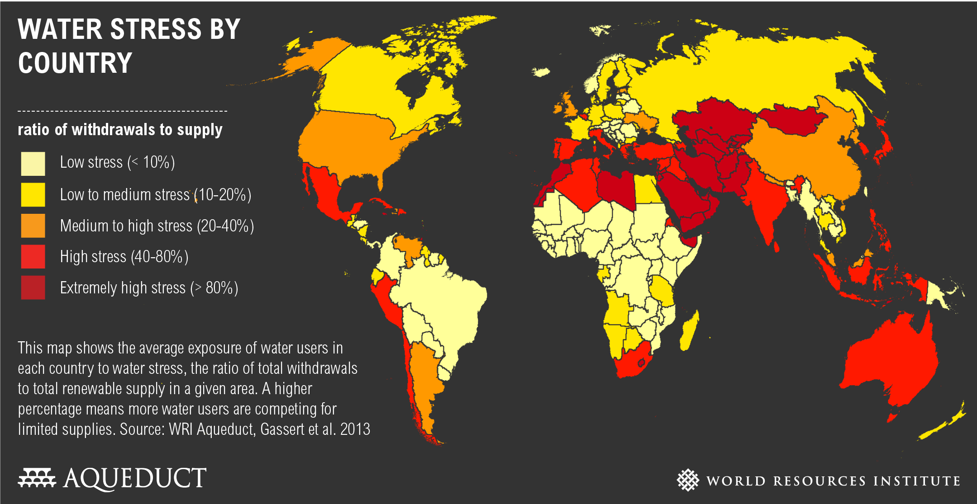

**Figure 2: Water Stress by Country in 2013, from WRI Aqueduct website**[[1]](#footnote-1)

These are older predictions, but they give us some idea of bets on the future (i.e. antenarrative, Boje 2001): that the situation will get worse before changes get implemented to slow down the growthmania of water capitalism.

I have been studying the water storytelling, its history right here in New Mexico. The Elephante Butte Dam was built in 1916 to store spring floodwaters, water flowing from the southern Colorado Rockies’ snowmelt and upstream waters from Northern New Mexico. The dam had unintended consequences. These included displacing local farmers to make way for the dam, and making major changes to the Chihuahuan Desert habitat. Most of all, the dam prevented the Rio Grande River from having enough powerful flow to move the large amounts o soil sediment and sand coming into the river from side channels and arroyos. As a result sediment began accumulating in the river. Finally, as climate change worsened, Colorado, Texas, and New Mexico (members of the Rio Grande Compact) regularly sue each other over river water allotments, and for pumping groundwater from aquifers along the Rio Grande River valley.

My university pumps 3 million gallons of water a day from the Mesilla Bolson aquifer, with no water saving plan, while the aquifer in Climate Change is not replenishing the Rio Grande River or its aquifers, at its older rate I will contrast this with El Paso’s Hueco aquifer that is being preserved, and their desalination plant (Sheng, Mace & Fahy, 2001). New Mexico, like so many states, is past Peak Water limit, on a slippery downward spiral water slide to no drinkable livable water at all. Water politics is intensifying over who has water rights, and how to divvy up less and less water, for more and more corporate farming, family farming, indigenous people, state, and consumer uses. We are so dependent on endless growth of water capitalism, that demands more dams and more drilling, and more people moving in, that demand even more water, as we destroy the water ecology that sustains all living species. We have secularized the water landscape, and commodified water in water capitalism.

In sum, water storytelling of growth for the sake of growth. The complexity of water politics of New Mexico is also expressed in the John Nichols novels: *The Milagro Beanfield War* (2000), *The Magic Journe*y (1978) , and *The Nirvana Blues* (2000). Nichols’ water storytelling is about how indigenous *Acequia water rights*, that Indigenous Way of Knowing (IWOK) what I will call ‘living water’ became displaced by a corporate progress narrative of growth for the sake of growth, the Anglo-legal system acts to dispossess indigenous peoples and generations of non-Anglo family farmers from their communal land and water rights in order to bring about so-called economic development of monocrop corporate agriculture (i.e. cotton & pecans). New Mexico is a water poor state where water politics in involved in every aspect of water life.

As the water storytelling goes, here in New Mexico, the notorious members of the Santa Fe Ring gained control of the Maxwell Land Grant and Railroad Company.[[2]](#footnote-2) The Reverend F. J. Tolby, a Methodist minister, spoke out against the Company turning small-holdings of land into public domain. In 1875 a gang, presumably hired by the Santa Fe Ring, murdered Tolby. Vigilante groups retaliated to avenge Tolby’s death. An anti-grant faction formed to fight the Maxwell Land Grant Company. Fighting became so intense in 1876, Governor Samuel Axtell cooled in soldiers to arrest leaders who opposed the Maxwell Land Grant Company. Settlers were declared to be squatters, and the Company fought for their forcible removal. Resistance continued into the 1890s, but most settlers had been evicted or settled for a small price.

As William James (1907: 96) puts it, “things tell a story.” The Rio Grande River tells us a tragic story of death and dying water, from climate change, from multinational water corporation greed, and consumer ignorance of the importance of preserving and protecting the ‘global water cycle’ from water speculators of Water Capitalism. Fountain (2018), Horning (2018), Parker (2018), and Pierce (2018) each told the same story of the impending death of the Rio Grande/ Rio Bravo River, which is over four million years old. In less than 150 years, the river has been reduced to a “dusty ribbon of sand in some parts, and most of the water that does flow is diverted to irrigate crops, including Mr. Rosales’s fields of wheat, oats, alfalfa and New Mexico’s beloved chilies” (Fountain, 2018). There were earlier stories, than the 2018 reports of Rio Grande dying, such as McDonald (2014).

The Franciscan monks in 1598 accompanied Juan de Oñate, and found the Manso and Pueblo peoples along the Rio Grande bacon were already there, living off the bounty of fish and ducks, and what monks described as the emerald green fields and pink sand. Now with climate change, and peak water crisis, the Rio Grande is dying a slow death, and will not be able to produce beauty or food anymore (McDonald, 2014). Parker (2018) asks a posthumanist question: “If we don’t think we need the Rio Grande for its water, are we willing to save it for its own sake?” Pierce (2018) ends his column by citing a Tweet from @realDonaldTrump, a narrative of climate denial: “Windmills are the greatest threat in the US to both bald and golden eagles. Media climbs fictional ‘global warming is worse. 2:19 PM - Sep 9 2014. The counternarrative of posthumanists, and Indigenous Ways of Knowing (IWOK) is about the living story the Rio Grande River has to tell, about its, impending death.

Last winter’s Colorado snowpack was the second-lowest on record, so by July water ran out, three months earlier than usual (Fountain, 2018). The Rio Grande River tells a story of climate change, with monsoon rains becoming more unpredictable “the long-term outlook for the river is clouded by climate change” (Fountain, 2018): “As the river dries, crews rescue endangered minnows from remaining pools of water.” 2017 was a wet year, but with global warming, declines in winter precipitation, and increases in agriculture, the long-term future, tells a death story. “For hundreds of years its water nourished the crops of native Puebloan people and Spanish colonizers” (Fountain, 2018). “Under state laws, farmers in the pueblos would be among the last to lose water” (Fountain, 2018).

People in New Mexico do not want to think of a time when the Rio Grande River runs dry, and dies. With the climate change, warming temperatures mostly attributable to human practices, it is more difficult for the Rio Grande to count on snowpacks and the snowmelt runoff. It is now 1/6th of average, and 90% of New Mexico is in severe drought (Fountain, 2018).

New Mexico and Texas divvied up the water with the Rio Grande compact in 1938. The United States and Mexico followed, in a 1944 treaty amendment. Life-giving water was reduced to mere debits and credits in an accounting ledger (Parker, 2018). “The Rio Grande is dying” (Horning, 2018). The river is dying, and its a sad, alarming, tragic story of “climate change, ignorance, politics and greed” (Horning, 2018).

To me the Rio Grande is a living entity entangled with other living entities, glaciers, mountains, and the desert. The living river lacks the articulation power to question the Rio Grande Compact, a humancentric treaty between Colorado, New Mexico, and Texas. By treaty, Colorado has first dibs, and that is a sad story for the downstream states, and worse news for Mexico. The River is telling a story, and would prefer the three states and two countries leave enough water flowing for the fish and wildlife. The Rio Grande Compact of 1938 is the epitome of a zero sum game. The Rio Grande River tells its own living and death story of climate change, more erratic drought conditions, less precipitation snow and rain, so aquifers are not recharging. “Rivers without water are not rivers. They are ghosts. If we let the Rio Grande die, we will be haunted by our failure to save her when we had the chance” (Horning, 2018). Less snow pack this year, and again the 1,900 mile long Rio Grande and its aquifers are being drain by pumping groundwater to meet the demands of agriculture, city, and suburban desert dwellers. This third longest river in in the US, is exceeded only by the Yukon and the combined Mississippi and Missouri Rivers. The Rio Grande River flows from the Colorado Rockies to the Gulf of Mexico. “Drained by farmers and divided by treaty, and fueled over in courtrooms, and neglected when not pumped and rain, the Rio Grande is at once one of America’s most famous rives and one of its most abuses” (Parker, 2018). The Rio Grande River and its aquifers are running dry. Hydroengineering over the last century, and the 1938 compact divvied up the Rio Grande, and :life-giving water was reduced to mere debits and credits in an accounting ledger” (Parker, 2018). “Ever since, the river has been tamed, dammed, channeled and diverted into aqueducts, canals and ditches. The American humorist Will Rogers liked to call the Rio Grande ‘the only river I know of that is in need of irrigating’” (Parker, 2018).

These days the snowpack is not what it used to be, and a century and a half of water rights obligations, mean the Rio Grande River has lowest recorded flows in history. Colorado, Texas, New Mexico, and Mexico fight over the river surface-water and aquifer groundwater. By late spring, when snowmelt is space, the river runs near dry, as fish cluster in sandy beds, awaiting their deaths (Parker, 2018). The endangered species, the tiny silvery minnow are on the verge of extinction, only 5% of the historic population remains. Three states and two national governments continue to drain the river. Most people have written off the Rio Grande River, beyond saving, a lost cause. Yet, it is still flowing. The Rio Grande River is replete with tragic stories, but it could still be saved with conservation and smarter water policies, in this epoch, called water capitalism.

No doubt my water storytelling has not been sufficient to change your water behavior and lifestyle. Thinking back to what changed my own, it goes something like this. When I was a young boy, my parents gave me a microscope. I used to collect water samples from the refrigerator drawers, rainwater, and from a marsh in Anchorage Alaska. I’d put a drop of this water on a slide and zoom to the highest power setting. I could see paramecium, amoeba, and protozoa doing cell division, and eating stuff, sometimes each other. I just ordered a microscope, so at age (almost) 71, I can renew my studies.

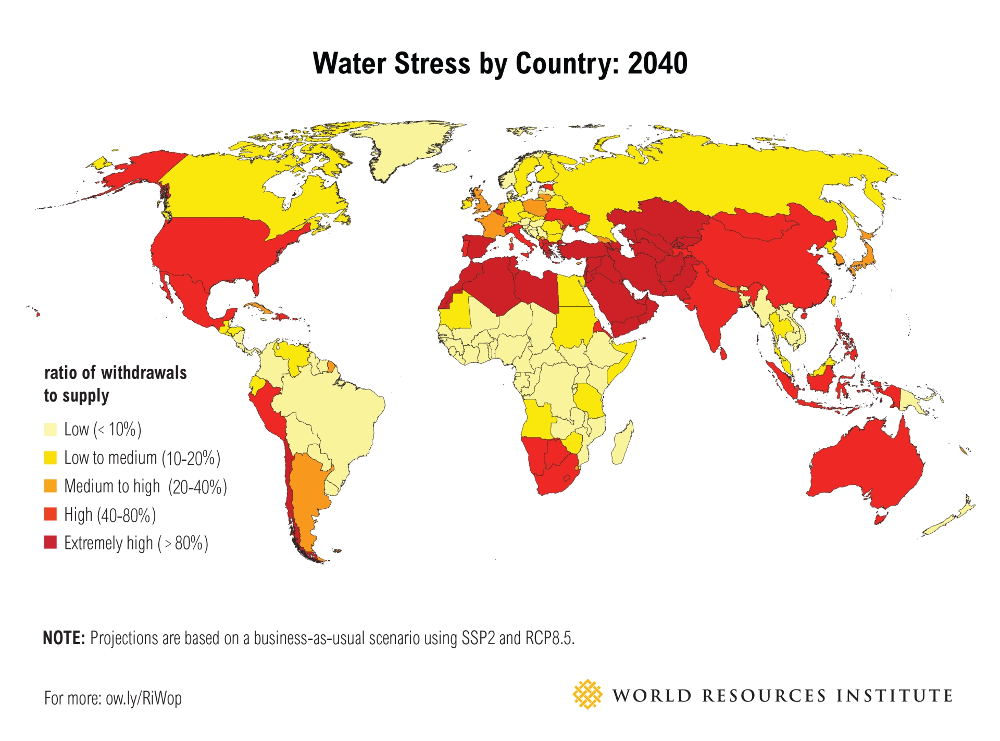

**Figure 3: Global Water Crisis Predictions for 2040** (World Resources Institute)[[3]](#footnote-3)

The map depicts the Water Stress by country will move more countries, such as in US, Mexico Southern Europe, Middle East, China, India, Australia, northern and southern Africa, etc. 🡺 into more severe water stress. In short, the scientific community, and water company/corporation CEOs have known the trendline, but water capitalism continues to grow unabated. We can see that more and more cites are in water crisis, since the news media, tells us narratives about it, on a daily basis, about tap water running out, water trucks bringing in water, etc. Yet, the human behavior habits around water in other cities continues, as before.

**Table 2: Cities with Water Stress we all read about**

1. Sao Paulo
2. Bangalore
3. Beijing
4. Cairo
5. Jakarta
6. Moscow
7. Istanbul
8. Mexico City
9. London
10. Tokyo
11. Miami

Each of these cities has its narratives and is widely circulated in the press. I will recount the Miami narratives, with a True Storytelling water history*: Miami drained the swamps, which in turn polluted Biscayne aquifer. This water crisis was detected in 1930, and no techno fix narrative has ever come to the rescue.* From this, I deduce, it is not like there will a change in US federal policy, or Florida state legislative mandates.

At a country-by-country, narrative level, the situation is about the same. Just as people in cities ignore the global water crisis, so are entire countries ignoring the water history of the planet! True Storytelling can report the facts, such as, 2.8 billion people in 48 countries now in ‘Water Stress’. There are 195 countries in the world, engaged in water-business-as-usual, and water-consumption-as-usual. People continue to life lifestyles that are against the best interests not only of other countries, but themselves.

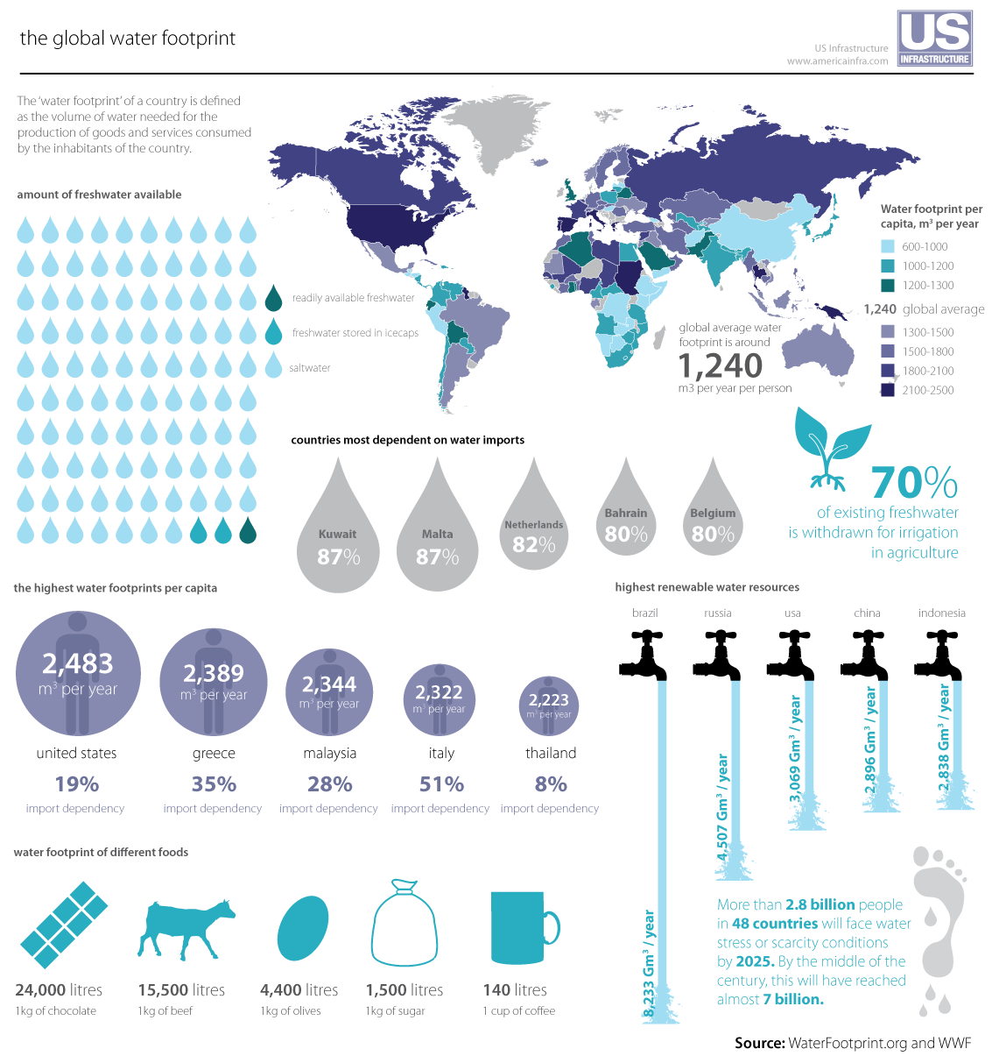

**Figure 4: Global Water Footprints around the World** (Waterfootprint.org & WWF)[[4]](#footnote-4)

Notice how people in the US have the highest water footprint in the world: 2,483 cubic meters of water per person, per year, which is above the global average of 1,243 cubic meters of water per person, per year. The global average already falls between water stress (1,700 cubic meters per person per year) and water scarcity (1,000 cubic meters per person per year). Narratives depicted in maps and statistics are no cure for stupid, self-centered human behavior. Rather, the global water system, I shall argue, is perfectly designed to the country-by-country results it is getting in water capitalism.

We have to takes some time to define more terms. There is a difference between freshwater in rivers and lakes and underground in aquifers, rainwater, ocean water, and virtual water. In particular, virtual water is the calculation of just how much water (usually river, lake, or groundwater) it takes to make products that humans consume.

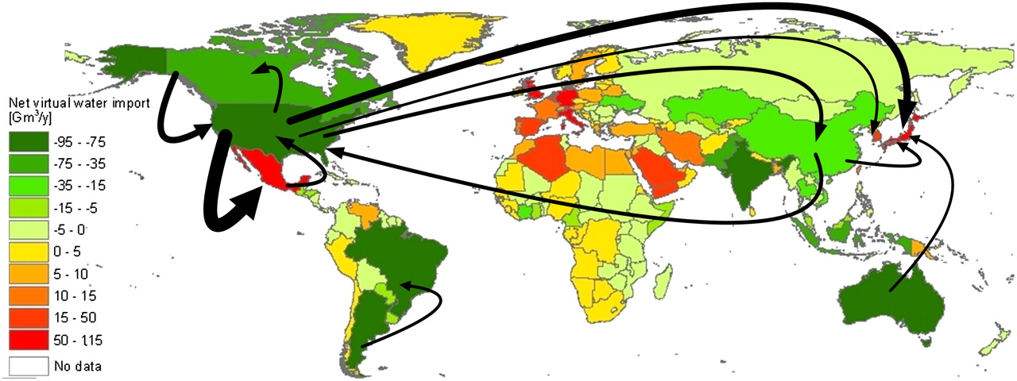

**Figure 5: Net Virtual Water Imports** (Waterfootprint.org)**[[5]](#footnote-5)**

The virtual water shown is the balance per country (Mekennen, Pahlow, Aldaya, Zarate, & Hoekstra, 2015). The direction of gross virtual water flows is related to trade in agricultural and industrial products over the period 1996–2005. Again we have known the World Water Crisis situation for some time, and not much has changed in our strategies, although the narrative rhetoric is a bit more widespread. Only the biggest gross flows (> 15 Gm3/y) are shown in the figure. My point here is that every agricultural and industrial product takes water to produce and transport (including the virtual water it takes to make the transport vehicles). A cup of water takes one cup of coffee needs 140 liters of water and oen liter of milk needs 1000 liters of water to be produced. “The ubiquitous hamburger needs an estimated 2,400 liters of water. Per capita, Americans consume around 6,800 liters of virtual water every day, over triple that of a Chinese person”.[[6]](#footnote-6) In sum, virtual water footprint is far larger than the actual water we drink, flush, or bath in.

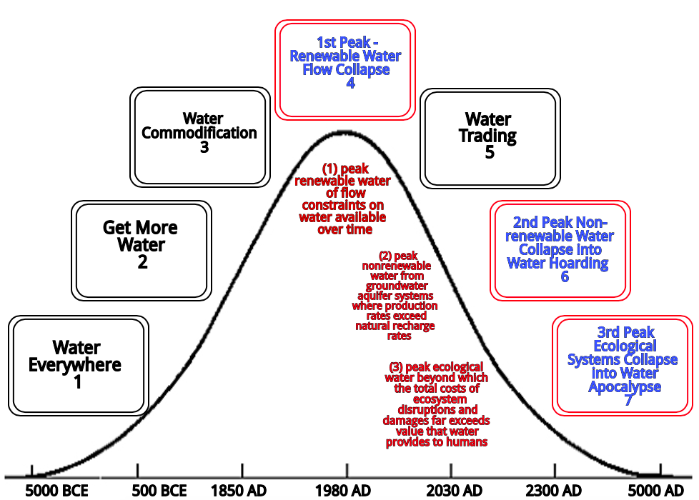

**Figure 6: Seven Phases of the Water Apocalypse** (Boje & Mølbjerg-Jørgensen, 2018)

These are rough estimates of how the three kinds of peak water events will affect seven phases of the Water Apocalypse (Boje & Mølbjerg-Jørgensen, 2018). Gleick and Palaniappan (2010) theorize three kinds of ‘peak water’ events, already happening, here and now: *(1) peak renewable water of flow constraints on water available over time; (2) peak nonrenewable water from groundwater aquifer systems where production rates exceed natural recharge rates; and (3) peak ecological water beyond which the total costs of ecosystem disruptions and damages far exceeds value that water provides to humans*.

**TRUE STORYTELLING:** Water Capitalism. To deconstruct the dominant water-as-usual narratives, we first need to identify the players and their strategies in Water Capitalism. We know the ‘what’ and the ‘how’ but do not pay enough attention to the ‘who’ (Boje & Saylors, 2018).

**WHAT is WATER HISTORY of Water Capitalism?** Water Commons 🡺 Water Property Rights 🡺 Water Commodification 🡺 Water Privatization 🡺 Water Capitalism 🡺 Water Stress became Water Scarcity

**How is Water Capitalism Happening?** It’s about ways empire operates. WB+IMF+NAFTA+WTO 🡺 Strategized Water Privatization 🡺 Made debtor nations out of developing countries + brought in Water Capitalism

Who: 🡺 **Water Companies** (Veolia Environnement France; Suez Environnement France; ITT Corporation US; United Utilities UK, etc.) and **Bottled Water Corporations** (Nestle, Coca Cola, Pepsi, etc.).

Identifying the ‘who’ is important for many reasons. Most of us at this conference are in management and organization studies. Here is a map of the ‘Water Companies’ playing their role in privatizing municipal water systems. Again, we have known their identity for some time, but in my field, the Academy of Management, had done little or nothing about it in terms of conference presentations or journal articles.

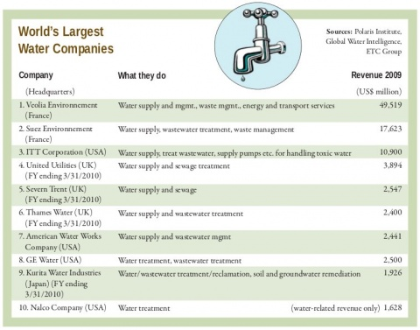

**Figure 7: World’s Ten Largest Water Companies Privatizing Municipal Water Systems[[7]](#footnote-7)**

Despite evidence of the growing Global Water Crisis, the privatization of municipal water systems by water companies, continues. The received narrative is that water companies, under privatization strategies, do more efficient job, at lower costs, than municipal water companies. Hudson (2017) for example points out the problems o poisoned water in Fling Michigan, as well other battles over water privatization in Wisconsin, and in New Jersey. Erbentraut (2014) reports, a few years earlier, on the war raging over drinking water between water companies and municipalities. He reports an earlier situation in Atlanta that privatized, and had to have its municipality reclaim the privatized water system back into public hands. Critics of water privatizations say there is evidence of rake hikes. In fact most municipalities (public utilities) in the US are doing a fabulous job.

**Table 3: 14 Biggest Bottled Water Corporations[[8]](#footnote-8)**

1. **Aquafina (Pepsi)**
2. **Dasani (Coca Cola)**
3. **Nestle Waters**
4. **Glaceau SmartWater**
5. **Poland Spring**
6. **Danone Bottled Water**
7. **Fiji**
8. **Tingyi**
9. **Deer Park**
10. **Ozarka**
11. **Bisleri**
12. **C’est Bon**
13. **Wahaha**
14. **Nougfu Spring**

First day of class, at the university, I pass out reusable water containers, and give students a lecture on the relative health value of refillable containers versus the single-use plastic that is polluting the landscape and ocean. I then do some PH tests on several prominent bottled water, the tap water, and the filtered water station water provided by the university. I empty the classroom trashcan, and put the single-use plastic into the recycle bin, which is located, outside the classroom, around the corner, by the soft drink and bottled water machines. I then introduce the 17 UN SDGs and as students team up, each group gets to work on one of them. As the semester unfolds, students begin to present their own research on the Global Water Crisis. I am working with the students to get them to the 7th Principles of True Storytelling: ‘You must reflect on the stories and how they create value.’ Ecofeminist, Dr. Vandana Shiva: “if you look at a Coca Cola bottle it always says produced by Coca Cola, and they are not meaning the plastic, they are meaning the water inside. All they have done is steal the water from somewhere.”[[9]](#footnote-9)

A post-Carboniferous Capitalism will do away with single-use plastic production & consumption. Aquafina & Pepsi contracts at New Mexico State University, where I have just retired. It is a a waste of water, and a very unhealthy higher education to allow water corporations to pollute the mind and body of students. We study other bottled water corporations. For example, fecal matter) was found in Nestle Pure Life and Baraka Water bottled water and live protozoa in samples of Aquafina bottled water, produced by PepsiCo which authors conclude is “unfit for human consumption.”[[10]](#footnote-10) Aquafina & Pepsi bottled water has twice the microplastic than tap water used to make it. Pepsi admits Aquafina is just tap water.

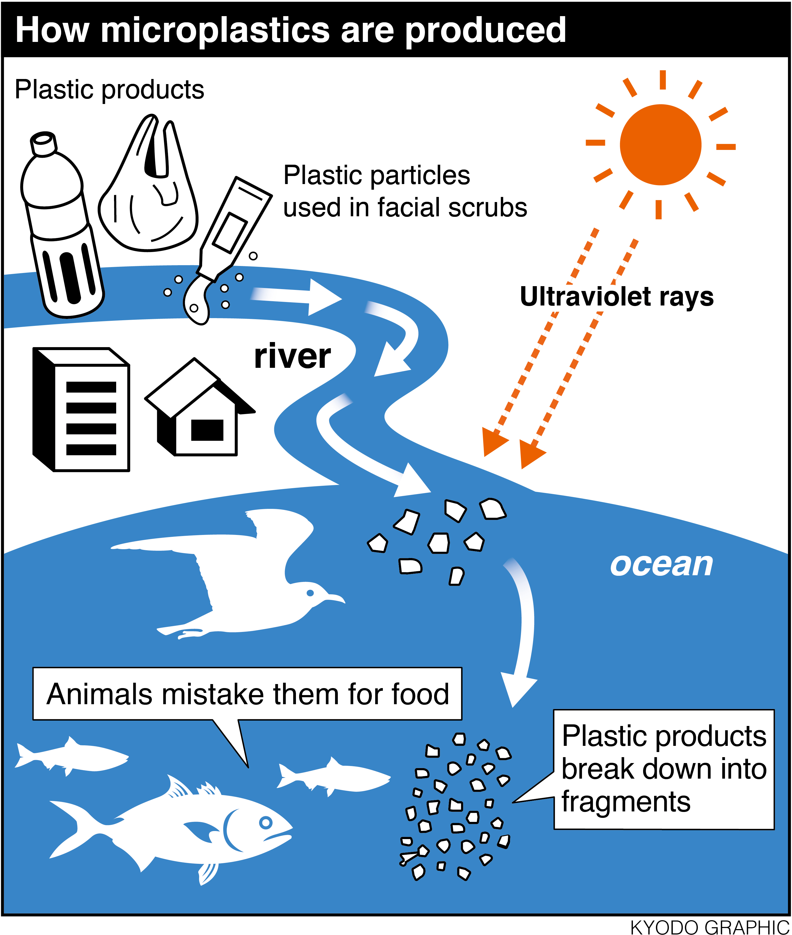

**Figure 8:How Microplastics are Produced and How Fish and Birds mistake it for Food[[11]](#footnote-11)**

As the term unfolds, we look at just how microplastics are produced. I brought in toothpaste, and showed how to test it for microplastics. I showed how to make my own toothpaste, conditioner, and shaving cream, and the use of an old-fashioned steel razor. I do this so that students learn they can live without single use plastic. Related microplastics, are how they break down and become nanoplastic particles. Since this is the ‘Quantum Storytelling Conference’ I know you will understand, that not only is William James (1907: 96) correct in observing, “things tell a story” but at a quantum level, nanoplastic, has a story to tell. The human body, the shrimp, fish, and bird bodies 🡺 ingest nanoplastic particles too small to see without an electron microscope. This is an example of quantum storytelling, the what, how, and who of nanoplastic in Water Capitalism. All macro- & nano-scale plastic absorb and leach hazardous substances during polymerization-manufacturing & in distribution & disposal plastic life cycle. Polymer chains fragment into monomers (or small oligomers), and macro-scale plastic becomes microplastic (size of grain of sand) and fragments to infinitesimal nanoplastic particles too tiny to see, light enough to float in the air, entering all spaces of the environment, penetrating marine, animal, plant, and human bodies to their very core. Impact of plastic absorbing & then leaching, in combining various chemicals, additive, using solvents, absorbing PCBs, and all sorts of hazardous chemicals, results in toxic chemical cocktails. Nanoplastic cocktails migrate across the global spatial surface, and have impact into depth of water, soil, and biota and human bodies.

**TRUE STORYTELLING SOLUTIONS TO THE WORLD WATER CRISIS**

There are solutions to the problems of Global Water Crisis. We could deconstruct the dominant water narratives marketed by water companies and water corporations. True Storytelling can help UN reformulate goals and measures that are bottom-up instead of WB+IMF+NAFTA+WTO 🡺 Strategized Water Privatization 🡺 Made debtor nations out of developing countries + brought in Water Capitalism. We can deconstruct the TINA Narrative and Business-as-usual & consumption-as-usual narratives that keep the 17 UN SDGs from being realized. I teach this to method of deconstruction to undergraduate students, so they can analyze water capitalism rhetoric.

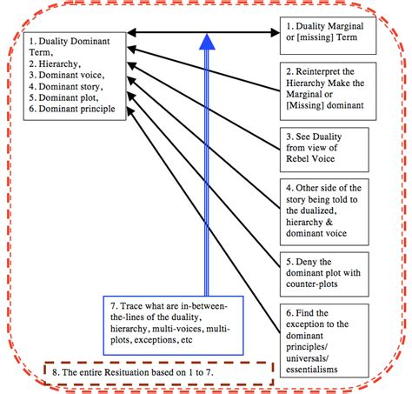

**Figure 9: Deconstructing Narratives** (adapted from Boje, 2001)

As an example, I will deconstruct the first paragraph of one of the UN SDGs to show how Water Capitalism rhetoric has crept into the UN narrative. I assume this is not by intention of the UN, but a result of the their encounters with corporate discourses. *UN Goal 14 paragraph:* “The world’s oceans – their temperature, chemistry, currents and life – drive global systems that make the Earth habitable for humankind. How we manage this vital resource is essential for humanity as a whole, and to counter balance the effects of climate change” UN Goal 13 Life Below Water.[[12]](#footnote-12) I will only demonstrate by using the first two steps (see Boje & Saylors, 2018, for the rest of it). Duality Search: Human Species 🡺 All Species; Ocean 🡺 All Water; Managing Water Resource 🡺 Water is Common Good

* **Reinterpret the Hierarchies**: ‘Water Capitalism’ 🡺 common good for all 🡺 water commodity traded for wealth accumulation. Another hierarchy Profit 🡺 Planet, Commodity 🡺 equality; Rich 🡺 poor; humanity 🡺 all other species.

I will summarize seven solutions that True Storytelling brings to the Water Capitalism and Global Water Crisis situation:

1. Deconstruct the Narratives of Water Capitalism in which one species own all the world’s water. Its humancentric.
2. Transition from monocrop big ag to permaculture local farming
3. Stop corporatization of municipal water; stop big corporation’s producing & marketing bottled water
4. Stop WTO, FAFTA, IMF, WB taking over UN SDG’s
5. Vote against politicians accepting lobby money form water corporations & companies, and big agriculture
6. Give more heed to Indigenous Ways of Knowing (IWOK) instead of Western Ways of Knowing (WWOK) that got us into Water Capitalism 🡺 Water Apocalypse
7. Reconnect to nature’s water in our own life to do what Gandhi says: ‘live the change you want to see in the world.’

As a local step, it is time to challenge the newest of the New Mexico governors and the new legislature, for not measuring well water depth, and aquifer height. I will tell you some stories students in our leadership class shared with me on October 15, 2018. The common theme is water capitalism in America is further dividing the super rich with ‘water rights’ from the poor who are losing their ‘water rights.’ Welcome to water capitalism. Piracy and water pillaging was practices on the Spanish Main. “In the 19th Century… the notorious land baron Henry Miller used pilfered water rights to amass a Central Valley empire larger than Belgium” (Davis, 1996: 81). These days its corporations the practice water piracy in an increasingly aggressive water capitalism.

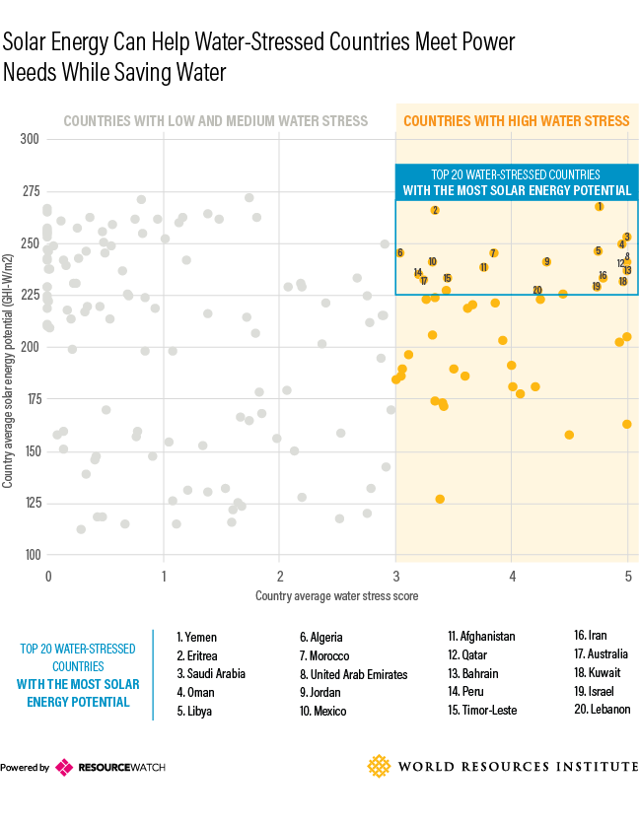

**Figure 10: Solar Energy Solutions to Water-Stressed Countries**

Help stories along on their way means being open to experiment. In the list of 20 water stressed countries, most have a high solar energy potential. In fact, looking at New Mexico, we have one of the best locations for solar energy in the country, yet it is vastly underdeveloped. My wife and I have photovoltaic energy. We are grid-tied, and this pays back the cost, since we produce more energy than we consume, and the electric company pays us for it. We also use the energy for collecting rainwater, pumping grey water to plants, and so forth.

**Part II: Applying True Storytelling to Reflections on my own Life Style on the Soggy Planet Earth**

**1st True Storytelling Principle: You yourself must be true and prepare the energy and effort for a sustainable future**

We embody water. You and I are 75% water as babies swimming in our mother’s womb. My mother was 55% water, and my dad, a bit fatter, was 60% water. Our bodies are 37.2 trillion living cells, 2/3rds intracellular water and 1/3rd extracellular water. Our brains are 73% water, and if we don’t drink enough of it, we cannot remember much at all. Our blood is 20% water, our lungs 83% water, and our muscles and kidneys each are 71% water. Our skin is 64% water and even our bins are 31% water. For our sustainable future, we do consume quite a lot of water to keep our body’s 37.2 trillion cells alive. Water lubricates our bones, helps digest our food, and wets our eyes, nose and throat. Our bodies are walking ecosystems in our water ecology.

By observing living water in nature we can learn to imitate and with water systems. Gregory Cajete (1999) says imitating and learning from nature is less work than having a technology and life styles that separate and alienate us form nature. Earth’s ecosystem makes 9087 billion cubic meters of water each year to support a community of plants, animals, microbiotic life, and people. 70% of the planet is covered by water, but only 2.5% is fresh water to drink. 1% of water is stored in glaciers and snowfields. About 30% of freshwater is stored as ground water in aquifers. This water life allows plant and soil bacteria life to flourish that supports tree and animal life.

A cubic meter of water is 264 US gallons of fluid. On average the global consumer uses 1,385 cu/metric tons of water a year. The US consumer uses more than twice that, or 2842 cubic metric tons of water each year. By comparison a China consumer uses 1071/yr and in India 1182/yr. So there is no water equality between countries. These figures are drinking water, bathing water, and plus what is called ‘virtual water. Virtual water is the hidden flow of water in trade of food and other commodities between countries. It takes lots of water to make things (Hoekstra & Mekonnen, 2012).

The virtual water balance per country is related to trade in agricultural and industrial products. It takes 1,340 cubic metric tons of water to make one metric ton of wheat. It takes 15,500 liters of water to feed a cow to maturity. A chicken consumes 1170 liters of water. Our water activity is a measure of the energy of the water in this trade system. You can go to [www.watercalculator.org](http://www.watercalculator.org) to calculate your own water footprint. Boje and Rosile together use 242 gallons a day from groundwater, rain water, grey water, and most of it from Virtual Water use buying imported goods. We are vegan and that uses 300 gallons of water a day for food, compared to 4,000 gallons a day for a meat-eater.

Las Cruses, located in the Chihuahuan Dessert, uses 6.5 billion gallons/year extracted from groundwater aquifers. NMSU, located in the Chihuahuan Dessert, uses 3 million gallons a day/ extracted from groundwater aquifers (NMSU).[[13]](#footnote-13) One million gallons a day for golf greens, one million for trees and grass suitable to non-desert climate, and one million for drinking and flushing. That means NMSU uses more than a trillion gallons a year pumped from the Mesilla Boson aquifer, a third of it for golf. Of the aquifer water, only 39% is fresh and drinkable. Aquifer groundwater is quite rare, 1.69% of the total water on the planet. Over-pumping aquifer groundwater for golf, monocrop agriculture, gas and oil mining, fracking, and to grow city and university beyond water capacity is quite wasteful, and unsustainable. It is also responsible, along with overgrazing (lack of grazing rotation) for the transformation of the Chihuahuan Dessert what the Spaniards like Juan de Oñate said was grass so high it reached the bellies of their horses. By 1880 Texas was grazing 500,000 head of cattle, and by 1900 that increased to nine million head. Then the taller grass declined by 70%.

New Mexico State University (NMSU), where I work for just this last semester, once had water experimenting at my university such as the geothermal project of the 1970s. I helped launch the vision of a School of Sustainability and did help initiate several sustainability minors in the curriculum. We can help this story along again. We can stage Popup events for clean quality living water. Water is life. We can move to a post-Carboniferous Water Capitalisms and do away with single use plastic production and consumption. We can share water with our neighbors in New Mexico by getting control of our aquifer extraction and replenishing cycle. We can move to a Zero Growth, Zero West ethical answerability for our water. That would be an implementation of the Principles of True Storytelling of New Mexico Water.

You can take a walk with me and see some of it in the deeper arroyos where I live on the East Mesa. The Chihuahuan Dessert has lost much of its biodiversity, and has been invaded by creosote, mesquite, and snake bushes. 345 Chihuahuan Dessert species are only found in small areas, others have gone extinct. It is known that better grazing rotation schemes with more moderate size herds could along with permaculture (a portmanteau word: permanent+agriculture) reverse desertification.

**2nd Principle: True storytelling makes spaces respecting the stories already there**

We have to make spaces to respect the stories of small towns across the US, and throughout the world that have run out of drinking water. Metropolitan cities, big agriculture companies, and corporate water companies are buing up water rights of the less wealthy. In New Mexico, my students tell me, water rights are more dear than land value. Water is an finite resource. If your family’s ancestors had water rights, you are grandfathered in to be first user, when the water table drops. Water rights in New Mexico are a birthright, and you don’t sell your birth claims to water. Water is a mater of identity.

Living water is also spiritual. And we therefore need an eco-philosophy of its spiritual nature. Cajete (1999) writes of a spiritual ecology, and for me, that includes the water spirit. The spiritual will of water is not that of the spirit of capitalism, and its too-often “self-serving will of materialist economic systems” (Cajete, 1999: 16). Dr. Masaru Emoto (2011) does water experiments affecting the vibratory frequency of water. He speaks to water, plays music to it, or meditates or prays on it. If you speak happiness to water, it forms different crystal patterns as compared when you speak hatefully to it. I have story about Nahdion, our Arabian Stallion getting on in years, stopped drinking. So I put my years of Shamanic training to use. I spoke positive things to his water bucket, and wrote some positive things on it. In a few hours Nahdion was drinking living water again.

We used Dr. Masaru Emoto’s water energy experiment to help Nahdion drink water by putting healing energy in his water bucket. I have an idea of how and why this works. Our body of 37.2 trillion living cells is 2/3rds water in those cells and other 1/3rd is water our cells swim within. How our body is 75% water as infant and 60 to 65% water as we become adults.

In New Zealand they are making space for spiritual living waters, in a new eco-philosophy. For 140 years, the local Māori tribe of Whanganui in the North Island has fought for the recognition of their river to have the same legal rights as a human being. The Whanganui River can go to court, own property, and as the tribe says, “I am the river, the river is me.” Water is a living entity. The Whanganui tribe considers the river to be an ancestor. *Te Awa Tupua* now has its own legal identity. Eight tribes worked to get Mount Taranaki granted the legal rights of a person. *Te Urewera* is a forest hill that is now granted the legal status of person in New Zealand.

***What if we in New Mexico worked to declare Organ Mountains, its waters and forest, the Rio Grande River, and all its aquifers the legal right of a person?*** Water quality is getting worse and water itself scarce.[[14]](#footnote-14) Water is aliveness. What if the ‘living whole’ of all water had its own rights and autonomy as a person? It would mean that we don’t treat water, mountain, or forest as a legal property of humans. “Water is a *taonga* of huge importance to Iwi and enhancing the healthier and wellbeing of our waterways is a priority for many Iwi”, wrote Mike Grace Māori liaison in 2010.

I am very exited about Mora County, New Mexico. They have granted water and natural resources the inalienable and fundamental rights to exist and flourish. They did this to stop the oil and gas fracking. Fracking pollutes the water, the air, the visibility of the night sky, and makes noise pollution with all the truck traffic (Ritchie, 2016). Fracking goes against the eco-philosophy of water as living spirit. It takes 4.5 million gallons of water to drill and fracture a deep gas well (Hanlon et al, 2013). This happens a lot in NW and SE parts of New Mexico. Fracking across the US used 250 billion gallons of water between 2005 and 2014 to extract oil and gas. This produced 210 billion gallons of wastewater.

We have a political race that is about fracking and water use. Steve Pearce, Republican, is running for governor against Lujan Grisham, Democrat. They differ on their approach to Fracking. Pearce says his opponents approach to fracking will drive fracking into Texas and rob the education budget of millions. Grisham says she does not advocate increasing the fracking footprint, and adds “the notion that oil and gas can’t survive when you also do renewable is false… In fact, it’s ludicrous.”

For me, water is spirit and has its own rights in the web of life. Right now we have ‘compact’ that is an outdated, unsustainable eco-philosophy. The ‘Rio Grande River (Río Grande del Norte) Compact’ was signed in 1938, and 1948 agreement with Mexico to work out ownership of water rights by Colorado, New Mexico, and Texas. The 1905-07 and 1944-45 water treaties between US and Mexico.[[15]](#footnote-15) In 1966, due to Colorado ignoring the compact, New Mexico decided to flood its desert with the owed water and in 1967, with Texas sued Colorado in US Supreme court. Texas has sued New Mexico for stealing billions of gallons of Rio Grande water. But these lawsuits are not granting legal status of personhood to the Rio Grande River. Nor does it end international water inequality.

“From its Colorado headwaters to the Gulf of Mexico, the Rio Grande is habitat for a plethora of animal and plant species, including migratory birds arriving from far to the north for winter refuge … Yet the river’s current order of importance in the bilateral relationship between the US and Mexico is far down the list of mutual priorities, upstaged by the so-called narco war, immigration, oil politics and issues of national security. That’s the assessment of a Mexican doctoral student who’s spent the fall semester in residence at the Department of Geography of New Mexico State University (Sun News, 2010)”.[[16]](#footnote-16)

There are ecological consequences of the water wars. Río Grande del Norte River runs from snow-fed mountain streams the Colorado Rocky Mountains through the arid and semiarid desert, to the Gulf of Mexico, a journey of 1,900 miles, while forming watershed of 336,000 square miles. In 1999 the US House of Representatives investigated how the Compact threaded the Rio Grande Silvery Minnow (endangered since 1994). It also threatens the New Mexico meadow jumping mouse (endangered since 2014) and the Western Yellow-Billed Cuckoo (threatened since 2014), and the Southwestern Willow Flycatcher (endangered since 1995). I say its time to make space for a story of the spiritual ecology of the Rio Grande River and its watershed, including its aquifer groundwater.

**3rd True Storytelling Principle: You must create stories with a clear plot creating direction and help people prioritize**

Las Cruces (population 329,000) and NMSU (enrollment 18,000) extract living water form Mesilla, Jornada del Muerto, and the Tularosa boson aquifers. The water from aquifers is being extracted faster than it is replenished. With climate change the aquifers are in crisis. 87% of the water from the Rio Grande River and the aquifers is used for agriculture.

Las Cruces water managers can learn from El Paso. El Paso’s Hueco aquifer is running out, so have established one of the few inland desalinization plants, and bought land east of the city, for future water use. Salinity is increasing in the New Mexico aquifer groundwater is becoming more contaminated with many kinds of agricultural pollutants. We need a clear plot storyline of how to develop water policy that is more ecocentric, less about the humancentric need to own the water rights, to use up all the water.

In 1980, we passed peak water, and are spending more money and energy, to get at the salted and contaminated water, and water seeped underground that is expensive to pump to the surface (Gleick & Palaniappan, 2010). At the same time, the water mismanagement is continuing the desertification of the Chihuahuan Dessert. Water is being drained from aquifers faster than it is replenished (Dimick, 2014). The economic growth model is out of touch with the reality of water needs of all the species living on the living water of New Mexico. It is out of touch with a sustainable eco-philosophy, and a living spiritual ecology of water.

We need a clear plot to the water future. It is now illegal in some states to collect rainwater.[[17]](#footnote-17) It is now illegal in Utah, Washington and Colorado, for individuals to collect rainwater. Other states that have rainwater collection laws include Arizona, Illinois, North Carolina, Ohio, Oklahoma, Texas, and Virginia. In all, eleven states have passed laws about collecting rainwater, which may not mean its actually illegal, and some states do offer tax incentives for collecting rainwater.[[18]](#footnote-18) In Oregon you need a ‘state water rights permit; to collect rainwater. Preventing people from diverting rainwater from their own roofs, to me, is a form of water enslavement. Big water corporations, city water utilities, and big agriculture can drain the aquifers, but we cannot collect rainwater!

Las Cruces now produces 6.5 billion gallon of clean and safe drinking water each year. What is price to the Chihuahuan Dessert? Groundwater is pumped out of the Mesilla and Jornada boson aquifers. The city has 30 aquifer water wells, with 30 regulating valves, and 600 miles of water lines (Las Cruces).[[19]](#footnote-19) Some of the aquifer wells show significant drops in water levels between 1980 and 2018, from 10 feet below ground to more than 50 feet, and others are much deeper, indicating a drop in the water table. Areas with less intensive irrigated agriculture or away from metropolitan centers show smaller decreases or remain static.

In all, the plot for a clear water policy in New Mexico is at a crossroads. Since 2011 Governor Susana Martinez’s administration aggressive attack water protection, and has stopped measurement of aquifer depth. At this time of Peak Water limits being passed, moving out people with skill in hydrology and geology, and doing regulatory rollbacks, leaves the Environmental Department quite ineffective to the challenge (Keller, 2013). There is a risk, if a plume of contaminating pollutants is not effetely monitored, and spreads through the aquifers. There is a threat from copper and the oil and gas fracking to the water quality of the aquifers. Dairy industry has boycotted the monitoring of its manure lagoons, balking at the regulatory and oversight expenses, and claiming its jobs would go out of state.

**4th True Storytelling Principle: You must have timing.**

Obviously the time is now to do something about water policy. Once upon a time, NMSU campus had a successful geothermal project. This timing needs to look at the longer history of the Chihuahuan Dessert. Consider what we as humans can learn form the water life, as the aquifer groundwater was pumped so low that only a few natural springs remain in the Organ Mountains, and other mountain ranges of the Chihuahuan Dessert. Extensive silver mining over-pumped the water, until it dropped the water table that fed the springs.

The 9.000 foot high 32 million-year-old Organ Mountain range of steep frantic and rhyolite slopes in the Chihuahuan Desert emerged from volcano lava flows. It has over 800 plant species, 185 bird species and several permanent springs.

On The Filmore Trial, you can pass the Modoc Mining Company site that mined lead and silver in some 13 mines.There were also copper and gold mines. The mines were prospected for over 200 years. The Torpedo and the Stevenson-Bennett mine line in the Torpedo-Bennett Fault Zone. Organ Mountains largest production mine was the ‘Torpedo Mine’. In 1930s mines in Organ Mountain area were inundated with water and mining ceased.

There is a story of a ‘Lost Padre Mine’ that still lies hidden by the Spanish colonists during the 1790’s (Kelley, 1975). In 1797 during the last Spanish occupation, a priest named Father La Rue, listened as a dying solder told him of the rich gold-bearing mountains. The Spanish explorers did not mine themselves, and instead appropriate the gold and turquoise mines of the Native Americans and used them for labor in the old mines. Father La Rue concealed all traces of the mine fearing another Spanish invading army. By the 1930s most of the lead-silver mines were closed. Mining stopped during WWII. Gold was produced in 20 different mines in the Organ district.

Now the mining of the Chihuahuan Dessert is of a different sort. It is all about fracking to release deeper oil and gas deposits. This means it’s a time of mining aquifers to use in the fracking. And it’s a time when agriculture is expanding, the pecan orchards in Dona Ana County. Mature pecan trees have deep and extensive roots to draw water, extracting most of the first 32 inches of soil water. They are also watered from the Rio Grande irrigation and from mining aquifer water. A mature pecan tree consumes 350 gallons of water each day. “Drip and micro irrigation system capacity for a mature pecan orchard should be 3,600-4,000 gallons of water per acre per day” in August, and as low as 648-72 gallons in April (UGA Extension).[[20]](#footnote-20) That is a lot of water. It begs the question that the drip and micro irrigation are more efficient than flooding the fields with river water, as is doe currently, but is it the time for such high water use, during climate change, during successive years of drought, and during the desertification of the Chihuahuan Dessert?

We can put these stories into the larger narrative and counternarrative of water capitalism. Ian Byatt (2004: 75) writes about the “new water capitalism” that is “not the same as market capitalism generally” because this is a natural monopoly power brought which water infrastructure happens. The water capitalism managers and water ministers are servants of water utility companies making increasingly huge investments, who are becoming servants of water corporations. The water regulators are servants of “politicians playing the zero-sum game of distribution” (Byatt, 2004: 77). “Privatization of water has not simply substituted a private monopoly for a public monopoly…. Water companies can use, and are now subject to, market forces” (Byatt, 2004: 77). Extraction of water from rivers and aquifers, means that licenses for extraction are traded, water is bought and sold between water companies, and those companies “can tap capital markets to finance investment in water abstraction, storage, and transfer schemes” (Byatt, 2004: 78). There is cross-board competition between states and nations for domestic water supplies. Water is a capital-intensive industry, which is increasingly under corporate control. Globally water companies of the State are being taking over by corporations, and privatized.

Osborne (2008) argues that the sustainable development agenda is wider than environmental economics of the short-term that does not question the long-term hidden cost. He gives the example of how in the UK, “support for .water capitalism; is only skin0deep. The main difference in Northern Ireland is that the timing of evolution created an opportunity for underlying concerns to express themselves” (p.14). Aggressive financing structures are in place in Water Capitalism to play the game of short-term speculative gains at the expense of long-term health and well-being.

In sum, timing is slipping away, coming undone, as water as public good becomes property right of states and individuals, and becomes privatized by water corporations.

**5th True Storytelling Principle: You must be able to help stories on their way to be open to experiment**

Students can help a story of water is life, along. It was through student initiatives, not by administration or faculty enthusiasm, that lead to the 2007 Climate Commitment and the 2009 Talloires Commitment by New Mexico State University. In 1996 I began working on sustainability at NMSU. I was there at the signing of the Talloires agreement, and in 2010, I initiated a Faculty Senate motion to establish a Sustainability Council, and by 2012 the University earned a Bronze Star, a Silver Star in 2013, and a Gold star in 2014 and again in 2017. This gave momentum to seeing up School of Sustainability, but with the budget crisis of 2008 then worsening with the fall of the gas and oil prices that funded higher education, there is no more momentum to be found.

Here is a story I would like to help along. What would be the impact of removal of Pepsi and Aquafina bottled soda and water from the New Mexico State University campus? The University of Canberra, Australia, has removed single-use bottled water for sale on its campus (Montgomery, 2017). Six months after the ban, a study found, students under 30 had changed behavior, and were brining refillable water bottles from home to use on campus. Leeds University students in UK have voted to ban single-use water bottles from their campus (Haydock, 2009). On Word Water Day McGill University announced it is phasing out the sale of 85,000 single-use bottled water a year, by May 1st 2019.[[21]](#footnote-21) In Sydney, students at Monte Saint' Angelo Mercy College pushed for the ban on the sale of bottled water at their canteen, in favor of using refillable water stations (Sydney Morning Herald, 2010). Winnipeg University was first of the Canadian universities panning single-use plastic bottles.[[22]](#footnote-22) Hong Kong University is first in China to ditch single-use plastic water bottle seals on its campus.[[23]](#footnote-23) Banning plastic bottled water and soda, is not so easy. In 2013 University of Vermont banned the plastic bottles, but there were unintended consequences, the number of single-use plastic of juices, shipped to campus actually went up.[[24]](#footnote-24) Habits are hard to break. On the other hand the successes outweigh the failures. Washington University at St. Louis was first in nation to ban sale of plastic single-use water bottles in 2009.[[25]](#footnote-25) Its sugary water soft drink fountain sales have dropped 46% since then. They Young Republicans protested the ban of Dasani bottled water, and passed out bottled water at the College of Saint Benedict in St. Joseph Minnesota. In short the bans on bottled water are mostly successful at some 30-university campuses, but on the other hand, juice in single use plastic sales, are up. Schools, universities, even entire cities and their businesses are beginning to ban the sale of single-use plastic bottles.[[26]](#footnote-26)

*Why not here at NMSU, and in Las Cruces, and New Mexico, and why not everywhere, become free of bottled water and sugary soda?* We have to ask about the health and well being consequences of Water Capitalism, privatizing water, and sugar-laden soda-water that is making us sick (Whelan & White, 2005). For example, fecal matter was found in Nestle Pure Life bottle water and live protozoa in samples of Aquafina water in Egypt (Ahram Online, 2016).[[27]](#footnote-27) Aquafina and Pepsi have twice the microplastic particles than tap water (Brueck, 2018), and tap water is what use, so it is from the single use plastic bottles leaching it, along with all the toxins encountered and absorbed, then leached along the production and supply chain. Plastic products break downing nanoplastic particles, smaller than you can see with a microscope. This is the kind of true storytelling that can impact single-use plastic bottle sales. Ecofemist Dr. Vandana Shiva says, “If you look at a Coca Cola bottle it always says produced by Coca Cola, and they are not meaning the plastic, they are meaning the water inside. All they have done is steal the water form somewhere”.[[28]](#footnote-28)

We can each help story along. To help the water story along, I have been doing composting which takes rain water I harvest, with nitrate, and carbon layers of waste, and lots of oxygen to make that compost. I am doing grey water collection, and I have cut back about all the plastic I had been purchasing, and have a way to go to get to zero-plastic waste (plastic takes heaps of water to make, and lots of water for the fossil fuel, especially fracking mining that Carboniferous capitalism requires). The story I am helping along, albeit, against the tide, is zero-growth economy, where what water remains is shared with all the dessert species.

**6th True Storytelling Principle: You must consider staging including scenography and artifacts**

During my last semester at this university students and I are staging a series of popup events about the 17 UN Sustainable Development Goals (SDGs). In both class every lecture, every project is about the SDGs. I was personally greatly inspired by Kolding Denmark’s popup event (August 25-26 2018). A Popup Event includes some displays, an invited audience, and invitations for some audience members to cross the invisible boundary between 'spectator' and 'actor', walk onto the stage and become what Augusto Boal calls 'spect-actor'. I work with True Storytelling consulting to municipalities in Denmark. I work with Jens Larsen and Lena Bruun, to carry true story initiatives into other communities. I was also inspired by how the IAE business college in Lyon had set up its application for the 17 UN SDGs.[[29]](#footnote-29) My vision is NMSU work to implement the Higher Education Sustainability Initiative (HESI), a partnership of UN agencies and initiatives that provide a platform for Higher Education Institutions to engage and contribute to the UN Sustainable goals. NMSU could join by simply filling in their online application (HESI).[[30]](#footnote-30)

**7th True Storytelling Principle: You must reflect on the stories and how they create value**

The 17 UN SDG’s create value, but their measures are not very good for cutting the growth of Carboniferous Capitalism, and its overuse of water. The single-use plastic water bottle consumption is way out of hand in Water Capitalism. NMSU has Aquafina and Pepsi contracts that replaced the Coca Cola and Dasani contracts. At the same time there are 50 times more wastebaskets, at my university, than plastic recycling bins, so most of the single use plastic is going to landfill.

With over pumping and the aquifer water waters some nations have reached peak water faster than other nations. After peak water comes peak grain, and many more peak foods after that. Fracking oil and gas is being used to prop up the global plastic production, which in 2015 was 448 million tons. Of this 161 million used in packaging, and 72 million in building an construction, 65 million in textiles, and 53 million in health care and agriculture products. It takes 1.85 gallons of water just to manufacture the plastic for the bottle holding a liter if bottled ‘groundwater’ taken from an aquifer. A pound of plastic uses 24 gallons to make it. It takes 13 gallons of water to make a gallon of paint. 32 gallons of beer takes 1,500 gallons of water. In the bottle water are endocrine disruptors, water-soluble chemicals such as solvents, DDT, PCBs, etc. The water itself is more of a health risk than tap water Pepsi and Coca Cola, bout use it to make Aquafina and Dasani (Datson, 2004).

Along the Texas/New Mexico border, Texas is drilling water wells into New Mexico aquifers to use to fracking the oil and gas in New Mexico. In Mexico it is way past peak water. Mexico reports wells drilled to depth of 400 feet are now drying up, and producing contaminated water, forcing users to drill to 750 feet or more.[[31]](#footnote-31) The aquifers are being exhausted, and will not replenish. Arroyos are notorious for being strong willed. Try to block an Arroyo with a diversion pipe, or a block of concrete, and it will break on through. The closer you to go the New Mexico/Texas border, you have to go 1,500 feet to reach the aquifer groundwater. And there are wells pumping aquifer water on the other side of borders, because aquifers are no respecter of human borders.

**Conclusions**

Water capitalism means water is being bought and sold like oil and gas, beer or any other commodity. I shall argue that water is alive, and quite the spiritual being, and we need to declare water a person with unalienable rights of existence, not a commodity for sale in ‘water capitalism’ (Byatt, 2004; Osborne, 2008; Ahlers & Zwarteveen, 2009; Mcdonald, 2009: 4; Block & Nelson, 2015). Segerfeld (2005), and Block and Nelson’s (2015), are in favor of Water Capitalism, saying it means market efficiency by treating water as “private property for oceans, lakes, rives, and aquifers… to be owned they same way one owns “pizza, shoes, and cows” (Block & Nelson, 2015: 24). They say neoliberal water rights privatization policies even offers hope for a feminist resistance movement contesting the gender inequality of the politics of water rights marketization. This seems like twisted logic too me.

Segerfeldt (2005) argues that the private sector will play an active role in the UN develop goals because most water distribution is currently carried out by public suppliers who have failed to provided equitable water access, while using storytelling and rhetoric that water is a public good. There is an increasing peak water crisis, and Segerfeldt’s (2005) narrative is massive scale privatization as the solution, and that means a rise in water prices to attain efficiency and the corrupt public sector has failed to attain.

I conclude that water capitalism is undergoing an evolution from wood capitalism, to coal capitalism, to gas and oil capitalism, and our existence now is a water capitalism mode of production and consumption that is increasingly being privatized by corporations taking over public goods, and that raises many ethical questions. In particular, how is it that indigenous people have lost their water rights and their common lands?

Water was once upon a time, part of the commons and is becoming private property called water resources and water commodity. Water has shifted from national common ownership to private property, and is bought as corporate property by Nestle, Pepsi, and Coca Cola to make and sell bottle water. To privatize bodies of water (oceans, lakes, rivers, aquifers) raises ethical questions. States and people have conflicting water claims.

We need to ask the ethical questions about Water Capitalism. Is corporate water the latest form of neocolonialism (Loomis, 2003: 189): “Western governments and the World Bank have pressed water privatization on nations in the developing world, often to the detriment of residents. Companies have provided poor service at high prices and have created social conflict in communities between those whose do and do not have access to clean water.” Is Water Capitalism, the sale of water rights by nations to corporations, a crime against Nature, an ecological injustice, against well-being (Denehy, 2008; White, 2013)? In the list of Las Cruces acceptable contaminants are arsenic, barium, chromium, nitrate, selenium, radioactive alpha, beta, and radium emitters, and uranium. There is also trichloroethylene (PPB). These are in small quantities, but how much is not a good to drink.

In sum we need to be de-growing our water drilling, our fracking, our use of water to make more single use plastic bags and water and soda bottles, and packing material. After peak water, it cost more to get the next water than the energy it generates, but that is life (Brown, 2013). Or is it slow death. We need to rethink the growth-at-all-cost economics theory. We need more true storytelling of our freshwater, tracing how water is essential to all life, to all species of life.

**References**

Abbey, Edward. (1968/1971). Desert Solitaire. New York: Ballantine Books

Ahlers, R., & Zwarteveen, M. (2009). The water question in feminism: water control and gender inequities in a neo-liberal era. *Gender, Place and Culture*, *16*(4), 409-426.

Block, W. E., & Nelson, P. L. (2015). *Water Capitalism: The Case for Privatizing Oceans, Rivers, Lakes, and Aquifers*. Lexington Books.

Brown, Lester. (2013). The real threat to our future is peak water. The Guardian. Accessed Oct 15 2018 at https://[www.theguardian.com/global-development/2013/jul/06/water-supplies-shrinking-threat-to-food](http://www.theguardian.com/global-development/2013/jul/06/water-supplies-shrinking-threat-to-food)

Boje, David M. (2001).***Narrative Methods for Organization and Communication Research*.** London: Sage.

Boje, D. M.; Larsen, Jens; Brunn, Lena. (2017). ‘True Storytelling. How to succeed with your implementation’, working paper. <http://oldfriendsindustries.com/?page_id=1048>

Boje, David M.; Mølbjerg Jørgensen, Kenneth. (2018). Making the future: the antenarrative challenge of sustainability for problem-based learning. Chapter for Learning Organization Handbook.

Boje, David M.; Saylors, Rohny. (2018). Contributions of Social Entrepreneurship to Narrative Reconstructing United Nations’ Goal 14 Life Below Water. Chapter for an Entrepreneurship Handbook.

Brown, Leaster. (2013). The real threat to our future is peak water'. Guardian, 6 July, 2013, accessed Dec 12 2018 at https://www.theguardian.com/global-development/2013/jul/06/water-supplies-shrinking-threat-to-food

Brueck, Hillary. (2018). Bottled water from major brands like Aquafina, Nestle, and Dasani has been found to contain tiny plastic particles that you're drinking. Accessed Oct 15 2018 at https://www.businessinsider.com/bottled-water-from-aquafina-nestle-dasani-contains-microplastics-2018-3Cajete, Gregory. (1999). A People’s Ecology: explorations in Sustainable Living. Santa Fe, NM: Clear Light Publishers.

Business Water Task Force. (2010). New Mexico Water Basics and An Introduction to Water Markets. Accessed Dec 6 2018 at https://aquadoc.typepad.com/files/nm-water-brochure-final.pdf

Byatt, Ian. (2004). Managing water for the Future: The Case of England and Wales. Pp. 73-88 in Julie Trottier and Paul Slack (Eds.) Managing Water Resources Past and Present: The Linacre Lectures 2002. NY/London: Oxford University Press.

Datson, Trevor. (2004). Coca - Cola Admits That Dasani is Nothing But Tap Water. Reuters accessed Oct 15 2018 at <https://www.commondreams.org/dasani-nothing-but-tap-water>

Davis, Mike. (1996). Water pirates and the infinite suburb. Capitalism Natural Socialism journal, Vol. 7 (2); 81-84.

Denehy, Janice. (2008). Water for sale: what are the costs? The Journal of School Nursing, Vol 24 (2): 59-60.

Dimick, Dennis. (2014). If you think the water crisis can’t get worse, wait until the aquifers are drained. National Geographic (August 21). Accessed Oct 15 2018 at https://news.nationalgeographic.com/news/2014/08/140819-groundwater-california-drought-aquifers-hidden-crisis/

Ebentraut, Joseph. (2015). There’s a secret war being waged over your drinking water. Huffington Post, accessed Nov 19 2018 at https://www.huffingtonpost.com/entry/water-privatization-why-you-should-care\_us\_5671cb10e4b0648fe301fab2

Emoto, M. (2011). *The hidden messages in water*. NY: Simon and Schuster.

Fountain, Henry. (2018). In a warming west, the Rio Grande is drying up. New York Times, May 24th, accessed Oct 17 2018 at <https://www.nytimes.com/interactive/2018/05/24/climate/dry-rio-grande.html>

Gleick, P. H., & Palaniappan, M. (2010). Peak water limits to freshwater withdrawal and use. *Proceedings of the National Academy of Sciences*, *107*(25), 11155-11162.

Hanlon, Peter et al. (2013). Food, Water and Energy: Know the Nexus. NY: Grace Communications Foundation. Accessed on line Oct 15 2018 at https://f05lt1jvsl61nlcd3hu2s61a-wpengine.netdna-ssl.com/wp-content/uploads/2018/10/knowthenexus\_final\_051513.pdf

Haydock, S. (2009), “Banning bottled water in universities”, *The Ecologist*,. accessed May 16 2018 at https://theecologist.org/2009/aug/11/banning-bottled-water-universities

Hoekstra, A. Y., & Mekonnen, M. M. (2012). The water footprint of humanity. *Proceedings of the national academy of sciences*, *109*(9), 3232-3237.

Horning, John. (2018). The Rio Grande is dying and only a new compact will save her. The Denver Post, June 12. Accessed Oct 17 2018 at <https://www.denverpost.com/2018/07/06/the-rio-grande-is-dying-and-only-a-new-compact-will-save-her/>

Hudson, Adam. (2017). Why water privatization is a bad idea for people and the planet. Alternet. April 18, accessed Nov 19 2018 at

James, W. (1907). Pragmatism, a New Name for Some Old Ways of Thinking, Popular Lectures. Online version accessed Sep 5 2018 at https://www.gutenberg.org/files/5116/5116-h/5116-h.htm#link2H\_4\_0006

Keller, Sarah Jane. (2013). New Mexico’s groundwater protections may take a hit, Oct. 24. Accessed Oct 15 2018 at https://www.hcn.org/issues/45.17/new-mexicos-groundwater-protections-may-take-a-hit

Kelley, T.E. (1975) The Lost Padre Mine and the Organ Mining District. Pp. 163-5 New Mexico Geological Society, 26th Annual Fall Field Conference Guidebook. Accessed online Oct 15 2018 at https://nmgs.nmt.edu/publications/guidebooks/downloads/26/26\_p0163\_p0165.pdf

Kershner, Jim. (1995). River of Kings in years past, the Spokane River was home to millions of Salmon, which brought bounty to the region’s tribes. The Spokesman-Review (newspaper). Aug 21. Accessed Dec 6 2018 at <http://www.spokesman.com/stories/1995/aug/21/river-of-kings-in-years-past-the-spokane-river/>

Loomis, E. (2013). The Global Water Crisis: Privatization and Neocolonialism in Film. Radical History Review, Vol. 2013 (116): 189-195.

Mikhailovich, K., & Fitzgerald, R. (2014). Community responses to the removal of bottled water on a university campus. *International Journal of Sustainability in Higher Education, 15*(3), 330-342. doi:http://libezp.nmsu.edu:2194/10.1108/IJSHE-08-2012-0076

McDonald, Colin. (2014). Rio Grande: River that never runs free. Rivard Report, San Antonio. Sep 27, accessed Oct 17 2018 at https://therivardreport.com/rio-grande-story/

McDonald, David A. (2009). Electric capitalism: Conceptualising electricity and capital accumulation in (South) Africa. Pp. in  David A. McDonald (ed.)  *Electric capitalism: Recolonising Africa on the power grid*.London: Routledge.

Mekonnen, M.M., Pahlow, M., Aldaya, M.M., Zarate, E. and Hoekstra, A.Y. (2015) [Sustainability, efficiency and equitability of water consumption and pollution in Latin America and the Caribbean, Sustainability, 7(2): 2086-2112.](https://waterfootprint.org/media/downloads/Mekonnen-et-al-2015-WFA-LAC.pdf" \o "Sustainability, efficiency & equitability of water in Latin America and the Caribbean" \t "_blank)

Montgomery, M. R. (2017). Water Capitalism: The Case for Privatizing Oceans, Rivers, Lakes, and Aquifers. *Quarterly Journal of Austrian Economics*, *20*(1), 103-107.

Nichols, John R. (2000). *The Nirvana Blues.* NY: Macmillan.

Nichols, John R. (2000). *The Milagro Beanfield War*. NY: Macmillan.

Nichols, John R. (1978). The Magic Journey. NY: Holt, Rinehart and Winston.

Osborne, Ian. (2008). Regulators are drivers of sustainable growth. Utility Week, Vol 28 (23): 13-22.

Parker, Richard. (2018). New York Times, Sep 8, 2018. The Rio Grande is Dying. Does Anyone Care? Accessed Oct 17 2018 at <https://www.nytimes.com/2018/09/08/opinion/sunday/rio-grande-river-drying-up.html>

Pierce, Charles P. (2018). Soon enough the Rio Grande won’t be a Rio anymore. Sep 10, accessed Oct 17 2018 at <https://www.esquire.com/news-politics/politics/a23063097/rio-grande-drying-up-hurricane-season-climate-change/>

Ritchie, Alex. (2016). ‘On the local fracking bans; Policy and preemption in New Mexico’ Digital Repository, accessed Oct 15 2018 at <https://digitalrepository.unm.edu/nrj/vol54/iss2/4/>

Segerfeldt, Fredrik, 2005. Water for Sale: How Business and the Market Can Resolve the World's Water Crisis. Wachington, DC: CATO Institute (translation of Swedish original, Stockholm: Timbro, 2003).

Sheng,Zhuping; Mace, Robert E. ; Fahy, Michael P. 2001).The Hueco Bolson: An Aquifer at the Crossroads. Pp. 66-75 from Texas State Publications, Ground water Reports, Chapter 4, accessed Oct 15 2018 at http://utminers.utep.edu/omwilliamson/hueco\_bolson.htm

Sydney Morning Herald (2010), “Sale of water is banned”, Accessed Oct 16 2018 at www.smh.com.au/environment/water-issues/sale-of-water-is-banned-and-thats-just-lubbly-bubbly-20100727-10uer.html

Whelan, J., & White, R. (2005). Does privatizing water make us sick?. *Health Sociology Review*, *14*(2), 135-145.

White, R. (2013). *Crimes against nature: Environmental criminology and ecological justice*. London: Taylor & Francis (Routledge).

Wozniak, Frank E. 1998. **Irrigation in the Rio Grande Valley, New Mexico: A study and annotated bibliography of the development of irrigation systems.** RMRS-P-2. Fort Collins, CO: U.S. Department of Agriculture, Forest Service, Rocky Mountain Research Station. 204 pages Accessed Dec 5 2018 at <https://www.fs.fed.us/rm/pubs/rmrs_p002.pdf>

1. Aqueduct website, accessed Nov 19 2018 at https://www.wri.org/resources/charts-graphs/water-stress-country [↑](#footnote-ref-1)
2. NM History.org accessed Nov 15 2018 at https://newmexicohistory.org/places/maxwell-land-grant [↑](#footnote-ref-2)
3. Water Stress 2040 chart accessed Nov 19 2018 at https://wriorg.s3.amazonaws.com/s3fs-public/uploads/water\_stress\_world\_map\_large.jpg?\_ga=2.179467108.1115909486.1542633655-869513523.1542633655 [↑](#footnote-ref-3)
4. Water Footprints around the world. Accessed Nov 19 2018 at https://upload.wikimedia.org/wikipedia/commons/d/d0/World\_Water\_Footprint.png [↑](#footnote-ref-4)
5. Accessed Nov 19 2018 at https://waterfootprint.org/en/water-footprint/national-water-footprint/virtual-water-trade/ [↑](#footnote-ref-5)
6. The concept of water footprint and virtual water, accessed Nov 19 2018 at https://www.gdrc.org/uem/footprints/water-footprint.html [↑](#footnote-ref-6)
7. World’s Largest Water Companies, accessed Nov 19 2018 at http://www.etcgroup.org/content/worlds-10-largest-water-companies [↑](#footnote-ref-7)
8. 14 Biggest Bottled Water Manufacturers accessed Nov 19 2018 at https://www.marketing91.com/top-bottled-water-brands/ [↑](#footnote-ref-8)
9. Quote is from podcast, accessed Nov 19 2018 at <http://podacademy.org/podcasts/ecofeminism/> [↑](#footnote-ref-9)
10. See Bottled Water in Egypt, accessed Nov 19 2018 at http://english.ahram.org.eg/NewsContent/3/12/216720/Business/Economy/Egypt-investigating-bottled-water-brands-after-sam.aspx; see Aquafina and Pepsi bottled water with microplastics more than in tap water, accessed Nov 19 2018 at https://www.businessinsider.com/bottled-water-from-aquafina-nestle-dasani-contains-microplastics-2018-3 [↑](#footnote-ref-10)
11. How microplastics are produced, accessed Nov 19 2018 at https://www.japantimes.co.jp/news/2016/07/19/reference/plastic-debris-oceans-growing-hazard-toxins-climb-food-chain/ [↑](#footnote-ref-11)
12. UN Goal 14 Life Below Water, accessed Nov 19 2018 at http://www.undp.org/content/undp/en/home/sustainable-development-goals/goal-14-life-below-water.html [↑](#footnote-ref-12)
13. NMSU drinking water reports accessed Oct 15 2018 at https://safety.nmsu.edu/environmental/drinking-water-information/ [↑](#footnote-ref-13)
14. “Anthropogenic compounds that have been detected in groundwater of the basin include volatile organic compounds (VOCs) (particularly chlorinated solvents and petroleum hydrocarbons) and pesticides (particularly herbicides with urban uses). Most detections of these compounds have been in monitoring wells in or near the Rio Grande inner valley—an area that is intrinsically susceptible to groundwater contamination because of the presence of recharge and depths to groundwater generally less than about 30 ft (Anderholm, 1987)—and the detected concentrations have been below maximum concentrations specified in the USEPA’s water-quality standards. In some cases, however, VOC detections near known chemical releases have resulted in the closure of private domestic wells and public-supply wells” (U.S. Environmental Protection Agency, 2006). Accessed Oct 15 2018 at https://pubs.usgs.gov/pp/1781/pdf/pp1781\_section11.pdf [↑](#footnote-ref-14)
15. Various sources: http://www.ose.state.nm.us/Compacts/RioGrande/RGCC%20Reports/RGCC%202017.pdf; http://www.ose.state.nm.us/Compacts/RioGrande/Tables/RGCompact\_Co\_Deliveries\_2008.pdf;and https://en.wikipedia.org/wiki/Interstate\_compact [↑](#footnote-ref-15)
16. Sun News 2010 (Dec 5) ‘Time to Reconsider Rio Grande Management?’

    by administrator, accessed Oct 15 2018 at https://fnsnews.nmsu.edu/time-to-reconsider-rio-grande-management/ [↑](#footnote-ref-16)
17. Naturalnews.com July 26 2010 Collecting rainwater now illegal in many states as Big Government claims ownership over our water, by Mike Adams, accessed Oct 17 2018 at https://www.naturalnews.com/029286\_rainwater\_collection\_water.html [↑](#footnote-ref-17)
18. Truthorfiction.com. Collecting rainwater is illegal in some states. Accessed Oct 16 2018 at https://www.truthorfiction.com/collecting-rainwater-is-illegal-in-some-states/ [↑](#footnote-ref-18)
19. Las Cruces accessed 15 Oct 2018 at <http://www.las-cruces.org/en/departments/utilities/water> [↑](#footnote-ref-19)
20. UGA Lenny Well, pecan water requirements and irrigation scheduling, accessed Oct 15 2018 at https://secure.caes.uga.edu/extension/publications/files/pdf/C%201106\_1.PDF [↑](#footnote-ref-20)
21. McGill (2018, 13 Apr), “Sustainability, say no to bottled water”, accessed Oct 16 2018 at <https://www.mcgill.ca/sustainability/channels/news/mcgill-ban-sale-bottled-water-campus-286611> [↑](#footnote-ref-21)
22. Winnipeg **University** ‘Which UK university will be the first to ban the plastic bottle, by TobiasAccessed Oct 16 2018 at http://jerrybottle.com/university-bans-plastic-water-bottles/ [↑](#footnote-ref-22)
23. Banthebottl.con HonKong University takes the lead to ban bottled water, Apri 21 2017, Accessed Oct 16 2018 at https://www.banthebottle.net/articles/hong-kong-unveristy-takes-the-lead-to-ban-bottled-water/ [↑](#footnote-ref-23)
24. NPR.org University of Vermont’s Ban on Bottled Water Backfires. Oct 24, 2015, by Taylor Dobbs, accessed Oct 16 2018 at https://www.npr.org/2015/10/14/448697099/university-of-vermonts-ban-on-bottled-water-backfires [↑](#footnote-ref-24)
25. [Wustl.edu](http://Wustl.edu) Water bottle ban a success; bottled beverage sales have plummeted, by Dianne Keggy, Apr 20 2016 accessed Oct 16 2018 at <https://source.wustl.edu/2016/04/water-bottle-ban-success-bottled-beverage-sales-plummeted/> [↑](#footnote-ref-25)
26. Bundyontap.com How did the Bottled Water Free Town idea come about? In Australia, the Bundy On Tap working committee of the township, decided to get free of single-used bottled water, accessed Oct 16 2018 at [www.bundyontap.com.au/bundyontap.html](http://www.bundyontap.com.au/bundyontap.html) [↑](#footnote-ref-26)
27. Ahram Online, 23 May, Egypt investigating bottled water brands after samples found contaminated. Accessed Oct 15 2018 at http://english.ahram.org.eg/NewsContent/3/12/216720/Business/Economy/Egypt-investigating-bottled-water-brands-after-sam.aspx [↑](#footnote-ref-27)
28. Ecofeminism podcast Nov 16 2014, accessed Oct 15 2018 at

    <http://podacademy.org/podcasts/ecofeminism/> [↑](#footnote-ref-28)
29. IAE-Lyon Business School Implementation of PRME and 17 UN Sustainability Goals accessed Oct 15 2018 at http://www.unprme.org/reports/iaelyonSchoolofManagementPRMEandUNGlobalCompactReport20132015.pdf [↑](#footnote-ref-29)
30. HESI registration accessed Oct 15 2018 at https://%20sustainabledevelopment.un.org/%20partnerships/hesi [↑](#footnote-ref-30)
31. Sun News. Border wells drying up. No author. Accessed Oct 15 2018 at

    https://fnsnews.nmsu.edu/border-wells-drying-up/ [↑](#footnote-ref-31)